Craft foam geologic structures student model set materials and instructions
Developed by Andrea Bair, Delta College, MI
Last edited July 18, 2019

These instructions will help you make a classroom/lab class set of 12 student fault and fold models as discussed at the 2019 Earth Educators’ Rendezvous teaching demonstration (weblink https://serc.carleton.edu/218576) Each student set fits easily in a gallon-sized zipper plastic bag for easy storage. Approximate total cost for the set of models is $30 and about 2 hours of time.

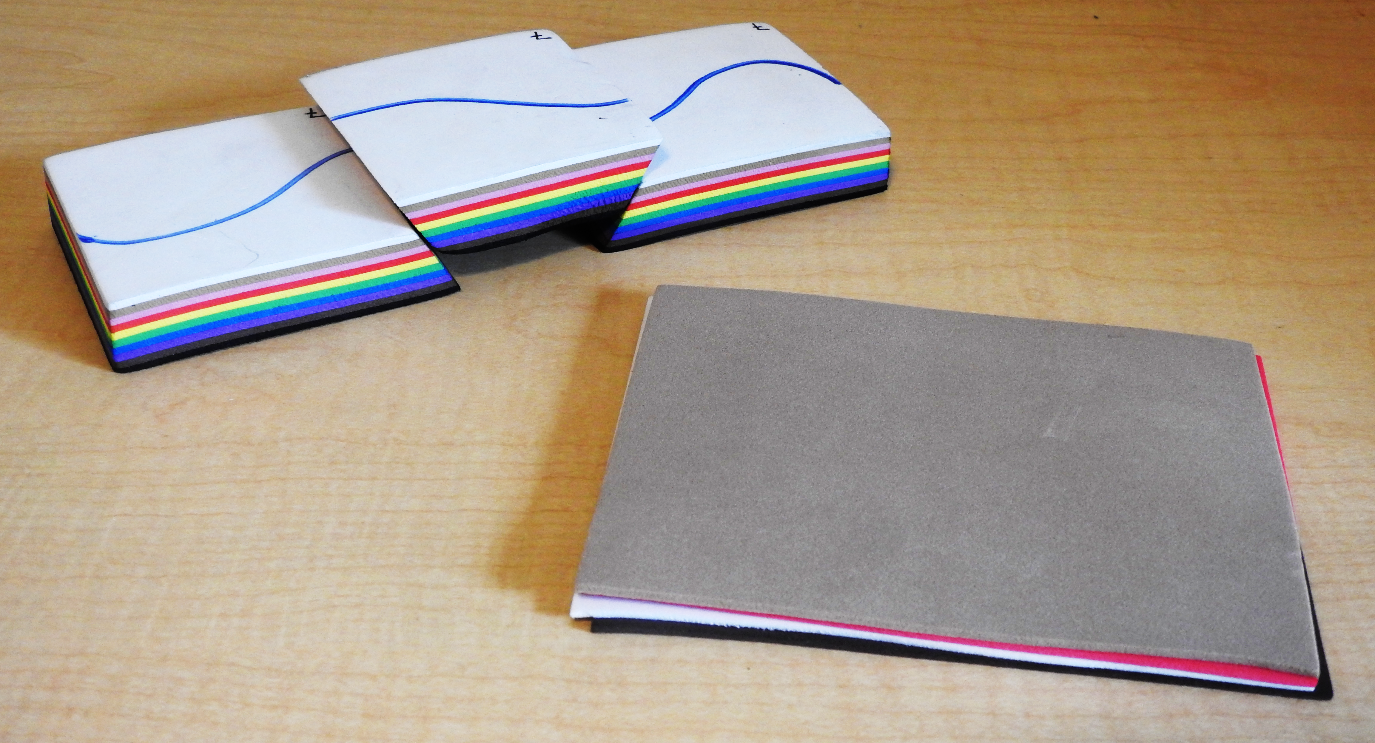

Basic needs to make structure models and run related lab activity:
-construct fault models with multiple layers of self-adhesive craft foam sheets
-assemble a separate set of loose craft foam sheets for fold modeling
-access to a standard table saw to cut the blocks (or help from someone who has this along with cutting expertise!)
-a Sharpie or other permanent marker
-1-gallon zipper plastic bags (12)

Other materials needed for the lab activity:
-lab activity write-up!
-8.5”x11” graph paper, one sheet per student (we like 4 squares/inch, as the models end up being about 3 squares tall)
-colored pencils (3 colors per student)
-ruler at least 12 inches long with metric markings

Materials for the fault models:
2 packages of 6” x 9” adhesive back craft foam sheets multicolor pack cost: ~$10 each

(Darice Foamies craft foam sheets, Sticky Back, Assorted colors, 2mm, 6”x9”, 40 sheets, Amazon.com; Creatology Adhesive foam sheets, Assorted colors, 2mm, 6”x9”, 30 sheets, Michaels)

Constructing the fault models:
My construction strategy is a balance between minimizing waste and maximizing uniformity between model sets. These foam sheet packs have 3-4 black and 3-4 white sheets, with more variable numbers for other colors. Models consist of a stack of 10 colored layers, with black on the bottom and white on the top; in between are 8 other colored layers that can differ between modes. Having white on top allows the addition of a drawn-on surface structure (river, road, fence) that will become offset with shear stress/ strike-slip fault development and makes it easy to see. A standard design makes writing lab instructions much easier too!

I worked with the Creatology foam sheet packs, with 3 white and 3 black sheets, so for each pack, I was able to make 3 10-layer foam stacks that were cut in half vertically to form 6 model sets. I have not worked with the Darice packs, but it appears they may make 4 stacks and 8 model sets per pack following the design described here.

I sort out all the stacks I’ll construct prior to removing any adhesive!

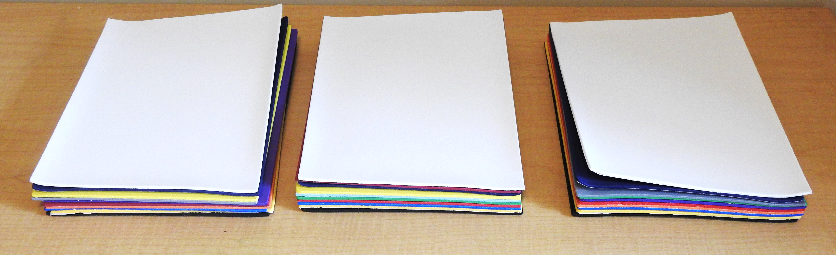

Construct the 10-layer foam stacks with black on the bottom, 8 layers of assorted colors in the middle, and a white layer on top. Start the stack construction by placing the black layer adhesive side UP and peeling off the adhesive layer.

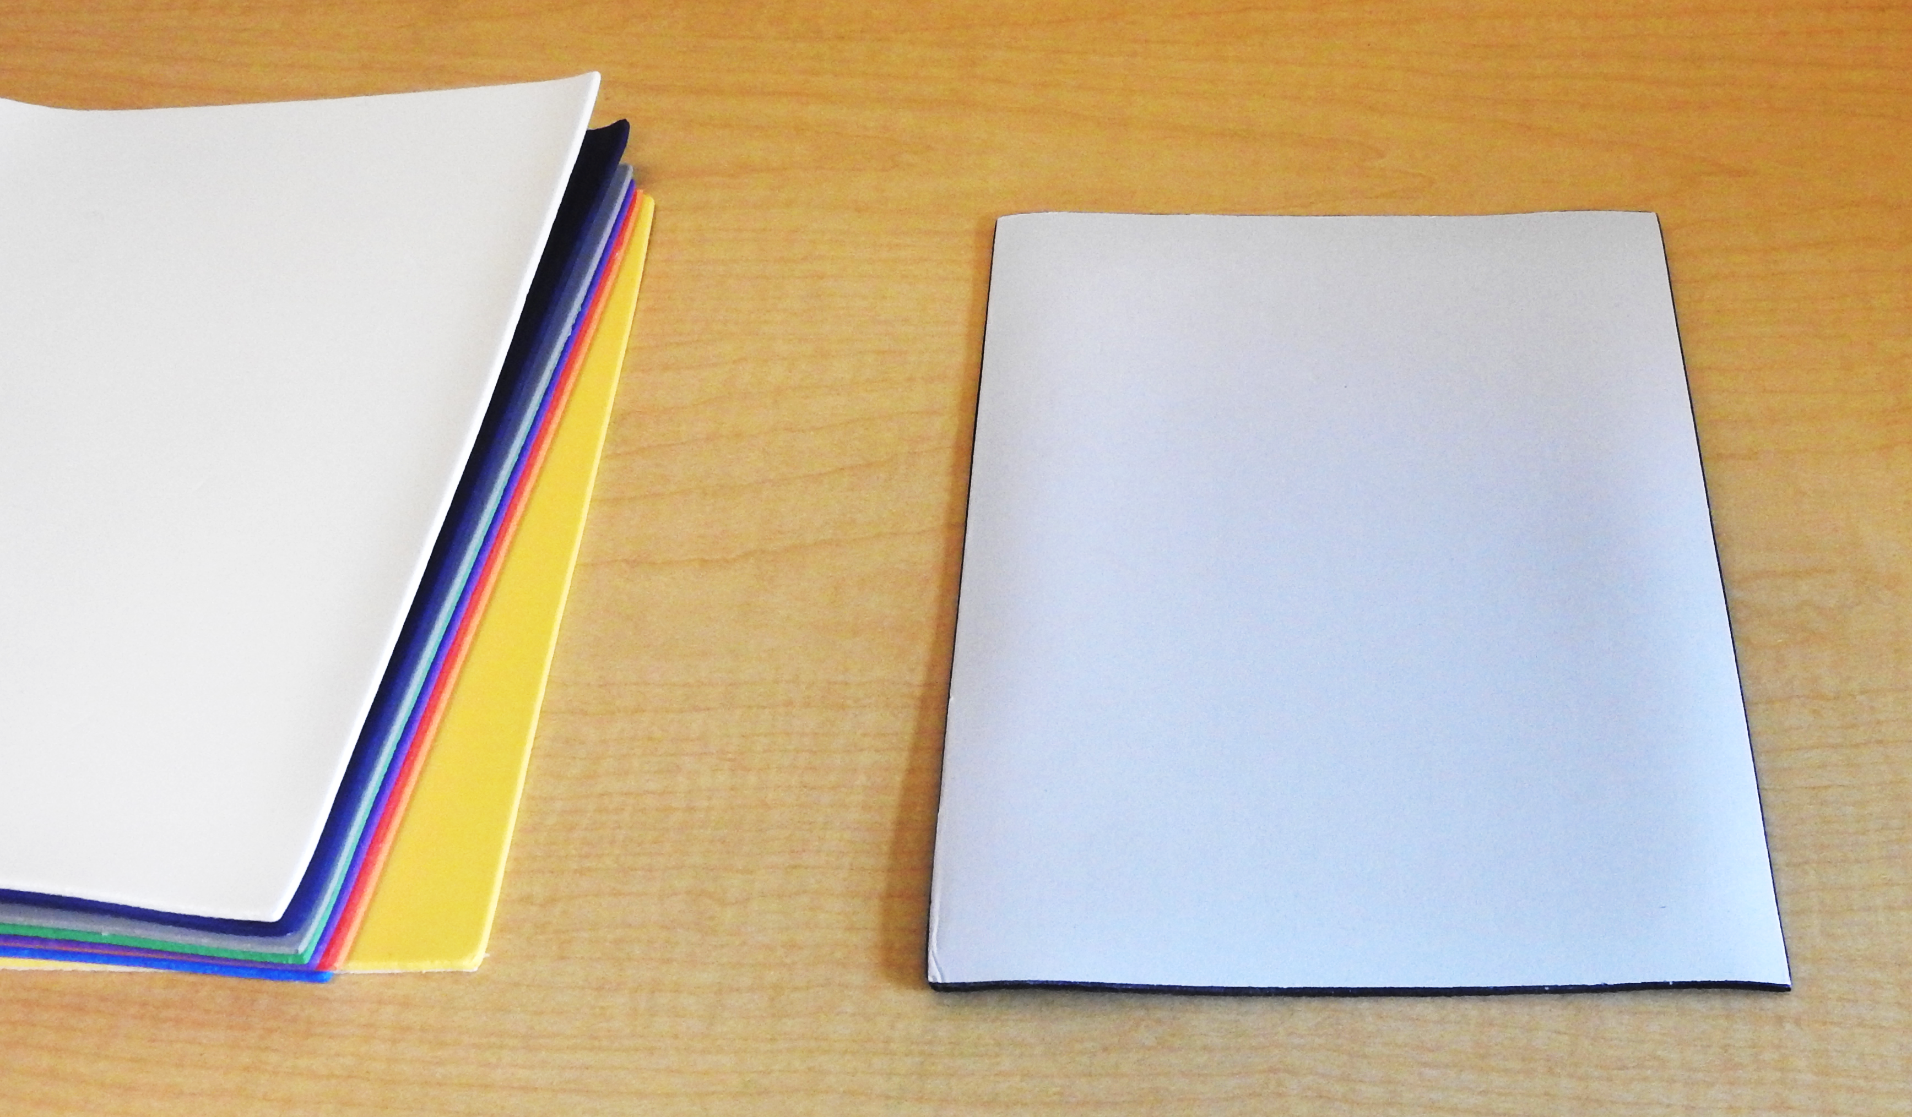
Remove the next layer you want (in my case, yellow) from your stack, remove the adhesive backing, and carefully stack the yellow sheet on the black sheet, adhesive sides for BOTH connecting. The bottom layer is the only example of adhesive sides facing each other.
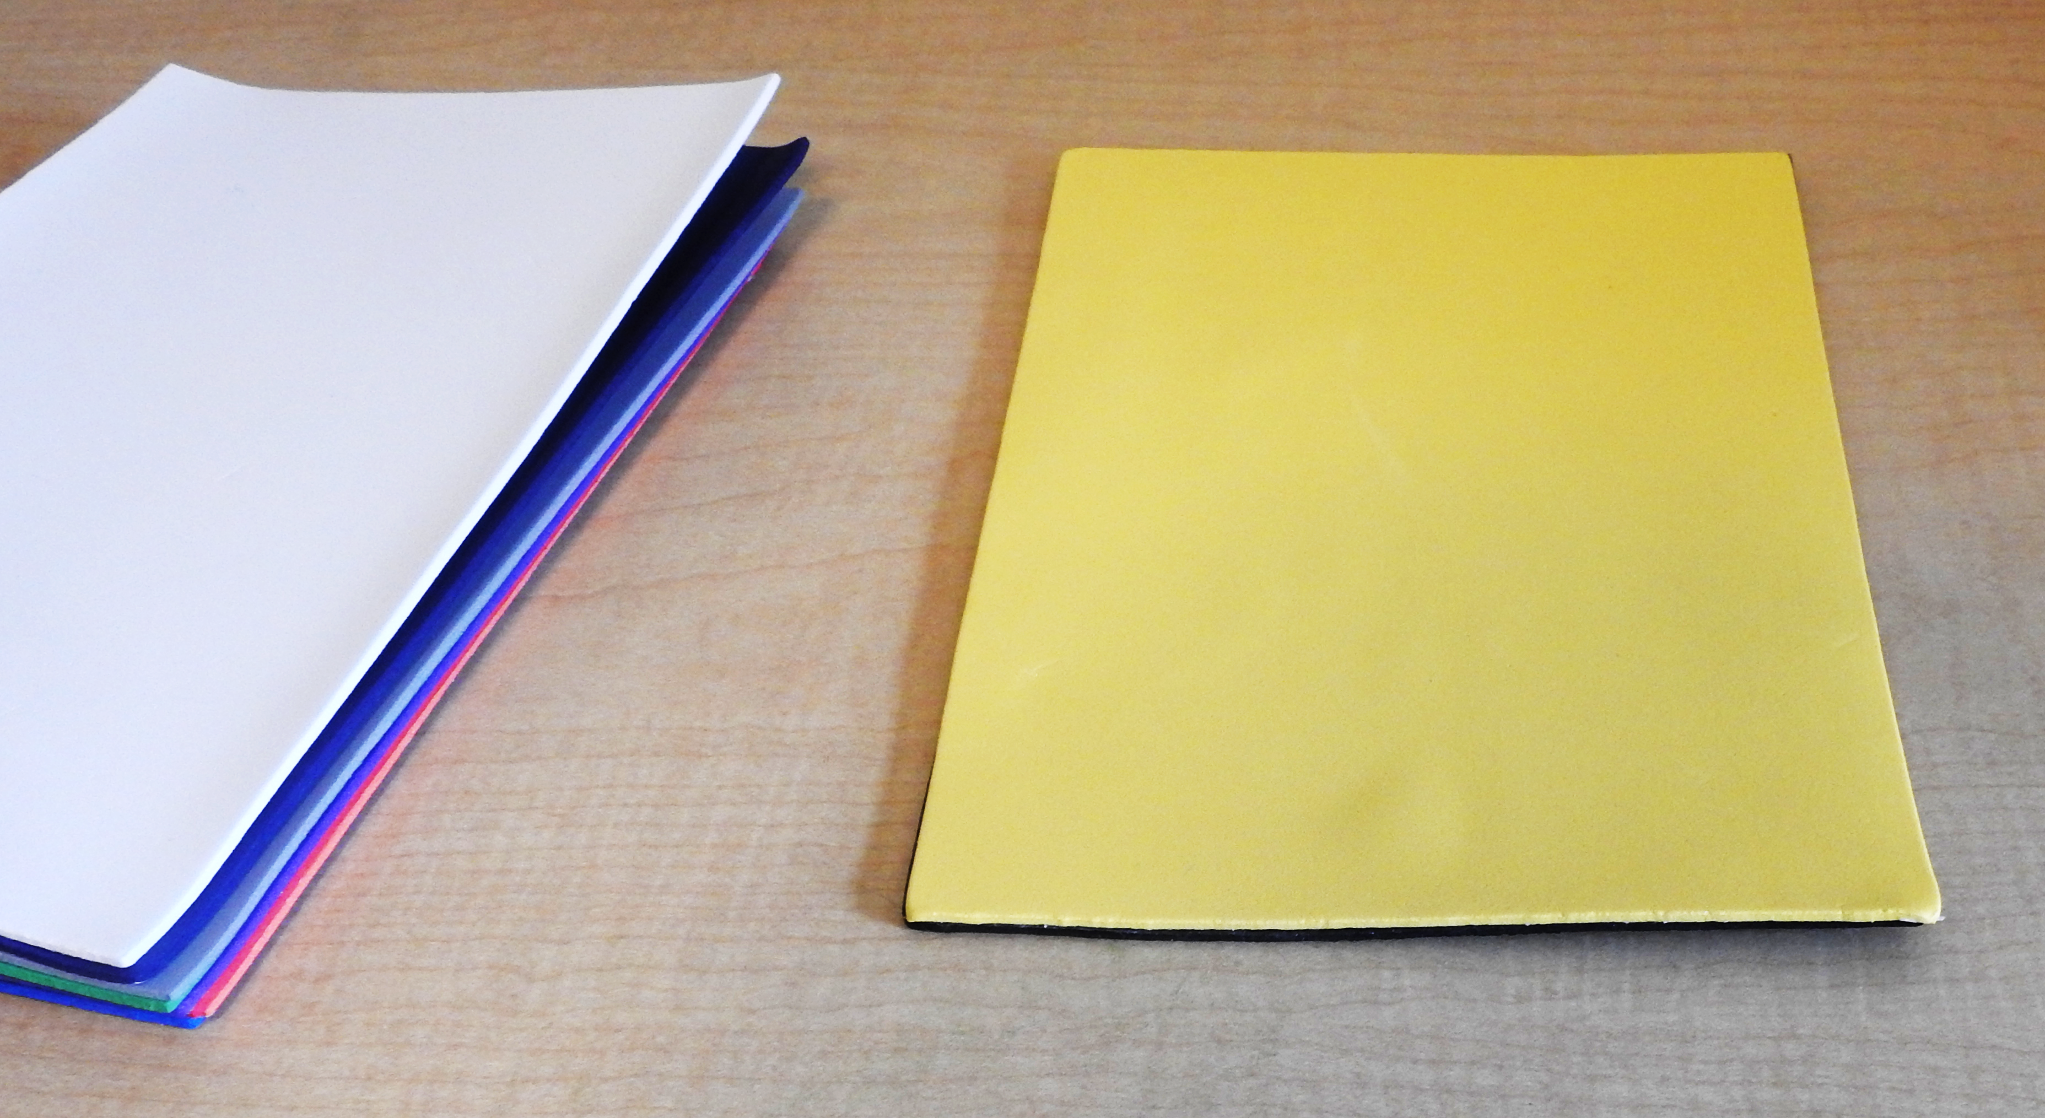

Add other layers as carefully as possible to reduce air bubbles and match up sides until you get your stack of 10 layers with white on top. Now you have a brick of 10 colored foam layers.

Now you need to cut the bricks into fault models. A standard table saw produces the best results, although you can use other cutting tools.

First, trim the vertical sides of the outer edges of the bricks to even things out. Making each of the models exactly the same size is not necessary.

Second, cut each of the approximately 6” x 9” bricks into half the long way, so you get two rectangular bricks that are approximately 6” long x 4.5” wide.

Up to this step you are making vertical cuts and probably did not need to measure or you’re your models – now you’ll need to do so to produce the two faults that dip 45° from horizontal. Refer to the schematic below to help you measure and mark the location of the faults. I chose to make the three fault blocks the same approximate dimensions from top or map view, so each are approximately 3” x 3”, and you are creating a horst and graben structure. You may wish to mark the top of the blocks with a pencil line.

Adjust the saw to cut at a 45° angle from horizontal. The cut will be 45° from horizontal dipping down towards the center of the middle block (the graben)

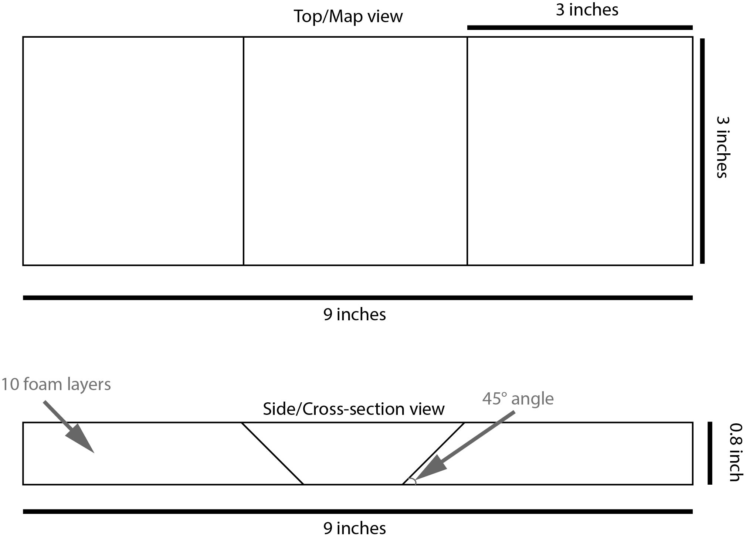

Repeat this step for all 6 of the foam bricks you created in the last step.

Now you’re ready to label each student foam block set. I chose to draw on a meandering river system on the top layer that goes across both faults with a blue sharpie; this seems to work well, but you might also consider sketching in a road if that makes sense in your own context. The irregularlity of the river shape makes it easier for students to align the blocks once they have been separated in storage.

I also recommend labeling each block with a unique number for its set – as each set is likely to be unique in color patterns and in precise dimensions, its useful to have all three blocks stay separate as a distinct set.

Materials for the fold models:
1 package of 6” x 9” craft foam sheets multicolor pack (not self-adhesive) cost: $6-$9

(Darice Foamies foam sheets multipack, assorted primary vibrant colors, 2mm, 6” x9”, 40 sheets, Amazon.com; Creatology foam sheets value pack, primary, 2mm, 6” x9”, 65 sheets, Michaels)

Constructing the fold models:
Super easy in comparison with fault models! Simply cut the 6” x 9” sheets in half, to give you 6”x 4.5” sheets. You can do this with the table saw, x-acto knife or other sharp knife, or with sharp scissors. Assemble each fold set with 3-5 different-colored 6” x 4.5” foam layers.

Putting together student model sets:
Each student model set contains one 3-piece fault block set, and one set of 3-5 loose foam layers. I find these are easily stored in a gallon-sized zipper bag, which also makes the model sets useful for transport and for loaning out to students who may have missed the lab or want to take them home for extra practice.

Notes:
- Using a single package of the recommended foam sheets requires some variation in the layer colors for different models (not all models will have identically-colored layers, but they will have tops and bottoms of identical color.)
- You can use any foam size or thickness you like, but I’ve found these to be useful because:
- The self-adhesive backing makes sticking them together simple and easy (no odor like other adhesives, and takes much less time than a separate adhesive.)
- The size makes relatively small but easy to construct and store models which are still large enough for students to work with easily.
- The size is small enough for students to sketch to scale on 8.5”x11” graph paper,
- These sheets are inexpensive and commonly available at craft stores.
- The color mix allows all the foam models in your set to have a white top and black bottom, while the other colors can be varied. It’s recommended to have a light colored top on which you can draw a river (or road, or other surface feature) as well as model ID numbers.

