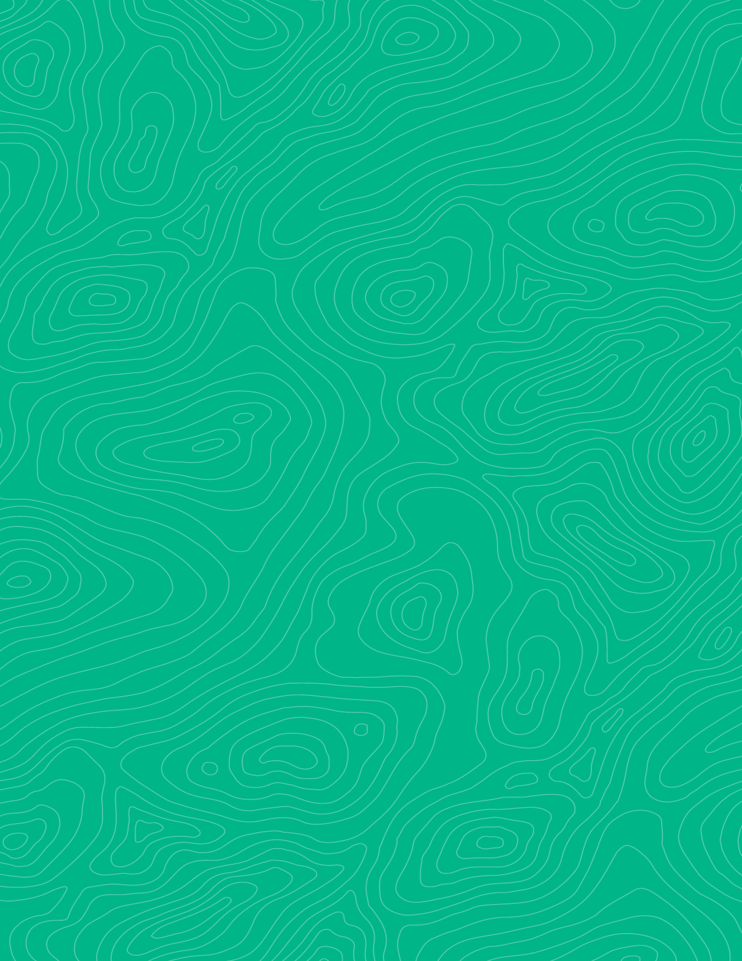

Teaching activity
How geologic beds and other planar features interact with topography: Rule of V’s

Teaching activity
Visible Geology is a free, web-based application that allows for the creation and exploration of 3D geological models. Visible Geology is an initiative of Seequent, The Bentley Subsurface Company, helping students visualise complex geological concepts in an intuitive digital environment, moving beyond traditional 2D methods to modernise geology education.

Introduction
An important and unique component of geoscience is the development of 3D visualization skills. We use information gathered on the Earth’s surface to make predictions about what is happening in the subsurface. One example of this is locating and mapping geologic bedding contacts and faults. Not only do we measure their orientations in the field, but we also determine where and how we may see the same feature elsewhere on the landscape. We do this by using our orientation measurements and building a sense of how the feature is expressed based on the surface topography—if, for example, erosion has occurred unevenly across the landscape (which happens basically 100% of the time), the contact or fault will be exposed (or not) differently in other locations across the field area. By growing your intuition about where to look next and why, you will not only save a lot of time looking for and mapping features in the field, you will also be able to use geologic maps to determine topographic relationships and begin to more easily “see” the features in 3-dimensions. With this activity we will begin to develop this skill.

Learning goals
- Practice using the Visible Geology web-based application to visualize geologic relationships in 3D
- Test how differently dipping geologic beds are expressed on the surface of a specific landscape (i.e., valley)
- Construct a list of rules for how planar features with different dips and dip orientations appear in in map view in a valley (i.e., the rule of V’s)

Using the Visible Geology modules
Try out the software: Visible Geology
You will need to log in with a Google account to be able to open the file we will work with for this lab.

Activity
You are now familiar with the basic tools in the Visible Geology web-based application. Now you are going to create and analyze block diagrams to describe the outcrop patterns that occur when dipping rock layers or faults (i.e., planar features) are exposed in a valley. You will be analyzing several different situations:
- Horizontal rock layers
- Vertical rock layers (90o dip)
- Layers dipping “up” the valley i.e., up-stream
- Layers dipping “down” the valley i.e., down-stream

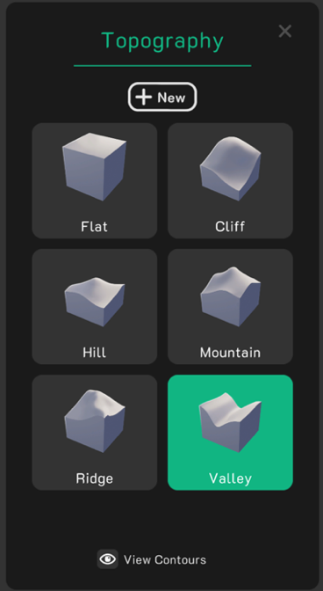
Set up:
Go to the Visible Geology web-based application and select the Geology Explorer module.
- First, go to the “Topography” tool to create topography on your block.
- Select “Valley” and make sure “View Contours” is on (see image right).
- When you exit out of the topography tool, your block diagram should now reflect this topography, and your geologic layers should also appear in both map and cross-section view.
- Click and rotate the block to see it from all sides, and even only top-down or map view.
- The generic “valley” shaped topography is ok but difficult to assign upstream and downstream directions since it is so symmetric.
- Instead, we will run our tests on the following topography (image below):


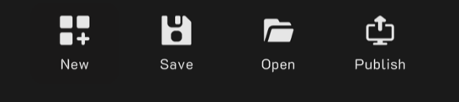
- Open a pre-created valley topography.

Project-ejKwZmhrQDkKxVHz5Nwxbr
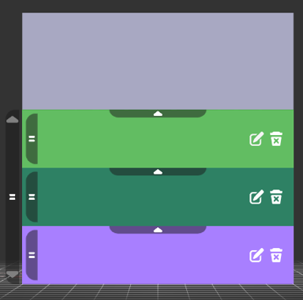
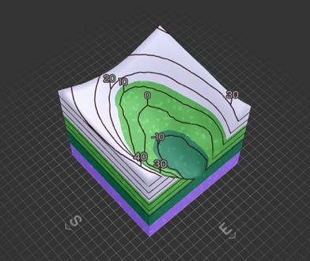
- Go to menu (bottom left corner):
- Select “open” and “input via code”:
- Type or copy the above code and open existing project
If you get a loading forever screen, hit reload.
- You will see a valley shape (image right). Numbers on the topography show the elevation contour.
Rock type | Thickness
Conglomerate | 35
Sandstone | 20
Siltstone | 10
Shale | 20
Limestone | 25
Dolomite | 35
- Create a series of horizontal geologic beds on the block diagram, using the “Layers” tool on the left tool ribbon (see table to the right).
- Edit the layers by clicking the pencil icon on each layer (see image to the right).
- Use the thicknesses given in the table and whatever colors you’d like.
- Add layers by clicking the plus sign (bottom right of edit tool).
- When you are done, exit out of the “Layers” tool.

*Create a document for this lab and take a screenshot of your map view, paste the image in a document you create for this lab, and on the image of the topography, draw in a heavy line to mark location of the stream located in the valley, along with an arrow indicating flow direction. Note: to capture images with a Windows machine use Windows key – shift – s, for a Mac use command key – shift - 4. (3pts)

Next, we’ll investigate the interaction of dipping geologic beds and topography, using the provided valley topography. Click into 3D view and rotate your block around to become familiar with what the topography looks like from several different angles.
- Horizontal bedding. Return to the 2D map view of your system. The model should consist of the topography and the 6 horizontal beds that you created earlier. Copy and paste your screenshot of the topo map in your lab doc. Describe the geologic contacts as they are exposed in the map view of YOUR model. Focus on how the shape and position of the geologic contacts compares with the topographic contours. (2pts)
- As you can see, the geologic contacts form a ‘V’ as they cross the valley. Use your own words to explain why this happens. (2pts)
- Geologic beds dipping up the valley upstream. Now modify your model so that the geologic layers dip down in the upstream direction. Use the “Events” tool.
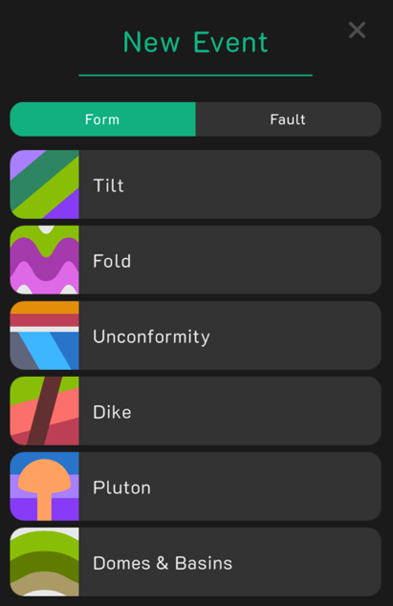
- Green and Red arrows will appear on your block and will be used to move your planar feature. Familiarize yourself with how to move and rotate the plane. This plane represents your beds, and can be used to create your own custom configurations.
- In this case, however, let’s all use the same strike and dip. You can enter strike and dip information in the text boxes in the bottom right corner of the screen. Note, you will use azimuthal notation and the right hand rule (RHR) all dip directions are +90 from the strike. Be sure to click “Apply”.
- The beds should be tilted into the following orientation: Strike: 180$°$ (Due South) Dip: 20$°$ (RHR makes this East)
- Experiment with rotating and tilting your new model to explore how the beds outcrop at the surface before moving on to the next question. Move between the 2D and the 3D views.
- Paste, a screenshot of your topo and tilted beds. Describe how the shape and position of the geologic contacts compare with the topographic contours for this case of the bedding dipping upstream. (3pts)

- Do the V’s point in the same direction as the topography (i.e., upstream)? (1pt)
- Are the V’s narrower or wider than the topographic V shapes? (1pt)
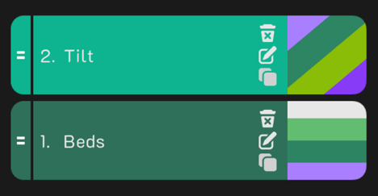
Now let’s increase our dip angle. The strike of the beds will remain the same, but the dip will be steeper, try 60$°$.
**Note you will need to delete the previous tilting event, or this new tilting event will be added on to the one you already tested. Click “History” on left panel menu.
- How does the shape and orientation shown by the geologic contacts as they cross the valley compare with your experiment at 20$°$? Can you explain why this happens? (remember, the topography has not changed) (3pts)

Vertical bedding. Now, using the “Events” tool, make all your bedding vertical. Copy and paste your screenshot of the topo map in your lab doc.
- Describe how the shape and position of the geologic contacts compare with the topographic contours. (2pts)

- The geologic contacts do not form a ‘V’ as they cross the valley. Use your own words to explain why this happens. (2pts)

Geologic beds dipping down the valley downstream. Now, let’s change our dip direction. Because this program uses the right-hand rule, what do you need to do to change your dip direction to be opposite to the direction you have been using? (1pt).
- Make your beds dip downstream at 60$°$. Paste a screenshot of your map on your lab doc. (2pts)

- Describe how the shape and position of the geologic contacts interact with the topography. (3pts)

- As we did before, keep the strike the same, but make your dips shallow (20$°)$. How do the V’s that are formed as they cross the valley compare with those formed by beds dipping steeply in the same direction (i.e., downstream)? (2pts)
- Use the experiments you performed above, and any other experiments you wish to explore, to Summarize the “Rule of V’s”. Your description should be written for another geology student who does not already know these rules, and should be detailed enough so they could apply them to analyze a new map area they have not seen before. (2pts each)
  - Horizontal Beds

  - Vertical Beds

  - Beds dipping upstream

  - Beds dipping downstream

  - How does the dip angle affect the V shape?

*Bonus (1pt): What does the bed exposure look like for a bed dipping downstream at the same steepness as the slope of the valley?

