

Reservoir sandstone stratigraphic correlation

Teaching activity
Visible Geology is a free, web-based tool that allows for the creation and exploration of 3D geological models. Visible Geology is an initiative of Seequent, The Bentley Subsurface Company, helping students visualise complex geological concepts in an intuitive digital environment, moving beyond traditional 2D methods to modernise geology education.
This lab activity allows students to construct stratigraphic models and use them to predict lithologic differences across the Appalachian basin. Then students are asked to evaluate areas for a prospective CO₂ subsurface storage project

Introduction (with geoscience context)
One of the strategies for mitigating CO₂ emissions involves injecting captured CO₂ underground into porous rock reservoirs. You will consider rock core data and geologic models to assess potential locations of Upper Devonian Hampshire Fm. sandstone that could serve as underground storage reservoirs for CO₂.

Learning goals
- Develop stratigraphic column construction skills
- Create core models that can be used to predict stratigraphic variability that can influence storage reservoir rock
- Infer stratigraphic variability from basin context

Pre-activity assignments/reading (if applicable)
- Bentley et al. Historical Geology free online textbook 4.2.1 Formations and Walther’s Principle
- Energy Education Encyclopedia: Oil and Gas Traps

Using the Visible Geology modules
Visit the Visible Geology web-based application to create diagrams for this assignment. Refer to this Youtube Tutorial for help.

Activity (description and steps)
Part 1: Core Column Construction
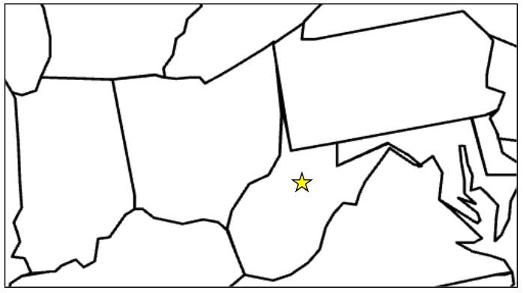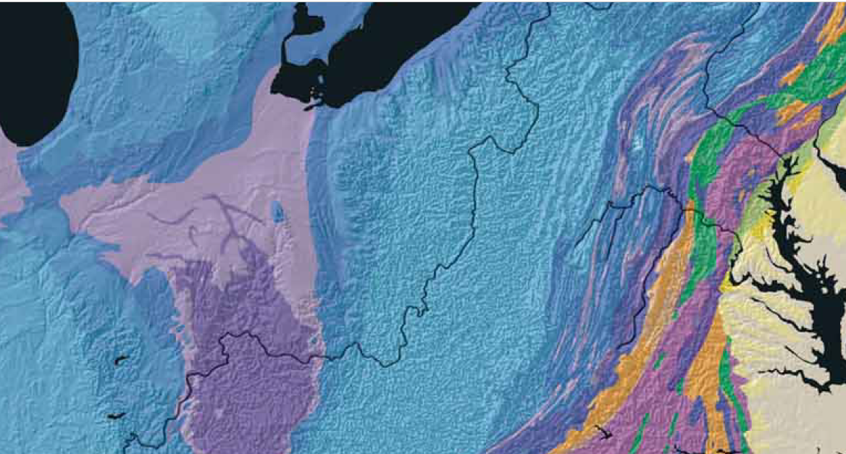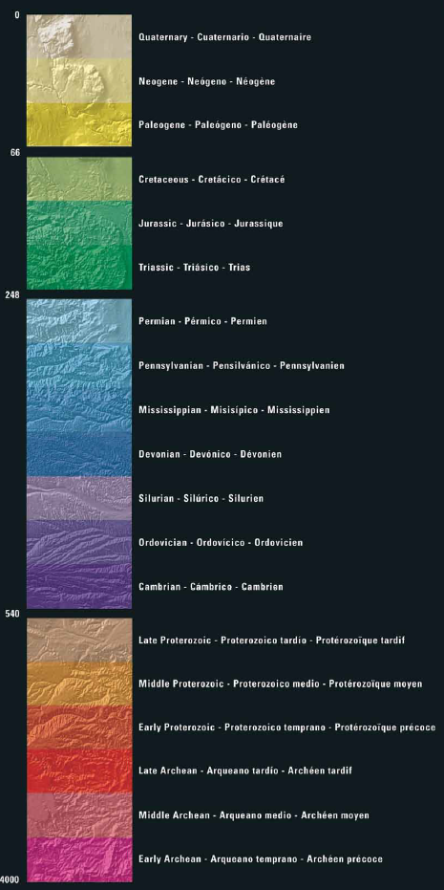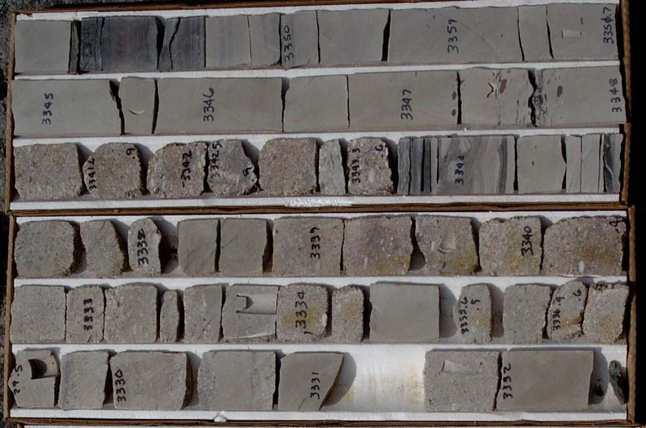

Western MD
Northern WV
Central OH
Explanation

Age (Ma)
Geologic Period
N

100 km
Dashed line indicates boundaries of the Appalachian basin
Instructions: A core was recently obtained at the location of the yellow star in the map where a well was drilled to >6000 ft and recovered about 30 ft. of Upper Devonian Hamshire Formation. Description of the Upper Devonian core was performed by the project geologist in the early 2000’s and this description was archived by the West Virginia Geological and Economic Survey.
- Use the archived core description in the Table provided in the following pages to construct a stratigraphic column for the Northern WV core. Note the core description starts with the oldest/bottommost sedimentary bed of the core (the deepest rock that was recovered); this means the subsequent beds in the table are found upward from that bottom bed, so using the Principle of Superposition the beds are listed in Table 1 in progressively younger order.
The beds are divided into 3 Stratigraphic Units based on the interpreted depositional environment, listed from oldest to youngest:
- Strat Unit 1: from 0 - 6.7 feet formed in an offshore environment
- Strat Unit 2: from 6.7 - 18.05 feet formed in a nearshore environment
- Strat Unit 3: from 18.05 - 30.05 feet formed in a delta plain channel environment

Table 1. Sedimentologic Description of the Hampshire Fm. Core from Northern West Virginia
Bed # | Bed Thickness (ft) | Sum  Thickness (ft) | LIthology | Sedimentary Structure | Environ. of deposition
BOTTOM OF CORE
1 | 0.1 ft | 0.1 | Dark gray shale | Fissile lamination | Offshore | STRAT UNIT 1
2 | 1.5 ft | 1.6 | Very fine-grained sandstone | Hummocky cross stratification | Offshore | STRAT UNIT 1
3 | 1.4 ft | 3 | Fine-grained sandstone | Hummocky cross stratification & horizontal stratification | Offshore | STRAT UNIT 1
4 | 0.6 ft | 3.6 | Fine-grained sandstone | Hummocky cross stratification & horizontal stratification | Offshore | STRAT UNIT 1
5 | 0.7 ft | 4.3 | Fine-grained sandstone | Hummocky cross stratification, mud rip-up clasts | Offshore | STRAT UNIT 1
6 | 2.25 ft | 6.55 | Fine-grained sandstone | horizontal lamination | Offshore | STRAT UNIT 1
7 | 0.15 ft | 6.7 | Dark gray shale | Fissile lamination | Offshore | STRAT UNIT 1
8 | 1.1 ft | 7.8 | Fine-grained sandstone | horizontal stratification | Nearshore
9 | 1.0 ft | 8.8 | Fine-grained sandstone | Hummocky cross stratification; rare rounded quartz pebbles (≈0.2 inch diameter) & mud rip-up clasts (≲0.1 inch diameter) | Nearshore | STRAT UNIT 2
10 | 0.2 ft | 9 | Pebble conglomerate, average size 0.4 cm | mud rip-up clasts (≲0.1 inch diameter); gravel in matrix of fine-grained sand | Nearshore | STRAT UNIT 2
11 | 0.4 ft | 9.4 | MISSING CORE |  | Nearshore | STRAT UNIT 2
12 | 0.4 ft | 9.8 | Medium-grained sandstone | Cross-lamination, mud rip-up clasts (≲0.1 inch diameter) | Nearshore | STRAT UNIT 2
13 | 0.15 ft | 9.95 | Dark gray shale | Fissile lamination | Nearshore | STRAT UNIT 2
14 | 2.4 ft | 12.35 | Fine-grained sandstone | Horizontal stratification | Nearshore | STRAT UNIT 2
15 | 0.15 ft | 12.5 | Dark gray shale | Fissile lamination | Nearshore | STRAT UNIT 2
16 | 0.55 ft | 13.05 | Fine-grained sandstone | Hummocky cross stratification | Nearshore | STRAT UNIT 2
17 | 1.0 ft | 14.05 | Dark gray shale | Fissile lamination | Nearshore | STRAT UNIT 2
18 | 2.6 ft | 16.65 | Fine-grained sandstone | Horizontal stratification, few scattered quartz pebbles (≈0.2 inch diameter) | Nearshore | STRAT UNIT 2
19 | 0.8 ft | 17.45 | Fine-grained sandstone | Horizontal stratification, few scattered quartz pebbles (≈0.2 inch diameter) | Nearshore | STRAT UNIT 2
20 | 0.6 ft | 18.05 | Fine-grained sandstone | Cross-stratification; thin (0.5 inch thick) horizon of quartz pebbles (≈0.2 inch diameter) and mud rip-up clasts (≲0.1 inch diameter) | Nearshore | STRAT UNIT 2
21 | 2.7 ft | 20.75 | Fine-grained sandstone | Horizontal stratification; rare rounded quartz pebbles (≈0.2 inch diameter) & mud rip-up clasts (≲0.1 inch diameter) | Delta plain channel | STRAT UNIT 3
22 | 0.3 ft | 21.05 | Pebble conglomerate, average size 0.4 cm | Horizontal stratification; mud rip-up clasts (≲0.1 inch diameter); gravel in matrix of medium- to coarse-grained sand | Delta plain channel | STRAT UNIT 3
23 | 1.7 ft | 22.75 | Medium-grained sandstone | Horizontal stratification; rare rounded quartz pebbles (≈0.2 inch diameter) | Delta plain channel | STRAT UNIT 3
24 | 0.2 ft | 22.95 | Pebble conglomerate, average size 0.8 cm | gravel in matrix of very coarse-grained sand | Delta plain channel | STRAT UNIT 3
25 | 0.2 ft | 23.15 | Coarse-grained sandstone | Horizontal stratification; rare mud rip-up clasts (≲0.1 inch diameter) | Delta plain channel | STRAT UNIT 3
26 | 0.3 ft | 23.45 | Medium-grained sandstone | Horizontal stratification; mud rip-up clasts throughout (≲0.1 inch diameter) | Delta plain channel | STRAT UNIT 3
27 | 1.6 ft | 25.05 | Very coarse-grained sandstone | Cross-stratification; rare scattered quartz pebbles (≈0.2 inch diameter) throughout bed | Delta plain channel | STRAT UNIT 3
28 | 0.8 ft | 25.85 | Medium-grained sandstone | Horizontal stratification | Delta plain channel | STRAT UNIT 3
29 | 0.7 ft | 26.55 | Coarse-grained sandstone | Cross-stratification; rare scattered quartz pebbles (≈0.2 inch diameter) throughout bed | Delta plain channel | STRAT UNIT 3
30 | 0.2 ft | 26.75 | Medium-grained sandstone | Cross-stratification; rare quartz pebbles (≈0.2 inch diameter) | Delta plain channel | STRAT UNIT 3
31 | 1.85 ft | 28.6 | Coarse-grained sandstone | Cross-stratification; rare scattered quartz pebbles (≈0.2 inch diameter) throughout bed | Delta plain channel | STRAT UNIT 3
32 | 0.25 ft | 28.85 | Medium-grained sandstone | Cross-stratification | Delta plain channel | STRAT UNIT 3
33 | 0.3 ft | 29.15 | Coarse-grained sandstone | No evident structures | Delta plain channel | STRAT UNIT 3
34 | 0.7 ft | 29.85 | Medium-grained sandstone | Trough cross-stratification | Delta plain channel | STRAT UNIT 3
35 | 0.2 ft | 30.05 | Coarse-grained sandstone | Cross-stratification | Delta plain channel | STRAT UNIT 3
TOP OF CORE
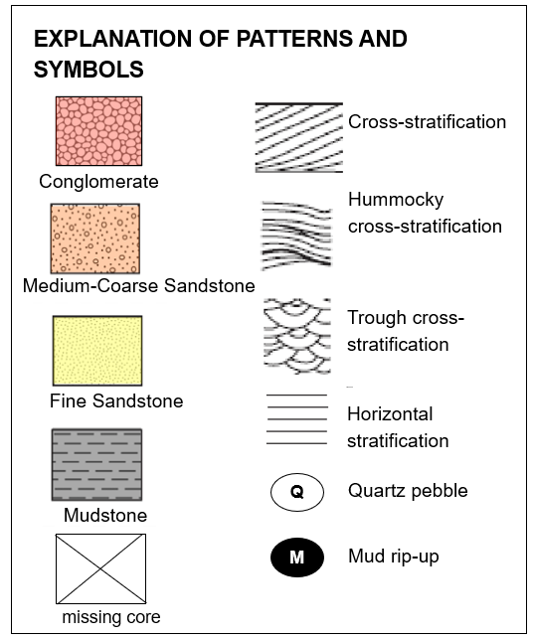
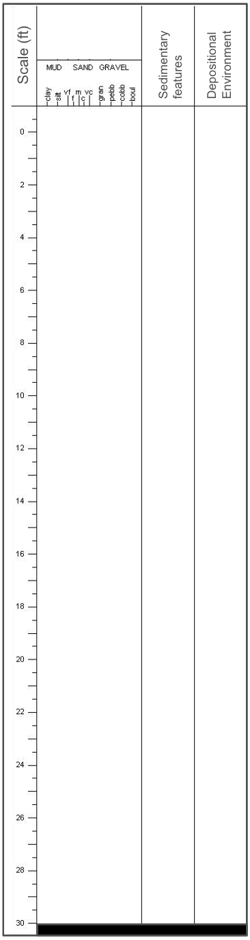
Q
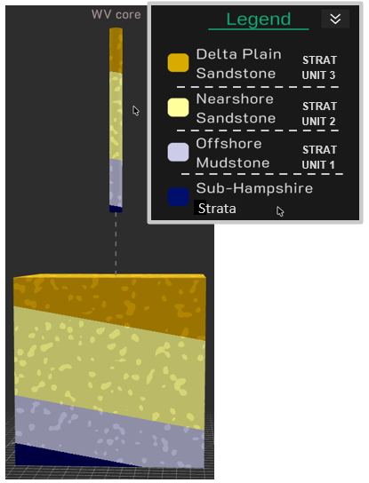
Part 2: Lateral Stratigraphic Modeling
The Hampshire Formation was deposited as part of a prograding sediment wedge, including a delta system. This delta system advanced or prograded from the proximal areas in eastern PA westward in modern coordinates across West Virginia toward Ohio. To the right the image shows a model of the WV core created with the Geology Explorer tool in Visible Geology. This representation of the core shows the 3 units in the proportion of they appear in the northern WV core:
- Strat Unit 1 is composed of offshore mudstone
- Strat Unit 2 composed of nearshore fine-grained sandstone
- Strat Unit 3 composed of delta plain coarse-grained sandstone.
Below the Hampshire units are sub-Hampshire strata.
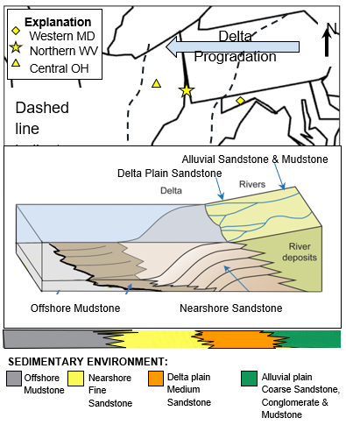
- Does the stacking pattern of the lithologies in the core suggest overall shoreline transgression or shoreline regression? Explain your answer:
- Using the Geology Explorer tool by Visible Geology , create a representative core of coeval Hampshire Fm. deposits you would expect to be present in the subsurface of Central OH and Western MD. Your core models should:
- Show the progression of deposits that would result from the same shoreline movement as you inferred from the WV Core
- Show units produced by environments of the Hampshire Fm. delta system (offshore, nearshore, delta plain and alluvial plain environments); Note the proportion of each unit you predict should differ based on the relative position of the core in the basin and with respect to the direction of delta progradation. Adjust the colors of the layers to reflect the depositional environment associated with each interval; colors should match the colors assigned to environments in the diagram to the left
To make your model:
- Create a new Project in Geology Explorer
- Click on Layers to edit/add beds. To change the color of a bed, click on the pencil icon in the block model. To remove a bed, click on the trash can icon in the block model. To add a bed, click on the ➕ icon in the menu in the lower right.
- The lowermost bed should be the Sub-Hampshire strata; make this layer a dark color.
- Hampshire stratigraphic units should be created above the Sub-Hampshire strata. You should decide how many Strat Units you want to show. There are 4 possible Strat Units:
- Offshore mudstone (color: gray)
- Nearshore fine-grained sandstone (color: light yellow)
- Delta plain channel medium-grained sandstone (color: dark orange)
- Alluvial plain coarse-grained sandstone, conglomerate and mudstone (color: green)
You should represent the Hampshire Fm. with at least 2 stratigraphic units but you do not have to have all 4 present in any one core.
- Adjust thickness of each bed so that it shows the relative thickness you predict for each Strat Unit at that location. Click on the 🔼 icon in the block model and drag to make the bed thinner or thicker. Depending on the position in the basin and relative position in the delta system, you should predict different thicknesses for each Strat Unit that you have chosen to represent in the Hampshire Fm. Be sure you have considered some logical reason for depicting the relative thickness of the units you show in each model.
- Make a core. Once you have your block model appearing the way you want it, click on the Core icon in the menu and add a vertical core. Give the core a title to reflect the location that it represents.
Paste links and screenshots of your core models in the sections below.

Central Ohio Core Model:
Link:
Screenshot:

Western MD Core Model:
Link:
Screenshot:

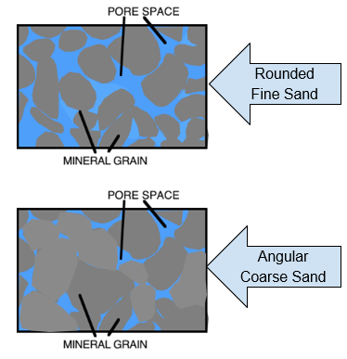
- Nearshore sandstone offers the best reservoir rock because the well-sorted and well-rounded grains means there is greater pore space available to store gas (see diagram below); based on this, which area do you think would have the thickest and most abundant Nearshore fine-grained sandstone reservoir rock: Western MD, Northern WV or Central OH? Explain your answer.

Part 3: Structural Modeling
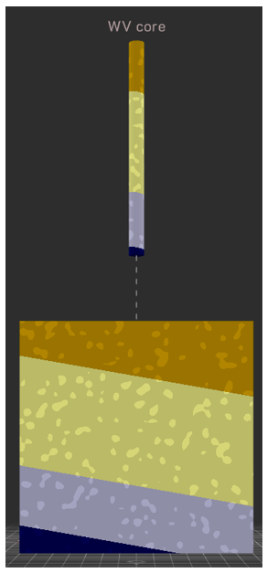
To determine if an area may be suitable for subsurface CO₂ sequestration, we will need to evaluate how likely the CO₂ may leak out. Storing gas in a subsurface reservoir requires not only a porous reservoir rock but a “trap”. Read about traps from the Energy Education Encyclopedia. Injected CO₂ will flow through porous rock upward buoyancy due to its lower density than surrounding material. NOTE: A thick mudstone overlies the Hampshire Formation in this area, forming an impermeable sealing rock that prevents vertical or upward flow. Therefore, the structural configuration of the Hampshire Fm. will be the primary influence on the direction of flow or migration of the CO₂.
Consider the WV core as an example. It is located in an area where the strata dip 5° toward the east.
- Examine the tilted core model of the Northern WV core in Visible Geology; In the Visible Geology web-based application, you can see the strata are shown tilted toward the east with 2X vertical exaggeration to accentuate dip. The tilt of the strata will cause CO₂ injected into this unit to migrate - what direction would injected CO₂ migrate?
- Edit your 2 Visible Geology models for the Western MD and Central OH cores in order to transform the strata into the appropriate structural configuration as described below.
- Central OH: strata dip ~5 ° toward the east but show this dip with 2X vertical exaggeration
- Western MD: strata have been deformed by folds with the following attributes as described below; for this location do not use any vertical exaggeration:
- Fold axis trend and plunge: 022/10°
- Fold amplitude = 16
- Fold wavelength = 20
Paste screenshots and links of your modified models for each area on the next page and for each model either describe using words or draw arrows to indicate the direction(s) fluid would flow through the reservoir rock. Remember there is an impermeable sealing rock that overlies the top of your model.
- Which area provides the best opportunity to trap injected CO₂ in nearshore sandstone of the Hampshire Fm.? Rank the 3 locations and provide evidence you determined from your core models to support your ranking. Consult the Energy Education Encyclopedia and explain your reasoning behind your selection choice.

Central Ohio:
Link:
Screenshot:

Western MD:
Link:
Screenshot:

Learning goal | Assessment criteria
Develop stratigraphic column construction skills | Create an accurate sedimentary log following professional conventions
Infer stratigraphic variability | Identify greater proportion of offshore facies toward the west and potential for alluvial plain facies in the east
Create predictive geologic models for potential storage reservoirs | Identify storage opportunities

