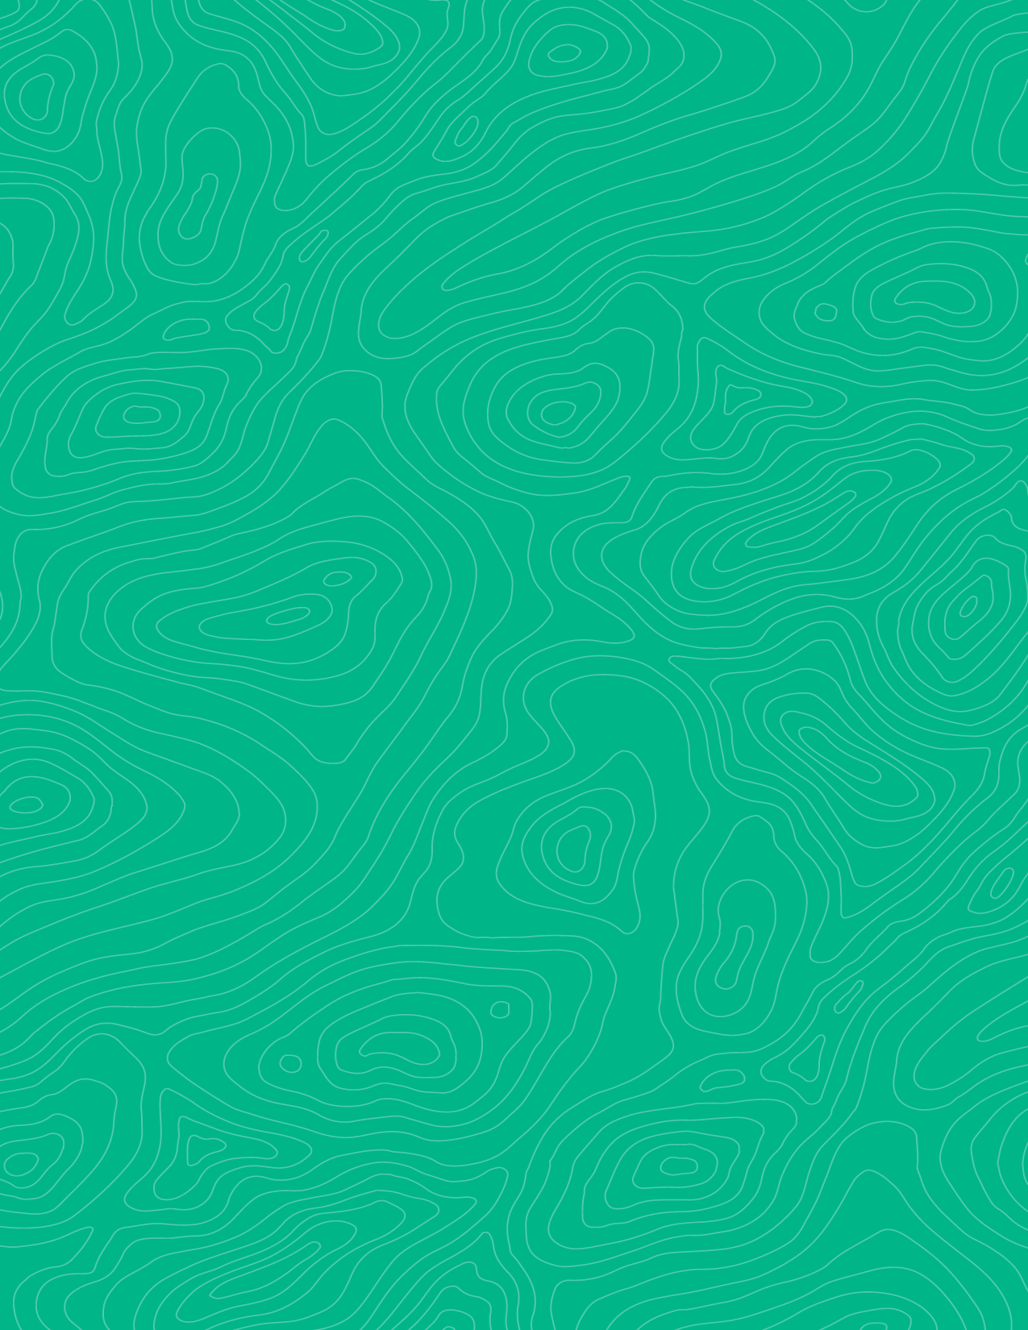

How geologic beds and other planar features interact with topography: Rule of V’s Pre-lab

Teaching activity
Visible Geology is a free, web-based application that allows for the creation and exploration of 3D geological models. Visible Geology is an initiative of Seequent, The Bentley Subsurface Company, helping students visualise complex geological concepts in an intuitive digital environment, moving beyond traditional 2D methods to modernise geology education.

Introduction
An important and unique component of geoscience is the development of 3D visualization skills. We use information gathered on the Earth’s surface to make predictions about what is happening in the subsurface. One example of this is locating and mapping geologic bedding contacts and faults. Not only do we measure their orientations in the field, but we also determine where and how we may see the same feature elsewhere on the landscape. We do this by using our orientation measurements and building a sense of how the feature is expressed based on the surface topography—if, for example, erosion has occurred unevenly across the landscape (which happens basically 100% of the time), the contact or fault will be exposed (or not) differently in other locations across the field area. By growing your intuition about where to look next and why, you will not only save a lot of time looking for and mapping features in the field, you will also be able to use geologic maps to determine topographic relationships and begin to more easily “see” the features in 3-dimensions. With this activity we will begin to develop this skill.

Learning goals
- Practice using the Visible Geology web-based application to visualize geologic relationships in 3D
- Test how differently dipping geologic beds are expressed on the surface of a specific landscape (i.e., valley)
- Construct a list of rules for how planar features with different dips and dip orientations appear in in map view in a valley (i.e., the rule of V’s)

Pre-activity assignments
We will use the Geology Explorer module for this activity.
First, you’ll want to familiarize yourself with the following basic tasks within the software:
- Rotating blocks and panning the image (space bar can toggle control between the two)
- Toggle between 2D (map) and 3D (block) views
- Creating a series of geologic beds
- Tilting beds in various strike and dip orientations
- Creating folds with various fold axis orientations
- Deleting geologic events from the geologic history
- Inserting dikes, and subsequently deform them by folding and/or faulting
- Creating cross sections
- Using strike and dip symbols on the map surfaces
Watch this short video that shows how to build a 3D model and change various aspects and geologic events.
Tips
- to rotate the block, click the screen and rotate your block around.
- use “layers” tool to create different geologic beds.
- use “events” tool to create deformation like tilting, folding, faulting, etc.
To turn in:
Create a document and paste screenshots of the different things you try.

Using the Visible Geology modules
Try out the software: Visible Geology

