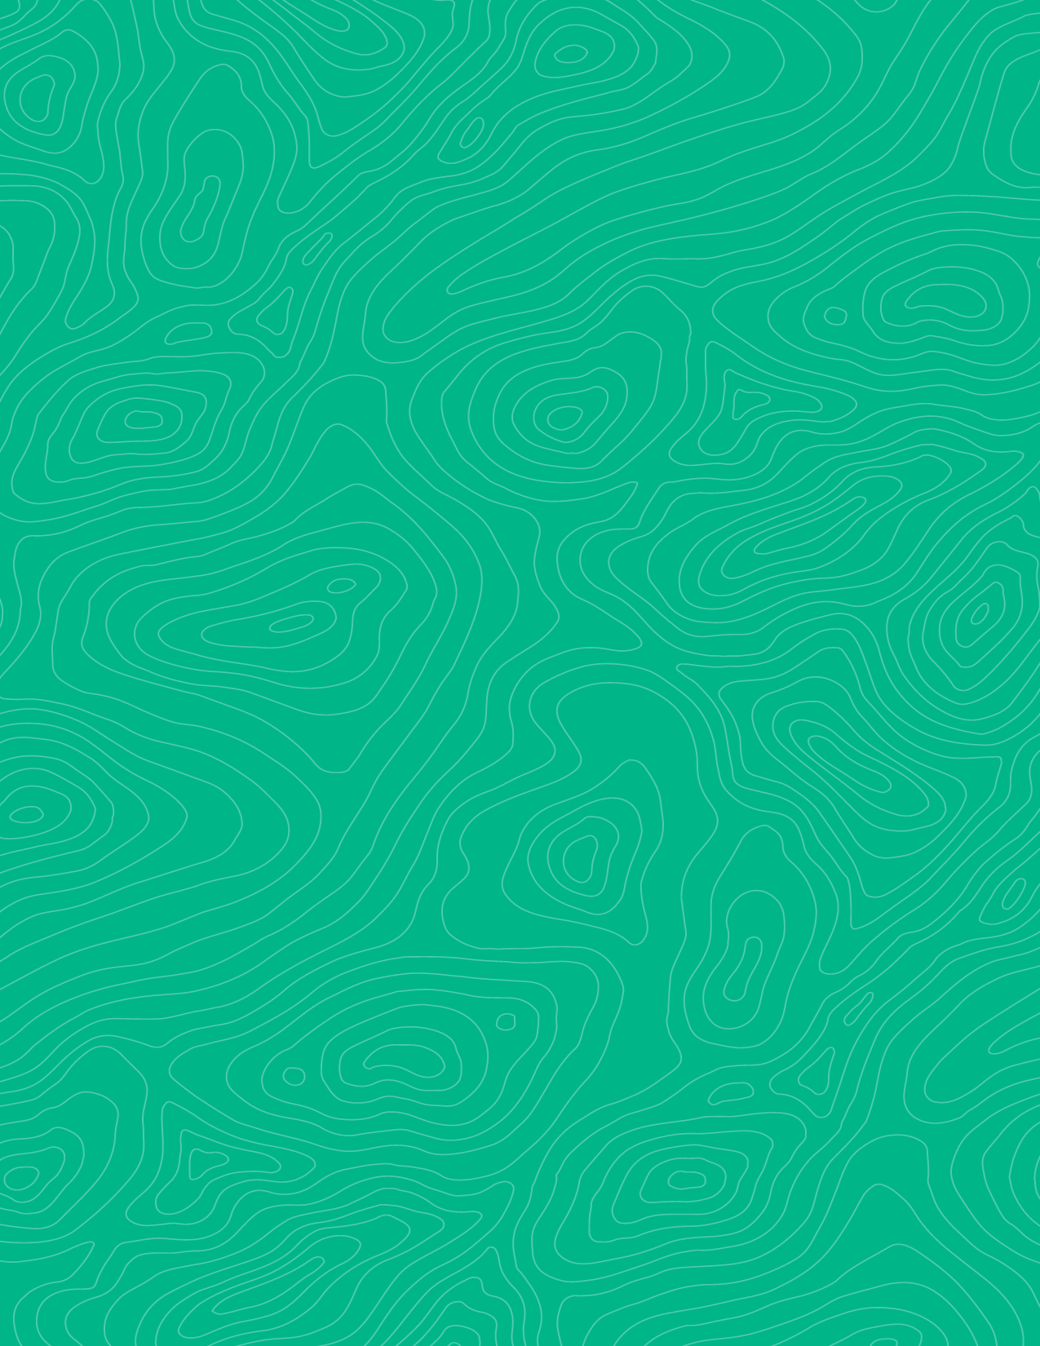
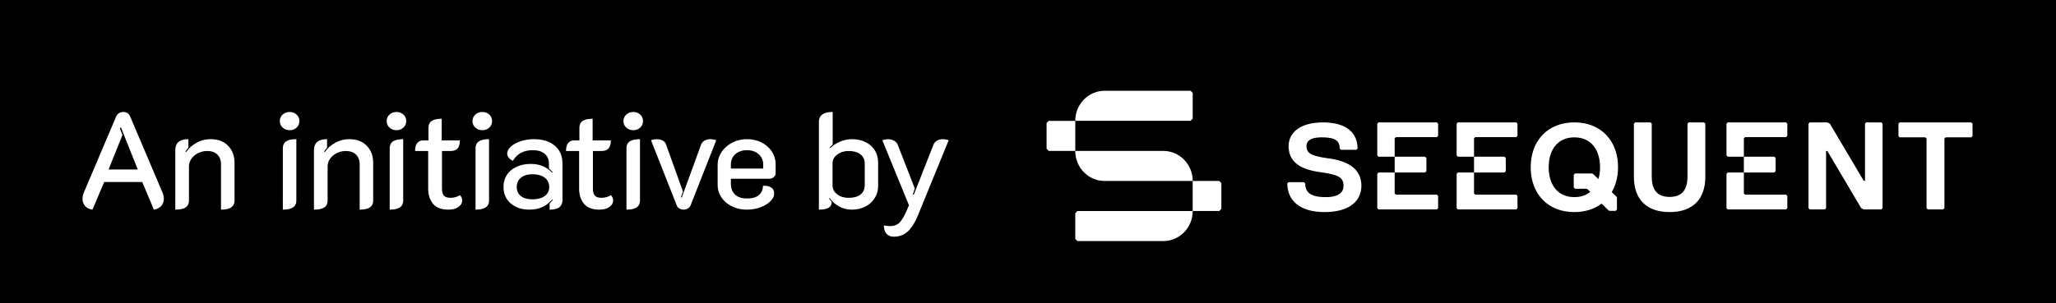
Combining map and cross section results into a 3-D model
Teaching activity
Visible Geology is a free, web-based applications that allows for the creation and exploration of 3D geological models. Visible Geology is an initiative of Seequent, The Bentley Subsurface Company, helping students visualise complex geological concepts in an intuitive digital environment, moving beyond traditional 2D methods to modernise geology education.
This activity is designed to follow an earlier assignment in which students create a geologic map and cross section of a field area. For EMU’s ESSC 355 Geological Field Methods course, the field area is a subset of the Argenta, MT 1:24,000 topographic map.

Introduction (with geoscience context)
Bedrock geologic maps and cross sections are each two-dimensional representations of three-dimensional geologic structures. As such, the information communicated in a map and cross section drafted for the same area must be internally consistent. This lab activity is designed to help students generate a three-dimensional representation of a geologic field area using data contained within a hand-drawn geologic map and cross section.

Learning goals
- Evaluate accuracy and internal consistency of a hand-drawn map and cross section by constructing a geologic model
- Develop a geologic history of the mapped field area based on constructed geologic model
- Predict the type and geometry of structures located outside of a field area based on three-dimensional model

Pre-activity assignments/reading (if applicable)
To complete this assignment successfully, students must have already completed a final or near-final version of a map and cross section for their field area. Students are also encouraged to visit the Geology Explorer program within Visible Geology to get comfortable with its functionality prior to starting the activity. Practicing with the Topography Sculpting tool is strongly encouraged.

Using the Visible Geology modules
- Open Visible Geology
- Once you open the site, click the Geology Explorer module to open a new model.
- The new model can be edited by adding layers of horizontal sedimentary rock as a starting condition and then modifying those layers through a number of possible brittle and ductile deformation events, erosion, and intrusions. These modifiers are found in the “events” panel.
- Brief tutorials on functionality are provided in this playlist.

Activity (description and steps)
- Summarize your map and cross section
Before generating a model using the Geology Explorer module, describe the structure(s) represented in the paper map and cross section you drafted in a previous activity.


- Set up your model
- Once you open your new model, navigate to the topography function on the left-side panel.
- Select the option to make a new topography, shown at the top of the menu. Select “Sculpt Terrain.”
- Keep the default settings in the east-west (blue arrow) and north-south (red arrow) directions; reduce the vertical dimension (green arrow) by approximately half.
- Use the various topography editing features to roughly mimic the topography of your entire field map (not just the area you have already mapped using field data and satellite imagery). Note that you can change the radius and strength of each editing feature to help with editing. Roughly mimicking topography means representing which regions of the map area are highest, which regions are lowest, and the position (trend, spacing) of prominent ridges. Do not spend too much time on this step… you can always return later to edit.
- Give your topography a name, then click “save and return”. Your default model should now appear with your specified dimensions and topography. If it does not, go to Topography -> My Topographies -> Select the one you just made.

- Now, add layers. Add at least the number of layers that are present in your map legend. You can rename them, recolor them to match your legend, and change their thicknesses. Just try the default thickness to start and revisit later.

- Navigate to the “events” menu where you will find operations to fault, intrude, fold, tilt, and erode the rocks in your model. Your task now is to perform whatever series of operations is necessary to produce a 3-D model of your field area that matches your map and cross section. While you are doing this, you will likely need to edit your layer thicknesses and positions, and perhaps the topography as well.

Note: You will almost certainly not match your map and cross section perfectly (check using the cross-section tool!). This is okay. Remember, you only roughly mimicked the topography, you have not calculated true unit thicknesses, some structures might be too small to model accurately in the Geology Explorer, and you may have made mistakes in your map and cross section. Focus on representing the gross structure of the field area.
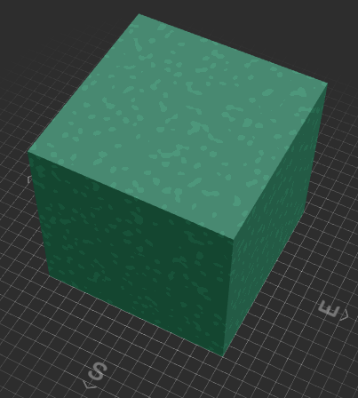
- When you are happy with your model, paste a screenshot of it below, taken from a southeastern view point as in the example at right.
Also, paste a link to your shareable model here:

- Investigate your model
- What structure(s) did you introduce in your model? Be as specific as possible. For example, if your model has a fault, report the type of fault, its strike, dip, dip direction, the slip direction (reported as rake), and the slip magnitude. If you added a fold, report the type of fold, plunge direction and magnitude, vergence, approximate interlimb angle, etc. If you added an unconformity, state which units unconformably overlie others.
- Compare and contrast your model and your paper map and cross section. To do this, you will want to reproduce approximately the same line of section from your paper map by using the xSection tool. Where you note discrepancies, offer an explanation as to why they exist. Paste an image of your generated cross section below along with your response. I also suggest using the cross-section tool to quickly visualize other portions of your map area. Or to visualize the same area in a different orientation (different section trend).
- Based on the events you included in your model, develop a geologic history of your field area. For each major event, explain how you know its relative timing. Remember, deposition and lithification of units as well as erosion should be included in your geologic history.

- Use your model
Your paper map and cross section were produced using data from only a restricted portion of your larger map area. Those data informed your model, which now represents the geology in the entire map area. Based on your model, what structure(s) is/are present in the western portion of the larger map area? Be specific, referencing place names from your map area as needed. If you note major discrepancies between your model and satellite imagery, describe them.

Assessment criteria
The assessment is designed to directly evaluate student mastery of the three specified learning goals through a combination of model construction, visual evidence, and analytical interpretation of the results.
Learning goal | Assessment criteria and deliverables
1. Evaluate accuracy and internal consistency of a hand-drawn map and cross section by constructing a geologic model | Assessment focus: correct identification of inconsistencies between hand-drawn map and cross section, creation of geologic model without any major (e.g., >250 m horizontal deviation) inaccuracies
 | Deliverables: written summary comparing hand-drawn map/cross section with constructed model, geologic model and cross section generated through geologic model
2. Develop a geologic history of the mapped field area based on constructed geologic model | Assessment focus: accuracy and completeness of written geologic history
 | Deliverables: Written geologic history of field area
3. Predict the type and geometry of structures located outside of a field area based on three-dimensional model | Assessment focus: description of predicted structure: Is it accurate? Is it detailed given the available information?
 | Deliverables: Description of predicted structural feature(s)

