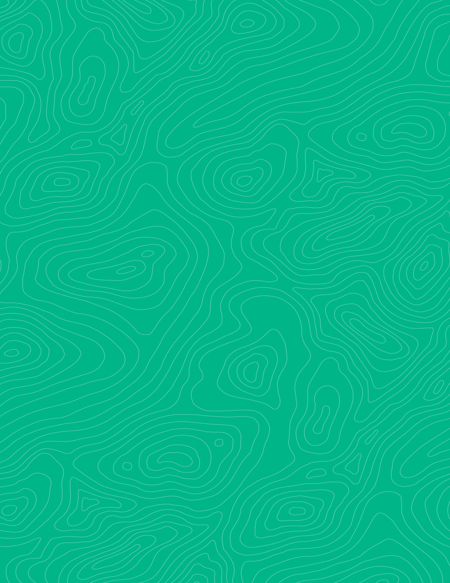
Teaching activity

Post Field Trip Data Analysis: Folds, Cross-sections, & Apparent dip
Visible Geology is a free, web-based application that allows for the creation and exploration of 3D geological models. Visible Geology is an initiative of Seequent, The Bentley Subsurface Company, helping students visualise complex geological concepts in an intuitive digital environment, moving beyond traditional 2D methods to modernise geology education.

The new and improved version includes many useful tools that we can use to evaluate hypotheses, plot and visualize field data, and evaluate interpretations. We will use the “Geology Explorer” “Stereonet” and “Apparent Dip” modules to follow up on the observations we made in the field and plot our field data. These exercises will be paramount and useful for the final interpretations you make, and the figures will be useful for writing your field trip reports.

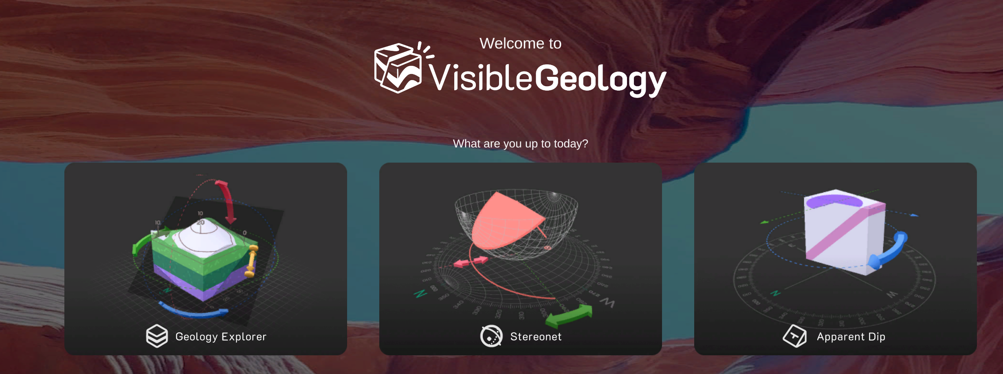

Introduction (with geoscience context)
On our field trip to the Devil’s Punchbowl, we documented structural deformation mainly in the form of faulting and finding in the Tertiary Punchbowl and San Francisquitto formations. We also saw some intrusive and gneissic rocks in the periphery of the map area. In the field we discussed various hypotheses and interpretations for what we saw, and we collected data to help test those hypotheses and back-up our interpretations. Before diving in to making conclusions of data it is always important and helpful to plot and visualize the data as well as think about what data might be missing or what limitations the collected data have. In this lab we will practice visualizing the structures we saw in the field and plot our collected data in ways that we can use to provide evidence for our interpretations of the geologic structure in the field area. Anything you create in this lab can be used in your final field trip report.

Learning Goals
- Practice using the Visible Geology modules to plot and visualize geologic relationships
- Create schematic models of fold structures
- Convert between true and apparent dip
- Interpret planar data on a stereonet projection

Using the Visible Geology Modules
First, go to Visible Geology.

Part 1: 3D visualization
Generating initial hypotheses and visualizations for features seen in the field. Create a document to paste screenshots of your work. (4pts)
- Practice making a fold, play with wavelength and amplitude, recall what we saw in the field and find a wavelength and amplitude that matches what you visualized and sketched in your notebook while we were there (screenshot and place in lab doc)
- Experiment with making the fold plunge in various orientations, recall what we saw in the field, try to create a plunging fold that matches what you saw/sketched while we were on our trip (screenshot and place in lab doc).

These simplified models you have created will help as you work on your structural interpretation of the field area and can even be used as schematic images in your report.

As you have noticed with geologic maps we have used and made in class, they are often accompanied by one or more cross-sections. These attempt to use what is seen on the mapped surface and project an interpretation and visualization of what may be happening in the sub-surface (or above the surface post-deformation and post-erosion). The lines for these cross-sections are not arbitrarily chosen. Mappers choose the location, length, number of cross-sections, etc. based on important areas that need more in-depth analysis and interpretation to understand what is happening.

Notice that I did not give you a cross-section line(s) on your field map. You will use the cross-section tool in the Geology Explorer module of Visible Geology to explore possible locations you’d choose for a cross-section line to give you the most information about the structure you mapped on our field trip. Using your model of a plunging fold akin to the one we saw in the field experiment with visualizing a cross-section perpendicular to the fold-axis, parallel to the axis, or oblique.
- Take a screenshot of each of these examples and describe what the cross-section shows as well as notes about what was interesting or surprising from the cross-section. (6pts)
- Experiment with various cross-section orientations and decide what line or lines you’d like to use for your analysis and interpretation of your own field map. Once you are happy with your cross-section line(s) take a screenshot and explain why you made the choice you did. (3pts)
- Next add this line to your field map. You may label it however you like (e.g., A-A’, X-X’, etc.) (2pts).

Part 2: Addressing apparent dip
Many of you expressed worry about not measuring the true dip of the surface you were measuring in the field. This happens a lot when you are making measurements on things like: uneven surfaces, poorly exposed outcrops, complex structural interactions between different planar features, beds in a plunging fold, etc. As we talked about in the field, if you come across any of these situations and you have low confidence in the plane you are measuring, make a note of that confidence level and why, and then be sure to take several (at least 3-5) measurements that can be used to determine the true dip of the plane, like we did with stereonets in lab.

We can use the Stereonet module in Visible to Geology to determine the ‘true dip’ in these situations.

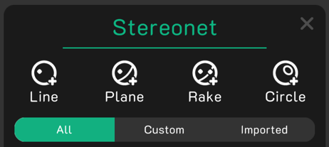
Start by watching this short video to see how you can tackle apparent dip questions using the Visible Geology web-based application.

- First, let’s find the true dip for field locations where you were unsure or had high uncertainty in the measurements you took on the planar surface (e.g., bedding plane, fault plane, etc.)
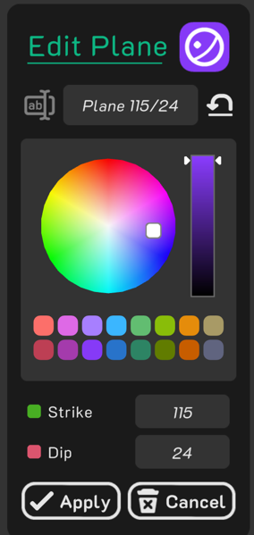
  - Use the Stereonet module in Visible Geology to plot the replicate measurements you took in the field
    - Recall that when you are making what you suspect are apparent dip measurements, they are treated like a linear orientation that may or may not be perpendicular to the strike of the plane. Thus, you will plot the dip direction as a trend and the dip as a plunge (i.e., a linear feature) and it will appear as a point on your stereonet
    - Once you plot all points for the plane in question, use the +plane tool to find the great circle that passes through all of your points.
    - The strike and dip of that plane will be displayed in the associated information panel for that plane.
    - Record this new orientation information and the method you used to obtain it in your field notebook.
  - Take screenshots and make notes for all locations where you took apparent dip data. (10pts)

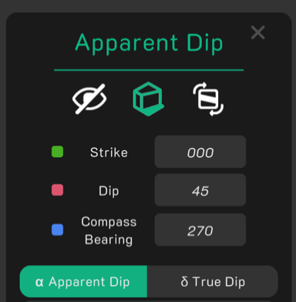
Apparent dip is also important when projecting measured orientation data in the field onto a cross-section. Hardly ever do we only collect data along a cross-section line and even if we do, hardly ever do the strikes of the planes cross the cross-section line at a perpendicular orientation. Because of this, we need to be able to convert our measured orientations to “apparent dips” to project them onto our cross-section lines.

- Next, you’ll want to prepare your map data to be projected onto the cross-section line(s) that you have chosen for further map analysis.
  - Determine which field data are appropriate to project on your cross-section line (e.g., a strike that is closer to parallel with your cross-section line may prove more difficult to project than one that is near perpendicular)
  - Create a table to organize your conversions. Add your measured strike and dip values to keep track of your converted data.
  - Use the Apparent dip tool in Visible Geology to convert the dips of the data you plan to project onto your cross-section.
  - Add the new values to your table (5pts). These are the dip values you will use when constructing your final cross-section figure(s) for your report.

Part 3: Determine Fold Orientation
In the field, we found and measured several structures including the large plunging fold. Before we left you drew an estimated fold axis on your map. We will now use your field measurements to calculate a much more accurate orientation for the fold axis.

Review the field data collected on your map. You should have orientations of faults, slicklines, ductile structures etc. To determine your overall fold structure orientation; however, you only want to use the bedding data collected from the fold limbs.

- Use the stereonet module in Visible Geology to plot all the bedding data related to the fold structure (add screenshots to your doc.). (8pts)
- Describe what the Stereonet plot shows (2pts)

- Is this what you expected the plot to look like? Why? Why not? (2pts)

- Color the data from each limb a different color to emphasize the data taken from one limb vs the other (1 pt) add screenshot of newly colored plot to lab doc.
- How did you know which data to color as one limb vs the other? (1pt)

- The great circles you have plotted all appear to cross in one general area. What does this mean? (2pts)

- Plot a point that represents the fold axis and record the trend and plunge of the fold axis. (3pts) add new screenshot to show this.
- Compare the trend to the line you drew on your map in the field. Describe the differences in trend values and explain why they may be different. (3pts)

