

Exploring fold interference patterns using Visible Geology
Teaching activity
Visible Geology is a free, web-based application that allows for the creation and exploration of 3D geological models. Visible Geology is an initiative of Seequent, The Bentley Subsurface Company, helping students visualise complex geological concepts in an intuitive digital environment, moving beyond traditional 2D methods to modernise geology education.
This activity uses Visible Geology's interactive 3D modeling modules to help students visualize and recreate complex fold interference patterns resulting from superposed folding events. It builds on foundational concepts from structural geology textbooks, such as the Processes in Structural Geology and Tectonics chapter on folds, by transitioning from 2D sketches to dynamic 3D models.

Introduction (with geoscience context)
In structural geology, folds are among the most visually striking features, representing ductile deformation where planar surfaces like bedding are bent or curved without fracturing. Superposed folding occurs when multiple deformation events affect the same rock layers, leading to fold interference patterns that reveal a region's complex tectonic history. These patterns, as described in resources like the PSGT textbook (Chapter 8), include four basic types (Type 0, 1, 2, and 3) arising from the superimposition of upright F2 folds on pre-existing F1 folds of varying orientations. Type 0 results in tightening of earlier folds; Type 1 produces "egg carton" or dome-and-basin structures; Type 2 creates "mushroom" patterns; and Type 3 yields "zig-zag" geometries. Understanding these patterns is crucial for interpreting deformation sequences in orogenic belts, where changes in stress regimes can produce variably oriented folds. This activity leverages Visible Geology's 3D tools to allow students to actively construct and manipulate these patterns, bridging theoretical concepts with practical visualization skills essential for field analysis and regional tectonic reconstructions.

Learning goals
- Identify and describe the geometric characteristics of the four basic fold interference patterns (Types 0-3) and explain how they form through superposition of multiple fold generations.
- Use 3D modeling tools to recreate superposed folds, manipulate variables like hinge line orientations and axial surface angles, and analyze resulting interference patterns in map, cross-section, and 3D views, and using stereonets.
- Interpret the implications of fold interference for deformation history, including changes in kinematic conditions and challenges in mapping fold orientations in multiply deformed terrains.

Pre-activity assignments/reading (if applicable)
Prior to the lab, students should read the "Superposed Folding" section of the PSGT textbook (Chapter 8, approximately pages 27-29), focusing on the principles of fold superposition, the four interference types, and their tectonic significance. Optionally, review earlier sections on fold anatomy and classification for foundational terminology (e.g., hinge lines, axial surfaces, interlimb angles). Students may also watch a short Visible Geology tutorial video on the Geology Explorer tool (available on this YouTube Playlist) to familiarize themselves with basic navigation.
Reference: van der Pluijm, B. and Marshak, S. (2020). Processes in Structural Geology & Tectonics. University of Michigan.

Using the Visible Geology modules
Access Visible Geology for free via the web (no login required for basic features; log in with a Google account for saving and sharing projects). This activity primarily uses the Geology Explorer module, which allows creation of stratigraphic templates, application of folds, and superposition of multiple deformation phases. Key features include: building layered sequences; fold tools for defining hinge lines, axial planes, wavelengths, amplitudes, and plunges; rotation and cross-section views for analysis; and export options for stereonets, screenshots, and models. Start with a simple undeformed stratigraphic block (e.g., 5-7 alternating layers for visibility), then apply sequential folds. Use the "Undo" function to iterate, and explore the interactive mode for real-time adjustments. Remember to save your work frequently (Menu > Save).

Activity (description and steps)
This ~2-hour guided inquiry lab has students recreate and analyze fold interference patterns step-by-step. Work individually or in pairs, saving screenshots and notes for a short report (e.g., 1-2 pages summarizing observations and interpretations).

Step 1: Build a base stratigraphic model
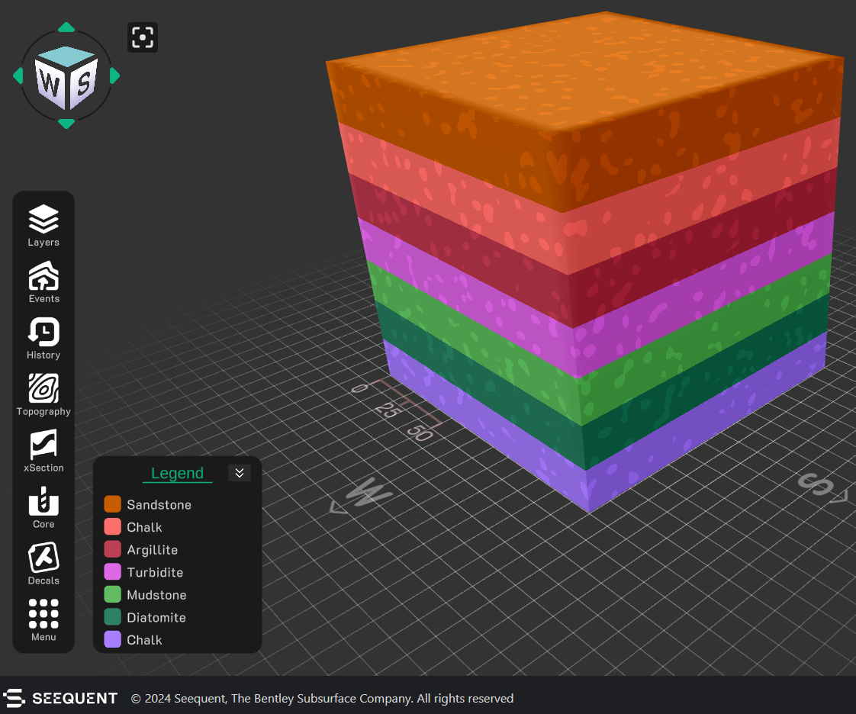
- Start a new model in Geology Explorer.
- Create an undeformed stratigraphic sequence: Add at least six horizontal layers of alternating colors/thicknesses (e.g., red sandstone, blue shale, green limestone; modify thickness to fill the default topography. You can edit unit thickness individually using the Edit Layer tools when a layer is selected, or drag the slider bar when Geologic Layers is enabled.
- View the model in 3D, map view (top-down), and cross-section (e.g., N-S and E-W profiles). Take a screenshot of the undeformed state and save it for your final submission.

Questions:
1a) How does this represent an initial sedimentary basin before deformation?

1b) What basic principle of Geology predicts the original orientation of layers prior to deformation?

Step 2: Apply first-generation (F1) folds
- Simulate an initial deformation event: Apply an upright F1 fold set by selecting Events - Fold. Try configuring the fold axial planes to have a N-S strike (000), a vertical dip (90), and a tight interlimb angle, accomplished by setting wavelength to ~5 units, and amplitude to ~20 units.
- Rotate the model as needed to observe hinge lines and limbs in profile. Estimate interlimb angles.
- Add ~10 decals distributed across the top surface. Your model should be similar to the image below.

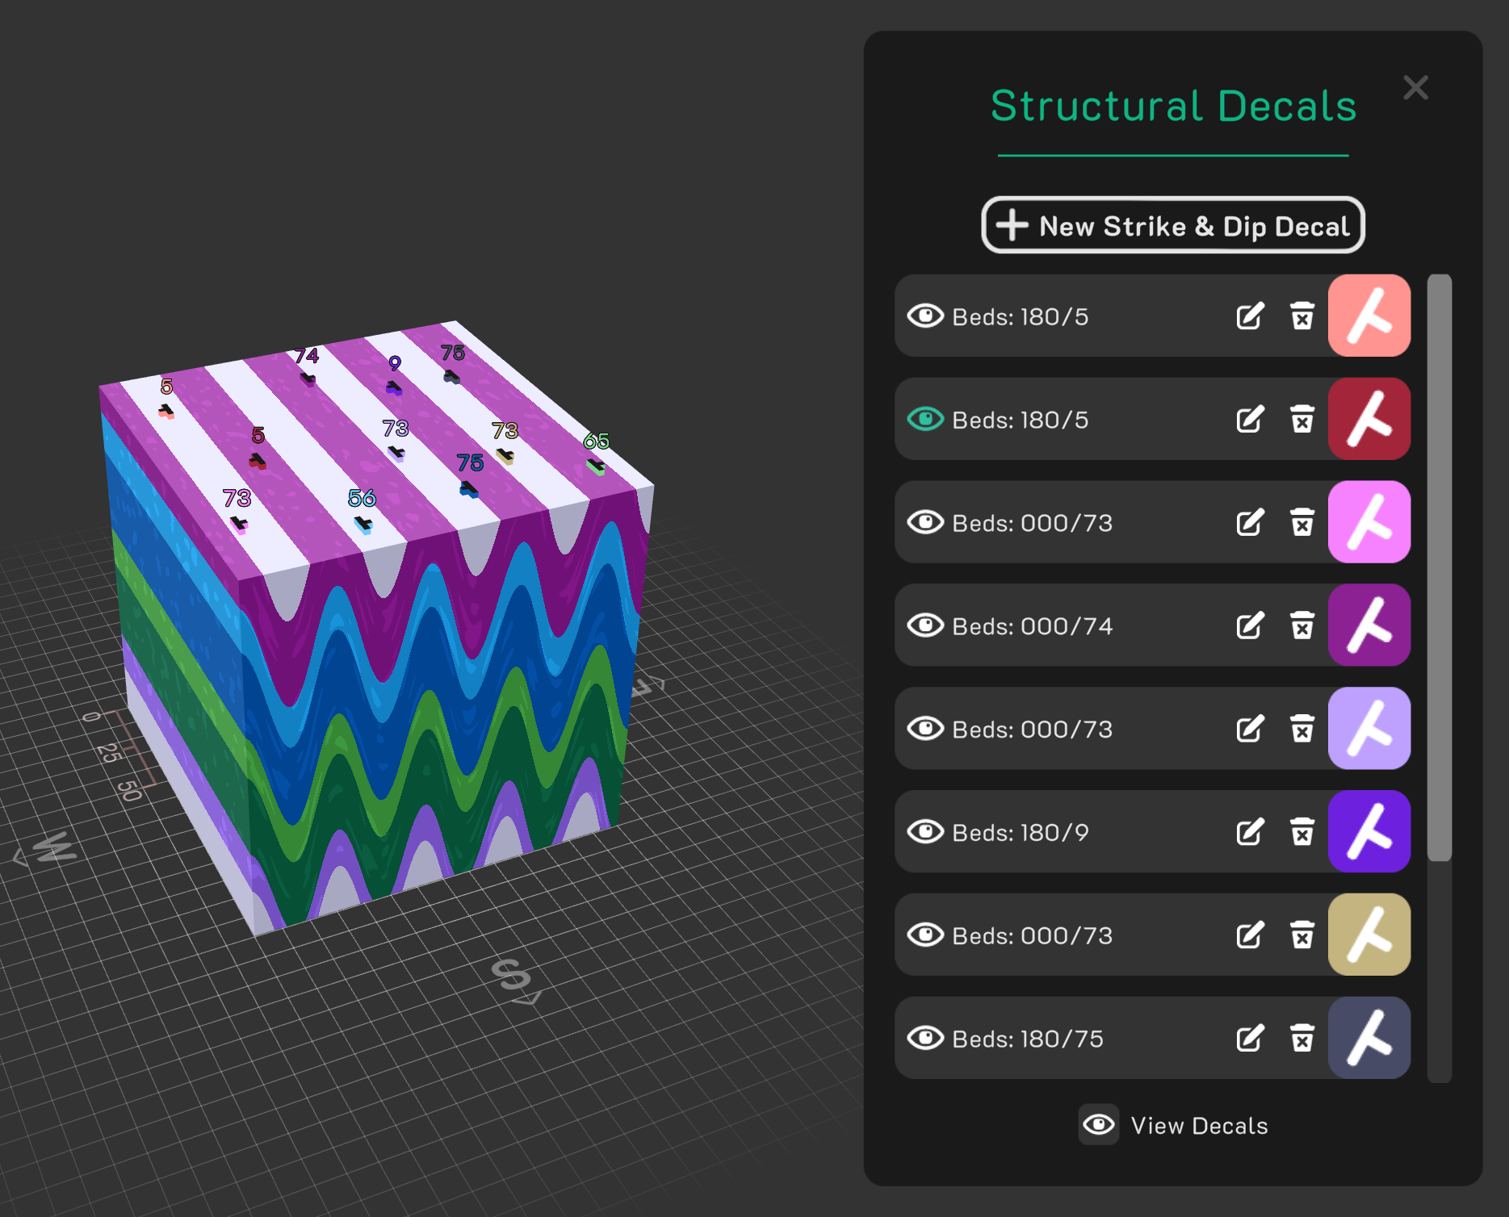
- Plot the bedding orientations on a stereonet by accessing Menu - Stereonet. Import the decals by clicking Import on the right side pane.
Question: 2) What do the intersections of great circles represent on the stereonet?

If you have a Google account, now would be a good time to log in with it and save your model in the Geology Explorer module and Stereonet module.
Step 3: Superimpose Second-Generation (F2) Folds and Recreate Interference Types
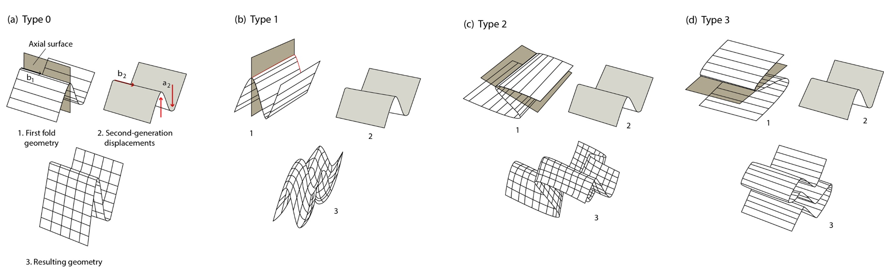
- Overlay upright F2 folds on the F1 model, varying fold parameters to produce each interference type (refer to Figure 8.37 in PSGT for guidance, copied above). After creating each fold interference pattern, you can return to the initial state (F1) by opening History and deleting the latest event.
- Type 0: Set F2 axial surfaces parallel to F1 (e.g., N-S striking, vertical dip); adjust amplitude to tighten F1 without new patterns.
- Type 1 ("egg carton"): Set F2 hinge lines and axial surfaces perpendicular to F1 (e.g., F2 E-W striking, vertical dip); observe dome-and-basin map patterns.
- Type 2 ("mushroom"): Set F2 axial surfaces at a high angle to F1 equivalents (both axial surfaces and hinge lines will need to be non-parallel); observe mushroom patterns in map view. Suggestion: start with your upright F1 fold and apply a slight tilt (Events > Tilt > Dip ~10 degrees). Next, apply a F2 folding event with strike ~080, dip ~85, and plunge ~80.
- Type 3 ("zig-zag"): Set F2 hinge lines parallel to F1 (strike 000), but axial surfaces perpendicular (dip ~00); note zig-zag outcrop traces. You may want to start with recumbent F1 by applying a ~90 degree tilt prior to F2.
- For each type: Adjust variables (e.g., wavelength, amplitude, plunge angles) and observe changes. Take screenshots in 3D, including map view and cross-section views (as many different orientations as needed).
Question: 3) How does varying amplitude and wavelength between F1 and F2 affect visibility of interference patterns? Relate to real-world challenges in field mapping.

Step 4: Analysis and Interpretation
Short-answer questions (several sentences per answer):
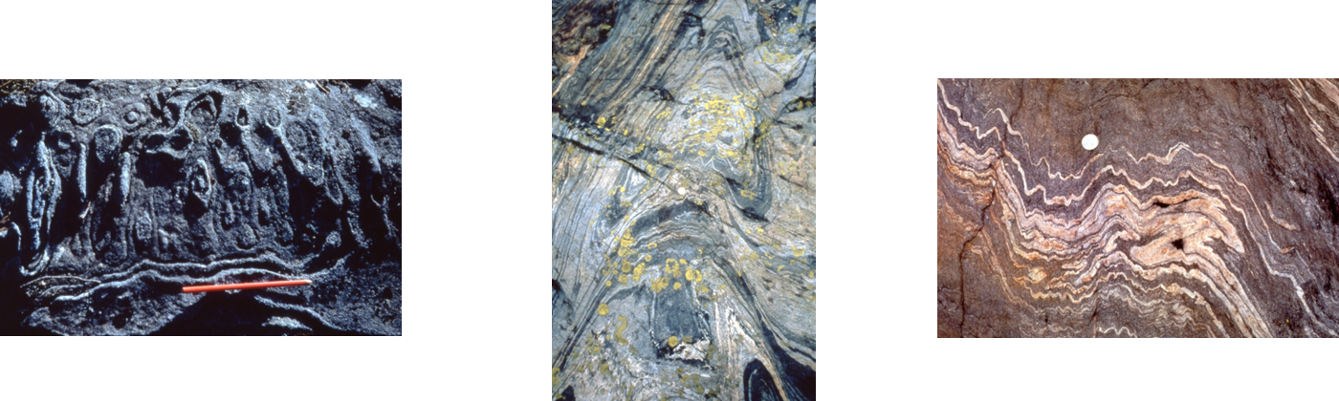
Question: 4) Compare your models to the outcrop photos of type 1, 2, and 3 fold interference patterns, above (PSGT, Chapter 8 lecture slides). Were you able to reproduce each interference pattern? Include screen shots of each as part of your answer.

Question: 5) Tectonic Implications (Progressive vs. Multiphase): Discuss the tectonic significance of each fold interference pattern (Types 0-3). Which patterns are typically associated with progressive deformation (a single, continuous stress regime) and which require multiphase deformation (two distinctly different, separate stress events)?

Question: 6) Reflect on this assignment. How might 3D modeling exercises prepare you for fold interference pattern interpretation in the field?

Assessment criteria
The assessment is designed to directly evaluate student mastery of the three specified learning goals through a combination of model construction, visual evidence, and analytical interpretation of the results.
Learning Goal | Assessment Focus | Deliverables
1. Identify and describe the geometric characteristics of the four basic fold interference patterns (Types 0-3) and explain how they form through superposition of multiple fold generations. | Understanding of the geometric characteristics of the four-fold interference patterns (Type 0, 1, 2, 3) and the fundamental principles of fold superposition. | Clear, correctly labeled screenshots for each of the four-fold interference patterns (Type 0-3) that successfully reproduce the characteristic map view geometries, as requested in Question 4 (Step 4).
2. Use 3D modeling tools to recreate superposed folds, manipulate variables like hinge line orientations and axial surface angles, and analyze resulting interference patterns in map, cross-section, and 3D views, and using stereonets. | Demonstrated proficiency in using the Visible Geology tools for model construction, applying fold parameters, and performing stereonet analysis of bedding orientations. | A screenshot of the undeformed stratigraphic model (Step 1). A screenshot of the F1 fold model (Step 2). An accurate stereonet plot correctly identifying the fold axis (great circle intersections) for the F1 fold set, as requested in Question 2 (Step 2).
3. Interpret the implications of fold interference for deformation history, including changes in kinematic conditions and challenges in mapping fold orientations in multiply deformed terrains. | Analytical and interpretive application of observations, linking model outcomes to real-world geological processes and field challenges. | Accurate and thorough short-answer responses to Question 3, 5, and 6 (Step 4) that discuss the effects of fold parameters on visibility, the tectonic implications of the resulting patterns, and a reflection on the value of 3D modeling for field interpretation.

