

Basin stratigraphic correlation
Teaching activity
Visible Geology is a free, web-based application that allows for the creation and exploration of 3D geological models. Visible Geology is an initiative of Seequent, The Bentley Subsurface Company, helping students visualise complex geological concepts in an intuitive digital environment, moving beyond traditional 2D methods to modernise geology education.
This lab activity allows students to examine and construct a basin-scale simulation of Appalachian stratigraphy and examine the variation in strata represented in drill core that would result. It would serve as the first introduction to the concept of sedimentary basins in an earth science majors course.

Introduction (with geoscience context)
Over the last 150 years, many deep wells have been drilled to locate oil and gas hydrocarbon resources in sedimentary basins. During this oil & gas exploration many sediment cores were extracted that provide information about the rock types present in the subsurface. You will integrate information from a geologic map and virtual rock cores to evaluate the mechanisms that formed the large accumulation of sedimentary strata of the Appalachian basin, then create a digital model for the adjacent Illinois basin.

Learning goals
- Develop geologic map reading skills
- Practice basic lithostratigraphic correlation
- Infer basin sedimentation history
- Create a basin model

Pre-activity assignments/reading (if applicable)
Bentley et al:
  - Chapter 2 The Story of Basins Past, Present, and Future
  - Chapter 3 Basins, Sea Level, and Accommodation Space

Using the Visible Geology modules
- Visit the Visible Geology web-based application
- Block model of the Appalachian basin for this activity
- Refer to this Youtube Tutorial for help
Activity (description and steps)
Part 1: Geologic model of the Appalachian basin
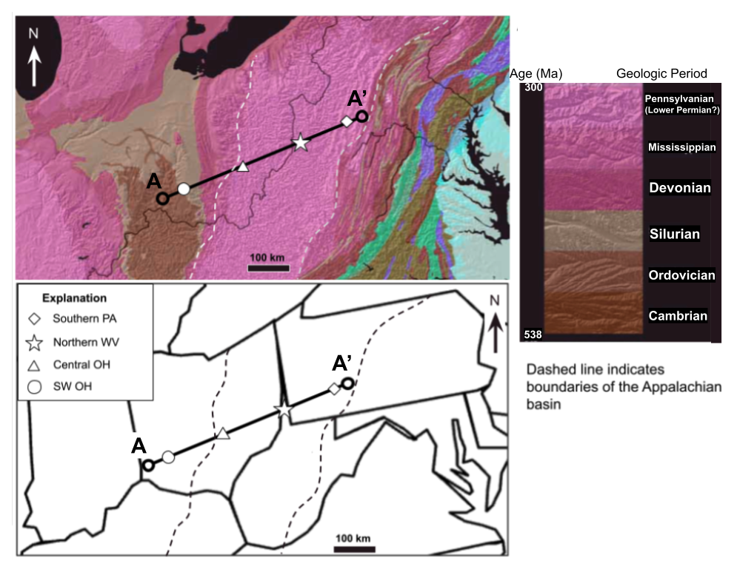
Examine the geologic map above. The map explanation to the right shows the geologic periods represented by sedimentary strata at the locations of the yellow symbols.
In the space below, describe the changes in surface bedrock from Southern PA to SW OH. Where are the oldest rocks exposed and where are the youngest rocks exposed?

The strata of the Appalachian basin are found between the dashed lines shown on the map. What is the age range of the rocks at the surface?

Examine the Visible Geology model in the Geology Explorer module of the region of the Appalachian basin between Southern PA and SW OH:
Geology Explorer Model
The model represents the strata and underlying rocks of the area. Note there is ~10x vertical exaggeration and actual dip of the strata is ~5°:
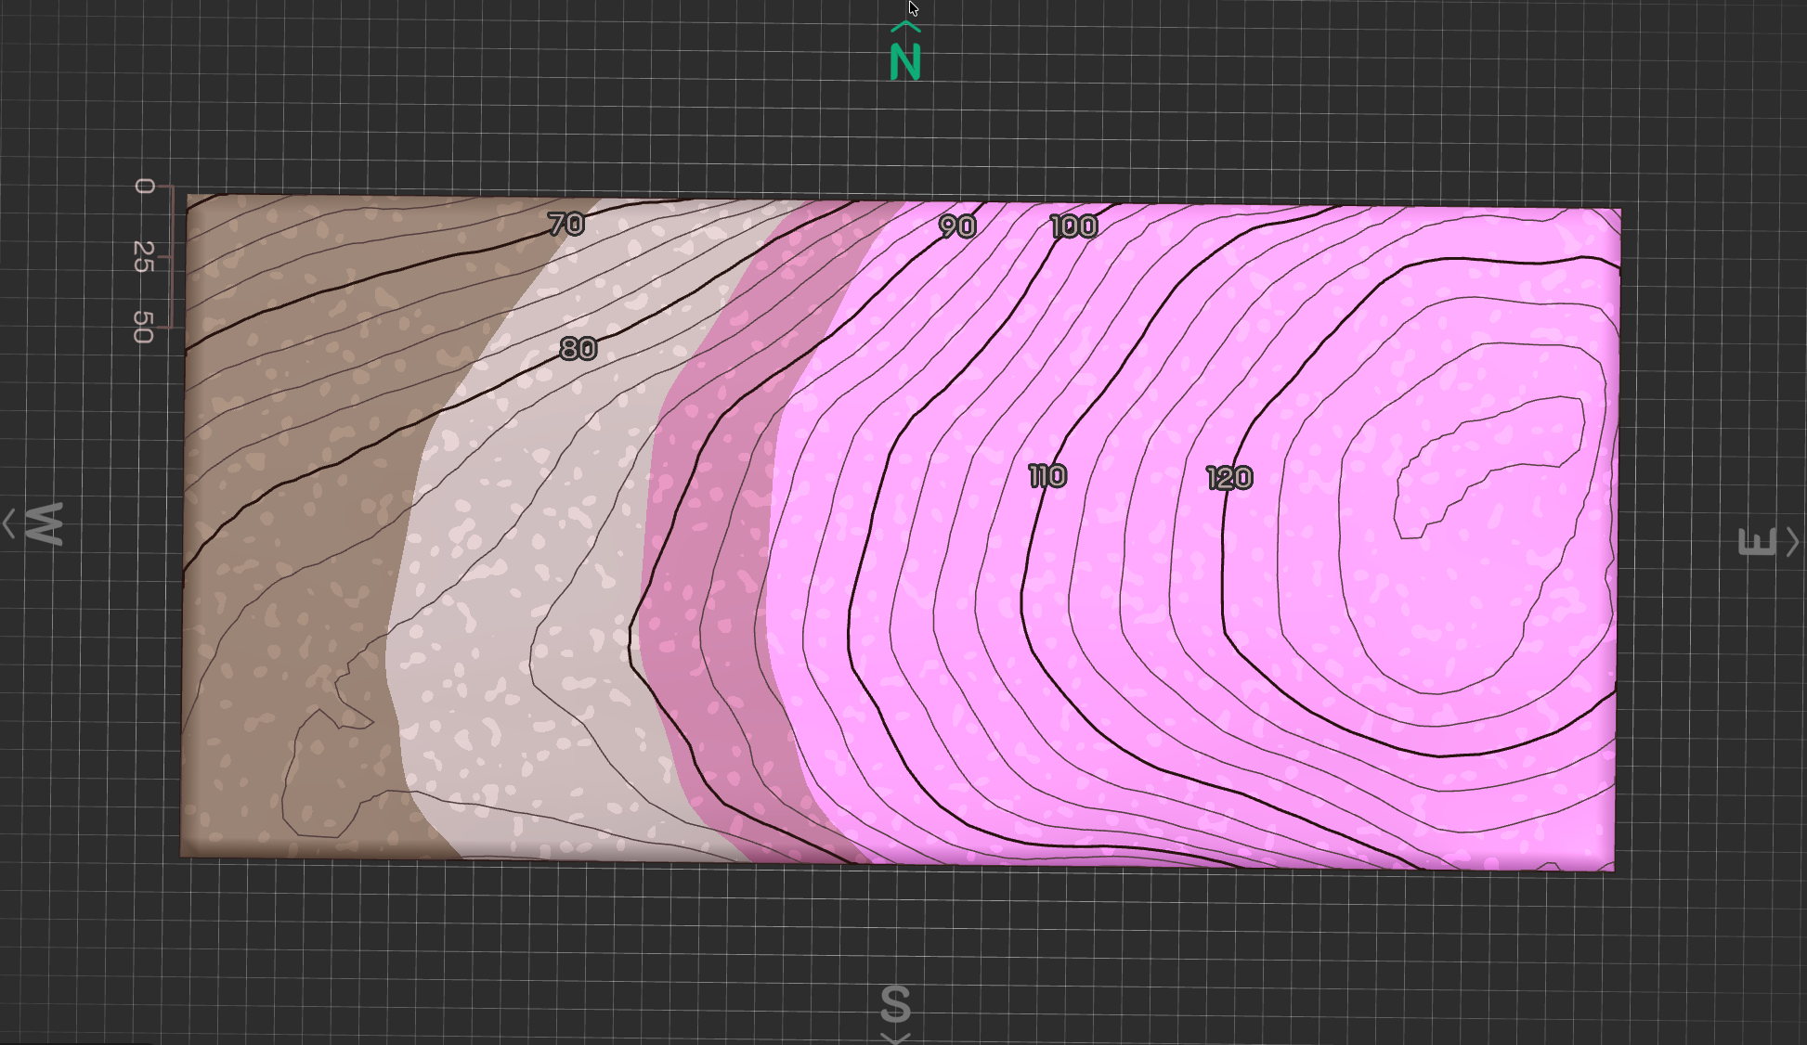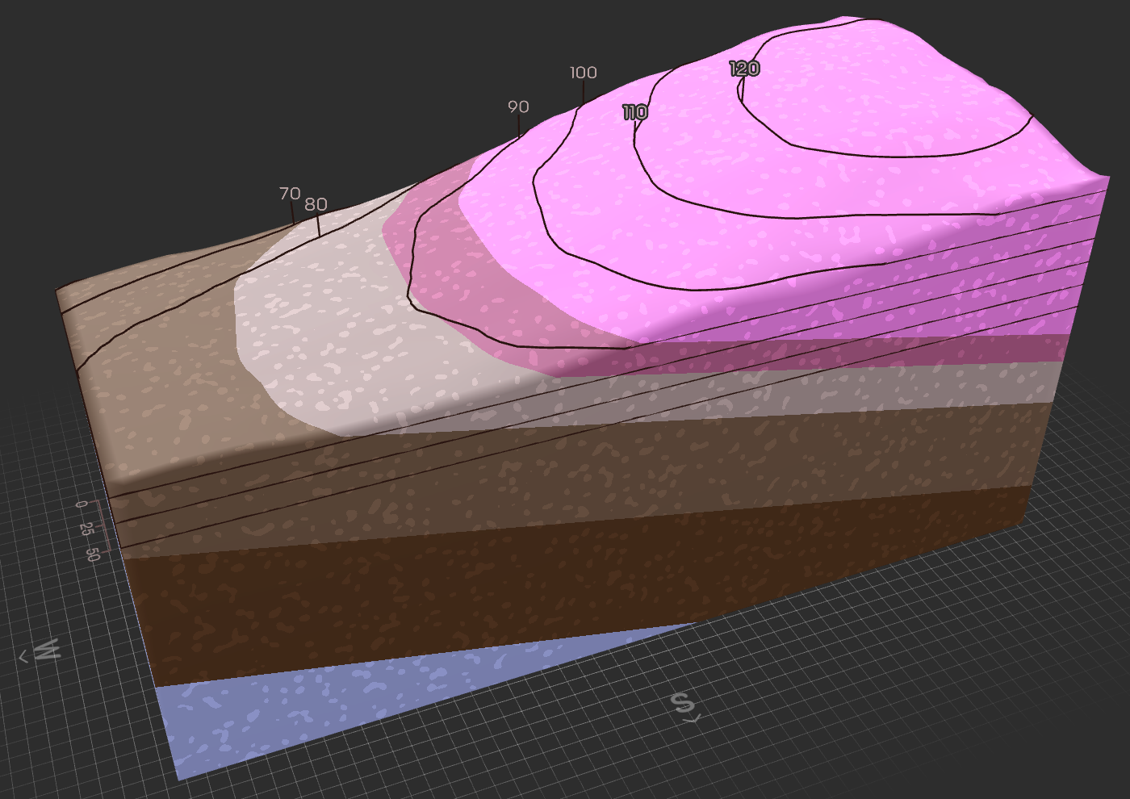
Describe the direction that the strata are dipping:

Note the oldest rocks are the “Crystalline Basement”, which are Precambrian igneous and metamorphic rocks. How does depth to basement change along this transect?

Explain how the dip and changes in crystalline basement depth relate to the change in bedrock exposed at the surface along the Appalachian basin transect:

What could have caused this regional dip in the strata of the Appalachian basin as well as the underlying rocks? Note there are fundamentally two senses of vertical motion: up and down. Come up with two different explanations that could explain the configuration of the rocks displayed in the model:

Part 2: Appalachian basin cores
Examine the diagram showing the cores depicted in the Visible Geology model for the Appalachian basin. Consider the position of northern WV along the transect that would be located between Southern PA and Central OH as shown on the map.
Using the Geology Explorer basin model to guide you, draw a depiction of the rock core that would be present at the location of northern WV in the blank space on the next page. Include all the rock units you think a core would encounter and show them at the appropriate depth and thickness they would appear relative to the cores shown for Central OH and southern PA.
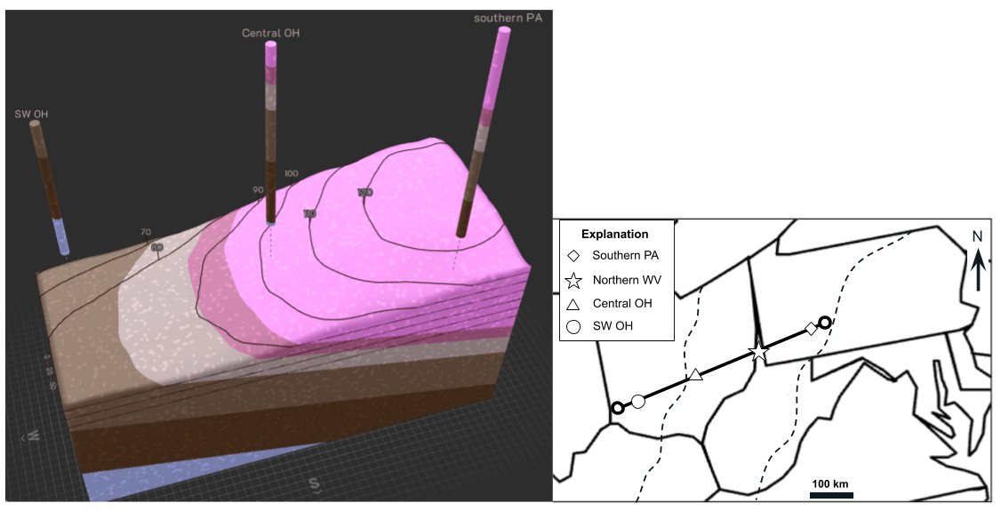
Once you have constructed your core, draw lines for a lithostratigraphic correlation of the rock units of each geologic period across the transect from SW OH to Southern PA. Be sure to color and fully label your correlation diagram.
Examine your correlation diagram and propose an explanation for the thickness variation of Pennsylvanian strata across the Appalachian basin. See if you can come up with at least 2 possible explanations:

Sedimentary strata accumulate where basin “subsidence” occurs. Which area of the Appalachian basin would you expect to have had the greatest amount of subsidence?

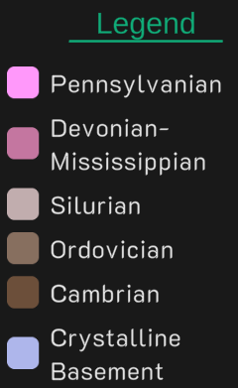

Southern PA
SW OH
Central OH
Northern WV
100 km

0

Part 3: Hypothesize a geologic model of the Appalachian basin
Using the Visible Geology Geology Explorer, create a new model that will show the subsurface geology of the region of Illinois basin.
- Use this tutorial to help you create your model. Start by creating a new Geology Explorer Model.
- Use the topography function to create a smooth topography that is 100-200 feet higher at B and gradually declines in elevation toward B’.
- The model should include all the same stratigraphic units and underlying crystalline basement rocks as the Appalachian basin, noting the following
- Add units to the model. For simplicity, you may model the Mississippian and Devonian strata together as one layer in the Visible Geology model for the Illinois basin as was done for the Appalachian basin.
- Your model should be constructed to show ~10x vertical exaggeration, and dip of the stratigraphic units in this area do not exceed ~5° (unexaggerated).
- You will need to play around with the unit thickness and direction of unit dip in order to get your model to match the map pattern
- The color of each unit should be edited to generally match the map but note the color match does not need to be perfect
Paste the link to your model and paste a screenshot of your model to this assignment.

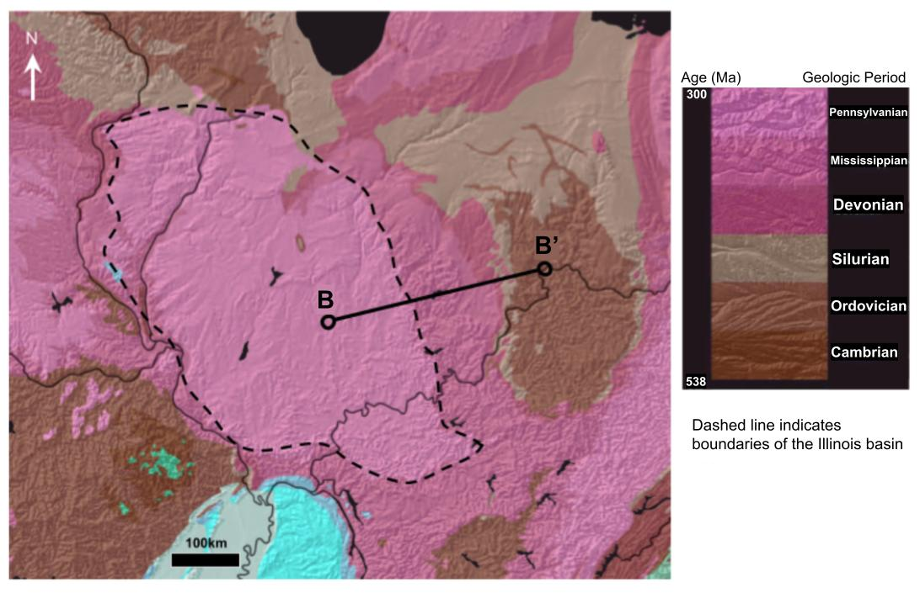
Select at least 2 areas of your basin for a core, with one core in an area with Pennsylvanian strata and one core in an area without Pennsylvanian strata.
Add these cores to your Geology Explorer model and add a screenshot of your model with these cores in the space below. Then in the box below, sketch a diagram of each core and perform a lithostratigraphic correlation between these as you did in Part 2.
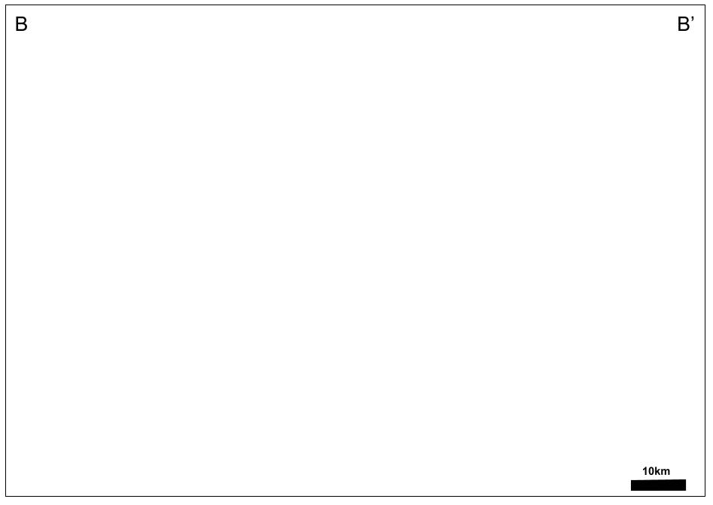
Consider what you learned in Parts 1 & 2 about where stratigraphic units tend to accumulate. Hypothesize a model for the formation of the Illinois basin.

Think about your model: what additional geologic data could be acquired to test your model? In other words, what would you be able to observe in the rocks that could indicate your model is valid or invalid?

Learning goal
Learning goal | Assessment criteria
Develop geologic map reading skills | Can relate spatial geometries of sedimentary strata to geologic map patterns
Practice basic lithostratigraphic correlation | Produce a lithologic correlation model using core information
Infer basin sedimentation history | Uses stratigraphic information to produce an explanation of where and why sediment accumulations form
Create a valid basin model | Basin model honors all constraints provided by the assignment and of the geologic map pattern

