
Analyzing plunging folds using stereonets and 3D modeling in Visible Geology
Teaching activity
Visible Geology is a free, web-based application that allows for the creation and exploration of 3D geological models. Visible Geology is an initiative of Seequent, The Bentley Subsurface Company, helping students visualise complex geological concepts in an intuitive digital environment, moving beyond traditional 2D methods to modernise geology education.
This hybrid activity integrates manual or digital stereonet techniques with Visible Geology's 3D modeling modules to analyze and reverse-engineer the geometry of a plunging antiformal fold. It expands on a stereonet analysis lab technique by adding a digital validation step, allowing students to visualize rotations, plunges, and deformation in 3D.

Introduction (with geoscience context)
Folds represent ductile deformation in rocks, where planar features like bedding are curved without fracturing, often due to processes such as grain sliding, kinking, or crystal plasticity (as discussed in the PSGT textbook, Chapter 8). Quantifying fold geometry— including the fold axis (hinge line orientation and plunge), axial plane, and overall shape—is essential for understanding strain distribution and regional tectonic history. For plunging folds, like the antiformal structure near Dillon, Montana, stereonet methods (beta and pi diagrams) help determine these elements from strike and dip (S/D) data collected from fold limbs. However, traditional 2D stereonets can abstract complex 3D rotations and geometries. This activity bridges that gap by guiding an analysis of real-world S/D data using stereonets, then"reverse engineering" the fold in 3D: starting from an undeformed stratigraphic sequence and applying the quantified parameters to recreate the structure. This approach highlights how plunge affects outcrop patterns and vergence, reinforces spatial reasoning for field methods, and validates calculations visually.
The style of plunging antiformal folding analyzed in this activity is characteristic of foreland fold-and-thrust belts, such as the one defining the Rocky Mountains. The structures near Dillon, Montana, are a direct result of the Sevier Orogeny—a major Late Jurassic to early Cenozoic mountain-building event in western North America. This event involved the eastward propagation of large, shallow-dipping thrust faults that stacked slices of crust atop the North American craton. The ductile folds analyzed in this activity represent the upper-crustal deformation that was produced in response to the massive compressional stresses generated by this large-scale thrusting. Understanding the orientation and plunge of these folds is thus key to reconstructing the regional strain field of the Sevier Orogeny.

Learning goals
- Determine fold axis trend/plunge (β-axis) and axial plane orientation (π-pole) from strike and dip data using beta and pi stereonet diagrams, and explain their geometric significance in plunging antiformal folds.
- Construct a 3D model of an undeformed stratigraphy and apply fold parameters (e.g., axis orientation, amplitude, plunge) to simulate deformation, verifying stereonet results through visual matching of outcrop patterns and rotations.
- Analyze the effects of variations in fold parameters (e.g., plunge angle) on 3D geometry and map-view traces, interpreting implications for tectonic processes and field mapping challenges.

Pre-activity assignments/reading (if applicable)
Before the session, review the "Anatomy of a Fold" and "Fold Classification" sections of the PSGT textbook (Chapter 8), focusing on terms like hinge line, axial surface, plunge, and cylindrical vs. non-cylindrical folds. Familiarize yourself with basic stereonet plotting (great circles for bedding planes, poles to planes) by reviewing prior laboratory exercises or using Visible Geology's Stereonet module. If not already completed, work through the provided Lab 3 instructions manually on tracing paper to plot the sample S/D data below. Optionally, watch a short tutorial on Visible Geology's Geology Explorer module (available on this YouTube Playlist).
Reference: van der Pluijm, B. and Marshak, S. (2020). Processes in Structural Geology & Tectonics. University of Michigan.

Using the Visible Geology modules
Access Visible Geology for free (no login needed for basic features; log in with a Google account for saving and sharing projects). This activity uses the Geology Explorer module for creating stratigraphic templates, applying folds/rotations, and generating views (3D, map, cross-section). It also leverages the stereonet tools to plot and analyze orientations digitally—import S/D data as planes or poles for beta/pi diagrams. Key tools: Layers for creating a stratigraphic template; Events - Fold for changing fold parameters (hinge orientation, plunge, amplitude, wavelength); Events - Tilt for controlling plunge; screenshot for capturing images (Windows key - shift - s on Windows, cmd - shift - 4 on Mac). Start models with relatively simple stratigraphy (e.g., 4-6 layers) for clarity, and use "Undo" or delete events in History to iterate. Remember to save frequently.

Activity (description and steps)
This ~90-120 minute hybrid lab/workshop is scaffolded for progressive learning. Use the provided sample S/D data (based on a plunging antiformal fold near Dillon, MT) or real field measurements if available. Work individually or in small groups; submit annotated stereonets (digital or scanned), Geology Explorer model screenshots, and a brief report (1-2 pages) interpreting results and variations. Assessment focuses on accuracy of calculations, model fidelity, and tectonic insights.
Sample Strike and Dip (S/D) Data (bedding measurements from fold limbs), with map locations and rock unit:
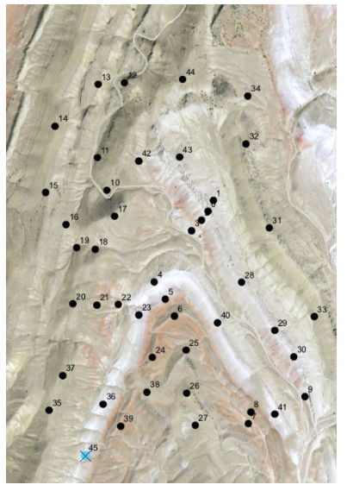

Map Location | Unit | Strike | Dip
21 | Kk3 | 195 | 65
22 | Kk3 | 198 | 60
23 | Kk2 | 200 | 63
24 | Kk1 | 202 | 59
25 | Kk1 | 253 | 42
26 | Trd | 250 | 40
27 | Trd | 251 | 41
28 | Kk4 | 325 | 62
29 | Kk4 | 322 | 60
30 | Kk4 | 333 | 67
31 | Kb | 329 | 65
32 | Kb | 350 | 87
33 | Kb | 350 | 88
34 | Kb | 352 | 85
35 | Pp | 188 | 34
36 | Kk2 | 203 | 56
37 | Pp | 206 | 35
38 | Kk1 | 204 | 58
39 | Kk1 | 203 | 55
40 | Kk2 | 335 | 70
41 | Kk2 | 330 | 65
42 | Kk3 | 217 | 55
43 | Kk4 | 318 | 56
44 | Pp | 182 | 30
45 | Kk2 | 197 | 64

Step 1: Stereonet analysis - Beta and Pi Diagrams (30-40 minutes)
- Using either tracing paper or Visible Geology Stereonet module, plot great circles for each S/D measurement on a "Beta Diagram." Label intersections of great circles—the common point is the β-axis (fold axis trend and plunge). If using Visible Geology, you can import these measurements by copying the formatted text below, opening Stereonet from Visible Geology, selecting “Import” from the Stereonet tools at right, selecting “Import from Text”, and pasting the formatted text. Add a line representing the fold axis by clicking “Line” then clicking on the location on the stereonet where the Great Circles intersect (visual average).
195, 65
198, 60
200, 63
202, 59
253, 42
250, 40
251, 41
325, 62
322, 60
333, 67
329, 65
350, 87
350, 88
352, 85
188, 34
203, 56
206, 35
204, 58
203, 55
335, 70
330, 65
217, 55
318, 56
182, 30
197, 64

- On a separate sheet, plot poles to the bedding planes for a “Pi Diagram.” If using Visible Geology Stereonet module, toggle on the poles by clicking the eyeball icon in the tools pane. Connect poles with a great circle (pi-girdle) to represent the fold’s cylindrical geometry; the pole to this girdle is the π-axis (normal to the axial plane). If using Visible Geology, this can be accomplished by adding a new plane and then hovering your cursor over the stereonet to pick the pole to the great circle that fits the bedding poles. Be sure to distinguish the pi-girdle from bedding measurements using symbol variations (e.g. change the color). Reference the below image for an example.
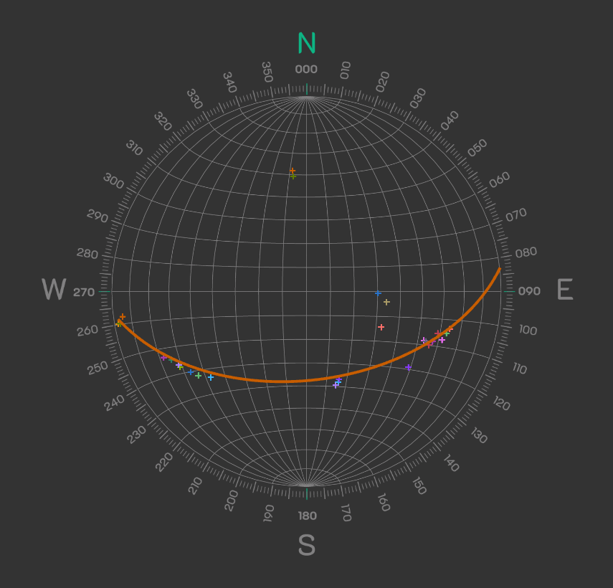
- Determine and record the fold axis trend and plunge, either using the line you chose for the Beta Diagram, or the Pole to the pi-girdle (these should be similar).
Question 1) What is the trend and plunge of the fold axis? How does the plunge affect limb contact traces? Predict the map-view trace of the fold axis on a flat erosion surface (e.g., are the contacts v-shaped or parallel? Which way does the v point for an anticline versus syncline?). It may be helpful to reference the provided satellite imagery (above).

Step 2: Build undeformed stratigraphic model in the Geology Explorer module
- Launch Geology Explorer and create a simple undeformed stratigraphic column: Add 5 horizontal layers of alternating colors/thicknesses (e.g., red shale, blue limestone, green sandstone; adjust thickness to fill the default topography).
- View in 3D and map (top-down) modes.
Question 2) This represents pre-deformation sedimentation—how might layer competencies (e.g., stiff vs. ductile) and/or thicknesses influence folding? Refer to the Mechanics of Folding section in PSGT, Chapter 8.

Step 3: Apply fold parameters to "Reverse Engineer" the structure
(20-30 minutes)
- Using your stereonet results, fold the model: Set the fold axis orientation by setting strike parallel the trend determined from β-axis, but in right-hand rule. This means that strike will be equal to the trend value + 180. Assume that the fold axial plane dips ~75 degrees to the west (dip should be set to 75 degrees). Set the amplitude (~20-30 units) and wavelength (~10-20 units). Set the plunge of the fold using the plunge determined from the β-axis. Negative plunge values will accomplish north plunge if using right-hand-rule for a west-dipping plane.
- View cross-sections parallel/perpendicular to the fold axial surface. Capture at least two different orientations using screen shots to include in your report. Also capture a view looking straight down on the top surface (i.e., topographic surface)—compare to your predicted trace from Step 1.
- Create a stereonet from the deformed model: Add several decals (in Geology Explorer, select Decals > + New Strike & Dip Decal) to each limb of the fold to capture bedding planes/poles. Import these to Visible Geology Stereonet (from Stereonet, select Import > Import From Geology Explorer) and determine whether they are a good match with the stereonet data you plotted in Step 1.

Question 3) Did your prediction of the geometry of contact traces in plunging fold limbs match the observed geometries (see satellite image, above)? Why or why not?

Question 4) Does the 3D model reproduce the original S/D data when "measured" on virtual limbs? Why or why not?

Assessment criteria
The assessment is designed to directly evaluate student mastery of the three specified learning goals through a combination of calculations, visual model fidelity, and analytical interpretation.
Learning goal | Assessment criteria and deliverables
1. Determine fold axis trend/plunge (β-axis) and axial plane orientation (π-pole) from strike and dip data. | Assessment focus: Accuracy of calculations and geometric significance.
 | Deliverables: Screen capture/scan of the Stereonet (Step 1) accurately plotting great circles, poles, the pi-girdle, and correctly identifying and labeling the β-axis (fold axis trend/plunge) and the π-axis (pole to the axial plane).
2. Construct a 3D model of an undeformed stratigraphy and apply fold parameters. | Assessment focus: Model fidelity and verification of stereonet results.
 | Deliverables: Screenshot of two cross-sections and one map view (Step 3) from the deformed Geology Explorer model that accurately reflects the fold parameters (axis orientation, plunge, axial plane dip) derived from the Step 1 stereonet analysis.
3. Analyze the effects of variations in fold parameters; interpreting implications for tectonic processes and field mapping challenges. | Assessment focus: Tectonic insights and spatial reasoning.
Deliverables: Accurate and thorough answers to Questions 1-4 (Steps 1, 2, and 3), which require students to:
• Predict and verify the effects of plunge on map-view contact traces (Q1, Q3).
• Interpret the influence of layer competency on folding (Q2).
• Evaluate the model's accuracy in reproducing the original S/D data (Q4).

