Making predictions and sketching planar contacts (17 pts)
N
For this activity we will use the augmented reality sandbox and provided topography map of the big island of Hawaii.

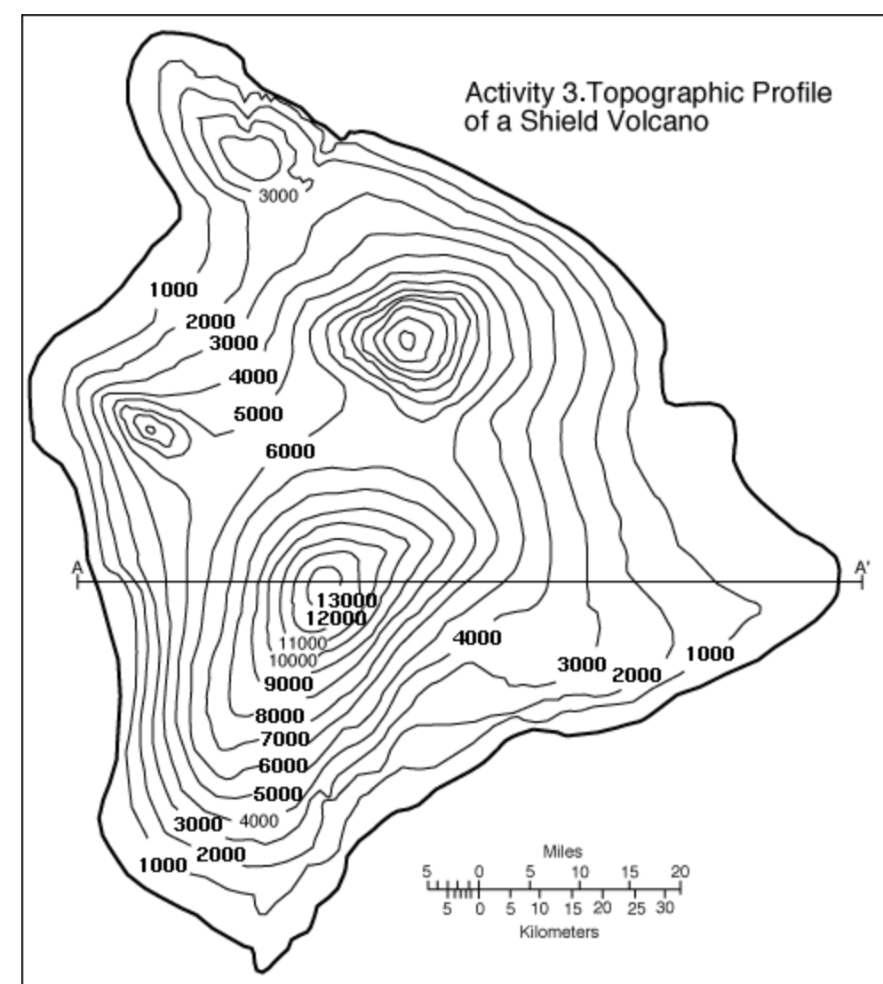
The sandbox topography should basically be what is shown on the topography map below (don’t criticize me too much I just piled up the sand by hand). Make sure you figure out the orientation of the topography map in relation to the sand topography.
C
A
B
N

- Make a prediction for how a plane (e.g., geologic bedding contact, fault) striking at 25º and dipping at 40º to the NW will appear on the map surface at point A. Draw your prediction in one color or the topography map (be sure to draw across the whole map, crossing through point A). (1pt).

- Now use the provided cardboard plane to manually add the plane and sketch the trace of the intersection with the topography on your map (use a different color or symbology). (1pt)

- How do your prediction and true test compare? (2pts)

- Now draw your prediction for how the same plane would appear shifted to the east, going through point B. (1pt)

- Use the provided cardboard plane to manually add the plane and sketch the trace of the intersection with the topography on your map (use a different color or symbology). (1pt)

- How do your prediction and true test compare? (2pts)

- Let’s try one more plane. This new plane is striking at 300º and dipping SW at 65º. Draw your prediction for the exposure of the plane crossing through point C. (1 pt)

- Use the provided cardboard plane to manually add the plane and sketch the trace of the intersection with the topography on your map (use a different color or symbology). (1pt)

- How do your prediction and true test compare? (2pts)

- What did you learn from this activity? (3pts)

- Did anything change in your thinking about planes interacting with surface topography? (2pts)

