Unit 3.2: Cloud in a Bottle Instructor notes
Sandra Penny, Russell Sage College
In this unit you’ll make a Cloud in a Bottle in order to demonstrate the structure of the atmosphere. This document will explain the physics of how this demonstration works, how you can connect this to the atmosphere for your students, and how to connect this information back to Unit 2.4 on Heat.

Materials Needed (video of one set-up and demonstration is included as the last slide in this unit’s slide deck):
- Empty clear bottle. Here are some options:
  - A clear 2L soda bottle is by far the most inexpensive option.
  - A glass 1 gallon or 5 gallon bottle with a narrow top also works great and has more longevity. Look for these with beer brewing and bottling equipment. A glass carboy with airlock, like this (1 gallon) or this (5 gallons), is perfect to provide a nice seal with the bike pump.
- Bicycle Pump.
  - For a small 1 gallon glass bottle or 2L soda bottle:
    - A small handheld bike pump. Here’s an example that also includes the needle/nozzle that you’ll need: Portable 10 inches Ball Pump Kit, Balloon Pump, Basketball Pump Air Pump with 5 Needles,1 Nozzle & Extension Hose
  - For a large 5 gallon glass bottle, you’ll need a proper stand-up bike pump. Here’s an example of a pump: Floor Bicycle Pump Pressure Gauge.
- Rubber stopper with a hole in the center that makes a tight fit with your bottle. These stoppers are common in beer brewing or wine fermentation equipment - look for a fermentation rubber stopper for use with airlock.
- A needle (used to air up a basketball, for example) or nozzle that connects to the bike pump and fits inside the rubber stopper’s hole with a tight seal.
- Or the Educational Innovations cloud in a bottle kit
- Or Jokari Keeper Pump bottle cap to use with any 2L bottle
- Matches and paper.
- Small amount of water (a few ounces is sufficient, even for a 5-gallon carboy).
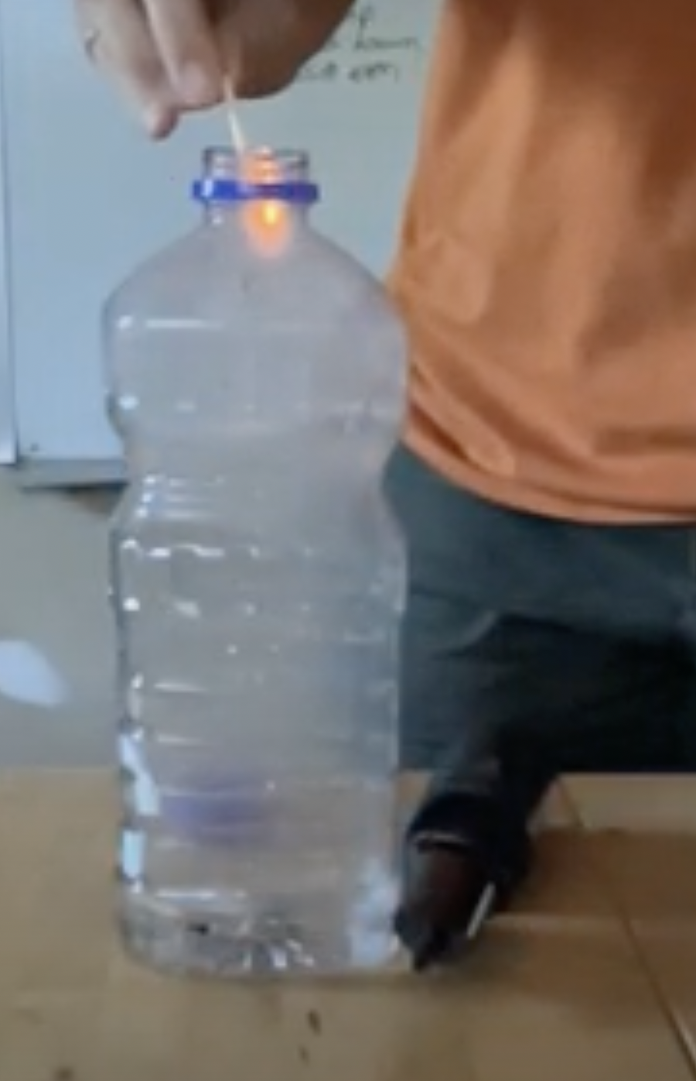
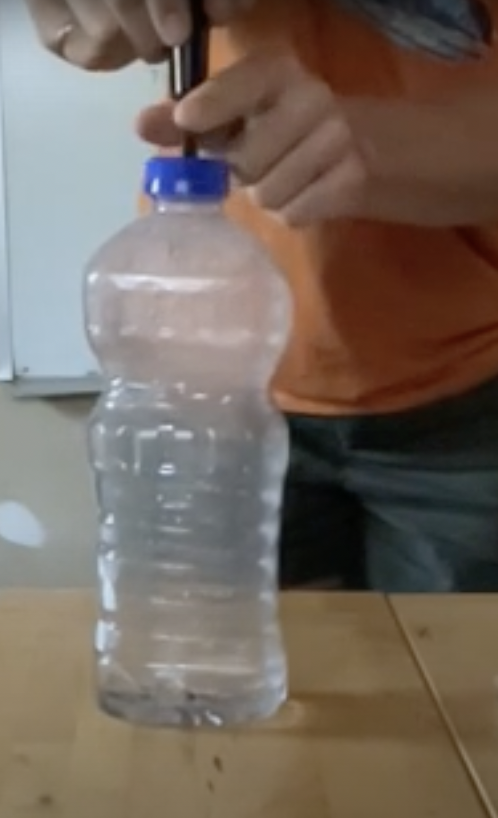
Demonstration instructions:
- One example of a set-up is shown in the figures to the right.
- Light a small piece of paper or match on fire and put it inside the bottle. The smoke particles will give something for the water vapor to latch onto when it comes time to form a cloud.
  - In the real world, these are called Cloud Condensation Nuclei (CCN) and they are a necessary ingredient for cloud formation at any temperature above about -40ºC! Natural CCN are from soot & black carbon like the smoke in your bottle. They also come from sea salt, dust, and particulate pollution like sulfate aerosols.
  - Test this out for yourself: try the experiment without the smoke and see that the cloud doesn’t form without it! It’s not really relevant to what we’re trying to learn today, but it’s an excellent air pollution demonstration if you have extra time. In the real world, clouds over the ocean have different optical properties than clouds over land because continental air is more polluted. For more information, check out the NASA articles listed at the end of this document.
- Pump air into the bottle until there is about 10-20 psi inside. If you have a large set-up, get a volunteer to help you with this: you’ll need someone to hold the rubber stopper in place and someone to do the pumping.
  - While you are pumping, discuss what is happening with your students: That extra air is increasing air pressure and it’s also adding ENERGY into the bottle. That energy must go somewhere. In this case, it’s mostly causing air to warm up.
  - A side benefit that’s super relevant for cloud formation: hot air can hold more water. Our liquid water is evaporating to turn to water vapor, an invisible gas.
  - Ask your students to make a prediction: What is going to happen to the temperature of the air in the bottle when the rubber stopper is released?
- Rapidly release the rubber stopper and watch a cloud form.
  - The release of the stopper might be loud! Let your students be surprised by the noise - it’s part of what makes this demonstration fun and memorable.
  - Ask the person holding the rubber stopper to pay attention to the temperature of the air that came out. They should have noticed it was pretty chilly.
- Recap why this happened: As the air escaped it rapidly expanded. Now all the energy that was once contained in the bottle is spread out over a much larger volume, so it cools. A PhET simulation: Gas Properties can be helpful to demonstrate this idea.
  - A side benefit that’s super relevant for cloud formation: cold air can’t hold as much water. Our water vapor can’t stay as a gas anymore, so it condenses. The water can latch onto the smoke particles we put in that air and stay suspended in the air even though it’s now a liquid, forming a cloud!

Follow-up explanations:
- This demonstration is dramatic and sure to be memorable, so make sure to spend some time at the end discussing why it works: it’s all a consequence of the law of conservation of energy. We add energy when we’re pumping the air in, causing the air to warm. We’re taking energy out when the air rapidly escapes, causing the air to cool. Water is really only here to show us the temperature: it evaporates into the warm air to form an invisible gas, and when the air rapidly escapes/cools that water vapor also rapidly condenses. The water vapor will condense onto the easiest nearby target: the smoke particles.
- Why does this experiment explain why it’s cold up high in the troposphere? The sun’s energy travels (mostly) straight through the atmosphere and is absorbed by the ground. The ground then heats the air just above it. This warm air is less dense than the surrounding air so it rises. As the air rises, it expands and cools, just like the air rapidly escaping our cloud bottle.
  - That less dense fluids will rise and more dense fluids will fall is a recurring theme in future units and directly related to the Unit 3 motivating question - make sure to emphasize this.
  - Comment: Some will use the ideal gas law to explain why it is cold high up in the troposphere. As an air parcel rises in the atmosphere, pressure, temperature, and volume all change simultaneously. Using the ideal gas law to explain this is not quite correct.

For interested instructors:
We’re not using the formal statement of the first law of thermodynamics in this course because it overcomplicates the picture, but here’s a more proper explanation that you’d find in a traditional physics course. The formal statement of the first law of thermodynamics is that the change in internal energy (ΔU) is equal to the difference between the heat (Q) added to/removed from the system and the work done (W) on/by the system.
ΔU = Q - W
- Why does it warm as the air enters the bottle? Pumping air into the bottle does work on the air (W<0). Much of this work goes to change the internal energy of the air inside the bottle (ΔU). For an ideal gas, ΔU∝ΔT (ΔU = 3/2 * NkΔT), so the temperature rises. Side note: Some of this work will add heat to the bottle due to dissipative forces like friction and some will even leave the bottle to go to the surroundings (Q > 0).
- Why does it cool as the air leaves the bottle? As air escapes the bottle, work is done by the gas as it expands (W = PΔV, W > 0). This process is very close to adiabatic (Q=0) because it happens so quickly that there is no time for air to exchange with the environment. Therefore, almost all of the Work done by the gas to expand is taken from the gas’s internal energy (ΔU < 0). For an ideal gas, ΔU∝ΔT, so the temperature falls.

Image credit: The images from Natalie Bursztyn are distributed under a creative commons BY-NC-SA 3.0 license.

References
- What are clouds made of? Are they more likely to form in polluted air or in pristine air? This NASA article briefly explains why smoke is needed to form a cloud in a bottle.
- Aerosols and Clouds (Indirect Effects). This NASA article explains why smoke and pollution change the optical properties of clouds in more detail. This Aerosol indirect effect is one of the most important uncertainties in global warming forecasts. As we stop emitting fossil fuels and the associated particulate pollution, the optical properties of clouds will change in ways that are very difficult to precisely predict and this will change how much light (heat energy that causes warming) is absorbed by the Earth system vs reflected/scattered away to space.
- PhET Simulation: Gas Properties. Use this to reinforce the idea that the air cools when the air escapes the bottle because now that heat energy is spread out over a larger volume: As you open the container and the air escapes, the temperature of the air in the vessel decreases.

