STUDENT HANDOUT • IN-CLASS WORKSHOP

User-Defined Functions in MATLAB
From scripts to a golf ball simulator, one idea at a time
Edwin Marte Zorrilla, University of Florida • Teaching Computation with MATLAB • CC BY-NC-SA 4.0

About this workshop
So far your programs have been scripts: MATLAB runs them top to bottom, once. In this workshop you will package code into functions: named blocks that take inputs, do one job, and hand results back. Each activity adds one new idea. Activity 6 combines all of them in a small physics simulation, and Activity 7 asks you to design your own functions from a problem statement.
Activity | New idea | Time
0. Script to Function | Turn fixed script code into a reusable function | 5 min
1. Basic Function Anatomy | One input, one output; call it twice | 10 min
2. The "Robust" Median | An if inside a function to handle empty input | 10 min
3. Handling Multiple Outputs | Two inputs, two outputs: [p, c] = perm(n, r) | 10 min
4. Function Interdependence | One local function calls another | 15 min
5. Functions with No Inputs | A "wrapper" that makes a plot | 10 min
6. Golf Ball Simulator | Two functions + logical indexing model a real system | 30 min
7. Design Your Own | Decide which functions a problem needs (homework) | 30–45 min

By the end you should be able to
- Convert a block of script code into a function by naming its inputs and outputs.
- Define and call functions with one output, several inputs and outputs, and no inputs.
- Explain why variables inside a function do not change variables in your script (pass-by-value).
- Handle an edge case inside a function with an if statement.
- Have one function call another instead of copying code.
- Combine functions with logical indexing to model and filter a physical system.
- Break a new problem into functions of your own design and justify the split.

Before you start
- Every activity uses local functions: the main script code goes at the top of the file and every function ... end block goes at the bottom. MATLAB (R2016b or later) requires this order.
- Each activity has a starter file (for example A1_basic_function_anatomy.m). Fill in each line marked % TODO.
- Recommended: for Activities 2–6, plan in pseudocode or a flowchart before you write code. Fixing a plan is faster than fixing code.

Conversion recipe. Use these five steps every time you turn script code into a function:
- Inputs: which variable(s) would you want to change between runs?
- Outputs: which variable holds the result you want back?
- Body: move the calculation into function ... end, using the input names instead of hard-coded values.
- Call: replace the original calculation in the script with a call to the function.
- Place: put the function definition at the bottom of the file.

Activity 0 — Script to Function
Goal: practice converting existing script code into a reusable function.
The script below works for only one fixed radius:
r = 5;
area = pi * r^2;
fprintf('Area: %.2f\n', area);
Rewrite the calculation as a function area_circle(r) that works for any radius. Call it for r = 5 and again for r = 2.5.

Starter code
r = 5;
area = []; % TODO: replace [] with a call to area_circle
fprintf('Area: %.2f\n', area);

r = 2.5; % second call: the same function, a different input
area = []; % TODO: call area_circle again
fprintf('Area: %.2f\n', area);

%% --- LOCAL FUNCTIONS (must stay at the bottom of the file) ---
function a = area_circle(r)
a = []; % TODO: compute the area from the input r
end
Check: r = 5 gives Area: 78.54; r = 2.5 gives Area: 19.63.

Activity 1 — Basic Function Anatomy
Goal: define a single-output function and call it more than once.
- Define a function stat that accepts a vector x and returns its mean m.
- Inside the function, compute the number of elements n with length, then use sum to find the mean.
- In the script, set values = [12, 4, 8.9, 6, 3] and call stat.
- Add 1 to every element of values and call stat again.
Predict first. Before you run it: by how much should the mean change after adding 1 to every value? Run the code and check.

Starter code
values = [12, 4, 8.9, 6, 3];
mean1 = []; % TODO: call stat
values = values + 1;
mean2 = []; % TODO: call stat again
fprintf('Mean before: %.2f Mean after: %.2f\n', mean1, mean2);

%% PART B: TRACE BEFORE YOU RUN (pass-by-value and scope)
% Do NOT change this part. First write down what you think the fprintf line
% will print for x, n and y. Then run the file and compare.
x = [2 4 6];
n = 99;
y = halve(x);
fprintf('x = %s, n = %d, y = %s\n', mat2str(x), n, mat2str(y));
% Explain any surprise in one sentence: why did x and n (not) change?

%% --- LOCAL FUNCTIONS ---
function m = stat(x)
n = []; % TODO: number of elements in x
m = []; % TODO: mean of x using sum and n
end

function out = halve(x)
% Used by Part B. It changes its own copy of x and creates its own n.
n = length(x);
x = x / 2;
out = x;
end
Check: the mean goes from 6.78 to 7.78.

Part B — Trace before you run
The bottom of the Activity 1 file has a second function, halve, that changes its own input. Do not run the file yet. Read Part B and predict what the fprintf line will print, then run it and compare.
x = [2 4 6];
n = 99;
y = halve(x);
fprintf('x = %s, n = %d, y = %s\n', mat2str(x), n, mat2str(y));

function out = halve(x)
n = length(x);
x = x / 2;
out = x;
end
Variable | My prediction | Actual output
x
n
y

In one sentence: why did x and n (not) change after the call?

Activity 2 — The "Robust" Median
Goal: put a conditional inside a function to handle an edge case.
Modify stat so that it:
- returns the median instead of the mean, and
- returns NaN when x is empty. Use an if statement.
Hint: the built-in functions median and isempty will help.

Starter code
disp(stat([12, 4, 8.9, 6, 3])) % expected 6
disp(stat([1, 2, 3, 4])) % expected 2.5
disp(stat([])) % expected NaN

%% --- LOCAL FUNCTIONS ---
function m = stat(x)
% Currently returns the mean. Change it as described above.
m = sum(x) / length(x);
end
Call | Expected result
stat([12, 4, 8.9, 6, 3]) | 6
stat([1, 2, 3, 4]) | 2.5
stat([]) | NaN

Activity 3 — Handling Multiple Outputs
Goal: return and capture two values from a single function call.
- Create a function perm that takes two inputs, n and r.
- It returns two outputs: the number of permutations p and the number of combinations c.
- Use p = n! / (n − r)! and c = p / r!. Hint: use factorial.
- In the script, call it as [p_result, c_result] = perm(x, y). The starter code picks a random n between 5 and 15 and a random r between 0 and n.

Starter code
x = randi([5, 15]); % random n
y = randi([0, x]); % random r, always 0 <= r <= n
% x = 10; y = 3; % uncomment to test a case from the table

[p_result, c_result] = deal([]); % TODO: replace with a call to perm(x, y)
fprintf('n = %d, r = %d -> permutations = %.0f, combinations = %.0f\n', ...
x, y, p_result, c_result);

% OPTIONAL CHALLENGE: make perm return NaN for both outputs when r > n.

%% --- LOCAL FUNCTIONS ---
function [p, c] = perm(n, r)
p = []; % TODO
c = []; % TODO: use p and factorial(r)
end

Test cases
n | r | Expected p | Expected c
10 | 3 | 720 | 120
5 | 2 | 20 | 10
5 | 5 | 120 | 1
5 | 0 | 1 | 1
5 | 1 | 5 | 5

Optional challenge. What happens when r > n, for example perm(5, 10)? Add an if so that perm returns NaN for both outputs in that case instead of producing an error.

Activity 4 — Function Interdependence
Goal: have one local function call another local function in the same file.
- stat1(x) returns the mean of x. It is given in the starter code.
- Write stat2(x), which returns the sample standard deviation.
- Key step: inside stat2, do not recompute the mean by hand. Call stat1 to get it.
- Use the formula below, then compare your result with MATLAB’s built-in std.
sd = √( Σ (x − m)² / (n − 1) ) → MATLAB: sd = sqrt(sum((x - m).^2) / (n - 1))
Element-wise operators. On a vector, ^, * and / follow matrix rules. Add a dot (.^, .*, ./) to apply the operation to each element. For example, if x = [10 20 30] then x.^2 gives [100 400 900], while x^2 is an error.

Starter code
data = randi([1, 50], 1, 10) + rand(1, 10);
fprintf('Data: [ '); fprintf('%.4f ', data); fprintf(']\n');
result = stat2(data);
fprintf('My standard deviation: %.4f\n', result);
fprintf('MATLAB std() for comparison: %.4f\n', std(data));

%% --- LOCAL FUNCTIONS ---
function sd = stat2(x)
m = []; % TODO: call stat1
n = length(x);
sd = []; % TODO: sample standard deviation
end

function m = stat1(x)
m = sum(x) / length(x);
end
Check: the two numbers printed at the end should match to four decimal places.

Activity 5 — Functions with No Inputs
Goal: write a "wrapper" function that runs a set of commands, such as making a plot, without any inputs.
- Create a function sin_plot that takes no input arguments and returns nothing.
- Inside it: make a vector x from 0 to 2π with 100 points (linspace), compute y = sin(x), and plot y against x.
- Call sin_plot() from the script.

Starter code
sin_plot();

%% --- LOCAL FUNCTIONS ---
function sin_plot()
x = []; % TODO: use linspace
y = sin(x);
plot(x, y);
title('Sine Wave from 0 to 2\pi');
xlabel('x');
ylabel('sin(x)');
grid on;
end

Reference output
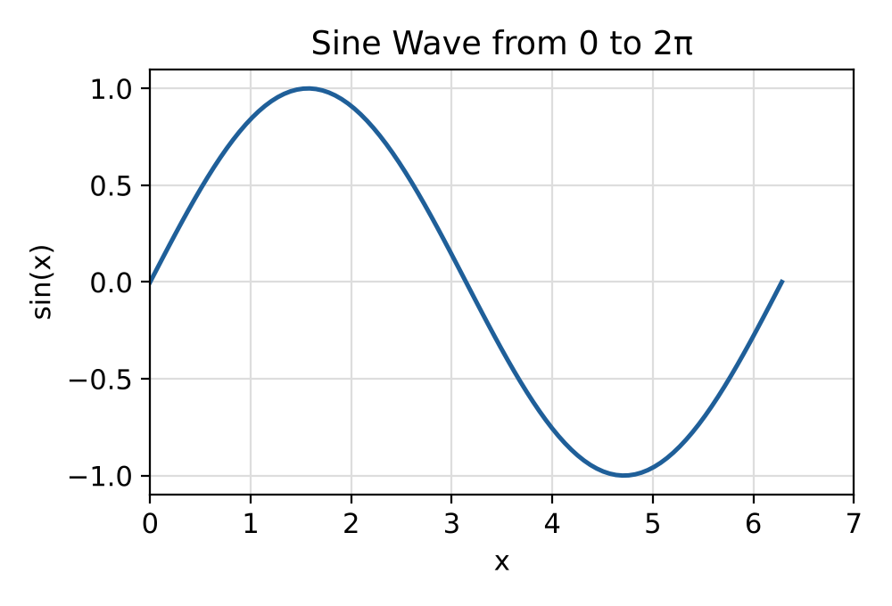

Activity 6 — The Golf Ball Simulator (capstone)
Scenario. You will build a flight simulator for a golf ball. Instead of one long script, you will write two small functions, one for the physics and one for a validity check, and a short main script that connects them. Your goal is to compute the (x, y) path of a ball launched at a given speed and angle and plot only the part of the flight that is above the ground.

Learning objectives
- Define a function with several inputs and several outputs.
- Handle degree-to-radian conversion inside a function.
- Use a logical array returned by a function to filter data (logical indexing).
- Recognize that variables such as g exist only inside the function that creates them.
Predict first. At the same launch speed, which lands farther: 30° or 60°? Which angle should give the longest shot? Write down your guesses, then test them with your simulator.

Step 1 — Physics function
Define get_trajectory at the bottom of the file.
- Inputs: v (launch speed, m/s), theta (launch angle, degrees), t (time vector, s).
- Outputs: x and y (position vectors, m).
- Formulas: x = v·cos(θ)·t and y = v·sin(θ)·t − ½·g·t², with g = 9.8 m/s².
- MATLAB’s sin and cos expect radians. Either convert theta or use sind and cosd. Use .^ for t².

Step 2 — Validation function
Define is_above_ground.
- Input: height (a scalar or vector). Output: valid, a logical array.
- Logic: true where height ≥ 0 and false where height < 0.

Step 3 — Main script
- The starter code picks a random speed (30–80 m/s) and angle (15–75°) and sets t = 0:0.05:20, which is long enough for every launch in that range to land.
- Call get_trajectory to get the raw x and y.
- Call is_above_ground(y) to create a logical mask named on_map.
- Keep only the valid points: x_final = x(on_map) and y_final = y(on_map).
- Plot y_final against x_final with labeled axes.

Starter code
v0 = randi([30, 80]); % launch speed, m/s
angle = randi([15, 75]); % launch angle, degrees
t = 0:0.05:20; % long enough for every launch to land
fprintf('Launching at %d m/s at %d degrees...\n', v0, angle);

%% 2. Trajectory
[x, y] = deal([]); % TODO: call get_trajectory

%% 3. Filter
on_map = []; % TODO: call is_above_ground on y
x_final = x(on_map);
y_final = y(on_map);

%% 4. Visualize
plot(x_final, y_final, 'LineWidth', 1.5)
xlabel('Distance (m)'); ylabel('Height (m)')
title(sprintf('Golf Ball Trajectory: %d m/s at %d%c', v0, angle, char(176)))
grid on
fprintf('Landing distance is about %.1f m\n', max(x_final));

% REFLECT: what would break if get_trajectory used sin/cos with degrees?

%% --- LOCAL FUNCTIONS ---
function [x, y] = get_trajectory(v, theta, t)
g = 9.8;
x = []; % TODO
y = []; % TODO
end

function valid = is_above_ground(height)
valid = []; % TODO: logical array
end

Reference outputs
Set the launch values by hand to compare with these reference cases. The landing distance should be close to the analytical range R = v²·sin(2θ)/g; the small difference comes from the 0.05 s time step.
Launch | Landing distance (≈) | Analytical range
73 m/s at 40° | 534 m | 535.5 m
48 m/s at 61° | 199 m | 199.4 m
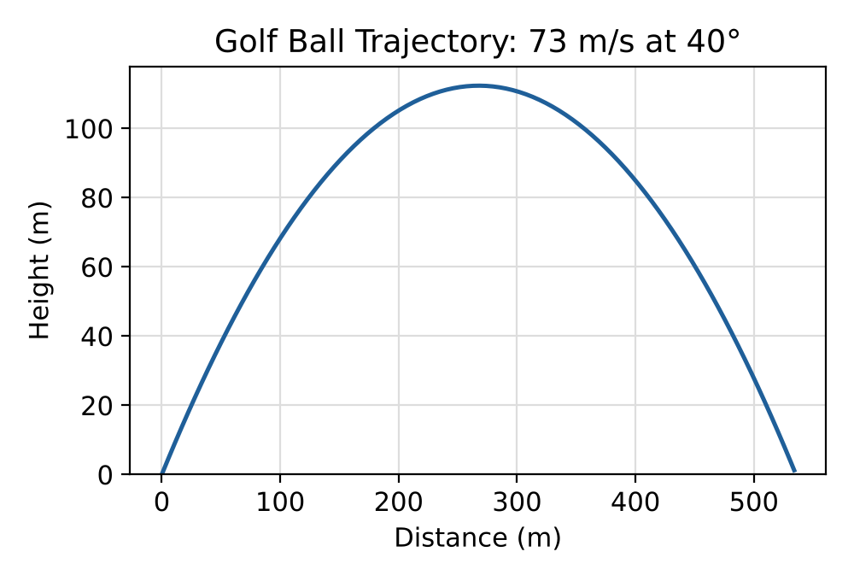
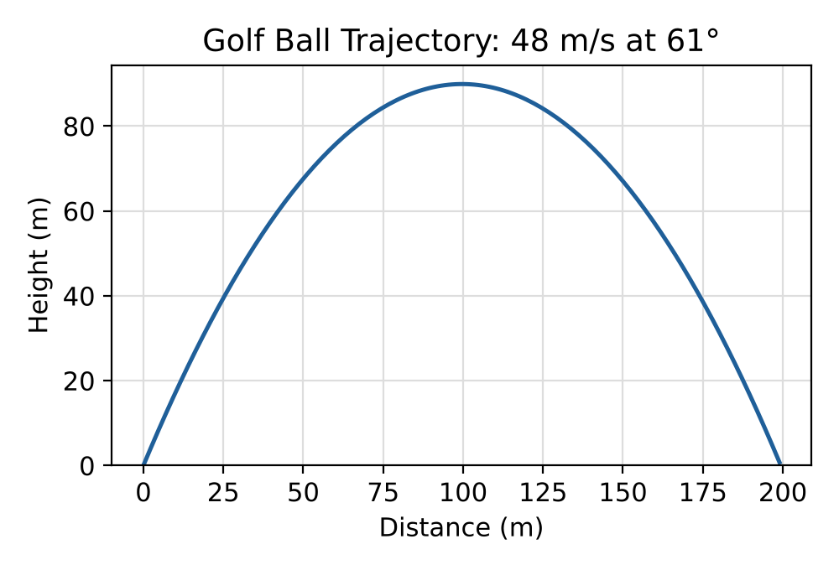
Reflect. Answer in two or three sentences:
1. Were your predictions about 30°, 60° and the best angle correct? What did the plots show?
2. What would go wrong if get_trajectory passed degrees to sin and cos? How would you spot it in the plot?
3. Which function from today would you reuse in a larger project, and why does keeping it separate make debugging easier?

Extensions (optional)
- Add a third output to get_trajectory, or write a new function, that returns the landing distance and time of flight.
- Overlay launches at 30°, 45° and 60° on one figure using hold on and a legend.
- Add a simple air-drag term and compare the drag-free and drag trajectories on one plot.

Activity 7 — Design Your Own Functions (homework)
Goal: decide for yourself how to split a problem into functions. Until now every function name, input and output was given to you. This time only the problem is.
Problem. A golf coach asks: "For a given launch speed, which launch angle sends the ball the farthest?" For a launch speed v0, compute the landing distance for every whole-degree angle from 1° to 89°, report the best angle and its distance, and plot landing distance versus angle.

Rules
- Reuse your get_trajectory and is_above_ground from Activity 6 by copying them to the bottom of A7_design_your_own.m.
- Design at least one new function yourself. You choose its name, inputs and outputs.
- Before coding, sketch a plan (pseudocode or a flowchart) showing which function does what.
- In the comment block at the top of the file, justify your design in two or three sentences: why did you split the problem the way you did?
Predict first. Which angle do you expect to win? Does the answer change if v0 changes? Test at least three speeds.

What you submit
- Your .m file with the design justification filled in.
- Your plan (photo or typed).
- The plot of landing distance versus angle for one speed.
- One or two sentences: was your prediction right?

Common errors and what they mean
Message or symptom | Likely cause
"Function definitions in a script must appear at the end of the file." | A function block is above script code. Move it to the bottom.
The result shows up as ans | You called the function without assigning its output to a variable.
"Too many input arguments" / "Too many output arguments" | The number of inputs or outputs in the call does not match the definition.
"Incorrect dimensions for raising a matrix to a power" | Use .^ instead of ^ on a vector.
The trajectory looks wrong or jagged | Degrees were passed to sin/cos. Use sind/cosd.
A variable from the function is "Unrecognized" in the script | Variables inside a function are local. Return the value as an output.

