ME 350 Vibrations I: with Applications
Summer Semester 2026

QUIZ 5 - 50 points !!!!!!!!
NAME: ____________________________________________

The objective of this quiz is to find a simple harmonic motion system in your daily life, take measurements of its natural frequency, and compare with the calculated natural frequency.
You will be submitting:
- a short report including pictures, equations, and descriptions of your system
- excel file with your measurements
- MATLAB program of the plot of the SHM.

When taking measurements of your system, make sure to do 10 separate measurements of at least 5 full cycles. On the excel file, you should report all 10 measurements, specifically the period and natural frequency calculated from said period. Make sure to also include an average at the bottom.

In your report, make sure to …
- include a picture of your system
- identify or define the “concept” of the SHM and what it is that you are measuring (i.e. person on a swing, person walking with groceries, etc.)
- define your variables
- write out equation used to find natural frequency, along with the equation of motion
- include a screenshot of your excel file
- include and compare measured frequency vs calculated frequency
- include plot(s) from MATLAB program
- discuss results and justifications for potential discrepancies or other findings

For the MATLAB program, you can simply plot a sine wave with the natural frequency measured vs calculated. You can submit ONE plot with both measured & calculated natural frequencies. Make sure your plots show the full duration of at least 5 full cycles and corresponding amplitude of the motion – i.e. your x-axis should be in terms of “time [s]” and y-axis should be “amplitude [m]” or “angle [degrees]” depending on what type of system you choose. Below is an example of a plot:

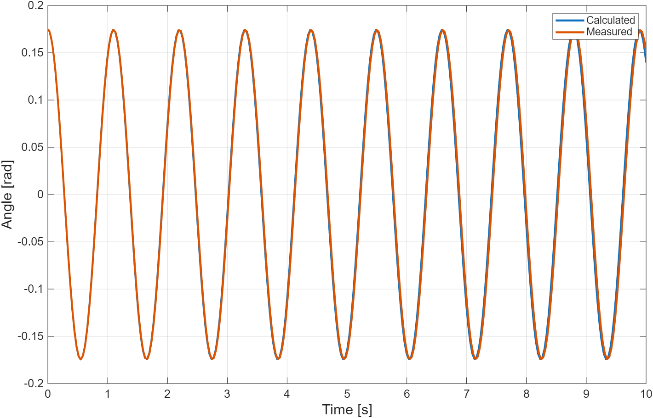

If you need help with MATLAB, first look through the MATLAB documentation or forums to see if you can find how to plot sine waves c:

