Homework: Build your own models of the steady-state geothermal gradient in MATLAB
Due: See Canvas

Perform calculations and create plots using MATLAB. Two starter scripts (Part1_geotherm_noexhumation.m and Part2_geotherm_exhumation.m) are provided. Please use this Word document to answer the posed questions with equations (use Word’s Equation Editor!), figures, and/or text. Please turn in your MATLAB scripts, functions, and this document.

Overview
The geothermal gradient (“geotherm”) is how the temperature changes with depth in the Earth. In the lithosphere, the rigid outermost layer of the Earth that includes the crust and the lithospheric mantle, heat is transported primarily by conduction. However, when rocks move fast on geological timescales (for example, during fault motion or erosional exhumation), they commonly also transport heat with them via advection. Thus, heat conduction and advection, combined with conditions such as the temperature at Earth’s surface and crustal heat production due to radioactive decay of K, control the shape of the geothermal gradient in space and time.

When we are interested in quantifying something that varies simultaneously in space and in time, like the Earth’s geotherm, the most general mathematical descriptions use partial differential equations (such as the diffusion equation, which when used to describe heat conduction is called Fourier’s Law). However, there are useful, published simplifications of these equations that can be solved analytically in a spreadsheet or MATLAB script—no numerical modeling required.

Several now-classic papers (Stüwe et al., 1994; Mancktelow and Graseman, 1997), and the Geodynamics textbook by Turcotte and Schubert, have treated the problems of steady-state geotherms with various complications involving heat production, exhumation (e.g., rocks getting closer to Earth’s surface via a process such as erosion), and topography. Not only are these approachable analytical solutions but they also provide important end-member cases that place constraints on a wide range of geological problems involving heatflow in the Earth. In many cases, especially those involving slow advection rates (~<0.5 mm/yr), these solutions may be all you need to make real progress on a problem of interest.

The approach presented here is mostly following notations and conventions of Mancktelow and Graseman (the appendix), but it pulls from Turcotte and Schubert’s textbook as well. This assignment is modified from an Excel-based problem set by Peter Reiners.

In MATLAB, you will implement several analytical solutions to the geotherm equation as user-defined functions, which you will then call in scripts to calculate the steady-state geotherm given specific conditions.

Background: The Fundamental Equations of Heatflow

General Equation
The most general equation we can write describes the variation in temperature in a homogeneous solid experiencing advection where thermal diffusivity and conductivity are independent of temperature is:

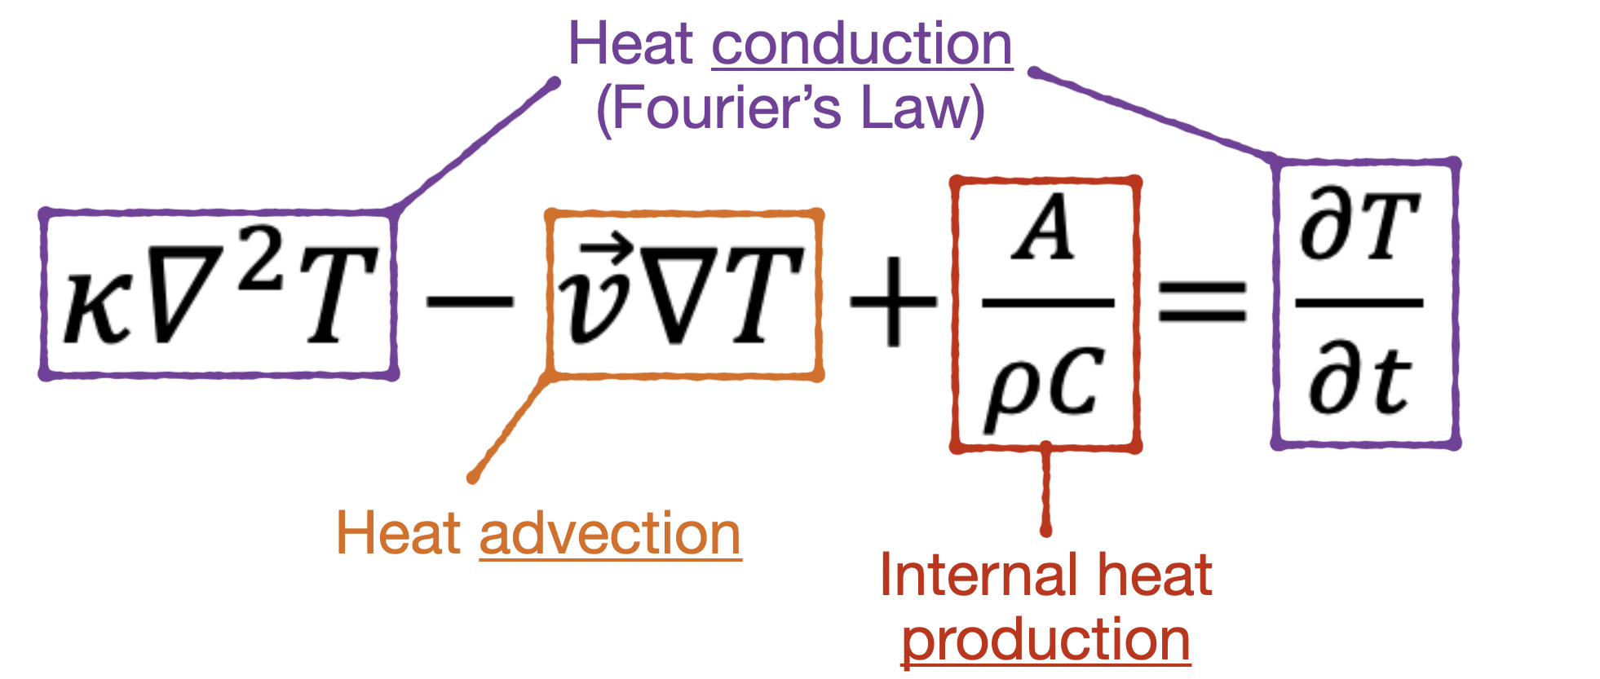(1),

where: T = temperature (C), t = time (s), v = velocity vector (m s⁻¹), 𝜅 = thermal diffusivity (m² s⁻¹) = k/𝜌C, k = thermal conductivity (W m⁻¹ C⁻¹), 𝜌 = density (km m⁻³), C = specific heat (J kg⁻¹ C⁻¹), and A = volumetric heat production (W m⁻³).

Math Notation Note: The upside-down triangle (∇) is the Greek letter nabla. Here, it is a placeholder symbol for partial derivatives in an unspecified number of spatial dimensions (1, 2, or 3).

Specify the dimensions of interest
In this assignment, we will model heat conduction in two dimensions (in x-z coordinates). We will model heat advection (i.e., rock motion or exhumation) just in the vertical (z) direction, in order to mimic erosional exhumation. So, we’ll swap out the ∇ notation in equation (1) for specific partial derivatives:

$κ\left(\frac{∂^{2}T}{∂x^{2}}+\frac{∂^{2}T}{∂z^{2}}\right)+u\frac{∂T}{∂z}+\frac{A}{ρC}=\frac{∂T}{∂t}$ (2),

where x = horizontal distance (m), z = vertical distance (m), positive downwards, and u = vertical velocity relative to the surface (m s⁻¹), positive upwards (i.e., exhumation is a positive number).

Assume steady state conditions
In this assignment, we will simplify the scope of our analysis (and thus this equation) by only solving for steady-state conditions, so the time-transient term in Eqn 2 (and thus all of Eqn 2) is set equal to zero:

$\frac{∂T}{∂t}=0$.

In other words, we will solve for geothermal gradients that are in equilibrium with specific conditions (that do not change as time elapses). We will compare among different steady-state geotherm scenarios, but we are not going to calculate how long it takes to achieve equilibrium if a condition changes.

Final note: As stated in the Introduction, solutions to Equation 1 for conditions that change over time require a numerical model—but not all heatflow problems in the Geosciences really require a numerical analysis. It’s generally best to start with simple (analytical) solutions to the heatflow equations and then add mathematical and computational complexities only as needed.
1. Geotherm with heat production, no exhumation or topography.
For a planar surface (no topography) and no exhumation, Eqn. 2 simplifies to a one-dimensional solution:

$k\frac{∂^{2}T}{∂z^{2}}+A\left(z\right)=0$ (3).

We will assume that the heat production (primarily from the natural radioactive decay of K, U, and Th) in the crust decays exponentially with depth:

$A\left(z\right)=A_{S}\exp\left(-\frac{z}{h}\right)$ (4)

where A_{S} is the volumetric heat production at the surface, and h is the depth at which it drops to 1/e of this surface value (this is sometimes called the “e-folding depth”).

Combining equations 3 and 4, integrating, and rearranging, yields the equation:

$T(z)=T_{S}+α\left[1-exp\left(-\frac{z}{h}\right)\right]+\frac{z}{L}\left\{\left(T_{L}-T_{S}\right)-α\left[1-exp\left(-\frac{L}{h}\right)\right]\right\}$ (5), where $α=\frac{A_{s}h^{2}}{k}$

This solution assumes the lithosphere is a slab of finite thickness L (km) with the following boundary conditions. The upper boundary (the surface) is at position z=0 and has a temperature of T_{S}. The lower boundary (the base of the lithosphere, aka the top of the asthenosphere) is at depth z=L and has a temperature of T_{L} at z=L. Note that we are using k (thermal conductivity) in these equations.

Instructions:

- Explain how Eqn. 2 simplified to Eqn. 3 for this problem, by describing what each term in Eqn. 2 means or describes physically.

- In MATLAB, open the provided files (a script Part1_geotherm_noexhumation.m and a function file SSGEOTHERM_NOEXHUMATION.m) to get oriented. Then, finish building the function file to implement Equation 5 as a user-defined function you will call in the script to calculate the temperature as a function of depth, T(z). (Hint: watch your units!) To test your function, use the following input values: A_{S} = 1.0 µWm⁻³; k = 2.5 Wm⁻¹K ⁻¹; L = 50 km; T_{S} = 10 °C; T_{L} = 1300 °C; h = 10 km. To make a smooth temperature curve, solve the equation every 50 or 100 m along the z dimension. (Answer check: you should get 178°C at 6 km depth)

- Once your function is working, return to the script (Part1_geotherm_noexhumation.m) and call the SSGEOTHERM_NOEXHUMATION function to calculate and plot temperature (T, in °C) as a function of depth (z, in km) in the lithosphere. Use same values for the inputs as part (b): A_{S} = 1.0 µWm⁻³; k = 2.5 Wm⁻¹K ⁻¹; L = 50 km; T_{S} = 10 °C; T_{L} = 1300 °C; h = 10 km. Plot depth on the y-axis, with values increasing down (we’re geoscientists, after all). Make two side-by-side plots on one figure using the subplot function. Plot the geotherm of the entire lithosphere on the left panel, and just the upper 10 km (the upper crust) on the right panel.

- Explore the sensitivity of the steady-state geotherm to the variables. This is called a sensitivity analysis. Compare the geotherm from part (c) with those that you get by increasing and decreasing the values as described below. For each scenario below, create a new figure that illustrates the effect (using the same subplot structure as in c) and paste your MATLAB figure(s) below to support your answers; please include the geotherm from part (c) as a clear ‘reference’ line so you can easily visualize the changes. In writing that accompanies each plot, briefly discuss what you find in each case, reporting specific numbers that quantify the changes in the geothermal gradient shape and/or temperatures a specific depth(s). In each case, also explain in a simple way why the geothermal gradient changes the way it does, by examining Equation 5 and/or considering the fundamentals of conduction and advection.

  - changing surface heat production by 10x and 0.1x
  - changing thermal conductivity by 2x and 0.5x
  - changing the lithospheric thickness by 2x and 0.5x
  - changing surface temperature by 2x and 0.5x
  - changing asthenosphere temperature by 0.8x and 1.2x
  - changing e-folding depth of heat production by 10x and 0.1x

- Consider what you think are reasonable variations in these variables on Earth, in various geologic settings. Choose a specific geologic setting. In that setting: which variables would be the most important to try to measure or, if a paleo setting, estimate for your individual area, and which could you likely just assume some typical value for? Explain.
2. Geotherm with exhumation and heat production; no topography.

We’re dealing again with a one-dimensional solution, but here we have to account for rock advection towards the surface (and the surface does not move, so “exhumation” happens). Eqn. 2 becomes:

$κ\left(\frac{∂^{2}T}{∂z^{2}}\right)+u\frac{∂T}{∂z}+\frac{A(z)}{ρC}=0$ (6).

We will again assume exponential decay of heat production with depth (equation 4). Using the same boundary conditions as before, the solution is:

$T=T_{S}+β\left[1-exp\left(-\frac{z}{h}\right)\right]+γ\left[1-exp\left(-\frac{u}{κ}z\right)\right]$ (7),

where:
$β=\frac{A_{S}h^{2}}{ρC\left(κ-uh\right)}$ (8a) and $γ=\frac{\left(T_{L}-T_{S}\right)-β\left[1-exp\left(-\frac{L}{h}\right)\right]}{1-exp\left(-\frac{u}{κ}L\right)}$ (8b).

Instructions:
- In MATLAB, open the provided files (a script Part2_geotherm_withexhumation.m and a function file SSGEOTHERM_WITHEXHUMATION.m) to get oriented. Then, finish building the function file to implement Equations 7 and 8 as a user-defined function you will call in the script to calculate the temperature as a function of depth, T(z). Use the same values for the constants and boundary conditions as in 1b, plus: C= 1000 Jkg⁻¹K⁻¹; 𝜌 = 3000 kgm⁻³. Note that 𝜅 = thermal diffusivity (m² s⁻¹) = k/𝜌C. As before: watch your units! mm/yr = km/Myr, and both are common use in Geoscience applications; but in this problem you’ll want u in SI units for the calculations themselves. (Answer check: at 30 km depth you should get ~801°C for u = 0.01 mm/yr and ~1052˚C for u = 1 mm/yr)

- Once your function is working, return to the script (Part2_geotherm_withexhumation.m) and call the SSGEOTHERM_WITHEXHUMATION function to calculate and plot on the same graph temperature (T, in Celsius) as a function of depth in the lithosphere (z) for exhumation rates (u) of 0.01 mm/yr, 0.1 mm/yr, 1.0 mm/yr, and 2.0 mm/yr. Use the same values for the constants and boundary conditions as in part (a). Also report the temperatures for the depths in the table below; I’ve provided the T and 30 km depth so you can check your answers.

z (km) | 0.01 mm/yr | 0.1 mm/yr | 1 mm/yr | 2 mm/yr
5
30 | 801 | 827 | 1052 | 1201
50
Pe
(part c)

- A useful dimensionless number in problems where heat is transported by both conduction and advection is the Peclet number (Pe), which is the ratio of heat transport rate by advection to heat transport rate by diffusion. In this case it is:

$Pe=L\frac{u}{κ}$ (9).

In general, when Pe >> 1, heat advection (i.e., exhumation, for example via erosion) dominates heat transport, and when Pe < 1, heat conduction dominates. When Pe ~ 1, you really need to consider both because they both contribute significantly to heat transport.

  - What are the Pe values for the cases in 2a? (Watch your units! Pe is dimensionless). Add to the table above.
  - For what erosion rates can we safely ignore the effects of erosion and simply model the thermal structure as we did in Question 1?

