Estimating Shell and Tube Heat Exchanger Purchase Cost with MATLAB
Process Design I
A preliminary exchanger estimate begins with the heat duty and the temperature driving force. In this activity, you will read a flow-arrangement correction factor, calculate the area of a shell-and-tube exchanger, and use MATLAB to estimate its equipment purchase cost. Your recommendation must explain how the correction changes the estimate and what the cost model leaves unresolved.

Engineering context
For two streams in ideal countercurrent flow, the log-mean temperature difference (LMTD) summarizes the driving force when heat capacities and the overall coefficient are approximately constant. A shell-and-tube exchanger with more than one tube pass does not maintain ideal countercurrent contact everywhere. You have to multiply the countercurrent LMTD by a correction factor Fₜ. The factor depends on the inlet and outlet temperatures through the ratios R and S and on the pass arrangement (Section 12.2 of the textbook).
In Section 16.5, you learn to estimate the f.o.b. purchase cost from a base cost correlated with heat-transfer area. Material, pressure, and tube-length factors adjust that base cost; a cost-index ratio adjusts its reference-year basis. This purchase cost does not include the full cost to install the exchanger or build a plant. The shell-and-tube correlations used here are valid for areas from 150 to 12,000 ft².

Design data
Given quantity | Value
Hot stream inlet and outlet | 200 °F and 140 °F
Cold stream inlet and outlet | 100 °F and 134 °F
Heat duty Q | 15,000,000 Btu/h
Estimated overall coefficient U | 150 Btu/(h·ft²·°F)
Configuration | One shell pass, two tube passes
Construction and design pressure | Carbon steel; shell pressure ≤100 psig
Tube length and cost basis | 20 ft; CE Plant Cost Index = 567

Assume steady operation, negligible heat loss, sensible heating and cooling, constant heat capacities, and a constant U. Use the same estimated U when comparing mechanical exchanger types. Assume the stream flow rates are chosen so that the stated duty and terminal temperatures satisfy the energy balances.
Calculation method
Label the hot and cold stream temperatures before using the equations. All temperature differences may be expressed in °F; area must be in ft² for the purchase-cost correlation.
Countercurrent reference from Seider Eq. (12.3). If the two terminal differences are equal, use their common value as the LMTD.
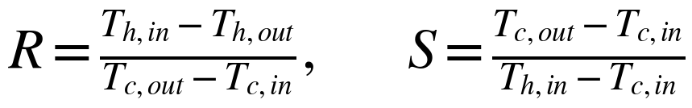
Chart coordinates from Seider Eqs. (12.5) and (12.6). Read Fₜ for a one-shell-pass, two-tube-pass exchanger from Fig. 12.15 or the calculated chart below.
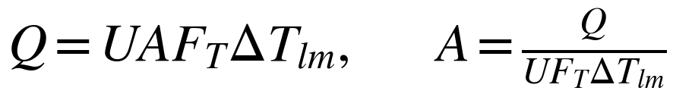
Corrected heat-transfer area from Seider Eq. (12.7). Compare it the area obtained by setting Fₜ = 1.
Equipment purchase cost
For the fixed-head exchanger in this activity, Eq. (16.40) gives the base cost C_{B} in U.S. dollars at CE index 567. The stated pressure, carbon-steel construction, and 20-ft tubes give correction factors Fₚ = Fₘ = F_{L} = 1. Equations (16.2) and (16.43) combine to give the purchase cost at a chosen cost index.
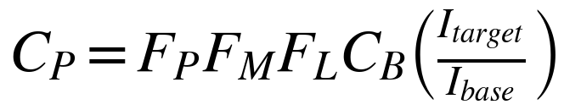
Use I = 567 for this exercise, so the cost-index ratio is 1. A different index would change the price basis; the value 567 is not a present-day index. The fixed-head correlation is applicable only when A lies between 150 and 12,000 ft².

MATLAB activity
- Establish the temperature driving force. Calculate both countercurrent terminal differences and the LMTD. Check that neither terminal difference is negative or zero. Sketch the two stream temperature profiles.
- Use the correction chart. Calculate R and S, locate the design point on Figure 1, and record an approximate Fₜ. Compare your reading with Seider Fig. 12.15 if the textbook is available. Explain what a value below 1 means physically.
- Size the exchanger. In MATLAB, calculate the area once with Fₜ = 1 and once with your chart reading. Report the percentage change and check that the corrected area falls within the correlation's valid range.
- Estimate Cₚ. Use the fixed-head base-cost equation for each area. Apply the stated factors and cost-index ratio. Compare the two f.o.b. purchase-cost estimates and report the percentage change.
- Examine sensitivity. Plot area and fixed-head purchase cost over hypothetical Fₜ values from 0.75 to 1.00 while holding Q, U, and the terminal temperatures fixed. Mark your chart result. State why these values represent hypothetical arrangements rather than different readings of a single fixed 1-2 exchanger.
- Make a recommendation. Explain whether the 1-2 arrangement is acceptable, what information is still needed to choose the exchanger, and why equipment purchase cost alone is insufficient. Seider recommends Fₜ near 0.85 or higher and treats values below 0.75 as generally unacceptable.

Submission and teaching guidance

What to submit
- A completed MATLAB .m script with inputs, validity checks, calculations, and a clearly labeled sensitivity figure.
- A 150 to 250 word design note reporting R, S, the chart reading, both areas, both fixed-head purchase costs, the percentage changes, and the next design check.
- A sentence identifying the reference cost index and distinguishing equipment purchase cost from installed capital investment.

What instructors should check
Students should read the 1-2 chart using their computed R and S, carry their own reading consistently through area and cost, verify units and correlation range, and interpret the correction as a change in driving force. Small differences caused by chart reading and rounding are expected. Ask students to identify a configuration change if the correction factor is too low.

Textbook source
Seider, W. D., Lewin, D. R., Seader, J. D., Widagdo, S., Gani, R., and Ng, K. M. (2017). Product and Process Design Principles: Synthesis, Analysis, and Evaluation, 4th ed. Wiley.
Relevant material: Section 12.2, Eqs. (12.3) to (12.7), Fig. 12.15; Section 16.5, Eqs. (16.39) to (16.45).

