Instructions for Simulation Assignments

Read these instructions carefully. There could be point deductions for not following them.
- This report (and all reports in APPL 101), should be single spaced with default margins, font, and font size.
- The entire report should be 3 pages maximum (including the algorithm).
- Your results section must include figures, which are your Matlab plots. Export the plots from Matlab (see instructions here) and paste them into your report.
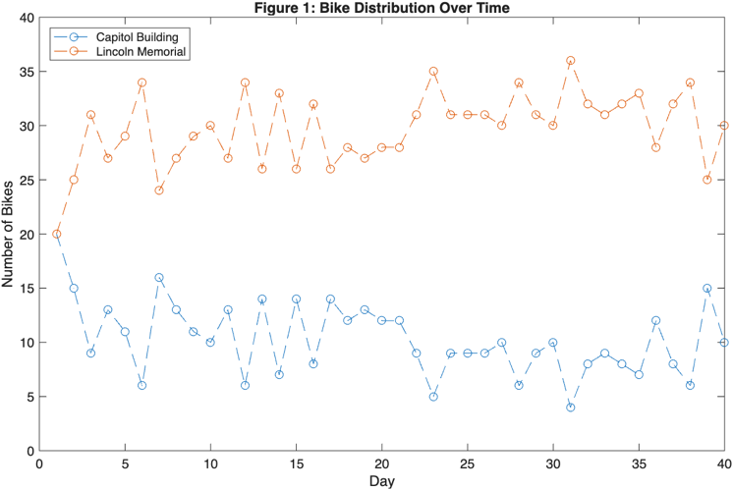
  - Use word wrapping so that the text wraps around the figure, as shown to the right.
  - The figures must be large enough to be readable. Increase the font size of any Matlab figures if necessary. The font size shown in this example to the right is barely large enough.
  - Plots should denote each simulation measurement with an “o” or similar marking. Since you do not know the value in-between these measurements, it doesn’t make sense to connect them with a solid line, but you can use a dashed line if desired, as shown in the example above.
  - Be sure that these graphs are labelled (figure 1, figure 2, etc), and the axes are labelled.
  - For each figure, you must clearly state what parameter values that you changed to produce these results. This can be in the figure title or in the text of the report.
- Citations: If you used AI (see policy below) or any websites, YouTube videos, or other sources to for your code, you should include a comment describing this at the top of your .mlx file.

Submit the following two files on Canvas:
- Report: “fullname_S1_report.pdf” (replace “fullname” with your first & last name)
- .mlx file: “fullname_S1_simulation.mlx” (replace “fullname” with your first & last name)

AI use policy

It is ok to use AI for this assignment, but you must cite it (see instructions above). However, AI may generate code that does not properly address the assignment prompts. Also, it may generate code that is more complicated than what we have introduced in class, and you may not understand how this code works. On the day that your simulation assignments are due, there will be a Matlab quiz based on the code needed to complete the assignment. Check the learning goals for each assignment to see which Matlab topics will be emphasized. If you really understand your code, then you are likely to do well on the quiz. But if you used AI without understanding how the resulting code works, then you will struggle with the quiz.

Therefore, we encourage you to use AI to help you think, not think for you! We recommend that you limit your AI use to help with troubleshooting but not with code generation. This will help you to succeed in this class, and more importantly, it will give you a strong foundation for developing simulations in Matlab or any programming language. And looking toward your future, having some basic familiarity in programming is a valuable career skill, no matter what your career.

