Feedback Loops Part 2: Causal Loop Diagrams

Example 1: negative loop

Below are two ways to represent an important physiological process. On the left is a narrative in words. On the right is a diagrammatic representation, called a "causal loop diagram." In the diagram, the “S” means that that direction is the same (e.g. both temperature and sweating go up), the “O” means that they are opposite directions (e.g. when sweating goes up, temperature goes down). The “-“ symbol in the middle represents that this is a negative loop.
Narrative | Corresponding causal loop diagram
When summer heat makes the human body too hot, it may respond by sweating. Evaporation of sweat from the skin causes the body temperature to go back down. This is a negative feedback loop, because the initial nudge (summer heat) pushes body temperature up, and the feedback loop pushes body temperature in the opposite direction, back down.

Example 2: positive loop

Below are two ways to represent an important ecological process. On the left is a narrative in words. On the right is a diagrammatic representation, called a "causal loop diagram." In the diagram, the “S” means that that direction is the same (e.g. both strength and hunting success go down). The “+“ symbol in the middle represents that this is a positive feedback loop.
Narrative | Corresponding causal loop diagram
When an injury reduces and animal’s strength, it may reduce a carnivore’s chance of successfully catching prey. Lack of food will further reduce the animal’s strength. This is a positive feedback loop, because the initial nudge (injury) pushes strength down, and the feedback loop pushes success hunting and in turn strength in the same direction, down. | 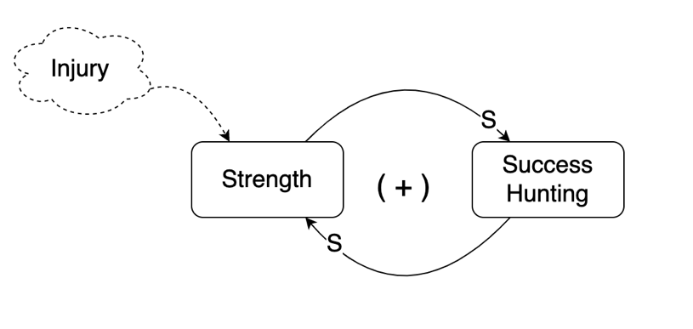
Question 1: Below is another narrative, and a partially filled out casual loop diagram. Fill out the blank spaces in the diagram. There are four places for you to fill out in the diagram: one blank node, the labels on the two arrows ("S" for "same" or "O" for opposite), and the sign in the middle of the loop (+ for positive or - for negative). Then complete the narrative.
Narrative | Corresponding causal loop diagram
When running around in the hot sun makes a dog's body too hot, it starts to pant to cool back down.

This is a (positive/negative) feedback loop, because ...

Question 2: Below is another narrative, and a partially filled out casual loop diagram. Fill out the blank spaces in the diagram. There are four places for you to fill out in the diagram: one blank node, the labels on the two arrows ("S" for "same" or "O" for opposite), and the sign in the middle of the loop (+ for positive or - for negative). Then complete the narrative.
Narrative | Corresponding causal loop diagram
An AI machine does not recognize Asian accents, causing individuals with accents to be frustrated and not use the AI. The AI machine has many users without an accent be successful in having the machine understand them. These users continue to use and train the AI to recognize their voices and accents.  This is a (positive/negative) feedback loop, because ... | 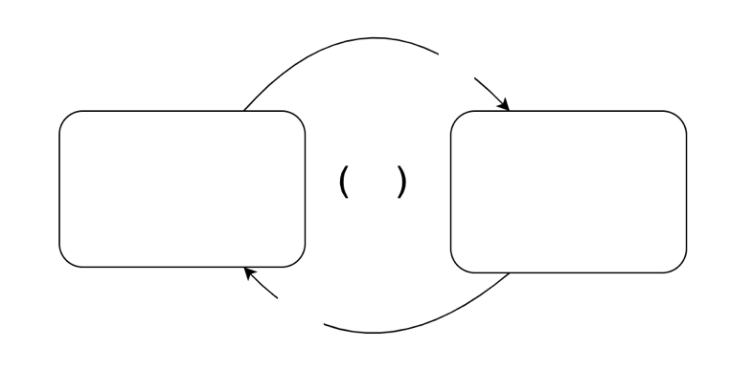

Question 3: Below is another narrative, and a partially filled out casual loop diagram. Fill out the blank spaces in the diagram and complete the narrative.
Narrative | Corresponding causal loop diagram
“Experts say the following decades of research have turned up similar findings. Escalating force by police leads to more violence, not less. It tends to create feedback loops, where protesters escalate against police, police escalate even further, and both sides become increasingly angry and afraid.”

This is a (positive/negative) feedback loop, because ...

Question 4: Think about your own thinking: In trying to understand these feedback loops, what were the advantages and disadvantages of the narrative representation? What were the advantages and disadvantages of the diagrammatic representation?

