**Mystery Bottles**

Name: ________________________________

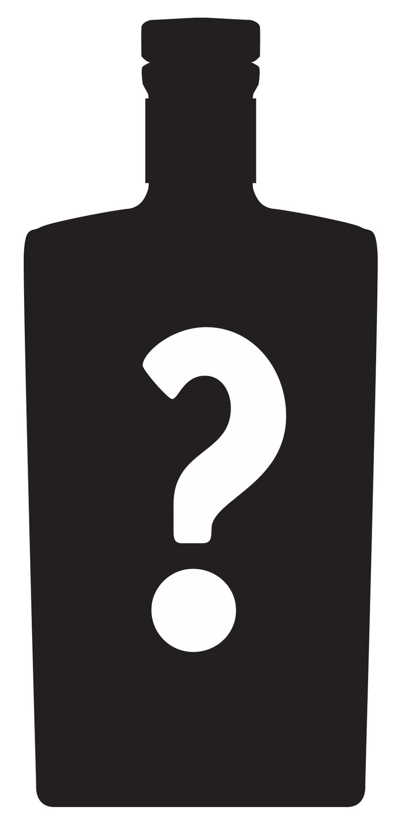How would you determine what is in the Mystery Bottle? You have an unlimited budget and access to any tool you can think of, but you may not open the bottle!

What is your hypothesis as to the contents of the bottle?

How could you test this hypothesis?