Estimating and Predicting Flood Heights after Extreme Rainfall Events
Purpose: This activity will help students recognize how flood height is related to variables such as rainfall intensity, drainage area, channel width, velocity, conservation of mass and flow resistance. Students will use calculations and graphical interpretation to infer possible flooding impacts.

Knowledge and Skills: Students will begin by quantifying the volume of water from rainfall data and river gauges over the watershed. Then, students will calculate velocity given peak discharge and river cross-sectional area, and graph data illustrating the relationship between velocity and stage height. Finally, they will hypothesize on potential flooding due to high-intensity precipitation events given specific river characteristics and reflect on the impacts flooding would have on local communities.

Task:
- Fill out data tables by performing calculations using the data provided and information provided in the lecture.
- Answer questions to analyze results and reflect on community impacts

Criteria for evaluation: Your answers will be graded on good faith completion (3 pts).
Completion criteria
- 1 point = minimal answers provided
- 2 points = answers provided are incomplete or do not address the questions
- 3 points = answers are complete and are written in complete sentences

Description of Activities

Part 1. Data processing and interpretation. Estimate the volume of water entering the Pigeon Watershed from rainfall data (1A) and stream gauge data (1B) and interpret the results.
Part 2. Estimate flood heights. Apply conservation of mass and utilize flow resistance equations to estimate flood heights along the Pigeon River in Canton, NC during Hurricane Helene in 2024.
Part 3. Predict impacts of hazard cascade. Model hazard cascades as a systems model for the Pigeon River and downstream communities.

Part 1. Data processing and interpretation. Estimate the volume of water entering the Pigeon Watershed, western NC, from rainfall and stream gauge data and interpret the results.
Background: In August 2021 the town of Canton, NC was battered by floods related to Tropical Storm Fred. Like Hurricane Helene in 2024, Fred began in the Atlantic, made landfall on the islands of Hispaniola and Cuba, and continued west, intensifying in the Gulf of Mexico. As it moved northward over the southern Appalachians, Fred dropped heavy rain along the Blue Ridge causing flooding along the Pigeon River watershed in the towns of Cruso and Canton, NC (Figure 1).
You will estimate the total precipitation and runoff from the Pigeon watershed during Tropical Storm Fred using a map of rainfall data and compare this estimate to the stream gauge record near Canton.
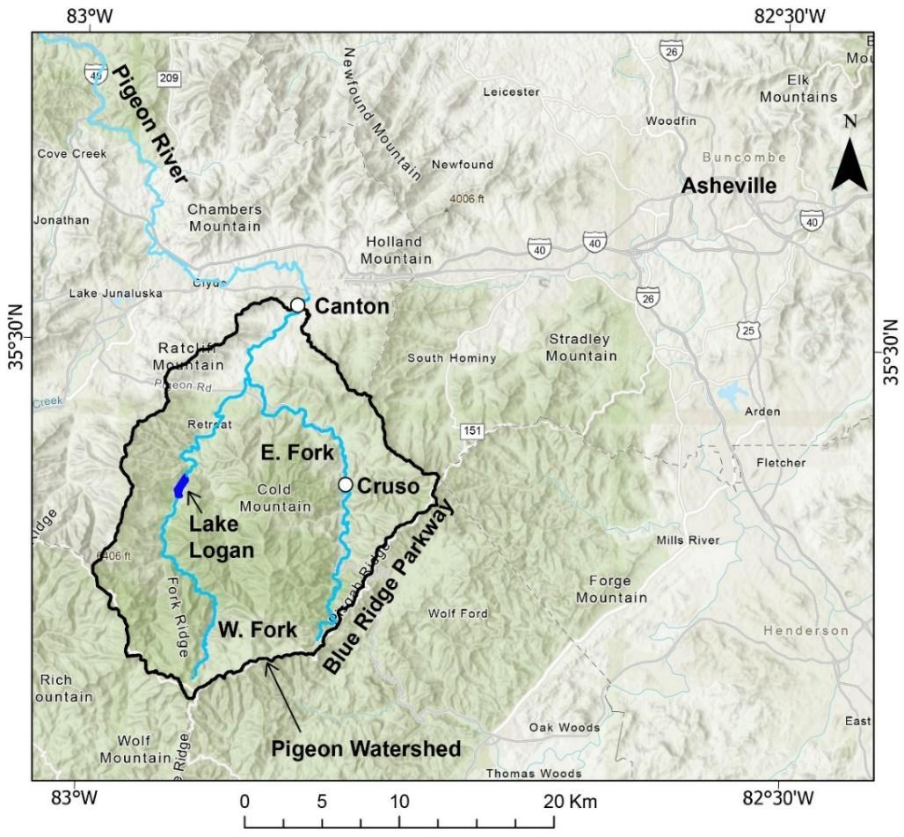
Figure 1. Location of the Pigeon River watershed (black outline) and nearby towns and notable locations.

Part 1A: Estimating runoff in the Pigeon River from radar data
- On the precipitation map (Figure 2), use the gridded color scale to estimate the total rainfall in each 5x5 kilometer box within the Pigeon watershed outlined by the black line. For boxes that cover only part of the watershed, estimate average precipitation within the area of the watershed and fill in the column for average rainfall in the table below.

Use the table provided for calculations, which has a row for each numbered 5x5 km box.
Unit conversion information is also provided on the next page. One example is provided.

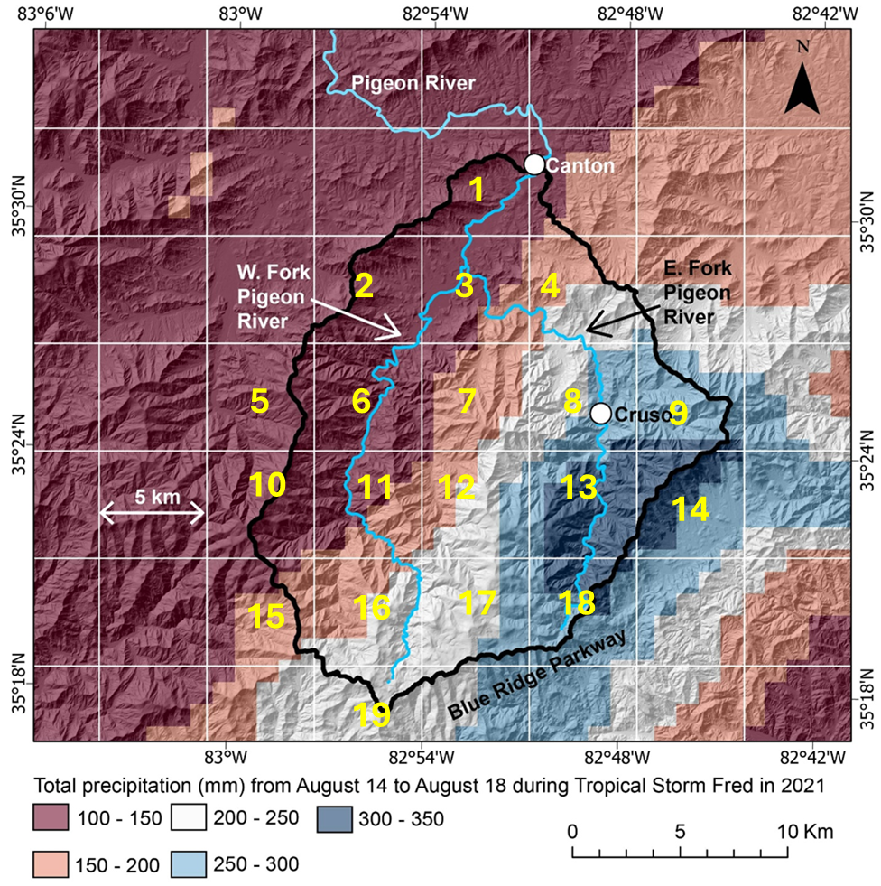
Figure 2. Map of radar derived precipitation (in mm) over the Pigeon River watershed (black outline). Note that each box is 5 km wide and 5 km tall.

Useful Unit Conversions | Relevant Equations
1 km = 1000 m  1 mm = 0.001 m  1 km² = 1000 [m] X 1000 [m] = 1,000,000 m² | Volume [m³] = Area [m²] X Depth [m]

Cell | Fraction of Area | Fractional Area  (convert km² to m²) | Average Rainfall  (convert mm to m) | Volume Rainfall  (m³)
1 | ~0.6 (60%) | (Fraction) * (Box area)  = 0.6 * 25km² * 1e6  15000000 m² | 125 mm / 1000 =  0.125 m | 15000000 m² x 0.125 m  = 1875000 m³
2
3
4
5
6
7
8
9
10
11
12
13
14
15
16
17
18
19
Summary data for Total Area,  Average Rainfall, and Total Volume |  | Total Area: | Average Rainfall: | Total Volume:

Reflection and Discussion Question: What impact will this volume of water have on the Pigeon River? What amount of water will get into the river? How high will the river get? …..For this, we need to measure the discharge: volume of water per unit time.
Part 1B: Recorded discharge of the Pigeon River from gauge data
- The following graph (Figure 3) shows the hydrograph of the Pigeon River in Canton, NC before and during Tropical Storm Fred. It illustrates river discharge (m³/s) over 48 hours. Use the hydrograph to answer the following questions.

  - The start of the discharge event (flood) is indicated on the hydrograph. Identify the end of the discharge event by marking the hydrograph.

  - Calculate the total volume of water during the flood using the table provided for calculations.
Use the provided start time of the flood as your reference point to partition the hydrograph into 2- to 3-hour increments of time, finishing at your defined end time of the flood. You may not need all the rows provided.
Determine average discharge for each increment by visually estimating the mean value from the y-axis on the hydrograph.
Calculate the water volume discharged (m³) for each time interval (seconds).
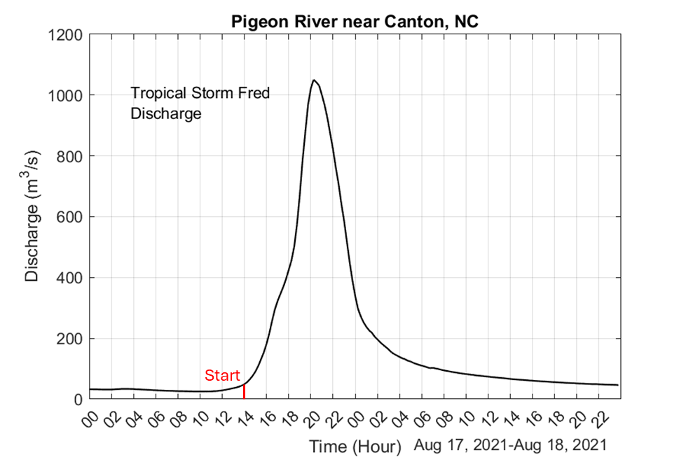
Figure 3. Discharge at the Canton stream gauge during Tropical Storm Fred.

Interval | Duration  (Hours) | Duration  (Seconds) | Average Discharge  (m³/s) | Water Volume  (m³)
Totals:

Part 1C: Data Analysis and Interpretation
- How do your calculated water volumes compare? Compare your water volume total estimated from precipitation data (Part A) to the estimate based on Canton gauge discharge (Part B) and provide a rationale for differences that goes beyond human error.

- Discharge is not the same as the height of water in a river channel. Other than the volume of water, what factors may impact the height of water in the channel (and thus the potential for flooding)?

- Flooding was a major problem during this storm. Brainstorm with the people around you: What other hazards may have resulted from this intense precipitation event?

Part 2. Estimate flood heights during Tropical Storm Fred and Hurricane Helene. Apply conservation of mass and utilize flow resistance equations to estimate flood heights along the Pigeon River in Canton, NC.

You will estimate the height and average velocity of the flood along a section of river (reach) upstream of Canton, NC and compare this to gauge records of river height (stage) from Tropical Storm Fred in 2021 and Hurricane Helene in 2024.
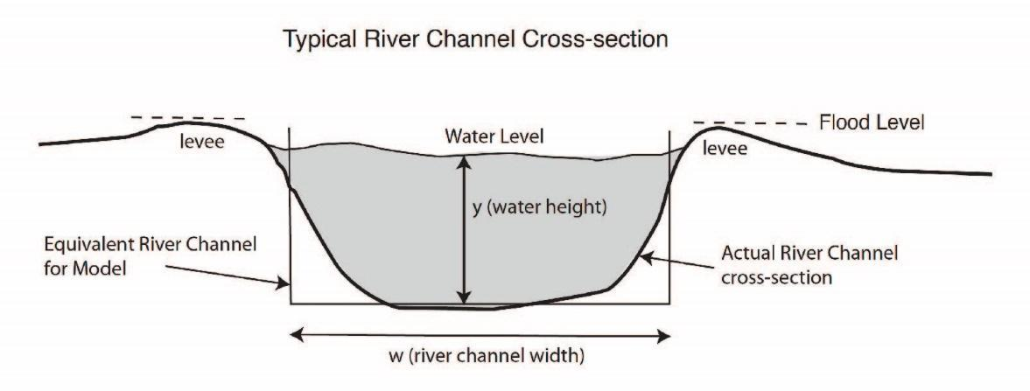
Figure 5. Diagram of a river cross-section approximated as a rectangular channel.

Part 2A: Estimating water velocity using river width and gradient
To estimate water velocity, we need to measure river width and the slope of the river.
The slope of the river provides the driving force for flow (gravity), and the river width sets the cross-section through which water passes (Figure 5).
      - Use the Google Earth image (Figure 6 below) to measure the width of the river (in meters) downstream of the gauge location (red star on Figure 7).
River channel width = ______________ m

      - The topographic map (Figure 7) illustrates the change in gradient (or slope) of the Pigeon River, with the highest and lowest locations within the watershed marked. Calculate gradient, change in height (or elevation) divided by distance, of this reach.
River gradient (slope) = __________________ m/m
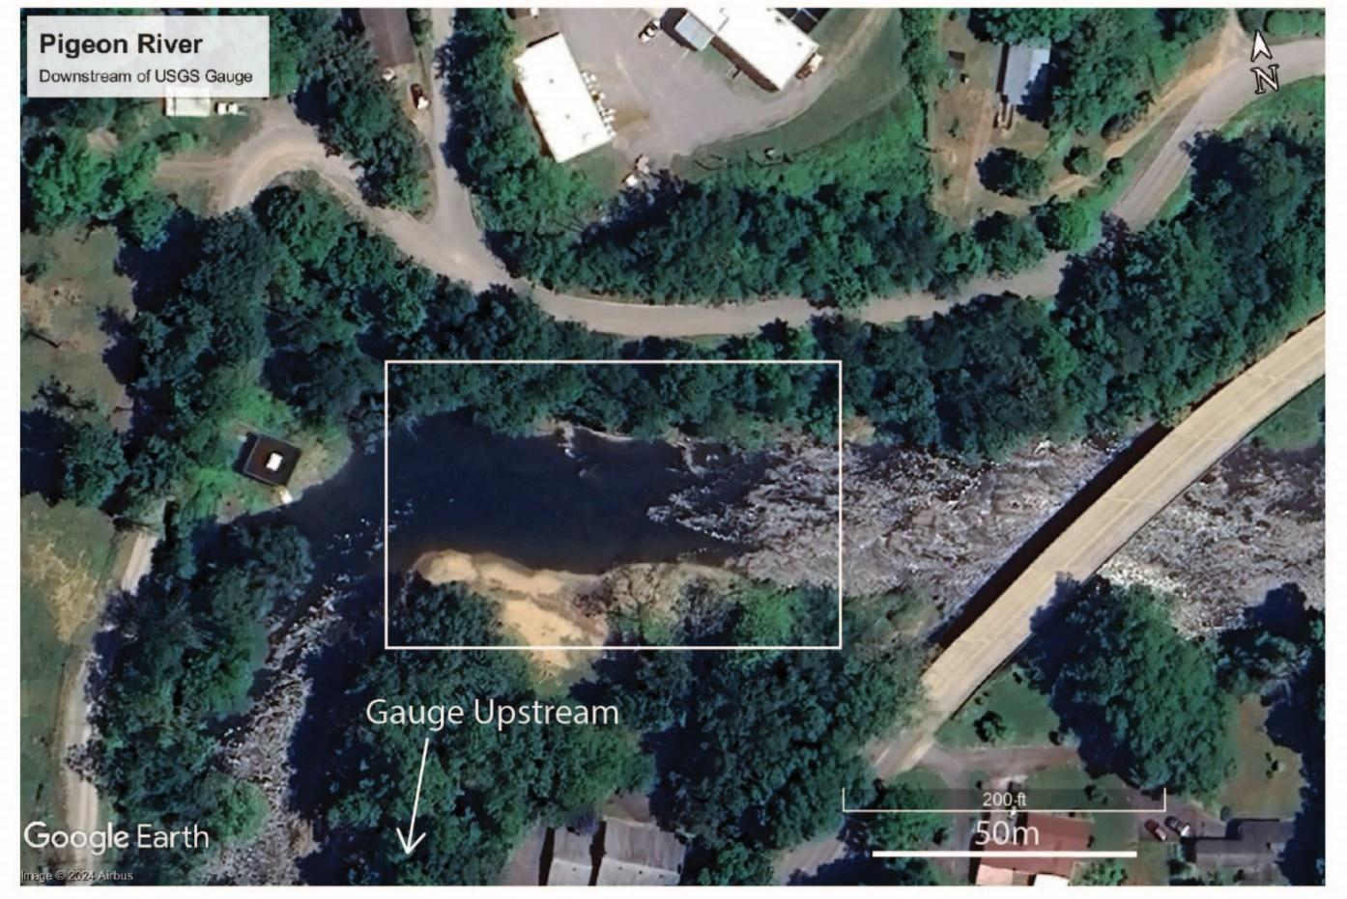
Figure 6. Google Earth image of channel width.

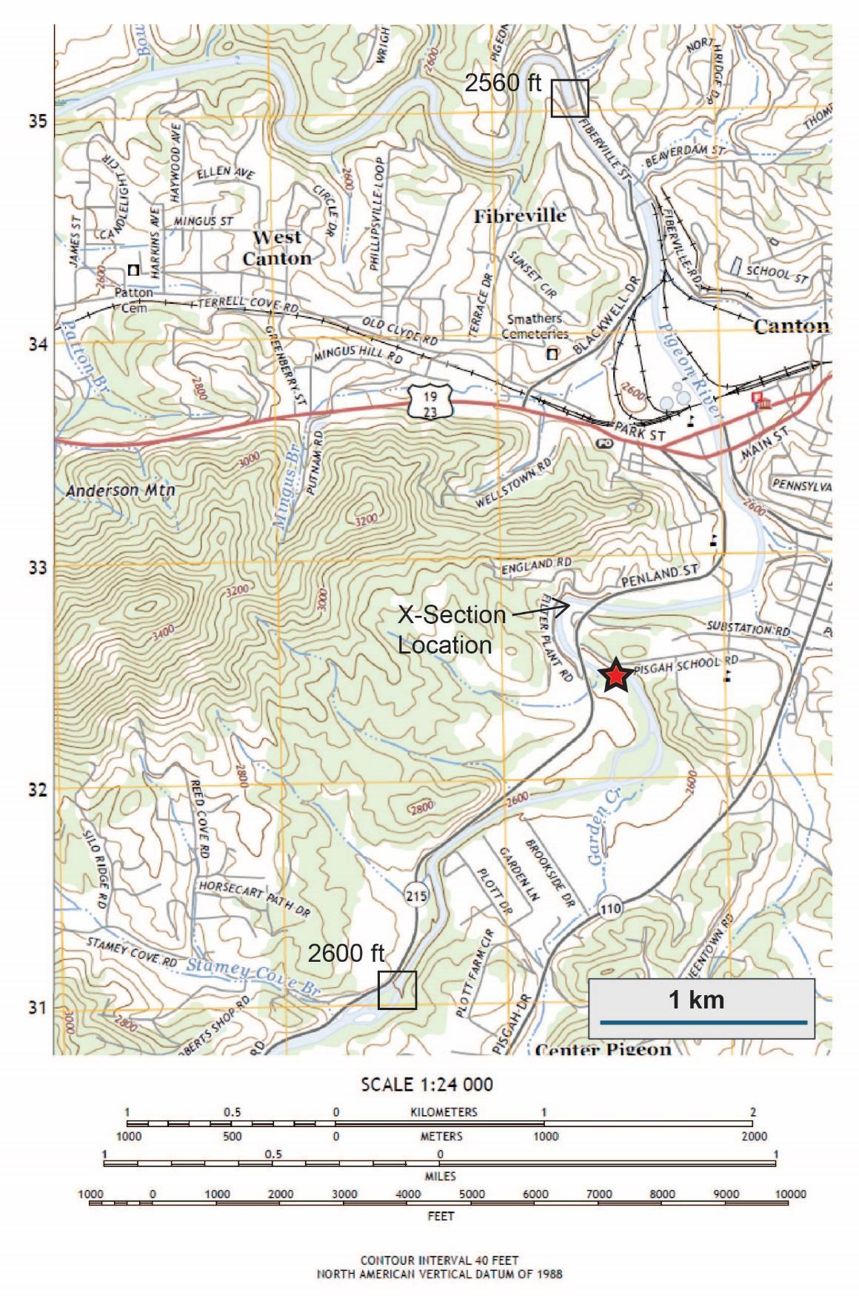 | Figure 7. Topographic map of the Pigeon River through Canton, NC. Boxes highlight contour intervals to calculate elevation change, and the red star denotes the USGS gauge location.
Part 2B: Calculating velocity to graphically solve for flood height
In general, water flowing down a river is confined by the cross-sectional area (Figure 5). To accommodate greater discharge associated with intense rainfall events, the river either must rise, flow faster, or both. To determine these values, we must solve for the solution of height and velocity that meet both conservation of mass (Eqn. 1) and flow resistance (Eqn. 2).
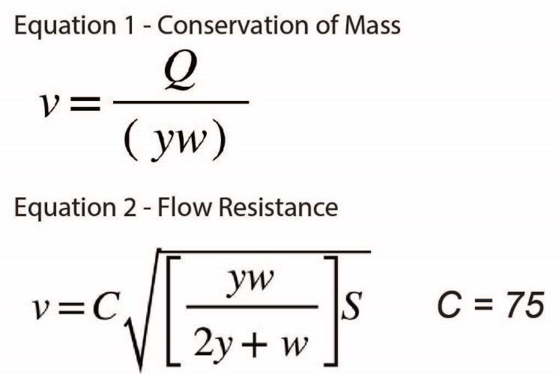
V = velocity (m/s)
Q = discharge (m3/s)
y = depth (m)
w = width (m)
C = roughness coefficient (unitless)
S = slope (m/m)

We will use the maximum recorded discharge along this reach for these calculations. Look at Figure 3 to see the peak discharge for Tropical Storm Fred illustrated (and to imagine how much bigger the peak was for Hurricane Helene!)

Peak discharge, Fred = 1050 m³/s
Peak discharge, Helene = 1900 m³/s

3. Use equation 1 to calculate flow velocities for the peak discharge values listed for each storm and the heights provided. Record your answers in the table.
4. Plot these values on the graph below and draw 2 curves: one for velocity values associated with Fred and one for Helene.
5. Use equation 2 to calculate velocities at the same series of river heights. This equation does not take discharge into account. Plot these values as a 3rd curve.
- Where the equation 2 curve and each of the equation 1 curves intersect gives us the flood height.
  - Flood height for Fred:
  - Flood height for Helene:

Height (m) | Velocity, Fred (Eqn. 1)  (m/s) | Velocity, Helene (Eqn. 1)  (m/s) | Velocity, (Eqn. 2)  (m/s)
1
2
3
4
5
6
7
8
9
10

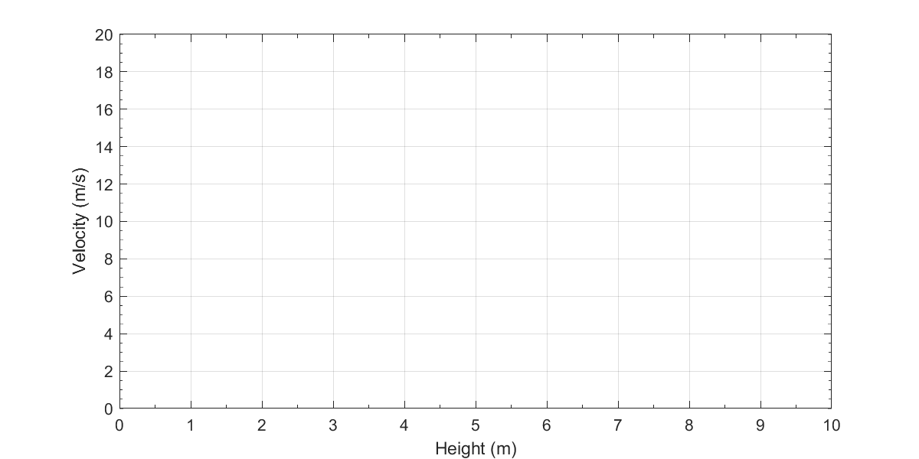
Part 2C: Data Analysis and Interpretation
- Compare your results to the heights of the river measured during each flood event (ask your instructor for a copy of the gauge record when you are ready). How close were your estimates for Fred? What about Helene? Identify two factors or assumptions that could account for the differences in your results and justify your answer.

- Equation 1 and 2 both estimate velocity based on a constant width, and equation 2 assumes a constant slope.
  - Brainstorm:
    - Would you expect width to remain constant, increase, or decrease during an intense precipitation event? Justify your answer.

    - Would you expect slope to remain constant, increase, or decrease during an intense precipitation event? Justify your answer.

- Equation 2 uses a frictional coefficient. If “C” is larger, there is less friction and flow velocity increases. If “C” is smaller, there is greater friction and lower velocity.
  - Brainstorm:
    - What could increase or decrease friction in a stream?

    - Would you expect friction to remain constant, increase, or decrease during an intense precipitation event? Justify your answer.

    - Based on your answer, how could frictional changes during a storm event change flood height estimates?

Part 3. Hazard cascades as a systems model
In this activity you analyzed how much water entered the watershed and predicted flood heights. But flooding is rarely an isolated hazard: Extreme rainfall can trigger a series of connected hazards known as a hazard cascade, increasing impacts on communities.
For example, flooding along the Pigeon River during Helene caused the downstream community of Canton to relocate the wastewater treatment plant due to repetitive flooding and release of raw sewage.
- Below are several processes that may occur during and after an extreme rainfall event. Draw arrows connecting them to show how one hazard can trigger another, with the “cause” as the base of the arrow and the “effect” at the head of the arrow. For example, an arrow has been drawn for you to illustrate that extreme rainfall can cause saturated soils. Many arrows can originate from a single process, and a process may be affected by more than one other process.

Extreme Rainfall

Saturated Soils

Landslides and Debris Flows

Trees and Sediment Enter Rivers

Channel Blockage or Reduced Flow Capacity

River Flooding (leaving channel)

Environmental Impacts on Communities and Infrastructure

- Could any of these “downstream” factors account for any of the differences noted between your modeled (e.g., calculated) and observed results in Parts 1 or 2? Justify your answer.

- Once you have connected the hazards, identify at least one additional hazard or impact that could occur in your own community and add it to the cascade.

