Mapping Habitat Changes Through Time Using ArcGIS Online

Executive Summary

Mapping changes in ecosystems through time using satellite data is a valuable way to track how humans or natural phenomena alter the land surface. In this lab you will use tools available in ArcGIS online to determine how wildfire occurrence from 2020-2022 impacted the landscape, and how this in turn might impact a range of wildlife, such as the California black bear. You will compare the sum of total affected areas and decide best management practices to conserve habitat in response to fire.

Introduction
Black bears inhabit various ecosystems throughout California; however, their range is continually impacted by wildfires, which are increasing in both size and frequency. Wildfires affect the black bear's habitat by decreasing vegetation and potential den sites and may even affect their habitable range. You will begin by adding geospatial data layers, including black bear range data from the California Department of Fish and Wildlife and historical wildfire perimeters from the California Department of Forestry and Fire Protection. You will filter wildfire data to focus on the years 2020, 2021, and 2022. Using spatial analysis tools, you will then determine the area of black bear habitat affected by wildfires using overlay functions and then merge the data to assess cumulative impacts over the three-year period. Finally, you will create a bar chart visualizing the total black bear habitat area impacted by wildfires over time.

Objectives:
By the end of this lab, students will be able to:
- Navigate ArcGIS Online Map Viewer to create and manage maps.
- Add and manipulate geospatial data layers from ArcGIS Online.
- Filter data layers to analyze specific timeframes.
- Conduct spatial analysis using overlay and merge tools.
- Create visual representations of geospatial data through charts.
- Assess the impact of wildfires on black bear habitats over multiple years.

Please follow all steps closely. Type your answers to any questions in red.

Laboratory Procedures:

Adding Data:

Step 1: Log in to ArcGIS online (all students from our institution have free access!) Once you have signed in, you can click “Map” on the menu, or go straight to ArcGIS Online Map Viewer: https://www.arcgis.com/apps/mapviewer/index.html

Step 2: Click “New Map” on the top and rename map to “Black Bear Range Affected by California Wildfires Lastname”.

Step 3: Click “Add” in the layers pane to the left of the map and select “browse” and then choose “ArcGIS Online” from the dropdown menu.

Step 4: Search “Black Bear Range - CWHR M151 [ds792]” by the Department of Fish and Wildlife, and click on it to add the feature layer to the map.
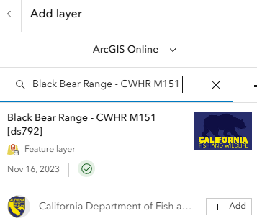
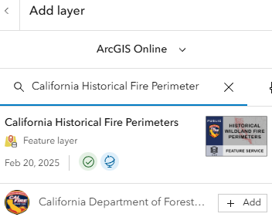
Step 5: Search “California Historical Fire Perimeter” by the California Department of Forestry and Fire Protection and click on it to add it to the map.

Step 6: Close out of the “add layer” browser. On the left menu bar, click “layers” and select the Fire perimeter layer. Click the three dots on the layer and click “ungroup”. Your “layers” should now appear as they do in the following image.

Step 7: Since only the “California Wildland Fire Perimeters (All)” layer will be needed: click the three dots on the “Recent Large Fire Perimeters (>=5000 acres)” layer and click “remove”

Step 8: Repeat Step 7 for the “California Fire Perimeters (1950+)”.

The California Wildland Fire Perimeters (All) layer includes fire perimeter data from 1878-2023. This lab will focus on 2020, 2021, and 2022.

Step 9: Click the three dots on the right of the “California Wildland Fire Perimeters (All)” layer and click duplicate.
Step 10: Repeat this step once more so that there are three “California Wildland Fire Perimeters (All)” layers.

Step 11: Click the three dots on the right again to rename these layers to:
“California Wildland Fire Perimeter 2020”
“California Wildland Fire Perimeter 2021”
“California Wildland Fire Perimeter 2022”

All data is now uploaded, and you may zoom into California for better visualization. You may zoom in and out using the +/- bar in the lower right-hand corner of the map.

Filtering Data:

Step 12: Click the Filter icon on the left side of the map.

Step 13: Select the “California Wildland Fire Perimeters 2020” layer from the drop-down menu. Then click “add new”.

Step 14: Select conditions where Year is 2020 and click save.

Step 15: Repeat steps 12-14 for the 2021 and 2022 layers, respectively, changing the year condition accordingly. Your map should now highlight only the fires that occurred in 2020, 2021, and 2023.
Data Analysis:
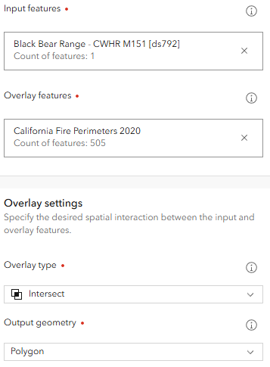
Step 16: Click the Analysis icon on the right side of the map. Click “tools” and type “Overlay Layers” in the search bar. Click on the Overlay Layers tool.

Step 17: In the overlay layers tool, Set:
Input Features: Black Bear Range - CWHR M151 [ds792]
Overlay Features: California Wildland Fire Perimeter 2020
Overlay Type: Intersect; Overlay geometry: Polygon
Output Name: “Affected Range Area 2020”
Click “Run”

Step 18: Repeat steps for “California Wildland Fire Perimeter 2021” and “California Wildland Fire Perimeter 2022”. (Creating the overlay layers may take a moment so be patient)

Step 19: If your new “Affected Range” layers didn’t automatically appear as Layers on the map, add the layers now. To do this, Click the “Layers” tab on the left and click “Add”. Use the “My Content” drop down, and the newly run layers should appear. Click “+Add” to add these layers to the map. If your layers automatically appeared after running the overlay tool, you may skip this step.

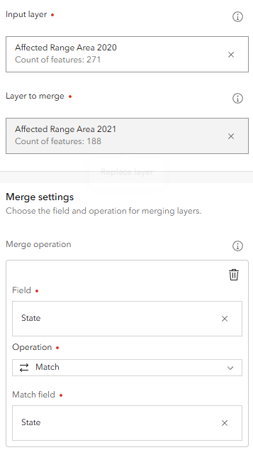
Step 20: Open the attribute table for “Affected Range Area 2020” (click the three dots, drop down to “show table”. Scroll to the very last column on the table, which should have a new field called “Area in Square Miles”. This field shows the area that overlapped between the fire perimeter and the black bear range. Each of your “Affected Range Area” files should also include this information.

Step 21: Open analysis tools again and search for “merge layer”. Click on the tool, and set:
Input Layer: Affected Range Area 2020
Layer to Merge: Affected Range Area 2021
Merge Settings:
Field: STATE
Operation: Match
Match Field: STATE
Output Name: “Affected Range Area 2020_2021” (please note: you MUST use the underscore, as a hyphen won’t work as a file name in this online tool!)
Click run

Step 22: Repeat this step using “Affected Range Area 2020_2021” as the input layer and “Affected Range Area 2022” as the layer to merge. Set Output Name to “Total Affected Range Area” and click run.


Step 23: On the right menu bar, click the configure charts icon. This may be hidden behind another “3 dot” icon, which says “more” when you move your mouse over it. Click the 3 dots and scroll to “configure charts”.

Step 24: Make sure the selected layer is “Total Affected Range Area”
- Click “add chart” and choose a bar chart
- Choose YEAR for category
- Click “select numeric fields” and choose “Area in Square Miles”
- Click “General” to change chart titles
- Rename chart title to “​​Affected Black Bear Range Area by California”
- Rename the y-axis to Sum of Affected Area (Square Miles)
- Rename the x-axis to Years
- The graph now shows the total area of the black bear range that has been affected by wildfires for each of the three years
- Click the save and open icon on the black tab to the right of the map and click save.

Step 25: Insert a screenshot of your graph below:

Part 2: Synthesis Questions. Type your answers in red.

  - Look at the map of the potential range (i.e. fundamental niche) of the California black bear. Does the range surprise you? Why or why not?

  - Do a little research on the fundamental niche of the black bear. What factors do you think prevent the black bear from inhabiting their fundamental niche?

  - Which years had the greatest number of wildfires? In what year did wildfires impact the range of the California black bear the most?

  - 2020 had more fires than 2021 or 2023. What climate or other factors may have led to this particularly bad wildfire year?

  - Describe reasons that wildfires may be essential to ecosystems, and thus the fundamental niche of the black bears.

  - Do a little research on wildfire history in California. How might wildfires occurrence and/or size be impacted by climate change? How might this impact ecosystem services? In which regions of the state should we be most cautious about the future of wildfire spread? Defend your answer.

