Name(s)____________________________________

1. Find the youngest grain (tells you the max deposition age of the rock)
   1. Which sample is younger? Write them accordingly on the figure below
2. Knowing the thickness from the figure below, determine the rate of sedimentation/ rate of extension.

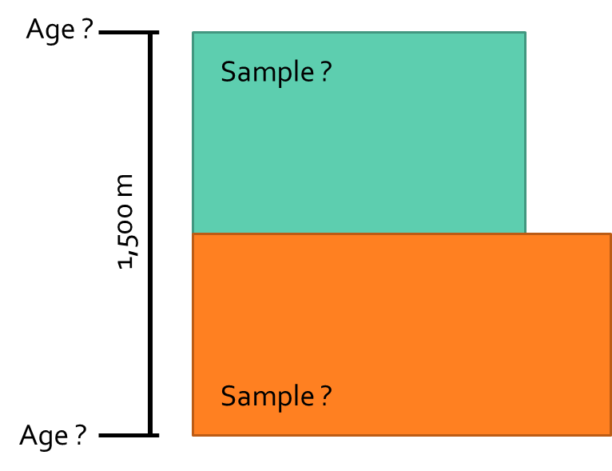

Sedimentation Rate = m / year