What are anisotropic rocks?
When we look at rocks that have been deformed, especially subduction-related rocks, the minerals are commonly not randomly oriented. This was a good starting assumption for Part 2, but to better model the velocities of our rocks, we need to take into account whether the minerals are aligned or not. Most minerals are seismically anisotropic, meaning that the speed of a seismic wave passing through the mineral depends on which way the wave travels (Fig. 3.1).
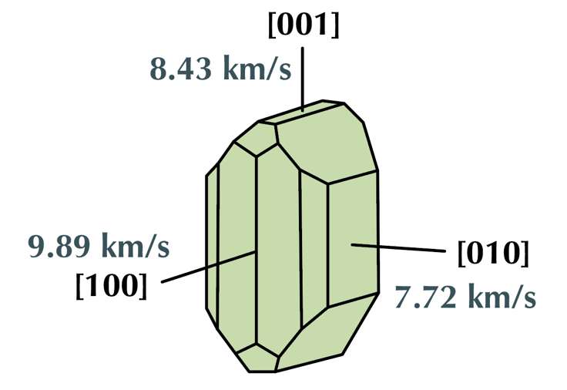
Figure 3.1. P-wave speeds for olivine in km/s. Note that waves passing through olivine parallel to the a-axis will travel fastest (after Christensen, 1984 & Bernard et al., 2021).

In Fig. 3.1, the a-axis has the fastest V_{P}, but seismic waves could pass through this crystal in any orientation (called the incidence angle), and if we had a collection of crystals they would likely not all be in the same orientation. In this part, we’re going to calculate the seismic velocities for any incidence angle for an effective media where we prescribe the orientations of these minerals.

Stiffness tensors
Remember that seismic wave speeds depend on rock properties. For an isotropic rock, we can calculate the average of the bulk (K) and shear (G) moduli and directly calculate the seismic wave speed (see Part 1). If we’re looking at anisotropic minerals, the bulk and shear moduli are not the same in each direction, and so the calculations become a bit more difficult.

If we want to relate stress to strain, we can use a simple model of a spring, where the strain ($ϵ$) and stress ($σ$) are related by the Young’s Modulus (E):
$$σ=Eϵ$$

Young’s Modulus (E) is a measure of the stiffness of a material and relates to the two moduli that we’ve been talking about (G and K) when you also take into account the compressibility (Poisson’s ratio or $μ$). Together, G, K, E, and $μ$ define the elastic properties of an isotropic material, and we can use these, along with the density, to calculate the p- and s-wave velocities through a mineral.

But, if you’ve taken structural geology, you know that stress cannot be represented with a simple number. We commonly represent stress in terms of the principal stress components ($σ_{1}$, $σ_{2}$, and $σ_{3}$), because stress is a three-dimensional field. We can also represent stress as a 9-component tensor, as written below.

$$\left[\begin{matrix}σ_{xx} & σ_{xy} & σ_{xz} \\ σ_{yx} & σ_{yy} & σ_{yz} \\ σ_{zx} & σ_{zy} & σ_{zz}\end{matrix}\right]$$

Strain can also be written as a 9-component tensor. To calculate the elastic strain that results from a stress, we use matrix algebra and the stiffness tensor (C), which mathematically relates stress and strain. This is analogous to the elastic moduli (K and G) and can be used to calculate seismic velocities. The stiffness tensor has 81 components to take into account the complexity of transforming a three-dimensional strain field into a three-dimensional stress field. Thankfully, we can simplify this to 36 components because of symmetry ($σ_{xy}= σ_{xx}$), so the stiffness tensors we use for seismic velocities are commonly written as:

$$C=\left[ \begin{matrix}\begin{matrix}\begin{matrix}C_{11} \\ C_{21}\end{matrix} & \begin{matrix}C_{12} \\ C_{22}\end{matrix}\end{matrix} & \begin{matrix}\begin{matrix}C_{13} \\ C_{23}\end{matrix} & \begin{matrix}C_{14} \\ C_{24}\end{matrix}\end{matrix} & \begin{matrix}\begin{matrix}C_{15} \\ C_{25}\end{matrix} & \begin{matrix}C_{16} \\ C_{26}\end{matrix}\end{matrix} \\ \begin{matrix}\begin{matrix}C_{31} \\ C_{41}\end{matrix} & \begin{matrix}C_{32} \\ C_{42}\end{matrix}\end{matrix} & \begin{matrix}\begin{matrix}C_{33} \\ C_{43}\end{matrix} & \begin{matrix}C_{34} \\ C_{44}\end{matrix}\end{matrix} & \begin{matrix}\begin{matrix}C_{35} \\ C_{45}\end{matrix} & \begin{matrix}C_{36} \\ C_{46}\end{matrix}\end{matrix} \\ \begin{matrix}\begin{matrix}C_{51} \\ C_{61}\end{matrix} & \begin{matrix}C_{52} \\ C_{62}\end{matrix}\end{matrix} & \begin{matrix}\begin{matrix}C_{53} \\ C_{63}\end{matrix} & \begin{matrix}C_{54} \\ C_{64}\end{matrix}\end{matrix} & \begin{matrix}\begin{matrix}C_{55} \\ C_{65}\end{matrix} & \begin{matrix}C_{56} \\ C_{66}\end{matrix}\end{matrix}\end{matrix}\right]$$

For any given mineral, we could calculate the resulting seismic velocity for any give incidence angle. Now, you might be saying that this sounds like an absolute nightmare, especially if you had multiple different minerals in multiple different orientations, a range of lithologies, and cared about a range of incidence angles. Luckily, we don’t have to do those calculations ourselves – the Matlab Seismic Anisotropy Toolbox (MSAT, Walker & Wookey, 2012) will do this for us!

Matlab Seismic Anisotropy Toolbox (MSAT) overview
Like the Abers & Hacker (2016) toolbox, MSAT (Walker & Wookey 2012) calculates seismic velocities for specific minerals in specific orientations and can average multiple minerals and multiple lithologies to calculate seismic velocities for a given effective media. It does not, however, take into account P-T conditions. See the example uses at the end of this document for ideas on how to incorporate prograde vs. retrograde metamorphism.

To get MSAT, go to the MSAT website. This website includes the latest version as well as instructions on how to download, unzip the files, and put them somewhere accessible for Matlab. MSAT does not require any fancy installations – it is simply a collection of Matlab functions.

This tutorial will walk you through calculating velocities for minerals and reading the resulting pole figures, changing mineral orientations, averaging over multiple minerals and multiple lithologies, and adding mineral stiffness tensors to the database. We recommend that you follow the steps in order, as each part will build on the previous part, but the list below details what skills will be covered in each step:

- Starting simple: a single olivine crystal
  - Loading & plotting seismic velocities
  - Reading the resulting graphs
  - Plotting different variables
  - Rotating a stiffness tensor
- Adding stiffness tensors to the database
  - How to build a stiffness tensor from published values
  - Modifying the MSAT database
- Modeling seismic velocities for a single lithology
  - Averaging isotropic and non-isotropic stiffness tensors
  - Plotting Vp/Vs
- Next steps and considerations for multiple lithologies

Starting simple: a single olivine crystal
Once you have MSAT installed (see above), open Matlab and make sure that you have either navigated to the msat folder within the MSAT-Master folder in the Files pane or that you have added the path to that folder using addpath('').

- To load the stiffness tensor for olivine and plot the velocities, you’re going to use two functions:

[C, rh] = MS_elasticDB('Olivine') % This gets the stiffness tensor (C) and the density (rh) for the mineral of your choice
MS_plot(C, rh) % This plots the seismic velocities for the stiffness tensor and densities that you loaded.

  - If you did not suppress the outputs by adding ; to the end of the line, Matlab will print out the stiffness tensor (C) and the density (rh) of olivine. They will look like this:
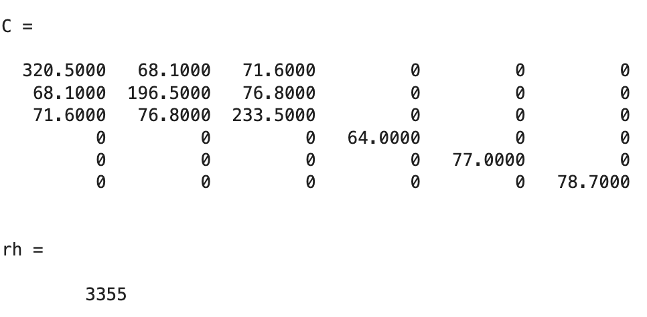
  - You will also get a graph of olivine velocities, including Vp, dVs, and Fast-shear polarization (Fig. 3.2)

What do these plots mean?
- V_{P} is the p-wave velocity for different incidence angles. We will describe how to read this in a moment! The anisotropy is:
$${\% V}_{P anisotropy}=\frac{V_{P max}- V_{P min}}{V_{P average}} x 100$$
- dV_{S} is the percent difference between the two s-wave velocities (V_{S1} and V_{S2}) for any given incidence angle. See the ‘Shear Wave Splitting’ box on the next page for a description as to what shear wave splitting is.
- Fast shear polarization shows the polarization orientation of the faster shear wave in 3D space (black sticks) overlain on the dVs values.
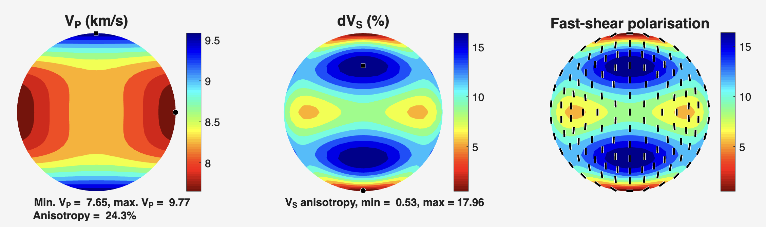
Figure 3.2. Seismic velocities for a single olivine crystal output by MSAT.
Shear wave splitting. As you dive into MSAT, you will see that it outputs V_{S1} and V_{S2}. This is because anisotropic minerals commonly split incoming shear waves into two perpendicular (orthogonal) polarizations with different velocities (Fig. 3.3). This is similar to birefringence in minerals when you look at them through a microscope under cross-polarized light. This shear wave splitting may be measured in seismic data and so knowing how different shear waves behave in your rocks can be important when comparing to seismic data.
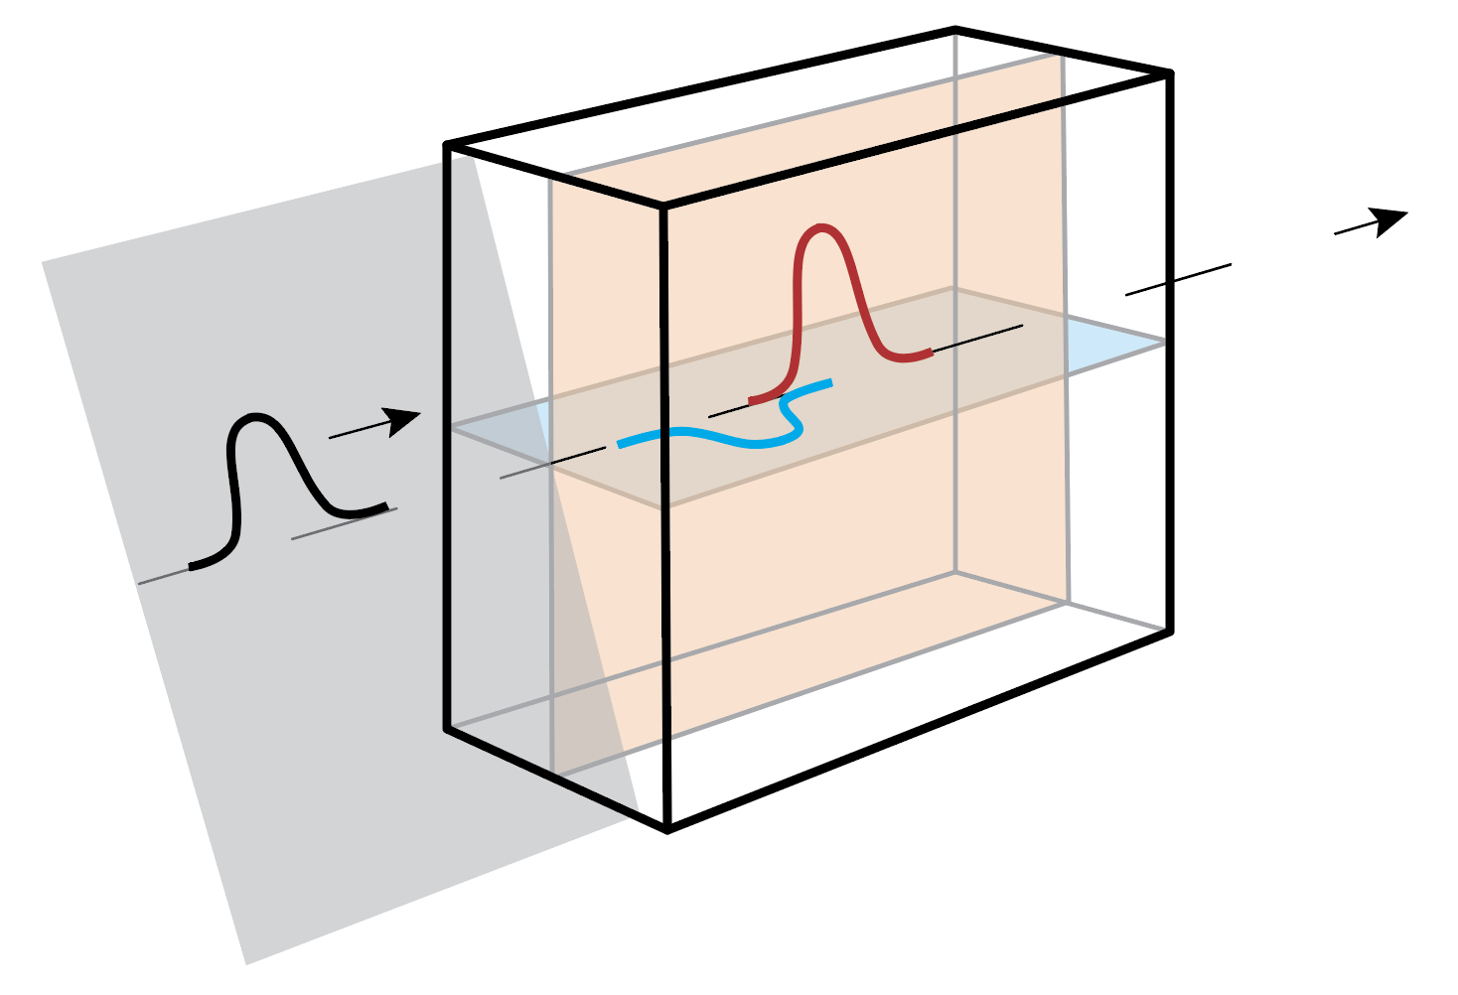
Figure 3.3. Example of an incoming shear wave (black) split into two orthogonal waves (fast in orange and slow in blue). Note that each wave has a plane of polarization in which the wave vibrates. The plane for the faster of the two shear waves is plotted in the Fast-Shear Polarization.

How to read these plots
You will work extensively with these plots in MSAT to make sure your minerals are oriented appropriately and to evaluate the seismic velocities of your modelled lithologies. These ‘pole figures’ are essentially a fancy stereonet plot that plot a value for each potential line orientation (point) on the stereonet. This results in a circular, colored plot that shows you all of the calculated values for all possible orientations. If you have worked with EBSD data before, you might be familiar with reading a pole figure, where the colors tell you the relative proportion of mineral axes in each orientation. In this case, each point on the pole figure corresponds to an incidence angle in 3D space for seismic waves. The color then tells you the seismic velocities for that particular incidence angle.

It is up to you if you treat these seismic velocity pole figures as analogous to a stereonet, where the outside of the circle is parallel to the surface of the Earth (Fig. 3.4a) or parallel to the surface of a thin section (Fig. 3.4b). We recommend the latter, as this is commonly how we think about mineral orientations in shear zones.
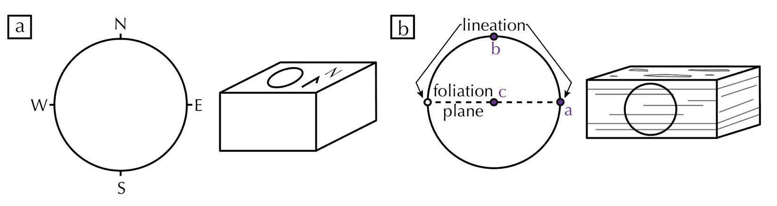
Figure 3.4. a) Orientations for a standard stereonet with points along the primitive circle representing cardinal directions. b) Orientations relative to a standard thin section (parallel to lineation and perpendicular to foliation) commonly used in pole figures.
Let’s use the setup of Fig. 3.4b as our model going forward. In this case:
- The value at Point A is the seismic velocities for waves travelling parallel to lineation.
- At Point B, the velocities are for waves travelling perpendicular to foliation.
- At point C, the velocities are for waves travelling perpendicular to lineation but in the plane of the foliation.
Try it!
Using the V_{P} graph in Fig. 3.2 and the diagram showing olivine p-wave velocities in Fig. 3.1, which way is the olivine crystal oriented? Assume the orientations of lineation and foliation used in Fig. 3.4b

Solution: The olivine crystal is oriented with the b-axis parallel to lineation, the a-axis perpendicular to foliation, and the c-axis perpendicular to lineation and in the plane of the foliation. Note! This is the convention for reporting stiffness tensors (C).

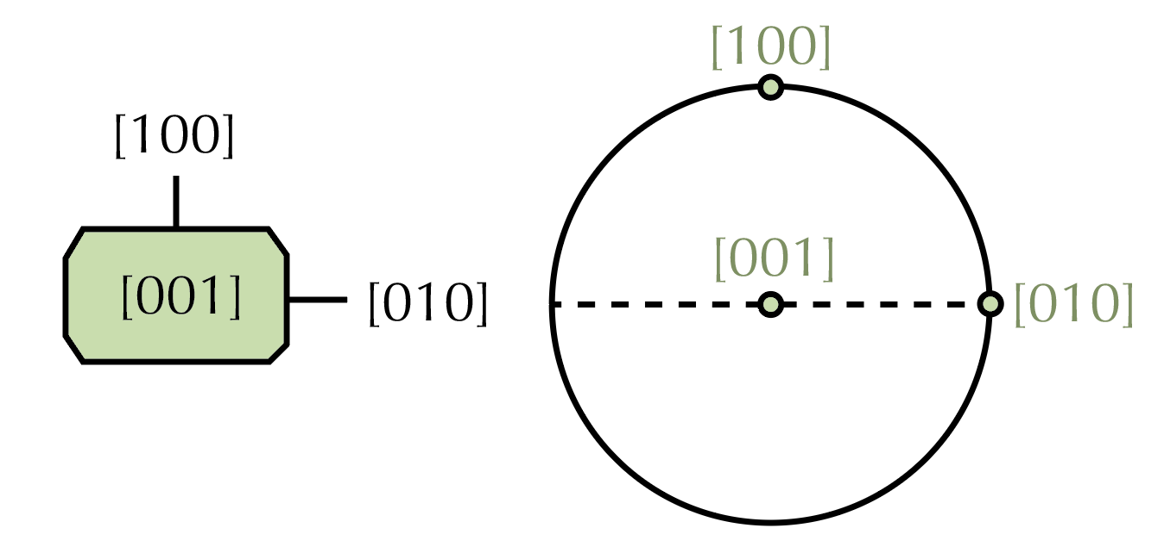
Figure 3.5. Orientation for an olivine crystal loaded directly from the MSAT database.

Note that we are interpreting orientation relative to lineation and foliation, but the orientations would not change if we interpreted this as a standard stereonet, only the translation to a real-world orientation would change (c-axis vertical, a-axis horizontal and trending N-S, b-axis horizontal and trending E-W).

Challenge
Which incidence angle through olivine (parallel to a-, b-, or c-axis) has the largest dVs? Is the largest dVs overall parallel to any of the axes?
Review: stereonets. Depending on the courses that you’ve taken over your geoscience career, you may or may not have seen (or remember) how to read a stereonet. Stereonets are a projection of 3D orientation data onto a 2D graph. We do this by looking at where the planes or lines intersect a hemisphere. Because we are plotting the line of intersection, planes are represented on a stereonet as lines and lines are represented as dots. If it has been a while since you’ve thought about a stereonet, we recommend going to Visible Geology and selecting their stereonet option. You can plot lines and planes in different orientations and see them both on the stereonet and in 3D.

Rotating a stiffness tensor
We can now interpret our olivine orientation, but this may or may not be the orientation that we actually want! Luckily, MSAT has a built-in function to rotate the stiffness tensors. You should rotate the stiffness tensors before you plot and/or average between different minerals. Rotating the stiffness tensor involves 3D rotations that follow the convention in Fig. 3.6, so we recommend trying a rotation and plotting to make sure that you have the correct orientation for your minerals.
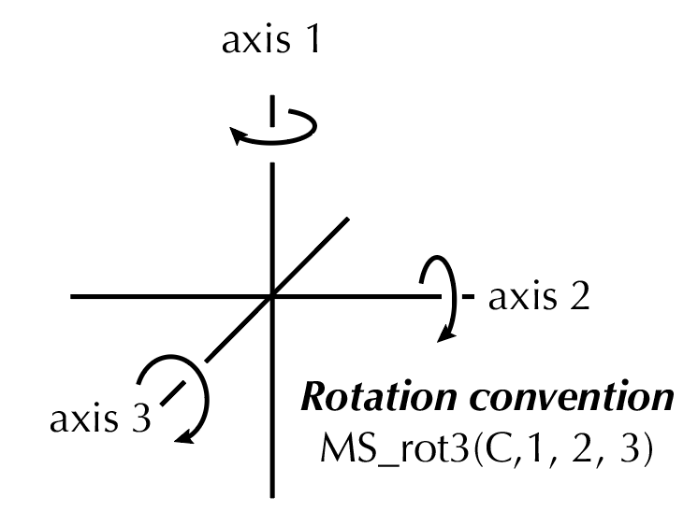

Figure 3.6. Rotation convention for the MS_rot3 function in MSAT, where the angles apply to the axes in order (see the try it below).
Try it!
Apply a 90° rotation to the olivine crystal around axis 1 and plot the resulting V_{P}. To do this, you should:
- Rotate the stiffness tensor first as shown below:
[C_rot] = MS_rot3(C,90,0,0)
- Plot only the resulting VP to simplify what you’re looking at. Use this version of MS_plot:
MS_plot(C_rot, rh,'plotmap',{'VP'})

Take a minute with your plot and the olivine crystal in Fig. 3.1 get a 3D picture of what happened to the crystal. The a-axis (fast direction) should be in the same orientation, but the c-axis (intermediate direction) should now be parallel to lineation.

Challenge
Imagine that we wanted the a-axis parallel to lineation based on data that we have about olivine orientations. What rotation would you call to get that orientation? Test it out and check your plot to ensure you did the right thing!

Adding stiffness tensors to the database
Tips & tricks.
There is no single ‘do this for every mineral’ rotation because each mineral is different and the considerations that you have for your rocks will be different. You will need to think through what rotations make sense for your calculations.
You will likely wind up loading and plotting many stiffness tensors, depending on the number of minerals in your rocks. Be sure to call each stiffness tensor something else (e.g., C_qtz) to keep them straight in your script and to keep from overwriting them. If you also have to rotate them, you can overwrite the original variable, but it might help to keep them separate so that you can check.
Chances are good that the database won’t contain all of the stiffness tensors that you want to use in your rocks. Mica is a good example – most metamorphic rocks contain some variety of mica and micas are commonly oriented within the foliation plane – but mica is not included in the original MSAT database. In this section, you will learn how to add stiffness tensors so that you can add any that you’re interested in!

Vaughan & Guggenheim (1986) published the muscovite elasticity tensor, with the following values:

C₁₁ | 181.0 |  | C₂₃ | 21.2
C₂₂ | 178.4 |  | C₁₃ | 25.6
C₃₃ | 58.6 |  | C₁₂ | 48.8
C₄₄ | 16.5 |  | C₁₅ | -14.2
C₅₅ | 19.5 |  | C₂₅ | 1.1
C₆₆ | 72.0 |  | C₃₅ | 1.0
 |  |  | C₄₆ | -5.2

This is a whole lot of numbers that we need to be sure get in the right spaces. We recommend writing this out initially, either by hand or in a spreadsheet or word processing software to make sure that you assign the values correctly. You also might notice that there aren’t enough values here to fill a full 36-component matrix. Let’s start by filling in what we know:
$$C=\left[ \begin{matrix}\begin{matrix}\begin{matrix}181.0 \\ C_{21}\end{matrix} & \begin{matrix}48.8 \\ 178.4\end{matrix}\end{matrix} & \begin{matrix}\begin{matrix}25.6 \\ 21.2\end{matrix} & \begin{matrix}C_{14} \\ C_{24}\end{matrix}\end{matrix} & \begin{matrix}\begin{matrix}-14.2 \\ 1.1\end{matrix} & \begin{matrix}C_{16} \\ C_{26}\end{matrix}\end{matrix} \\ \begin{matrix}\begin{matrix}C_{31} \\ C_{41}\end{matrix} & \begin{matrix}C_{32} \\ C_{42}\end{matrix}\end{matrix} & \begin{matrix}\begin{matrix}58.6 \\ C_{43}\end{matrix} & \begin{matrix}C_{34} \\ 16.5\end{matrix}\end{matrix} & \begin{matrix}\begin{matrix}1.0 \\ C_{45}\end{matrix} & \begin{matrix}C_{36} \\ -5.2\end{matrix}\end{matrix} \\ \begin{matrix}\begin{matrix}C_{51} \\ C_{61}\end{matrix} & \begin{matrix}C_{52} \\ C_{62}\end{matrix}\end{matrix} & \begin{matrix}\begin{matrix}C_{53} \\ C_{63}\end{matrix} & \begin{matrix}C_{54} \\ C_{64}\end{matrix}\end{matrix} & \begin{matrix}\begin{matrix}19.5 \\ C_{65}\end{matrix} & \begin{matrix}C_{56} \\ 72.0\end{matrix}\end{matrix}\end{matrix}\right]$$

This is a good start, but it’s definitely not all we need. To finish filling this out, we need to use some rules:
- To know if we should fill these in as 0 or a different value, we need to know the mineral symmetry. Mica is a monoclinic mineral, so this means that the remaining values in the upper triangular part of the matrix will be 0. See Fig. 3.7 for the layout for all mineral symmetry classes. It is paramount that you get the correct class for your mineral, or the calculations are likely to be wrong (and may not even work)!

$$C=\left[ \begin{matrix}\begin{matrix}\begin{matrix}181.0 \\ C_{21}\end{matrix} & \begin{matrix}48.8 \\ 178.4\end{matrix}\end{matrix} & \begin{matrix}\begin{matrix}25.6 \\ 21.2\end{matrix} & \begin{matrix}0 \\ 0\end{matrix}\end{matrix} & \begin{matrix}\begin{matrix}-14.2 \\ 1.1\end{matrix} & \begin{matrix}0 \\ 0\end{matrix}\end{matrix} \\ \begin{matrix}\begin{matrix}C_{31} \\ C_{41}\end{matrix} & \begin{matrix}21.2 \\ C_{42}\end{matrix}\end{matrix} & \begin{matrix}\begin{matrix}58.6 \\ C_{43}\end{matrix} & \begin{matrix}0 \\ 16.5\end{matrix}\end{matrix} & \begin{matrix}\begin{matrix}1.0 \\ 0\end{matrix} & \begin{matrix}0 \\ -5.2\end{matrix}\end{matrix} \\ \begin{matrix}\begin{matrix}C_{51} \\ C_{61}\end{matrix} & \begin{matrix}C_{52} \\ C_{62}\end{matrix}\end{matrix} & \begin{matrix}\begin{matrix}C_{53} \\ C_{63}\end{matrix} & \begin{matrix}C_{54} \\ C_{64}\end{matrix}\end{matrix} & \begin{matrix}\begin{matrix}19.5 \\ C_{65}\end{matrix} & \begin{matrix}0 \\ 72.0\end{matrix}\end{matrix}\end{matrix}\right]$$
- There are still missing values! We solve this by recognizing that the matrix must be symmetric. That means that C₁₂ and C₂₁ are the same, for example. Using this, we can complete everything else:

$$C=\left[ \begin{matrix}\begin{matrix}\begin{matrix}181.0 \\ 48.8\end{matrix} & \begin{matrix}48.8 \\ 178.4\end{matrix}\end{matrix} & \begin{matrix}\begin{matrix}25.6 \\ 21.2 \end{matrix} & \begin{matrix}0 \\ 0\end{matrix}\end{matrix} & \begin{matrix}\begin{matrix}-14.2 \\ 1.1\end{matrix} & \begin{matrix}0 \\ 0\end{matrix}\end{matrix} \\ \begin{matrix}\begin{matrix}25.6 \\ 0\end{matrix} & \begin{matrix}21.2 \\ 0\end{matrix}\end{matrix} & \begin{matrix}\begin{matrix}58.6 \\ 0\end{matrix} & \begin{matrix}0 \\ 16.5\end{matrix}\end{matrix} & \begin{matrix}\begin{matrix}1.0 \\ 0\end{matrix} & \begin{matrix}0 \\ -5.2\end{matrix}\end{matrix} \\ \begin{matrix}\begin{matrix}-14.2 \\ 0\end{matrix} & \begin{matrix}1.1 \\ 0\end{matrix}\end{matrix} & \begin{matrix}\begin{matrix}1.0 \\ 0 \end{matrix} & \begin{matrix}0 \\ 0\end{matrix}\end{matrix} & \begin{matrix}\begin{matrix}19.5 \\ 0\end{matrix} & \begin{matrix}0 \\ 72.0\end{matrix}\end{matrix}\end{matrix}\right]$$
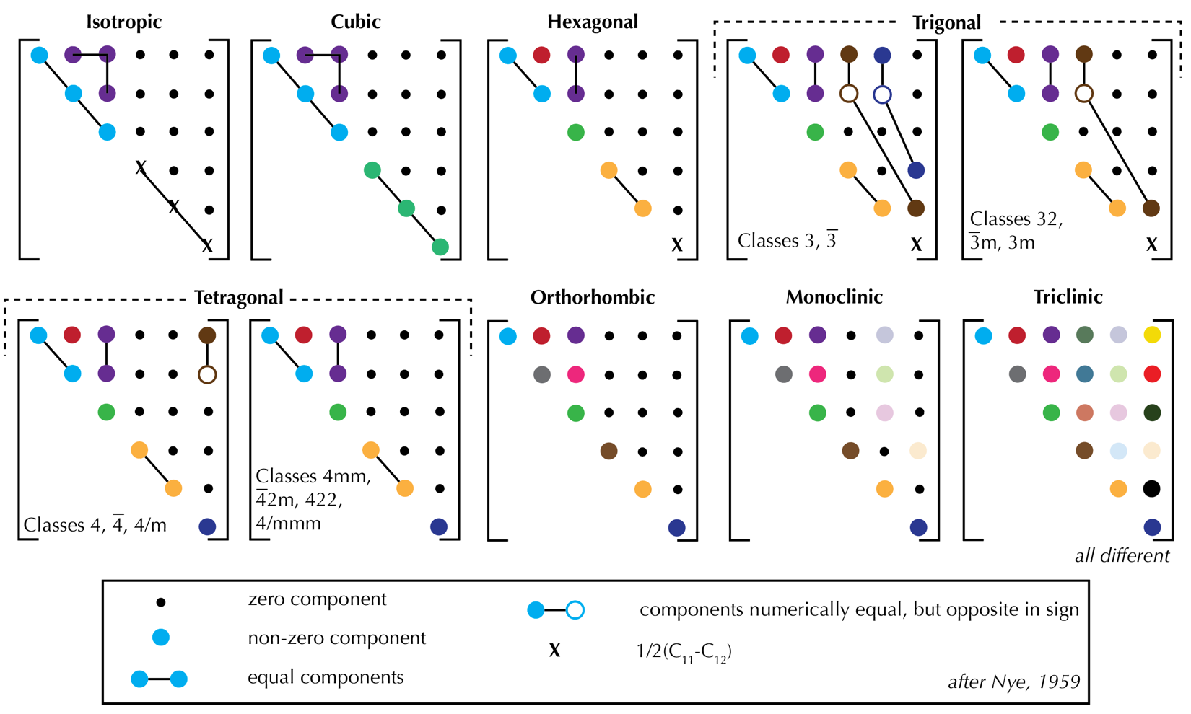

Figure 3.7. Conventions for stiffness tensors for different mineral symmetries. Published stiffness tensors will commonly only report the unique C_{ij} values. For example, an isotropic tensor might only report two numbers: C₁₁ and C₁₂, because all of the remaining non-zero components can be figured out from those.

Now we need to add the stiffness tensor to the MSAT database.
- Open MS_elasticDB.m in Matlab.
  - If you scroll down to Line 58, you’ll see the function call followed by the command ‘case,’ which tells the function to look for your input (mineral name) and to get the information for that particular input.
- The first entry is for olivine. Note that it has two options to call it: either the full mineral name or the abbreviation. The variable ‘info’ stores the citation information, and then you have two variables: C (the stiffness tensor) and rh (the density in kg/m³)

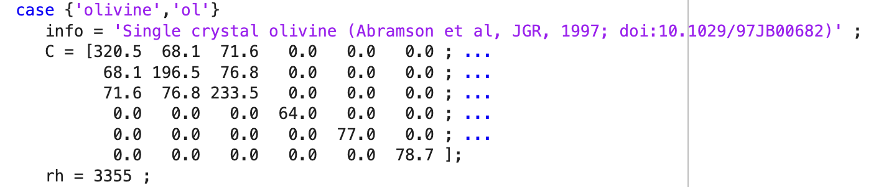
- To add a new mineral, copy and paste the entire block shown above, from case to the ; after the density.
  - You must paste this above the line that says otherwise and you cannot paste it within another block (between case and the ; after rh = ####).
- For this tutorial, add a return on Line 70 and paste the entire block on Line 70.
  - You will now have two copies of olivine in your database, so let’s edit this to match the muscovite stiffness tensor from above.
  - Note! You will need to add the density. This is a great time to go back to the Abers & Hacker (2016) toolbox and calculate the velocities and densities for a single mineral at standard temperatures and pressures. Remember that MSAT doesn’t adjust for P-T conditions, so you should be consistent.
  - Once you have it added, check your script against the screencap below. We highly recommend that you use extra spaces to keep the components aligned as shown below.

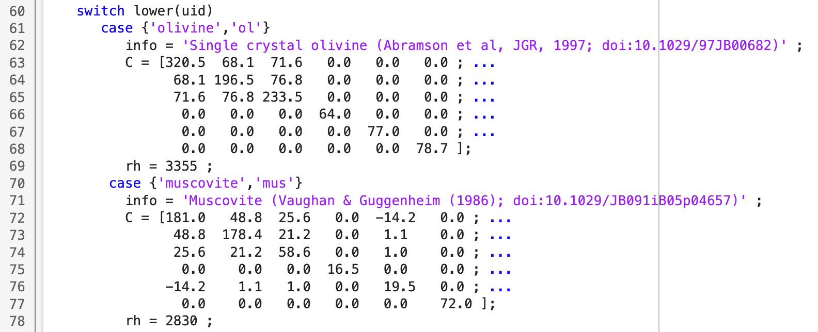

- Let’s see what the plot looks like!
  - Remember to load the stiffness tensor and density with: MS_elasticDB
  - And plot with: MS_plot. If you get an Elasticity matrix error: non-symmetric, check your numbers against the ones above. This is the most common error to get at this point, and it means that you’ve mistyped something when you added the stiffness tensor.

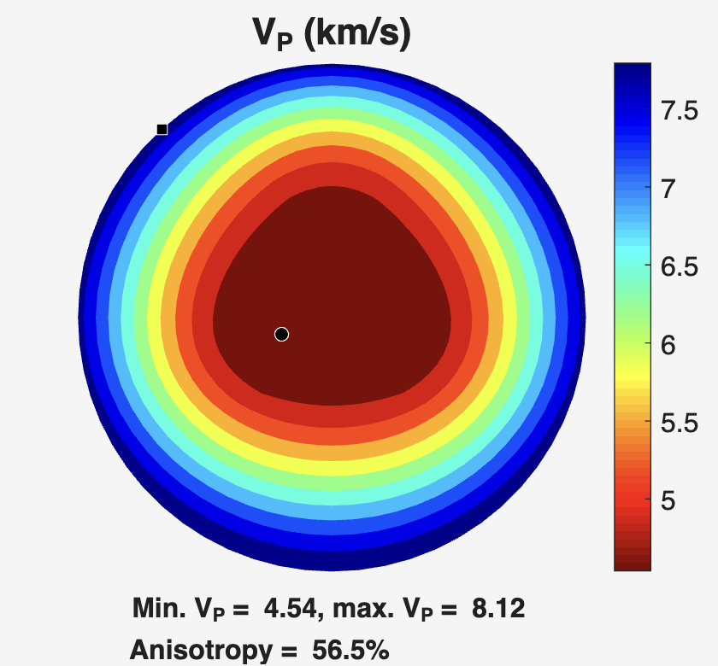
Try it! The c-axis in muscovite is seismically slow. Does this make sense given the plot and the conventional orientation for the stiffness tensors shown in Fig. 3.5? Hint: the answer is yes!
Try it!
Now let’s try adding a slightly more complicated mineral stiffness tensor: calcite! Calcite is a trigonal ($\overline{3}m$class) mineral. We will be using the components reported by Chen et al. (2001):

C₁₁ | 149.4 |  | C₁₂ | 57.9
C₃₃ | 85.2 |  | C₁₃ | 53.5
C₄₄ | 34.1 |  | C₁₄ | -20.0

If you look at the number on non-zero component in the trigonal ($\overline{3}m$class) in Fig. 3.7, you should notice that there aren’t NEARLY enough values reported to fill this out. This is because some values are the same as the reported ones and some are calculated from the reported ones.
- Figure out the complete stiffness tensor. We recommend doing this on paper first.
- Add the calcite stiffness tensor and density to MS_elasticDB.m following the steps from the muscovite example.
- Try to plot V_{P} for calcite. If you have made a mistake, this is the most likely place it will show up!
  - If you get an Elasticity matrix error: non-symmetric, check your stiffness tensor against the solution below. It likely means that you don’t have the correct values.

If you’ve done it right, your V_{P} plot should look like this:

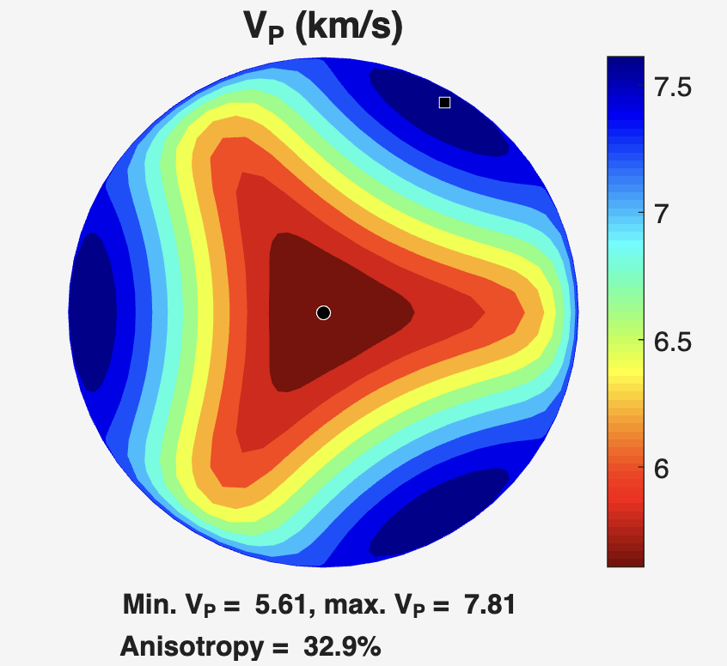

Below is the full stiffness tensor if you get stuck:

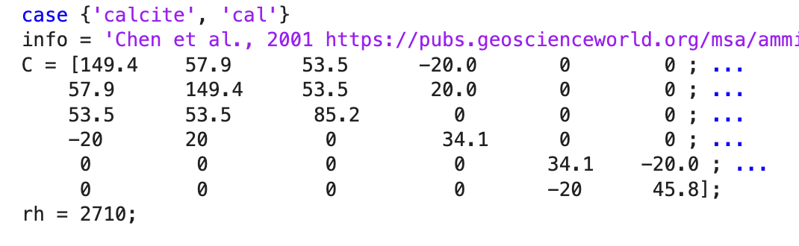

Modelling seismic velocities for a single lithology
In this next section, we are going to present a technique that models the velocities for a single ideal lithology. You can do these calculations using EBSD data and MSAT, which will take into account the actual mineral orientations and relative abundances. If you are interested in doing this, check out the MSAT User Guide for the functions that you should use. This tutorial walks you through how to do these calculations for variations on a larger scale than can commonly be measured with EBSD data (e.g., outcrop to km-scale exposures) that we can’t easily get at with EBSD.

If you want to combine these methods, you can get representative samples for each lithology, calculate the seismic velocities from the EBSD data using MSAT, and then average the lithologic velocities as described below.

Example rock: quartz mica schist
Let’s start by pretending that we have a quartz mica schist (75% quartz and 25% mica) that we want to model. For the purposes of this exercise, we’re going to pretend that the quartz deformed by pressure solution creep. This would mean that the quartz is likely randomly oriented. On the other hand, micas commonly have a strong shape preferred orientation, with the short axis (c) oriented perpendicular to foliation. This imparts a crystallographic preferred orientation as well, because of the crystal habit. To model this rock, we are going to:
- Calculate isotropic velocities for the randomly oriented quartz and calculate an equivalent stiffness tensor
- Load and rotate the muscovite stiffness tensor to an appropriate orientation
- Calculate a weighted average of the stiffness tensors to model the whole lithology
- Extracting velocities and plotting V_{P}/V_{S}

Remember from Part 1 that we are creating an effective medium. By taking the relative abundance of isotropic (randomly oriented) quartz and oriented muscovite and calculating a weighted average stiffness tensor, we are creating a pretend ‘rock’ that will behave the same as a foliated quartz-mica schist with alternating zones of quartz and mica. This is because the seismic velocity data is sampling at larger scales and averaging these smaller scale variations.

Step 1: Creating an isotropic quartz stiffness tensor
Quartz is not an isotropic mineral! But quartz in ductilely deformed rocks can be randomly oriented, depending on the deformation mechanism. This step is appropriate for quartz deformed by pressure solution or diffusion creep, but if you have good evidence of wide-spread dislocation creep in quartz, you might want to model your quartz as an anisotropic media. For the purposes of this example, we’re going to use the quartz to show you how to deal with randomly oriented minerals.

- Load the quartz stiffness tensor from the MSAT database, using the code below:
[C, rh] = MS_elasticDB('quartz')
- Plot the quartz velocities, which will calculate isotropic velocities
  - To do this, your first need to modify MS_plot to make the isotropic velocities available.
  - On Line 129, where the function is defined, it currently reads:
function MS_plot(C,rh,varargin)
  - Change this line to read:
function [VPiso, VSiso] = MS_plot(C,rh,varargin)
This will allow you to access the average wave speeds that MS_plot calculates.
  - Now try plotting it and assigning VPiso and VSiso using:
[VPiso, VSiso] = MS_plot(C, rh)

Note that it does not matter which pole figures you plot, so you can choose to plot only VP if you would like.
- Calculate an equivalent isotropic stiffness tensor.
  - MSAT has a function to do this as long as you provide the average V_{P} and V_{S} values and the density. This function is MS_iso and is called as such:
[C_qtziso] = MS_iso(VPiso,VSiso,rh);
  - Once you have called this function and have an equivalent stiffness tensor for isotropic quartz (C_qtziso), plot V_{P} using MS_plot. You should get a plot with a single color because this stiffness tensor is isotropic. See the plot below to check your work:
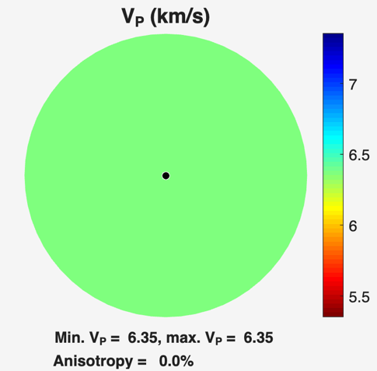

Step 2: Creating a stiffness tensor for mica in the correct orientation
We’re going to pretend our mica is oriented with respect to the foliation because this is common for deformed mica. This is a case where working with idealized rocks is useful, because mica commonly doesn’t index well on EBSD, making it hard to collect actual orientation data.
- Load the muscovite stiffness tensor from the MSAT database, using the code below. We’ve already done this, so you might have the stiffness tensor already, depending on whether you’ve changed the variable names. As written, this will overwrite the quartz stiffness tensor, but we only need the isotropic one for the calculations we’re doing, so this is okay.
[C, rh] = MS_elasticDB('muscovite')
- Next, we need to rotate the muscovite stiffness tensor into an orientation that makes more sense for our plotting convention shown in Fig. 3.4b. Mica is a platy mineral where the c-axis is the short axis. In most deformed rocks, mica orients so that the a- and b-axes are within the foliation plane and the c-axis is perpendicular to the foliation. The c-axis is the seismically slow axis of mica.
  - Let’s plot the muscovite stiffness tensor in its current orientation and see if it makes sense for our case. Remember to use MS_plot to visualize the mineral orientation:
  - This plot shows us that the c-axis is oriented in the foliation plane and perpendicular to lineation (Fig. 3.8). This is not what we want, so we need to rotate it. Check Fig. 3.6 for the rotation convention and try to come up with the MS_rot3 call that you need before checking the next step.
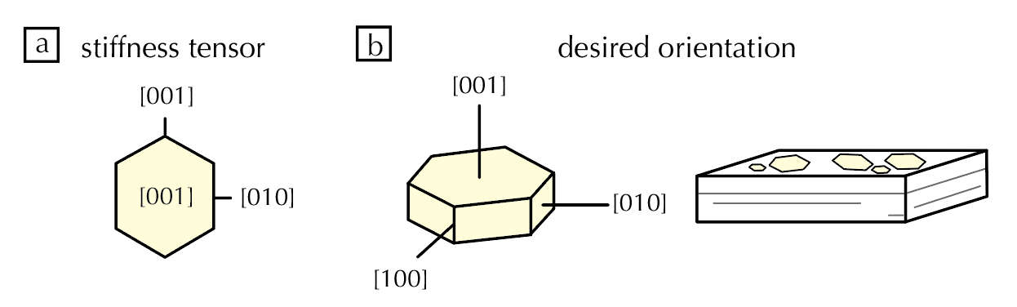
Figure 3.8. a) Diagram showing the mica orientation just loaded from the database, based on the convention for stiffness tensors. b) desired orientation with respect to a foliation. To get this, we need to rotate the stiffness tensor.

    - To get the c-axis perpendicular to foliation, we need to rotate 90° around Axis 2. The call in Matlab looks like this:
[C_mus_rot] = MS_rot3(C,0,90,0);
    - You want to assign this to a unique variable name, as written above, so that you can use it in the next step.
    - If we plot this, we get minimum velocities perpendicular to the foliation, which is what we want. We recommend that you always plot to make sure that your rotations are correct!
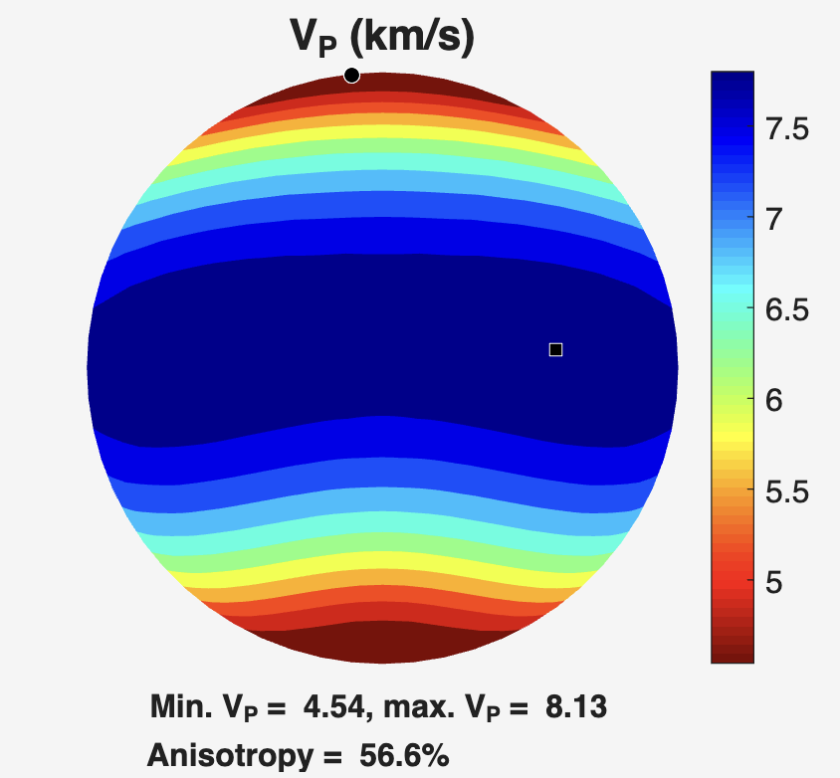
  - Note that this implies that the a- and b-axes also have a preferential orientation, with the b-axis parallel to lineation. This is unlikely for our micas if they are simply flattened into the foliation plane. We might expect that the a- and b-axes would be randomly oriented in the foliation plane. However, this doesn’t matter for mica as the velocities are relatively isotropic in these axes (see above).
    - This is not true for shear wave splitting, so if you are considering V_{S1} and V_{S2} separately, you should think about how to incorporate that variations (see suggestions at the end of this document).
Try it! You don’t have to take our word for it that the velocities don’t vary much for the a- and b-axes. Try rotating the stiffness tensor around Axis 1 and see how much of a difference it makes.

Step 3: Calculating a weighted average to model lithologic velocities
We now have stiffness tensors for our component minerals. To figure out the velocities for the rocks instead of the minerals, we are going to calculate a weighted average stiffness tensor and use that to model the velocities. This is analogous to what we did in Part 2, we’re just working with more complicated variables. Luckily, MSAT has a built in function to average stiffness tensors for us. The function call looks like this:

[Cave,rhave]=MS_VRH(VF, C1, rh1, C2, rh2, C3, rh3, ...)
[Cave,rhave]=MS_VRH([.25 .75],C_mus_rot, rh_mus, C_qtziso, rh_qtz)

VF is the volume fraction and must add up to 1. Be sure to put the volume fractions in the same order as your stiffness tensors.

This function will automatically output the Voight-Reuss-Hill (VRH) average for however many components you add in. You can also have it output the Reuss average and the Voight average, if you want. These are three different ways of calculated a weighted average of a stiffness tensor. The Voight is the mathematical upper bound, and the Reuss is the mathematical lower bound. The Voight-Reuss-Hill is an arithmetic mean of these two bounds and is a good average approximation of the resulting tensor. If you want, you can compare the outputs of these different methods to see how much of a difference they make.

- Calculate the Voight-Reuss-Hill average for a rock that is 25% oriented mica (C_mus_rot) and 75% randomly oriented quartz (C_qtziso) using MS_VRH (see above for how to type this out).
- Plot the velocities from this average stiffness tensor.
  - “Hey, these look a lot like what I plotted for muscovite on its own,” you might say. That’s because your quartz is isotropic, so the anisotropy comes from the muscovite, but the absolute values are different (left and center below) and the anisotropy is less when quartz is averaged in.
  - You can test this by setting the caxis color limits to the max and min V_{P} for muscovite only (right below). This can be done in Matlab using:
caxis([4.54 8.13])
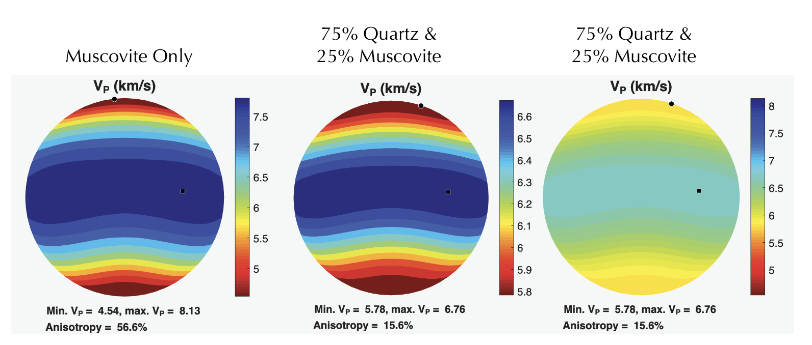
Try it! Change the relative abundances so that it is mostly quartz or mostly muscovite. What happens to the velocities and anisotropy? Does it make sense given that we are assuming quartz is randomly oriented.
Step 4: Extracting velocities for specific incidence angles and plotting V_{P}/V_{S}
We can look at the pole figures to determine the range of velocities and relative patterns, but we might want to extract velocities for specific incidence angles. To do this, we use the built in function MS_phasevels

[pol,avs,vs1,vs2,vp] = MS_phasevels(C,rh,inc,azi)

- Get the velocities perpendicular to foliation. In this case, inc = 0 and azi = 0. You should get the following results:
$$V_{S1}=3.7220 km/s$$
$$V_{S2}=3.6606 km/s$$
$$V_{P}=5.8127 km/s$$
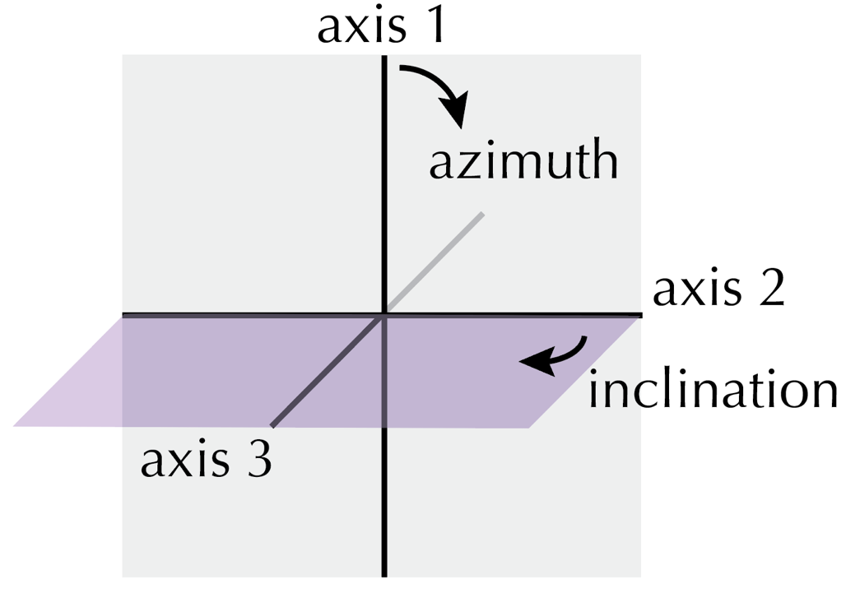

Figure 3.9. Diagram showing how angles are defined for MS_phasevels. For azimuth, the angle is zero parallel to axis 1. For inclination, the angle is zero at the axis 1 – axis 2 plane.
Try it! What are the velocities in the plane of foliation and perpendicular to lineation (axis 3)?

Hint: check your values against the pole figure and make sure that they make sense!

Depending on the data that you’re comparing to, you might care about the V_{P}/V_{S} ratio. This is very common for velocities from receiver functions and common in data from subduction zones. If you extract the velocities for specific orientations, you can directly calculate V_{P}/V_{S} in Matlab. But you might want to also be able to plot V_{P}/V_{S} so that you can see different patterns. To do this, we’re going to add some lines of code to MS_plot.
- Open the MS_plot file in Matlab
- Add the following on Line 414 directly above where it says case 'avspol'

case 'vpvs'
% VPVS ratio
contour_pole(X, Y, VP./((VS1+VS2)./2), view_angle, VScvect,...
cmap, fntsz, ...
buggyMATLAB, 'V_{P}/V_{S}')

case 'vpvs1'
% VPVS ratio
contour_pole(X, Y, VP./(VS1), view_angle, VScvect,...
cmap, fntsz, ...
buggyMATLAB, 'V_{P}/V_{S1}')

case 'vpvs2'
% VPVS ratio
contour_pole(X, Y, VP./(VS2), view_angle, VScvect,...
cmap, fntsz, ...
buggyMATLAB, 'V_{P}/V_{S2}')

This will allow you to plot V_{P}/V_{S}, V_{P}/V_{S1}, and/or V_{P}/V_{S2} for any stiffness tensor that you create. Try plotting these three:

MS_plot(Cave, rhave,'plotmap',{'vpvs','vpvs1','vpvs2'})

You should get a set of plots as shown below. Notice that the patterns are slightly different than V_{P} alone.

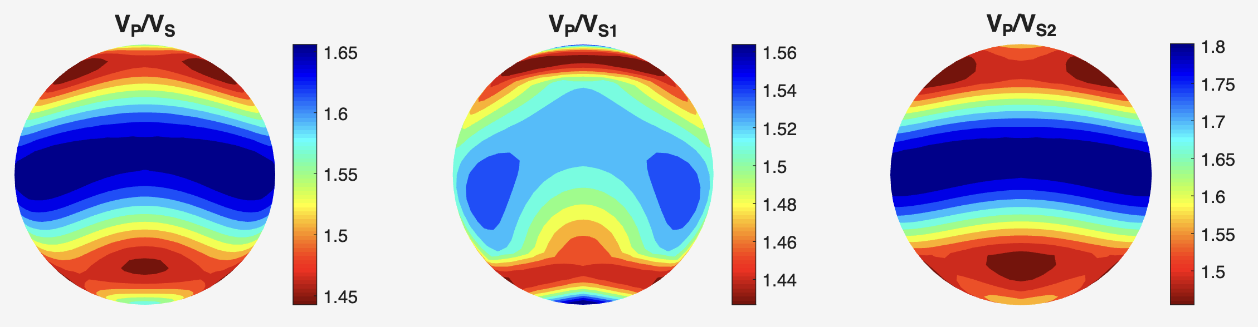
Try it! You now have all the skills you need to model any lithologies and any suite of rocks that contain multiple lithologies. Even though we only calculated an effective stiffness tensor for one lithology, you can take that effective stiffness tensor and calculate a weighted average with others using MS_VRH to model velocities for multiple lithologies. You’re going to try that now! The area that you are interested in is composed of:
- 60% quartz mica schist, which you’ve already modelled
- 30% calcschist, which is composed of:
  - 40% randomly oriented calcite
  - 30% muscovite oriented as in the quartz-mica schist
  - 30% randomly oriented quartz

You have all of the stiffness tensors you need in the database, so follow the strategy from this section:
- Load stiffness tensors for all minerals
- Create an isotropic stiffness tensor for the randomly oriented minerals
- Calculate the average stiffness tensor for each lithology
- Calculate the average stiffness tensor for the suite of rocks by averaging each lithology’s average stiffness tensor with a volume fraction [0.6 0.3]

When you’ve completed the last part, check your calculations using the V_{P} plot below. You should notice that there is only a small difference between this and the quartz mica schist – slightly faster because of the calcite and slightly more anisotropic because there is more mica overall.

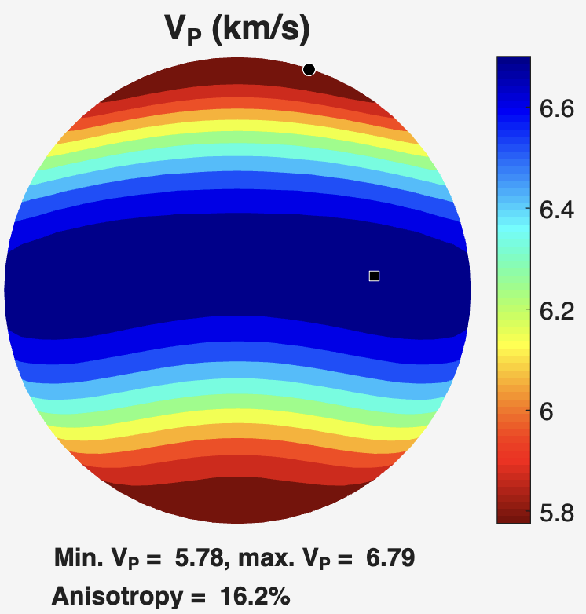

Challenge. Calcite is a more complicated mineral to model because it doesn’t have 3 orthogonal axes. Let’s imagine that you have a calcschist with the c-axis perpendicular to the foliation but the other axes randomly oriented in the foliation plane. How might you model this using the techniques that we’ve learned so far?

Modelling your own area
You can go from here to model your own rocks! You will need to decide on what lithologies you want to account for, determine the mineral modal abundances for each lithology, determine which minerals you want to model as aligned (and what orientations) and which minerals you want to model as isotropic, and determine the modal abundances of the lithologies that you want to model.

As you get started on this part, you might be asking the questions:
- How many lithologies?
- How detailed do I need to be with my minerals?

These are tough questions, but you can determine how detailed you need to be using a sensitivity analysis. This is a strategy where you change your assumptions and see how much of a different it makes in the overall calculations. Examples:
- You have some lenses of a different lithology that make up a small proportion of the overall rocks. Calculate velocities with or without these lithologies to see if including them significantly changes the results.
- Similarly, you have a small proportion of a mineral in a given lithology. Calculate the velocities with and without that mineral accounted for to determine if including it significantly changes the results.

Sensitivity analyses are a great way to determine what simplifying assumptions you can or can’t make!

Also remember that this does not take into account the P-T conditions, but you can model prograde and retrograde lithologies by changing the mineral modal abundances (e.g., glaucophane vs. chlorite) based on what minerals you expect in each lithology. This can help you determine whether your overall velocities vary on each path.

References
Bernard, R.E., Schulte-Pelkum, V. and Behr, W.M., 2021. The competing effects of olivine and orthopyroxene CPO on seismic anisotropy. Tectonophysics, 814, p.228954.
Chen, C.C., Lin, C.C., Liu, L.G., Sinogeikin, S.V. and Bass, J.D., 2001. Elasticity of single-crystal calcite and rhodochrosite by Brillouin spectroscopy. American Mineralogist, 86(11-12), pp.1525-1529.
Christensen, N.I., 1984. The magnitude, symmetry and origin of upper mantle anisotropy based on fabric analyses of ultramafic tectonites. Geophysical Journal International, 76(1), pp.89-111.
Nye, J. F. Physical Properties of Crystals. London: Oxford University Press, 1959.
Vaughan, M. T., and Guggenheim, S. 1986. Elasticity of muscovite and its relationship to crystal structure, J. Geophys. Res., 91(B5), 4657–4664.
Walker, A.M. and Wookey, J., 2012. MSAT—A new toolkit for the analysis of elastic and seismic anisotropy. Computers & Geosciences, 49, pp.81-90.

