What’s in Your Water?
Applying Hydrogeology to Real World Problems

Part I: Water and Weathering

Have you ever stopped to think about where water comes from in Arizona? It may not be something we consciously think about every day, but it's important to know where Arizona’s water is coming from and what makes up its chemical composition.

Q1.1 Before continuing, make a prediction about where Arizona’s water comes from.

The interaction between rocks and water is a dynamic process that is influenced by a wide range of physical, chemical, and environmental factors. When rocks come in contact with water, several physical processes take place. Firstly, the water exerts a force on the rocks, which can cause them to break down into smaller pieces over time. This is known as mechanical weathering. Secondly, water can also dissolve minerals in rocks, causing them to break down chemically. This is known as chemical weathering. Both of these processes can contribute to the erosion of rocks, and ultimately lead to the deposition of sediments in another location.

Q1.2 What are some ways in which rocks interact with water and how are these processes affected by water?

Q1.3 What may happen to the chemical composition of water due to these interactions?

The water we drink and use in our daily life is part of a complex global water cycle and surface water is a major part of that cycle. Surface water is broadly defined as rainwater that flows from geographically higher elevations to lower elevations and a watershed is a geographical area where all of the rain that falls ends up flowing into one river (Figure 1). Watersheds can be made of multiple different rock types depending on the geologic history of the area. Tempe Town Lake, located in Tempe, AZ, is a combination of water from the Salt and Verde watersheds as well as Colorado River water brought in via the CAP canal (Figure 1).

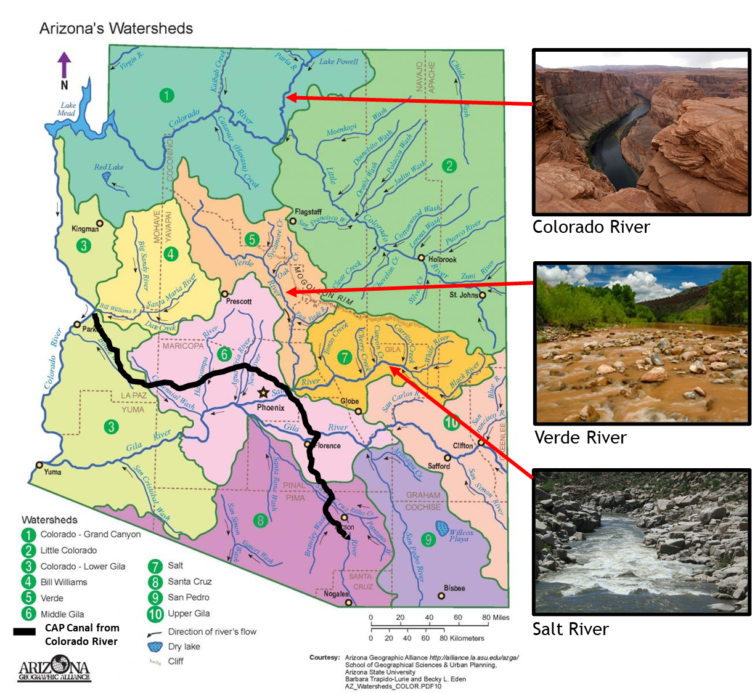

Figure 1: Watershed map of Arizona with example pictures of the Colorado, Verde, and Salt Rivers. The Central Arizona Project (CAP) canal is shown as the solid black line.

Q1.4 Describe any differences you notice in the river environments shown in Figure 1.

Q1.5 How could the watershed environment impact the composition of water sources? (HINT: Take a moment to think about whether the geological environment is identical for all three watersheds.)

Rock composition plays a significant role in determining the chemical composition of water sources. The common term “rock” is used to describe a solid containing multiple minerals. Minerals are the pure crystalline solid forms of chemical compounds with distinct physical and chemical properties. Minerals can be dissolved by water leading to increased aqueous (dissolved in water) concentrations of the mineral’s component elements (ions). You have probably observed this “water-rock reaction” on a much smaller scale in your kitchen when you make a glass of salt water. Common table salt (NaCl) is a mineral called halite.
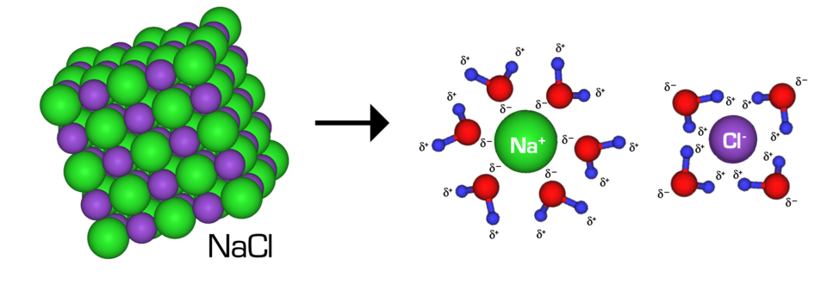
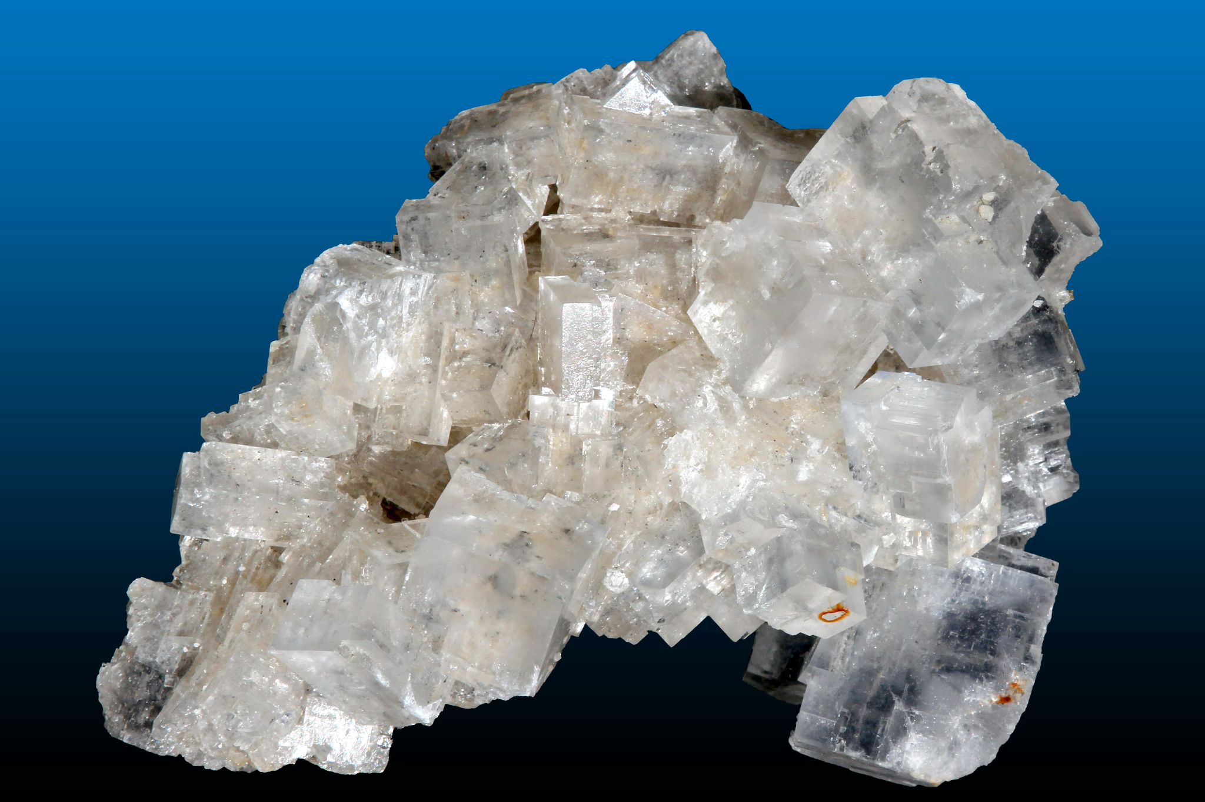

Figure 2: Halite is a mineral widely known as table salt. It dissolves into sodium and chloride ions in water.

We can write a dissolution reaction to understand the different ions present in solution when halite dissolves:

NaCl(s) → Na⁺(aq) + Cl⁻(aq)

(s) indicates a solid and (aq) indicates dissolved in water (aqueous phase). We are not showing water in this reaction as it is implied with (aq).
There are many different types of minerals in the world and by studying rock formations, we can better understand the different environments that water has interacted with over time. As water flows over and through a watershed, water can encounter many different types of minerals and the chemical composition of the water reflects the mineral composition of the watershed.

The mineral halite is found within the Salt River watershed. As water dissolves some of the halite you will observe increased sodium (Na⁺) and chloride (Cl⁻) ions in the river.

Q1.6 What type of dissolved ions would you expect to find in a river if its watershed contained anhydrite deposits like the Colorado River does? Anhydrite has the chemical formula CaSO₄.

We can plot differences in chemical composition between water sources (based on region) on a ternary plot like the example below. Upstream samples from the Salt, Verde, and Colorado Rivers are shown as red, black, and blue circles, respectively. We are considering these upstream samples as individual sources of water, also called endmember compositions.

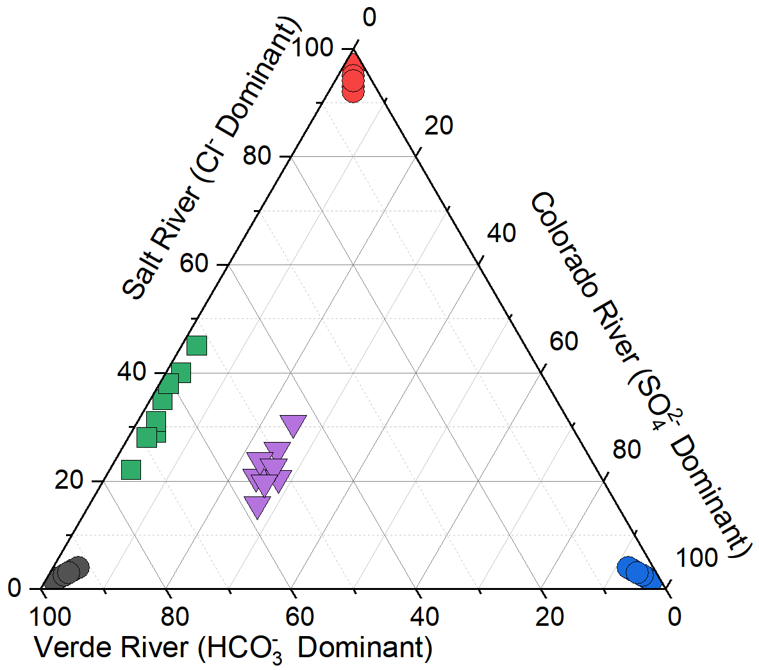

Figure 3: Ternary diagram showing endmember river compositions. The Colorado River composition is blue, Verde River is black, and the Salt River is in red.
Q1.7 Looking at Figure 3, hypothesize why the cluster of green squares separates out from the endmember compositions.

Q1.8 Looking at Figure 3, what process(es) could drive the cluster of purple triangles to exhibit their distinct signature?

Here is a stunning example of mixing rivers in Geneva Switzerland:
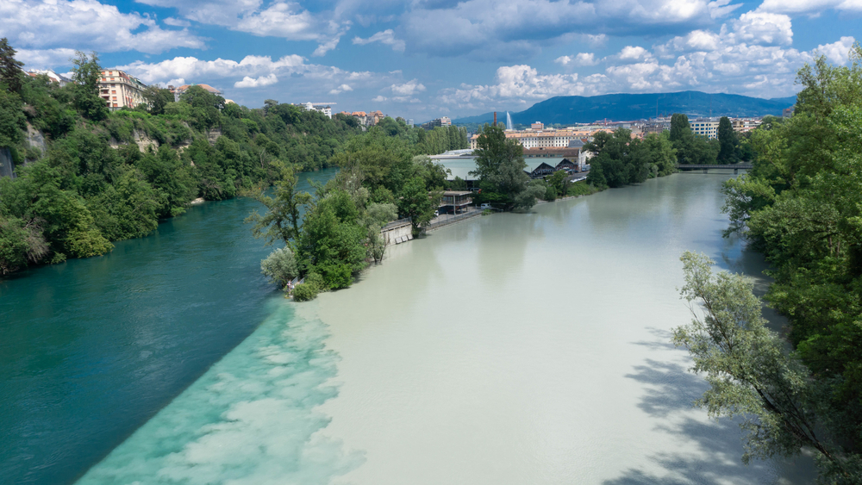
Figure 4: Rivers in Geneva, Switzerland.

Q1.9 How many water sources are you able to observe in Figure 4?

Q1.10 What evidence do you see for the mixing of the water sources in Figure 4?

Part II: Chemical Properties
Think about the scenario you just described where you noticed different water sources were mixing together. This not only impacts the color of the water, but also how much of each type of mineral is present in the endmember sources and downstream mixing area. This property is called concentration, which refers to the amount of a substance present in a given volume of water, and can drastically affect the liquids appearance and chemical behavior.

To help illustrate this concept, imagine you have three clear glasses of water, and you want to add food coloring to them. If you add just one drop of red food coloring to glass 1, you might barely notice a difference in its color. If you add 5 drops to glass 2, and a tablespoon to glass 3, the water will become increasingly darker.

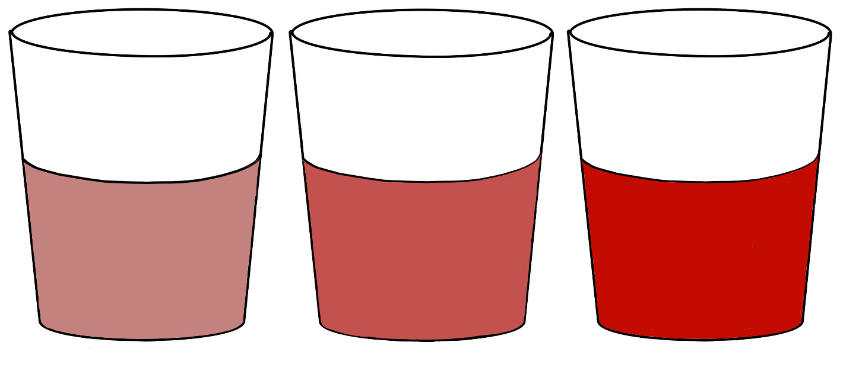

#1 #2 #3

Figure 5: Example of concentration changes by adding differing amounts of food coloring.

Q2.1 How would you compare the concentration of food coloring in Figure 5? Which glass has the highest concentration?

Q2.2 Can you think of any real-life examples where understanding concentration would be important?

A higher concentration isn’t always associated with a color change, however. Let’s revisit the table salt example from earlier. Dissolving halite (table salt) into water does not change the color of the solution, but the water will taste saltier as you add more table salt. If you were to add a couple of grains of table salt to a glass of water you probably wouldn’t be able to taste any difference but if you add a tablespoon of salt your glass of water would taste like the ocean! By adding more table salt to the glass of water, you are increasing the concentration of sodium (Na⁺) and chloride (Cl⁻) ions in the solution. Tasting chemical solutions is never a good idea so scientists have invented specialized machines to analyze the chemical concentrations in water!

Q2.3 What does it mean when we say a substance has a higher concentration in a given volume of water?

Q2.4 How does concentration relate to the dissolving of minerals in a water source?

When we think about concentration it’s easy to imagine solid substances like minerals and table salt dissolving into water and increasing concentration but hydrogen ions in water are also measured as a concentration. Hydrogen ions are the most abundant element in our universe, and their concentration is so important that it has its own scale, known as the pH scale. pH historically denotes the “potential of hydrogen” or the “power of hydrogen” which directly relates to the logarithmic concentration of hydrogen ions (H⁺) in a solution.

A lower pH value indicates a higher concentration of H⁺ ions (and consequently less OH⁻, called the hydroxide ion), signifying a more acidic solution. In contrast, a higher pH value indicates a lower concentration of H⁺ ions (and consequently more OH⁻), denoting a more basic solution. The more H⁺ the lower the pH number and higher pH values indicate less H⁺. When H⁺ and OH⁻ are at the same concentration in a solution (equilibrium) we call that neutral (pH = 7 @ 25ºC). Brackets “[ ]” in chemical equations indicate concentration so the chemical equation for pH equilibrium is: [H⁺] = [OH ⁻]

Having a lot of hydrogen ions in solution (or very few for that matter) can change the interactions between chemicals in the water and can make the solution more reactive with other materials. In order to better understand this concept, let's look up the pH of some common substances online! Approximate values are acceptable.

Q2.5 Battery Acid (Sulfuric Acid): _______________

Q2.6 Ocean Water: _______________

Q2.7 Bottled Drinking Water: _______________

Q2.8 Coffee: _______________

Q2.9 Bleach: _______________

Q2.10 Why do you think it is bad to get battery acid or concentrated bleach on your skin?

Chemical analysis allows us to measure the concentration of dissolved ions (from minerals) and H⁺ in water. However, it is important to note that once minerals are dissolved in water, their dissolved ionic parts can combine and form new compounds that may be different from the starting compounds. For example, in the Salt river, positive sodium ions, Na⁺, from halite can combine with a negative sulfate ion, SO₄²⁻, from anhydrite dissolving in the Colorado river to form a new compound,$Na_{2}SO_{4}$. This “new” compound was not part of the starting minerals (halite or anhydrite) but has parts from each starting ingredient. The recombining of positive and negative ions from multiple initial compounds to form new compounds is called chemical speciation.
Similar to the biological classification of species where Mandrills and Snow Monkeys are both types of monkey (sharing similar DNA) but live in vastly different environments. Just like you would expect to find Mandrills in Western Africa and Snow Monkeys in the snowy regions of Japan, different chemical species are more dominant in different solutions of water.

The pH of a solution can greatly influence which compounds form when minerals dissolve in water. Adjusting the pH increases or decreases H⁺ ions on one side of a chemical equation, altering the equilibrium chemical speciation, which can change the concentration of chemical species in solution. Some chemical species stay dissolved in the water while others will form a solid and precipitate out of water over time, or vice versa. Part III of this lab provides us an opportunity to investigate chemical speciation and its connection to pH using a public health emergency as an example.

Q2.11 In your own words, explain what happens when minerals dissolve in water.

Q2.12 If you have two cups of water with vastly different pH values, would you expect to find the same chemical species present in each cup of water? Explain your reasoning.

Q2.13 Using the concept of speciation, give examples of 5 compounds that could possibly be formed from the following ions (hint: think back to a previous chemistry class, positive and negative charges should sum together): Ca²⁺, Mg²⁺, Pb²⁺, Na⁺, Zn²⁺, NH₄⁺, Li⁺, Cl⁻, Br⁻, F⁻, SO₄²⁻, NO₃⁻, OH⁻, CO₃²⁻. Examples: Pb²⁺ can combine with CO₃²⁻ (2 positive charges with 2 negative charges) to make PbCO₃ (lead carbonate). Pb²⁺ can also combine with Cl⁻ (2 positive charges with 1 negative charge) to make PbCl⁺.

Part III: Real Life Chemical Speciation Example

The residents of the City of Townsville, USA were concerned when they noticed the water coming out of their taps was a strange color. Some residents even reported an unpleasant metallic taste. The residents called the City of Townsville department of water quality and were reassured many times the drinking water was safe. Despite this reassurance, the residents were still worried and started to notice an increase in sickness within the community. Convinced that something was seriously wrong, the residents of the City of Townsville began to investigate.

The community took samples of tap water from around the City of Townsville and discovered some tap water was almost opaque! This is a picture of some of the water samples.

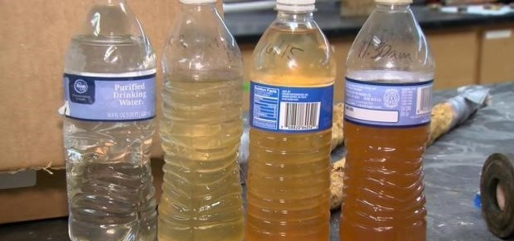

Figure 6: Water samples collected by residents of the City of Townsville

Q3.1 Based on your current knowledge, what is your initial hypothesis about what is going on with the City of Townsville’s water?

Q3.2 If this were happening in your town, what would you do with the water samples as a first step to understanding the composition of the water? What types of information would you want to know about the water assuming you had full access to scientific equipment?

The residents knew that all of their water came from the same source – the City of Townsville water treatment plant – so they brought in a state environmental inspector to assist with the investigation. The City of Townsville department of water quality fully cooperated with the inspector and allowed her to access all of their records and data logs.

The inspector was provided with a map of the City of Townsville that showed most of the drinking water service lines supplying individual houses used lead piping. This did not strike her as unusual though as there are an estimated 9-13 million lead service pipes across the USA.
The inspector had a flashback to when she was studying for the Professional Engineer exam and remembered that typically, lead carbonate (PbCO₃, a chemical species of lead) scale builds up on the inside of a lead pipe and forms a relatively insoluble layer that prevents the bare metal of the lead pipe from dissolving into the water. An example of scale build up is shown in Figure 7.

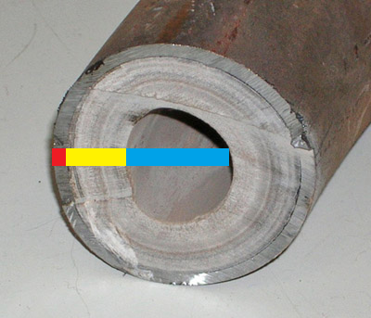
Figure 7: Cross section of scale build up inside of a pipe. Metal pipe section indicated in red, scale buildup section indicated in yellow, and free flowing water section indicated in blue.

Next on the inspectors list was examining the water plants daily operational logs. The inspector was surprised to discover the City of Townsville department of water quality recently authorized a change in the water source supplying the plant. The plant operators assured the inspector the water from the new source was being properly treated and was perfectly safe to drink.

As the inspector was browsing the daily logs, she got a call from the state lab where the tap water samples were sent. The technician at the lab informed the inspector that the water samples contained dangerous concentrations of lead and asked if the samples came from the local hazardous waste treatment facility. The water treatment plant manager saw a wave of horror cross the inspector’s face.

Q3.3 If the pipes had always been made of lead, but the residents are only getting sick now, what changes do you suspect caused the increased amounts of lead and why?

The inspector did not see any data for the pH of the new water source but she did see the original water source was logged at a pH of 10. The inspector used a pH meter to measure the pH of the new water source flowing through the water treatment plant. The inspector recorded the new water source had a pH of 5.5.

Figure 8 (below) is an idealized model where tap water is allowed to reach equilibrium with lead pipe scale (PbCO₃) at different pH values. This model does not incorporate the flow through aspect of water flowing in a pipe but represents water in constant contact with lead scale. Here is the generalized chemical reaction for this model:

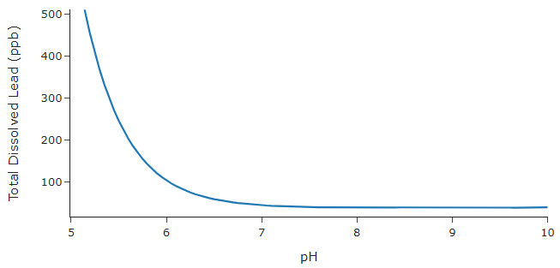
PbCO₃ (s) + H⁺ (aq) ⇌ Pb²⁺ (aq) + HCO₃⁻ (aq)

Figure 8: Idealized equilibrium model of water in contact with lead scale (PbCO₃) as a function of pH. The solid line indicates total lead dissolved (parts per billion) in water at equilibrium. Calculated using the WORM Portal, details in references.
Q3.4 Based on Figure 8, how does total dissolved lead in the drinking water change as you lower pH?

Q3.5 Now reflect back to your original hypothesis from Question 3.1. Do you want to change your prediction of what is going on with the City of Townsville’s water? Why or why not?

Q3.6 Summarize in 1-2 sentences, what is one plausible explanation for the dangerous amounts of lead in the residents’ of the City of Townsville’s drinking water?

The fictionalized situation above actually began unfolding around 2014 in Flint, Michigan, leading to a major health crisis in the community. Your investigation demonstrates how important it is to identify and understand potential sources of water supply contamination, especially when making such a large change to a critical drinking water system. This type of knowledge is crucial in real-life situations to prevent harmful health effects and ensure safe drinking water for all.

As of January 2022, Flint officially marked its sixth year in a row of being in compliance with water standards as they pertain to the federal Lead and Copper Rule, a public health measure developed by the EPA to improve lead sampling. As of September 2022, the Michigan government announced that it was in its final phase of replacing old lead service lines with modern infrastructure. The city of Flint and the Michigan Department of Environment, Great Lakes and Energy reports that 95% of the old infrastructure has been updated. Flint water quality is still being continuously monitored and infrastructure upgrades are in progress.

The pH difference between water supplies was just a part of the chemistry changes that led to the Flint crisis, you can read more about it here.
This activity was created by PhD candidate Vince Debes, Professor Molly Simon, Research Scientist Grayson Boyer, Professor Everett Shock, and undergraduate Peyton Idleman at Arizona State University.

References:

Figure 1: Arizona watersheds and pictures
- CAP canal line
  - https://www.cap-az.com/water/cap-system/water-operations/system-map/
  - https://www.cap-az.com/wp-content/uploads/2021/07/img-system-map-blank-2021.png
- Verde River Image
  - https://www.nature.org/en-us/get-involved/how-to-help/places-we-protect/verde-river/
- Salt River (Upstream) Image
  - https://earthly-musings.blogspot.com/2010/05/rafting-rapids-and-geology-of-salt.html
- Colorado River Image
  - https://www.politico.com/news/2023/02/04/colorado-river-biden-climate-change-water-00080990
- Arizona watersheds map:
  - https://19january2021snapshot.epa.gov/urbanwaterspartners/rio-reimagined-rio-salado-urban-waters-partnership_.html

Figure 2: Halite mineral picture and NaCl dissolving
- https://commons.wikimedia.org/w/index.php?curid=49736222)
  - Lech Darski - Own work, CC BY-SA 4.0 <https://creativecommons.org/licenses/by-sa/4.0>, via Wikimedia Commons
- https://commons.wikimedia.org/wiki/File:NaCl_dissolving.png
  - Ahazard.sciencewriter, CC BY-SA 4.0 <https://creativecommons.org/licenses/by-sa/4.0>, via Wikimedia Commons

Figure 3: Ternary diagram
- Generated by Vince Debes with idealized river data using Origin Graphical Software version 2019

Figure 4: Rivers in Geneva Switzerland
- https://unusualplaces.org/confluence-of-rhone-and-arve-rivers-geneva/

Figure 5: Food coloring concentration example
- Generated by Peyton Idleman

Figure 6: Flint, MI drinking water samples
- https://www.cbsnews.com/news/usa-today-network-report-lead-contamination-in-water-nationwide-levels-rival-flint/

Figure 7: Pipe scale build up
- https://www.usgs.gov/media/images/hardness-water-lime-scale-buildup-inside-water-pipe

Figure 8: Lead vs. pH diagram
- Generated by Vince Debes using the Water-Organic-Rock-Microbe (WORM) Portal, an open source tool for performing thermodynamic calculations.
  - https://worm-portal.asu.edu/
- Input water quality data is from the following sources.
- https://www.michigan.gov/flintwater/water-infrastructure-projects/monitoring/wqa-flint-dist/city-of-flint-distribution-system-monitoring-data-expanded-data-set
- 2022-05-09 Sample point 1
  - https://www.cityofflint.com/wp-content/uploads/2023/06/Annual-Water-Quality-Report-2022.pdf
- Dissolved oxygen data from Springwell Treatment Plant:
  - https://dearbornheightsmi.gov/DocumentCenter/View/1784/Water-Quality-Report-2022-PDF?bidId=

In text links
- Global water cycle
  - https://www.usgs.gov/special-topics/water-science-school/science/water-cycle
- Halite in the Salt River watershed
  - https://www.mindat.org/loc-53707.html
- Anhydrite in the Colorado River watershed
  - https://pubs.usgs.gov/bul/1715c/report.pdf
- Ternary plot information
  - https://serc.carleton.edu/mathyouneed/geomajors/ternary/index.html
- 9-13 million lead service pipe information
  - https://www.nrdc.org/resources/lead-pipes-are-widespread-and-used-every-state
- 2022 Flint 6 year compliance
  - https://mphdegree.usc.edu/blog/the-flint-water-crises/
- Continued monitoring and infrastructure efforts in Flint
  - https://www.cityofflint.com/progress-report-on-flint-water/
- American Chemical Society detailed information about Flint crisis
  - https://cen.acs.org/articles/94/i7/Lead-Ended-Flints-Tap-Water.html

