Geo Journey Module 1 Check-In (WEEK 2)

Use this Google Sheet to record the names of people in your group and the tectonic setting you would like to explore this semester.

Group Members:
- ________________
- __________________
- ________________
- __________________

Tectonic Setting (one per group, no duplicates):
Place a number 1 next to your first choice, a 2 next to your second choice, and a 3 next to your third choice.

Options

- Oceanic Divergent Boundary
- Continental Divergent Boundary
- Oceanic Hotspot
- Continental Hotspot
- Continental Arc
  - Flat-slab subduction
- Island Arc
- Back-Arc
- Fore-Arc
- Continental Collision

Module 1 Mandatory Reflection Questions (1-2 paragraphs; each group member must submit individual response):
- What is your group’s rationale for choosing this tectonic setting? In other words, why do you think the geology of this setting is important to share with others?
- What guidelines have you created to guide group communication and behavior?
- What are the consequences of not adhering to these group norms?
Need ideas? Here are some resources:
  - Establishing-community-agreements-and-classroom-norms
  - Community Norms and Expectations

Module 2 Check-In (WEEK 6)
Tectonic Setting: _________________
Field Trip Destination:____________________
Group Members:
1_________________
2_________________
3_________________
4_________________

Checklist of material for your story map. Links, figures, and copies of the following items should be compiled in this Google Doc and accessible to your group members and me.
- Location and rationale for choice (~1 paragraph).
- Why did you choose this particular location to represent your tectonic setting?
- Basemaps (one each of the following). Note: to make your future life easier, copy and paste your maps into this Google Doc with source information–URL, author(s), date accessed, etc.
- Geologic (1:24,000 is best, but you can use up to 1:100,000)
- Plate tectonic (cross-section of plate tectonic process in your location)
- Topographic (1:24,000 is best, but you can use up to 1:100,000)
- Local infrastructure at your field trip destination:
- Access (paved or dirt roads? trails?)
- Lodging (camping or hotels)
- Cell service
- Water
- Food (restaurants, grocery stores, etc)
- Hospitals
- Potential hazards (wildlife, infectious disease(s), geologic, etc.)
- Annotated Bibliography (GSA citation format); should include at least 4 sources with ~1 paragraph annotations in your own words. Annotations should include:
- Summary of each paper
- Explanation of how it relates to your field trip location, tectonic setting
Sources may include:
Review papers, field guides, academic papers on the geochemistry and/or petrology of your setting
- Permitting (what official or unofficial permissions do you need to visit this/these site(s)?
  - Landowner permission
  - Visas
  - Scientific permits (collecting, etc.)
  - Guides
- Land acknowledgement
  - On whose ancestral homeland will your field trip take place? (use https://native-land.ca/)
  - How will you ensure your visit respects local populations and the environment?
- Socio-political setting
  - What is the local history of your area? Ex: this area was settled by…in the year….
  - How will you avoid performing 'parachute science’ in this area?

Module 2 Mandatory Reflection Questions (1-2 paragraphs; each group member must submit individual response):
1) 'So far, what is working in your group? What would you like to change?'
2) What is the most surprising thing you’ve learned about your location/tectonic setting so far?’

Geo Journeys Module 3 Check-In (WEEK 9)
Tectonic Setting: _________________
Field Trip Destination:____________________
Group Members:
1_________________
2_________________
3_________________
4_________________
This check-in is meant to guide you toward collecting focused geologic material for your story map. Links and copies of the following should be compiled in a Google Doc accessible to your group members and me.
This module check-in should include photographs of and information about the geology at your field sites. In your google doc, provide the following:
- Brief discussion of igneous and metamorphic rock types at your field trip sites (discussion must be in your own words; do not use direct quotes)
- Photographs of outcrops (gigapan, if possible), with interesting and noteworthy features listed
- Photographs of hand samples with dominant minerals listed. Note: if these aren't available, take a picture of a suitable classroom hand sample and provide a rationale for why it is a good representation
- Photomicrograph of thin sections (XPL and PPL), with dominate minerals listed
- Citations for all images and figures, and information and data that is not your own

Module 3 Mandatory Reflection Questions (1-2 paragraphs; each group member must submit individual response):
- What is working well in your group? What would you like to change?
- How would you communicate the petrographic characteristics of rocks from your location to a person with a visual impairment?’’

Geo Journeys Module 4 Check-In (WEEK 13)
Tectonic Setting: ____________________
Field Trip Destination:_____________________
Group Members:
1_________________
2_________________
3_________________
4_________________

This check-in is meant to guide you toward collecting, organizing, and showcasing geochemical data for your story map and identifying links to volcanology, geology hazards, and economic geology. Links and copies of the following should be compiled in a Google Doc accessible to your group members and me.
This module check-in should include multiple components:
- A spreadsheet of data from your field trip area, or your broader plate tectonic region (ex: geochemical data from Yellowstone National Park or the Cascade Range)
  - Organize your data following the format used on John Brady's geochemical tools webpage
(Major element data, followed by trace element data; make sure to format correctly, ex: MgO instead of MGO)
- TAS (Na2O + K2O vs. SiO2) classification diagram and 4 Harker Variation Diagrams.
  - Use this webpage to generate Harker diagrams for at least 4 major element oxides, plotted against either SiO2 (felsic to intermediate rocks) or MgO (mafic to ultramafic rocks): https://www.science.smith.edu/~jbrady/petrology/igrocks-tools/variation-diagram.php
  - Use this webpage to generate a TAS diagram:
https://www.science.smith.edu/~jbrady/petrology/igrocks-tools/tas-volcanic.php
- Trace element concentrations presented as one spider diagram
  - Use this webpage to generate a spider diagram: https://www.science.smith.edu/~jbrady/petrology/igrocks-tools/spider-diagram.php
- Description of trends observed each diagram (see examples below)
- Description of volcano type(s) in field trip destination (ex: Volcán Ometepe, in Nicaragua, is an example of a stratovolcano. This type of volcano is associated with continental arcs (ocean-continent subduction zones) and intermediate magma compositions formed by basalt differentiation (and potentially, magma contamination/mixing with partially melted continental crust).
- Description of geologic hazards (ex: lahars, pyroclastic flows, earthquakes, lava flows, etc.)
- Economic geology (ex: arc magmatism is associated with the formation of Cu porphyry systems, such as the Freeport McMoRan Morenci Mine in southern Arizona)

Module 4 Mandatory Reflection Questions (1-2 paragraphs; each group member must submit individual response):
- What are the strengths of your project at this stage? What components still need work?
- How is geochemical data used to identify tectonic processes?

Please see following pages for examples and other resources for Module 4

EXAMPLE TAS DIAGRAM
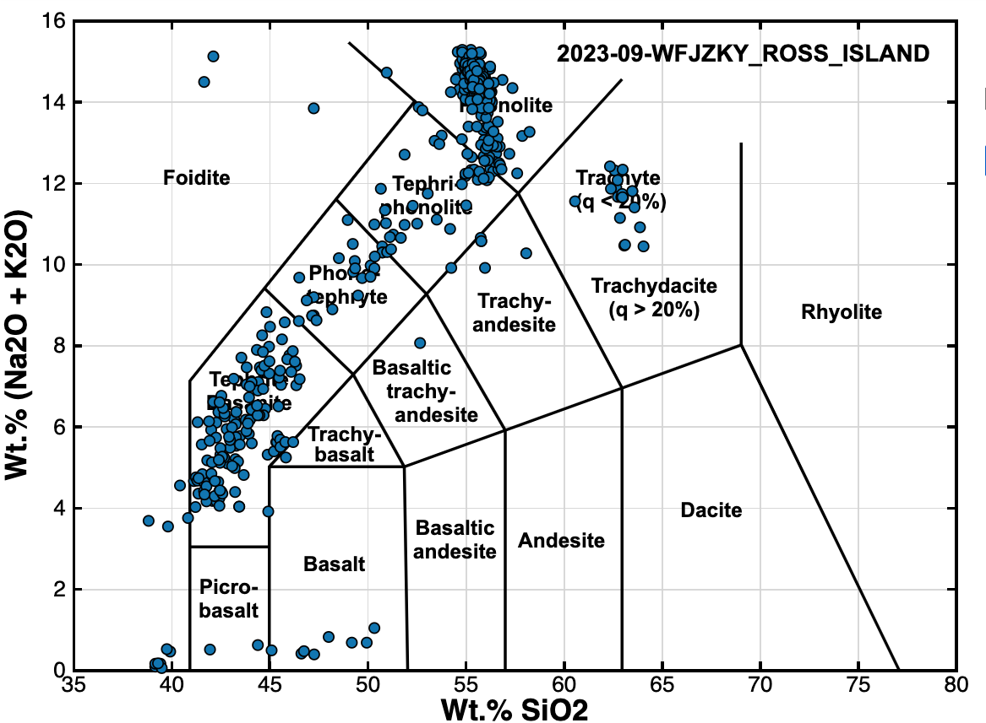
EXAMPLE DESCRIPTION OF TRENDS: Volcanic rocks from Mount Erebus range from subalkaline basalts and picro-basalts to alkaline tephrites, phonalites, and trachytes. They are dominantly alkaline, which is a common signature of melted continental crust and the waning stages of mantle plume volcanism
EXAMPLE HARKER DIAGRAM (note: four Harker diagrams are required)
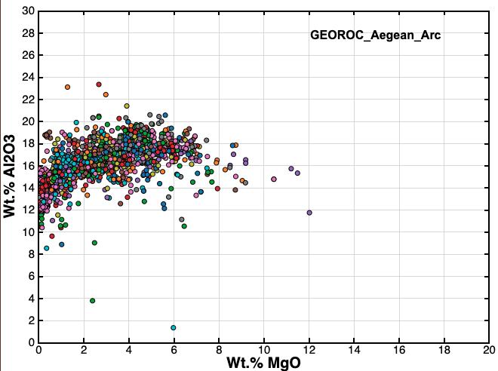
EXAMPLE DESCRIPTION OF TRENDS: This Harker diagram was created from geochemical analyses of Aegean Arc samples from the GEOROC database. Most samples plot between 14-18 wt% Al2O3 and 1-5% MgO. The most primitive samples (closest to parent composition) have MgO between 8-12 wt. %, and the most evolved samples (greater degrees of fractional crystallization) have the lowest MgO (<2 wt %) and highest Al2O3 (>20 wt%). The slight bend in the trend of MgO vs Al2O3 may indicate fractional crystallization of plagioclase.
EXAMPLE SPIDER DIAGRAM:
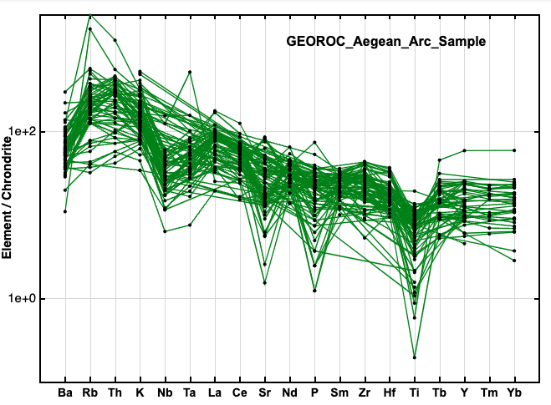
EXAMPLE DESCRIPTION OF TRENDS: This spider diagram was created from geochemical analyses of Aegean Arc samples from the GEOROC database. It shows enrichment in large ion lithophiles like Ba and Rb and depletion in HFS elements Nb, P, and Ti. This is consistent with island arc petrogenesis.
NOTE: do not use pre-made TAS, Harker, or spider diagrams from outside sources (e.g., a paper on Columbia River Basalts). I'd like you to find the geochemical data, use it to generate Harker and spider diagrams, and describe the trends that you see.
Module 4 Resources:
Geochemical databases:
- EarthChem: https://www.earthchem.org/
- GeoROC: https://georoc.eu/georoc/new-start.asp

Example Rubric, Module 5 (Final StoryMap and Presentation*)
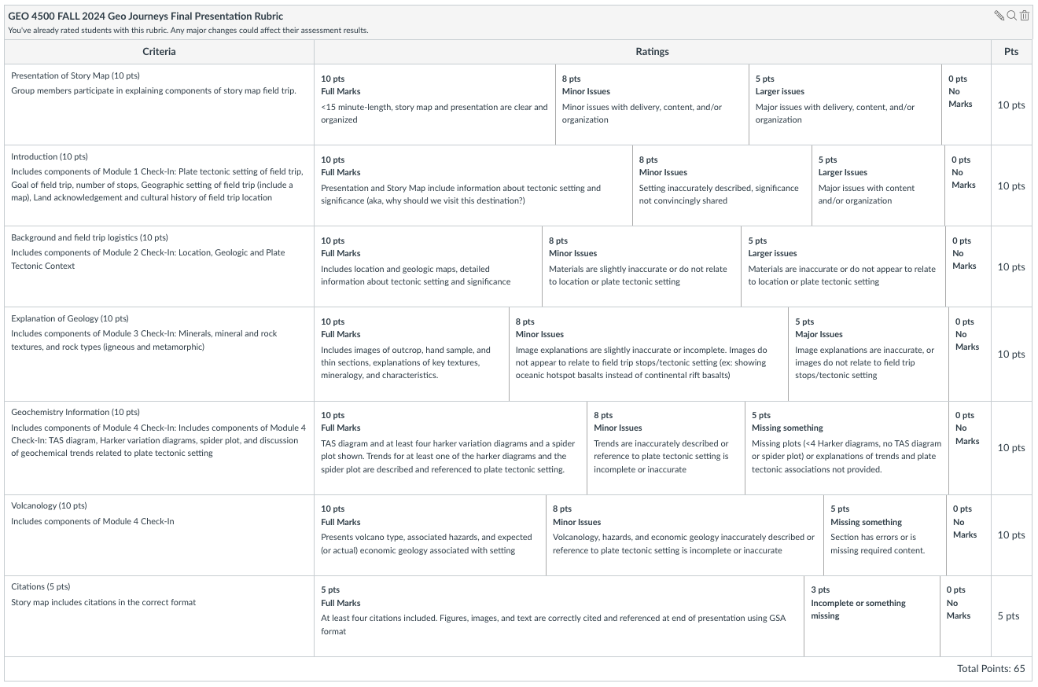
*optional

