GIS Lab: Monitoring Vegetation Recovery Using NDVI

Lab Introduction
The Hakalau Forest National Wildlife Refuge on the island of Hawai’I has undergone extensive reforestation efforts since it was established in 1985. Previously clearcut for cattle grazing, efforts to save endemic species within the Refuge have included replanting the forest by hand. In this lab, you will explore how satellite imagery can be used to monitor vegetation regrowth over time using NDVI (Normalized Difference Vegetation Index). Read more on NDVI and its use in monitoring green vegetation here. Ultimately, you will calculate the extent to which reforestation efforts have been successful over the past 30 years.
This lab is split into two parts:
- Part 1: Calculate NDVI from Landsat imagery for three different years and assess changes in tree cover area using a vegetation threshold.
- Part 2: Validate Landsat NDVI results using higher-resolution Sentinel-2 imagery.

Part 1 – Calculating NDVI

Step 1: Set Up Your Project
- Download the ZIP file: Hakalau_TeachingAid.zip
- Right click the ZIP file and select Extract All
- Extract to a gisclass folder, or whichever folder you use for data organization while in ArcGIS Pro
- Open ArcGIS Pro
- Click Open another project, navigate to the Hakalau_TeachingAid folder, and open Hakalau_Lab.aprx
- Once the project has loaded, open the Catalog Pane
- Open “Folders” and ensure “Hakalau_TeachingAid” is available.
- If not, right click “Folders” and select “Add Folder Connection”
- Navigate to and select the “Hakalau_TeachingAid” folder. This allows easy access to the necessary files we will be using.

Step 2: Explore the Study Area
Before we make any calculations, let’s get familiar with the geography of the Hakalau Forest and the areas under study.
- View the Layers in the Contents Pane. Two shapefiles should be visible:
- RefugeBoundary – the official boundary of the Hakalau Forest National Wildlife Refuge
- NewForest – current study area restoration efforts
- Use the Contents Pane to toggle each layer on and off, observing how NewForest is a subset within the larger RefugeBoundary
- Using the Explore tool (the hand icon), look around the refuge
Question 1 – What differences do you notice about the new forest area versus the entire refuge area?

Step 3: Prepare Imagery
Note: The downloaded bands have already been projected using WGS 1984 UTM Zone 5N.
- In the Catalog Pane, expand Folders > Hakalau_TeachingAid > Landsat_NDVI > Landsat_2000
- Add the following files to map view:
  - Band3_2000.TIF
  - Band4_2000.TIF
- Open the Clip Raster tool (Geoprocessing > Clip Raster)
- Set your Input Raster to NDVI_2000.TIF
- Set Clip Features to NewForest
- Set the Output Name as NDVI_2000_clip
- Under Output Extent, check the box “Use Input Features for Clipping Geometry.
- Click Run
- Repeat these steps with images from the years 2014 and 2024, setting the output names to NDVI_2014_clip and NDVI_2024_clip.

Step 4: Raster Calculation
In this step, you’ll use satellite data to calculate NDVI (Normalized Difference Vegetation Index) for three different years. NDVI is a widely used remote sensing index that measures vegetation health based on how much red and near-infrared light a plant reflects.
The formula for NDVI is:
NDVI = (NIR – Red) / (NIR + Red)
Note: Landsat 7 and 8/9 satellites use different band classifications. This will be crucial in the raster calculations:
Landsat 7 (2000):
- Band 3 = Red
- Band 4 = NIR
Landsat 8/9 (2014 and 2024):
- Band 4 = Red
- Band 5 = NIR

- Open the Raster Calculator in the Geoprocessing pane.
- In the expression box, recreate the formula:
(“Band4_2000_clip” - “Band3_2000_clip”) / (“Band4_2000_clip” + “Band3_2000_clip”)

- Double check your formula (any errors will result in an incorrect result)
- Name the output raster “NDVI_2000” and run the tool
- Reopen the Raster Calculator
- In the expression box, write out:
(“Band5_2014_clip” - “Band4_2014_clip”) / (“Band5_2014_clip” + “Band4_2014_clip”)
- Name the output raster “NDVI_2014” and click run
- One more time, go back to the Raster Calculator
- Write the expression:
(“Band5_2024_clip” - “Band4_2024_clip”) / (“Band5_2024_clip” + “Band4_2024_clip”)
- Name the output raster “NDVI_2024” and click run. You should now have three NDVI rasters (years 2000, 2014, and 2024).

Step 5: Manipulate Symbology
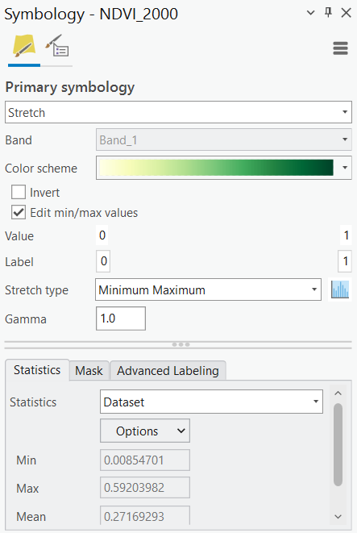
To compare threshold values, we need to create consistent symbology across years. We will accomplish this by changing both the stretch type and creating a range of values that will be consistent across rasters.
- In the contents pane, right click on NDVI_2000 and open symbology
- Under “Stretch type” select “Minimum Maximum”
- Check “Edit min/max values”
- Change the value markers to 0 and 1. If done correctly, both “value” and “label” will have the same number.
- Use the green multi-part color scheme to display the data
- Repeat these steps for the NDVI_2014 and NDVI_2024 rasters

Step 6: Threshold NDVI to Classify Vegetation
We will now move on to Boolean thresholding of NDVI values. While NDVI values are often compared on a -1 to +1 scale, for the purposes of this study, we will use our manufactures 0 to 1 scale that is consistent across study years. A threshold value of 0.36 has been determined to best represent the lowest NDVI value of tree cover.
- Open the Raster Calculator
- In the expression box, type the following:
“NDVI_2000” > 0.36
- Name the output raster “NDVI_2000_Bool”
- Run the tool
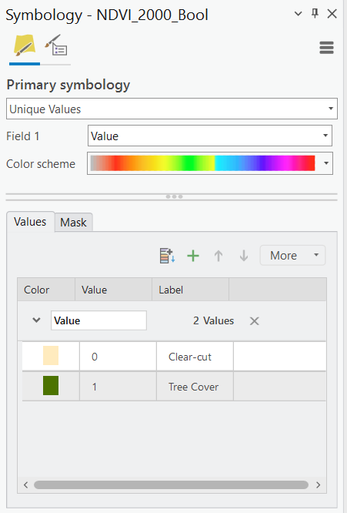
- This process now creates a binary raster where:

  - 0 = NDVI ≤ 0.36 (Clear-cut)
  - 1 = NDVI > 0.36 (Tree Cover)

- Right click the new NDVI_2000_Bool layer and open symbology
- Under “Label” within the Values section, re-label each section:

  - 0 = Clear-cut
  - 1 = Tree Cover

- Adjust the colors of each value so that Clear-cut is beige and Tree Cover is dark green
- Repeat this thresholding process for NDVI_2014 and NDVI_2024.

Step 7: Calculate NDVI Change Across Time
To calculate the change in tree cover, we need a quantitative measure of the amount of green area. Because we performed a Boolean Analysis, we can calculate this from information within the Attribute Table.
- Open the Attribute Table for the NDVI_2000_Bool raster. Each row represents a classified value (0 or 1, representing Clear-cut and Tree Covered area, respectively), along with a “Count” field, which shows how many pixels fall into that category.
- To calculate the percentage of reforested area, divide the number of pixels labeled “1” by the total number of pixels (pixels labeled “0” + pixels labeled “1”) and multiply the result by 100.
- Repeat this process for the NDVI_2014_Bool and NDVI_2024_Bool rasters.

Question 2 - What percentage of the NewForest region was reforested in 2000?
Question 3 - What percentage of the NewForest region was reforested by 2014?
Question 4 - What percentage of the NewForest region was reforested by 2024?
Question 5 – What factors may have contributed to the rate of change between 2000 and 2014?
Question 6 -What factors might explain the dramatic increase between 2014 and 2024?

Part 2 – Validating Data Against Sentinel-2 Imagery
While the Landsat Satellite has provided key information to scientists since its launch in the 1970’s, new satellite missions, such as Sentinel-2 provide higher resolution data that can provide further insights into land conditions. Since it wasn’t launched until 2014, we cannot use it for the whole of this study. However, it is an excellent tool for validating our Landsat findings.

Step 1: Add Sentinel Layer to Map
The provided Sentinel layer shows areas of tree cover and non-tree cover obtained using the same Boolean analysis as before. Imagery used for the analysis was obtained from the National Agriculture Imagery Program.
- In the Catalog Pane, navigate to Folders > Hakalau_TeachingAid > Sentinel_2024
- Drag Sentinel_NDVI.lyrx onto your map.

Step 2: Visually Compare with Landsat NDVI
- Turn on only the NDVI_2024_Bool and Sentinel_NDVI layers.
- Toggling the layers on and off, compare the two.
- Zoom in on patchy or recovering forest to observe resolution and classification differences.

Question 7 – How does Sentinel-2’s higher spatial resolution affect your ability to detect changes in vegetation?
Question 8 – Do you think the Sentinel image validates your previous forest recovery estimate (Question 4)? If so, how? If not, why not?

