Analyzing student performance on more than 1200 Physical Geology Quiz Questions based on question format

We routinely assign a variety of forced choice questions for students as part of either formative assessments in class (e.g., Conceptests) or summative quizzes and/or exams. Despite this perhaps being the most common way we assess our students, there has been relatively little research conducted to compare and contrast student success with different question formats.
This document contains all of the CLASS quiz questions (beginning on page 6) we used during a typical semester. CLASS (Confidence-based Learning Accuracy Support System) is an online quizzing tool (learn more here https://www.classforlearning.com). Our goal in creating CLASS was to encourage two effective study strategies, distributed practice and practice testing. In distributed practice, students make multiple attempts at the same quiz topic over the course of several days. Practice testing, sometimes referred to as retrieval practice, encourages students to try to recall information from memory.
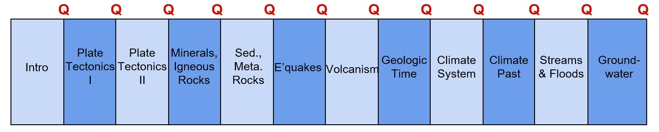
This introduction focuses on student performance on various quiz question formats. We analyzed thousands of answers to more than 1200 questions by approximately ninety students in a Physical Geology course at NC State University. The Physical Geology course was divided into 12 topics, each taking about two 75-minute lectures (Fig. 1). Students had the opportunity to complete a 10-question CLASS quiz as often as they liked within a few days of the end of each topic. Each topic has a series of learning objectives, and we tried to create at least 10 questions per objective. There was an average of more than 100 questions per quiz, consequently, even if students made multiple attempts, they rarely saw the same questions twice.
Figure 1: Physical Geology topics, generally taught as two Tuesday/Thursday lectures followed by a quiz.
Students could make an unlimited number of attempts at each quiz and their highest score counted toward their final grade in the course. The class averaged about five attempts per quiz. Students made more attempts as the average quiz score declined (Fig. 2).
The quizzes were composed of five major question formats. A little over half of the questions were standard true/false (15%) or multiple choice (45%). The next largest group of questions are multiple choice questions that include some type of image (21%) such as a schematic cross section, a photograph of a rock or landform, a graph, a diagram etc. (Fig. 3). We also used a double true/false format (9%) and these types of questions proved among the most challenging to students (Fig. 3). But the questions that students generally found to be the most difficult were “Select All” questions (10%: Fig. 3).
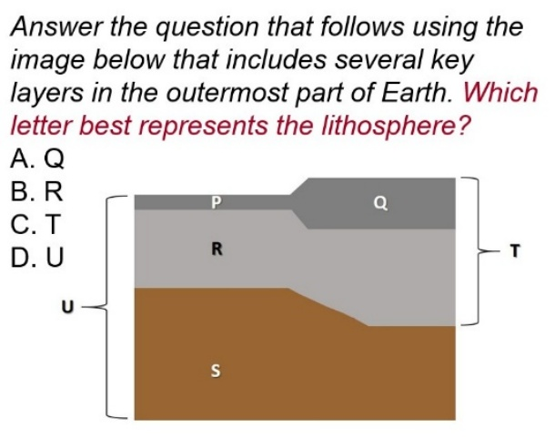
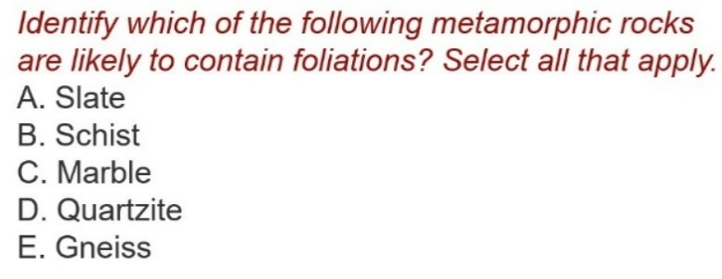
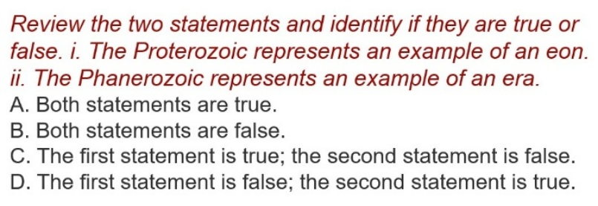
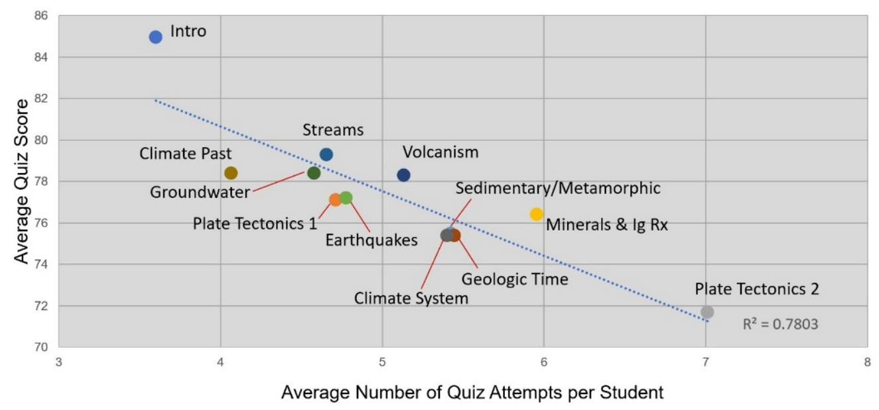
Figure 2: Average number of quiz attempts per student vs. Average quiz score

Figure 3: Sample quiz question styles. Multiple choice with an image, Double True/False and Select All

When we examined student performance on more than 1200 questions across these five question formats for a Fall semester course, we found that there was nearly a 20-point difference in scores with True/False questions averaging 82.7% and Select All questions averaging 63.5%. However, this wasn’t the whole story. The multiple-choice questions may have had 2, 3, 4 or 5 or more answers and student performance varied considerably on that basis. We have further subdivided the questions so that we have four examples in each multiple-choice group (questions with 2, 3, 4 or 5 answer choices) and our three other types (Fig. 4). Students do well on some questions in every format and similarly, often record low scores on questions in many categories. The general pattern remains but limiting the multiple-choice answer options tends to increase student performance. Students did best on multiple choice questions with just two choices averaging 86.5% or 82.8%, with the lover score depending on whether an image was present. The average score for all multiple choice questions was 81.1% and this declined slightly with four answer choices (79.5%).
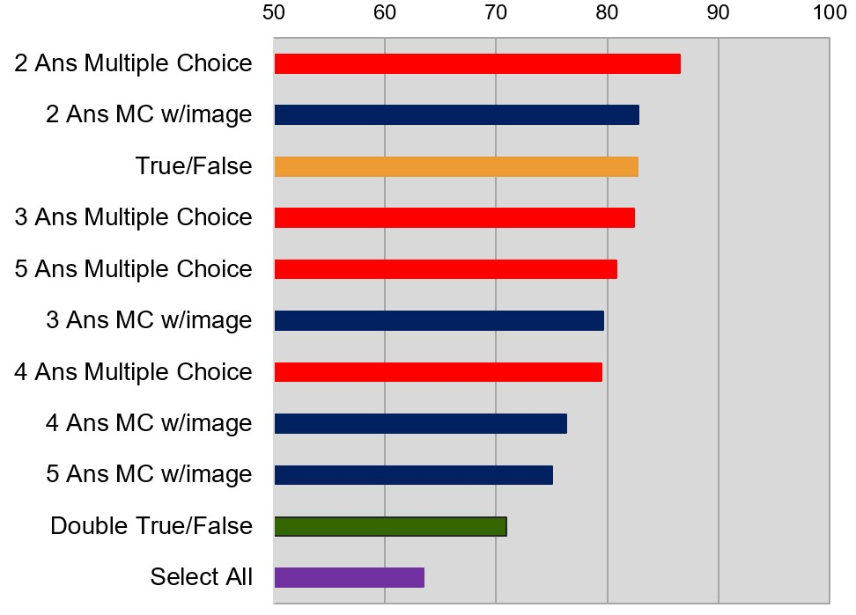

Figure 4: Average score by expanded question format.

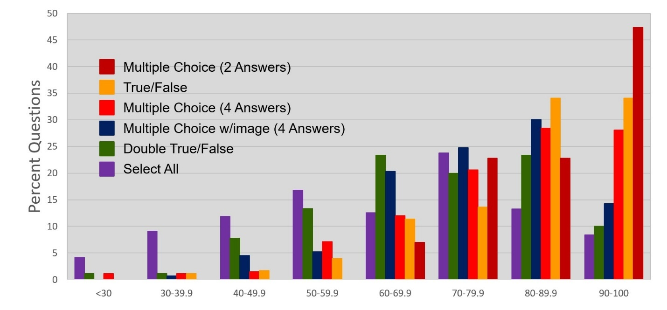
Students had the lowest performance on Select All questions with a little over 20% of these questions earned an A or B grade (80+%) and a similar number averaging a score of below 50% (Fig. 5). Students also found the Double True/False category challenging but a higher proportion of these questions earned an A or B and less than 10% of participants scored below 50% (Fig. 5). Examining results for the 4-part multiple-choice question with an image; nearly 45% of these questions averaged 80% or higher (Fig. 5). The most common question format was the “standard” multiple-choice question with over 50% of these questions averaging an A or B score. There are very few questions in this category that record less than 50% correct answers (Fig. 5). Nearly 70% of True/False questions averaged scores of 80% or higher, and students had the highest performance on multiple choice questions with just two answer choices. Nearly 5% of the quiz questions were in this format and about half of these questions averaged a score of 90 or higher (Fig. 5). These questions were never scored below the 60% range.
Figure 5: Question format score distribution
Given that we were able to establish the average score for each question format, and the number of those questions on each quiz for that semester’s course, we used this information to predict the average score for quizzes on each topic. If we had a reasonable distribution of questions, we should be able to estimate a predicted score that is close to the actual quiz average (Table 1).
Table 1: Volcanoes and Volcanic Processes Quiz Analysis
Question format | Average Score | # of Questions | Question Total | Predicted Average Quiz Score  9373.6  121  = 77.47  Actual Average Quiz Score  = 78.31
2 Ans MC | 86.5 | 7 | 605.5
2 Ans MC w/image | 82.8 | 0 | 0
True/False | 82.7 | 16 | 1323.2
3 Ans MC | 82.4 | 14 | 1153.6
4 Ans MC | 79.5 | 34 | 2703.0
5 Ans MC | 80.85 | 4 | 323.4
3 Ans MC w/image | 79.6 | 2 | 159.2
4 Ans MC w/image | 76.3 | 12 | 915.6
5 Ans MC w/image | 75.05 | 6 | 450.3
Double True/False | 70.9 | 12 | 850.8
Select All | 63.5 | 14 | 889
Total |  | 121 | 9373.6
We created the quizzes organically, building questions that seemed to be a good fit for specific learning objectives without making any conscious effort to distribute a specific number of each question format in each quiz. However, most topics end up with relatively consistent scores (Fig. 2). For example, the first plate tectonics topic had about the same number of questions as Volcanism (n=123 vs. 121) but is made up of a very different mix of questions yet it yielded a similar average score.

The Volcanism quiz had nearly half (49%) of its questions in a multiple choice format without images, 21% as Double True/False or Select All questions, 17% were multiple choice questions including an image and 13% were standard True/False questions. In contrast, the Plate Tectonics I quiz was made up of 42% multiple choice questions with an image, 32% “regular” multiple choice, and the rest distributed among True/False (16%) and Double True/False or Select All questions (10%). Despite these contrasting combinations of questions, the actual average scores and predicted average scores were both essentially within a point of each other (Fig. 6). Consequently, it becomes apparent that there were several different ways to combine questions to make quizzes that generated similar scores. Doing a similar analysis for the rest of the topics yields a plot (Fig. 6) which shows ten of the twelve topics clustering close to the equal score line.
However, there were two exceptions (Fig. 6). The quiz for the Introduction topic which discusses the basic characteristics of the earth sciences and the scientific method has a mix of questions in almost every category that are easier than the course standard. We decided not to change these questions as the first quiz served as a gateway to the course and the quizzing tool, so we were fine with it being a soft landing.
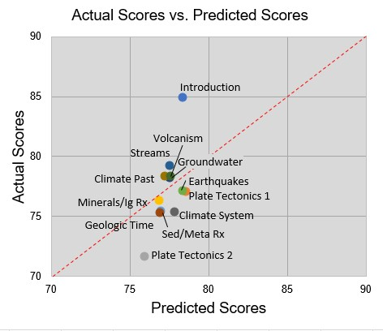

Figure 6: Actual average CLASS quiz scores vs. Predicted average CLASS quiz scores on the basis of question format

In contrast, the second plate tectonics topic has clusters of questions on a couple of concepts with low scores. In particular, we have a higher proportion of low scoring Select All questions in this topic. We sought to edit these questions in an effort to end up with a quiz result more in line with the others. We had some success with this latter strategy before. Prior to the Fall course, we reviewed results from the previous year and edited a series of very low scoring questions accordingly. Most of these questions fell in the Select All category and were converted to Select X where X was the number of correct answers (for example, see Fig. 7). These are still difficult questions, but as students can have unlimited quiz attempts, we felt that the formative value of these challenging questions merited their inclusion in the quiz.
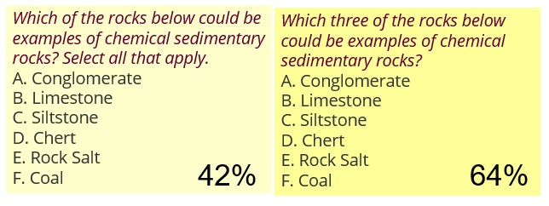
Figure 7: Select All to Select X format change resulted in a 22% improvement in student performance on this question.

In summary, instructors who are seeking to assess student learning could use this information to create quizzes, conceptests, or exams with a mix of question formats with varying degrees of difficulty. We share the final collection of our questions, presented by topic and learning objective, in the pages that follow.

Final CLASS Question Collection

Proportion of question formats per topic.

Topic | True/False | Multiple Choice (no images) | Multiple Choice (w/images) | Double True/False | Select All (Select X) | Totals
Introduction | 12 | 40 | 3 | 15 | 11 | 81
Plate Tectonics I | 28 | 49 | 55 | 11 | 1 | 144
Plate Tectonics II | 26 | 37 | 28 | 23 | 16 | 130
Minerals & Igneous Rocks | 20 | 39 | 16 | 8 | 11 | 94
Sedimentary & Metamorphic Rocks | 20 | 66 | 31 | 6 | 16 | 139
Earthquakes | 16 | 46 | 19 | 8 | 8 | 97
Volcanoes | 16 | 67 | 14 | 14 | 11 | 122
Geologic Time | 3 | 67 | 40 | 6 | 16 | 132
Earth’s Climate System | 13 | 39 | 13 | 10 | 6 | 81
Earth’s Climate Past | 13 | 23 | 11 | 8 | 8 | 63
Streams and Floods | 12 | 37 | 17 | 4 | 8 | 78
Groundwater | 11 | 43 | 10 | 5 | 12 | 81
Totals | 190 | 553 | 257 | 118 | 124 | 1242
Percent Totals | 15.30 | 44.52 | 20.69 | 9.50 | 9.98

Note that the number of questions per topic and the format of the questions is different from the question used in the analysis of the semester discussed in the section above. While the total number of questions remains about the same, some questions have been deleted, others added, and some have been slightly rewritten or converted to an alternative format.
Correct answers identified by bold font.

Introduction

LO1. I can define the term geology.

Which of the following is the best definition for the term "geology"?
- Geology is the study of rocks, minerals, and natural resources
- Geology is the study of the origin, structure, composition, and history of the Earth
- Geology is the study of the land and how it came to be

Geology includes the discovery and analysis of ancient civilizations and material culture.
- True
- False

Geology is the study of the origin, structure, composition and history of Earth.
- True
- False

Geology is the study of human history and prehistory through the excavation of sites and the analysis of artifacts and other physical remains.
- True
- False

Review the two statements below and identify if they are true or false:
i. Geology is the study of human history and prehistory through the excavation of sites and the analysis of artifacts and other physical remains.
ii. A geologist might work for a company searching for oil and gas reserves
- Both statements are true.
- Both statements are false.
- The first statement is true; the second statement is false.
- The first statement is false; the second statement is true.

Which of the following would be tasks a geologist might do as part of their job? Select all that apply.
- Geologists may serve on teams of scientists that plan the exploration of other planets.
- Geologists would work for companies searching for buried oil and gas reserves.
- Geologists can interpret Earth’s history to predict future natural events on our planet.
- Geologists would evaluate the risk from future landslides.

Review the two statements below and identify if they are true or false.
i. Geology includes the study of earth’s composition, structure, and processes.
ii. A geologist might work for a company that measures groundwater flow.
- Both statements are true.
- Both statements are false.
- The first statement is true; the second statement is false.
- The first statement is false; the second statement is true.

Review the two statements below and identify if they are true or false.
i. Geology includes the study of the origin, composition, and structure of Earth.
Ii. Geologists interpret the characteristics of rocks, minerals and fossils to unravel Earth’s history.
- Both statements are true.
- Both statements are false.
- The first statement is true; the second statement is false.
- The first statement is false; the second statement is true.

LO2. I can explain how people interact with geology in their lives.

The available natural resources that an area contains are largely dictated by the area's geology.
- True
- False

The battery in your cell phone requires geologic materials to produce.
- True
- False

How often do you interact with minerals or mineral products in your daily life?
- Several times a day
- Once or twice a day
- A few times a week
- A few times a year

Review the two statements below and identify if they involve people interacting with geology.
i. Quartz sand is used as an essential component in glass.
ii. We can write with pencils using the mineral graphite.
- Both statements are true.
- Both statements are false.
- The first statement is true; the second statement is false.
- The first statement is false; the second statement is true.

Review the two statements below and identify which involve people interacting with geology.
i. A family tours a cave during a visit to a national park.
ii. A city government uses a multiyear record of data on river levels to design a flood control system.
- Both statements are true.
- Both statements are false.
- The first statement is true; the second statement is false.
- The first statement is false; the second statement is true.

Review the two statements below and identify which involve people interacting with the products of geological processes.
i. Copper in your cell phone was extracted from the mineral chalcopyrite.
ii. Commercial companies mine salt from underground rock formations.
- Both statements are true.
- Both statements are false.
- The first statement is true; the second statement is false.
- The first statement is false; the second statement is true.

Which of the following are made from geologic materials? Select all that apply.
- Dry wall (wallboard)
- Steel
- Vaccines

Review the two statements below and identify if they are true or false:
i. Cell phones contain many geologic materials.
ii. Glass is made from geologic materials.
- Both statements are true.
- Both statements are false.
- The first statement is true; the second statement is false.
- The first statement is false; the second statement is true.

What is the source for the graphite in your pencil lead?
- It is a natural product that is derived from a mineral
- It is a natural product that is derived from plants
- It is a natural product that is derived from marine organisms
- It is a manufactured product created during the oil refining process
- It is a product created during the manufacturing of paint

LO3. I can distinguish between data and interpretations and types of data.

Review the pair of statements and determine if they represent data or interpretation:
i. There is an area of low topography southwest of Yellowstone National Park
ii. The low topography southwest of Yellowstone formed when North America moved over a hot spot
- Both statements are data.
- Both statements are interpretations.
- The first statement is data; the second is an interpretation.
- The first statement is an interpretation; the second is data.

Which of the following is data rather than an interpretation?
Some trees along Yellowstone Lake were flooded when the land north of the lake rose because of movement of magma deeper in the crust
- Rising and sinking of the land around Yellowstone is related to underlying magma
- The ages of volcanic centers near Yellowstone indicate that North America is moving southwest over the mantle
- All of these are data rather than interpretations
- All of these are interpretations rather than data

Which of the following is an example of quantitative data?
- Augustine volcano represents a dangerous situation
- The rocks were dark gray and angular
- The steam coming from the mountain was dark gray in color
- The rocks were too hot to touch
- None of these

Which of the following is an example of quantitative data?
- The rocks were dark gray and angular
- The rock layer was 12 feet thick
- The volcano was emitting a small amount of smoke
- The rocks were too hot to touch

Which of the following is NOT an example of quantitative data? Select all that apply.
- The peak of Mt. St. Helens is at an elevation of 8366 feet
- Mt. St. Helens contains layers of andesite and basalt
- The rocks on the trails of Mt. St. Helens are angular and sharp
- The debris avalanche was up to 0.7 cubic miles (2.9 km3) in volume

Which of the following are examples of quantitative data? Select all that apply.
- Augustine volcano produced a lava of andesitic composition
- The lava had a temperature of 900 C
- The oldest lava flows in the area were determined to be 760,000 years old
- Much of the area was covered in a layer of gray andesite when the rock solidified

Geologists who use visual observations to name the types of rocks found in an area during a mapping project are using quantitative data.
- True
- False

Classify the segment in quotations of the following statement. Analysis of the composition of air trapped in air bubbles in ice layers on Antarctica revealed that “the concentration of carbon dioxide in the atmosphere 200 years ago was 280 parts per million (ppm)” which is lower than present day concentrations.
- This is an example of data
- This is an example of an interpretation

Classify the following statement. “The National Oceanographic and Atmospheric Administration (NOAA) predicted that the coming hurricane season would be near-normal.”
- This is an example of data
- This is an example of an interpretation

Classify the underlined part of the following statement. GPS stations around Houston detected that the whole area had moved down approximately two centimeters by the weight of the water that fell during Hurricane Harvey.
- This is an example of an interpretation
- This is an example of data

Classify the following statement. “A geology student examined the rocks and fossils present in a cliff and told the instructor that she thought that the rocks were formed under shallow marine conditions.”
- This is an example of data
- This is an example of an interpretation

Classify the segment in quotations of the following statement. A report by the US Geological Survey noted that “groundwater levels in a major US aquifer had dropped by 3 meters between 1950 and 2015.”
- This is an example of data
- This is an example of an interpretation

Classify the following statement. One explanation for declining groundwater levels in major US aquifers is that there is greater demand for water to support crops in a warming climate.
- This is an example of data
- This is an example of an interpretation

Classify the following statement: “Wolf Creek crater, Australia, is 880 meters in diameter” .
- This is an example of data
- This is an example of an interpretation

Classify the segments in quotations of the following statement: “Wolf Creek crater, Australia was formed by the impact of a meteorite.”
- This is an example of data
- This is an example of an interpretation

Classify the following statement. Climate models predict that future temperatures in the Arctic region may increase twice as fast as warming trends over the rest of Earth’s surface.
- This is an example of data
- This is an example of an interpretation

LO4. I can identify the differences between observations, hypotheses, and predictions in multiple scenarios (scientific process).

Which of these statements is a more accurate description about the relative roles of observations and hypotheses in science?
- Observations are only as good as the hypotheses on which they are based.
- Hypotheses are only as good as the observations on which they are based.

In the context of science, how would you classify the following statement? “The continued use of fossil fuels will raise global temperatures.”
- Prediction
- Observation

Scientists Luis and Walter Alvarez suggested the dinosaurs became extinct when an asteroid collided with Earth 65 million years ago. “They noted that the rare element iridium was present in 65 million year old rock layers around the world.” The second sentence is an example of ___
- an observation
- a hypothesis

What steps are involved in having a hypothesis become an established theory?
- A United Nations scientific panel votes on whether the hypothesis is accepted
- A U.S. government agency votes on whether the hypothesis is accepted
- The hypothesis is consistent with new data and investigations used to test its predictions
- The hypothesis makes sense when explained by politicians

Read the short article below and answer the questions that follow.
Geologists are watching a volcano in Iceland very closely. Iceland is a volcanic island near the middle of the northern Atlantic Ocean. Over the last few weeks, there has been a steady increase in earthquake activity in the area around the volcano. Previous eruptions released vast clouds of ash and other debris that disrupted daily flights between the US and Europe. The volcano is located beneath a major glacier, below 500 meters of ice, and can’t be observed directly. Instruments can detect up to several thousand earthquakes per day below the volcano and geologists believe that the earthquakes are generated as magma moves around within the volcano.

What was the principal prediction described in the article?
- Iceland is a volcanic island
- Volcanic eruptions have the potential to disrupt trans-Atlantic flights
- A volcano on Iceland might erupt
- A volcano is located below a glacier

What observations did scientists collect?
- They identified the locations of glaciers and volcanoes
- They noted the timing of trans-Atlantic flights
- They measured the thickness of ice in a glacier
- They recorded changes in earthquake activity near a volcano

What is a hypothesis that attempts to explain the data collected by geologists?
- Volcanoes on Iceland are often located below glaciers
- Earthquakes signal the potential for a future eruption
- Flights from Europe and the US often travel near to Iceland
- Cities located near the volcano may suffer earthquake damage

Review the graph and answer the questions that follow. The information presented on this graph is often referred to as the Keeling Curve.
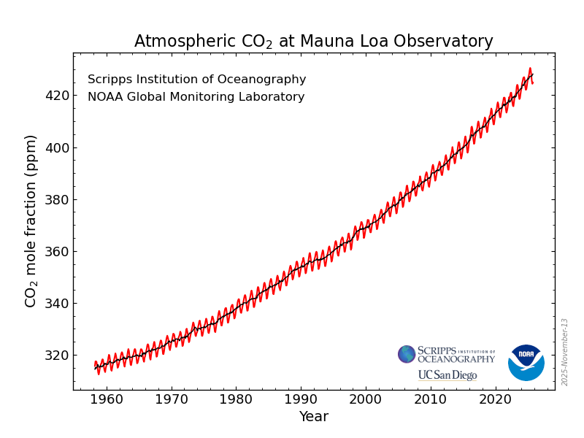
https://gml.noaa.gov/ccgg/trends/

What is the data represented on this graph?
- Atmospheric carbon dioxide (CO₂) concentrations vs. Time
- Global average temperatures vs. Time
- Atmospheric carbon dioxide (CO₂) concentrations vs. Global average temperatures
- Population growth vs. Time

What is a prediction that could be made from the information represented on this graph?
- Carbon dioxide (CO₂) concentrations increased by approximately 60% from 1960 to 2010.
- Global average temperatures increased as carbon dioxide (CO₂) concentrations increased.
- Atmospheric carbon dioxide (CO₂) concentrations will rise to more than 430 parts per million by 2030
- As the global population increases, we would expect a similar rise in the concentration of atmospheric carbon dioxide (CO₂)

Which of the following represents a hypothesis that attempts to explain the data represented by the graph?
- Carbon dioxide (CO₂) concentrations have increased steadily from 1960 to today.
- Global average temperatures have increased as carbon dioxide (CO₂) concentrations increased.
- Atmospheric carbon dioxide (CO₂) concentrations will continue to increase in the next few decades.
- Global concentrations of carbon dioxide have increased as human activities resulted in the greater use of carbon-rich fossil fuels

LO5. I can summarize the characteristics of the scientific process.

Correctly complete the sentence that follows. Scientific explanations are NOT ___
- based on observations
- tentative
- limited by technology
- able to answer all questions

Which is the best description of a scientific study?
- A scientific study allows you to be able to explain something so that you are able to touch it and see it. In science you have to see it for it to be true.
- A scientific study involves making hypotheses, collecting data, and performing experiments or testing claims, to reach a conclusion supported by evidence.
- A scientific study uses mathematics to do calculations and generate graphs that can be used to closely examine facts.

Science is often applied to provide answers to ethical dilemmas.
- True
- False

A hypothesis is supported by more scientific observation and research than a theory.
- True
- False

A theory is generally supported by more scientific observation and research than a hypothesis.
- True
- False

Once a scientific explanation has been established it never needs to be changed.
- True
- False

In the context of science, how would you classify the following statements?
i. The continued use of fossil fuels will raise global temperatures by 2C or more by 2100.
ii. The average global temperature in 2024 was the highest ever recorded (by 2025).
- Both statements are predictions.
- Both statements are observations.
- The first statement is a prediction; the second is an observation.
- The first statement is an observation; the second statement is a prediction.

Review the graph and determine if the statements that follow are true or false. The information presented on this graph is often referred to as the Keeling Curve.
https://gml.noaa.gov/ccgg/trends/

Review the two statements below and identify if they are true or false:
I. The change in carbon dioxide concentration with time represents data
Ii. Using the graph to estimate of the carbon dioxide concentration in 2030 would represent a prediction
- Both statements are true.
- Both statements are false.
- The first statement is true; the second statement is false.
- The first statement is false; the second statement is true.

Review the two statements below and identify if they are true or false:
I. The illustrated change in carbon dioxide concentration with time represents a prediction
Ii. Explaining the trend in the graph as the result of increased human use of carbon-rich fossil fuels would represent a hypothesis
- Both statements are true.
- Both statements are false.
- The first statement is true; the second statement is false.
- The first statement is false; the second statement is true.

LO6. I can identify parts of the four main components of the earth system.

Plants and animals are part of the ___
- Hydrosphere
- Geosphere
- Biosphere
- Atmosphere

Weather occurs in the ___
- Geosphere
- Atmosphere
- Biosphere
- Hydrosphere

Ice and glaciers are a special part of the ___
- Geosphere
- Atmosphere
- Biosphere
- Hydrosphere

Which are the four major parts of the earth system? Select all that apply.
- Geosphere
- Atmosphere
- Biosphere
- Hydrosphere
- Ethnosphere

Read the statement that follows and identify which components of the earth system are represented. Select all that apply. "As a group of travelers trek through the Sahara Desert, a gust of wind picks up the desert sand and obscures their vision."
- Geosphere
- Atmosphere
- Biosphere
- Hydrosphere

Read the statement that follows and identify which components of the earth system are represented. Select all that apply. "A hermit crab finds a new shell on the ocean floor."
- Geosphere
- Atmosphere
- Biosphere
- Hydrosphere

LO7. I can explain how matter is exchanged between the four main earth system components.

Complete the following sentence accurately. Exhaling CO₂ and other gases from your lungs moves materials from the ___
- geosphere to the atmosphere
- hydrosphere to the biosphere
- atmosphere to the biosphere
- biosphere to the atmosphere
- hydrosphere to the geosphere

Complete the following sentence accurately. Inhaling oxygen and other gases into your lungs moves materials from the ___
- geosphere to the atmosphere
- hydrosphere to the biosphere
- atmosphere to the biosphere
- biosphere to the atmosphere
- hydrosphere to the geosphere

Identify the earth system exchange when meltwater from a glacier evaporates.
- geosphere to the atmosphere
- hydrosphere to the atmosphere
- atmosphere to the biosphere
- biosphere to the atmosphere
- hydrosphere to the geosphere

Photosynthesis is an example of interactions between which two systems?
- geosphere and atmosphere
- hydrosphere and atmosphere
- atmosphere and biosphere
- hydrosphere and biosphere

If one of the earth system components undergoes change, it will result in changes in other earth system components.
- True
- False

Groundwater that dissolves minerals from rocks it flows through transfers matter from the ___
- geosphere to the atmosphere
- hydrosphere to the geosphere
- geosphere to the hydrosphere
- biosphere to the geosphere

Human activities that result in the contamination of a river represent interaction between which two components of the earth system?
- geosphere and hydrosphere
- hydrosphere and biosphere
- atmosphere and hydrosphere
- geosphere and biosphere

Over the course of thousands of years, plant material is gradually buried deeper and deeper in Earth and eventually converted to coal. Which two components of the earth system are involved in this process?
- geosphere and hydrosphere
- hydrosphere and biosphere
- geosphere and biosphere

Matter is transferred from the hydrosphere to the atmosphere. Which of the following scenarios illustrates this pathway?
- Water seeps out of the ground into a natural spring.
- Carbon dioxide is released from fossil fuels into the air.
- Water evaporates from a lake into the air.
- Carbon dioxide from the air is absorbed by the ocean.

Read the statement that follows and identify which components of the earth system are represented. Select all that apply. “Groundwater dissolves limestone to form a cave.”
- Atmosphere
- Biosphere
- Geosphere
- Hydrosphere

Read the statement that follows and identify which components of the earth system are represented. Select all that apply. “Plants release oxygen.”
- Atmosphere
- Biosphere
- Geosphere
- Hydrosphere

LO8. I can use carbon to explain how relationships between the four main earth system components may change over time.

Which of the following is an example of how carbon can move between components of the earth system? Select all that apply.
- between the atmosphere and the biosphere via photosynthesis
- between the geosphere and the atmosphere via the burning of fossil fuels
- between the atmosphere and the hydrosphere via ocean acidification
- between the hydrosphere and the geosphere via physical weathering

What does the term "flux" mean in relation to the movement of carbon within the earth system?
- Flux represents the size of the carbon reservoir in each earth system component.
- Flux is a measure of the proportion of carbon in each "sphere" of the earth system.
- Flux represents the rate of flow of carbon between earth system components.
- The flux is the amount of carbon that can be added to each "sphere" of the earth system.

Carbon makes up about 4% of the gases in Earth's atmosphere.
- True
- False

How many of the five following items contain some form of carbon?
Soil – Air – Forests - Shells of marine organisms – Coal.
- One
- Two
- Three
- Four
- Five

Identify the list of earth system components starting with the largest carbon reservoir and going to the smallest carbon reservoir?
- Biosphere, Atmosphere, Hydrosphere, Geosphere
- Atmosphere, Geosphere, Biosphere, Hydrosphere
- Geosphere, Atmosphere, Hydrosphere, Biosphere
- Geosphere, Hydrosphere, Biosphere, Atmosphere

Carbon is transferred between the four major earth system components each year. Which components of the earth system are gaining carbon each year? (Select all that apply.)
- Atmosphere
- Biosphere
- Geosphere
- Hydrosphere

The four major earth system components serve as reservoirs for carbon. Review the two statements that follow and identify if they are true or false:
i.The biosphere holds approximately three times the carbon that is in the atmosphere
ii.The geosphere holds more than 100,000 times more carbon than the atmosphere
- Both statements are true.
- Both statements are false.
- The first statement is true; the second statement is false.
- The first statement is false; the second statement is true.

The four major earth system components serve as reservoirs for carbon. Review the two statements that follow and identify if they are true or false:
i.The biosphere is the second smallest carbon reservoir
ii.The hydrosphere is the largest carbon reservoir
- Both statements are true.
- Both statements are false.
- The first statement is true; the second statement is false.
- The first statement is false; the second statement is true.

The four major earth system components serve as reservoirs for carbon. Review the two statements that follow and identify if they are true or false:
i.The biosphere is the smallest carbon reservoir
ii.The geosphere is the largest carbon reservoir
- Both statements are true.
- Both statements are false.
- The first statement is true; the second statement is false.
- The first statement is false; the second statement is true.

Carbon is transferred between the four major earth system components each year. Review the two statements that follow and identify if they are true or false:
i.Carbon is being added to the atmosphere each year
ii.Carbon is being lost from the geosphere each year
- Both statements are true.
- Both statements are false.
- The first statement is true; the second statement is false.
- The first statement is false; the second statement is true.

The four major earth system components serve as reservoirs for carbon. Which is the smallest carbon reservoir?
- Atmosphere
- Biosphere
- Geosphere
- Hydrosphere

The four major earth system components serve as reservoirs for carbon. Which is the largest carbon reservoir?
- Atmosphere
- Biosphere
- Geosphere
- Hydrosphere

Plate Tectonics, Part 1

LO1. I can describe the ideas resulting in the continental drift hypothesis.

The concept of continental drift suggested that the southwest coast of Africa matches the ___
- west coast of North America
- west coast of Europe
- east coast of Australia
- east coast of South America

The shape of the east coast of North America matches with the shape of the northwest coast of Africa.
- True
- False

The remnants of a former land bridge between Africa and South America can be seen today on the floor of the Atlantic Ocean just south of the equator.
- True
- False

Alfred Wegener suggested that all the continents were joined together in a single supercontinent known as Pangaea.
- True
- False

Which of the following was NOT an observation that led to the continental drift hypothesis?
- The coastlines of several continents were observed to fit together like jigsaw puzzle pieces.
- A land bridge was discovered to connect South America and Africa.
- Evidence was found that glaciers once covered land masses that are now close to the equator.
- Fossils of the same organisms are found on different continents.

Review the two statements below and identify if they are true or false.
i.The continental drift hypothesis proposed that India was located near the South Pole when it was part of the supercontinent Pangaea.
ii. Fossils of the same land animals were found in ancient rocks on continents that are now separated by wide oceans.
- Both statements are true.
- Both statements are false.
- The first statement is true; the second statement is false.
- The first statement is false; the second statement is true.

Review the two statements below and identify if they are true or false.
i. Pangaea formed relatively early in Earth’s history, about 2 billion years ago.
ii. Pangaea began to split up approximately 200 million years ago.
- Both statements are true.
- Both statements are false.
- The first statement is true; the second statement is false.
- The first statement is false; the second statement is true.

If Pangaea was to be reassembled, which pair of mountain ranges would match up?
- Appalachians (North America) and Andes (South America)
- Andes (South America) and Alps (Europe)
- Appalachians (North America) and Atlas (North Africa)

An ice sheet covered parts of several continents for millions of years after the formation of Pangaea. In addition to present day Antarctica, which of the following continents were at least partially covered by the ice sheet?
- South America only
- South America and Africa only
- South America, Africa, and Australia
- South America, Africa, Australia and India

Which of the following were BOTH land animals that migrated overland between continents during the time of Pangaea?
- Cynognathus and Lystrosaurus
- Dunkleosteus and Mesosaurus
- Glossopteris and Archaeopteris

Which of the following represents an ancient type of fern that grew on several continents during the time of Pangaea?
- Cynognathus
- Glossopteris
- Lystrosaurus
- Mesosaurus

What was the main reason why continental drift was not widely accepted when Wegener originally proposed the hypothesis?
- The hypothesis required very low global temperatures to explain why almost the entire Earth was frozen soon after the formation of Pangaea.
- Wegener could not identify an appropriate process to explain how the continents could have moved through the oceanic crust.
- The hypothesis required long, narrow land bridges that scientists of the time could not identify.

Which of the following was an observation that supported the continental drift hypothesis?
- Scientists discovered a land bridge that had once connected South America and Africa.
- Scientists found evidence that large ice sheets had covered continents that had been located near the North Pole.
- Scientists found fossils of the same land-dwelling animals on continents that are now separated by wide oceans.

There is evidence from several locations that a large ice sheet covered parts of North America, Europe and Asia during the time of Pangaea.
- True
- False

There is evidence from several locations that a large ice sheet covered parts of South America, Africa and Australia during the time of Pangaea.
- True
- False

The continental drift hypothesis proposed that India was initially located near the South Pole when it was part of the supercontinent Pangaea.
- True
- False

The continental drift hypothesis proposed that Earth’s surface was divided into tectonic plates.
- True
- False

LO2. I can compare and contrast plate tectonics with the continental drift hypothesis.

Alfred Wegener's Continental Drift hypothesis contained an explanation of how the plates moved.
- True
- False

The theory of plate tectonics is based on the idea that the shapes of the continents seem to fit together like puzzle pieces.
- True
- False

Plate tectonics provides an explanation for how the continents change position (an explanation that Wegener's Continental Drift lacked).
- True
- False

How did the theory of plate tectonics "complete" Wegener's continental drift hypothesis?
- It provided the missing land bridge between South America and Africa
- It explained how the continents could move over long time periods

Review the two statements below and identify if they are true or false.
i.The continental drift hypothesis was based on evidence of similar geological features that are present on different continents.
ii.The theory of plate tectonics was supported by observations about the rocks and features of the ocean floor.
- Both statements are true.
- Both statements are false.
- The first statement is true; the second statement is false.
- The first statement is false; the second statement is true.

Review the two statements below and identify if they are true or false.
i.The continental drift hypothesis involved matching the distribution of volcanoes between different continents.
ii.The theory of plate tectonics explains the distribution of earthquakes around the world.
- Both statements are true.
- Both statements are false.
- The first statement is true; the second statement is false.
- The first statement is false; the second statement is true.

The Continental Drift hypothesis identified the boundaries of the major tectonic plates.
- True
- False

How are the concepts of continental drift and plate tectonics similar?
- They both explain the global distribution of volcanoes and earthquakes.
- They both identify that continents change their positions over millions of years.
- They both account for the difference in the relative ages of rocks on the continents and ocean floors.

Plate tectonics and continental drift are the same thing. Plate tectonics is the modern day name for continental drift.
- True
- False

The theory of plate tectonics explains past processes that shaped the Earth and also explains present-day processes.
- True
- False

Plate tectonics provided evidence that the supercontinent Pangaea did not exist.
- True
- False

Review the two statements below and identify if they are true or false.
i. The continental drift hypothesis proposed that Earth’s surface was divided into plates.
ii. Alfred Wegener found fossils of land animals from Africa and South America in rock layers on the floor of the Atlantic Ocean.
- Both statements are true.
- Both statements are false.
- The first statement is true; the second statement is false.
- The first statement is false; the second statement is true.

Much of the North American continent has traveled approximately northward, to higher latitudes, from its location during the time of Pangaea.
- True
- False

Review the two statements below and identify if they are true or false.
i. Continental drift proposed that Earth’s surface was divided into plates.
ii. Plate tectonics provided a mechanism to explain how the positions of the plates changed over time.
- Both statements are true.
- Both statements are false.
- The first statement is true; the second statement is false.
- The first statement is false; the second statement is true.

The theory of plate tectonics was developed by scientists after they made which pair of observations?
i. They discovered a ridge system on the floor of the world’s oceans.
ii. They identified the same fossils of land animals on different continents
iii. They recognized that ancient mountain belts were aligned in the supercontinent Pangaea.
iv. They found matching patterns in the age of ocean floor rocks on either side of the Atlantic and other oceans.
- i and ii
- ii and iii
- iii and iv
- iv and i

LO 3. I can make a labeled sketch to show the relationship of crust, mantle, lithosphere, and asthenosphere.

The top of the mantle is closer to the surface below the Atlantic Ocean than below the North American continent.
- True
- False

What proportion of the mantle's thickness is represented in the asthenosphere?
- Approximately 45%
- About 25%
- Less than 10%
- More than 90%

How much of the mantle is present in the lithosphere?
- All of it
- None of it
- Less than 5%
- More than 50%
- Approximately 30%

The oceanic crust is ___ than the continental crust, which is why the floor of the ocean is far below the level of the continents.
- thicker and less dense
- older and more fractured
- thinner and more dense
- younger and less fractured

The top of the mantle is closer to the surface below the North American continent than below the Atlantic Ocean.
- True
- False

The mantle begins approximately ___ kilometers below continents
- 5
- 35
- 135
- 1530

Which of the following features is most likely to represent the boundary between two tectonic plates?
- the shoreline of a continent
- the location of a linear island chain
- the location of an oceanic ridge

Rocks at any location on the North American continent are part of the lithosphere.
- True
- False

Rocks at any location on the floor of the Atlantic Ocean are part of the mantle.
- True
- False

The North American continent and the North American plate are the same.
- True
- False

Alaska is located on the North American plate.
- True
- False

Where are the tallest mountains most likely to be located on a continent?
- near to a convergent plate boundary
- along any margin adjacent to an ocean basin
- just inland from a wide continental shelf
- in older rocks within the continental interior (far from a plate boundary)

Which of the following features is most likely to represent the boundary between two tectonic plates?
- the edge of a continental shelf
- the location of an oceanic trench
- the margin of an ocean basin

Answer the questions that follow using the image below that includes several key layers in the outermost part of Earth. Assume that the right margin of the figure is approximately 300 kilometers deep.
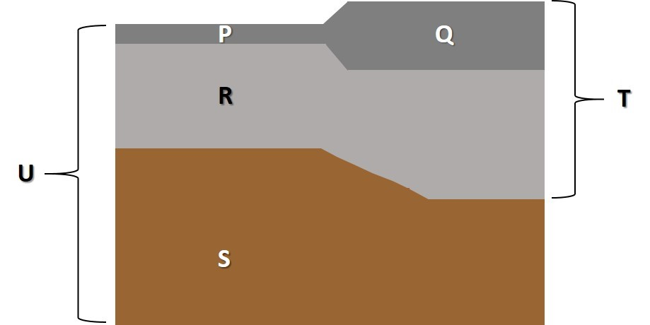

What does the letter P represent on the image?
- Crust
- Mantle
- Lithosphere

What does the letter Q represent on the image?
- Crust
- Mantle
- Lithosphere

What does the letter R represent on the image?
- Crust
- Mantle Lithosphere
- Lithosphere
- Asthenosphere

What does the letter S represent on the image?
- Crust
- Mantle Lithosphere
- Lithosphere
- Asthenosphere

Which letter in this image best represents the lithosphere?
- Q
- R
- T
- U

Which two letters in this image best represent parts of the mantle?
- P & Q
- R & S
- Q & T

Which letter(s) on this image best represents the components of a tectonic plate?
- T
- R and S
- P and Q
- U

Continental crust is ___________ and ___________ than oceanic crust.
- Thicker, more dense
- Thicker, less dense
- Thinner, more dense
- Thinner, less dense

At which location is the crust the thickest?
- Transform boundary
- Divergent boundary
- Continental-continental convergent boundary
- Oceanic-continental convergent boundary
- Oceanic-oceanic convergent boundary

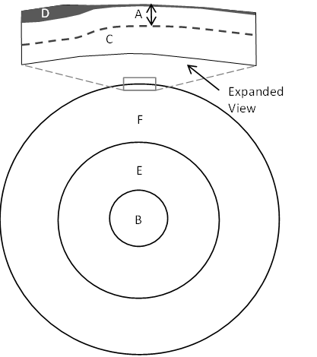
Imagine the circle in the diagram represents a cross section through Earth with the layers and boundaries shown are approximately to scale.
Which letters all represent part of the mantle?
- B and E
- A and D
- C, F and E
- A, C, and F

Answer the question that follows using the image below that includes several key Earth layers. Assume that the figure represents a distance of approximately 3000 kilometers from top to bottom.
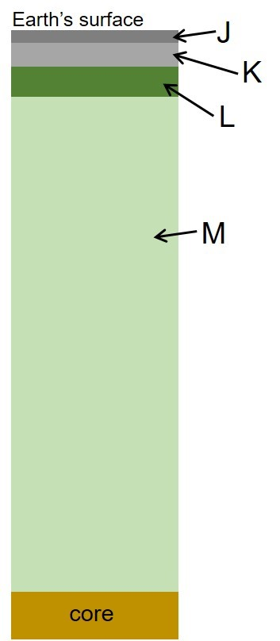

What does the letter L best represent in the image?
- Crust
- Mantle lithosphere
- Lithosphere
- Asthenosphere
- Mantle

Which letters on this image represent parts of the mantle?
- M only
- M and L only
- M, L, and K only
- MLK and J

Which pair of letters represent the lithosphere?
- J and K
- K and L
- L and M

LO4. I can make a labeled sketch to define the characteristics of a “tectonic plate”.

Answer the question that follows using the image below that includes several key layers in the outermost part of Earth. Assume that the right margin of the figure is approximately 300 kilometers deep.

Which letter(s) on this image best represents the components of a tectonic plate?
- T
- R and S
- P and Q
- U

Answer the question that follows using the image below that includes several key Earth layers. Assume that the figure represents a distance of approximately 3000 kilometers from top to bottom. Which column best represents the relative scale of a tectonic plate and other components of Earth’s interior?
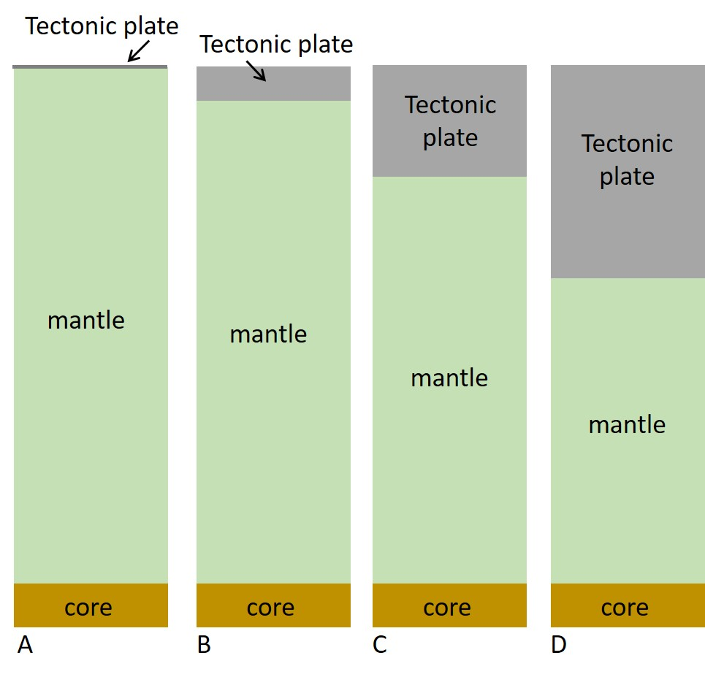
- A
- B
- C
- D
Answer the questions that follow using the sketched image below that includes several key layers in the outermost part of Earth. Assume that the left margin of the figure is approximately 500 kilometers deep.
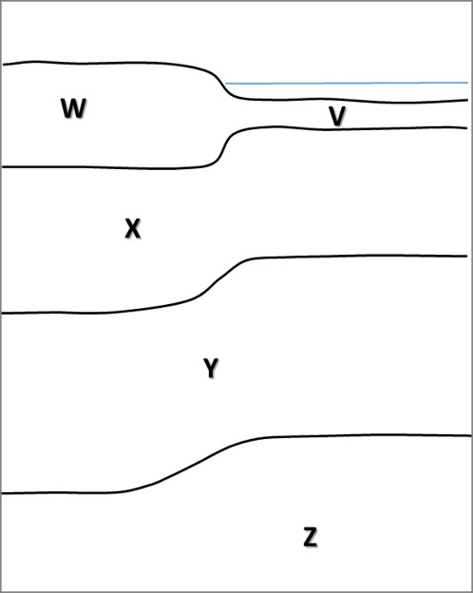

Review the two statements below and identify if they are true or false.
i. Layer X represents mantle lithosphere.
ii. Layer Y represents the asthenosphere.
- Both statements are true.
- Both statements are false.
- The first statement is true; the second statement is false.
- The first statement is false; the second statement is true.

Review the two statements below and identify if they are true or false.
i. Layers V and W both represent Earth’s crust.
ii. Layer X represents the asthenosphere.
- Both statements are true.
- Both statements are false.
- The first statement is true; the second statement is false.
- The first statement is false; the second statement is true.

Review the two statements below and identify if they are true or false.
i. Layer V represents oceanic crust.
ii. Layer X represents the uppermost layer of the mantle.
- Both statements are true.
- Both statements are false.
- The first statement is true; the second statement is false.
- The first statement is false; the second statement is true.

Which letter(s) on this image best represent(s) the components of a tectonic plate?
- W
- X
- W and X
- X and Y

Answer the questions that follow using the image below that includes several key Earth layers. Assume that the left margin of the figure is approximately 300 kilometers deep.
Which of the following lettered features best represents a tectonic plate in the image?
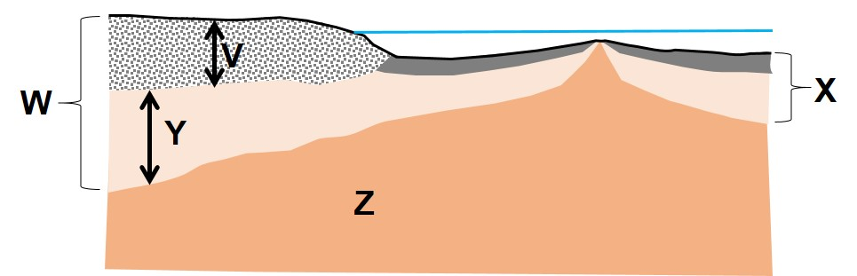
- V
- Y
- X
- Z

How many tectonic plates are represented in the image?
- 1
- 2
- 3

Which of the following lettered features represent tectonic plates in image?
- V and W
- V and Y
- X and Z
- X and W

LO5. I can identify the distributions of the principal features of Earth’s surface.

Most mountains on the North American continent are located ___
- near a passive plate margin
- near an active plate margin
- far from plate margins in the continental interior

What is the best way to complete this sentence? A continental shelf is ___
- a shallow section of seafloor surrounding a continent
- a narrow section of continental crust that joins two continents
- a region of high ground of level elevation within a continental interior
- a segment of a continent that protrudes into an adjoining ocean

Which section of the US coastline has the widest segment of continental shelf?
- East coast which is an active margin
- West coast which is an active margin
- East coast which is a passive margin
- West coast which is a passive margin

The 50 states of the United States of America are present on how many tectonic plates?
- 1
- 2
- 3
- 4

Continents are present at both the North and South Pole.
- True
- False

Which of the following is more likely to be found nearer to the edges of continents?
- Linear island chains
- Island arcs
- Oceanic ridges

Which of the following pairs of features are most likely to be found next to each other?
- An island arc and an oceanic trench
- A linear island chain and a continental shelf
- An oceanic ridge and an oceanic trench
- A linear island chain and an island arc

Which three of the following features are most likely to be found at, or adjacent to, boundaries between tectonic plates? Select all that apply.
- Oceanic trenches
- Linear island chains
- Oceanic ridges
- Island arcs
- Continental shelves

Answer the questions that follow using the numbered boxes on the map below.
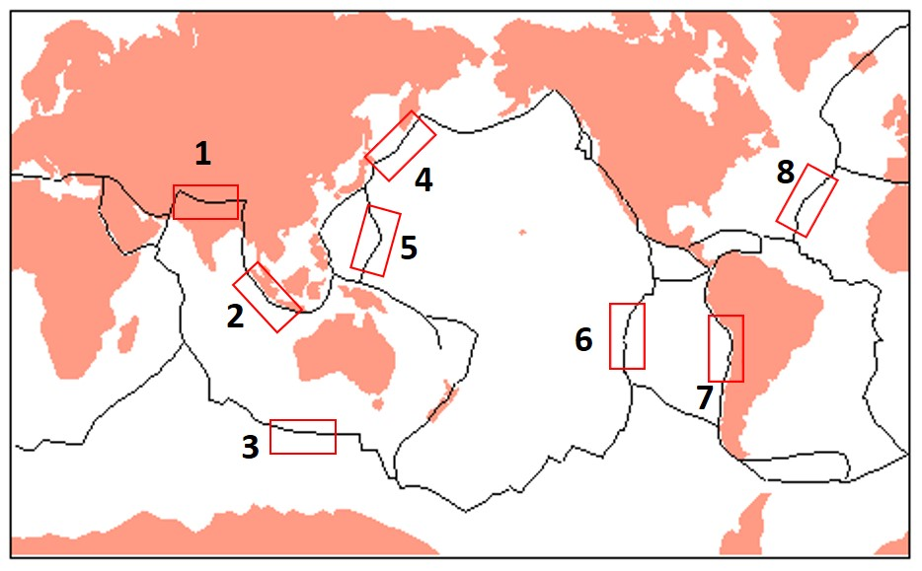
Which of these locations ALL represent oceanic ridges?
- 3, 4, 5, and 6
- 5, 6, and 8
- 2, 4, 5, and 7
- 3, 6, and 8

At which locations would you find oceanic trenches?
- 3, 4, 5, and 6
- 5, 6, and 8
- 2, 4, 5, and 7
- 3, 6, and 8

At which pair of locations would you find island arcs?
- 6 and 8
- 4 and 5
- 1 and 2
- 3 and 7

Approximately what age are the oldest rocks in the Atlantic and Pacific Oceans?
- 420 million years
- 70 million years
- 180 million years
- 4.5 billion years

Which of these locations ALL represent divergent plate boundaries?
- 2, 3, and 4
- 6, 7, and 8
- 4, 5, and 7
- 3, 6, and 8

Answer the questions that follow using the map below.
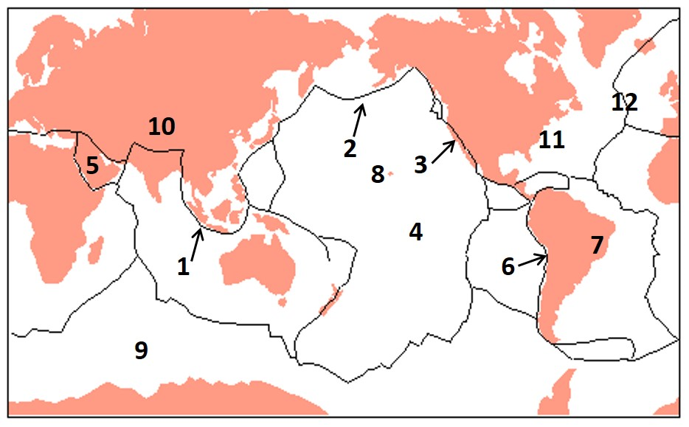

Identify the location of a transform plate boundary.
- 1
- 3
- 6
- 10

Identify the location of a convergent plate boundary with an island arc.
- 2
- 3
- 6
- 12

Identify the location of a convergent plate boundary with a volcanic arc.
- 2
- 3
- 6
- 12

Identify the location of a site with a very young crust (<2 million years).
- 1
- 4
- 7
- 12

Identify the location of a site with Earth’s thickest continental crust.
- 10
- 9
- 7
- 5

Which location would have the oldest oceanic crust?
- 4
- 9
- 11
- 12
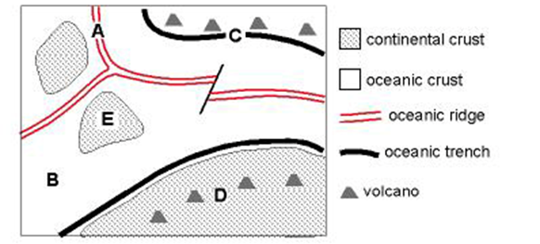
Examine the idealized plate tectonic map to the right and answer the two questions that follow
How many tectonic plates are present on the map?
- 2
- 3
- 4
- 5
- 6

At which location is the asthenosphere closest to the surface?
- A
- B
- C
- D
- E

Finish this sentence by choosing the best selection from the list below to identify where we could find oceanic ridges in the major ocean basins. The oceanic ridge system is present in the
- Pacific, Atlantic and Indian ocean basins.
- Indian and Pacific Ocean basins, but not Atlantic Ocean basin.
- Pacific and Atlantic Ocean basins but not the Indian Ocean basin.
- Atlantic Ocean basin only.

The eastern edge of the South American continent is a(n) ____________ margin.
- active
- passive

LO6. I can draw the approximate locations of the plate boundaries on a world map and name the major plates.

Examine the four maps that show potential plate boundary configurations for the Atlantic Ocean and neighboring continents. Which map best represents the actual plate boundary locations?
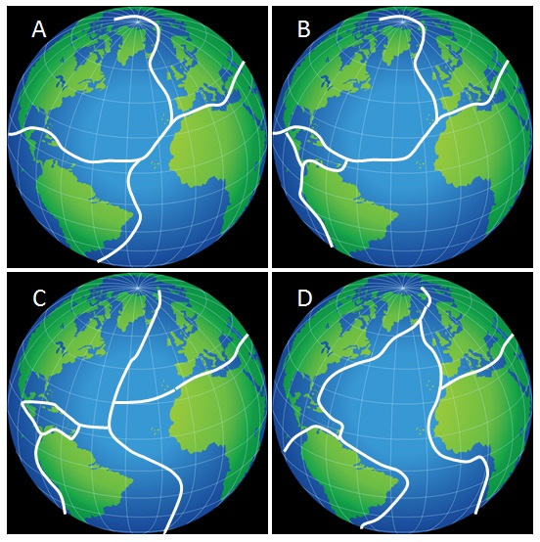
- A
- B
- C
- D

Which is NOT the name of a tectonic plate? Select all that apply.
- Atlantic
- North American
- Pacific
- Antarctic

Examine the four maps that illustrate potential plate boundary configurations for the Indian Ocean. Which map best represents the actual locations of plate boundaries?
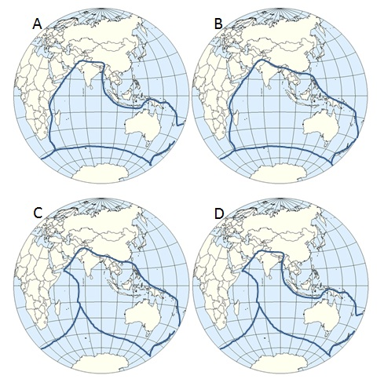
- A
- B
- C
- D

Oceanic trenches are present at most locations along the margins of which ocean basins?
- Only the Pacific Ocean basin
- Only the Atlantic Ocean basin
- Only the Indian Ocean basin
- Both the Pacific and Atlantic Ocean basins
- Both the Atlantic and Indian Ocean basins

What is the name of the small plate that lies between North America and the Pacific Plate?
- Cascadia
- Cocos
- Juan de Fuca
- Alaska

The United States of America is present on how many tectonic plates?
- 1
- 2
- 3
- 4
- 5
Review the image below that shows the outlines of the major plates. Use the figure to answer questions that follow.
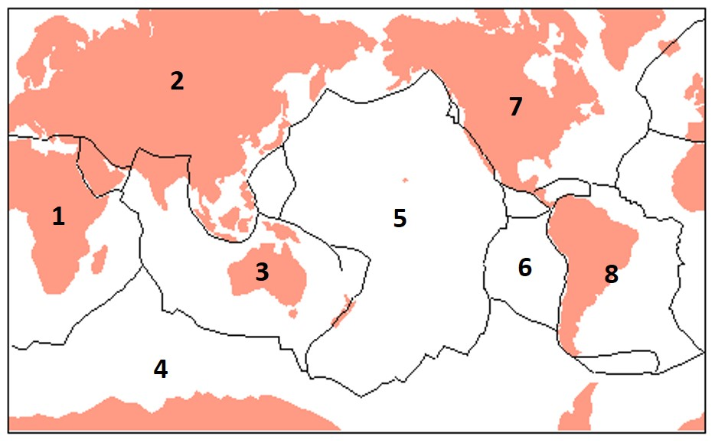
Review the two statements below and identify if they are true or false.
i. Plate #3 is the Antarctica plate.
ii. Plate #6 is the Nazca plate.
- Both statements are true.
- Both statements are false.
- The first statement is true; the second statement is false.
- The first statement is false; the second statement is true.

Which number corresponds to the Atlantic Plate?
- 1
- 7
- 8
- There is no Atlantic Plate

Which numbers best correspond with the Indian-Australian, Eurasian, and Nazca plates (in that order)?
- 3, 2, and 6
- 2, 1 and 5
- 3, 7, and 5
- 4, 2, ad 6

LO7. I can describe the relative motions of plates at the three major types of plate boundary.

Complete this sentence. At divergent boundaries ___
- plates move towards each other.
- plates move away from each other.
- plates slide past each other.

Complete this sentence. At convergent boundaries ___
- plates move towards each other.
- plates move away from each other.
- plates slide past each other.

Complete this sentence. At transform boundaries ___
- plates move towards each other.
- plates move away from each other.
- plates slide past each other.

Review the image below that shows locations along major plate boundaries. Use the figure to answer questions that follow.
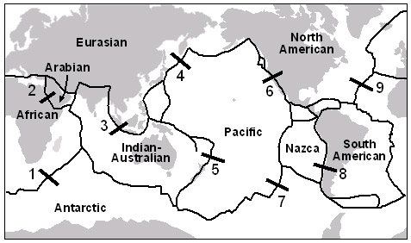
Which three locations are examples of divergent, convergent, and transform boundaries (in that order)?
- 1, 2, 3
- 6, 3, 8
- 5, 9, 2
- 7, 4, 6
- 4, 1, 3

What type of plate boundary is present at location #1?
- Transform
- Convergent
- Divergent

What type of plate boundary is present at location #2?
- Transform
- Convergent
- Divergent

What type of plate boundary is present at location #3?
- Transform
- Convergent
- Divergent

What type of plate boundary is present at location #4?
- Transform
- Convergent
- Divergent

What type of plate boundary is present at location #5?
- Transform
- Convergent
- Divergent

What type of plate boundary is present at location #6?
- Transform
- Convergent
- Divergent

What type of plate boundary is present at location #7?
- Transform
- Convergent
- Divergent

What type of plate boundary is present at location #8?
- Transform
- Convergent
- Divergent

What type of plate boundary is present at location #9?
- Transform
- Convergent
- Divergent
The figure below shows a potential cross section (profile view) through the outermost layers of Earth. Assume that the left margin of the figure is approximately 300 kilometers deep.
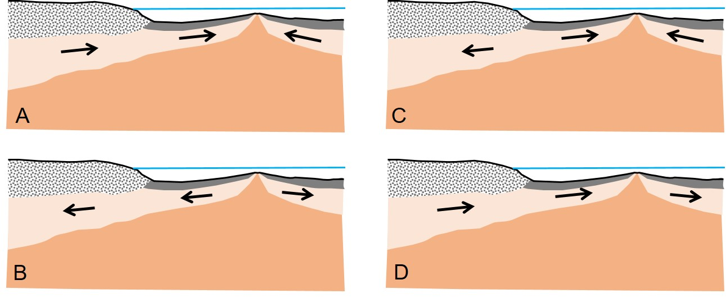
Review the cross section and identify which figure best illustrates the likely plate motions for this plate configuration.
- A
- B
- C
- D

The figure below shows a potential cross section (profile view) through the outermost layers of Earth. Assume that the right margin of the figure is approximately 300 kilometers deep. Review the cross section and identify which figure best illustrates the likely plate motions for this plate configuration.
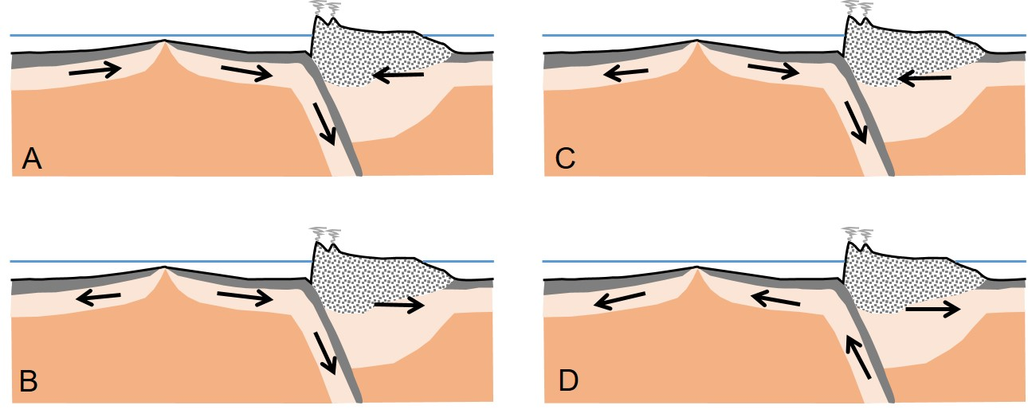
- A
- B
- C
- D

LO8. I can describe the physical features and geological processes, at a divergent plate boundary.

Relative to elsewhere in oceanic tectonic plates, the oceanic lithosphere ___ below an oceanic ridge.
- Is thinner
- Is thicker

The figure below shows a potential cross section (profile view) through the outermost layers of Earth. Review the cross section and answer the questions that follow. Assume that the margins of the figure are approximately 300 kilometers deep.

Which letter best represents the distribution of the asthenosphere at a divergent plate boundary?
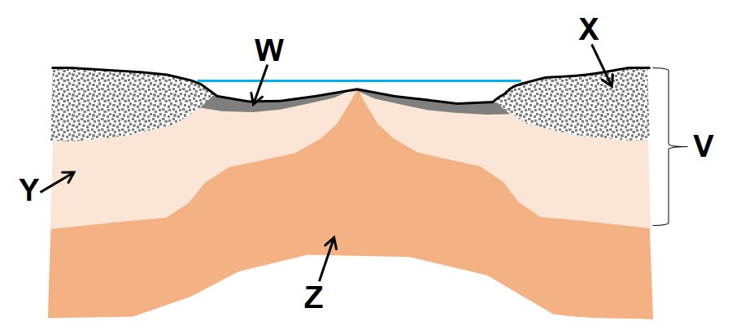
- V
- W
- Y
- Z

What two letters best represent the components of the oceanic lithosphere?
- W and X
- W and Y
- X and Y
- Y and Z

What layer best represents the mantle lithosphere?
- V
- W
- Y
- Z

Which lettered feature would not have been present before the boundary began to form?
- W
- X
- Y
- Z

The figure below shows a potential cross section (profile view) through the outermost layers of Earth. Review the cross section and answer the questions that follow. Assume that the margins of the figure are approximately 300 kilometers deep.

Which letter best represents the location of the oldest oceanic crust?
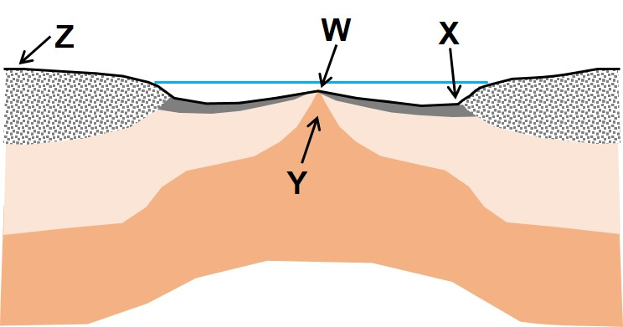
- W
- X
- Y
- Z

Which letter best represents the location of the youngest oceanic crust?
- W
- X
- Y
- Z

Review the two statements below and identify if they are true or false.
i. Magma forms at location Y.
ii. Earthquakes are most likely to occur at X.
- Both statements are true.
- Both statements are false.
- The first statement is true; the second statement is false.
- The first statement is false; the second statement is true.

How many plates are present in this configuration?
- 1
- 2
- 3
- 4

The figures below show potential cross sections (profile view) through the outermost layers of Earth. Review the cross section and answer the question that follows. Assume that the margins of the figure are approximately 300 kilometers deep.

Which image best represents the relative motions of plates at a divergent plate boundary?
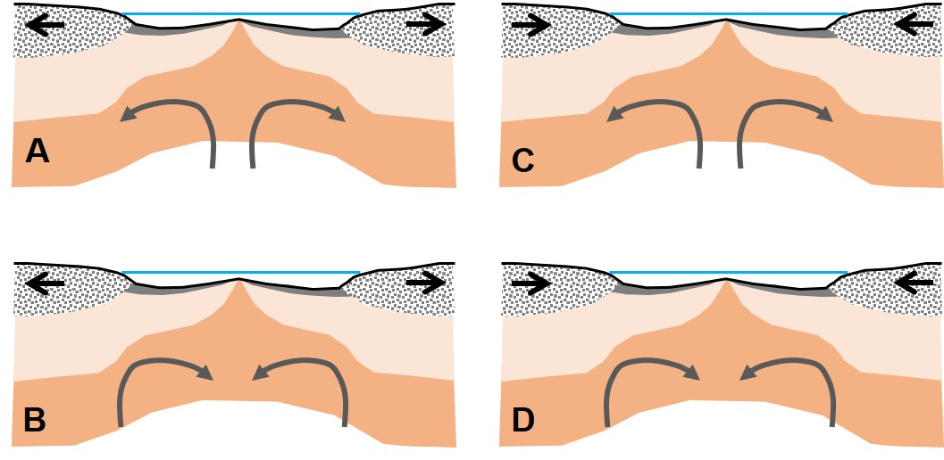
- A
- B
- C
- D

Which statement is more accurate?
- Divergent boundaries are most commonly located toward the center of an ocean basin.
- Divergent boundaries are most commonly located toward the margins of an ocean basin.

Review the two statements below and identify if they are true or false.
i. Rocks on the floor of the ocean basins are younger than most rocks in continents.
ii. The age of the ocean floor increases with increasing distance from the oceanic ridge.
- Both statements are true.
- Both statements are false.
- The first statement is true; the second statement is false.
- The first statement is false; the second statement is true.

The presence of both ___ and ___ are characteristic of divergent plate boundaries.
- Hot spots; island arcs
- Shallow earthquakes; island arcs
- An oceanic ridge; shallow earthquakes
- Hot spots; an oceanic ridge

Island arcs are typically found along divergent plate boundaries.
- True
- False

Divergent plate boundaries are also known as hot spots.
- True
- False

Shallow earthquakes occur in association with divergent plate boundaries.
- True
- False

Which graph best shows how the depth of the ocean floor changes across a mid-ocean ridge?
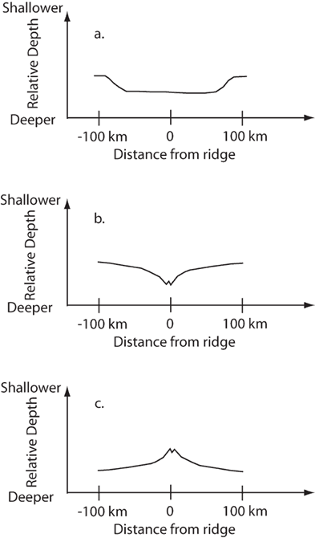
- A
- B
- C
LO9. I can explain how ocean basins form and grow.

Rift valleys form when continental crust begins to break up early in the formation of an ocean basin.
- True
- False

Where do the rocks that form the oceanic crust below a new ocean basin come from?
- Magma rises from below to form new ocean floor
- Sediment is eroded from the continents to create the floor of new ocean basins
- Shells and bones of marine organisms gradually are deposited in a widening ocean basin
- Continental crust is thinned and subsides to form the new oceanic floor

Which statement best describes where to find the oldest rocks in ocean basins?
- Adjacent to oceanic trenches
- Along the margins of continents
- Adjacent to the oceanic ridge

Which statement is the most accurate about potential changes in the size of ocean basins?
- Ocean basins grow gradually wider over many millions of years.
- Ocean basins grow gradually narrower over many millions of years.
- Ocean basins may become either narrower or wider over many millions of years.

Are the world’s ocean basins all growing wider, moving the continents further apart?
- True
- False

Two ocean basins of similar size and age each have a central, north-south trending oceanic ridge. Both are surrounded to the east and west by continents. Basin X is bounded by passive continental margins while basin Y is bounded by subduction zones. Which basin is getting larger, and which is getting smaller?
- Both are increasing in size as both have oceanic ridges.
- Both are getting smaller as both are surrounded by continents.
- Basin X is getting smaller, and basin Y is growing larger.
- Basin X is growing larger, and basin Y is becoming smaller.

Which statement about the relationship between age and the character of the ocean floor is TRUE?
- Deeper regions of the ocean floor tend to be younger
- The Pacific is larger than the Atlantic because it contains older oceanic floor
- Oldest oceanic crust is only present near trenches
- Youngest oceanic crust is near the ridges

How did the Atlantic Ocean basin start to form?
- By breaking apart an older ocean basin between the African and North American plates.
- By breaking apart a larger continental mass located approximately where the Atlantic Ocean basin is today.

The first stage in the formation of the Atlantic Ocean was breaking up the crust of a supercontinent composed of both the African and North American plates.
- True
- False

Identify a continental location that is in the early stages of forming a new ocean basin?
- The continental shelf of Western Australia
- Beneath the Mississippi Valley in North America
- Just south of the Himalaya Mountains in Asia
- Eastern Africa, south of the Red Sea

Two ocean basins of identical size are almost surrounded by continents. The oceanic lithosphere below Ocean A is bordered by plate boundaries. The sea floor under Ocean B has a plate boundary running along its center but none along its margins. Under which ocean is the oceanic floor most likely increasing in width?
- Ocean A
- Ocean B

Two ocean basins of identical size are almost surrounded by continents. The oceanic lithosphere below Ocean A is bordered by plate boundaries. The sea floor under Ocean B has a plate boundary running along its center but none along its margins. Under which ocean is the oceanic floor most likely decreasing in width?
- Ocean A
- Ocean B

How many of the following boundary locations are examples of divergent plate boundaries?
i. Nazca and South American plates
ii. Indian-Australian and Antarctica plates
iii. Pacific and Eurasian plates
iv. North American and Eurasian plates
- None
- One
- Two
- Three
- Four

Examine the diagram below that shows oceanic and continental crust surrounding a plate boundary. Based on the current plate tectonic setting, what direction is location Y moving toward?

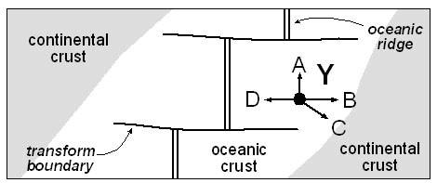
- A
- B
- C
- D

Plate Tectonics, Part 2

LO1. I can explain the characteristics of hot spots.

Hot spot locations on Earth's surface are independent of plate tectonic boundaries.
- True
- False

Hot spots ___
- are any area of a tectonic plate that features volcanic activity.
- are areas where the underlying mantle is hotter and more buoyant than the surrounding mantle.
- are associated with convergent boundary volcanism and are caused by subducting plates.

Which of the following are true of hot spot volcanic chains? They consist of ___. Select all that apply.
- lines of volcanic islands that are all volcanically active
- lines of volcanic islands that vary in age
- lines of volcanic islands that are all the same age
- lines of volcanic islands that vary in volcanic activity

Hot spots can only occur where there is an active plate boundary.
- True
- False

Which of the following locations are formed above a hot spot? Select all that apply.
- Hawaiian Islands
- Aleutian Islands
- Yellowstone
- Juan de Fuca

Approximately how far would a volcano, that formed over a hot spot on the fast-moving Pacific plate, travel in 1000 years. (Assume a constant rate of plate motion. 1 km = 1000 m; 1 m = 100 cm)
- 10-20 meters
- 100-200 meters
- 10-20 kilometers
- 100-200 kilometers

Hot spots are found in association with mantle plumes.
- True
- False

Hot spots are found in association with volcanic island arcs.
- True
- False

What is the source for the magma that forms hot spots?
- The magma source is in the shallow mantle, similar to magma below oceanic ridges
- The magma source is located near the mantle/core boundary
- The magma source is the melting of plates that heat up as they descend into a subduction zone
- The magma source is the partial melting of the lower continental crust in rift zones

What type of feature forms above an oceanic hot spot over several millions of years?
- A linear island chain
- An island arc
- A volcanic arc
- A rift zone

Where are hot spots most likely to be found?
- In the interiors of plates
- Near plate boundaries

The Aleutian Islands (Alaska) formed above a hot spot.
- True
- False

Review the two statements below and identify if they are true or false.
i. Volcanoes become older with increasing distance from a hot spot location.
ii. A hot spot remains in a fixed location in the mantle as a plate moves over it.
- Both statements are true.
- Both statements are false.
- The first statement is true; the second statement is false.
- The first statement is false; the second statement is true.

Which of the following statements is consistent with hot spots? They:
- result in a chain of islands that are all volcanically active.
- form the beginnings of new continents.
- are used to determine that plates are moving, as well as the direction
- involve two plates interacting.

LO2. I can interpret the pattern of hot spots to determine the direction of plate motion.

Located on the Pacific plate, the Hawaiian chain of islands was caused by ___
- a convergent boundary between the Pacific plate and a neighboring plate
- a divergent boundary splitting the Pacific plate
- a transform boundary between the Pacific plate and a neighboring plate
- a hotspot below the moving Pacific plate

Examine the diagram below. The lettered objects represent volcanoes formed on an oceanic plate above a hot spot. The arrow illustrates the direction of plate motion. Which volcano is the oldest?
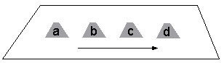
- a
- b
- c
- d

Examine the diagram below. The lettered objects represent volcanoes formed on an oceanic plate above a hot spot. Use this image to answer the questions that follow.

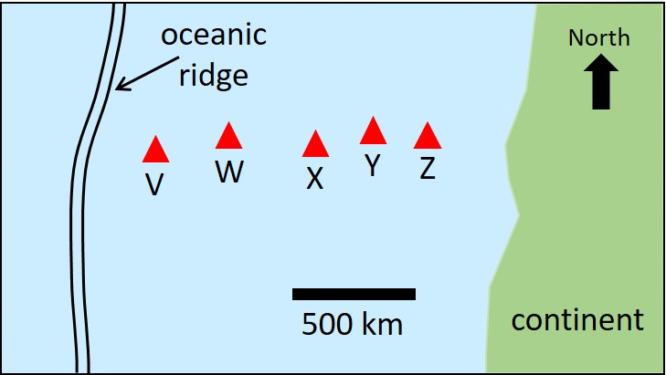
Which volcano is the oldest?
- V
- W
- X
- Y
- Z

Which volcano is the youngest?
- V
- W
- X
- Y
- Z

What is the direction of motion for the oceanic plate to the east of the oceanic ridge?
- The plate is moving to the east
- The plate is moving to the west

Examine the diagram below. The lettered objects represent volcanoes formed on an oceanic plate above a hot spot. Analysis of the ages of rocks on the volcanoes reveals that V is 10 million years old, X is 82 million years old and Y is 92 million years old. Use this image to answer the questions that follow.
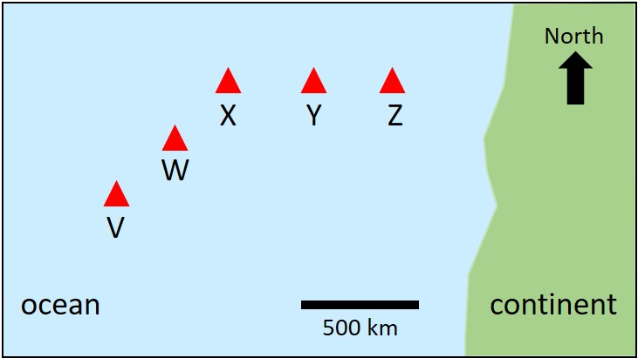

Use the information provided to determine the directions of plate motions over time.
- Plate initially moved to northeast, then to the east
- Plate initially moved to west, then to the southwest
- Plate initially moved to east, then to the northeast
- Plate initially moved to southwest, then to the west

Use the information provided to predict how the rate of plate motion varied with time.
- Plate initially moved faster and then slowed down
- Plate initially moved slowly and then sped up
- Rate of plate motion did not change over time
- Rate of plate motion cannot be determined from hot spot ages.

Examine the diagram below that represents a map view of an oceanic plate. The lettered objects represent volcanoes formed above a hot spot. Analysis of the ages of rocks on the volcanoes reveals that V is 20 million years old and Z is 130 million years old. Use this image to answer the questions that follow.
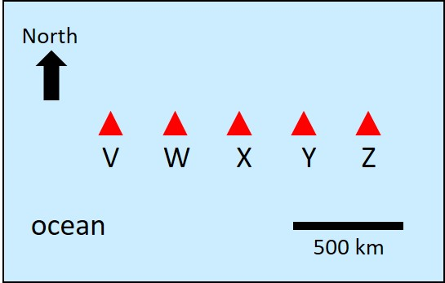

What is the direction of plate motion?
- The plate is moving to the east
- The plate is moving to the west

Where is the hot spot located now?
- Below V
- Below Z
- To the west of V
- To the east of Z
- Below V, W, X, Y, and Z

Volcanoes become younger with increasing distance from a hot spot location.
- True
- False

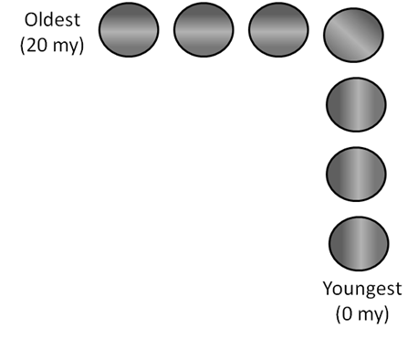
Interpret the diagram of a hot spot track to fill in the blanks in this sentence.
From 20 to 10 million years ago, a plate was moving ______ over a hotspot. 10 million years ago, the plate changed direction and has been moving _____ ever since, forming the island chain shown.
- East, North
- West, South
- East, South
- West, North

LO3. I can explain the process of convection that drives plate tectonics.

Earth's internal heat is derived from which of the following sources? Select all that apply.
- Heat left over from the formation of the Earth
- Combustion of volatile elements in Earth's inner core
- Nuclear fusion of Hydrogen to Helium in Earth's inner core
- Radioactive decay of isotopes in the mantle and crust

Review the two statements below and identify if they are true or false.
i. Heat from Earth’s core is the principal driver of plate tectonics.
ii. Much of the heat that drives plate tectonics comes from the decay of radioactive isotopes in the mantle.
- Both statements are true.
- Both statements are false.
- The first statement is true; the second statement is false.
- The first statement is false; the second statement is true.

Which of the schematic diagrams below best represents mantle convection and plate motions associated with plate tectonics?
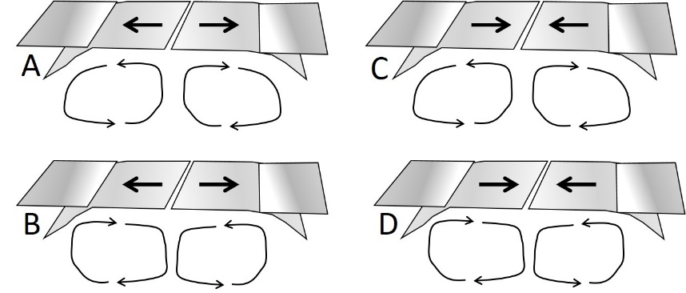
- A
- B
- C
- D

What is the principal cause of convection in Earth’s mantle?
- Earth’s rotation on its axis
- The transfer of heat from Earth’s interior
- The movement of tectonic plates
- Earthquakes and volcanic activity

Mantle material would be most likely to descend in convection cells below which features?
- Oceanic ridges
- Hot spots
- Subduction zones
- Continental margins

Mantle material would be most likely to move upward below which features?
- Oceanic ridges
- Subduction zones
- Continental margins

Review the two statements below and identify if they are true or false.
i. Mantle plumes are typically found below the locations of hot spots.
ii. Convection carries mantle material downward in association with subduction zones.
- Both statements are true.
- Both statements are false.
- The first statement is true; the second statement is false.
- The first statement is false; the second statement is true.

The movement of tectonic plates generates convection in Earth’s mantle.
- True
- False

Yellowstone formed above a hot spot.
- True
- False

Convection in Earth’s mantle results in the movement of tectonic plates.
- True
- False

The underlying mechanism hypothesized to drive plate tectonics is
- loss of heat from Earth’s interior by convection.
- continental crust is more buoyant than oceanic crust.
- consumption of oceanic crust within subduction zones.
- tectonic boundaries are always associated with earthquakes.
LO4.I can describe the physical features and geologic processes at a convergent plate boundary.

Island arcs are most closely associated with which features?
- oceanic fracture zones
- continental shelves
- mountains
- oceanic ridges
- oceanic trenches

Which of the following surface features are associated with convergent boundaries? Select all that apply.
- Oceanic trenches
- Mountain chains
- Oceanic ridges
- Island arcs

Oceanic lithosphere must be destroyed in a subduction zone before two continents can collide along a convergent plate boundary.
- True
- False

Melting of a tectonic plate descending a subduction zone is the source of magma at a convergent plate boundary.
- True
- False

A trench is present at a convergent boundary where two oceanic plates are colliding.
- True
- False

Two oceanic plates collide along a convergent plate boundary. Plate A is traveling at 7 cm/year and the oceanic crust along the boundary is dated at 40 million years of age. Plate B is moving at 2 cm/year and a sample of the oceanic crust near the boundary is determined to be 120 million years old. Predict which plate will descend into a subduction zone.
- Plate A
- Plate B

Two oceanic plates begin to move with convergent motion. Generally, which plate will subduct below the other? Select all that apply.
- The older one
- The younger one
- The denser one
- The less dense one

Which answers are correct for the following statement? Before the collision between continents there must be ___. Select all that apply.
- volcanoes formed along the edge of one of the continents.
- the formation of an oceanic ridge between the continents.
- oceanic lithosphere being consumed in a subduction zone.

Oceanic trenches are present at most locations along the margins of ___
- the Pacific Ocean
- the Atlantic Ocean
- the Indian Ocean
- A and B
- B and C

The figure below shows potential cross sections (profile view) through the outermost layers of Earth. Assume that the right margin of the figure is approximately 300 kilometers deep. Review the cross sections and identify which figure best illustrates the likely features associated with such a plate configuration.
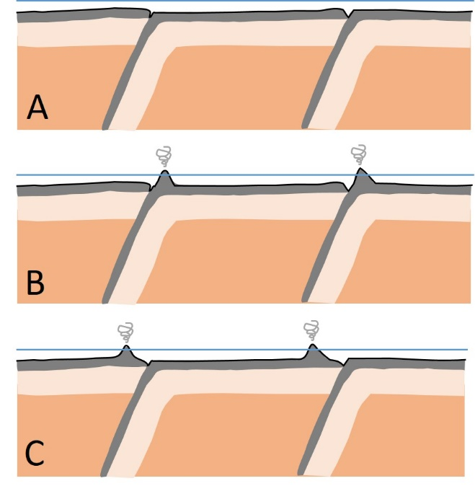
- A
- B
- C

Review the two statements below and identify if they are true or false.
i. Magma rises through the over-riding plate at an ocean-ocean convergent boundary.
ii. Mountain belts are present on the descending plate at an ocean-continent convergent boundary
- Both statements are true.
- Both statements are false.
- The first statement is true; the second statement is false.
- The first statement is false; the second statement is true.
The figure below shows a potential cross section (profile view) through the outermost layers of Earth. Assume that the right margin of the figure is approximately 300 kilometers deep.
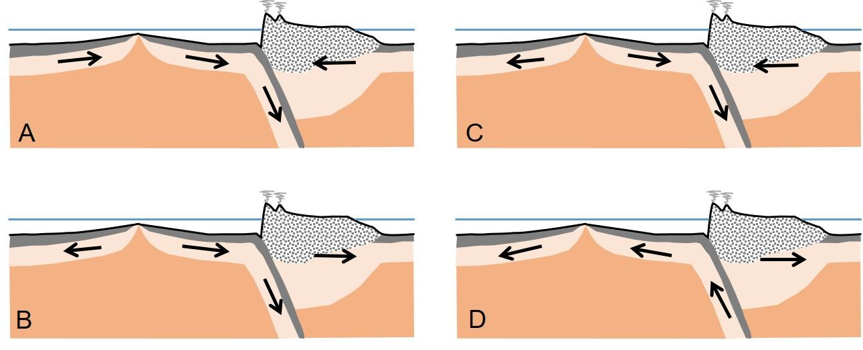
Review the cross section and identify which figure best illustrates the likely plate motions for this plate configuration.
- A
- B
- C
- D

Review the two statements below and identify if they are true or false.
i. A trench is present at a convergent boundary where two continental plates are colliding.
ii. A volcanic arc is present on either side of a continent-continent convergent boundary.
- Both statements are true.
- Both statements are false.
- The first statement is true; the second statement is false.
- The first statement is false; the second statement is true.

Review the two statements below and identify if they are true or false for ALL types of convergent plate boundaries.
i. Oceanic lithosphere is present on at least one side of the boundary.
ii. Rocks on either side of the boundary are typically of different ages.
- Both statements are true.
- Both statements are false.
- The first statement is true; the second statement is false.
- The first statement is false; the second statement is true.

Review the two statements below and identify if they are true or false.
i. A trench is present at a convergent boundary where two oceanic plates are colliding.
ii. An island arc is present on the over-riding plate at an ocean-ocean convergent boundary.
- Both statements are true.
- Both statements are false.
- The first statement is true; the second statement is false.
- The first statement is false; the second statement is true.

Review the two statements below and identify if they are true or false.
i. Magma forms at convergent plate boundaries when the descending plate melts.
ii. The thickest crust on Earth is found at a continent-continent convergent boundary.
- Both statements are true.
- Both statements are false.
- The first statement is true; the second statement is false.
- The first statement is false; the second statement is true.

LO5. I can compare and contrast the three types of convergent plate boundary.

What is true about ocean-continent convergent boundaries? Select all that apply.
- The more dense plate is subducted under the less dense plate
- The less dense plate is subducted under the more dense plate
- Magma will generate volcanic activity on the subducting plate
- Magma will generate volcanic activity on the overriding plate
- The plates relatively move towards one another
- The plates relatively move away from one another

All convergent boundaries generate magma and volcanism.
- True
- False

Continental-continental boundaries can be described as "collisions" due to the buoyant nature of the continental crust and subsequent lack of subduction.
- True
- False

Large earthquakes are associated with all three types of convergent plate boundaries.
- True
- False

Where do the largest (greatest magnitude) earthquakes typically occur?
- At all types of plate boundaries
- Only at convergent and divergent plate boundaries
- Only at transform and divergent plate boundaries
- Only at convergent plate boundaries
- Only at divergent plate boundaries
- Only at transform plate boundaries

Which type of plate boundary best corresponds to the boundary between the South American plates and Nazca plates?
- Oceanic-oceanic
- Continental-oceanic
- Continental-continental

Review the two statements below and identify if they are true or false.
i.The highest mountains on Earth are associated with continent-continent convergent boundaries.
ii.The thickest crust on Earth is associated with ocean-continent convergent boundaries.
- Both statements are true.
- Both statements are false.
- The first statement is true; the second statement is false.
- The first statement is false; the second statement is true.

Which of the following is a type of convergent boundary? Select all that apply.
- Oceanic-oceanic
- Continental-oceanic
- Continental-continental
- Hot spot

Consider the three types of convergent plate boundaries and use the figure below to answer the questions that follow.
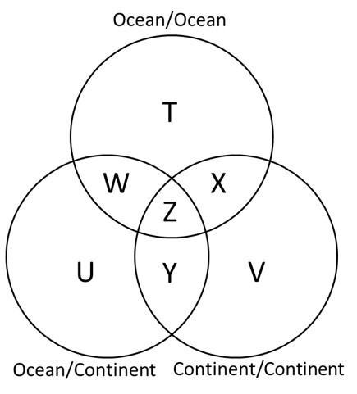

Which statement(s) could be placed in the area labelled "W" in the Venn diagram? Select all that apply.
- Present along margins of the Pacific plate
- Oceanic lithosphere present on both sides of the boundary
- Plates move towards each other
- Result in the formation of multiple volcanoes on land or volcanic islands
- Magma rises to the surface at or near the boundary

Which statement(s) could be placed in the area labelled "Z" in the Venn diagram? Select all that apply.
- Plates move toward one another
- Involved subducting oceanic lithosphere at some point during their history
- Magma rises to the surface at or near the boundary
- Are evidenced by prominent trenches on Earth's surface
- Rocks on either side of boundary are typically of different ages

Which statement(s) could be placed in the area labelled "X" in the Venn diagram? Select all that apply.
- Plates move toward one another
- Results in some of the highest topography on Earth
- Magma rises to the surface at or near the boundary
- Result in the formation of multiple volcanoes on land or island arcs
- Involved subducting oceanic lithosphere at some point during their history

Which statement(s) could be placed in the area labelled "Y" in the Venn diagram? Select all that apply.
- Plates move toward one another
- Magma rises to the surface at or near the boundary
- Result in the formation of multiple volcanoes on land or island arcs
- Involved subducting oceanic lithosphere at some point during their history
- Results in some of the highest topography on Earth
- Can produce large earthquakes

LO6. I can identify examples of transform plate boundaries around the world.

Which two of the following are sites of a presently active transform boundary?
- West coast of South America
- West coast of Africa
- West coast of the United States (i.e., California)
- Along the South Island of New Zealand

Which of the following best completes the sentence explaining the global occurrence of transform boundaries? The majority of active transform boundaries are found ___
- adjacent to active convergent boundaries along the margins of plates.
- adjacent to active divergent boundaries near oceanic ridges.

Hot spots are typically associated with transform plate boundaries.
- True
- False

What direction is the Pacific plate moving relative to the North American plate along the transform boundary represented by the San Andreas Fault system?
- Southeast
- Northwest
- Northeast
- Southwest

Review the map of plate boundaries. Which of the following pairs BOTH represent transform plate boundaries?
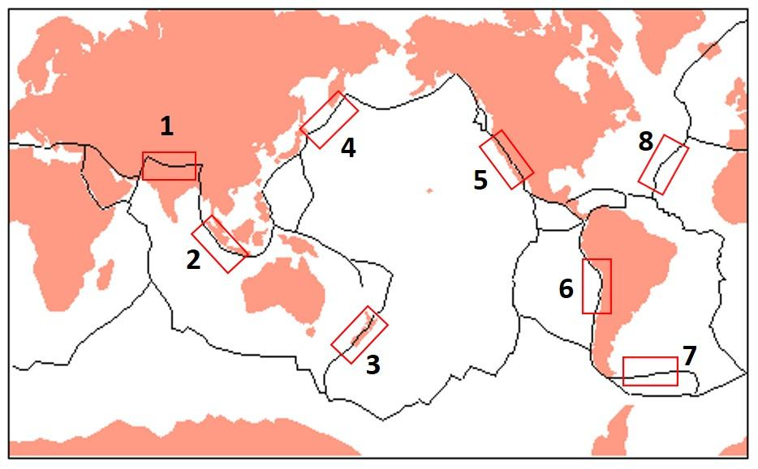
- 1 & 4
- 3 & 7
- 2 & 6
- 2 & 8

Which of the following is the most characteristic of transform plate boundaries?
- Volcanoes
- Rift valleys
- Earthquakes
- Mountain ranges

Review the two statements below and identify if they are true or false.
i. Transform boundaries often feature extensive volcanism
ii. Shallow earthquakes occur along transform plate boundaries.
- Both statements are true.
- Both statements are false.
- The first statement is true; the second statement is false.
- The first statement is false; the second statement is true.

LO7. I can describe the physical features and geologic processes at a transform plate boundary.

Which of the following is associated with active transform boundaries?
- Extensive volcanism
- Extensive shallow earthquakes
- Extensive earthquakes of varying depths (shallow and deep)
- A and C

Oceanic fracture zones are continuations of ___ boundaries that segment the ___ boundary between plates in the Atlantic Ocean.
- convergent; transform
- transform; convergent
- divergent; transform
- transform; divergent

What are the relative directions of motion on either side of a transform boundary?
- Plates move apart
- Plates move toward each other
- Plates slide past each other

The North American plate is bounded by what types of plate boundaries?
- Convergent only
- Convergent and divergent only
- Convergent, divergent, and transform

Examine the idealized sketch map that shows the location of two segments of oceanic ridge separated by a transform plate boundary. Where do earthquakes occur?
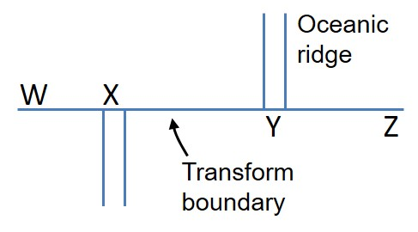
- Between W and Z
- Between X and Y
- From W and X and Y to Z

Examine the idealized maps which illustrate an oceanic ridge (double lines) separated by a transform boundary. Which image shows the correct plate motions associated with the transform boundary?
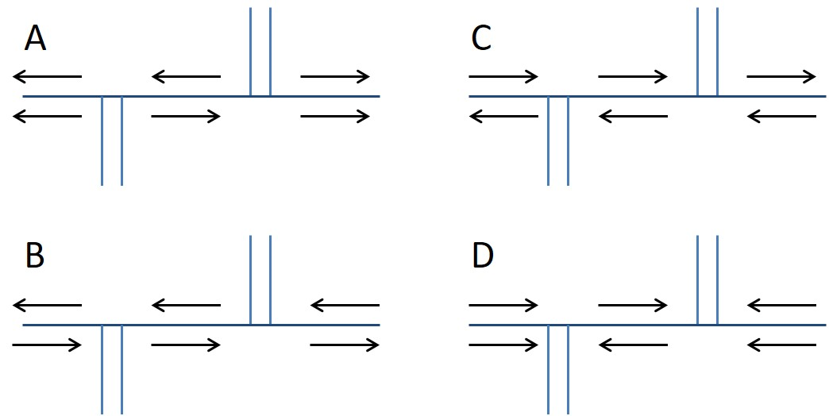
- A
- B
- C
- D

The presence of volcanic hot spots is characteristic of transform plate boundaries.
- True
- False

LO8. I can identify the factors that influence the rate of plate motion and explain why some plates move faster than others.

Answer the question that follows using the map below. Which location accurately illustrates the relative motions of plates on either side of a boundary?
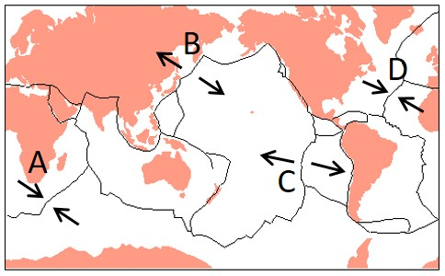
- A
- B
- C
- D

Answer the question that follows using the map below. Which location accurately illustrates the relative motions of plates on either side of a boundary?
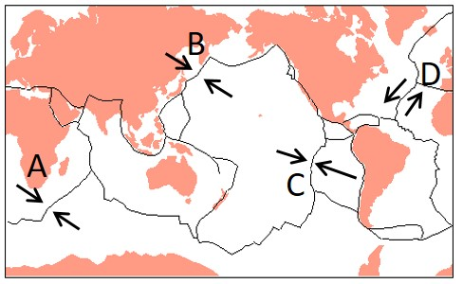
- A
- B
- C
- D

Answer the question that follows using the map of tectonic plates. Which pair of arrows most accurately illustrate the relative motions of the tectonic plates?
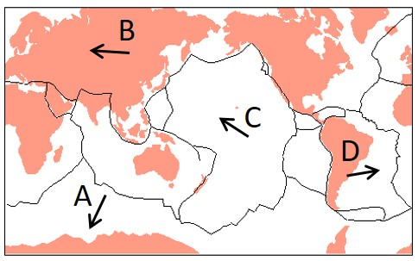
- A and C
- B and D
- C and B
- D and A

Answer the question that follows using the map of tectonic plates. Which pair of arrows most accurately illustrate the relative motions of the tectonic plates?
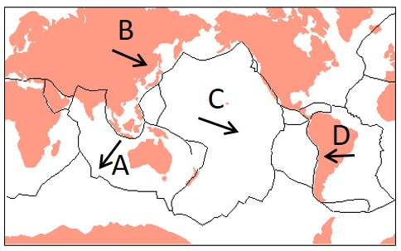
- A and C
- B and D
- C and B
- D and A

The Pacific Ocean is wider than the Atlantic Ocean because
- plate motions are faster in the Pacific.
- the Pacific has two oceanic ridges whereas the Atlantic only has one.
- oceanic lithosphere is consumed at subduction zones in the Atlantic but not in the Pacific.

Review the map of tectonic plates and answer the question that follows.
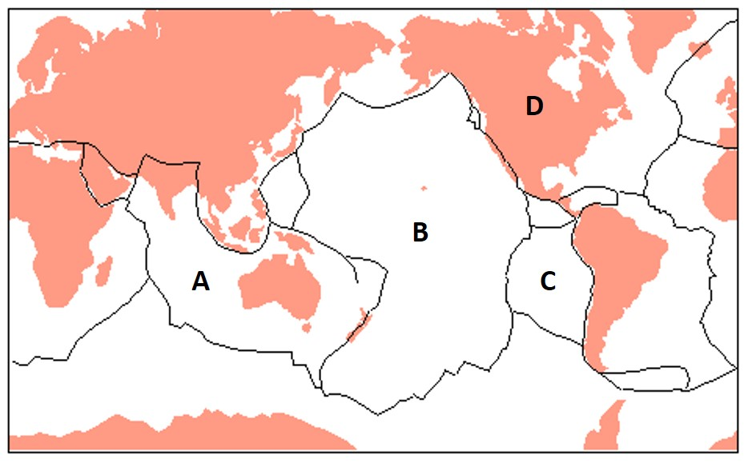
Which location is on the slower moving plate?
- A
- B
- C
- D

Review the map of tectonic plates and answer the question that follows.
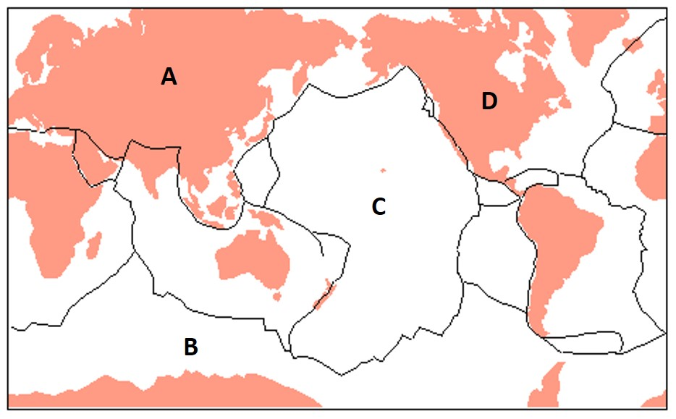
Which location would move the greatest distance in a year?
- A
- B
- C
- D

Which force results in faster plate motions?
- Ridge push
- Slab pull

Which forces are driving motions of the South American plate?
- Ridge push only
- Slab pull only
- Ridge push and slab pull

Which forces are driving motions of the Pacific plate?
- Ridge push only
- Slab pull only
- Ridge push and slab pull

Which forces are driving motions of the North American plate?
- Ridge push only
- Slab pull only

Review the four idealized maps of plate configurations and answer the questions that follow.
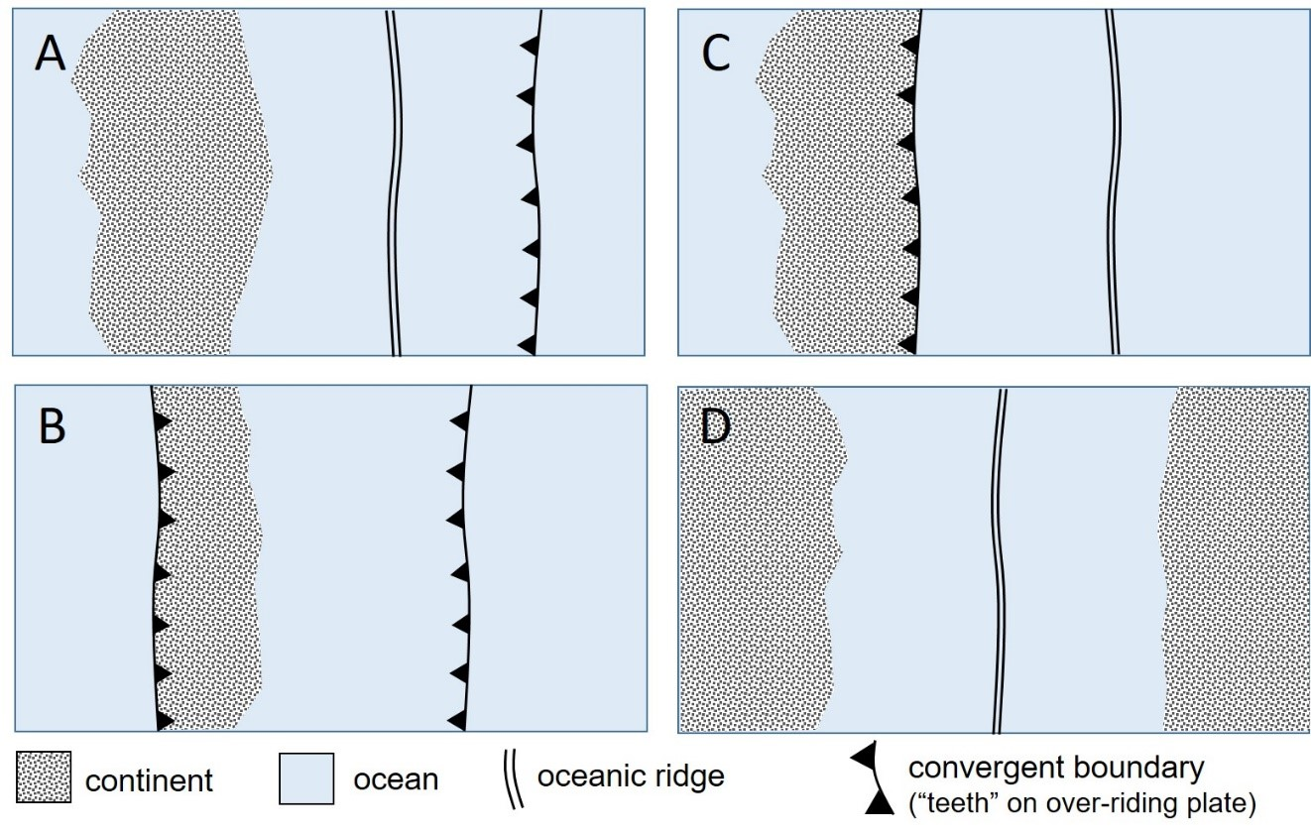

Which maps illustrate examples where plates are experiencing ridge push? Select all that apply.
- A
- B
- C
- D

Which map illustrates a plate that is experiencing both slab pull and ridge push?
- A
- B
- C
- D

Review the four idealized maps of plate configurations and answer the questions that follow.
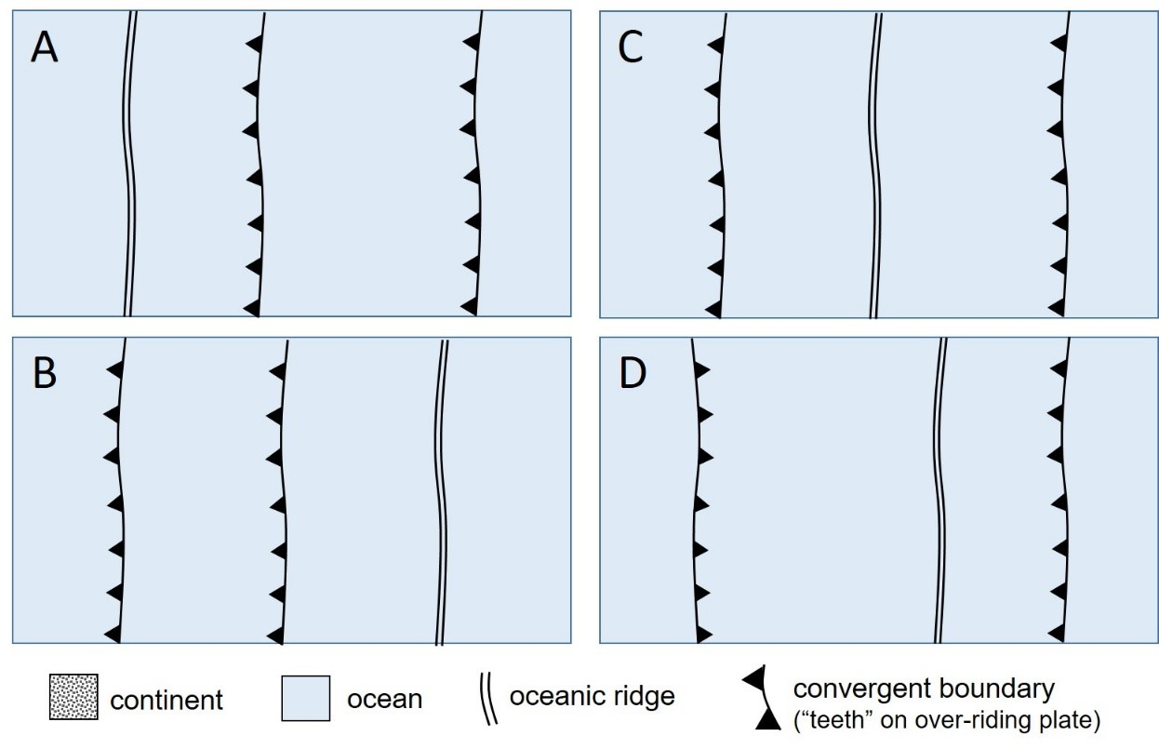

Which two maps illustrate a plate that is experiencing both slab pull and ridge push?
- A
- B
- C
- D

Which map illustrates two plates that are each experiencing both slab pull and ridge push?
- A
- B
- C
- D

Review the two idealized maps of plate configurations and answer the question that follows.
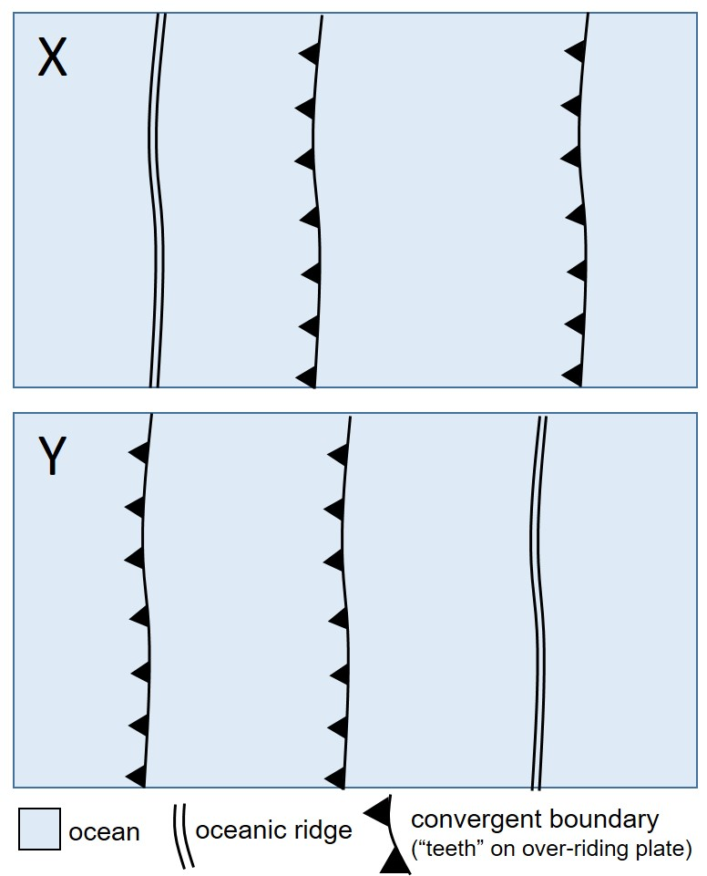

Which map(s) illustrate a plate that is experiencing both slab pull and ridge push?
- X only
- Y only
- X and Y

Review the map of tectonic plates and answer the questions that follow.
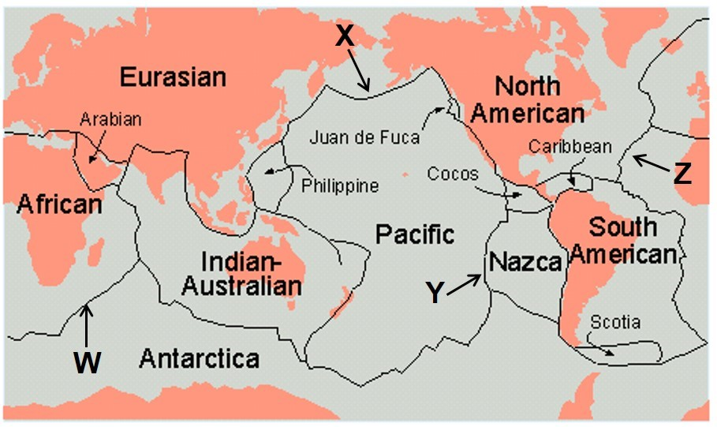
At which location is slab pull taking place?
- W
- X
- Y
- Z

Which of the following would you classify as fast-moving plates? Select all that apply.
- African
- Pacific
- South American
- Nazca
- Eurasian

Which of the following would you classify as slow-moving plates? Select all that apply.
- Antarctica
- Pacific
- North American
- Indian-Australian

Examine the cross section showing a series of tectonic plates and answer the questions that follow.
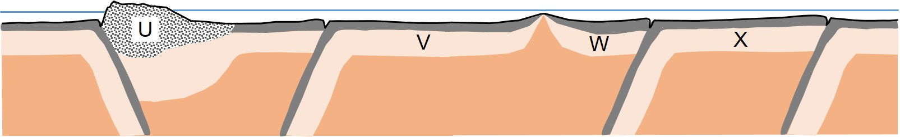
Review the two statements below and identify if they are true or false.
i. This cross section illustrates part or all of six tectonic plates.
ii. The fastest moving labeled plate would be V.
- Both statements are true.
- Both statements are false.
- The first statement is true; the second statement is false.
- The first statement is false; the second statement is true.

Review the two statements below and identify if they are true or false.
i. Plate W is experiencing both ridge push and slab pull.
ii. The fastest moving labeled plate is U.
- Both statements are true.
- Both statements are false.
- The first statement is true; the second statement is false.
- The first statement is false; the second statement is true.

Examine the cross section showing a series of tectonic plates and answer the questions that follow.
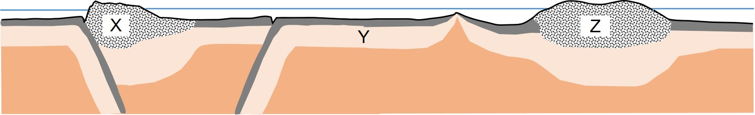

Review the two statements below and identify if they are true or false.
i. Plate Y is experiencing both ridge push and slab pull.
ii. The fastest moving labeled plate is X.
- Both statements are true.
- Both statements are false.
- The first statement is true; the second statement is false.
- The first statement is false; the second statement is true.

Review the two statements below and identify if they are true or false.
i. Plate X is experiencing slab pull.
ii. The fastest moving labeled plate is Y.
- Both statements are true.
- Both statements are false.
- The first statement is true; the second statement is false.
- The first statement is false; the second statement is true.

LO9. I can describe the relationship between plate tectonics and past and future supercontinents.

The supercontinent Pangaea formed 280 million years ago and began to split up approximately 180 million years ago. The plate tectonic cycle results in continents coming together to form supercontinents several times during Earth's history.
- True
- False

Pangaea is the only supercontinent that has existed in Earth's history.
- True
- False

Review the two statements below and identify if they are true or false.
i. The continents of Africa, South America, North America and Eurasia were all included in the supercontinent Pangaea.
ii. Most of Earth’s continental landmasses were together in the supercontinent Pangaea for approximately half of Earth’s history.
- Both statements are true.
- Both statements are false.
- The first statement is true; the second statement is false.
- The first statement is false; the second statement is true.

Review the two statements below about predictions for the future of plate tectonics and determine if they are true or false.
i. Fifty million years from now the Atlantic Ocean will be much wider than today.
ii. Fifty million years from now Australia will be colliding with southeast Asia.
- Both statements are true.
- Both statements are false.
- The first statement is true; the second statement is false.
- The first statement is false; the second statement is true.

Which list places the tectonic events in the correct order from oldest to youngest?
- 1. Collision of India with Eurasia; 2. Separation of Africa and South America; 3. Opening of the North Atlantic Ocean
- 1. Separation of Africa and South America; 2. Opening of the North Atlantic Ocean; 3. Collision of India with Eurasia
- 1. Opening of the North Atlantic Ocean; 2. Separation of Africa and South America; 3. Collision of India with Eurasia

The collision of India with Eurasia occurred before the opening of the North Atlantic Ocean.
- True
- False

Approximately how often have most of Earth’s land masses been together in a supercontinent?
- Once
- Several times (approximately 5-15)
- Hundreds of times
- Never

Review the two statements below and predict if they are true or false.
i. Pangaea formed early in Earth’s history, around 2 billion years ago.
ii. North America and Africa separated from each other before India collided with Eurasia.
- Both statements are true.
- Both statements are false.
- The first statement is true; the second statement is false.
- The first statement is false; the second statement is true.

Review the map of the tectonic plates and answer the questions that follow.
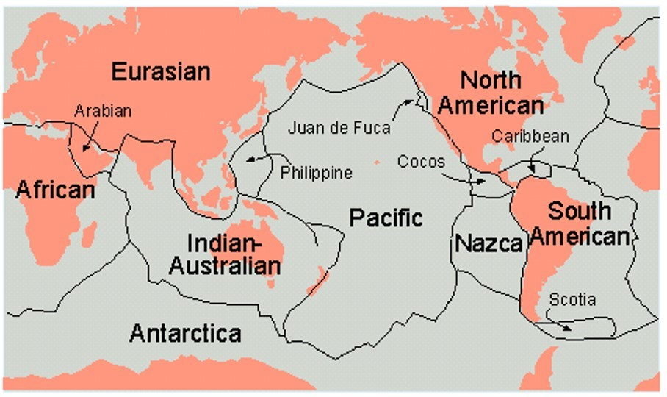
Which plate is more likely to become smaller during the next several millions of years?
- Nazca
- South America
- North America
- Africa

Review the two statements below about predictions for the future of plate tectonics and determine if they are true or false.
i. Several million years from now the Nazca plate will be larger.
ii. Fifty million years from now South America will be much closer to Australia.
- Both statements are true.
- Both statements are false.
- The first statement is true; the second statement is false.
- The first statement is false; the second statement is true.

On the basis of its present-day plate setting, would you predict that the African plate will become larger or smaller in the next several million years?
- Larger
- Smaller

On the basis of its present-day plate setting, would you predict that the South American plate will become larger or smaller in the next several million years?
- Larger
- Smaller

LO10. I can describe the characteristics and tectonic evolution of the North American continent.

Most mountains on the North American continent are located ___
- in the East
- in the West
- around the Gulf of Mexico
- in northern Canada

The continent of North America can be attributed to a single mountain-building event.
- True
- False

The continent of North America was assembled from crustal blocks of rock that range in age from 4 billion years old to just a few million years old.
- True
- False

The rocks of the North American continent are both very old and roughly the same age.
- True
- False

Where would you find the oldest rocks in the North American continent?
- In the interior of the continent
- Along the margins of the continent

Review the two statements below and determine if they are true or false.
i. The oldest rocks in North America are found in the interior of the continent
ii. The oldest rocks in the North American continent are approximately 1.8 billion years old.
- Both statements are true.
- Both statements are false.
- The first statement is true; the second statement is false.
- The first statement is false; the second statement is true.

Review the two statements below and determine if they are true or false.
i. The North American continent has remained the same size for approximately 1 billion years
ii. The North American continent has remained in its current position for approximately 1 billion years
- Both statements are true.
- Both statements are false.
- The first statement is true; the second statement is false.
- The first statement is false; the second statement is true.

Review the two statements below and determine if they are true or false.
i. What we now know as the North American continent was smaller in the past and has grown over geologic time as pieces of lithosphere were added along its margins
ii. The North American continent has changed position on Earth throughout its history.
- Both statements are true.
- Both statements are false.
- The first statement is true; the second statement is false.
- The first statement is false; the second statement is true.

The rocks that are present in any continent today were present as parts of several supercontinents throughout Earth’s history.
- True
- False

What is the term used to describe pieces of adjacent continental crust with very different geologic histories?
- Mountain ranges
- Continental shields
- Tectonic terranes
- Horsts and grabens
- Arches and basins

Tectonic terranes found on continents may contain remnants of oceanic floor rocks.
- True
- False

Which of the following characteristics may vary between adjacent tectonic terranes? Select all that apply.
- Original tectonic setting
- Age of rocks
- Fossils
- Type of rocks (e.g., igneous vs. sedimentary)
- Sequence of rocks

Review the two statements below and determine if they are true or false.
i. Adjacent tectonic terranes typically contain rocks of different ages.
ii. Adjacent tectonic terranes were typically formed in different tectonic settings.
- Both statements are true.
- Both statements are false.
- The first statement is true; the second statement is false.
- The first statement is false; the second statement is true.

Review the two statements below and determine if they are true or false.
i. A microcontinent (continental fragment) might represent a future tectonic terrane
ii. A chunk of oceanic crust might represent a future tectonic terrane.
- Both statements are true.
- Both statements are false.
- The first statement is true; the second statement is false.
- The first statement is false; the second statement is true.

Review the two statements below and determine if they are true or false.
i. A tectonic terrane represents a fragment of crustal material with a distinct geologic history
ii. Terranes are most likely to be added to continents in association with divergent plate boundaries
- Both statements are true.
- Both statements are false.
- The first statement is true; the second statement is false.
- The first statement is false; the second statement is true.

Approximately how old are the oldest rocks in the North American continent?
- 1.8 billion years
- 4 billion years
- 600 million years
- 620,000 million years

A linear island chain (e.g., Hawaii) could form a tectonic terrane.
- True
- False

Elements and Minerals

LO1. I can identify the most common elements in the whole Earth and in the crust.

Which mineral would you most likely find in Earth's mantle?
- Olivine
- Quartz
- Nickel
- Iron

Which list contains three of the eight most common elements in Earth’s crust?
- Iron, nitrogen, nickel
- Silicon, sulfur, potassium
- Oxygen, calcium, aluminum
- Carbon, lead, oxygen

Which pair of the following lists exclusively include some of the eight most common elements found in silicate minerals? (If a list contains an element that is not among the eight most common elements, the answer is incorrect.)
- Oxygen, potassium, magnesium
- Iron, sodium, calcium, aluminum
- Zinc, manganese, sulfur
- Iron, silicon, carbon, hydrogen

Which three elements are proportionally more abundant in Earth's interior (e.g., core, mantle) than in Earth's crust?
- Oxygen
- Silicon
- Iron
- Magnesium
- Aluminum
- Sulfur

Select the appropriate pair of elements to fill in the blanks in the following sentence: Less dense elements such as ___ are found in the crust and more dense elements such as ___ are present in Earth’s core.
- silicon; oxygen
- oxygen; iron
- sulfur; nickel
- magnesium; silicon

Oxygen is the most common element in Earth’s crust and iron is the most common element in Earth’s core.
- True
- False

Read the two statements that follow and identify if they are true or false.
i. Oxygen is the most common element in Earth’s crust.
ii. The silicates are the most common mineral group in Earth’s crust.
- Both statements are true
- Both statements are false
- First statement is True; Second statement is False
- First statement is False; Second statement is True

LO2. I can define and explain the difference between an element, mineral, and rock.

A mineral is a solid, naturally occurring, inorganic substance with an ordered internal (atomic) structure and a specific (but not fixed) chemical composition.
- True
- False

The rocks on Mars are the same as the rocks on Earth and probably formed by similar geologic processes.
- True
- False

Rocks can combine together to form minerals.
- True
- False

Ice is a mineral.
- True
- False

A mineral can contain just one element.
- True
- False

Sodium is an example of which of the following?
- An element
- A mineral
- A type of rock

Olivine is an example of which of the following?
- An element
- A mineral
- A type of rock

Basalt is an example of which of the following?
- An element
- A mineral
- A type of rock

A mineral is typically composed of two or more elements.
- True
- False

Minerals typically contain more elements than rocks.
- True
- False

There are more naturally occurring elements on Earth than there are different types of minerals.
- True
- False

Which list contains an example of an element, a mineral and a rock, in that order?
- sulfur, basalt, silicate
- travertine, calcite, aluminum
- silicon, rhyolite, calcite
- aluminum, feldspar, peridotite

LO3. I can identify the main chemical characteristics of the major classes of rock-forming minerals, particularly the silicates class.

Which three of the following are silicate minerals?
- Calcite
- Feldspar
- Olivine
- Gypsum
- Quartz

Which type of silicate structures contain the most shared oxygen atoms?
- Independent
- Double chains
- Framework
- Sheets

Silicates are the most common rock-forming mineral class.
- True
- False

The formula for the mineral pyrolusite is MnO2. Identify the mineral class that contains pyrolusite.
- Silicates
- Oxides
- Native minerals
- Sulfides

Review the two statements below and identify if they are true or false.
i. Copper metal is an example of a mineral in the native minerals class.
ii. Halides, oxides, sulfides contain a metal bonded to a nonmetal.
- Both statements are true.
- Both statements are false.
- The first statement is true; the second statement is false.
- The first statement is false; the second statement is true.

Sulfate minerals contain the elements sulfur and oxygen.
- True
- False

Rock-forming minerals are divided into different classes based on their chemistry.
- True
- False

Review the two statements below and identify if they are true or false.
i. Silicate minerals are classified based on how the silicon-oxygen tetrahedra are connected together.
ii. There are different types of silicate minerals that are classified by the number of silicon-oxygen tetrahedra present in the mineral.
- Both statements are true.
- Both statements are false.
- The first statement is true; the second statement is false.
- The first statement is false; the second statement is true.

Review the two statements below and identify if they are true or false.
i. The mineral barite (BaSO4) is classified as a sulfide mineral.
ii. The mineral pyrite (FeS2) is classified as a sulfate mineral.
- Both statements are true.
- Both statements are false.
- The first statement is true; the second statement is false.
- The first statement is false; the second statement is true.

Review the statements that follow and determine if they are true or false.
i. Magnesium is relatively more abundant in the mantle than in the crust
ii. Silicon is relatively more abundant in the core than in the crust
- Both statements are true.
- Both statements are false.
- The first statement is true; the second statement is false.
- The first statement is false; the second statement is true.

Igneous Rocks

LO1. I can explain how texture is used to classify volcanic and plutonic igneous rocks.

Complete this sentence. Igneous rocks have large crystals when they ___.
- form at shallow depths in Earth's crust.
- grow in slow cooling magma at depth.
- form in the presence of water.
- grow in magmas enriched in gases.

When magma cools and solidifies, it forms a ___ rock.
- clastic
- crystalline

An igneous rock that has clearly visible crystals that can be described with the naked eye is ___. Select all that apply.
- coarse-grained
- fine-grained
- volcanic
- plutonic

An igneous rock that has microscopic crystals that cannot be seen with the naked eye can be described as ___. Select all that apply.
- coarse-grained
- fine-grained
- volcanic
- plutonic
Review the image of igneous rocks and answer the questions that follow.
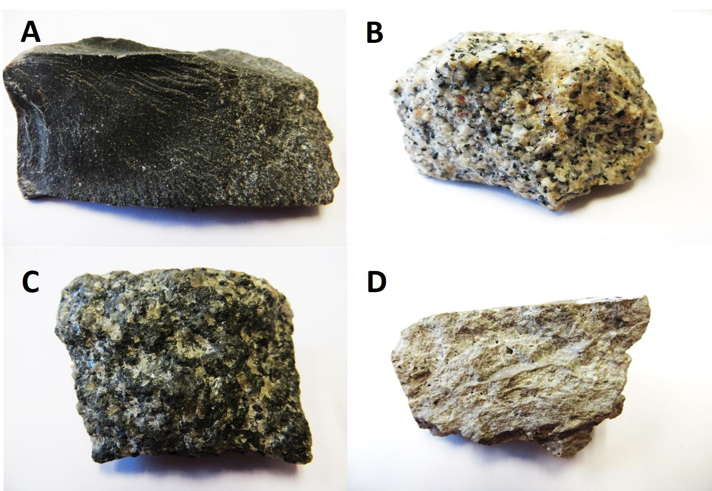
Which two samples would be classified as coarse-grained, plutonic igneous rocks?
- A and B
- B and C
- C and D
- D and A
Which two samples would be classified as fine-grained, volcanic igneous rocks?
- A and B
- B and C
- C and D
- D and A

Which statement about igneous rocks is the most accurate?
- A plutonic igneous rock forms on Earth’s surface and has large crystals.
- A volcanic igneous rock forms below Earth’s surface and has large crystals.
- A volcanic igneous rock forms on Earth’s surface and has microscopic crystals.
- A plutonic igneous rock forms below Earth’s surface and has microscopic crystals.

The size of crystals in an igneous rock will be larger, the more rapidly the magma that forms the rock cools and solidifies.
- True
- False

Review the two statements below and identify if they are true or false.
i. Rocks formed during a volcanic eruption will have a fine-grained texture because they cool quickly.
ii. Rocks formed when magma solidifies beneath Earth’s surface will have large crystals.
- Both statements are true.
- Both statements are false.
- The first statement is true; the second statement is false.
- The first statement is false; the second statement is true.

The texture of an igneous rock can refer to ___. Select all that apply.
- the size of the crystals in the rock
- the shape of the crystals in the rock
- the color and luster of the crystals in the rock
- the chemical composition of the crystals in the rock

What is the best characterization of a fine-grained igneous rock?
- It is composed of silica-rich minerals
- It is composed of silica-poor minerals
- It can be composed of either silica-rich or silica-poor minerals
- It would be composed of neither silica-rich nor silica-poor minerals.

What is the explanation for the difference in texture between plutonic and volcanic igneous rocks?
- The plate tectonic setting where magma was generated
- The difference in the silica content of the original magmas
- Contrasts in the chemical composition of the original source rocks
- The rate of temperature change during crystallization of the magmas

LO2. I can describe how different types of magma form in association with the following plate settings - oceanic ridge, ocean-continent subduction zone, hot spot.

What is the most common composition of magma supplying volcanoes in continents above subduction zones?
- Mafic
- Intermediate
- Felsic

What is the main source for the water that promotes melting in mantle rocks above subduction zones?
- Water seeps into the subduction zone from the overlying ocean.
- Water is trapped in sediments that lie on top of the ocean floor of the subducting plate.
- Water is expelled from the crystal structure of minerals subjected to increasing temperatures and pressures in the subducting plate.

Magma that leads to volcanism at oceanic ridges is generated by ___.
- plumes of hot mantle material rising from below
- melting via the addition of water from the ocean crust
- decompression melting due to the removal of overlying material

Magma that leads to volcanism along subduction zones is generated by ___.
- plumes of hot mantle material rising from below
- melting via the addition of water from the ocean crust
- decompression melting due to the removal of overlying material

Magma that leads to volcanism at hot spots is generated by ___.
- plumes of hot mantle material rising from below
- melting via the addition of water from the ocean crust
- decompression melting due to the removal of overlying material

Decompression partial melting of mantle rocks below an oceanic ridge would generate magma with a composition similar to which rock type?
- Peridotite
- Andesite
- Rhyolite
- Basalt

Water is added to hot rocks to promote melting at what type of plate boundary?
- Convergent
- Divergent
- Convergent and divergent
- Transform
- Convergent, divergent, and transform

Basalt may be formed by partial melting at which three types of tectonic setting?
- Convergent plate boundaries
- Divergent plate boundaries
- Continental rifts
- Hot spots

Andesite is most likely to be found at which type of tectonic setting?
- Oceanic hot spot
- Ocean-continent convergent boundary
- Oceanic ridge
- Continental rift

What is the source for most of the magma on Earth?
- Plumes of hot rocks and magma that rise from the core/mantle boundary
- Melting of mantle rocks by multiple processes at plate boundaries
- A layer hot material in Earth’s interior where it is hot enough to cause melting

LO3. I can describe how geologists use color to classify igneous rocks into compositional groups

Which two characteristics are generally true for a lighter-colored igneous rock.
- It is more mafic
- It is more felsic
- It has more silica
- It has more iron and magnesium

Which two characteristics are generally true for a darker-colored igneous rock.
- It is more mafic
- It is more felsic
- It has more silica
- It has more iron and magnesium

A mafic rock has a dark color because it is rich in silica.
- True
- False

Review the image of igneous rocks and answer the questions that follow.

Which pair of rocks are most likely to have a felsic composition?
- A and C
- B and D
- C and D
- B and A

Which pair of rocks are most likely to have a higher proportion of mafic minerals?
- A and C
- B and D
- C and D
- B and A

Which rock is most likely a plutonic, felsic rock?
- A
- B
- C
- D

Which rock is most likely a volcanic, felsic rock?
- A
- B
- C
- D

Which rock is most likely a plutonic, mafic rock?
- A
- B
- C
- D

Which rock is most likely a volcanic, mafic rock?
- A
- B
- C
- D

A mafic igneous rock is typically composed of ___-colored minerals and has relatively high proportions of ___.
- dark; silica
- dark; iron and magnesium
- light; silica
- light; iron and magnesium

A felsic igneous rock is typically composed of ___-colored minerals and has relatively high proportions of ___.
- dark; silica
- dark; iron and magnesium
- light; silica
- light; iron and magnesium
Review the image of igneous rocks and answer the questions that follow.
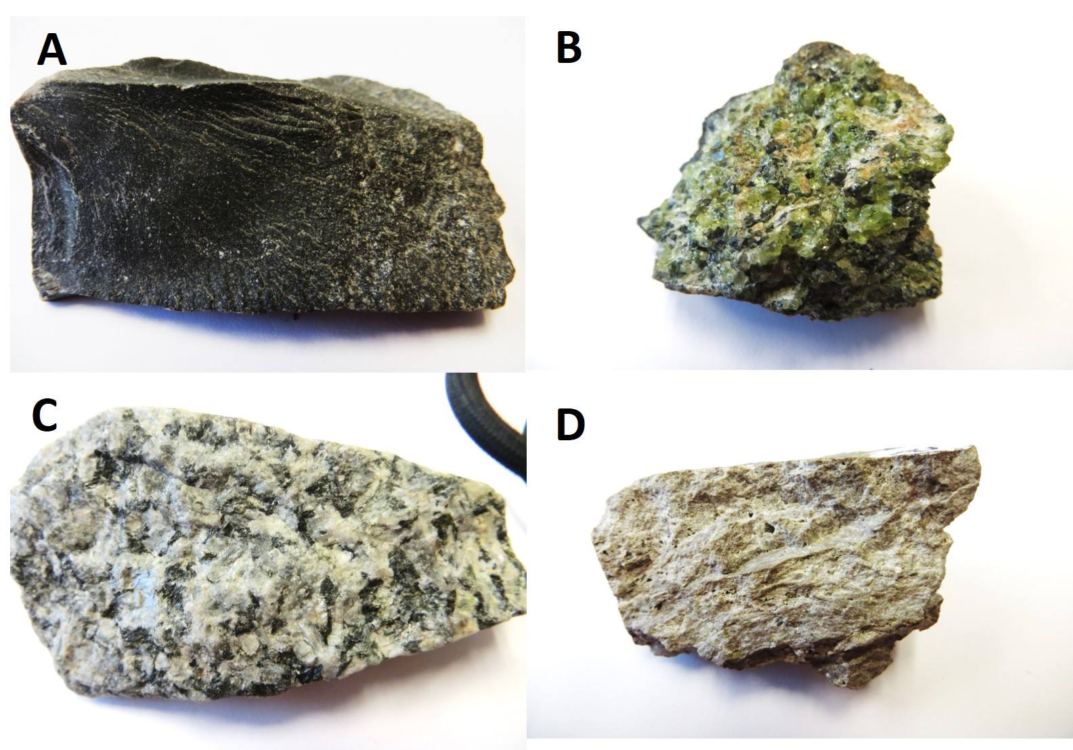

Which rock is most likely to have an ultramafic composition?
- A
- B
- C
- D

How is a mafic, plutonic igneous rock different from a felsic, volcanic igneous rock?
The mafic, plutonic rock has…
- Smaller crystals, more silica and a lighter color
- Larger crystals, more silica and a lighter color
- Smaller crystals, less silica and a darker color
- Larger crystals, less silica and a darker color

LO4. I can describe the three principal mechanisms for melting rocks.

Which three conditions make it more likely that melting of rocks in Earth's crust will occur?
- Addition of water
- Decreasing temperature
- Increasing pressure
- Decreasing pressure
- Increasing temperature

Decompression melting is more likely to occur if a hot rock is uplifted ___.
- slowly
- rapidly

Which plate tectonic setting is most likely to experience decompression melting?
- Island arc above a subduction zone
- Volcanic arc above a subduction zone
- Oceanic ridge

Two identical rocks are subjected to different pressures as a result of burial in Earth’s crust. Rock X is under high pressure; Rock Y is under lower pressure. Temperature gradually increases at the same rate for both rocks while all other conditions remain stable. Minerals in which rock will melt first?
- Rock X
- Rock Y

Two identical rocks (Rock V; Rock W) are buried to similar depths in Earth’s crust and are subjected to the same pressures. Both rocks are under relatively high temperatures but not sufficient to cause melting of their minerals. Rock V undergoes rapid uplift toward Earth’s surface while Rock W undergoes rapid burial to greater depths. Minerals in which rock will melt first?
- Rock V
- Rock W

Review the graphs in the image below and answer the question that follows. Which graph most accurately represents the physical conditions within Earth’s crust that influence whether rocks and minerals remain solid or undergo melting?
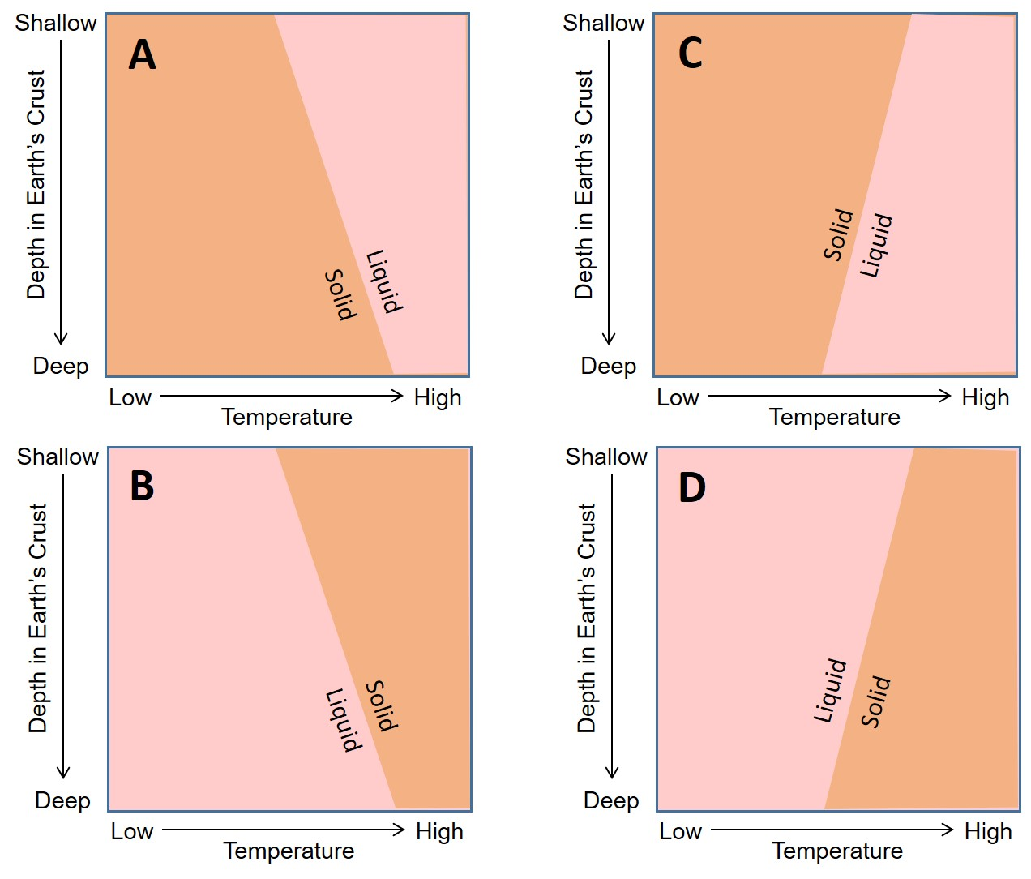
- A
- B
- C
- D

Review the graph and answer the question that follows. The graph represents the physical conditions within Earth’s crust that influence the formation of magmas. Which point on the graph represents magma?
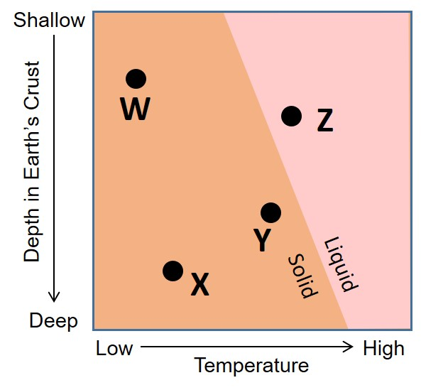
- W
- X
- Y
- Z

Review the diagram and answer the question that follows. This graph represents the physical conditions within Earth’s crust that influence the formation of a mafic magma.
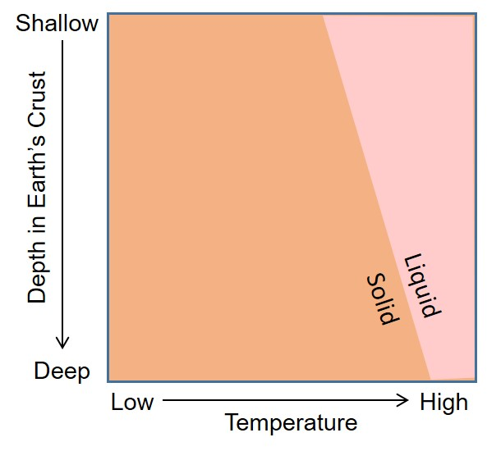
How would the position of the Liquid/Solid phase boundary change if we were to construct a similar graph for felsic magmas?
- The position of the boundary would not change
- The position of the boundary would move to the right
- The position of the boundary would move to the left
Review the diagram and answer the questions that follow. The dashed arrows represent different melting histories for rocks in Earth’s crust.
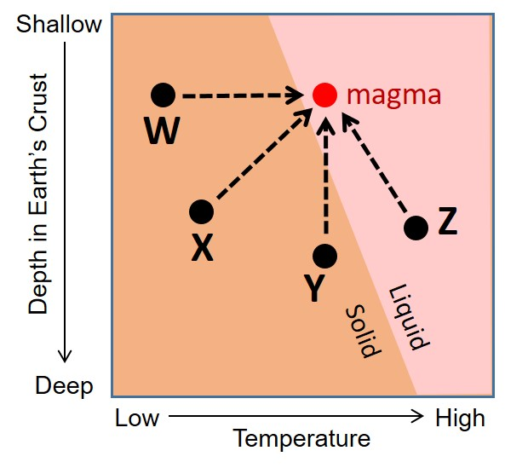
Which arrow represents the most likely melting path for a rock that was heated by a nearby magma body?
- W
- X
- Y
- Z

Which arrow represents the most likely melting path for a rock that experienced decompression melting?
- W
- X
- Y
- Z

Review the two statements below and identify if they are true or false.
i. Adding water to a hot rock will raise the temperature needed for melting to occur.
ii. Rocks melt at higher temperatures under higher pressures.
- Both statements are true.
- Both statements are false.
- The first statement is true; the second statement is false.
- The first statement is false; the second statement is true.

Which igneous rock type is most likely to be found at all three of these tectonic settings: i) Divergent plate boundaries; ii) Continental rifts; iii) Hot spots?
- Andesite
- Basalt
- Granite
- Peridotite

Review the diagram and answer the question that follows. This graph represents the physical conditions within Earth’s crust that influence the formation of magma.
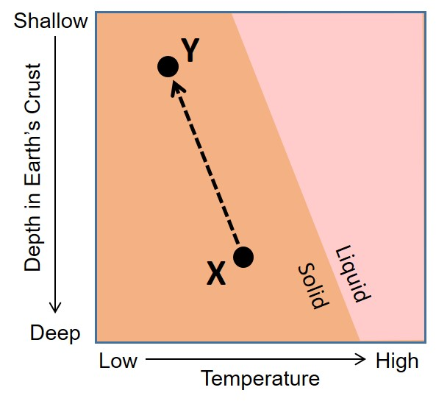
What happens to a rock moving from position X to position Y?
- The rock moves higher in the crust but undergoes no change in state
- The rock moves deeper in the crust but undergoes no change in state
- The rock moves higher in the crust and undergoes decompression melting
- The rock moves deeper in the crust and undergoes decompression melting

How will the addition of water affect what will happen to hot dry rocks in Earth’s interior?
- The rocks will become cooler and less likely to melt
- The rocks will become hotter and more likely to melt
- The temperature of the rock will not change but it will become less likely to melt
- The temperature of the rock will not change but it will become more likely to melt

Interpret the graph to determine which of the following changes in conditions represent the main process of magma generation associated with oceanic ridges? Magma forms when material moves . . .
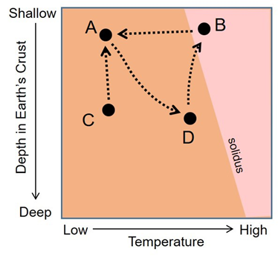
- From A to D
- From B to A
- From C to A
- From D to B
LO5. I can define the term "partial melting."

Partial melting produces a more ___ magma than the source material. Select all that apply.
- felsic
- mafic
- silica-rich
- silica-poor

Basalt is produced by partial melting of rock from which source?
- Mantle
- Continental crust
- Oceanic crust

Partial melting of the continental crust would produce a(n) ___ magma.
- mafic
- intermediate
- felsic
- ultramafic

Partial melting of mantle (ultramafic) rocks will generate a(n) ___ magma.
- mafic
- intermediate
- felsic
- ultramafic

Partial melting occurs when some of the minerals present in a rock melt while other minerals remain solid.
- True
- False

A magma produced by partial melting will have a more felsic composition than the source rock.
- True
- False

A magma produced by partial melting will have a more mafic composition than the source rock.
- True
- False

Felsic minerals melt at lower temperatures than mafic minerals.
- True
- False

Mafic minerals melt at lower temperatures than felsic minerals.
- True
- False

What are the characteristics of the magma produced by partial melting of a rock?
- The magma will have the same chemical composition as the source rock
- The magma will have a more mafic composition than the source rock
- The magma will have a more felsic composition than the source rock
- The magma will have a more mafic composition at higher melting temperatures and a more felsic composition at lower melting temperatures

Review the two statements below and identify if they are true or false.
i. Minerals with the lowest silica content will melt last.
ii. Partial melting generates a more silica-rich magma than the source rock.
- Both statements are true.
- Both statements are false.
- The first statement is true; the second statement is false.
- The first statement is false; the second statement is true.

What types of igneous rocks are formed as a result of partial melting?
- Felsic, volcanic rocks only
- Felsic, plutonic rocks only
- Mafic, volcanic and plutonic rocks only
- Felsic, volcanic and plutonic rocks only
- All types of volcanic and plutonic rocks

Which of these igneous rock types is most likely to be formed as a plutonic rock at a convergent boundary between an oceanic plate and a continental plate?
- Gabbro
- Peridotite
- Granite
- Basalt

Rocks melt at higher temperatures under higher pressures.
- True
- False

Why does partial melting of a rock result in the formation of a magma with different silica content?
- Silica-rich minerals melt at lower temperatures forming a more silica-rich magma.
- Silica-poor minerals melt at lower temperatures forming a more silica-poor magma

Sedimentary Rocks

LO1. I can explain the difference between clastic, chemical, and biochemical sedimentary rocks and identify the common examples of each.

Fill in the blanks to complete the sentence that follows. ___ sedimentary rocks, like ___, form when living organisms cause minerals to precipitate out of solution.
- Biochemical; limestone
- Biochemical; coal
- Clastic; sandstone
- Chemical; chert

Fill in the blanks to complete the sentence that follows. ___ sedimentary rocks, like ___, form when dead organisms are converted into rock.
- Chemical; limestone
- Biochemical; coal
- Clastic; sandstone
- Clastic; granite

Fill in the blank to complete the sentence that follows. ___ rocks sedimentary rocks, like ___, form when loose sediments are compacted and cemented.
- Biochemical; limestone
- Clastic; chert
- Clastic; sandstone
- Clastic; limestone

Classify and name the rock shown in the image.
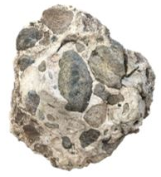
- Clastic sedimentary rock; shale
- Biochemical sedimentary rock; limestone
- Biochemical sedimentary rock: chalk
- Clastic sedimentary rock; conglomerate

Classify and name the rock shown in the image.
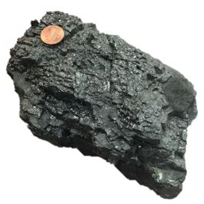
- Clastic sedimentary rock; sandstone
- Biochemical sedimentary rock; coal
- Chemical sedimentary rock; chert
- Chemical sedimentary rock; gypsum

Classify and name the rock shown in the image.
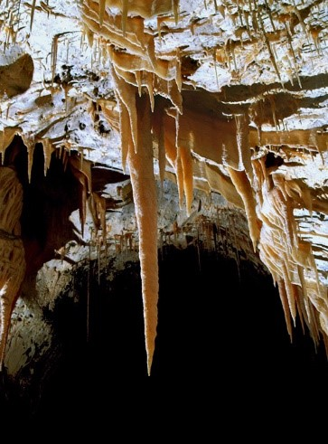
https://www.nps.gov/subjects/caves/speleothems.htm
- Biochemical sedimentary rock; chalk
- Biochemical sedimentary rock; coal
- Chemical sedimentary rock; chert
- Chemical sedimentary rock; limestone

Sedimentary rocks are divided into three main types based on which two characteristics?
- the grain size of sediments
- the type of materials involved
- the depth of formation
- their processes of formation

Which three of the rocks below are examples of clastic sedimentary rocks?
- Sandstone
- Shale
- Rock salt
- Conglomerate
- Limestone
- Coal

Which two of the rocks below are examples of biochemical sedimentary rocks?
- Sandstone
- Chert
- Coal
- Conglomerate
- Chalk
- Shale

Which three of the rocks below could be examples of chemical sedimentary rocks?
- Siltstone
- Chert
- Coal
- Conglomerate
- Rock salt
- Limestone

LO2. I can describe the differences between physical and chemical weathering using specific examples.

Which type of sedimentary rock is most likely to be dissolved by chemical weathering processes?
- Shale
- Sandstone
- Coal
- Limestone

Which common mineral in granite is converted to clays during chemical weathering?
- Quartz
- Feldspar
- Sand
- Silicon

Hydrolysis occurs when some minerals are dissolved in water.
- True
- False

Hydrolysis occurs when some strong minerals are converted to clay due to reactions with water.
- True
- False

Which statement is more likely to be true?
- Weathering will be "more rapid" in fractured rocks because the fractures make it easier for water to interact with the minerals in the rock.
- Weathering will be “less rapid” in fractured rocks because the fractures make it easier for water to flow through the rock without interacting with minerals.

The process of adding a spoonful of sugar to hot tea is similar to what happens with which weathering process?
- Dissolution
- Oxidation
- Hydrolysis

Physical weathering can cause rocks to expand and fracture in both extreme heat and extreme cold conditions.
- True
- False

Review the two statements below and identify if they are true or false.
i. Physical weathering can involve breaking down minerals and rocks by dissolving them.
ii. Rust is an example of chemical weathering where iron and oxygen react to form a new material.
- Both statements are true.
- Both statements are false.
- The first statement is true; the second statement is false.
- The first statement is false; the second statement is true.

Which type of weathering contributes to the following scenario? Groundwater flows through limestone. The water then drips from the ceiling of a cave, when the water reacts with the air, limestone precipitates forming a stalactite.
- Physical weathering
- Chemical weathering
- Weathering does not occur in the scenario.

Which example best explains what a rock endures during physical weathering in a cold environment of a northern state such as Montana or Minnesota?
- The water from the snow melting dissolves parts of the rock
- The cold conditions cause the rock to contract and break off from the outcrop
- Minerals react with the water in the melting snow
- The water freezes and thaws in cracks in the rock, breaking up the rock and minerals

LO3. I can explain how clastic sedimentary rocks are formed.

Pieces of rock that are weathered to become sediment are known as clasts.
- True
- False

Erosion is the process by which rocks break down to form sediment.
- True
- False

Which processes are associated with the lithification of sedimentary rocks? Select all that apply.
- Transportation
- Sorting
- Compaction
- Cementation
- Chemical weathering

Which type of sedimentary rock is most likely to be formed on the floor of deep ocean basins?
- Coal
- Sandstone
- Shale
- Limestone

Which sequence most accurately represents the series of steps in the formation of a clastic sedimentary rock?
- Transportation, compaction, weathering, cementation
- Weathering, transportation, compaction, cementation
- Cementation, transportation, weathering, compaction
- Compaction, weathering, transportation, cementation

Which of the statements below is the most accurate?
- Clastic sedimentary rocks form as a result of physical weathering only.
- Clastic sedimentary rocks form as a result of chemical weathering only.
- Clastic sedimentary rocks form as a result of both physical and chemical weathering.
- Weathering is not an important aspect of the formation of clastic sedimentary rocks.

Review the two statements below and identify if they are true or false.
i. Clastic sedimentary rocks are classified by clast size.
ii. Sand is the smallest clast-size.
- Both statements are true.
- Both statements are false.
- The first statement is true; the second statement is false.
- The first statement is false; the second statement is true.

Increasing temperatures and pressures cause minerals to become molten, which serves as the cement for a clastic sedimentary rock.
- True
- False

Clastic sedimentary rocks can form as a result of precipitation from a solution.
- True
- False

Excess water is forced out, and sediments are squeezed together during the process of ___.
- Cementation
- Erosion
- Compaction
- Hydrolysis

Which of the following statements best describes the process of lithification?
- The process by which minerals are dissolved in groundwater and streams.
- The result of the compaction of sediment grains and subsequent addition of a cementing agent by groundwater.
- What happens when microscopic marine organisms accumulate in thick deposits on the sea floor.
- Iron minerals in a rock react with oxygen in the air during weathering to stain the rock red.

Which type of sedimentary rock is formed from rock and mineral fragments weathered from rocks on Earth’s surface?
- Clastic
- Chemical
- Biochemical
- Physical

Clastic sedimentary rocks are primarily classified on the basis of which of the following?
- Composition of clasts
- Size of clasts
- Shape of clasts
- Age of clasts

What happens to sediment clasts as they move further from their source?
- They become more angular
- They become better sorted
- They clump together to form bigger rocks
- Both A and B

Read the two statements that follow and identify if they are true or false.
i. Hydrolysis is a chemical weathering process that converts feldspar to clay.
ii. Chalk is an example of a clastic sedimentary rock.
- Both statements are true
- Both statements are false
- First statement is True; Second statement is False
- First statement is False; Second statement is True

LO4. I can name examples of clastic sedimentary rocks with different grain sizes.

Which of the following rocks is both a clastic sedimentary rock and has the largest grain size?
- Sandstone
- Shale
- Limestone
- Coal
- Conglomerate

Which of the following clastic rocks is made from clay-sized particles?
- Sandstone
- Shale
- Siltstone
- Conglomerate

Which of the following clastic rocks may be made from pebble-sized particles?
- Sandstone
- Shale
- Siltstone
- Conglomerate

It is possible to distinguish individual grains of sandstone with the naked eye.
- True
- False

Which statement is true?
- It is possible to distinguish individual grains of siltstone with the naked eye
- It is possible to distinguish individual grains of shale with the naked eye
- It is possible to distinguish individual grains of both shale and siltstone with the naked eye
- It is not possible to distinguish individual grains of shale or siltstone with the naked eye

Which sediment type has a clast size similar to that of standard-sized sugar crystals or Kosher salt crystals?
- Sand
- Silt
- Clay
- Gravel

Which sediment type has a clast size similar to that of hazelnuts, cashews, or unpopped popcorn kernels?
- Sand
- Silt
- Clay
- Gravel

Which rock type is most likely to exhibit better sorting of sediment clasts?
- Sandstone
- Conglomerate

Which of the following series of terms is a list of sediment sizes from largest to smallest in the correct order?
- Pebble, cobble, sand, silt, clay
- Cobble, pebble, sand, silt, clay
- Clay, silt, sand, cobble, pebble
- Silt, sand, cobble, pebble, clay

LO5. I can explain how transportation controls the size, shape and sorting of clastic sediment.

As clasts are transported downstream, which of the following properties increases? Select all that apply.
- Roundness
- Sorting
- Particle size

Clastic sediments are classified on the basis of which two factors?
- Color
- Shape
- Size
- Density

As clasts are transported downstream, which of the following properties decreases?
- Roundness
- Sorting
- Particle size

Sorting refers to the range of clast sizes present in sediment.
- True
- False

Deposition refers to the range of clast sizes present in sediment.
- True
- False

Clastic sediment transported and deposited by glaciers will contain both small and large clasts.
- True
- False

Identify the sorting of sediment transported and deposited by glaciers.
- The sediment will be well-sorted
- The sediment will be poorly-sorted

Sand deposited by rivers typically is ___ sorted than sand deposited by wind and is likely to have ___ clast sizes.
- less; larger
- less; smaller
- more; larger
- more; smaller

As clasts are transported downstream, particle size ___.
- Increases
- Decreases

Which statement best summarizes what happens to the sorting, roundness and size of clasts of sediment as they are transported downstream?
- Sorting, roundness, and grain size all decrease
- Sorting, roundness, and grain size all increase
- Sorting and roundness both increase and grain size decreases
- Sorting increases and roundness and grain size both decrease
- Sorting decreases, roundness and grain size both increase

LO6. I can explain how common types of biochemical sedimentary rocks are formed.

Which of the following rocks is made from billions of coccolithophores?
- Siltstone
- Chalk
- Chert
- Coal

Which of the following rocks can be made from the siliceous (silica-rich) shells of marine micro-organisms?
- Limestone
- Chalk
- Chert
- Coal

Which of the following rocks can be made from the accumulation of dead plants?
- Limestone
- Chalk
- Chert
- Coal

Which of the following rocks can be made from the precipitation of calcite by marine organisms such as corals?
- Limestone
- Gypsum
- Chert
- Coal

Biochemical rocks can be formed from the activities of live organisms or dead organisms.
- True
- False

Biochemical sedimentary rocks can form as a result of precipitation from a solution.
- True
- False

Review the two statements below and identify if they are true or false.
i. Biochemical rocks form due to changes in the physical conditions of the environment.
ii. Biochemical rocks often form in marine environments.
- Both statements are true.
- Both statements are false.
- The first statement is true; the second statement is false.
- The first statement is false; the second statement is true.

Limestone can be formed as a result of precipitation from a solution.
- True
- False

Which three statements are true about the rock shown here?
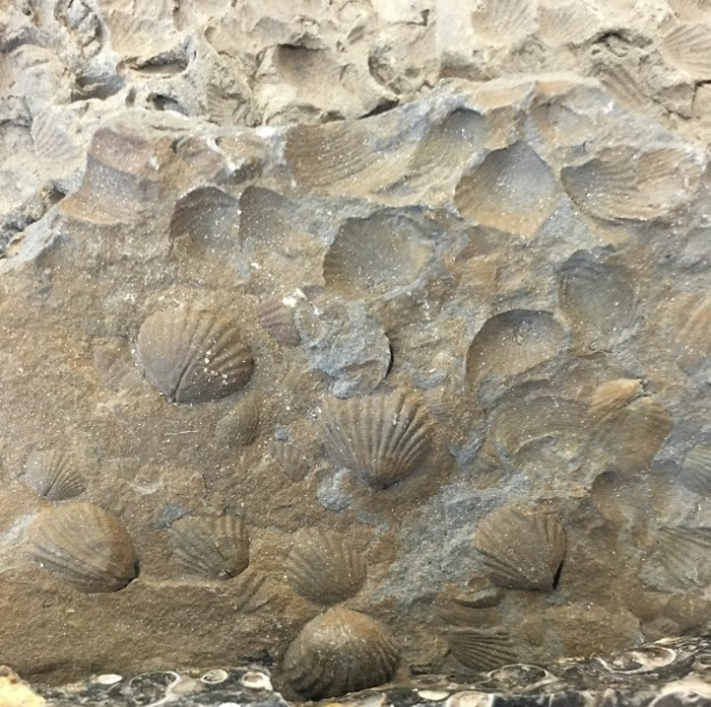
- The rock is an example of coal.
- The rock is an example of limestone.
- This rock was likely formed by the cementation of shells and/or coral skeletons.
- This rock was likely formed from the burial and compaction of dead vegetation.
- This rock is primarily made of carbon.
- This rock is primarily made of calcium carbonate.

Biochemical sedimentary rocks typically form as a result of ___.
- precipitation of minerals that occurs when freshwater meets seawater
- precipitation of minerals that occurs due to the actions of marine organisms
- precipitation that occurs when minerals are added to sea water due to volcanic processes at oceanic ridges

What type of sedimentary rock would be created if it was composed of the shells of clams, oysters, and/or mussels?
- Biochemical
- Chemical
- Clastic

What is the principal role that living organisms play in the formation of biochemical sedimentary rocks?
- They break the rock into smaller fragments
- They dissolve minerals from the rock
- They cause minerals to be precipitated from solution
- They trap sediment grains

LO7. I can explain how common types of chemical sedimentary rocks are formed.

Which of the following rocks are evaporites? Select all that apply.
- Rock salt
- Gypsum
- Sandstone
- Limestone

Precipitated rocks on the ceilings and floors of caves (stalactites and stalagmites) are formed by processes that cause them to be classified as which type of sedimentary rock?
- Biochemical
- Chemical
- Clastic

Rock salt can form as a result of precipitation from a solution.
- True
- False

What is the source of salt in seawater?
- Minerals dissolved from rocks on the continents
- Minerals dissolved from shells of marine organisms
- Minerals added to sea water from volcanic processes at oceanic ridges
- Minerals dissolved from rocks on the sea floor

Which is the best explanation for why chemical sedimentary rocks form?
- They form when streams and groundwater dissolves rocks
- They form due to the actions of marine organisms that cause precipitation of minerals
- They form as minerals and elements of decayed plants collected in warm, wet environments
- They form due to changing physical conditions in natural environments that promote precipitation

Which of the following is a rock that could be formed by precipitation of minerals at a hot spring?
- Coal
- Rock salt
- Marble
- Travertine (limestone)

Thick layers of salt are found among ancient sedimentary rocks of North America. How were the salt layers formed?
- Groundwater deposited salts among existing sedimentary beds
- The salts were extracted from streams and lakes by the actions of microscopic organisms
- Salts were deposited from waters of shallow seas that once covered parts of the continent
- Rivers deposited salts when they entered ancient lakes

Examine the four Venn diagrams. Which diagram most accurately represents the classification of chemical and biological sedimentary rocks?
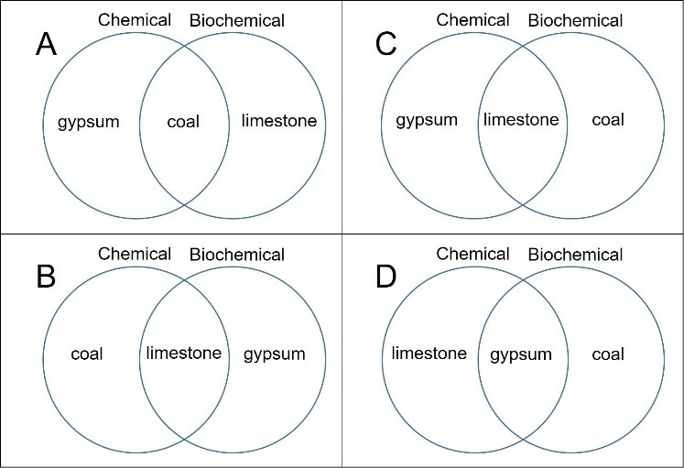
- A
- B
- C
- D

Which type of sedimentary rocks are formed from mineral-rich spring waters?
- Biological
- Chemical
- Clastic

LO8. I can explain how the characteristics of sedimentary rocks can be used to interpret ancient environments.

Which of the following lists places the sedimentary environments in the correct order from those that are farthest offshore to those that are on, or near, the shoreline?
- Beach; lagoon; coastal dunes; barrier island; continental shelf
- Lagoon; beach; coastal dunes; barrier island; continental shelf
- Continental shelf; barrier island; lagoon; beach; coastal dunes
- Continental shelf; barrier island; beach; lagoon; coastal dunes

Most layers of sedimentary rock are termed beds.
- True
- False

Review the two statements that follow and identify if they are true or false.
i. Travertine (a form of limestone) can be formed by precipitation at a hot spring.
ii. Coal typically indicates an ancient tropical wetlands environment.
- Both statements are true.
- Both statements are false.
- The first statement is true; the second statement is false.
- The first statement is false; the second statement is true.

Which sedimentary environment is likely to contain the most poorly sorted sediment?
- Lake
- Stream channel
- Desert sand dunes
- Mountain slopes

Which sedimentary environment is likely to contain the most well sorted, fine-grained sediment?
- Lake
- Stream channel
- Desert sand dunes
- Mountain slopes

Which two sedimentary environments are likely to contain some gravel-sized sediment?
- Lake
- Stream channel
- Desert sand dunes
- Mountain slopes

Which three sedimentary environments are likely to be the location for the formation of sandstone?
- Beach
- Cave system
- Desert
- Reef
- Stream channel

How would you interpret what happened in a location if the three sedimentary rocks shown here were deposited in this sequence?
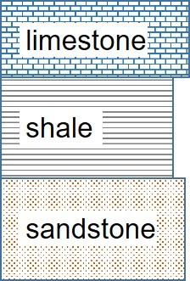
- This sequence indicates a rising sea level
- This sequence indicates a falling sea level
- This sequence indicates wetter climate in a continental interior
- This sequence indicates a drying climate in a continental interior

Which sedimentary rock type is most likely to form in the open ocean?
- Sandstone
- Chalk
- Conglomerate
- Rock salt

Which sedimentary rock type is most likely to indicate the presence of a former coral reef?
- Limestone
- Chalk
- Gypsum
- Shale

Which two sedimentary environments are likely to be the location for the formation of chemical sedimentary rocks?
- Coastal lagoon
- Cave system
- Desert sand dunes
- Slow moving streams
- Deep seafloor

How would you interpret what happened in a location if the three sedimentary rocks shown here were deposited in this sequence?
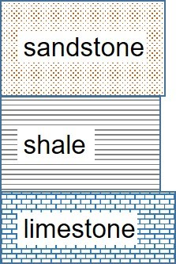
- This sequence indicates a rising sea level
- This sequence indicates a falling sea level
- This sequence indicates wetter climate in a continental interior
- This sequence indicates a drying climate in a continental interior

How would you interpret what happened in a location if the three sedimentary rocks shown here were deposited in this sequence?
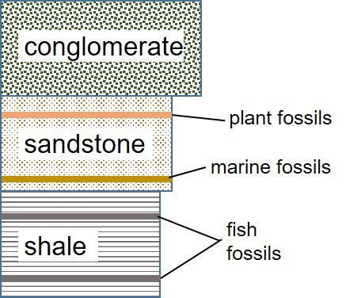
- This sequence indicates an initial ocean setting, followed by a beach environment that was then replaced by sediment eroded from a mountain range.
- This sequence indicates that a large continental lake formed and was gradually filled in by sediment from stream systems which became more rapid over time.
- This sequence indicates that course clastic sediment was deposited from fast moving streams. As stream velocity decreased, finer grained sediment was deposited and gradually the area was submerged by the ocean.

The Rock Cycle

LO1. I can sketch and label a diagram to summarize the rock cycle.

Which of the following sequences of rocks correctly demonstrates a possible entire revolution around the rock cycle?
- Granite -> limestone -> gneiss -> granite
- Granite -> gneiss -> sandstone -> granite
- Granite -> quartzite -> schist -> granite
- Granite -> sandstone -> quartzite -> granite

Which of the following rocks can be transformed into another type of rock via some geologic process associated with the rock cycle?
- Igneous
- Sedimentary
- Metamorphic
- All of the above

Review the line in the graph which illustrates how temperature changes with time and interpret which part of the rock cycle it best represents.
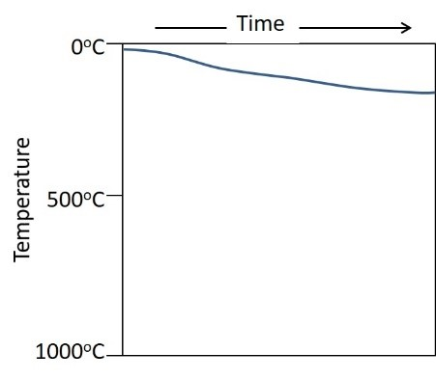
- Sand is lithified to form sandstone
- Limestone is metamorphosed to form marble
- Marble is uplifted to Earth’s surface
- Magma cools to form granite
- Shale is heated and converted to magma

Review the line in the graph and interpret which part of the rock cycle it best represents.
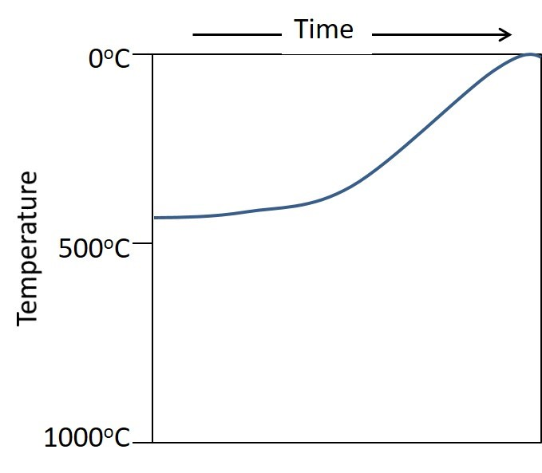
- Sand is lithified to form sandstone
- Limestone is metamorphosed to form marble
- Marble is uplifted to Earth’s surface
- Magma cools to form granite
- Shale is heated and converted to magma

Review the line in the graph which illustrates how temperature changes with time and interpret which part of the rock cycle it best represents.
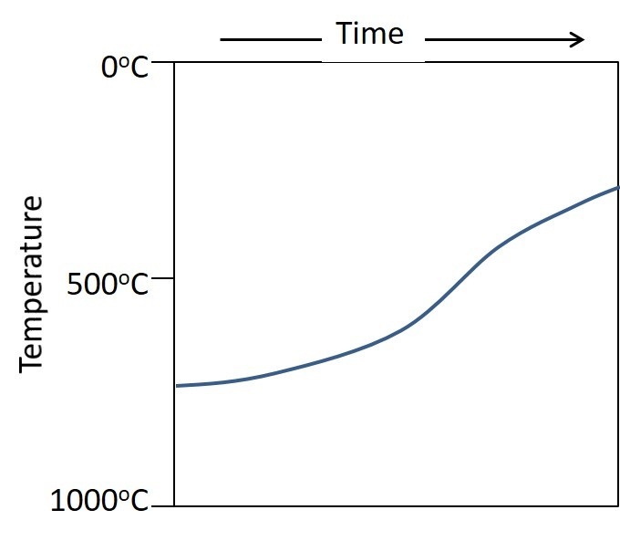
- Sand is lithified to form sandstone
- Limestone is metamorphosed to form marble
- Marble is uplifted to Earth’s surface
- Magma cools to form granite
- Shale is heated and converted to magma
Review the line in the graph which illustrates how temperature changes with time and interpret which part of the rock cycle it best represents.
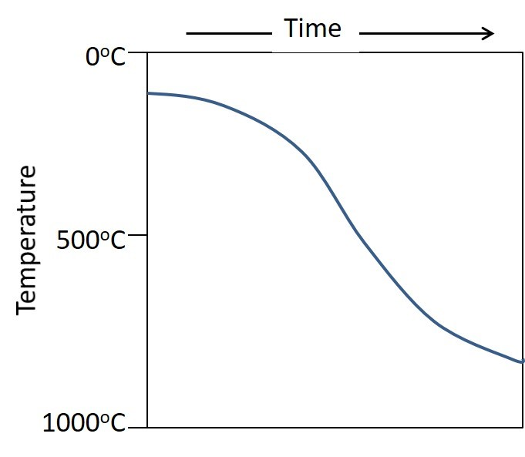
- Sand is lithified to form sandstone
- Limestone is metamorphosed to form marble
- Marble is uplifted to Earth’s surface
- Magma cools to form granite
- Shale is heated and converted to magma

Review the figure of the rock cycle and answer the questions that follow.
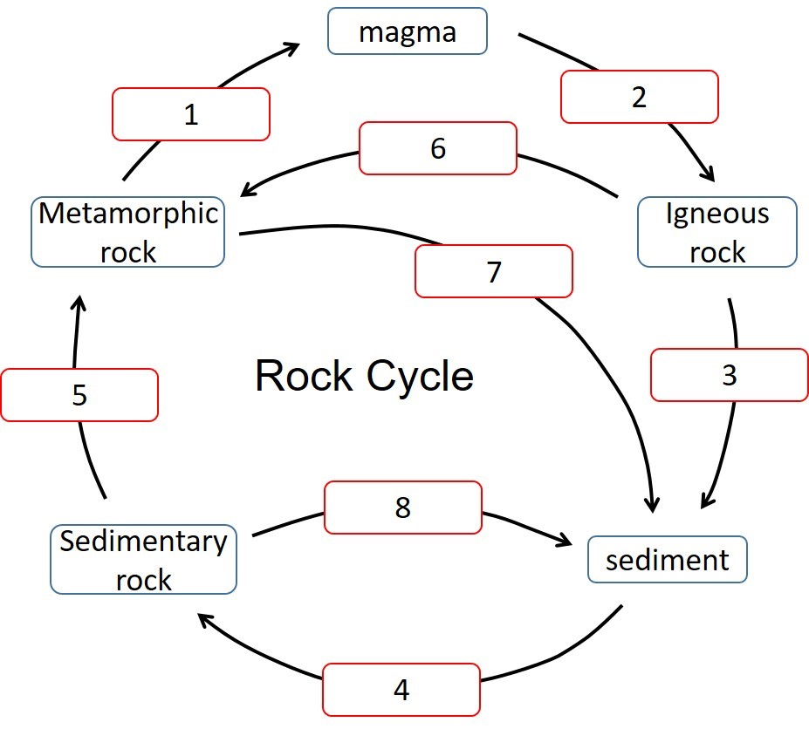

Predict which term should be placed in box #1.
- Melting
- Lithification
- Heat & pressure
- Cooling & solidification
- Weathering & erosion

Predict which term should be placed in box #2.
- Melting
- Lithification
- Heat & pressure
- Cooling & solidification
- Weathering & erosion

Predict which term should be placed in box #3.
- Melting
- Lithification
- Heat & pressure
- Cooling & solidification
- Weathering & erosion

Predict which term should be placed in box #4.
- Melting
- Lithification
- Heat & pressure
- Cooling & solidification
- Weathering & erosion

Predict which term should be placed in box #5.
- Melting
- Lithification
- Heat & pressure
- Cooling & solidification
- Weathering & erosion

Predict which term should be placed in box #6.
- Melting
- Lithification
- Heat & pressure
- Cooling & solidification
- Weathering & erosion

Predict which term should be placed in box #7.
- Melting
- Lithification
- Heat & pressure
- Cooling & solidification
- Weathering & erosion

Predict which term should be placed in box #8.
- Melting
- Lithification
- Heat & pressure
- Cooling & solidification
- Weathering & erosion

Review the figure of the rock cycle and answer the questions that follow.
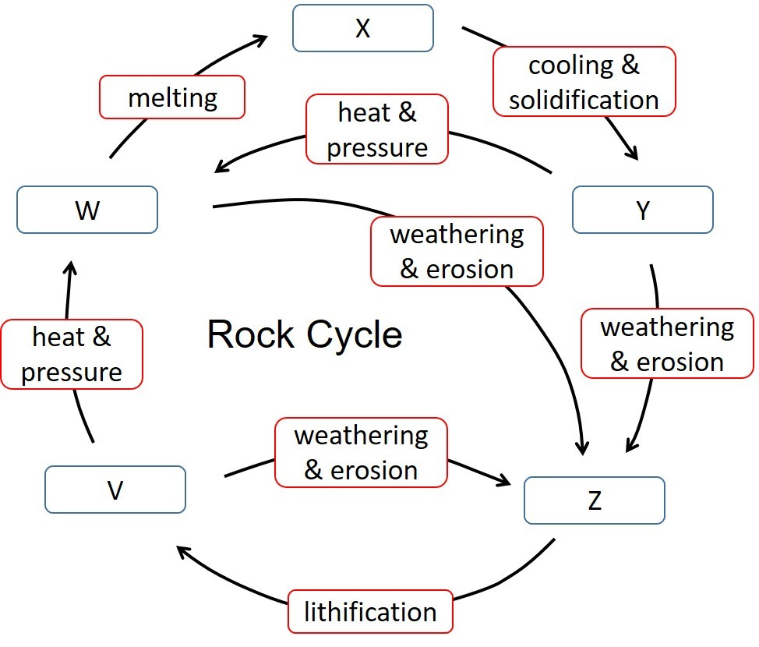
There are five missing items labeled by letters. Predict which term would be the best choice for item V.
- Sediment
- Sedimentary rock
- Magma
- Igneous rock
- Metamorphic rock

There are five missing items labeled by letters. Predict which term would be the best choice for item W.
- Sediment
- Sedimentary rock
- Magma
- Igneous rock
- Metamorphic rock

There are five missing items labeled by letters. Predict which term would be the best choice for item X.
- Sediment
- Sedimentary rock
- Magma
- Igneous rock
- Metamorphic rock

There are five missing items labeled by letters. Predict which term would be the best choice for item Y.
- Sediment
- Sedimentary rock
- Magma
- Igneous rock
- Metamorphic rock

There are five missing items labeled by letters. Predict which term would be the best choice for item Z.
- Sediment
- Sedimentary rock
- Magma
- Igneous rock
- Metamorphic rock

What happens to temperature and pressure with increasing depth on Earth? Select all that apply.
- Temperature increases
- Pressure increases
- Pressure decreases
- Temperature decreases

Metamorphic Rocks

LO1. I can explain how and why rocks behave differently at shallow and deep levels in the crust.

High pressures deep in Earth prevent minerals from recrystallizing and new minerals from forming.
- True
- False

The temperature required to melt rocks increases with increasing depth below Earth’s surface.
- True
- False

What is the best estimate of the temperature range for the formation of metamorphic rocks?
- More than 200 C
- Less than 400 C
- Less than 1000 C
- Between 600-1200 C
- Between 200-800 C

The temperature range over which metamorphism occurs doesn’t change on the basis of rock composition.
- True
- False

Temperatures increase downward below Earth’s surface. The rate of increase in temperature is known as the geothermal gradient. What is an approximate geothermal gradient (in degrees Celsius) for an area in the center of a continent?
- 5 C per kilometer of depth
- 25 C per kilometer of depth
- 50 C per kilometer of depth
- 100 C per kilometer of depth

LO2. I can describe conditions necessary for metamorphism.

Identify all the conditions that would be likely to promote metamorphism. Select all that apply.
- Increasing pressure
- Tectonic stress
- Presence of hot fluids
- Increasing temperature
- Uplift and erosion of overlying rocks

The presence of hot fluids can cause rocks to undergo metamorphism.
- True
- False

Contact metamorphism takes place under what types of conditions?
- High pressure and high temperature conditions
- High pressure and low temperature conditions
- Low pressure and low temperature conditions
- Low pressure and high temperature conditions

What is the name given to metamorphism that occurs in rocks surrounding a magma chamber?
- Contact metamorphism
- Regional metamorphism
- Geothermal metamorphism
- Physical metamorphism

What is the name given to the preferred orientation of minerals found in many types of metamorphic rocks formed during regional metamorphism?
- Contact fabric
- Inclination
- Lithification
- Foliation

How does grain size (texture) change during metamorphism as limestone is converted to marble?
- Grain size increases
- Grain size decreases

LO3. I can classify common examples of metamorphic rocks.

What rock is formed when limestone undergoes metamorphism?
- Granite
- Quartzite
- Chalk
- Marble
- Slate

Complete the sentence that follows using the most appropriate pair of terms. Sandstone is converted to the ___ rock named ___ as a result of metamorphism.
- foliated; quartzite
- non-foliated; quartzite
- foliated; marble
- non-foliated; marble

Which metamorphic rock formed under the highest temperature and pressure conditions?
- Slate
- Gneiss
- Schist
- Phyllite

Which metamorphic rock formed under the lowest temperature and pressure conditions?
- Slate
- Gneiss
- Schist
- Phyllite

What is the name of a low grade metamorphic rock formed by the metamorphism of shale?
- Slate
- Quartzite
- Schist
- Marble

Identify which of the following metamorphic rocks are likely to contain foliations? Select all that apply.
- Slate
- Schist
- Quartzite
- Marble
- Gneiss

Review the two statements that follow and identify if they are true or false.
i. Tabular minerals crystallize under stress to form a foliation in marble.
ii. Gneiss is a metamorphic rock featuring alternating bands of light and dark colored minerals.
- Both statements are true.
- Both statements are false.
- The first statement is true; the second statement is false.
- The first statement is false; the second statement is true.

Classify the image of the metamorphic rock provided.
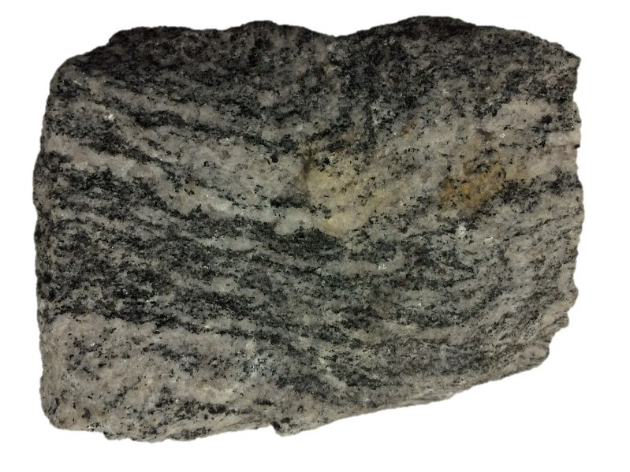
- Phyllite
- Marble
- Gneiss
- Slate

Name a medium-grained foliated metamorphic rock formed under intermediate temperature and pressure conditions.
- Schist
- Marble
- Gneiss
- Slate

Tabular or sheet-like minerals in metamorphic rocks are aligned to form a fabric known as a foliation. Which of the following is a metamorphic rock that does NOT contain a foliation?
- Slate
- Schist
- Marble
- Sandstone

LO4. I can explain how metamorphism differs with plate tectonic settings.

Regional metamorphism occurs in association with which three of the following tectonic environments?
- Oceanic hot spots
- Continent-continent convergence
- Oceanic ridges
- Ocean-continent convergence

In which plate tectonic setting is metamorphism most likely to occur under high temperature, low pressure conditions characterized by hot fluids?
- Within a plate descending a subduction zone
- Within an over-riding plate above a subduction zone
- Associated with an oceanic ridge system
- In shallow continental crust in a plate interior

Metamorphism is most likely to occur under low temperature, high pressure conditions at which plate tectonic setting?
- Within a plate descending a subduction zone
- Within an over-riding plate above a subduction zone
- Associated with an oceanic ridge system
- In shallow continental crust in a plate interior

Metamorphism is least likely to occur under which conditions?
- thin a plate descending a subduction zone
- Within an over-riding plate above a subduction zone
- Associated with an oceanic ridge system
- In shallow continental crust in a plate interior

Examine the diagram that indicates how temperature and pressure change with depth in Earth. Answer the questions that follow.
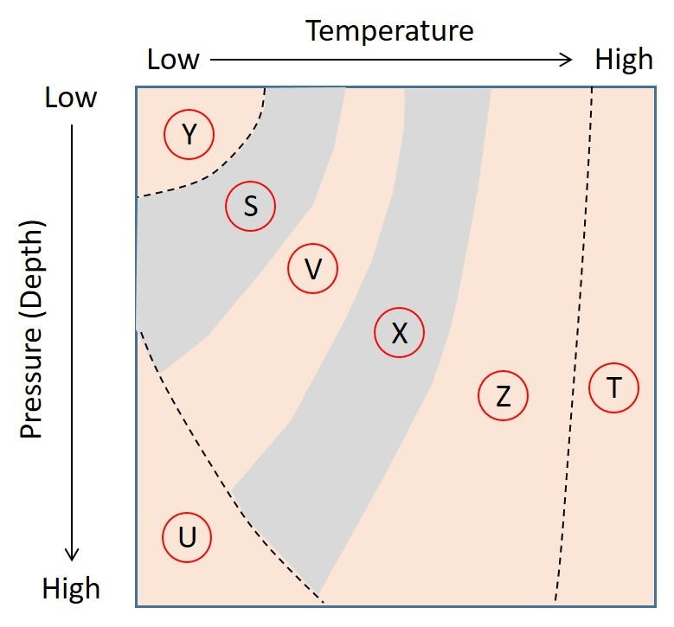
What does the letter S most likely represent in this figure?
- Conditions where metamorphism would not occur
- Conditions under which slate would form
- Conditions under which gneiss would form
- Conditions that would not be found in Earth’s crust

What does the letter T most likely represent in this figure?
- Conditions that would result in melting of some minerals
- Conditions under which slate would form
- Conditions under which gneiss would form
- Conditions that would not be found in Earth’s crust

What does the letter U most likely represent in this figure?
- Conditions that would result in melting of some minerals
- Conditions under which schist would form
- Conditions under which phyllite would form
- Conditions that would not be found in Earth’s crust

What does the letter X most likely represent in this figure?
- Conditions that would result in melting of some minerals
- Conditions under which schist would form
- Conditions under which slate would form
- Conditions that would not be found in Earth’s crust

What does the letter Y most likely represent in this figure?
- Conditions where metamorphism would not occur
- Conditions under which slate would form
- Conditions under which gneiss would form
- Conditions that would not be found in Earth’s crust

What does the letter Z most likely represent in this figure?
- Conditions that would result in melting of some minerals
- Conditions under which gneiss would form
- Conditions under which phyllite would form
- Conditions that would not be found in Earth’s crust

Earthquakes and Earthquake Hazards

LO1. I can define the terms strike, dip, hanging wall and foot wall.

The hanging wall is always ___ the footwall of an inclined fault.
- to the right of
- to the left of
- above
- below

The footwall is always ___ the hanging wall of an inclined fault.
- to the right of
- to the left of
- above
- below

What term is used to refer to the inclination of a fault surface (or any surface)?
- Stress
- Strike
- Foliation
- Dip

What is the term used to refer to a horizontal line on an inclined fault surface (or any surface)?
- Stress
- Strike
- Foliation
- Dip

If you were to pour water on an inclined surface, it would travel down ___.
- Stress
- Strike
- Dip
- Foliation

Which of the angles illustrated on this image is an accurate measure of the dip angle of the slope represented in the bricks (see arrows)?
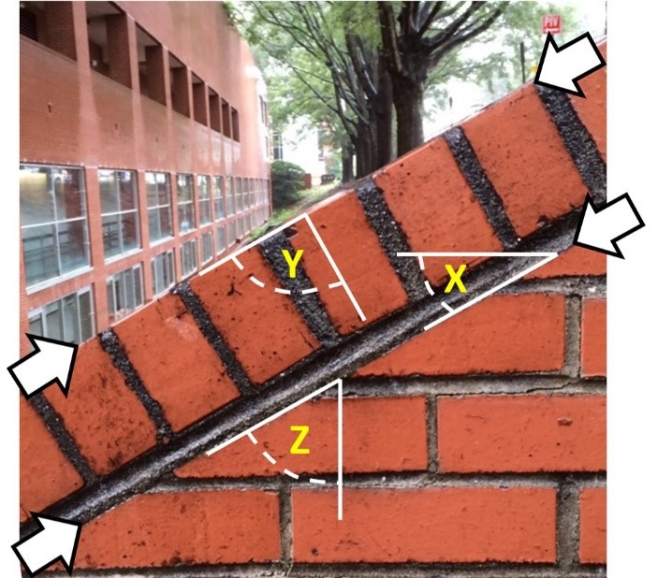
- X
- Y
- Z

Which of the lines illustrated on this image is an accurate representation of the strike of this sloping surface?
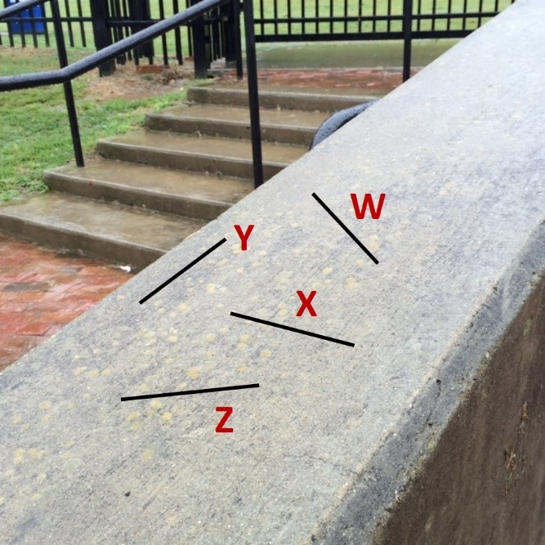
- W
- X
- Y
- Z
Which of the lines illustrated on this image represents the strike of this sloping surface?
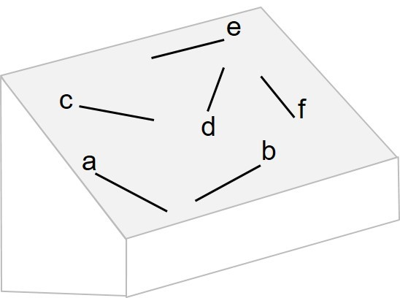
- A, b, c, d and e
- f only
- e and f only
- e only
- a, b and c

Examine the diagram and answer the question that follows.
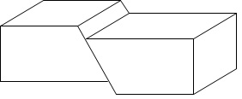
Determine which term would be the most appropriate to complete the following sentence. The hanging wall is on the ___ side of the fault.
- rIght
- left

Examine the diagram and answer the question that follows.
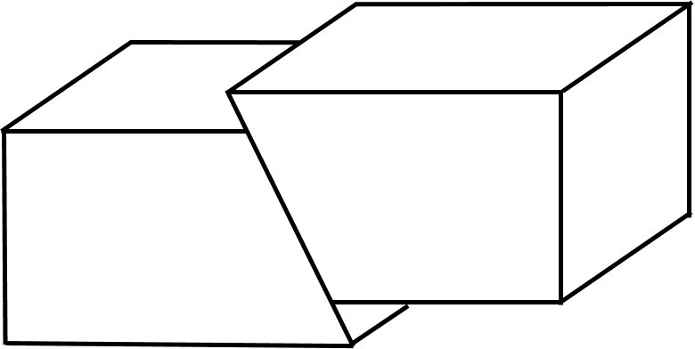
Determine which term would be the most appropriate to complete the following sentence. The hanging wall is on the ___ side of the fault.
- rIght
- left
Examine the diagram of a fault. Is the following statement true or false? The hanging wall is on the left side of the fault.
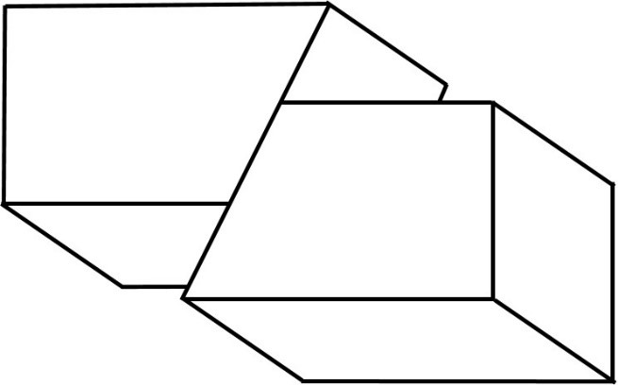
- True
- False

LO2. I can sketch and label the three major types of faults.

Select the answer with the correct terms and order to best fill in the blanks in the following statement. “Blocks on either side of a ___ fault move up or down an inclined surface while ___ faults may move horizontally."
- strike-slip; dip-slip
- dip-slip; strike-slip
- strike-slip; strike-slip
- dip-slip; dip-slip

Select the response that correctly fills the blanks (in order): “There are two main types of ___ fault: ___ and ___ faults."
- dip-slip; regular; reverse
- strike-slip; normal; reverse
- strike-slip; normal; inverted
- dip-slip; normal; reverse

Select the two pairs of responses that correctly fill the blanks (in order): “The ___ is immediately above the fault plane in a ___ fault."
- footwall; normal
- footwall; reverse
- hanging wall; normal
- hanging wall; reverse

Select the response(s) that correctly fills the blanks (in order): “The ___ is immediately below the fault plane in a ___ fault." (select all that apply)
- footwall; normal
- footwall; reverse
- hanging wall; normal
- hanging wall; reverse

A vertical strike-slip fault will have no hanging wall or footwall.
- True
- False

Which faults typically involve horizontal movements of Earth’s crust?
- Reverse faults
- Normal faults
- Strike-slip faults
- Dip-slip faults

Examine the diagram and answer the question that follows.
What type of fault is represented by the line drawing
- Reverse fault
- Normal fault
- Strike-slip fault

Examine the diagram and answer the question that follows.

What type of fault is represented by the line drawing?
- Normal dip-slip fault
- Reverse dip-slip fault
- Left-lateral strike-slip fault
- Right-lateral strike-slip fault

Examine the diagram and answer the question that follows.
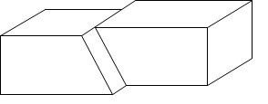
What type of fault is represented by the line drawing?
- Normal dip-slip fault
- Reverse dip-slip fault
- Left-lateral strike-slip fault
- Right-lateral strike-slip fault

What type of fault is represented by the offset of stream channels in the photograph?
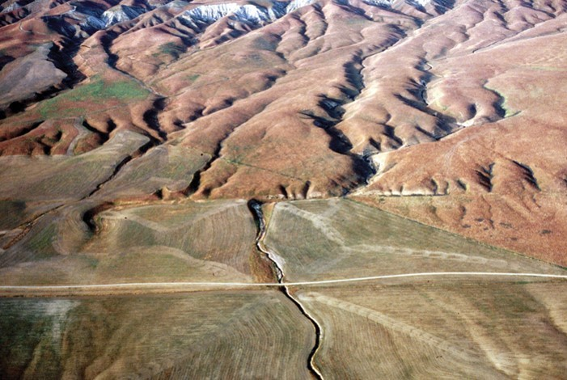
USGS
- Normal dip-slip fault
- Reverse dip-slip fault
- Left-lateral strike-slip fault
- Right-lateral strike-slip fault

What type of fault is represented by the dashed line in the photograph looking down on Earth’s surface from above?
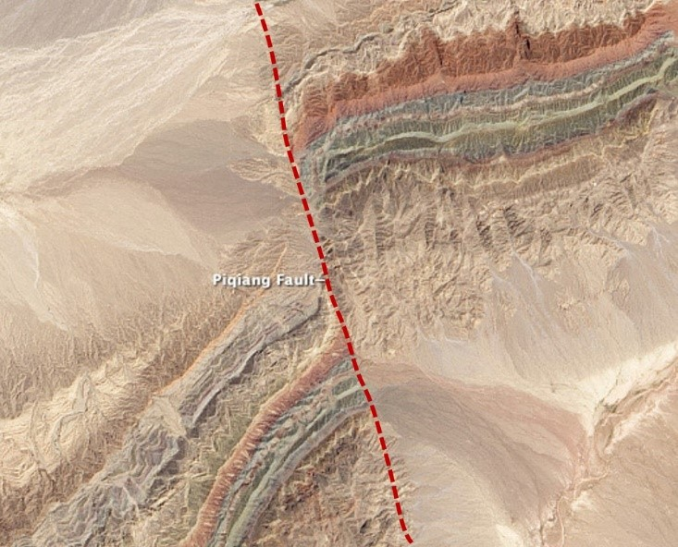
https://earthobservatory.nasa.gov/images/82853/faults-in-xinjiang
- Normal dip-slip fault
- Reverse dip-slip fault
- Left-lateral strike-slip fault
- Right-lateral strike-slip fault

Examine the image that illustrates a fault (solid line) and determine where X is located.
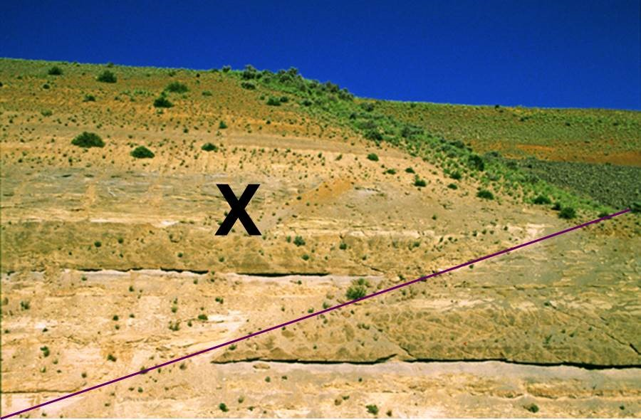
- X is in the hanging wall of a normal fault
- X is in the footwall of a normal fault
- X is in the hanging wall of a reverse fault
- X is in the footwall of a reverse fault

Which type of fault is best matched with the appropriate plate boundary?
- Normal dip-slip fault and transform boundary
- Reverse dip-slip fault and divergent boundary
- Left-lateral strike-slip fault and convergent boundary
- Right-lateral strike-slip fault and transform boundary

LO 3. I can explain how rocks deform in association with earthquakes.

In what depth range do most earthquakes occur?
- 0-70 km
- 70-300 km
- More than 300 km

What is the name of the landform that indicates movement on a fault has occurred?
- Epicenter
- Fault scarp
- Hypocenter
- Fault line

How will most types of rock respond to a significant tectonic stress at shallow depths (above ~10km)?
- They will flow as a weak solid.
- They will break as a brittle solid.

How will most types of rock respond to a significant tectonic stress at depths below ~15km?
- They will flow as a weak solid.
- They will break as a brittle solid.

Rocks crack or fracture in response to increased stress, regardless of temperature or pressure conditions.
- True
- False

When will rocks that are located near an active fault change shape (deform) relative to the timing of an earthquake on the fault?
- Never
- Both before and after the earthquake occurs
- Before the earthquake occurs
- After the earthquake occurs

Rocks adjacent to a fault will change shape before slip occurs on the fault during an earthquake.
- True
- False

Approximately how far will the ground be offset during surface rupture associated with most medium to large earthquakes?
- A few meters
- A few centimeters
- More than 100 meters
- Several tens of meters
Examine the time vs. stress figure and answer the questions that follow,

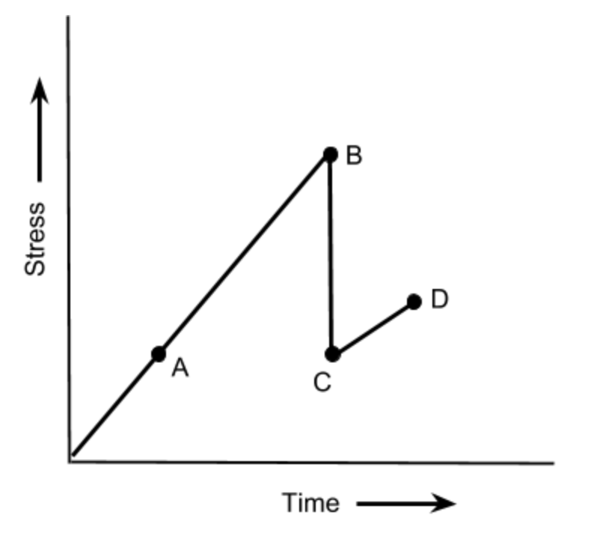
Which point represents the exact moment an earthquake occurs?
- A
- B
- C
- D

Which point represents the period immediately after the earthquake occurred?
- A
- B
- C
- D

Which point represents a time when the rocks are accumulating strain, but no earthquake has occurred?
- A
- B
- C
- D

Review the two statements and identify if they are true or false.
i. Normal faults form when Earth’s crust is under tension in locations such as an oceanic ridge.
ii. Reverse faults are most likely to form under conditions of compression, such as on a continental margin along a convergent plate boundary.
- Both statements are true.
- Both statements are false.
- The first statement is true; the second statement is false.
- The first statement is false; the second statement is true.

Review the two statements and identify if they are true or false.
i. Normal faults form when Earth’s crust is under compression.
ii. Strike-slip faults are most likely to form under conditions of shear, such as at a transform plate boundary.
- Both statements are true.
- Both statements are false.
- The first statement is true; the second statement is false.
- The first statement is false; the second statement is true.

LO4. I can discuss how faults accumulate slip which accounts for 100s km of movement between tectonic plates.

Large faults, like the San Andreas Fault, are hundreds of kilometers long. During a large earthquake, where do movements of 1-10 meters occur on the fault?
- All along the fault
- Along a segment of the fault 10’s of kilometers in length
- Along a segment of the fault a few meters in length

Plate A moves 5 centimeters per year past plate B. The Carillo Fault is located along the plate boundary and consistently produces large earthquakes with 5 meters (500 centimeters) of fault slip. If plate motions are directly converted to movement on the Carillo Fault during earthquakes, approximately how long is the interval between large earthquakes on the fault?
- 5 years
- 1000 years
- 10 years
- 100 years
- 50 years

Movement on a shallow fault would typically offset the ground surface during a moderate to large earthquake by approximately 50-100 meters.
- True
- False

Movement on a shallow fault would typically offset the ground surface during a moderate to large earthquake by approximately 5-10 meters.
- True
- False

The San Andreas fault zone represents the boundary between the North American and Pacific Plates. Geologists estimate that there has been more than 300 kilometers of fault slip on the fault zone. On the basis of your understanding of fault slip rates, predict approximately how long the fault zone has represented an active tectonic boundary.
- 30 million years
- 400,000 years
- 6 million years
- 5000 years

Large faults, like the San Andreas Fault, may be as much as 1000 kilometers long. During a large magnitude earthquake, where is fault slip most likely to occur on the fault?
- All along the fault
- Along 700-1000 kilometers of the fault
- Along a segment of the fault 10’s-100’s of kilometers in length
- Along a segment of the fault a few meters in length

Plate A collides with plate B, forming a series of reverse faults along the edge of a continent on plate B. Slip on a major reverse fault gradually raises the elevation of the land surface. Uplift is partially balanced by erosion and other forces, resulting in a net gain in elevation of 0.5 centimeters per year (1 meter = 100 centimeters). Approximately how long would it take to generate a mountain with an elevation similar to Denali, the tallest mountain in North America, elevation 6190 meters? (Assume the uplift starts from just above sea level).
- 60 million years
- 12 million years
- 600,000 years
- 12,000 years
- 3000 years

The North Anatolian Fault (NAF) system represents a plate boundary between the small Anatolian plate and several other larger plates. The NAF is similar in size to the San Andreas Fault in California. The image shows four versions of the NAF, each with fault segments of different lengths in blue and pink. On the basis of what you know about how earthquakes occur on faults, predict which map most accurately represents segments of the NAF that slipped to generate large magnitude earthquakes since 1939.
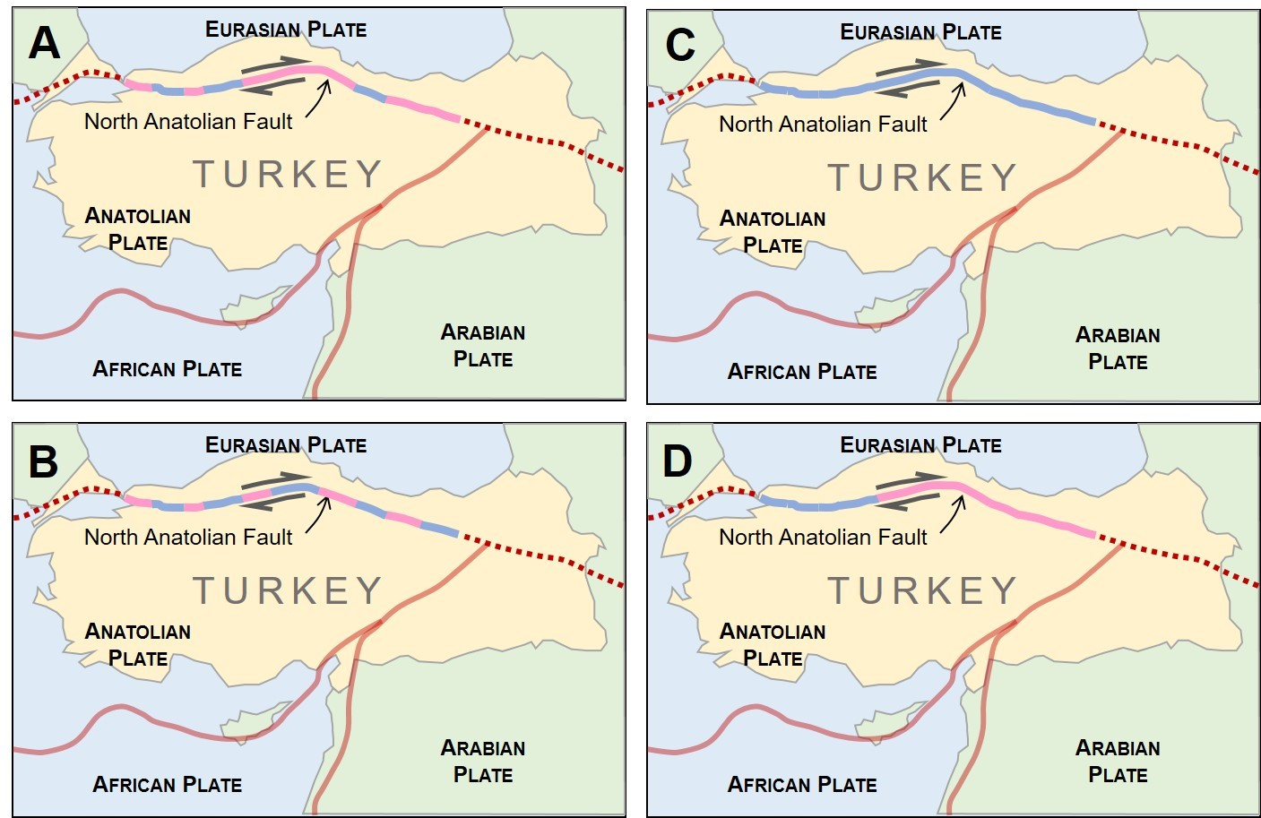
- The NAF broke on several fault segments of different lengths
- The NAF broke on several fault segments of similar lengths
- The NAF broke on a single long fault segment
- The NAF broke on two longer fault segments

Which statement is most accurate?
- The size of an earthquake is not related to the length of the fault segment that breaks during an earthquake. Big earthquakes are just as likely to occur on short faults as long faults.
- The size of an earthquake is generally related to the length of the fault segment that breaks during an earthquake. Bigger earthquakes are more likely to occur on longer faults.

LO5. I can explain how earth scientists use seismic waves to locate and measure earthquakes.

How many different seismograph records have to be analyzed to accurately determine the location of an earthquake epicenter?
- More than 12
- At least 5
- 2
- 3
- 1

What do scientists measure to calculate the size (magnitude) of an earthquake?
- The difference between arrival times of P and S waves
- The amplitude of S waves
- The amplitude of P waves
- The difference in arrival times of S and surface waves

What is the name given to the source of an earthquake?
- Seismic apex
- Epicenter
- Hypocenter or focus
- Quake-o-matic

How does the difference in arrival times for seismic waves change with increasing distance from an earthquake location?
- The time between the arrival of P and S waves does not change.
- The time between the arrival of P and S waves decreases.
- The time between the arrival of P and S waves increases.

Which of the following are examples of body waves? Select all that apply.
- P waves
- S waves
- Surface waves

Which type of seismic wave would not travel through the molten materials of Earth's outer core?
- P waves
- S waves

Which type of seismic wave can travel through the molten materials of Earth's outer core?
- P waves
- S waves

In what order do seismic waves arrive at a seismometer? (From first to last arrival.)
- Surface wave, P wave, S wave
- P wave, S wave, surface wave
- S wave, P wave, surface wave
- Surface wave, S wave, P wave

The closer a location to an earthquake, the faster the P waves move.
- True
- False

Review the two statements and identify if they are true or false.
i. The speed of seismic waves is faster at convergent plate boundaries and slower at divergent boundaries.
ii. The difference in arrival times for P and S waves increases as the distance to the earthquake epicenter increases.
- Both statements are true.
- Both statements are false.
- The first statement is true; the second statement is false.
- The first statement is false; the second statement is true.

Review the two statements and identify if they are true or false.
i. Body waves travel in three dimensions, both horizontally and vertically through Earth.
ii. Surface waves arrive at a seismograph station first because they travel over Earth’s surface while body waves have to travel through Earth’s interior.
- Both statements are true.
- Both statements are false.
- The first statement is true; the second statement is false.
- The first statement is false; the second statement is true.

LO6. I can summarize the difference between measures of earthquake intensity and magnitude.

Earthquake intensity refers to people's perceptions and the damage that results from an earthquake.
- True
- False

The amplitude of a seismic wave is used to determine earthquake magnitude.
- True
- False

Which of the following has a subjective element to its interpretation (i.e., it will vary from person to person)?
- Earthquake magnitude
- Earthquake intensity

The description of damage that follows represents a measure of earthquake ___ measured with a value of approximately ___. "Slight damage in buildings designed to withstand earthquakes; heavy damage in poorly constructed structures. Chimneys, columns, walls may fall. "
- intensity; 5
- intensity; VIII
- magnitude; 5
- magnitude; VIII

Review the two statements and identify if they are true or false.
i. Magnitude is a measure of the energy released at the source of an earthquake and is determined by measuring the amplitude of seismic waves on a seismogram.
ii. Intensity is a measure of the effects of an earthquake on people and structures such as buildings and roadways.
- Both statements are true.
- Both statements are false.
- The first statement is true; the second statement is false.
- The first statement is false; the second statement is true.

How much greater is the ground motion generated by a magnitude 8 earthquake than a magnitude 4 earthquake in the same geological region?
- Twice as large
- Four times as large
- 10,000 times larger
- 100 times larger

Which earthquake measurement scale uses Roman numerals?
- Magnitude
- Intensity

Review the two statements and identify if they are true or false.
i. There is a single magnitude value for a given earthquake.
ii. There can be many different intensity values for an individual earthquake.
- Both statements are true.
- Both statements are false.
- The first statement is true; the second statement is false.
- The first statement is false; the second statement is true.

Review the two statements and identify if they are true or false.
i. A given earthquake will have multiple magnitude values, depending on the relative locations of the seismograph stations.
ii. A given earthquake will have multiple intensity values for an individual earthquake, depending on the locations where values are recorded.
- Both statements are true.
- Both statements are false.
- The first statement is true; the second statement is false.
- The first statement is false; the second statement is true.

Two sites, locations X and Y record magnitude and intensity values for the same earthquake. X is closer to the epicenter of the earthquake; Y is farther away. Which statement correctly summarizes the magnitude and intensity values recorded at the two locations?
- Intensity is greatest at X; magnitude would be the same for each site
- Intensity is greatest at Y; magnitude would be the same for each site
- Intensity is greatest at X; magnitude would be lower at Y
- Intensity is greatest at Y; magnitude would be lower at Y

What are the greatest values recorded using the magnitude and intensity scales, respectively?
- 11; X
- 8.4; X
- 9.5; XII
- XII; 10.5
- X; 8.1

Magnitude 8 or larger earthquakes occur on average approximately once a year.
- True
- False

Which three answers contribute to the magnitude of a particular earthquake?
- The area (length) of the fault segment that breaks
- The amount of slip that occurs on the fault
- The type of fault
- The rigidity or stiffness of the rocks around the fault
- The type of plate boundary associated with the fault

Several cities experience shaking from a magnitude 6 earthquake. Which statement is the most accurate?
- The cities will experience the same earthquake intensity
- The cities will experience different earthquake intensities

How much greater is the ground motion generated by a magnitude 5 earthquake than a magnitude 4 earthquake in the same geological region?
- Twice as large
- About 25% greater
- 10 times greater

Which statement is true about how scientists measure earthquakes?
- Intensity represents the magnitude of an earthquake and is measured by the Mercalli scale
- Magnitude measures damage from an earthquake and is measured by the Richter scale
- Intensity represents shaking associated with an earthquake and magnitude measures the resulting damage
- Magnitude measures shaking associated with an earthquake and intensity represents the damage from the event.

LO7. I can describe at least five different types of hazards resulting from earthquakes.

The 1960 Chile earthquake generated a tsunami that killed people in Hawaii and Japan.
- True
- False

Thousands of people died from earthquakes in previous centuries but in recent years technology has resulted in no significant loss of life from earthquakes.
- True
- False

Which three of the following hazards are directly associated with the ground shaking from earthquakes?
- Widespread fires
- Tsunami
- Landslides
- Liquefaction

Identify three secondary hazards that can occur or be triggered by earthquakes (but are NOT directly associated with the ground shaking itself)?
- Widespread fire
- Uplift and/or subsidence of the land surface
- Liquefaction
- Flooding
- Collapse of buildings

Under what conditions is liquefaction most likely to occur?
- When material on steep slopes undergoes shaking
- When faults move suddenly after many years of no activity
- When water saturated sediments experience an earthquake
- When tall buildings and highway overpasses collapse

How far will the ground be offset during surface rupture associated with most medium to large earthquakes?
- A few meters
- Several tens of meters
- More than 100 meters

Consider the relative frequencies of earthquakes of different sizes and respond to the statement that follows. "Most earthquakes result in some damages."
- True
- False

A tsunami is an example of a seismic wave.
- True
- False

Earth materials can affect the degree of shaking associated with an earthquake. Review the two statements and identify if they are true or false.
i. Weaker materials such as mud and sediment can absorb the energy from the earthquake to reduce the potential for damage to buildings and structures.
ii. The rigid nature of bedrock minimizes the amount of shaking associated with earthquakes.
- Both statements are true.
- Both statements are false.
- The first statement is true; the second statement is false.
- The first statement is false; the second statement is true.

What type of plate boundary configuration is most commonly associated with tsunami?
- Divergent plate boundaries
- Convergent plate boundaries
- Transform plate boundaries
- Tsunami are associated with all boundary types

Which ocean basin is most likely to experience a tsunami?
- Atlantic Ocean
- Pacific Ocean
- Indian Ocean
- Southern Ocean

During an earthquake, you would expect a building on _________ to experience the LEAST amount of damage.
- Bedrock
- Mud (clays with water in the pore space)
- Sands and gravels
- They would all experience the same damage
LO8. I can explain the geological conditions that are likely to result in greater risk from future earthquakes.

Which of the following generates MOST earthquakes?
- Movement of magma below volcanoes
- Movement of tsunami waves
- Movement on faults
- Asteroid impact events

Which of the following may generate earthquakes? Select all that apply.
- Movement of magma below volcanoes
- Movement of tsunami waves
- Movement on faults
- Asteroid impact events

Which pair of statements are correct?
- Earthquakes are most frequent around the edge of the Pacific Ocean.
- Deep earthquakes have the potential to occur at all types of plate boundaries.
- The deepest earthquakes are typically found at subduction zones.
- Earthquakes occur most frequently in association with oceanic ridges.

Where are most of the faults that have generated earthquakes in the US?
- Western US
- Eastern US
- Central US

Which of the following US cities would have the LOWEST risk for dangerous earthquakes?
- Honolulu, HI
- Anchorage, AK
- Seattle, WA
- San Francisco, CA

Which of the following international cities would have the LOWEST risk for earthquakes and related hazards based on their plate tectonic setting?
- Madrid, Spain
- Lima, Peru
- Christchurch, New Zealand
- Tokyo, Japan

What type of plate boundary is associated with the largest earthquakes?
- Aseismic
- Divergent
- Transform
- Convergent
All areas of the midwestern United States maintain a low risk for earthquake hazards.
- True
- False

Due to its low elevation and high potential for sinkholes, Florida has a high risk for earthquake-related hazards.
- True
- False

Which of the plate configurations pictured here would experience the most frequent and largest earthquakes?
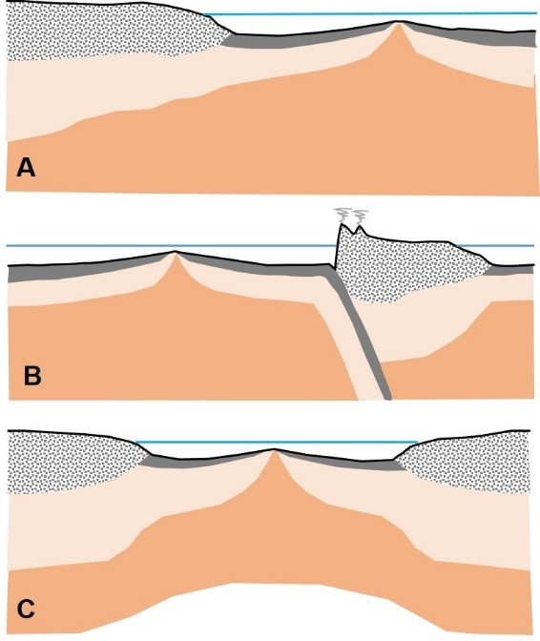
- A
- B
- C

Where will earthquakes occur most frequently in the cross section of the plate boundary shown here?
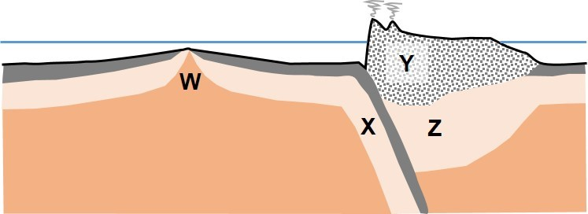
- W
- X
- Y
- Z

Where will earthquakes occur most frequently in the cross section of the plate boundary shown here?
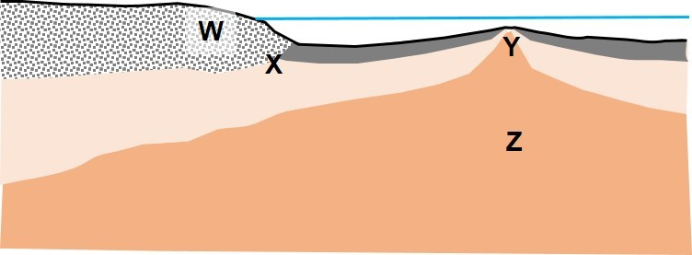
- W
- X
- Y
- Z

The figures below show the location of a plate boundary (dashed line) and the distribution of earthquake foci (filled circles). The color of the filled circle indicates the depth of the earthquake focus. Use the pattern of the depths of foci to predict which figure best represents a convergent plate boundary between two oceanic plates.
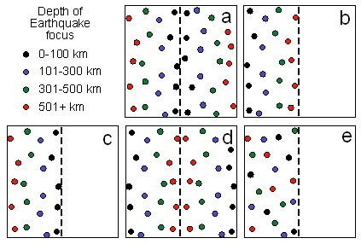
- a
- b
- c
- d
- e

Volcanoes & Volcanic Hazards

LO1. I can compare and contrast the features of shield volcanoes and composite volcanoes.

What is the most common rock erupted from shield volcanoes?
- Basalt
- Andesite
- Rhyolite
- Granite

What is the most common rock erupted from composite volcanoes?
- Basalt
- Andesite
- Rhyolite
- Granite

What plate tectonic features are associated with the majority of composite volcanoes?
- Continental shelves
- Transform boundaries
- Oceanic ridges
- Hot spots
- Subduction zones

Which type of volcano would cover the largest area and contain the greatest volume of volcanic rocks?
- Shield volcano
- Composite volcano
- Scoria cone

Based on its plate tectonic setting, what type of volcanoes would you expect in each location? Select any and all correct matches of location and volcano type.
- West coast of South America; composite
- West coast of South America; shield
- Pacific Northwest (Oregon, Washington) of the US; composite
- Pacific Northwest (Oregon, Washington) of the US; shield
- Hawaiian islands; composite
- Hawaiian islands; shield

Pick the option that correctly fills in the blanks in the following statement: "___ volcanoes are generally larger in overall size and volume of material but have less steep slopes than ___ volcanoes."
- composite; shield
- shield; composite
- composite; all other

What is the volcano type depicted in the image?
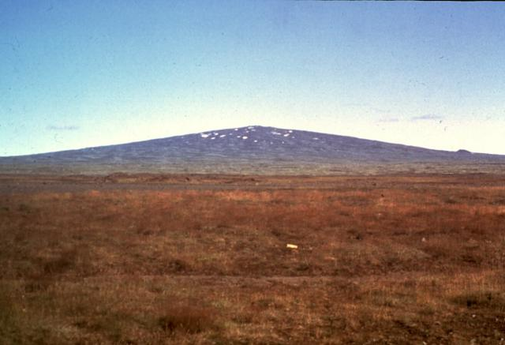
https://volcano.si.edu/gallery/photos/GVP-05768.jpg
- Shield volcano
- Composite volcano
- Cinder cone
- Lava dome

What types of volcano are depicted in the image?
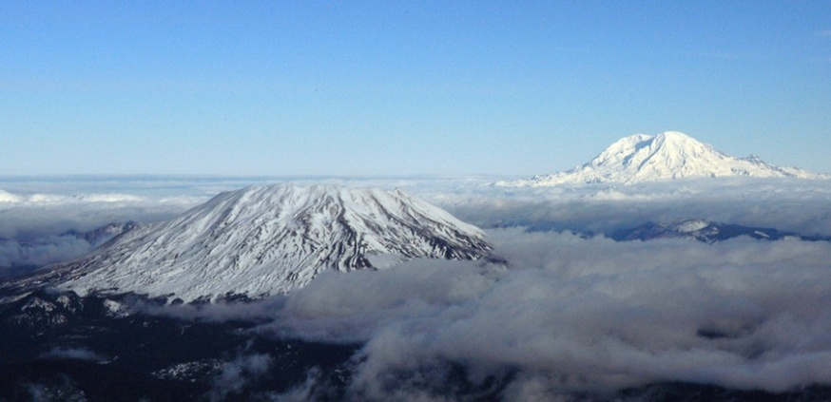
USGS
- Shield volcano
- Composite volcano
- Cinder cone
- Lava dome

Some types of volcanoes are larger than others. Which of the following types of volcanoes form larger structures with heights measured in thousands of meters? Select all that apply.
- Composite volcanoes
- Shield volcanoes
- Lava domes
- Cinder cone volcanoes

Which type of volcano is most likely to contain rocks with intermediate silica content?
- Shield volcano
- Composite volcano
- Cinder cone
- Lava dome

Review the two statements that follow and identify if they are true or false.
i. Composite volcanoes are present in the Aleutian Islands along the convergent plate boundary between the North American and Pacific plates
ii. Shield volcanoes are the principal types of volcanoes in the Cascade Range of the Pacific Northwest (Oregon, Washington, and northern California).
- Both statements are true.
- Both statements are false.
- The first statement is true; the second statement is false.
- The first statement is false; the second statement is true.

Review the two statements that follow and identify if they are true or false.
i. Composite volcanoes are present in the Aleutian Islands along the convergent plate boundary between the North American and Pacific plates
ii. Shield volcanoes are the principal types of volcanoes that formed above the hot spot that generated the Hawaiian island chain.
- Both statements are true.
- Both statements are false.
- The first statement is true; the second statement is false.
- The first statement is false; the second statement is true.

Review the two statements that follow and identify if they are true or false.
i.Shield volcanoes are present in the Aleutian Islands along the convergent plate boundary between the North American and Pacific plates
ii.Composite volcanoes are the principal types of volcanoes that formed above the hot spot that generated the Hawaiian island chain.
- Both statements are true.
- Both statements are false.
- The first statement is true; the second statement is false.
- The first statement is false; the second statement is true.

A shield volcano typically produces volcanic rocks with low silica content.
- True
- False

Most active volcanoes on Earth are examples of ___ volcanoes formed in association with ___.
- composite; hot spots
- shield; hot spots
- composite; subduction zones
- shield; subduction zones

Which type of volcano is mainly composed of lava?
- Composite
- Shield

If a shield and a composite volcano both formed on land and were of similar diameter, which would be taller?
- Composite
- Shield

Review the two statements that follow and identify if they are true or false.
i. Composite cone volcanoes are typically formed in association with island arcs or volcanic arcs
ii. Shield volcanoes are most likely to be composed of igneous rocks with high silica content
- Both statements are true
- Both statements are false
- The first statement is true; the second statement is false
- The first statement is false; the second statement is true

LO2. I can compare and contrast the features of cinder cone volcanoes and lava domes.

Which of the following types of volcanoes is the smallest?
- Shield volcano
- Composite volcano
- Cinder (scoria) cone

What is the feature depicted in the figure?
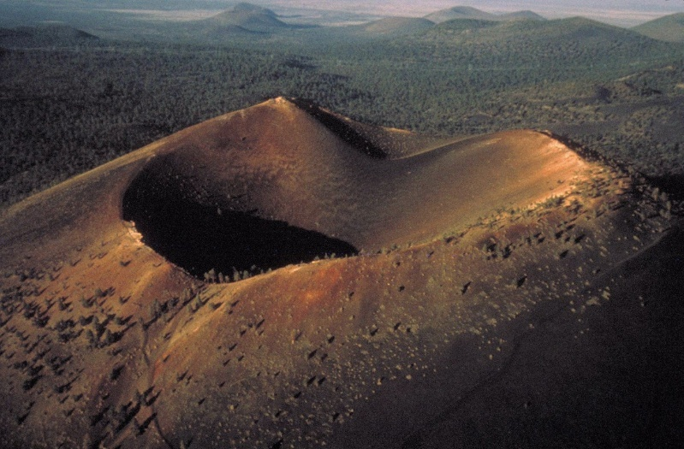
https://www.nps.gov/articles/000/volcanic-craters.htm
- Shield volcano
- Composite volcano
- Cinder cone
- Lava dome

Examine the image that shows a feature located within a volcanic crater. What is the name of the feature is the red arrow pointing to in the figure?
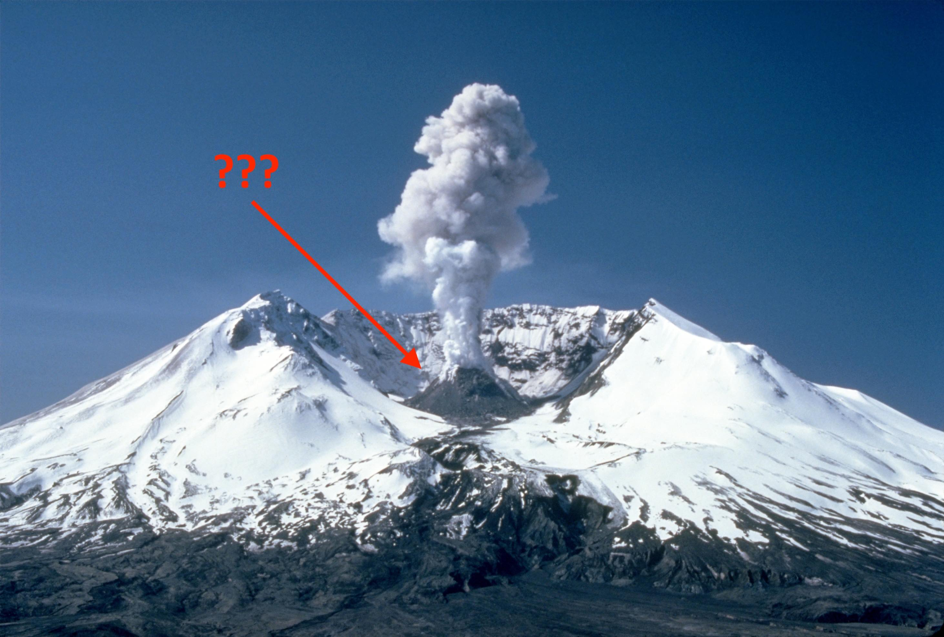
USGS
- Shield volcano
- Composite volcano
- Cinder cone
- Lava dome

Volcanic domes are typically larger than composite volcanoes.
- True
- False

Select the response that best fills the blanks in the following statement:
"Considering the size of the four types of volcanoes, ___ are considerably smaller in scale than ___."
- cinder cones and composite volcanoes; lava domes and shield volcanoes
- cinder cones and shield volcanoes; lava domes and composite volcanoes
- cinder cones and lava domes; composite volcanoes and shield volcanoes
- composite volcanoes and shield volcanoes; cinder cones and lava domes
- lava domes and shield volcanoes; cinder cones and composite volcanoes
- lava domes and composite volcanoes; cinder cones and shield volcanoes

Some types of volcanoes are smaller than others. Which of the following types of volcanoes form smaller structures often no more than several hundreds of meters high? Select all that apply.
- Shield volcano
- Composite volcano
- Cinder cone
- Lava dome

Volcanic domes are composed of low viscosity lava.
- True
- False

Review the two statements that follow and identify if they are true or false.
i. Lava found in lava domes in typically more silica rich than lava that forms shield volcanoes
ii. Lava domes typically form on the flanks of larger volcanoes
- Both statements are true.
- Both statements are false.
- The first statement is true; the second statement is false.
- The first statement is false; the second statement is true.

Review the two statements that follow and identify if they are true or false.
i. The materials in cinder cones form when magma is blasted into the air and falls back to ground around a central vent
ii. Cinder cones typically form on the flanks of larger volcanoes
- Both statements are true.
- Both statements are false.
- The first statement is true; the second statement is false.
- The first statement is false; the second statement is true.

Which contains a more viscous form of lava?
- Lava domes
- Shield volcanoes

LO 3. I can describe the volcanic hazards that are associated with an eruption.

Most of the thousands of people killed from the historical eruptions of Vesuvius (Italy) and St. Pierre (Martinique) died as a result of ___.
- lava flows
- pyroclastic flows
- volcanic ash
- lahars
- toxic gases

What is tephra?
- A high viscosity lava flow formed by a non-explosive eruption
- Volcanic material blasted into the air by an eruption
- The name given to gases that drive volcanic eruptions
- The mixture of water and lava formed in submarine eruptions

Pyroclastic flows are most likely to form in association with composite volcanoes rather than shield volcanoes.
- True
- False

What is a lahar?
- A large, flowing volume of lava that is hard to the touch (LA-va HAR-d)
- Volcanic material of varying sizes that is erupted into the atmosphere
- A volcanic mudflow consisting of pyroclastic material, pre-existing rocks, and water
- A denser than air flow of hot gas and volcanic material that moves down slope after an eruption

What is a pyroclastic flow?
- A large, flowing volume of lava that is hard to the touch (LA-va HAR-d)
- Volcanic material of varying sizes that is erupted into the atmosphere
- A volcanic mudflow consisting of pyroclastic material, pre-existing rocks, and water
- A denser than air flow of hot gas and volcanic material that moves down slope after an eruption

Which eruption product has the potential to travel farthest from a composite volcano?
- Pyroclastic flow
- Lava flow
- Tephra
- Lahar

Which of these products of a volcanic eruption would typically travel farthest from a volcano?
- Lava
- Pyroclastic flow
- Lahar

Which statement is most accurate?
- Pyroclastic flows are common products of shield volcanoes and lava flows form often in association with composite volcanoes
- Pyroclastic flows and lava flows are common products of both shield and composite volcanoes
- Pyroclastic flows are common products of composite volcanoes and lava flows form often in association with shield volcanoes

Which eruption product has the potential to travel the least distance from the vent of a composite volcano?
- Pyroclastic flow
- Lava flow
- Tephra
- Lahar

Which volcanic hazard is most likely to cause destruction in towns located 30-60 kilometers from a composite volcano?
- Pyroclastic flow
- Lava flow
- Lahar

Tephra and lahar deposits can both include fine-grained particles as well as boulder-sized materials.
- True
- False

How many false statements are included in the paragraph that follows? “Seattle is located to the east of the active volcanoes of the Cascade Range. These composite volcanoes have erupted on average 3-5 times per century during the last few thousand years. The volcanoes are formed above a hot spot located where the North American and Juan de Fuca plates collide.”
- 0 false statements
- 1 false statements
- 2 false statements
- 3 false statements
- 4 false statements

A lahar forms when material from a volcanic eruption interacts with material from what other part of the earth system?
- Atmosphere
- Biosphere
- Hydrosphere

What is the name given to the dark cloud of material erupting from the pictured volcano?
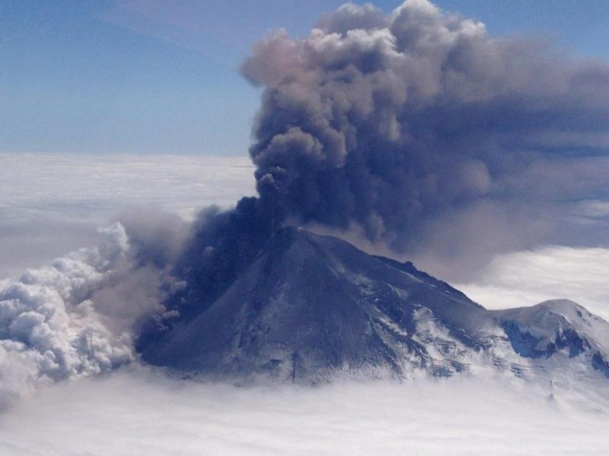
https://avo.alaska.edu/images/dbimages/1368993168.jpg
- Tephra
- Pyroclastic flow
- Lahar
- Lava fountain

What is the name given to the material (indicted by the arrow) erupting from the volcano in this image?
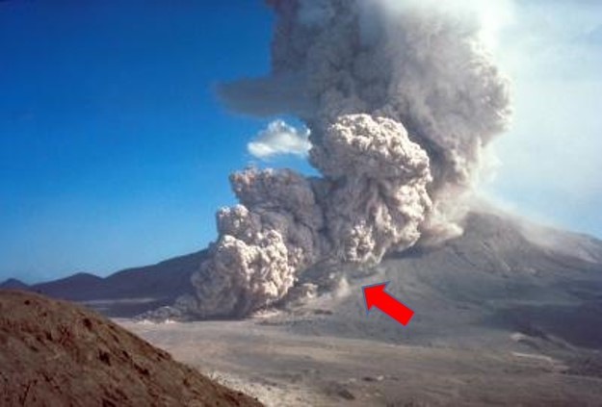
https://www.usgs.gov/media/images/pyroclastic-flow-aug-7-1980-eruption-stretches-moun
- Tephra
- Pyroclastic flow
- Lahar
- Lava fountain
LO4. I can describe the eruption sequence for Mount St. Helens (1980).

Mount St. Helens is part of which mountain range and is located in which state?
- Sierra Nevada Range, Oregon
- Sierra Nevada Range, California
- Cascade Range, Washington
- Cascade Range, California

Which of the following sets of terms correctly describes the main events in the sequence of events during the eruption of Mt. Saint Helens in 1980?
- Bulge; landslide; eruption begins; lateral blast
- Landslide; bulge; eruption begins; lateral blast
- Lateral blast; landslide; eruption begins; bulge
- Eruption begins; bulge; lateral blast; landslide

Which of the following ground-based volcanic hazards associated with the eruption of Mt. Saint Helens (i.e., not tephra) covered the largest area surrounding the volcano?
- Pyroclastic flow deposits
- Lahar deposits
- Lateral blast deposits

Which of the following ground-based volcanic hazards associated with the eruption of Mt. Saint Helens traveled the farthest from the volcano?
- Pyroclastic flow deposits
- Lahar deposits
- Lateral blast deposits
- Lava flow

Which of the following products of the volcanic eruption traveled no farther than the base of the volcano?
- Pyroclastic flow deposits
- Lahar deposits
- Lateral blast deposits
- Lava flow

Volcanic activity that has occurred at Mount St. Helens was initially generated in association with the hot spot below the North American plate that currently lies below Yellowstone National Park.
- True
- False

Volcanic activity that has occurred at Mount St. Helens is associated with the magma formed in the mantle overlying the subduction zone between the North American and Juan de Fuca plates.
- True
- False

Review the two statements that follow and identify if they are true or false.
i. In May 1980, Mount St. Helens erupted with no warning
ii. Mount St. Helens eruptions occur approximately 20,000 years apart
- Both statements are true.
- Both statements are false.
- The first statement is true; the second statement is false.
- The first statement is false; the second statement is true.

Which of the following was not a significant product of the eruption of Mount St. Helens?
- Pyroclastic flow deposits
- Lahar deposits
- Lateral blast deposits
- Lava flows

Which of the following occurred prior to the eruption of Mount St. Helens? Select all that apply.
- Earthquake activity increased below the volcano
- The shape of the volcano changed
- There were increased gas emissions from the volcano
- Small lava flows occurred more frequently on the volcano’s flanks

Review the two statements that follow and identify if they are true or false.
i. Volcanic activity at Mount St. Helens was associated with magma formed above a subduction zone between the North American and Juan de Fuca plates
ii. The 1980 eruption of Mount St. Helens occurred after several weeks of geological activity on and around the volcano.
- Both statements are true
- Both statements are false
- The first statement is true; the second statement is false
- The first statement is false; the second statement is true

LO5. I can define the term viscosity and I can give examples of everyday materials with high and low viscosity.

Which of the following is the best definition for viscosity?
- Viscosity is the thickness of the material
- Viscosity is a property that measures a material's resistance to flow
- Viscosity is a rate that refers to how fast a material flows

Which of the following everyday materials has the highest viscosity?
- Water
- Oil
- Milk
- Honey

Which one of the following everyday materials has the lowest viscosity?
- Water
- Oil
- Peanut butter
- Honey

Gasoline is a substance with high viscosity.
- True
- False

Materials with a high viscosity can be described as ___ and materials with a low viscosity can be described as ___.
- thin and runny; thick and sluggish
- thin and sluggish; thick and runny
- thick and sluggish; thin and runny
- thick and runny; thin and sluggish

Viscosity refers to which of the following?
- The density of a fluid material
- The gas content of a fluid
- The temperature and gas content of a fluid
- The resistance to flow of a fluid

Review the two statements that follow and identify if they are true or false.
i. Glue and tar are materials with low viscosity, meaning that they flow slowly.
ii. Olive oil has a lower viscosity than peanut butter.
- Both statements are true.
- Both statements are false.
- The first statement is true; the second statement is false.
- The first statement is false; the second statement is true.

Which list correctly lists common materials from low viscosity to high viscosity?
- Tar – peanut butter – honey – air – water
- Water – air – peanut butter – honey – tar
- Air – water – honey – peanut butter – tar
- Air – water – tar – peanut butter – honey

Materials with low viscosity flow easily.
- True
- False

Review the two statements that follow and identify if they are true or false.
i. Viscosity refers to the mass of material in a given volume.
ii. Solids have a lower viscosity than liquids.
- Both statements are true.
- Both statements are false.
- The first statement is true; the second statement is false.
- The first statement is false; the second statement is true.

Which list of materials is in order from lowest viscosity to highest viscosity?
- Water – honey – peanut butter - mayonnaise
- Gasoline – ketchup – mayonnaise – olive oil
- Olive oil – mayonnaise – ketchup – water
- Milk – olive oil – honey – peanut butter

LO6. I can explain the controls on magma viscosity.

Lava with high viscosity would flow quickly.
- True
- False

Which of the following types of magma has the highest viscosity?
- Andesitic
- Rhyolitic
- Basaltic

Which of the following types of magma has the lowest viscosity?
- Andesitic
- Rhyolitic
- Basaltic

Which of the following types of magma has an intermediate viscosity?
- Andesitic
- Rhyolitic
- Basaltic

Review the figure and identify which of the magmas indicated by the lettered symbols would have the lowest viscosity on the basis of these properties.
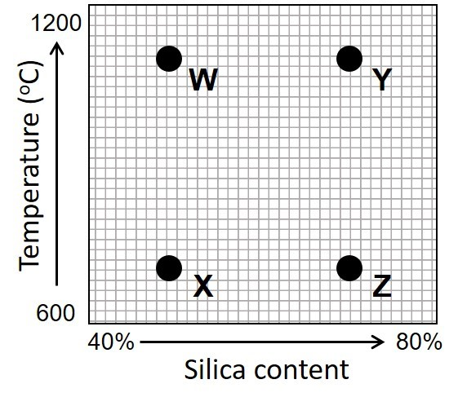
- W
- X
- Y
- Z

Review the two statements that follow and identify if they are true or false.
i. Rhyolitic magma has higher viscosity than other common types of magma.
ii. Basalt is typically formed from low viscosity magma.
- Both statements are true.
- Both statements are false.
- The first statement is true; the second statement is false.
- The first statement is false; the second statement is true.

The viscosity of magma ___ as its temperature ___. Select all that apply.
- increases; increases
- decreases; decreases
- increases; decreases
- decreases; increases

Which of the following controls the viscosity of magma? Select all that apply.
- Silica content
- Volume of magma
- Distance from plate boundary
- Temperature
- Gas content of magma

Basalt has a ___ viscosity rank, because it has a ___ temperature and a ___ silica-content.
- high; high; high
- low; high; low
- high; low; high
- high; high; low

Which is the most accurate statement about viscosity and magma?
- Mafic magmas are hotter and have higher viscosity than felsic magmas
- Magmas from composite volcanoes have relatively high viscosity
- High viscosity magmas flow at higher speeds than low viscosity magmas
- The viscosity of magma is related to the amount of gas dissolved in the magma

Which is the most accurate statement about viscosity and magma type?
- Felsic magmas typically have higher temperatures and higher viscosity than mafic magmas
- Felsic magmas typically have lower temperatures and higher viscosity than mafic magmas
- Felsic magmas typically have lower temperatures and lower viscosity than mafic magmas
- Felsic magmas typically have higher temperatures and lower viscosity than mafic magmas

Review the graph of silica content and temperature for different types of magma and answer the questions that follow.
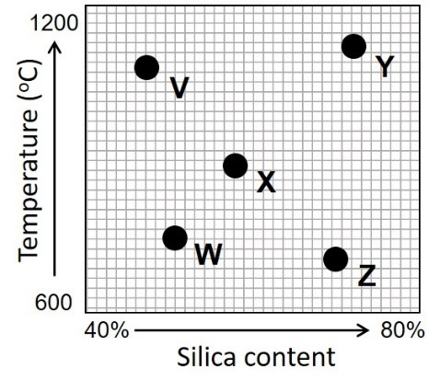
Which lettered symbol best represents the properties of basaltic magma?
- V
- W
- X
- Y
- Z

Which lettered symbol best represents the properties of rhyolitic magma?
- V
- W
- X
- Y
- Z

Which lettered symbol best represents the properties of andesitic magma?
- V
- W
- X
- Y
- Z

Geologists discover two igneous rocks that were both originally formed as lava. Rock A is dark-colored and rock B is light-colored. Which rock formed from magma with the higher viscosity?
- Rock A
- Rock B
- No difference

LO7. I can discuss how magma viscosity influences volcanic eruptions.

Gas pressure is more likely to build up in eruptions of ___.
- high viscosity magma
- low viscosity magma

Gas bubbles are more likely to form in magma ___.
- due to reduced pressure close to Earth's surface.
- under high temperature conditions at depth in Earth's crust.

Explosive eruptions of volcanoes occur due to magmas having a ___ gas content and a ___ viscosity.
- higher; higher
- higher; lower
- lower; higher
- lower; lower

More-violent eruptions occur where gases cannot escape easily.
- True
- False

Review the two statements that follow and identify if they are true or false.
i. Magma associated with an explosive eruption could have high viscosity with a rhyolitic composition.
ii. If gas escapes easily from magma it is likely to result in an explosive eruption.
- Both statements are true.
- Both statements are false.
- The first statement is true; the second statement is false.
- The first statement is false; the second statement is true.

How would you classify the viscosity of the magma that produced the eruption of Mount Kilauea in Hawaii and the character of the eruption itself?
- Low-viscosity magma that produced a violent eruption
- High-viscosity magma that produced a violent eruption
- High-viscosity magma that produced a mild eruption
- Low-viscosity magma that produced a mild eruption

The silica content of magma influences how readily gases can escape during an eruption.
- True
- False

The volume of magma will increase as it rises through the crust toward Earth’s surface.
- True
- False
Which three of the following characteristics are most likely to be associated with magma that produced a mild volcanic eruption?
- Rhyolitic composition
- Basaltic composition
- High temperature
- Low temperature
- Gases escape easily
- Gases trapped

Which three of the following characteristics are most likely to be associated with magma that produced a violent volcanic eruption?
- Rhyolitic composition
- Basaltic composition
- High temperature
- Low temperature
- Gases escape easily
- Gases trapped

Review the two statements that follow and identify if they are true or false.
i. Gases escape more easily from a low viscosity magma than a high viscosity magma.
ii. Eruptions are more violent in volcanoes with low viscosity magma.
- Both statements are true.
- Both statements are false.
- The first statement is true; the second statement is false.
- The first statement is false; the second statement is true.

What type of volcano is associated with the more viscous magma?
- Shield
- Composite

Which pair of terms would make the best match to fill the blanks in the following sentence? Gases escape more easily from a __________ viscosity magma; that is why eruptions are more violent from volcanoes that are supplied by __________ viscosity magma.
- high; high
- high; low
- low; low
- low; high

Magma viscosity is primarily dependent upon which combination of factors?
- water content and temperature of magma
- basalt content and gas content of magma
- water content and pressure of magma
- composition and temperature of magma
- depth of magma source and gas content of magma
LO8. I can sketch the formation of a caldera and explain why these types of eruptions are so destructive.

A caldera is a giant volcanic crater.
- True
- False

Which of the following are indicators of a caldera eruption? Select all that apply.
- Pillow lavas
- Flood basalts
- Mountains associated with a subduction zone
- A crater that is tens of kilometers across
- A thick layer of volcanic tephra over a large area

The collapse of rocks overlying a depleted magma chamber is associated with the eruption of what volcanic feature?
- Flood basalts
- Caldera
- Volcanic dome
- Shield volcano

What is the name given to the large crater pictured here? The crater is 10 km in diameter and up to 1000 meters deep.
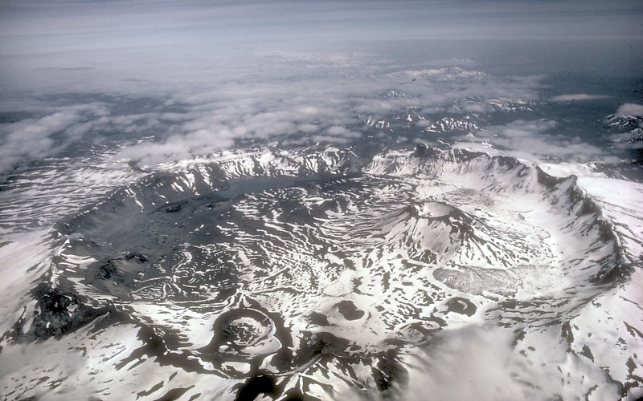
https://avo.alaska.edu/images/dbimages/display/1317154840_ak14.jpg
- Caldera
- Shield volcano
- Scoria cone
- Composite volcano

Massive eruptions have occurred at Yellowstone approximately every 600,000 to 700,000 years. The last one was 640,000 years ago.
- True
- False

Select the response that best fills the blank in the following statement: "Eruptions associated with calderas are generally ____ eruptions associated with composite volcanoes."
- much smaller than
- much larger than
- about the same size as

A caldera eruption is generally smaller than the eruption of a typical composite volcano.
- True
- False

Fill in the blank in the following sentence. The past eruptions of the Yellowstone caldera were approximately ___ times larger than the 1980 eruption of Mount St. Helens.
- 10
- 100
- 1000

Which of the following figures best represents a sketch section through a caldera?
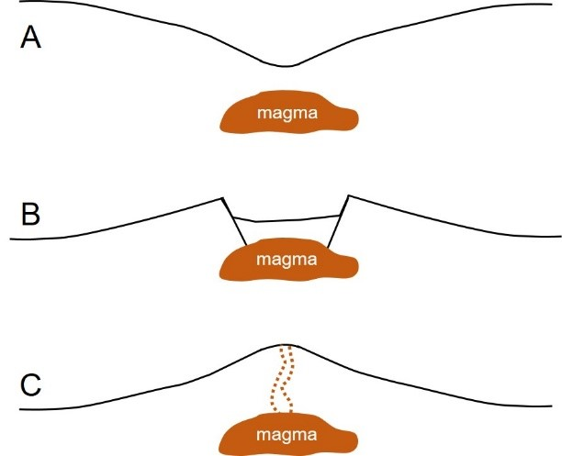
- A
- B
- C

How large a region would be affected by a future eruption of the Yellowstone caldera, Wyoming?
- The area immediately around Yellowstone National Park would be destroyed but most neighboring states would suffer little associated damage.
- Much of the state of Wyoming, as well as parts of neighboring states (Idaho, Montana, Utah) would be covered in several meters of tephra but the rest of the US would be unaffected
- Much of the western US would be covered in tephra ranging in thickness from centimeters to meters but the eastern half of the US would be unaffected
- Much of the continental US would be covered in tephra with states around Yellowstone having several meters of deposits and eastern states receiving a light coating of ash

LO9. I can list the features and processes that geologists study when trying to predict a volcanic eruption.

Volcanoes are more likely to be found adjacent to island arcs around the edge of the ___ Ocean.
- Atlantic
- Pacific
- Indian

What typically happens before a volcanic eruption?
- Earthquakes increase and the amount of gas released increases
- Earthquakes decrease and the amount of gas released increases
- Earthquakes decrease and the amount of gas released decreases
- Earthquakes increase and the amount of gas released decreases

Which of the following are examples of data that would be useful for geologists to collect to potentially predict a volcanic eruption? Select all that apply.
- Seismic (earthquake) measurements
- Gas emission measurements
- Rock samples from near the volcano
- Temperature measurements around the volcano
- Topographic measurements of the shape of the volcano

Earthquakes are often associated with a volcanic eruption. Where are these earthquakes located and why do they happen?
- Earthquakes occur in the volcano itself during the eruption as magma pushes its way to the surface
- Earthquakes occur several kilometers below the volcano due to movement on related faults as the volcano collapses into the magma chamber following the eruption
- Earthquakes occur several kilometers below the volcano due to movement of magma through the crust before the eruption
- Earthquakes occur around the volcano during and after the eruption as material blasted out of the volcano falls back to the surrounding ground surface

What would you expect to happen to the shape of a volcano as magma moved around prior to an eruption?
- Magma rising below the volcano would push the volcano slopes outward, increasing the tilt of most surfaces
- Magma rising below the volcano would push the volcano slopes inward, decreasing the tilt of most surfaces
- Magma moving within the volcano would remove support for the cone, causing the slopes to collapse inward and decreasing the tilt of most surfaces
- Magma moving within the volcano would remove support for the cone, causing the slopes to collapse inward and increasing the tilt of most surfaces

Review the graph of volcanic gas emissions related to an eruption. On the basis of the graph, which letter is most likely to correspond with the timing of an eruption?

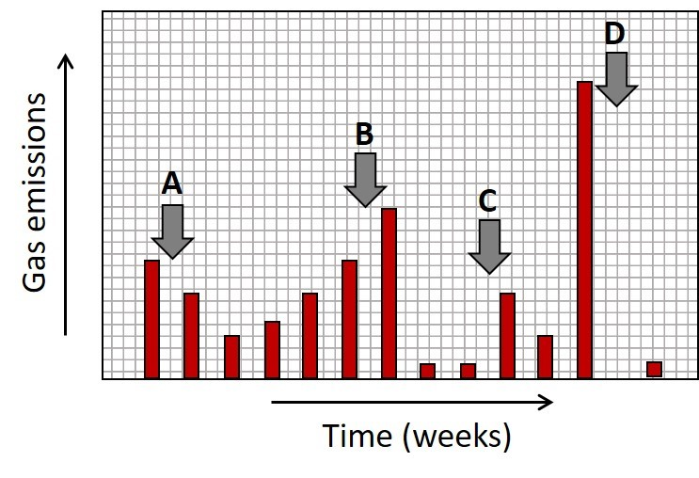
- A
- B
- C
- D

A tiltmeter is an instrument that measures the angle of a surface such as the flank of a volcano. Higher tilt values represent steeper slope angles. Review the graph that illustrates tiltmeter data from a volcano that has experienced some recent eruptions. On the basis of the graph, which letters are most likely to correspond with the timing of eruptions?
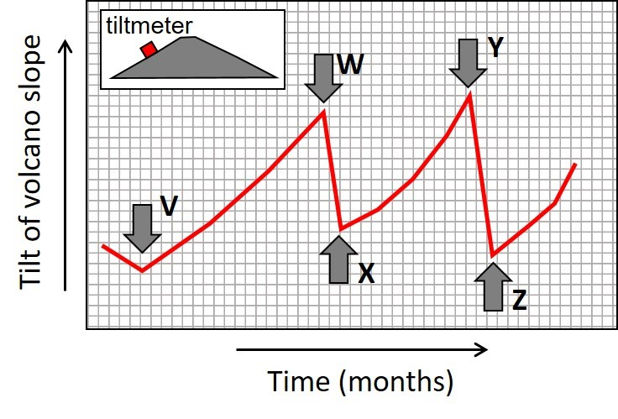
- V
- X & Z
- W & Y
- V, W, &Z
- W, X, Y, & Z

Which explanation best describes what would happen to gas emissions prior to a volcanic eruption?
- Magma rising within the volcano would block escaping gases, reducing gas emissions
- Pressure would decrease on magma rising below the volcano, increasing gas emissions
- Pressure would increase on magma rising below the volcano, reducing gas emissions
- Escaping gases would cause an increase in earthquake activity, triggering an eruption

LO10. I can describe the characteristics of flood basalts and how they changed the climate.

Which of the following is the best description of a flood basalt?
- A flood basalt is the technical term for the process that creates basalt at a mid-ocean ridge
- A flood basalt is a particularly violent eruption that ejects lava bombs and other tephra over a wide area
- A flood basalt is an enormous eruption or series of eruptions of basaltic lava that spreads out over a large area
- A flood basalt is a special type of eruption that causes flooding of coastlines on surrounding continents

How might a volcanic eruption affect the climate? Select all that apply.
- Tephra can block incoming solar radiation
- Eruptions can add greenhouse gases to the atmosphere that trap heat
- Heat from large eruptions can increase regional or global temperatures
- Magma released at oceanic ridges can warm the ocean and the overlying atmosphere

What is the source for most flood basalts?
- Flood basalts form when several shield volcanoes cover a large area of the crust
- Flood basalts are most often linked to magma from mantle plumes
- Flood basalts are typically associated with continental rifting events
- Flood basalts form from magma released at oceanic ridges
- Flood basalts are generated during the break up of supercontinents (e.g., Pangaea)

What is the impact of flood basalts on global climates?
- They result in global cooling and may trigger “icehouse” or snowball Earth conditions
- They contribute to global “hothouse” conditions

What was the impact of flood basalts on global temperatures and atmospheric composition?
- They resulted in warmer temperatures and lower carbon dioxide concentrations
- They resulted in cooler temperatures and lower carbon dioxide concentrations
- They resulted in warmer temperatures and higher carbon dioxide concentrations
- They resulted in cooler temperatures and higher carbon dioxide concentrations

Following the eruption of flood basalts, how did global climate conditions compare with the present day?
- Conditions were warmer than today
- Conditions were cooler than today
- Conditions were similar to today

How long did climatic changes associated with flood basalts last for?
- They were relatively short term, lasting for years or decades
- They produced changes in global climate that lasted for centuries or even thousands of years
- They were relatively long term, lasting for millions of years

What is the viscosity of flood basalts?
- They have high viscosity
- They have low viscosity

Review the two statements that follow and identify if they are true or false.
i. Flood basalts form relatively thin piles of volcanic rock.
ii. Flood basalts typically originate from mantle plumes
- Both statements are true.
- Both statements are false.
- The first statement is true; the second statement is false.
- The first statement is false; the second statement is true.

Geologic Time

LO1. I can identify the major intervals of geologic time, including how and when they began and ended.

Approximately what age was determined for the oldest rocks that have been found on Earth?
- 400 million years
- 2500 million years
- 1.7 billion years
- 4 billion years
- 6.5 billion years

Earth is approximately ___ years old.
- 4.6 million
- 46 million
- 460 million
- 4.6 billion
- 46 billion

Which of the following time intervals are eras? Select all that apply.
- Cambrian
- Mesozoic
- Phanerozoic
- Cenozoic

Ages were calculated for four rocks. Which of the following rocks would be classified as Precambrian?
- Rock A, 400 million years old
- Rock B, 2000 million years old
- Rock C, 3800 million years old
- Rock D, 720 million years old

Which represents the longest interval of geologic time?
- An era
- An eon

Which list contains the names of the three eras in order from oldest to youngest?
- Archean, Proterozoic, Phanerozoic
- Paleozoic, Mesozoic, Cenozoic
- Cenozoic, Mesozoic, Paleozoic
- Phanerozoic, Proterozoic, Archean

Which list contains the names of the three eons in order from oldest to youngest?
- Archean, Proterozoic, Phanerozoic
- Paleozoic, Mesozoic, Cenozoic
- Cenozoic, Mesozoic, Paleozoic
- Phanerozoic, Proterozoic, Archean

Review the two statements below and identify if they are true or false.
i. The Proterozoic is a time interval that began 2.5 billion years ago.
ii. The Phanerozoic is a time interval that has lasted for approximately 540 million years.
- Both statements are true.
- Both statements are false.
- The first statement is true; the second statement is false.
- The first statement is false; the second statement is true.

Review the two statements below and identify if they are true or false.
i. The Proterozoic represents an example of an eon.
ii. The Phanerozoic represents an example of an era.
- Both statements are true.
- Both statements are false.
- The first statement is true; the second statement is false.
- The first statement is false; the second statement is true.

Review the two statements below and identify if they are true or false.
i. The Proterozoic represents an example of an era.
ii. The Paleozoic represents an example of an era.
- Both statements are true.
- Both statements are false.
- The first statement is true; the second statement is false.
- The first statement is false; the second statement is true.

Which eon began approximately 542 million years ago?
- Proterozoic
- Mesozoic
- Phanerozoic
- Archean

LO2. I can explain how geologists apply relative time principles to place different rock units in the correct chronological order.

The principle of original horizontality states that ___.
- the layers at the bottom of the sequence are the oldest
- tilted layers have undergone deformation after their formation
- the oldest rocks are more likely to be horizontal than the youngest rocks
- tilted layers will gradually be returned to a horizontal position

The principle of superposition states that ___.
- older rock units can be cross cut by younger rocks
- sedimentary rocks are deposited as horizontal layers
- higher sedimentary layers are younger than lower layers
- younger sediment can contain pieces of an older rock

Geologists find an outcrop of the plutonic igneous rock granite that is surrounded by limestone and shale in the arrangement shown in the diagram. Which rock is younger?
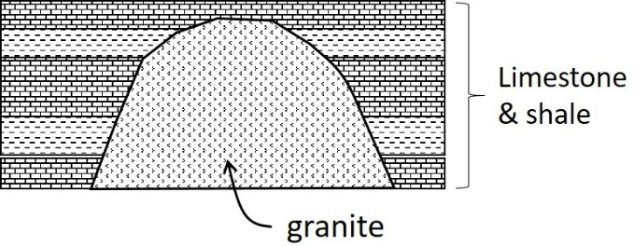
- Granite
- Limestone

A student examines a series of flat-lying sedimentary rock layers in the walls of a deep canyon. What principle is the student most likely to use to determine the order in which the layers were formed?
- Superposition
- Original horizontality
- Cross-cutting relations

If a geologist finds pieces of rock A contained within rock B, the implication is that ___.
- Rock A is younger than Rock B.
- Rock B is younger than Rock A.
- both rocks formed at the same time.

A geologist finds an outcrop of sandstone overlying granite. The base of the sandstone layer contains angular pebbles of granite (see image). What is the most likely explanation for this arrangement?
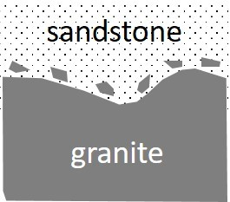
- The granite is older than the sandstone and the pebbles were formed during an episode of erosion.
- The sandstone is older than the granite and the pebbles represent small blobs of magma that cooled in the sandstone.
- The granite is younger than the sandstone and the pebbles were formed during an episode of erosion.
- The sandstone is younger than the granite and the pebbles represent small blobs of magma that cooled in the sandstone.

A geologist finds an outcrop of sandstone overlying granite. The granite contains chunks of the sandstone (see image). What is the most likely explanation for this arrangement?
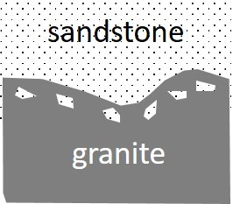
- The granite is older than the sandstone and the chunks of sandstone were formed during an episode of erosion.
- The sandstone is older than the granite and the chunks represent pieces of sandstone that were incorporated into the magma before it cooled.
- The granite is younger than the sandstone and the chunks of sandstone were formed during an episode of erosion.
- The sandstone is younger than the granite and the chunks represent pieces of sandstone that were deposited onto the magma as it cooled.

The principle of cross cutting relations states that older rocks are cut by younger rocks or features.
- True
- False

When determining the sequence of past geological events, which of the principles listed below does not belong?
- The youngest layer is on top, and the oldest is on the bottom.
- A younger magma can bake or otherwise change older rocks that are nearby.
- A geologic feature is older than a rock unit or feature it crosses.
- A younger rock or deposit can include pieces of an older rock.

The principle of ___ assumes that the beds at the bottom of a sequence of rocks are ___ than the beds at the top.
- original horizontality; younger
- superposition; younger
- original horizontality; older
- superposition; older

Use the figure that shows an outcrop of sedimentary layers that include a fault and an igneous pluton below to answer the questions that follow.
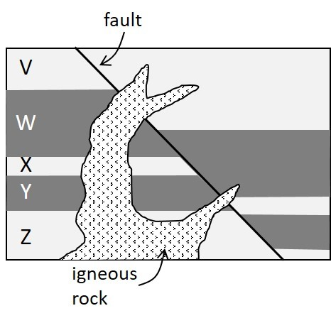
Which principle is most applicable in determining the relative ages of the horizontal sedimentary rocks indicated by the lettered layers?
- Original horizontality
- Superposition
- Cross-cutting relations
- Inclusions

Which principle is most applicable in determining the relative ages of sedimentary layer W, the fault and the igneous rock?
- Original horizontality
- Superposition
- Cross-cutting relations
- Inclusions

LO 3. I can interpret images or diagrams to predict the relative ages of rock units and identify different types of unconformities.

Examine the relative time diagram and answer the questions that follow.
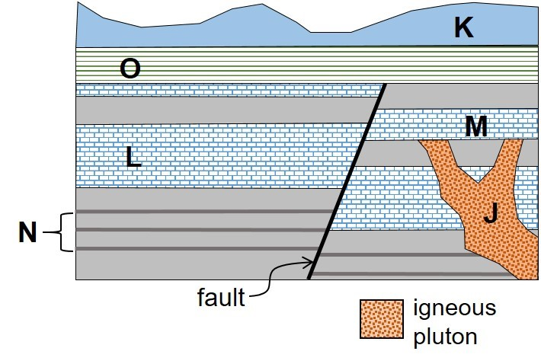
Identify which of the following events happened AFTER the formation of the igneous pluton J. Select all that apply.
- Erosion of Unit J
- Deposition of Unit M
- Faulting depicted by the black line
- Deposition of Unit O

Which of the following events happened BEFORE the formation of the igneous pluton J? Select all that apply.
- Deposition of Unit L
- Deposition of Unit M
- Faulting depicted by the black line
- Deposition of Unit N

When the igneous pluton J was emplaced?
- Between the deposition of Units M & O
- After the deposition of Unit K
- After the formation of the fault
- Between the deposition of Units L & M

Place the formation of the labeled features in the correct order from oldest to youngest.
- K, O, M, L, N, J, fault
- N, L, M, J, O, fault, K
- N, L, J, M, fault, O, K
- J, N, fault, L, M, O, K

What type of unconformity surface is present between units J and M?
- Disconformity
- Angular unconformity
- Nonconformity

Examine the associated relative time diagram and answer the questions that follow.
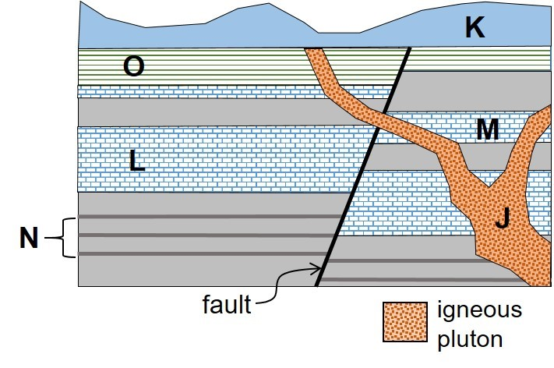
Place the formation of the labeled features in the correct order from oldest to youngest.
- K, O, J, M, L, N, fault
- N, L, M, O, fault, J, K
- N, L, M, J, fault, O, K
- J, N, fault, L, M, O, K

Identify when the igneous pluton J was emplaced.
- Between the deposition of Units O & K
- After the deposition of Unit K
- Before the formation of the fault
- Before the deposition of Units L & M

What type of unconformity surface is present between units O and K?
- Disconformity
- Angular unconformity
- Nonconformity
- There is no unconformity between these units

Examine the associated relative time diagram and answer the questions that follow.
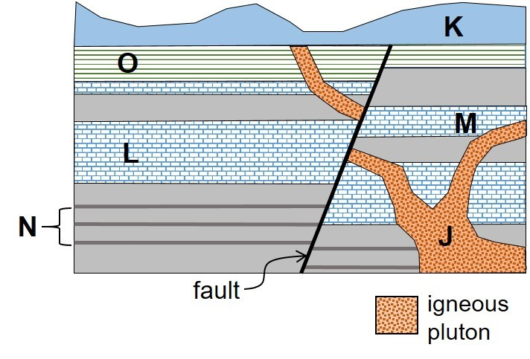
Place the formation of the labeled features in the correct order from oldest to youngest
- K, O, J, M, L, N, fault
- N, L, M, O, fault, J, K
- N, L, M, O, J, fault, K
- J, N, fault, L, M, O, K

Identify which of the following events happened BEFORE the formation of the igneous pluton J. Select all that apply.
- Deposition of Unit L
- Deposition of Unit M
- Faulting depicted by the black line
- Deposition of Unit O

Examine the associated relative time diagram and identify which of the labeled surfaces represents an angular unconformity?
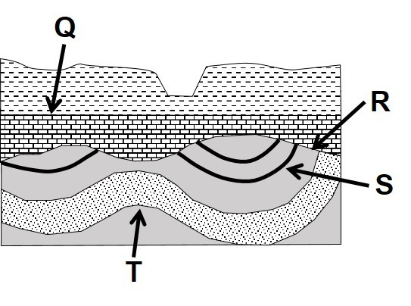
- Q
- R
- S
- T

Examine the associated relative time diagram and answer the questions that follow.
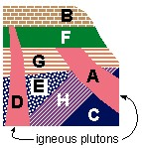

What is the oldest rock unit?
- A
- B
- C
- D
- E

Which unit was formed before A but after E?
- C
- E
- G
- F
- D

Which unit is composed of granite and is older than F.
- A
- H
- C
- D
- E

Which unit is a sedimentary rock that did not experience contact metamorphism.
- A
- B
- C
- D
- E

What is the possible age of F if A is 100 million years old and D is 70 million years old?
- 85 Myrs
- 170 Myrs
- 55 Myrs
- 110 Myrs

LO4. I can draw and interpret images, diagrams, and labeled sketches of the three types of unconformity (angular unconformity, disconformity, nonconformity) and describe the origins of each type.

What type of unconformity is illustrated here?
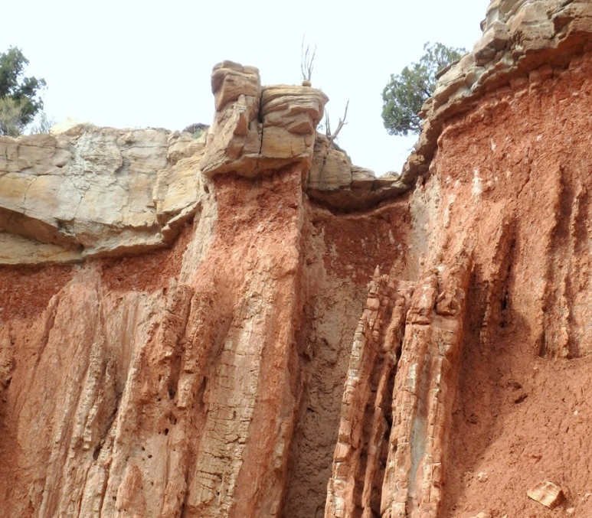
https://geology.utah.gov/wp-content/uploads/snt50-1_salina-cyn-unconformity-closeup-773x1030.jpg
- Disconformity
- Angular unconformity
- Nonconformity

Which of the following statements best describes an unconformity?
- Unconformities are present where there are different rocks touching, causing them to not "conform" to expectation
- Unconformities are the result of weathering and erosion of rocks
- Unconformities are horizons that represent "missing time" caused by the destruction of rocks that were once present

Which type of unconformity is caused by the weathering and erosion of horizontal sedimentary rocks followed by subsequent deposition of sediment?
- Disconformity
- Angular unconformity
- Nonconformity
- None of these

Which type of unconformity can be caused by the deposition of a sequence of sedimentary rocks on top of an eroded outcrop of granite?
- Disconformity
- Angular unconformity
- Nonconformity
- None of these

Which type of unconformity is caused by the weathering and erosion of already-tilted rock units and subsequent deposition of flat-lying beds of sediment?
- Disconformity
- Angular unconformity
- Nonconformity
- None of these

What is the best example of the characteristics of a disconformity?
- Igneous rock is covered by sedimentary rock layers
- Conglomerate is deposited on top of an erosional surface in sedimentary rocks
- An erosional surface in sedimentary rocks is covered by parallel sedimentary rock layers

Which of the following is an unconformity most likely to represent?
- Deposition of rocks
- Weathering and erosion of rocks
- The formation of a magma pluton
- Metamorphism of sedimentary rocks

Examine the image and answer the questions that follow.

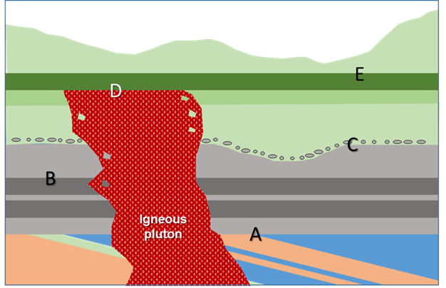
Which three of the lettered surfaces show evidence that they are unconformities?
- A
- B
- C
- D
- E

Which lettered surface(s) shows evidence that weathering and erosion of a sequence of tilted rock units occurred followed by the deposition of sedimentary rocks?
- A only
- B and C
- C only
- C and D
- E only

Which lettered surface shows evidence that it is a disconformity?
- A
- B
- C
- D
- E

Which lettered surface shows evidence that it is a nonconformity?
- A
- B
- C
- D
- E

LO5. I can explain what happens during the decay of radioactive isotopes.

Which two of the following are potential parent isotopes of lead?
- Uranium
- Potassium
- Rubidium
- Thorium

Which of the following are one of the daughter isotopes of uranium?
- Lead
- Argon
- Strontium
- Potassium

Which of the following is a daughter isotope of potassium?
- Lead
- Argon
- Strontium
- Rubidium

Which of the following statements is correct if two atoms have the same number of neutrons and different number of protons?
- They represent the same element.
- They represent different elements.

Which of the following statements is correct if two atoms have different numbers of neutrons and the same number of protons?
- They represent the same element.
- They represent different elements.

Which process results in the decrease in the atomic number of an isotope following radioactive decay?
- Alpha decay
- Electron capture
- Beta decay

One of the isotopes of potassium (K) is represented by K-40. What does “40” (typically written as superscript to the left of the elemental symbol) indicate?
- That potassium has 40 protons.
- That potassium has 40 neutrons.
- That potassium has 40 protons and neutrons.

Which is the larger number?
- Atomic number
- Mass number

What is the name given to atoms with different numbers of neutrons in their nucleus?
- Ions
- Isotopes
- Alpha particles
- Electrons

The isotope of potassium represented by K-40 has 40 ___ and a(n) ___ number of 40.
- protons; atomic
- protons; mass
- protons and neutrons; atomic
- protons and neutrons; mass

When a neutron changes to a proton the atomic number of an element ___ and the mass number ___.
- decreases by 1; does not change
- decreases by 1; increases by 1
- increases by 1; does not change
- increases by 1; increases by 1

When a proton changes to a neutron the atomic number of an element ___ and the mass number ___.
- decreases by 1; does not change
- decreases by 1; increases by 1
- increases by 1; does not change
- increases by 1; increases by 1

If an isotope has a neutron converted to a proton its atomic number would ___ by one and its mass number would ___.
- decrease; decreases by 1
- decrease; stay the same
- increase; increase by 1
- increase; stay the same

If an isotope loses two protons and two neutrons its atomic number would decrease by ___ and its mass number would decrease by ___.
- 2; 2
- 4; 2
- 2; 4
- 4; 4

LO6. I can discuss how geologists use the relative proportions of parent and daughter isotopes to determine the number of half-lives that have occurred and predict the numerical ages of rocks

Radiometric dating of a mineral grain within a sedimentary rock sample returns an age of 1.5 billion years. What does this tell us about the sedimentary rock?
- It is 1.5 billion years old
- It is older than 1.5 billion years old
- It is younger than 1.5 billion years old
- Nothing

Which radioactive isotope would be best to use to date the age of charcoal in a Native American fire pit?
- Potassium
- Uranium
- Argon
- Carbon

Radioactive decay allows scientists to determine ___. Select all that apply.
- when clastic sedimentary rocks formed
- when granite solidified below ground
- when lava erupted onto Earth's surface and crystallized
- when basaltic magma formed

Which of the following radiometric dating techniques would NOT be suitable to date a 700-million-year-old rock?
- Uranium-lead
- Potassium-argon
- Uranium-thorium
- Radiocarbon

Which of the following is not an appropriate dating method for a 700-million-year-old rock because ____.
- Uranium-lead dating; too few half-lives have passed to determine an age
- Radiocarbon dating; too few half-lives have passed to determine an age
- Uranium-lead dating; too many half-lives have passed to determine an age
- Radiocarbon dating; too many half-lives have passed to determine an age

Scientists measuring the amount of a radioactive element in a rock sample discover that the sample contains seven times as many daughter isotopes as parent isotopes of the element. How many half-lives have occurred?
- 1
- 3
- 5
- 7

If radioactive decay began with 400,000 parent isotopes, how many parent isotopes would be left after 3 half-lives?
- 50,000
- 200,000
- 100,000
- 300,000
- 25,000

Isotope X has a half-life of 10 days. If you began an experiment with a 400-gram sample of the isotope, how much isotope X would be left after 20 days?
- 400 grams
- 300 grams
- 100 grams
- 200 grams
- 50 grams

Which graph best represents the change in the proportion of unstable (parent) radioactive isotopes with time?
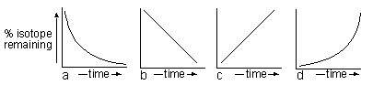
- a
- b
- c
- d

The half-life of a radioactive isotope is 100 million years. Scientists testing a rock sample discover that the ration of parent and daughter isotopes indicates that the rock is 200 million years old. What percentage of parent isotopes would be present in the sample?
- 25%
- 50%
- 75%
- 100%

The half-life of a radioactive isotope is 600 million years. Scientists testing a rock sample discover that the ration of parent and daughter isotopes indicates that the rock is 1800 million years old. What percentage of daughter isotopes would be present in the sample?
- 50%
- 87.5%
- 75%
- 93.75%

The half-life of Uranium-238 is 4.5 billion years. Approximately what proportion of this isotope would remain in the oldest known rocks on Earth?
- 33%
- 52%
- 73%
- 2%

What is the ratio of parent to daughter isotopes after 4 half-lives?
- 1:12
- 1:8
- 1:7
- 1:15

Imagine that an element formed with 4,000 million radioactive parent isotopes but now there are only 500 million parent isotopes remaining. How many half-lives have occurred?
- 1
- 2
- 3
- 4
- 5

Imagine that an element formed with 4,000 million radioactive parent isotopes but now there are only 500 million parent isotopes remaining. If the half-life of the isotope is 1 million years, how old is the element?
- 2,000,000 million years
- 2,000,000 years
- 3,000,000 million years
- 3,000,000 years

The half-life of a radioactive isotope X is 2 billion years. Approximately what proportion of the parent isotope and its daughter product would be present in a rock that is 4.5 billion years old?
- 53% parent; 47% daughter
- 47% parent; 53% daughter
- 21% parent; 79% daughter
- 10% parent; 90% daughter

The half-life of a radioactive isotope preserved in an element found in an igneous rock sample is 400 million years. Scientists testing the sample discover that the element contains three times as many daughter isotopes as parent isotopes. What is the age of the mineral?
- 400 million years
- 800 million years
- 1200 million years
- 1600 million years

LO7. I can discuss how scientists use the ages of igneous rocks to determine when sedimentary rock units were formed.

Four outcrops of rock are examined in different locations of a state. The sequences of rock at each outcrop are illustrated in the four columns in the figure. Examine the figure and answer the questions that follow.
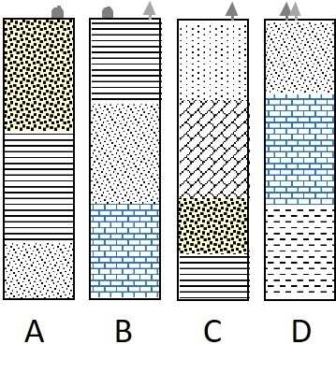
Which location has the youngest rock layers at the surface?
- A
- B
- C
- D

Which column contains the oldest rock layers?
- A
- B
- C
- D

Four outcrops of rock are examined in different locations of a state. The sequences of rock at each outcrop are illustrated in the four columns in figure. Each column contains a layer of volcanic ash (in red, with letters) that can be dated to assign ages to some of the rock layers.
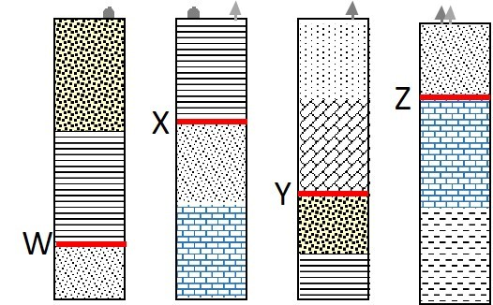

Which two ash layers are the same age?
- X & Y
- Y & Z
- W & X
- Z & W
- Y & W

Each column contains a layer of volcanic ash (in red, with letters) and three ash layers have been dated to assign ages to some of the rock layers. The three ages that were obtained were 115 million years, 145 million years and 180 million years. Which ash layers are represented by which ages?
- Y is 115 Myrs; X is 145 Myrs; Z is 180 Myrs
- W is 115 Myrs; X is 145 Myrs; Z is 180 Myrs
- X is 115 Myrs; Z is 145 Myrs; Y is 180 Myrs
- W is 115 Myrs; Z is 145 Myrs; Y is 180 Myrs

Four outcrops of rock are examined in different locations of a state. The sequences of rock at each outcrop are illustrated in the four columns in the figure. Each column contains a layer of volcanic ash (in red, with letters) and three ash layers have been dated to assign ages to some of the rock layers. The three ages that were obtained were 130 million years for Y; 150 million years for W; and 170 million years for Z.
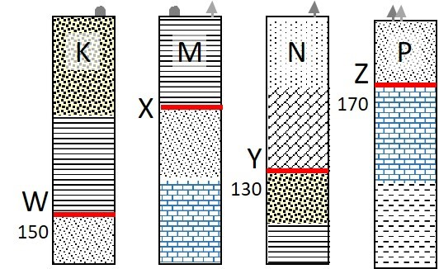

Which is the best estimate of when was the layer K deposited?
- Before 150 million years ago
- After 130 million years ago
- Between 150-170 million years ago
- Between 130-150 million years ago

Which is the best estimate of when was the layer M deposited?
- Before 150 million years ago
- After 130 million years ago
- Between 150-170 million years ago
- Between 130-150 million years ago

Which is the best estimate of when was the layer N deposited?
- Before 150 million years ago
- After 130 million years ago
- Between 150-170 million years ago
- Between 130-150 million years ago

Which is the best estimate of when was the layer P deposited?
- Before 150 million years ago
- After 130 million years ago
- Between 150-170 million years ago
- Between 130-150 million years ago

A geologist dug a 5-meter deep trench across a suspected fault zone in southern California. She then constructed a sketch of the configurations of sediment layers and other features in the trench. She interpreted two faults (X, Y) and was able to collect several samples for subsequent dating. Because these were recent sediments that had been deposited within the last 1000 years, she was able to use radiocarbon dating. The ages of four samples are provided on the figure, use this information to answer the questions that follow.
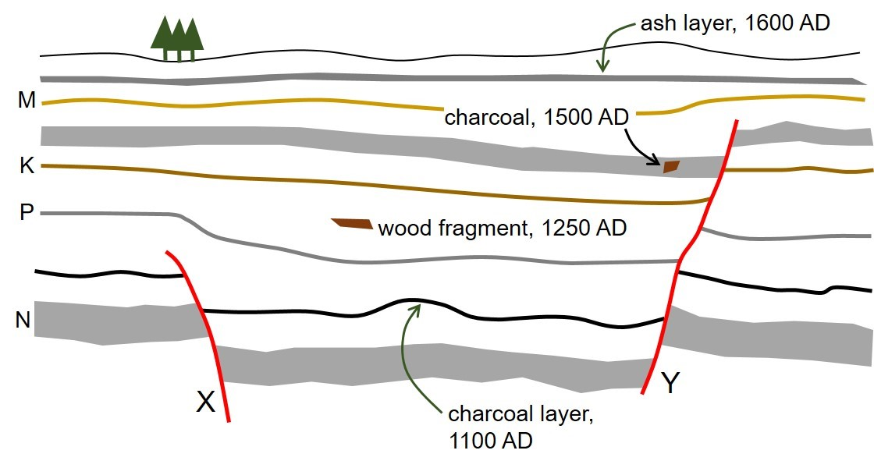
Which is the best estimate of when fault X formed?
- Before 1100
- Between 1100 and 1250
- Between 1250 and 1500
- Between 1500 and 1600

Which is the best estimate of when fault Y formed?
- Between 1100 and 1250
- Between 1250 and 1500
- Between 1500 and 1600
- After 1600

Which answer correctly places the list of items in the correct order of formation, from oldest to youngest?
- oldest – charcoal layer, wood fragment, layer P, fault X - youngest
- oldest – wood fragment, charcoal layer, layer P, ash layer - youngest
- oldest – layer P, fault Y, charcoal fragment, layer K - youngest
- oldest – layer N, fault X, layer K, fault Y - youngest

Four outcrops of rock are examined in different locations of a state. The sequences or rock at each outcrop are illustrated in the four columns in the diagram. Each column contains a layer of volcanic ash and three ash layers have been dated to assign ages in millions of years to some of the ash layers. The three ages that were obtained are noted on the diagram.
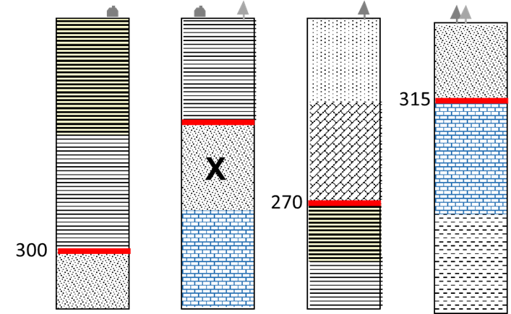
Match the rock units and provide the best estimate of when layer X was deposited?
- More than 315 million years ago
- Between 300-315 million years ago
- Between 270-300 million years ago
- Less than 270 million years ago

LO8. I can explain the development of the major components of the earth system and identify the correct sequence for key events in Earth’s history

During which eon did life become abundant on Earth?
- Archean
- Phanerozoic
- Proterozoic

How did the moon form?
- As a result of a massive volcanic eruption on the early Earth
- It was captured by Earth’s gravity soon after the planet’s formation
- Due to a collision between Earth and a smaller planet-sized body

Carbon dioxide was more abundant in Earth’s early atmosphere than it is in the air we breathe today.
- True
- False

Which is the more primitive form of cells that became established first on Earth and when do they show up as preserved in fossils?
- Eukaryotic; 3.5 billion years ago
- Eukaryotic; 540 million years ago
- Prokaryotic; 3.5 billion years ago
- Prokaryotic; 540 million years ago

The land masses would have had no evidence of life on them for much of Earth’s history. For approximately how much of Earth’s history has life been relatively abundant in the oceans and/or the land surface?
- 82%
- 62%
- 42%
- 12%
- 2%

Which three of the following are interpreted to be approximately the same age as Earth.
- Meteorites
- Venus
- The Sun
- The Universe

Which is the best description of conditions on Earth’s surface soon after it formed?
- The surface was covered in a global ocean with no continents
- There was a single supercontinent surrounded by an ocean
- It was mostly molten rock with no water present
- It would have been covered in solid rock and marked by hundreds of deep craters
- It would have been similar to today with several continents but in different positions

Review the two statements below and identify if they are true or false.
i. Earth’s major mantle and core were separated early in the planet’s formation.
ii. Gases like carbon dioxide, ammonia and methane were more common than oxygen and nitrogen in the early Archean atmosphere.
- Both statements are true.
- Both statements are false.
- The first statement is true; the second statement is false.
- The first statement is false; the second statement is true.

Review the two statements below and identify if they are true or false.
i. Some of the water in Earth’s oceans originated from comets and asteroids that collided with the early Earth.
ii. The gases in Earth’s early atmosphere were transported to Earth by comets and asteroids that collided with the planet.
- Both statements are true.
- Both statements are false.
- The first statement is true; the second statement is false.
- The first statement is false; the second statement is true.

Review the two statements below and identify if they are true or false.
i. They earliest fossils were mosses and lichen that grew on rocks to form primitive soils
ii. The first primitive bacteria were present on Earth around 3.8 billion years ago.
- Both statements are true.
- Both statements are false.
- The first statement is true; the second statement is false.
- The first statement is false; the second statement is true.

The earliest fossils were created by cyanobacteria that formed structures similar to algal mats that trapped sediment to form mound-like features known as stromatolites.
- True
- False

Early life forms produced the gas ___ which reacted with other elements in the oceans to form an unusual chemical sedimentary rock known as ___ that was characteristic of the Archean Eon.
- oxygen; banded iron formation.
- carbon dioxide; banded iron formation
- oxygen; stromatolites
- carbon dioxide; stromatolites

Snowball Earth conditions occurred during ___ when ___.
- the early Archean; Earth was bombarded by icy comets.
- the early Archean; most of the planet’s surface was covered by glaciers
- the late Proterozoic; Earth was bombarded by icy comets
- the late Proterozoic; most of the planet’s surface was covered by glaciers

Which of the following statements are true. Select all that apply.
- The Phanerozoic is the shortest Eon.
- The Phanerozoic Eon is divided into three eras.
- The Mesozoic and Cenozoic eras are separated by the extinction event that killed the dinosaurs.
- The Paleozoic is the oldest Era in the Phanerozoic.

A layer of shale lies above a layer of limestone. Each layer contains different fossils. What are the two best potential explanations for these contrasts?
- The fossils represent organisms living at different times in Earth's history
- The layers have different thicknesses
- The layers are formed in different environments containing different species
- Limestone is a biochemical sedimentary rock and shale is a clastic rock

Place the following events in Earth’s history in the correct chronological order from oldest to youngest.
- First birds, Age of Fishes, Dinosaurs went extinct, beginning of Mesozoic
- Beginning of Mesozoic, First birds, Age of Fishes, Dinosaurs went extinct
- Age of Fishes, Beginning of Mesozoic, First birds, Dinosaurs went extinct
- Dinosaurs went extinct, First birds, Beginning of Mesozoic, Age of Fishes

Examination of the fossil record has caused scientists to infer that:
- Life on Earth evolved steadily from complex forms to more simple forms.
- Dinosaurs were wiped out by an extinction event at the end of the Precambrian.
- Many organisms that lived on Earth have become extinct.
- Life on Earth has not changed significantly in the last 100 million years

Which of the following is NOT true?
- The oldest rocks on the continents have been determined to be several billion years old and the oldest ocean floor rocks are dated to be a few hundred million years old.
- Most fossils that are preserved in the rock record show up in rocks formed within the last 540 million years.
- Scientists have determined the age of the Earth using radioactive isotopes of the element carbon.
- Major changes to life on Earth in the Phanerozoic Era were associated with widespread natural disasters.

LO9. I can interpret information from the fossil record to explain how life changed through geologic time, including major extinction events.

Global extinction events mark the boundaries between which time intervals? Select all that apply.
- Mesozoic and Precambrian
- Precambrian and Paleozoic
- Mesozoic and Cenozoic
- Paleozoic and Cenozoic
- Paleozoic and Mesozoic

At which time boundary did fossils with shells become abundant?
- Mesozoic and Precambrian
- Precambrian and Paleozoic
- Mesozoic and Cenozoic
- Paleozoic and Cenozoic
- Paleozoic and Mesozoic

Which of the following represent fossils? Select all that apply.
- Impressions of leaves preserved in coal
- Bones of mammoths found in glacial deposits
- Footprints of dinosaurs preserved in mudstone
- Shells of ancient marine organisms preserved in limestone

Fossils are more likely to be preserved under which conditions?
- Slow burial
- Rapid burial

The systematic change in fossils found in a sequence of rocks is known as ___.
- faunal succession
- punctuated equilibria
- taxonomic sequencing

Which three of the following first appeared in the Mesozoic Era?
- Birds
- Fish
- Insects
- Flowering plants
- Dinosaurs
- Reptiles

Fossils are common in sedimentary rocks representing how much of Earth's history?
- 54%
- 77%
- 12%
- 32%

Which three of the following first appeared in the Paleozoic Era?
- Birds
- Fish
- Insects
- Flowering plants
- Dinosaurs
- Reptiles

Which of the following first appeared in the Cenozoic Era?
- Birds
- Fish
- Dinosaurs
- Flowering plants
- Large mammals

Which of the four organisms were the last to show up in the geologic record?
- Corals
- Trilobites
- Stromatolites
- Dinosaurs

Organisms developed shells at the start of which time period?
- Cambrian
- Cretaceous
- Cenozoic
- Precambrian

Fossils deemed "index fossils"___.
- lived for a relatively long time
- lived for a relatively short time

When did the dinosaurs become extinct?
- At the end of the Mesozoic era
- At the end of the Paleozoic era
- At the end of the Cenozoic era
- At the end of the Phanerozoic eon

Which three of the following statements are true? Select all that apply.
- The dinosaurs became extinct at the end of the Mesozoic era.
- The youngest era is the Phanerozoic.
- Oxygen had become relatively common in Earth’s atmosphere during the time of Snowball Earth conditions.
- The moon represents a stray asteroid that was captured by Earth’s gravity soon after the planet formed.
- The first evidence of life on Earth is recorded in rocks approximately 3.8 billion years old.

It is easier to assign a specific age to rocks containing fossils that ___.
- lived for a relatively long time
- lived for a relatively short time

Four outcrops of rock are examined in different locations of a state. The rock types and the fossils they contain are illustrated in the adjacent diagram. Which fossil would be the best choice to use as an index fossil for these rocks?
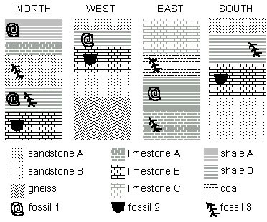
- Fossil 1
- Fossil 2
- Fossil 3

Radiometric dating of a mineral grain within a sedimentary rock sample returns an age of 1.5 billion years. How does the age of the mineral grain compare to the age of the sedimentary rock?
- The mineral grain and the sedimentary rock are the same age
- The mineral grain is younger than the sedimentary rock
- The mineral grain is older than the sedimentary rock
Carefully examine the relative positions of the lettered arrows on the timeline below and estimate the ages represented by each arrow. Answer the questions that follow.
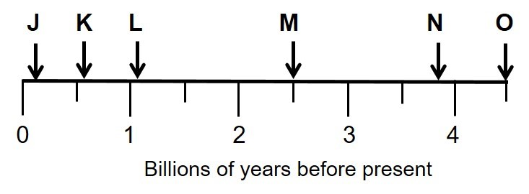

Identify which letter corresponds most closely to the first abundant fossils
- K
- L
- M
- N
- O

Identify which letter corresponds most closely to the extinction of the dinosaurs.
- J
- K
- L
- M

Identify which letter corresponds most closely to the age of the oldest known life on Earth.
- K
- L
- M
- N
- O

Identify which letter corresponds most closely to the start of the Proterozoic.
- J
- K
- L
- M
- N

Earth’s Climate System

LO1. I can explain the principal characteristics of Earth that support life.

If Earth was smaller, which three features would be most affected?
- Source of Earth's original water
- Strength of the magnetic field
- Gravity
- Thickness of the atmosphere
- Composition of the atmosphere

What is the principal reason for the presence of liquid water on Earth?
- The size of the Earth
- The distance of Earth from the sun
- The early bombardment by comets
- The composition of the atmosphere

Because Earth is larger than Mars, Earth would still have liquid water at the surface if it was located where Mars is today.
- True
- False

Which two conditions or characteristics are important in providing Earth with an atmosphere?
- Earth's magnetic field
- The composition of the atmosphere
- Earth's size (mass)
- Earth's position relative to the sun and other planets
- The presence of the moon

Why is Earth warm enough to support life?
- Heat from Earth's surface is released as infrared radiation that is absorbed by some gases in the lower atmosphere
- X-rays, gamma rays and other solar radiation excite gas molecules in the upper atmosphere
- Radiation from the sun is absorbed by ozone in the stratosphere
- Visible sunlight is absorbed by low clouds and converted to heat that warms the atmosphere

Earth’s seasons are influenced by the tilt of the planet’s axis. Which condition is most important in maintaining consistent seasonal patterns?
- The presence of a nearby Moon
- The mass of the planet
- Earth’s magnetic field
- The relative size of the Sun

What are the two principal gases that make up 99% of Earth's dry air?
- methane and carbon dioxide
- oxygen and methane
- oxygen and carbon dioxide
- oxygen and nitrogen
- nitrogen and carbon dioxide

How would the temperature of Earth differ if carbon dioxide made up 3% of the atmosphere
- Earth would be warmer
- Earth would be cooler
- There would be no change

What is the best way to complete the following partial sentence? Water is present at Earth’s surface as ___?
- a liquid
- a solid and a liquid
- a solid, a liquid, and a gas

Which statement is the most accurate?
- Smaller stars produce less heat but last for a longer time than large stars
- Smaller stars last longer and generate more heat than large stars
- Smaller stars burn more brightly and for less time than large stars
- The bigger the star, the more heat it produces and the longer it lasts

Review the two statements that follow and identify whether they are true or false.
i. Earth’s moon is much larger than moons of other terrestrial planets.
ii. The most important benefit of the moon is that it protects Earth from dangerous asteroids and comets.
- Both statements are true.
- Both statements are false.
- The first statement is true; the second statement is false.
- The first statement is false; the second statement is true.

Earth’s outer surface is composed of a series of mobile plates. What is the principal driving force for the moving plates?
- Earth's hot interior
- Earth's magnetic field
- The presence of a nearby moon

LO2. I can discuss how the composition of the atmosphere regulates global climate.

What are the two most common gases in the atmosphere? (select each of the two that apply)
- methane
- nitrogen
- carbon dioxide
- oxygen
- ozone

What is the approximate concentration of carbon dioxide in the atmosphere?
- 37000 parts per million (3.7%)
- 430 parts per million (0.043%)
- 13 parts per million (0.0013%)
- 7300 parts per million (0.73%)

Which of the following values is the closest approximate concentration of carbon dioxide in Earth’s atmosphere in parts per million (ppm)?
- 38,000
- 0.008
- 430
- 2800
- 75

Which three of the following are greenhouse gases that trap heat in Earth's atmosphere?
- methane
- nitrogen
- carbon dioxide
- oxygen
- water vapor

Oxygen represents a larger proportion of the gases in Earth's atmosphere than all types of greenhouse gases combined.
- True
- False

Water vapor can act like a greenhouse gas in Earth's atmosphere.
- True
- False

What would the average temperature of Earth’s surface be without the presence of greenhouse gases in our atmosphere?
- 15ºC (59ºF)
- 7ºC (45ºF)
- 0ºC (32ºF)
- -18ºC (0ºF)

Greenhouse gases make up less than 0.1% of Earth’s atmosphere.
- True
- False

Greenhouse gases make up approximately 4% of Earth’s atmosphere.
- True
- False

How do greenhouse gases contribute to warmer temperatures on Earth’s surface?
- Some of the infrared radiation that escapes from Earth’s surface is absorbed by greenhouse gases and emitted back down toward the surface
- Some of the infrared radiation that escapes from Earth’s surface is absorbed by greenhouse gases and warms the upper atmosphere
- Some of the infrared radiation that escapes from Earth’s absorbs additional solar energy from incoming sunlight to warm the planet
- Some of the infrared radiation that escapes from Earth’s surface is in the form of pollution that blocks incoming solar radiation, thus increasing temperatures

LO3. I can sketch the relationship between Earth and the sun to illustrate why there are seasonal changes in temperature on Earth.

Select the appropriate term to fill in the blank in the sentence that follows. In another 11,500 years, Earth's precession will cause its axis to be tilted in the _______ direction in comparison to its present orientation.
- same
- opposite

When is Earth closer to the sun?
- spring
- summer
- fall
- winter

How would increasing the tilt of Earth's axis influence July temperatures in the United States?
- it would make them warmer
- it would make them cooler

How would decreasing the tilt of Earth's axis influence July temperatures in the United States?
- it would make them warmer
- it would make them cooler

How would decreasing the tilt of Earth's axis influence December temperatures in the United States?
- it would make them warmer
- it would make them cooler

How would increasing the tilt of Earth's axis influence December temperatures in the United States?
- it would make them warmer
- it would make them cooler

The smaller area of the Polar regions relative to the equatorial regions means that the Poles receive more sunlight per square meter.
- True
- False

More sunlight reaches Earth's surface at the Polar regions than at the equator.
- True
- False

What type of radiation is trapped in the atmosphere by greenhouse gasses and in which direction is it traveling?
- Ultraviolet; toward Earth
- Ultraviolet; away from Earth
- Infrared; toward Earth
- Infrared; away from Earth

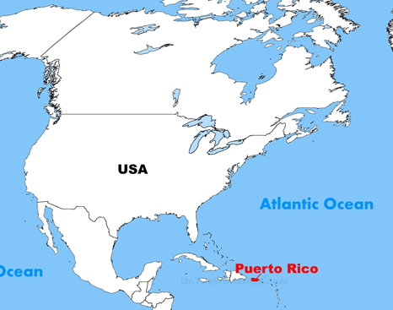
The US territory of Puerto Rico is located at latitude 18º North. On approximately which of these dates would someone living in Puerto Rico sees the sun directly overhead in the middle of the day?

- End of May
- Mid-February
- Late November
- Mid-September

Review the two statements that follow and determine if they are true or false.
i. Average temperature at the Equator during July would increase if the tilt angle of Earth’s axis increased to 27 degrees.
ii. Average temperature at the Tropic of Capricorn (23.5 degrees South) during July would decrease if the tilt angle of Earth’s axis increased to 27 degrees.
- Both statements are true
- Both statements are false
- The first statement is true; the second statement is false
- The first statement is false; the second statement is true

When would the sun be most likely to be overhead in the tropics of the Northern Hemisphere?
A. Between the spring equinox and summer solstice only
B. Between the spring and fall equinox
C. Between the fall equinox and the winter solstice only
D. Between the fall and spring equinox
Which figure best illustrates the path of Earth’s annual orbit around the sun?
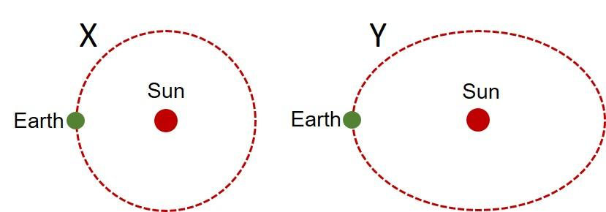
- X
- Y

Use the figure to answer the questions that follow. The figure labeled Position #1 shows the relative positions of the Earth and Sun (figure not to scale).
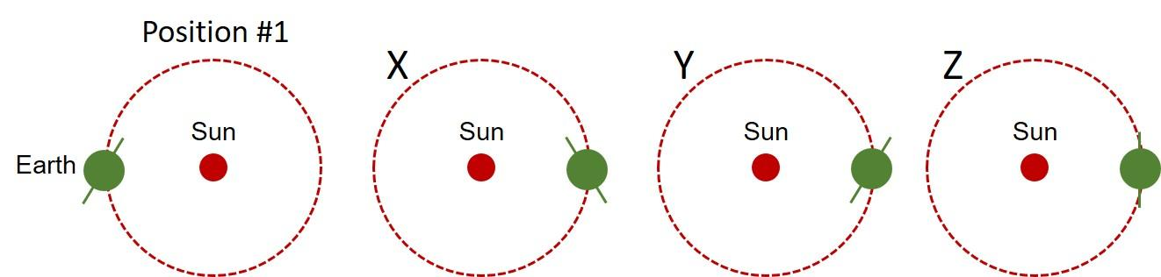
Which of the other three configurations best illustrates the position of Earth and its axis six months later?
- X
- Y
- Z
Use the figure to answer the questions that follow. The figure labeled Position #1 shows the relative positions of the Earth and Sun (figure not to scale).
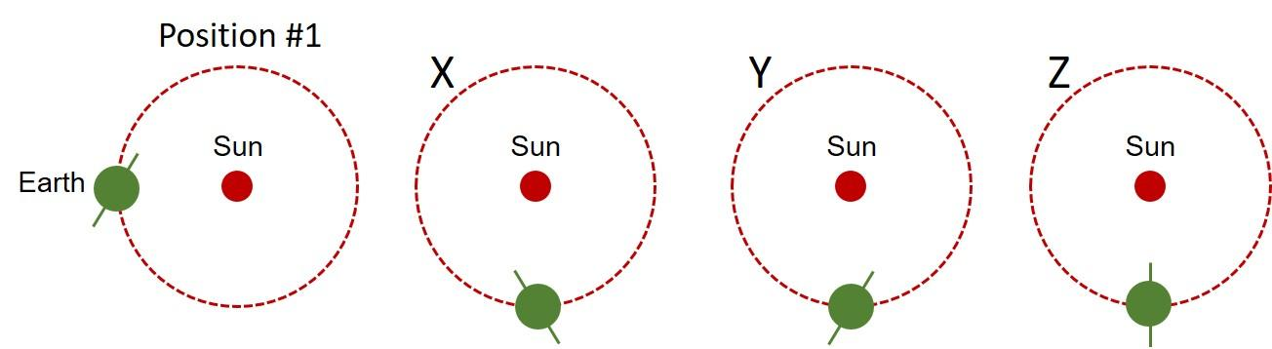
Which of the other three configurations best illustrates the position of Earth and its axis three months later?
- X
- Y
- Z
Which configuration best illustrates the position of Earth and its axis relative to the sun over the course of four seasons? (Figure not to scale)
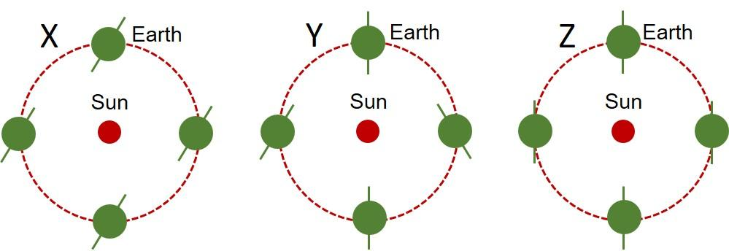

- X
- Y
- Z

LO4. I can explain how patterns of temperature, precipitation and cloud cover vary on Earth.

Air flows ___________ the equator at the surface in the Northern and Southern Hemispheres.
- toward
- away from

How many atmospheric flow cells are present in each hemisphere?
- 4
- 6
- 3
- 2

A rainforest would be most likely found under what conditions?
- Rising air at around 30 degrees north and south of the equator
- Descending air at around 30 degrees north and south of the equator
- Descending air at the equator
- Rising air at the equator

Clear skies over land located at approximately 30 degrees latitude are associated with ____________ air.
- stable
- rising
- descending

Many deserts are located around 30 degrees north or south of the equator.
- True
- False

All deserts have high average temperatures.
- True
- False

Air descends above most desert areas.
- True
- False

Rainforests are located around the equator.
- True
- False

Review the statements that follow and identify if they are true or false.
i. Clear skies are characteristic of rising air, cloudy skies occur above descending air.
ii. Antarctica can be considered a cold desert.
- Both statements are true
- Both statements are false
- The first statement is true; the second statement is false
- The first statement is false; the second statement is true

Review the statements that follow and identify if they are true or false.
i. There is a greater range of temperatures on land than in the oceans.
ii. Generally, higher temperatures are found at lower latitudes.
- Both statements are true
- Both statements are false
- The first statement is true; the second statement is false
- The first statement is false; the second statement is true

Review the statements that follow and identify if they are true or false.
i. Air rises above the Polar regions.
ii. Globally, clouds are more common near the Poles and less common near the Equator.
- Both statements are true
- Both statements are false
- The first statement is true; the second statement is false
- The first statement is false; the second statement is true

Review the two statements that follow and identify if they are true or false.
i. Higher average temperatures are recorded in the oceans than on the continents.
ii. Earth’s atmosphere can be divided into three circulation cells in both the northern and southern hemispheres.
- Both statements are true
- Both statements are false
- The first statement is true; the second statement is false
- The first statement is false; the second statement is true

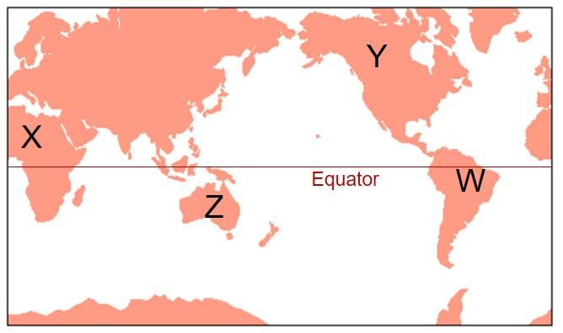
Examine the map and answer the question that follows.

At which pair of locations would you expect to find deserts?
- W & X
- X & Y
- Y & Z
- W & Z
- X & Z

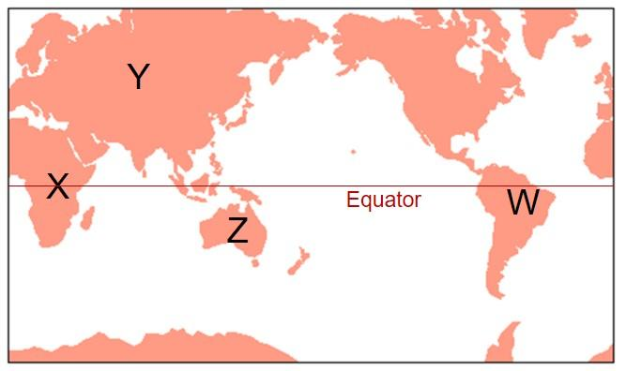
Examine the map and answer the question that follows.

At which pair of locations would you expect to find rainforests?
- W & X
- X & Y
- Y & Z
- W & Z
- X & Z

Examine the map and answer the question that follows.
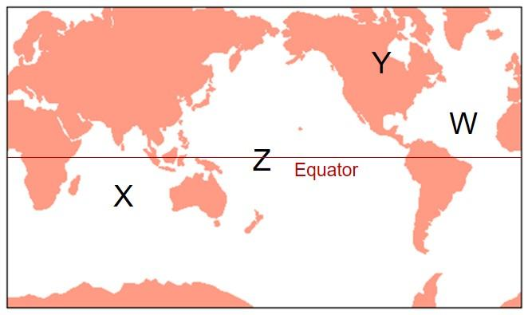

At which pair of locations would you expect to find descending air?
- W & X
- X & Y
- Y & Z
- W & Z
- X & Z

Examine the graph and answer the questions that follow.
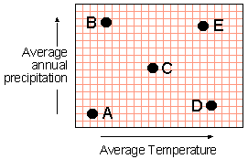

Which of the points on the graph best represents conditions at the equator?
- A
- B
- C
- D
- E

Which of the points on the graph best represents conditions at the poles?
- A
- B.
- C
- D
- E

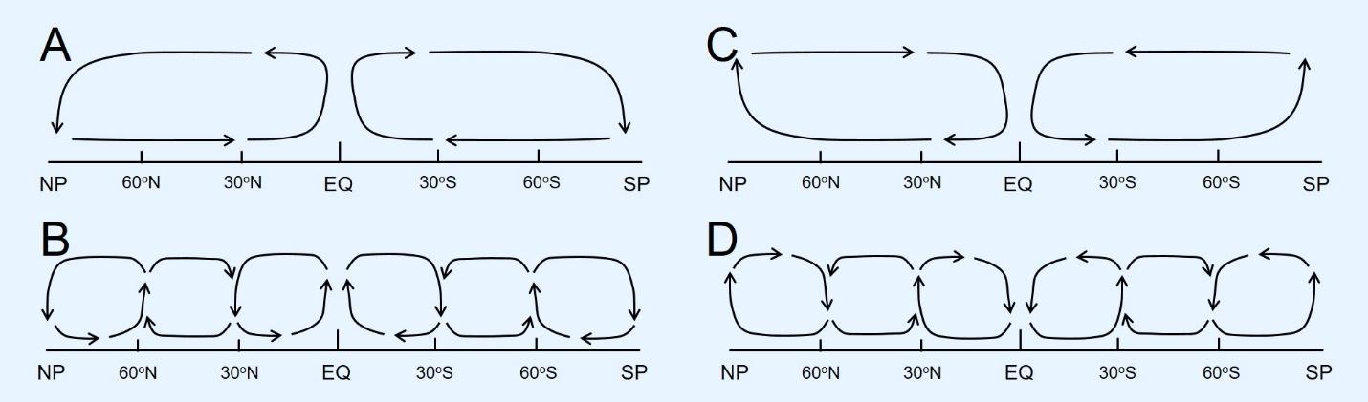
The four figures below show vertical cross sections through the lower part of Earth’s atmosphere along a line from the North Pole (NP) through the equator (EQ) to the South Pole (SP).
Which illustration most accurately represents the distribution of rising and descending air that accounts for the major global climate patterns?
- A
- B
- C
- D

Which of the following describes the relationship between temperature differences, circulation of air, and wind blowing along the surface of the earth?
- Temperature differences cause warm air to rise and cold air to sink, which leads to circulation of the air that causes wind to blow along the surface of the earth
- Temperature differences cause warm air to rise and cold air to sink, but this movement does not lead to circulation of the air, and therefore does not cause wind to blow along the surface of the earth
- Circulation of the air causes the wind to blow along the surface of the earth, but the circulation is not caused by temperature differences
- There is no relationship between temperature differences, circulation of air, and wind. The only cause of air moving along the surface of the earth is the rotation of the earth

LO5. I can identify examples of climate proxies and discuss what climate proxies tell us about ancient climates.

Higher concentrations of atmospheric carbon dioxide occur during periods of ___ climates in the geologic past.
- warmer
- cooler

Which two of the following have been used as proxy climate records that show variations in climate throughout the last 1000 years?
- Ice cores
- Tree rings
- Sediment deposits
- Thermometer records

Which of the following represents a proxy record of long-term climate change measured in millions of years?
- Radioactive decay
- Pollen
- Oxygen isotopes
- Tree rings

A time of warmer climate will lead to ___ oxygen isotope ratio value.
- a lower
- a higher
- no change in

Select the paired terms below that best fill the blanks in the following sentence: "The ___ the climate, the ___ the oxygen isotope value in microfossils preserved in ocean sediments." Select all that apply.
- warmer; lower
- colder; lower
- warmer; higher
- colder; higher

Temperatures have warmed more rapidly in the last century than at any other time in the last 1000 years.
- True
- False

Review the statements that follow and identify if they are true or false.
i. There is much more of the 18-O oxygen isotope in ocean water than the 16-O isotope.
ii. During an ice age, the ratio of 18-O/16-O in ocean water would have been higher than it is during the present day.
- Both statements are true.
- Both statements are false.
- The first statement is true; the second statement is false.
- The first statement is false; the second statement is true.

Review the statements that follow and identify if they are true or false.
i. There is much more of the 16-O isotope in ocean water than the 18-O isotope.
ii. If all the world’s ice sheets were to melt, the ratio of 18-O/16-O in ocean water would decrease.
- Both statements are true.
- Both statements are false.
- The first statement is true; the second statement is false.
- The first statement is false; the second statement is true.

Examine the graph of oxygen isotope ratios vs. time and answer the questions that follow.
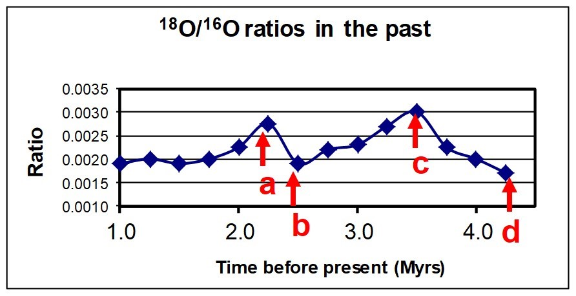
Which letter corresponds to the highest temperatures on the basis of the graph data?
- a
- b
- c
- d

Point c represents values from 3.5 million years ago and point b was 2.5 million years ago. How were ocean temperatures changing from time c to time b?
- Warming
- Cooling

How does the relative proportion of the 18-O isotope in ocean water change during periods of extensive glaciation (ice ages)?
- It increases
- It decreases

Scientists study the ratio of a pair of isotopes preserved in the shells of marine microfossils as a proxy for ocean temperatures in the geological past. Identify the two isotopes that they use.
- 16-O and 18-O
- 14-C and 14-N
- 14-O and 14-N
- 16-C and 14-O

What would happen to the two oxygen isotopes found in oceans during ice ages?
- 16-O will be trapped in ice sheets, resulting in a decrease in the 18-O/16-O ratio
- 18-O will be trapped in ice sheets, resulting in a decrease in the 18-O/16-O ratio
- 16-O will be trapped in ice sheets, resulting in an increase in the 18-O/16-O ratio
- 18-O will be trapped in ice sheets, resulting in an increase in the 18-O/16-O ratio

What would happen to the two oxygen isotopes found in oceans if the ice sheets in Antarctica and Greenland were both to melt?
- 16-O will be released as the ice melts, resulting in a decrease in the 18-O/16-O ratio
- 18-O will be released as the ice melts, resulting in a decrease in the 18-O/16-O ratio
- 16-O will be released as the ice melts, resulting in an increase in the 18-O/16-O ratio
- 18-O will be released as the ice melts, resulting in an increase in the 18-O/16-O ratio

Which of the following proxy climate indicators can be used to interpret the composition of the atmosphere?
- Ice cores
- Tree rings
- Sediment deposits
- Thermometer records

Scientists analyzed oxygen isotopes in shells of marine fossils for two intervals of Earth’s history. Fossil A had more O¹⁸ relative to O¹⁶ (a higher ratio) than fossil B. Which fossil was alive during a time of warmer climate?
- Fossil A
- Fossil B

LO6. I can explain how solar radiation affects Earth’s climate system.

The amount of solar energy striking a square meter of Earth's surface is approximately equal all over Earth.
- True
- False

What wavelength(s) of incoming solar radiation reach the Earth's atmosphere?
- Ultraviolet
- Visible
- Infrared
- All of the above

What is the wavelength of the outgoing thermal radiation being emitted from the Earth's surface?
- Ultraviolet
- Visible light
- Infrared

What proportion of incoming solar energy is absorbed at Earth’s surface?
- 51%
- 19%
- 30%
- 4%
Review the statements that follow and identify if they are true or false.
i. The warmed Earth’s surface gives off infrared energy.
ii. The atmosphere (and clouds) reflect more incoming solar energy than it absorbs.
- Both statements are true
- Both statements are false
- The first statement is true; the second statement is false
- The first statement is false; the second statement is true

Review the statements that follow and identify if they are true or false.
i. Earth is absorbing more solar radiation that it is emitting back to space.
ii. The atmosphere (and clouds) absorb more incoming solar energy than it reflects.
- Both statements are true
- Both statements are false
- The first statement is true; the second statement is false
- The first statement is false; the second statement is true

Which type of cloud allows solar radiation to pass through but blocks heat radiating from Earth’s surface?
- High level cirrus clouds
- Low level cumulus clouds
- Both cirrus and cumulus clouds.
- Neither cirrus and cumulus clouds

Which type of cloud reflects most incoming sunlight but also heat radiating from Earth’s surface?
- High level cirrus clouds
- Low level cumulus clouds
- Both cirrus and cumulus clouds
- Neither cirrus and cumulus clouds

Which of the following statements is incorrect about solar radiation?
- It can be reflected by low- and high-level clouds
- It can be destroyed by low- and high-level clouds
- It can be absorbed by low- and high-level clouds
- It can be scattered by low- and high-level clouds

Which statement is correct about incoming solar radiation?
- It is greater near the equator and less at the poles
- It is less near the equator and greater at the poles
- It is essentially the same at all latitudes
- It is greater in the tropics during our summer; but greater near the poles during winter

Earth’s Climate Past

LO1: I can describe the characteristics of common types of glaciers.

Which combination of conditions is best suited to the formation of glaciers? Select all that apply.
- High latitudes
- Low elevations
- Low latitudes
- High elevations

Glaciers can only form when there are very large amounts of snow in a short period of time, regardless of the rate of snow loss (called "ablation")
- True
- False

Which is the best estimate for the thickness of ice in the largest ice sheet on Earth today?
- 700 meters
- 83 meters
- 11800 meters
- 4300 meters

Is the following statement true or false? "An ice sheet could be regarded as a piedmont glacier."
- True
- False

Ice sheets are generally younger and thicker than alpine glaciers.
- True
- False

Alpine glaciers are solid blocks of ice that behave as solids.
- True
- False

Which statement is true?
- Alpine glaciers are typically larger and older than ice sheets
- Alpine glaciers are typically larger and younger than ice sheets
- Alpine glaciers are typically smaller and older than ice sheets
- Alpine glaciers are typically smaller and younger than ice sheets

The terminus of an alpine glacier is the ___ point of a glacier.
- highest
- lowest

What are the two ways that glaciers can create landforms? Select all that apply.
- Via deposition of glacial material
- Via erosion of surrounding material
- Via complex interactions within the glacier itself

What is the name of the steep-walled valleys where alpine glaciers typically begin?
- Crevasse
- Moraine
- Terminus
- Cirque
- Arête

Is the following statement true or false? "An alpine glacier could be a tidewater glacier if it terminated in an ocean."
- True
- False

Which of the following sets of terms best fill in the blanks in the following statement regarding the creation of glacial landforms? "Glaciers do all of their ___ while they are ___." Select all that apply.
- eroding; retreating
- deposition; retreating
- eroding; progressing
- deposition; progressing

Fill in the blanks to correctly complete the following sentence. Glaciers are most likely to be found in locations at _____ latitudes and/or ____ elevations.
- low; low
- low; high
- high; low
- high; high

LO2. I can describe features formed by glacial erosion and deposition.

What is the name given to the sharp ridges that separate glacial valleys?
- Cirques
- Arêtes
- Crevasses
- Striations

Which valley shape is most characteristic of an area that has been glaciated?
- U-shaped valley
- V-shaped valley
- None of the above

Identify the phrase that best fits the blank in the following sentence. "Ice is to glaciers as ___ to moraines."
- lakes are
- snow is
- erratics are
- till is

Which is the best description of glacial till?
- Fine-grained sands deposited by streams of meltwater near a glacier’s terminus
- Angular boulders plucked out of the valley walls by a moving glacier
- A mix of clay, sand, and boulders left behind when ice melts
- A rock formed from glacial deposits

A large metamorphic rock was found on the prairie of Kansas (where there are no naturally occurring metamorphic rocks) and turned into a large monument/plaque. What is your best hypothesis for what you would call this rock?
- An asteroid
- An anomaly
- A glacial erratic
- A cobble

Which of the following terms best defines the furthermost pile of unsorted till deposited by a glacier as it is melting?
- Moraine
- Lateral moraine
- Terminal moraine
- Esker

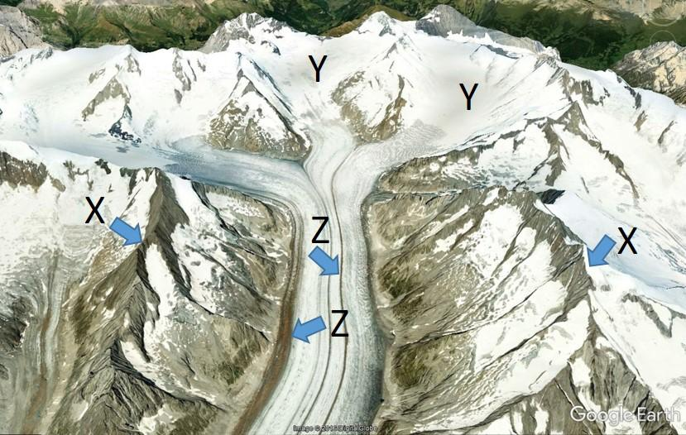
Examine the associated image and answer the questions that follow.
Image source: Google Earth
Which lettered features represent cirques?
- X
- Y
- Z

Which lettered features represent arêtes?
- X
- Y
- Z

Which lettered features represent moraine?
- X
- Y
- Z

Review the two statements that follow and identify if they are true or false.
i. A kettle is a lake formed when a block of ice is trapped in till and melts.
ii. A long sinuous ridge of sorted sediment that originally forms below a glacier is known as an erratic.
- Both statements are true
- Both statements are false
- The first statement is true; the second statement is false
- The first statement is false; the second statement is true

What is the name that geologists give to the sediment deposited by a glacier as illustrated in the associated image?
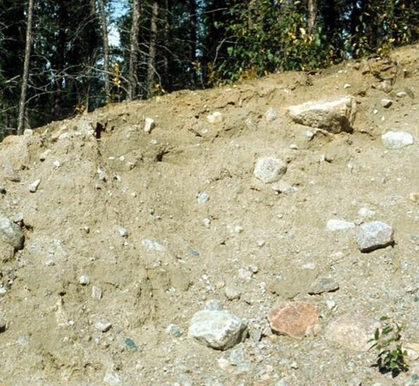
USGS
- Outwash
- Till
- Drumlin
- Esker

What are the names that geologists give to the labeled landforms illustrated in the associated image?
Image source: Google Earth
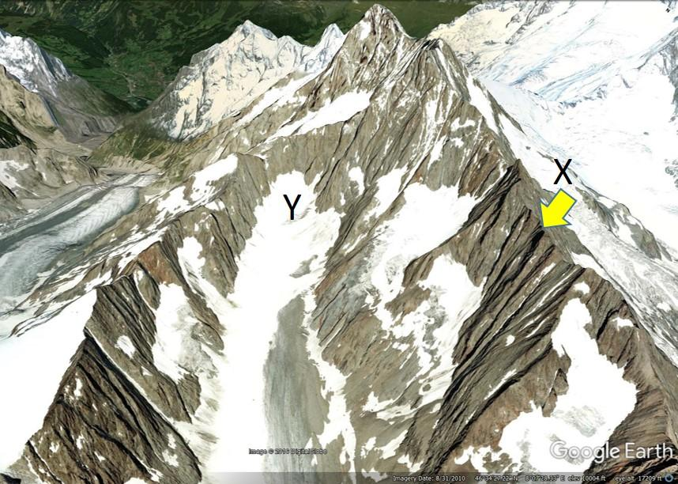
- X is an arête; Y is a U-shaped valley
- X is a cirque; Y is an arête
- X is a cirque; Y is a U-shaped valley
- X is an arête; Y is a cirque

Examine this shaded-relief map of Ohio and answer the questions that follow.
Source: Ohio EPA
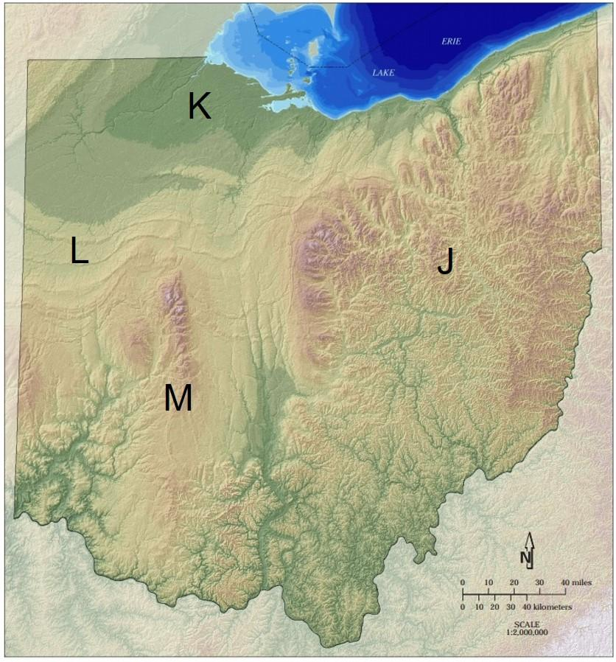
Which letters correspond with regions of the state that were glaciated during the last ice age?
- J, K, L & M
- J, K, L
- K & L
- J & M
- L & M

What glacial landform is represented by the patterns indicated by the letter L?
- Moraines
- U-shaped valleys
- Arêtes
- Drumlins

The maximum extent of a continental ice sheet is marked by the location of which features?
- Erratics
- U-shaped valleys
- moraines
- the equilibrium line

Examine the image below and answer the questions that follow.
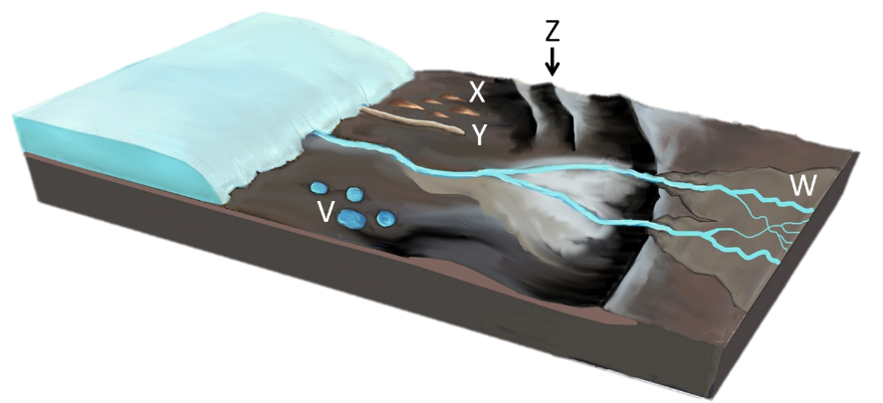
Select all the depositional glacial landforms that are correctly attributed to the lettered features on the associated image. Select all that apply.
- V represents kettle lakes
- W represents an outwash plain
- X represents drumlins
- Y represents an esker
- Z represents a moraine

Select the two depositional glacial landforms that are correctly attributed to the lettered features on the associated image.
- W represents an outwash plain
- Z represents an esker
- X represents drumlins
- Y represents a moraine

Which feature best represents an example of a moraine deposit?
- W
- Z
- X
- Y

Which pair of features are most likely to be composed of sorted sediment deposited by running water?
- X & Z
- V & Z
- X & Y
- Y & W
- W & X

LO3. I can discuss the characteristics of ice ages and the climate factors related to changes in the size of glaciers.

The last ice-age can be divided into ___ and ___.
- short, warm glacials; long cold interglacials
- long, warm glacials; short cold interglacials
- short, cold glacials, long, warm interglacials
- long, cold glacials; short, warm interglacials

The last ice age occurred because more land area was located close to the poles.
- True
- False

How often do ice ages occur in Earth's history and how long do they last?
- At regular intervals, on average, about one very 50 million years and they last for about 100,000 years each
- At irregular intervals, approximately one every 500 million years and they last for millions of years
- At irregular intervals, approximately one every 200 million years and they last for millions of years
- At regular intervals, approximately one every billion years and they last for about 100,000 years each

Consider the downward trend in Arctic sea ice coverage over the last few decades. From the following list, select which is the most probable explanation for this trend.
- Sea ice is generally decreasing due to rising sea levels from other areas, thus causing the Arctic ice to melt in the newly-introduced water
- Sea ice is decreasing every year due to the thinning of the ozone layer that would normally block ultraviolet radiation that is now allowed to melt the ice
- Sea ice is increasing some years due to more cosmic winds and other external forcing mechanisms, but is generally decreasing due to increased temperatures from industrial pollution
- Sea ice is generally decreasing and that is exposing darker ocean waters which are absorbing more solar energy and warming up, thus resulting in less ice production

What would happen to Earth's albedo during an ice age
- The average albedo of Earth’s surface would increase
- The average albedo of Earth’s surface would decrease
- The average albedo of Earth’s surface would not change

Fluctuations of temperatures that occur over a few thousand years during an ice age may be attributed to which of the following factors? Select all that apply.
- Changes in the shape of Earth’s orbit relative to the sun
- Changes in the angle of tilt of Earth’s axis
- Changes in the direction of tilt of Earth’s axis (precession)
- Variations in the rate of plate motions

Review the two statements that follow and identify if they are true or false.
i. Near-global ice sheets created snowball Earth conditions during the Phanerozoic Eon.
ii. The recent Pliocene-Quaternary ice age was due to changing climate patterns caused by a change in atmospheric carbon dioxide concentrations.
- Both statements are true
- Both statements are false
- The first statement is true; the second statement is false
- The first statement is false; the second statement is true

Review the two statements that follow and identify if they are true or false.
i. Near-global ice sheets created snowball Earth conditions during the Proterozoic Eon.
ii. The recent Pliocene-Quaternary ice age was due to changing climate patterns caused by a change in the intensity of solar radiation.
- Both statements are true
- Both statements are false
- The first statement is true; the second statement is false
- The first statement is false; the second statement is true

Review the two statements that follow and identify if they are true or false.
i. Near-global ice sheets created snowball Earth conditions during the Proterozoic Eon.
ii. The recent Pliocene-Quaternary ice age was due to changing climate patterns caused by a change in ocean circulation patterns.
- Both statements are true
- Both statements are false
- The first statement is true; the second statement is false
- The first statement is false; the second statement is true

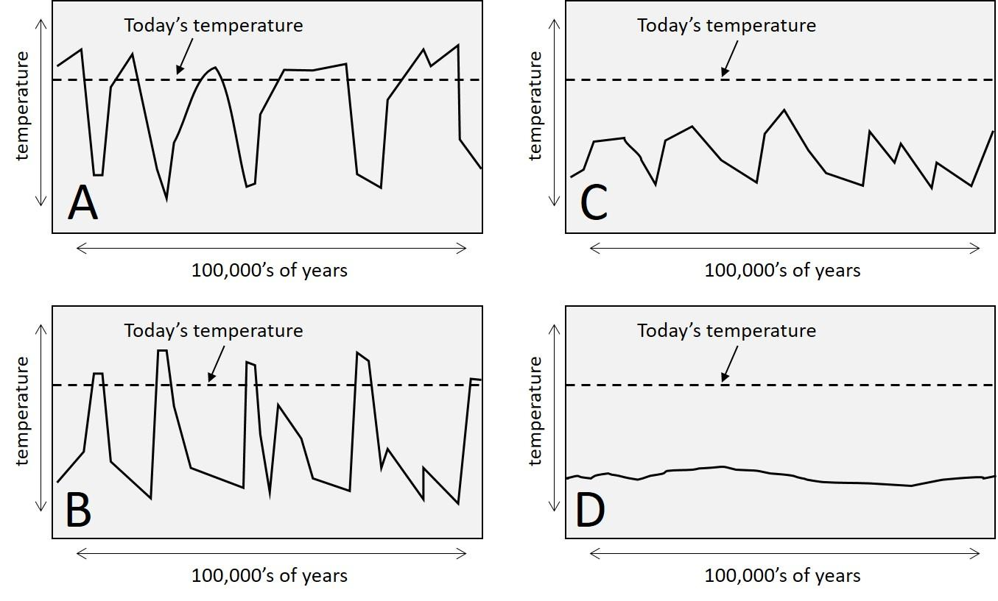
Review the four graphs. Which best illustrates the fluctuations and range of temperatures during an ice age?

- A.
- B
- C
- D

Examine the three simplified graphs of temperature vs. time below. Which is the most accurate representation of how temperature has varied over the last 1000 years?
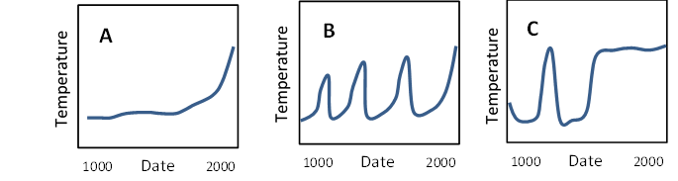
- A
- B
- C

LO4. I can define the term climate change and discuss how climate forcings may result in a change in Earth’s energy balance (causing changes in climate and temperature).

The greenhouse effect is another name for global warming.
- True
- False

Evidence for whether or not climate change is occurring can be found by looking at the weather conditions out your window.
- True
- False

The hole in the ozone is one of the main causes of recent climate change (in addition to greenhouse gasses).
- True
- False

What would happen to Earth's albedo during an ice age?
- The average albedo of Earth’s surface would increase
- The average albedo of Earth’s surface would decrease
- The average albedo of Earth’s surface would not change

Which two of the following are examples of negative internal forcing?
- Volcanic tephra deposits blocking out sunlight
- Release of greenhouse gasses by volcanoes
- Release of greenhouse gasses by humans
- More low clouds reflecting more solar radiation
- Air pollution reflecting solar radiation

"Anthropogenic climate forcing" refers to climatic changes that will affect humans directly.
- True
- False

Which two of the following represent anthropogenic climate forcings?
- Air pollution
- Variations in Earth’s orbit
- Natural lands are replaced by buildings
- Sea level rises

What type of temperature records would be the best for scientists to examine to determine if climate change was occurring?
- They would compare the seasonal temperatures between a pair of successive years
- They would compare maximum high and low temperatures over a decade
- They would compare average temperatures for several decades
- They would compare maximum high and low temperatures with temperatures of 100 years ago

A climate forcing refers to a change in Earth’s energy balance.
- True
- False

A positive climate forcing refers to a change in Earth’s energy balance that results in more incoming solar energy and/or less outgoing energy.
- True
- False

A positive climate forcing refers to a change in Earth’s energy balance that results in conditions that are considered to be better for economic development and agriculture.
- True
- False

Review the two statements that follow and identify if they are true or false.
i. Greater melting of Arctic sea ice would be an example of a positive climate forcing.
ii. A volcanic eruption that produced a large tephra cloud would be an example of a negative climate forcing.
- Both statements are true
- Both statements are false
- The first statement is true; the second statement is false
- The first statement is false; the second statement is true

Review the two statements that follow and identify if they are true or false.
i. Greater melting of Arctic sea ice would be an example of a natural internal climate forcing.
ii. A volcanic eruption that produced a large tephra cloud would be an example of a natural external climate forcing.
- Both statements are true
- Both statements are false
- The first statement is true; the second statement is false
- The first statement is false; the second statement is true

Review the two statements that follow and identify if they are true or false.
i. An increase in the presence of low cumulus clouds would be an example of a positive climate forcing.
ii. An increase in the presence of high (cirrus) clouds would be an example of a negative climate forcing.
- Both statements are true
- Both statements are false
- The first statement is true; the second statement is false
- The first statement is false; the second statement is true
Review the two statements that follow and identify if they are true or false.
i. An increase in use of fossil fuels would be an example of a negative climate forcing.
ii. An increase in the presence of low cumulus clouds would be an example of a negative climate forcing.
- Both statements are true
- Both statements are false
- The first statement is true; the second statement is false
- The first statement is false; the second statement is true

Which factor do scientists believe is most responsible for increases in Earth’s temperature over the last century?
- A 3-5% increase in the emission of solar energy from the equatorial region of the sun
- The combined changes in the tilt of Earth’s axis and the shape of its orbit
- Increases in the concentration of carbon dioxide, methane and some other atmospheric gases

Global temperatures in the past 1000 years have ___.
- fluctuated over a 5ºC range between warm and cold intervals every few centuries
- generally declined from a high of approximately 18ºC between 1100 and 1200
- experienced approximately a 1ºC change with the most profound changes occurring in the last century
- steadily increased by several degrees starting around 1400

What would the average temperature on earth be like without the greenhouse effect?
- Slightly colder than it is now
- Much hotter than it is now
- Slightly hotter than it is now
- Much colder than it is now
- About the same

A series of massive volcanic eruptions occurred at sites around the world during the latter part of the Mesozoic Era. These eruptions resulted in a change in global climates for several millions of years. Why?
- The heat from the eruptions of lavas at over 1000ºC increased global temperatures.
- The eruptions generated tephra that blocked incoming sunlight; cooling the planet.
- Greenhouse gases were added to the atmosphere, causing an increase in temperatures.
- The eruptions caused a hole to form in the ozone layer, letting in more solar radiation and increasing temperatures.

Which of the following both represent anthropogenic climate feedbacks?
- Volcanic eruptions; air pollution from transportation
- Natural variations in Earth’s orbit; variations in Earth’s tilt
- Air pollution from transportation; croplands replacing natural forest
- Sea-level rise; volcanic eruptions

Streams and Floods

LO1. I can sketch and label the hydrologic cycle to show how water moves between different parts of the Earth System.

Place the following parts of the hydrologic cycle in the most logical sequence:
- Evaporation; precipitation; surface runoff to ocean; condensation
- Precipitation; evaporation; surface runoff to ocean; condensation
- Surface runoff to ocean; condensation; evaporation; precipitation
- Evaporation; precipitation; condensation; surface runoff to ocean
- Evaporation; condensation; precipitation; surface runoff to ocean

Rivers in the southeastern US ultimately carry water to which locations? Select all that apply.
- Pacific Ocean
- Gulf of Mexico
- Gulf of California
- Atlantic Ocean

Freshwater would float above salt water along the coast.
- True
- False

The area drained by a stream is known as a drainage divide.
- True
- False

The area drained by a stream is known as a drainage basin.
- True
- False

Review the partially completed figure of the hydrologic cycle and answer the questions that follow.

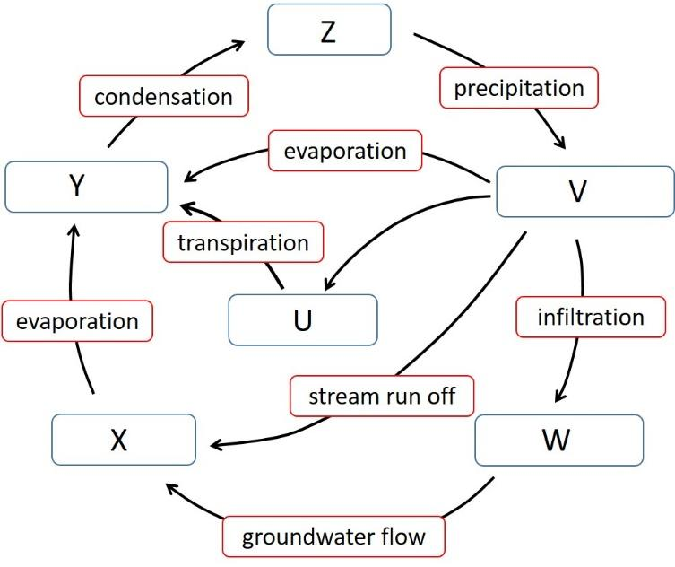
What pair of terms would best represent the letters U, V?
- Clouds, Atmosphere
- Oceans, Water on Land
- Groundwater, Vegetation
- Groundwater, Clouds
- Vegetation, Water on Land

What pair of terms that would best represent the letters X, Y?
- Clouds, Water on Land
- Oceans, Atmosphere
- Groundwater, Vegetation
- Groundwater, Clouds
- Vegetation, Oceans

What pair of terms would best represent the letters W, Z?
- Clouds, Water on Land
- Oceans, Atmosphere
- Groundwater, Vegetation
- Groundwater, Clouds
- Vegetation, Oceans

Review the partially completed figure of the hydrologic cycle and answer the questions that follow.
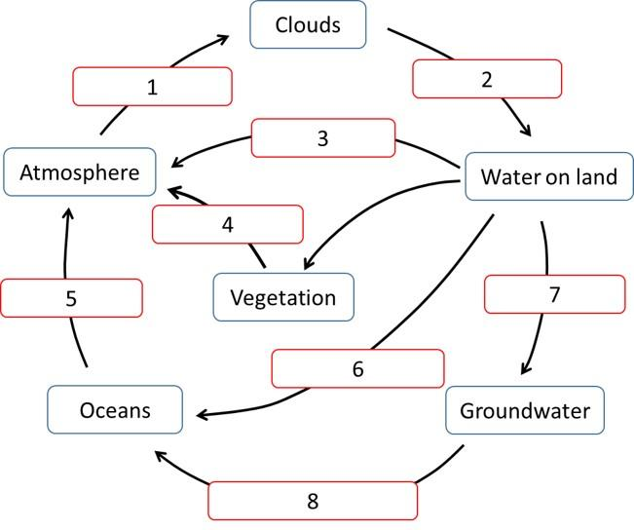
What pair of terms that would best represent the numbers 1, 2?
- Condensation; precipitation
- Precipitation; evaporation
- Evaporation; condensation
- Infiltration; transpiration
- Stream run off; groundwater flow

What pair of terms would best represent the numbers 3, 4?
- Condensation; precipitation
- Precipitation; evaporation
- Infiltration; condensation
- Evaporation; transpiration
- Stream run off; groundwater flow

What pair of terms that would best represent the numbers 5, 7?
- Precipitation; groundwater flow
- Evaporation; infiltration
- Infiltration; condensation
- Evaporation; transpiration
- Stream run off; condensation

LO2. I can explain how much water is present among different components of the Earth System.

Approximately what percentage of Earth's water is held in the oceans?
- 9%
- 57%
- 89%
- 97%

Lakes hold about 40 times more of the world's freshwater than rivers.
- True
- False

Which one of the following selections correctly lists each of the largest reservoirs of water for each type? a) all water; b) freshwater; and c) fresh surface water
- oceans; groundwater; rivers
- oceans; ice caps and glaciers; rivers
- oceans; ice caps and glaciers; lakes
- fresh water; ground water; lakes

What is the largest reservoir of fresh water on Earth?
- Rivers
- Lakes
- Groundwater
- Ice caps and glacier

Which of the following statements are NOT true?
- The largest percentage of Earth's water is held in the oceans.
- The largest percentage of Earth's water is saline.
- The largest percentage of Earth's freshwater is held in ice.
- The largest percentage of Earth's surface water is held in rivers.

Which list places global freshwater sources in the correct order from largest to smallest?
- Groundwater; surface water; glacial ice
- Glacial ice; surface water; groundwater
- Groundwater; glacial ice; surface water
- Glacial ice; groundwater; surface water
- Surface water; glacial ice; groundwater

Approximately how much of Earth’s surface is covered by oceans?
- 55%
- 70%
- 83%
- 97%
Review the lists of the four components of the hydrologic cycle. Predict which best presents the order for how long a drop of water would typically remain in the system. Start with the component with the shortest residence time (days) and finish with the component with the longest residence time (thousands of years).
- Winter snow; ocean; atmosphere; deep groundwater
- Ocean; deep groundwater; winter snow; atmosphere
- Atmosphere; winter snow; ocean; deep groundwater
- Winter snow; atmosphere; deep groundwater; ocean

Water on the land surface represents less than 1% of all of Earth’s freshwater.
- True
- False

Approximately how much of all the water on Earth is represented by groundwater?
- 30%
- 3.5%
- 1%
- 69%

LO 3. I can discuss how stream discharge is calculated and explain why it varies with time and location.

Which equation is used to calculate stream discharge?
- velocity x width x depth
- width x depth x length
- length x width x depth x time
- width x depth x time

Which of the following data is NOT essential for determining a stream's discharge?
- The velocity of the water in the stream channel
- The width of the stream channel
- The depth of the stream channel
- The length of the stream channel

Discharge is a measurement of ___. (lower score)
- the speed of a stream's flow per unit length
- the likelihood of a flood at a given time
- the volume of water that passes through a stream channel per unit time
- the velocity of water in a specific segment of a stream channel per unit time

Which of these measurements represents the height of water levels in a stream?
- Stream turbidity
- Stream discharge
- Stream stage
- Stream velocity

What is the discharge for a rectangular stream channel that is 3 meters deep, 20 meters long, 6 meters wide, and with a velocity of 5 meters per second?
- 18 cubic meters per second
- 30 meters per second
- 90 meters per second
- 90 cubic meters per second
- 1800 meters per second
- 1800 cubic meters per second

If you make a stream channel smaller, the discharge of the stream will increase. (low score)
- True
- False

What is the discharge for a rectangular stream channel that is 2 meters deep, 4 meters wide, and with a velocity of 3 meters per second?
- 12 cubic meters per second
- 24 cubic meters per second
- 9 cubic meters per second
- 11 cubic meters per second

What units are used to measure stream discharge?
- Meters per second
- Square meters per hour
- Cubic meters per second
- Meters per hour
- Square meters per second

What two words would best fill in the blanks in the following sentence: Stream discharge would increase with ___ size of a drainage basin and ___ slope. (low score)
- decreasing, decreasing
- decreasing, increasing
- increasing, decreasing
- increasing, increasing

Which of the following settings would you expect to see a more rapid increase in stream discharge following a rain event?
- An urban environment
- A rural environment
- A completely-undeveloped natural environment

If all other stream characteristics remained the same, an increase in stream gradient (slope) would result in an increase in discharge.
- True
- False

What is the discharge of the stream shown in the accompanying figure if the velocity is 5 meters per second?
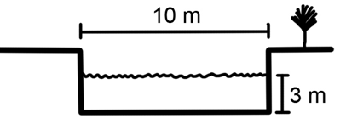
- 30 cubic meters per second
- 90 cubic meters per second
- 150 cubic meters per second
- 350 cubic meters per second
- none of the above

LO4. I can draw a simple hydrograph showing how discharge would vary before, during and after a storm.

Consider the hydrograph and answer the questions that follow.
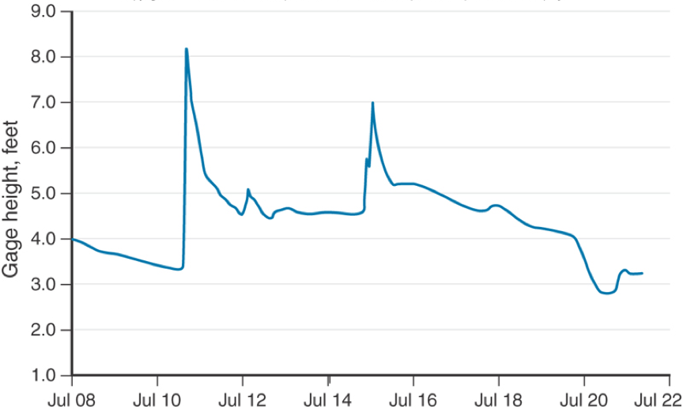
Which two dates did it likely rain in this stream's drainage basin area?
- July 10
- July 11
- July 12
- July 13
- July 14
- July 15

Which date most likely represents discharge conditions that are closest to typical for this stream when not experiencing a precipitation event?
- July 9
- July 13
- July 15
- July 17

On which date was gage height at 5 feet?
- July 8-9
- July 13-14
- July 16-17
- July 20-21

During which of the following periods is the rate of change for a stream's discharge the highest for an urban stream?
A. The increase to the peak immediately after a storm event
B. The decrease from the peak several days after a storm event
C. The change in discharge during these two time periods is roughly the same

This figure shows two hydrographs for different stations along the same river that have been plotted together. Which plot represents the station that is further downstream?
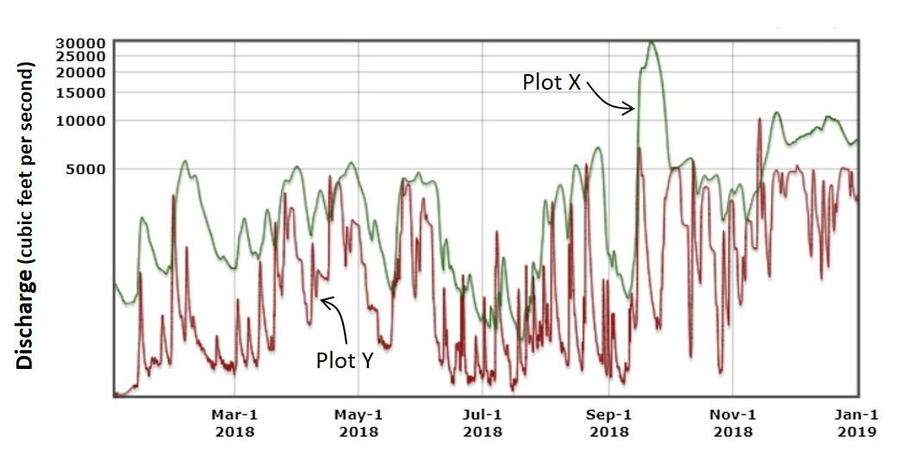
USGS
- Plot X
- Plot Y

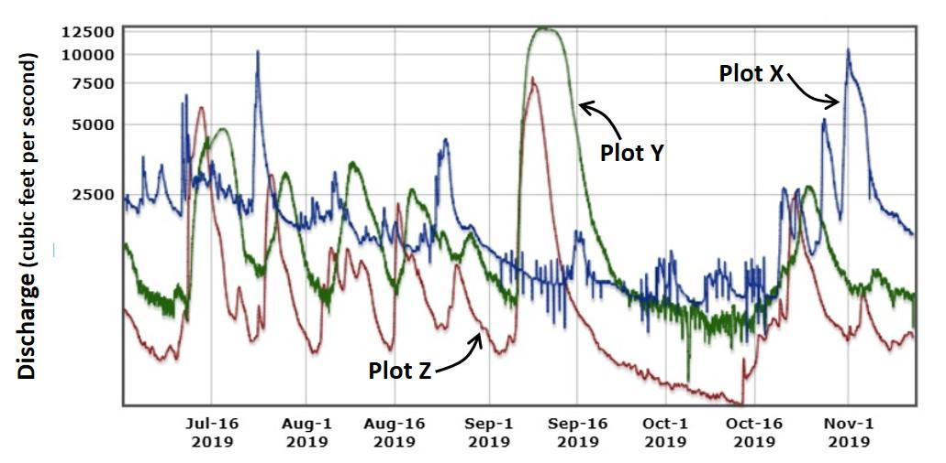
This figure shows three hydrographs that have been plotted together. All three hydrographs represent stream gauging stations in the same state. Two stations are in the same drainage basin, the other is in a different drainage basin located approximately 500 kilometers away. Use the discharge data to determine which plots are from locations in the same drainage basin?
USGS

- Plot X and Plot Y are from the same drainage basin
- Plot Y and Plot Z are from the same drainage basin
- Plot Z and Plot X are from the same drainage basin

This figure shows three hydrographs for three different stream gauging stations that have been plotted together for the month of August, 2019. All three hydrographs represent stream gauging stations in the same state. Two stations are in the same drainage basin, the other is located in a different drainage basin located approximately 500 kilometers away. Use the discharge data to answer the questions that follow.
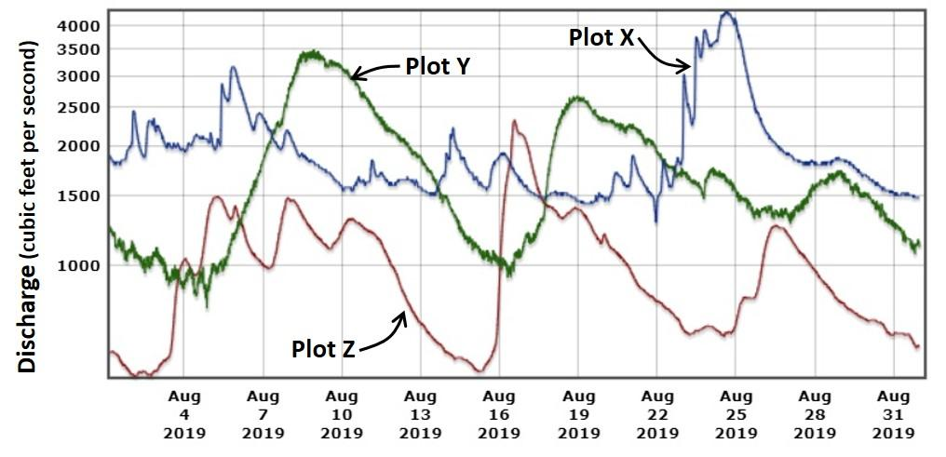
USGS

Which plots are from locations in the same drainage basin?
- Plot X and Plot Y are from the same drainage basin
- Plot Y and Plot Z are from the same drainage basin
- Plot Z and Plot X are from the same drainage basin

Which plot represents the stream with the greatest total discharge throughout the month of August?
- Plot X
- Plot Y
- Plot Z

Plots Y and Z represent readings on the same river at different locations. Which plot represents the location that is usually the first to experience precipitation events?
- Plot Y
- Plot Z

This figure shows two hydrographs for different gauging stations along the same river that have been plotted together for the last two weeks of August, 2019. Both plots show the effects of precipitation events on discharge. Use the plot to answer the questions that follow.
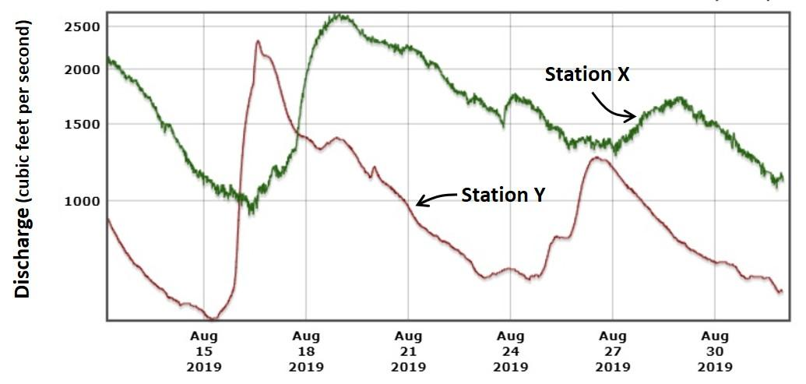
USGS
Where was the precipitation most likely located?
- Upstream of Station Y
- Between Station Y and Station X
- Upstream of Station X but downstream of Station Y
- Downstream of Station X
- Upstream of Station Y but downstream of Station X

Which plot represents the station that is farther upstream?
- X
- Y

LO5. I can describe how stream flow characteristics change as a river flows downstream.

The ___ are present at the source area of a stream in areas of ___ stream gradient. In contrast, a ___ forms because of deposition in areas of ___ gradient.
- headwaters; low; delta; high
- delta; low; headwaters; high
- delta; high; headwaters; low
- headwaters; high; delta; low

What type of materials are part of the bedload in a stream during transport? Select all that apply.
- Silt and clay
- Sand
- Gravel
- Soluble materials

Which four of the following features INCREASE traveling downstream?
- Size of sediment particles
- Stream gradient
- Stream sediment load
- Stream velocity
- Width of stream channel
- Stream discharge

Most people can walk faster than the average flow velocity of most streams.
- True
- False

Silt and clay particles are the types of materials that are part of the bed load in a stream during transport.
- True
- False

Determine if the following statements are true or false.
i. Stream gradient increases traveling downstream
ii. Stream velocity increases traveling downstream
- Both statements are true
- Both statements are false
- The first statement is true; the second statement is false
- The first statement is false; the second statement is true

Determine if the following statements are true or false.
i. Stream channel width increases traveling downstream
ii. The size of particles transported by the stream increases downstream
- Both statements are true
- Both statements are false
- The first statement is true; the second statement is false
- The first statement is false; the second statement is true

Determine if the following statements are true or false.
i. Stream discharge increases downstream
ii. Stream gradient decreases downstream
- Both statements are true
- Both statements are false
- The first statement is true; the second statement is false
- The first statement is false; the second statement is true

Which of the following statements is the most accurate summary of stream flow characteristics?
- The largest particles are found in the low gradient part of the stream channel and the greatest velocities are recorded in the high gradient part of the channel
- The largest particles are found in the low gradient part of the stream channel and the greatest velocities are recorded in the low gradient part of the channel
- The largest particles are found in the high gradient part of the stream channel and the greatest velocities are recorded in the low gradient part of the channel
- The largest particles are found in the high gradient part of the stream channel and the greatest velocities are recorded in the high gradient part of the channel

Which statement is MOST accurate?
- Stream velocity increases downstream and stream gradient decreases
- Stream velocity decreases downstream and stream discharge increases
- Stream channel width increases downstream and discharge decreases
- Streams carry larger sediment as water travels downstream and stream velocity increases

Which material requires the lowest velocity to be eroded from the bed of a stream channel?
- Gravel
- Sand
- Clay

LO6. I can explain how erosion, transportation and deposition occur in streams.

Where do deltas form?
- They could form in a lake, reservoir or ocean where stream velocity decreases
- They only form at the mouth of a stream where it enters an ocean
- They form anywhere stream velocity increases

Where is stream erosion most significant?
- In steep mountains streams
- Along the floodplain near the mouth of the river

What name is given to the sediment carried by a river?
- Sediment load
- Drainage network
- Stream budget
- Drainage budget

What type of materials are suspended in the stream during transport?
- Silt and clay
- Sand
- Gravel
- Soluble minerals

The amount of sediment carried by a stream decreases with decreasing stream velocity.
- True
- False

Which of the following sediment types would be transported regardless of a stream's velocity? Select all that apply.
- Silt
- Clay
- Sand
- Gravel

What is likely to happen when stream velocity decreases?
- Erosion will increase and the stream will pick up more sediment from the walls and floor of the channel
- Deposition will increase and larger sediment particles will be dropped on the floor of the channel
- Erosion of larger sediment will continue but clay and sand sized particles will be deposited
- Less deposition will occur than before, mostly with sand and clay sized particles being deposited

LO7. I can sketch and explain the difference between a braided stream and a meandering stream.

Which type of stream is most likely to have a well-developed floodplain?
- Braided stream
- Meandering stream

Which type of stream is most likely to have deposits of gravel in the channel?
- Braided stream
- Meandering stream

Which type of stream is most likely to have the greatest sediment load?
- Braided stream
- Meandering stream

Where would you find a point bar in association with a meander bend?
- On the inside of the meander
- On the outside of the meander
- In the middle of the channel

Where does water flow fastest around a meander bend?
- On the outside of the meander
- On the inside of the meander
- In the middle of the channel

Which of the following terms best describes the stream in the image?
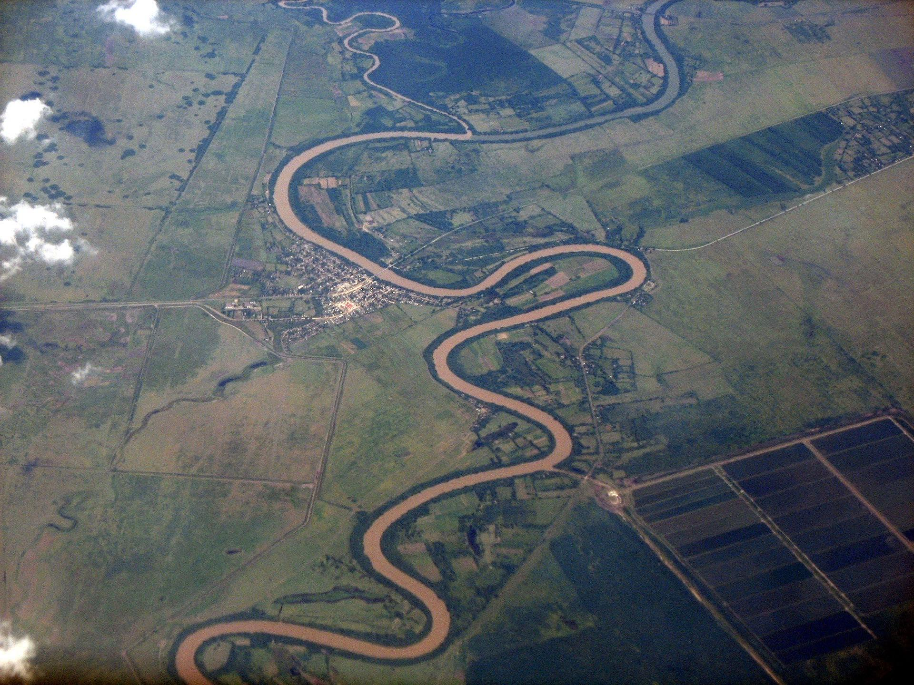
https://en.wikipedia.org/wiki/Cauto_River#/media/File:Rio-cauto-cuba.JPG
- Braided stream
- Meandering stream

LO8. I can explain at least five reasons why flooding may occur in a given stream.

Which of the following are common causes for flooding in an area? Select all that apply.
- Large amounts of precipitation over a short period of time
- Larger than average amounts of precipitation over a long period of time
- Large amounts of snowmelt over a short period of time
- Significant changes to the physical landscape over a short period of time

Which of the following human modifications to the physical landscape could lead to an increased risk of flooding in an area? Select all that apply. (low score)
- The paving of previously natural areas with asphalt
- The rerouting of water via storm sewers
- The terraforming of wetlands into new agricultural land
- The new damming or leveeing of otherwise naturally-occurring stream channels
- The collapse of previously constructed dams or levees

Floods only happen immediately after significant storm events.
- True
- False

Which of the following are the primary causes of flooding in the Eastern United States? Select all that apply.
- Hurricanes or tropical storms
- Snowmelt
- Large non-tropical storms

How would the conversion of wetlands to agricultural lands impact the risk of flooding in a region?
- It would increase the flooding risk
- It would decrease the flooding risk
- There would be no change to the risk of flooding

A growing city expands outward, converting natural lands to housing developments and shopping malls. How would this change impact the risk of flooding in a region?
- It would increase the flooding risk
- It would decrease the flooding risk
- There would be no change to the risk of flooding

A land conservation trust purchases some unused agricultural lands and converts them to wetlands. How would this change impact the risk of flooding in a region?
- It would increase the flooding risk
- It would decrease the flooding risk
- There would be no change to the risk of flooding

Determine if the following statements are true or false.
i. Hurricanes are more likely to cause flooding in the eastern U.S. than the western U.S.
ii. Snowmelt is more likely to cause flooding in the western U.S. than the eastern U.S.
- Both statements are true
- Both statements are false
- The first statement is true; the second statement is false
- The first statement is false; the second statement is true

Which of the following are BOTH examples of adjustments to flooding?
- Building a downstream dam and constructing levees along a stream in a city.
- Purchasing flood insurance and regulating zoning for parks in the floodplain.
- Regulating zoning for parks in the floodplain and building levees along a stream channel.
- Dredging a channel to increase its depth and building an upstream dam.

LO9. I can explain why streamflow data is important to society.

How would urbanization influence the potential for flooding?
- Urbanization will increase streamflow and increase the risk of flooding
- Urbanization will reduce streamflow and increase the risk of flooding
- Urbanization will increase streamflow and decrease the risk of flooding
- Urbanization will reduce streamflow and decrease the risk of flooding

Which of the following is NOT a potential outcome of monitoring of stream discharge values?
- Inform National Weather Service flood forecasts
- Inform knowledge regarding the availability of drinking water
- Help predict when the next significant flooding event will occur
- Help define water levels in freshwater ecosystems
- Inform decisions regarding recreational use of stream systems (i.e., rafting, etc.)
- Inform the design of construction projects

Stream gauge information can help solve disputes between states regarding water rights and consumption.
- True
- False

Groundwater Systems

LO1. I can describe what we mean when we use the term “groundwater”.

There is much more of Earth's freshwater in rivers and streams than in groundwater.
- True
- False

Groundwater accounts for approximately ___ of the world's freshwater or about 1% of the world's total water.
- 10%
- 20%
- 30%
- 40%.

Where is groundwater found? Select all that apply.
- In cave systems in some types of rock, such as limestone
- In tiny spaces between grains in sediments and sedimentary rocks
- In fractures in any type of rock
- In giant storage reservoirs constructed by aliens who were eaten by the dinosaurs
- In channels of underground rivers

Groundwater represents all water on the ground and below the ground on Earth.
- True
- False

Groundwater and surface water never interact as they are two different reservoirs of fresh water.
- True
- False

Most groundwater is present in underground lakes and cave systems.
- True
- False

What is groundwater?
- Water in contact with the ground surface
- Water on or below the ground surface
- Water below the ground surface

Identify if the following statements are true or false.
i. Groundwater is found in underground stream systems
ii. Groundwater is present in tiny spaces between grains of sediment and sedimentary rocks
- Both statements are true
- Both statements are false
- The first statement is true; the second is false
- The first statement is false; the second is true

LO2. I can define the terms porosity and permeability.

Which of the following statements best describes the difference between a rock's porosity and permeability?
- Porosity refers to the presence of holes in the rock and the permeability refers to the percentage of holes to rock
- Porosity refers to the amount of free space in the rock and permeability refers to the level which the spaces are connected
- Porosity refers to how well water will be held in the rock and the permeability refers to the level of space in the rock

Rocks can have high porosity but very low permeability.
- True
- False

Rocks can have high permeability and very low porosity.
- True
- False

What is the name given to the void spaces between grains of sediment?
- Permeables
- Pores
- Whorls
- Vesicles

What is the term that represents the percentage of sediment that is made up of spaces between the grains?
- Porosity
- Aquifer
- Water table
- Permeability

A beaker is filled with 1000 milliliters (ml) of coarse well-rounded sand. Water is poured into the beaker until it reaches the top of the sand. Which of the following values best predicts approximately how much water was added to the beaker?
- 50 mL
- 600 mL
- 350 mL
- D50 mL

Which earth material has the greatest permeability?
- Clay
- Sand
- Basalt
- Gravel

Which earth material would have the greater permeability?
- Unfractured basalt
- Fractured basalt

How would the porosity and permeability values be changed as sand is converted to sandstone?
- Porosity would increase, permeability would decrease
- Porosity would decrease, permeability would increase
- Both would increase
- Both would decrease
- Neither would change

Approximately what proportion of unconsolidated gravel or coarse sand would be composed of spaces between grains?
- 35%
- 55%
- 5%
- 15%

Three identical containers are filled with flour, with uncooked rice, and with coffee beans. Predict how they would rank in terms of permeability (from highest to lowest).
- Coffee beans, rice, flour
- Flour, coffee beans, rice
- Rice, flour, coffee beans
- Coffee beans, flour, rice
- Flour, rice, coffee beans

Review the two statements below and identify whether they are true or false.
i. Porosity is the proportion of a rock that is composed of open spaces.
ii. Permeability is the capacity of a fluid to flow through a rock.
- Both statements are true
- Both statements are false
- The first statement is true; the second statement is false.
- The first statement is false; the second statement is true.

LO 3. I can explain how these porosity and permeability might change in different earth materials.

Rank the following earth materials from high permeability to low permeability.
- Sand, rounded gravels, granite, sand and clay mixture
- Rounded gravels, sand, sand and clay mixture, granite
- Granite, sand, sand and clay mixture, rounded gravels
- Sand and clay mixture, granite, sand, rounded gravels

How would the permeability of materials change as sand undergoes lithification to form sandstone?
- Permeability would stay about the same
- Permeability would decrease
- Permeability would increase

How would the porosity of materials change as sand undergoes lithification to form sandstone?
- Porosity would stay the same
- Porosity would increase
- Porosity would decrease

Select the option below that best fills the blanks in the following statement: "Igneous rocks are generally ___ porous or permeable unless they are ___."
- not; constrained units
- very; constrained units
- not; fractured
- very; fractured

Select the option below that best fills the blanks in the following statement: "Volcanic rocks can be very ___ but are not usually ___."
- permeable; porous
- porous; permeable

LO 4. I can define the water table.

Drilling down from Earth's surface, which zone would you encounter first?
- Unsaturated zone
- Saturated zone

Where is the water table? Select all that apply.
- Top of saturated zone
- Top of unsaturated zone
- Bottom of unsaturated zone
- Bottom of saturated zone

Select the option below that best fills the blanks in the following statement: "All of the rock/sediment below the water table is ___ and everything above it is ___."
- unsaturated; unsaturated
- saturated; unsaturated
- unsaturated; unsaturated
- unsaturated; saturated

If you were to drill a cylindrical hole downward into the ground, you would (in most places) eventually hit water. The horizon where you reach water is represented by the ___. Select all that apply.
- water table
- water zone
- top of the saturated zone
- bottom of the unsaturated zone

The boundary between the saturated zone and the unsaturated zone is called the ___.
- aquifer
- water table
- permeability
- hydrologic cycle

Generally, how far below Earth’s surface would you expect to find the water table?
- More than 100 meters
- Between 50-100 meters
- Between 10-50 meters
- Between 1-10 meters
- Less than 1 meter

LO5. I can explain how the position of the water table varies relative to the land surface.

Which is the best description of the shape of the water table?
- The shape of the water table is random and is related to geology, not the shape of the land surface
- The shape of the water table is opposite to the topography of the land surface
- The shape of the water table is similar to the topography of the land surface

Which is the best description of the shape of the water table?
- The shape of the water table is related to the geometry of the underlying rock units, not the shape of the land surface
- The shape of the water table is random and is related to rock type, not the shape of the land surface
- The shape of the water table is opposite to the topography of the land surface
- The shape of the water table is similar to the topography of the land surface

How does the geometry of the water table relate to the land surface above it?
- It matches it exactly
- It often is the opposite
- It matches the surface, but is more subdued

Imagine a stream that is located at the bottom of two steep slopes. Knowing what you know about the water table, what type of stream would you predict the stream to be?
- A gaining stream
- A losing stream

Groundwater moves from areas where the water table is low to areas where the water table is high.
- True
- False

Predict the nature of groundwater flow in the saturated zone below a slope that is tilted from west to east.
- Groundwater would not flow unless it was removed by pumping of wells
- Groundwater would flow from west to east
- Groundwater would flow from east to west
- Groundwater would flow vertically downward as water infiltrated into the ground after a precipitation event

Predict the most likely orientation of the water table below a slope that is tilted from north to south.
- The water table would be horizontal
- The water table would slope from south to north
- The water table would slope from north to south

The map below shows the elevation in meters of the water table in three wells (A, B, C) underlying a hill. Read the statements below and identify the best answer.
- If well A was contaminated by a pesticide spill, wells B and C would both be at risk of contamination.
- If well B was contaminated by a pesticide spill, wells A and C would both be at risk of contamination.
- If well C was contaminated by a pesticide spill, wells A and B would both be at risk of contamination.
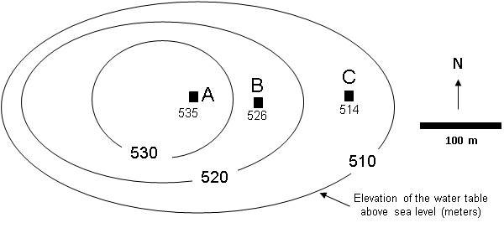

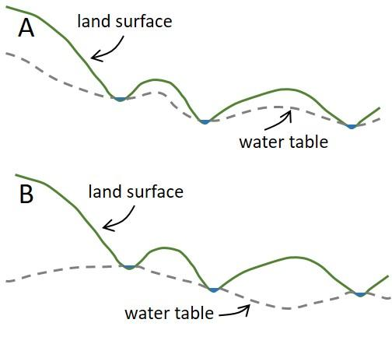
Review the image. The image illustrates the configuration of the land surface and two alternative configurations for the water table. Which would be more likely to be accurate in a temperate environment that experienced moderate temperatures and precipitation?
- A
- B

LO6. I can sketch and label an illustration of two types of aquifer systems (open aquifer, confined aquifer).

Soil resting on top of a gravel deposit would represent what type of aquifer?
- Confined
- Unconfined

Below the surface of the Earth there is a unit of rock that is made up of the sedimentary rock, shale. All of the rock units above it (extending to the surface) are either sandstones or sediment. Which of the following types of aquifer is present in the area above the shale?
- A confined aquifer
- An unconfined aquifer
- Cannot determine with the given information

Below the surface of the Earth there is a unit of rock that is made up of the sedimentary rock, shale. Above the shale unit is a sandstone unit. Above the sandstone unit is another shale unit. The sandstone unit contains abundant groundwater. Which of the following types of aquifer is present in the sandstone unit?
- A confined aquifer
- An unconfined aquifer
- Cannot determine with the given information

At some distance below the surface of the Earth there is a unit of rock that is made up of the sedimentary rock, sandstone. Below the sandstone unit is a unit of the sedimentary rock, shale. It is unknown what types of rock lie above the sandstone unit. The sandstone unit contains abundant groundwater. Which of the following types of aquifer is present in the sandstone unit?
- A confined aquifer
- An unconfined aquifer
- Cannot determine with the given information

Select the option below that best fills the blanks in the following statement: "A confined aquifer must have ___ permeability units ___ the rock containing the groundwater."
- high; above
- low; above
- low; below
- high; below

Which is the best description of an aquifer?
- The boundary between the saturated zone and the unsaturated zone
- Groundwater that flows readily through rocks and sediment below ground
- Rock of sediment below ground that accommodates the flow and storage of groundwater
- Underground rock or sediment below streams or lakes

What type of materials are most likely to be associated with a confining unit? Select all that apply.
- Sand
- Gravel
- Clay
- Shale

Which material would consistently make the best aquifer?
- Soil
- Gravel
- Granite
- Shale

Confined aquifers have good permeability but poor porosity while unconfined aquifers have both good porosity and good permeability.
- True
- False

The top of an unconfined aquifer is represented by ___.
- The water table
- A confining unit
- An artesian layer

An aquifer can be both confined and unconfined in different locations.
- True
- False

Review the image of four columns of rock layers below ground and answer the questions that follow. The layers represent a combination of sandstone and shale.
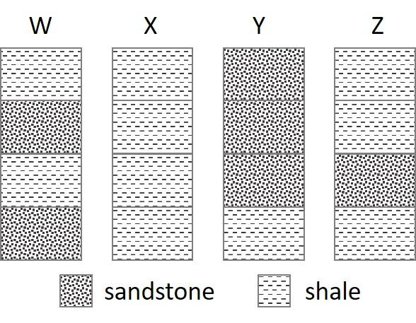
On the basis of the configurations, which column(s) contain a confined aquifer?
- W, X, Y, and Z
- W, Y, and Z
- W, X, and Y
- W and Z
- Only Y

On the basis of the configurations, what type of aquifer is represented in column Y?
- An unconfined aquifer
- A confined aquifer
- It does not represent an aquifer

On the basis of the configurations, what type of aquifer is represented in column Z?
- An unconfined aquifer
- A confined aquifer
- It does not represent an aquifer

LO7. I can identify the types of materials that make up aquifers in the US.

What type of rock is most likely to contain caves and sinkholes?
- Limestone
- Sandstone
- Fractured granite
- Schist

What name is given to an underground body of rock or sediment that contains a substantial supply of groundwater?
- Aquifer
- Aquitard
- Artesian well
- Aquiclude

Which of the following materials form aquifers in the United States? Select all that apply.
- Solid igneous rock
- Fractured igneous rock
- Sand and gravel
- Carbonates
- Sandstone

Which of the following is the most common aquifer material in the United States?
- Solid igneous rock
- Fractured igneous rock
- Sand and gravel
- Carbonates
- Sandstone

What is the source for most groundwater resources in the US?
- Limestone cave systems
- Fractured rocks
- Sand and gravel

Identify if the pair of statements that follow are true or false.
i. Limestone aquifers are commonly found in Florida
ii. Sand and gravel aquifers are commonly found in Midwestern states such as Illinois and Ohio
- Both statements are true
- Both statements are false
- The first statement is true; the second statement is false
- The first statement is false; the second statement is true

Identify if the pair of statements that follow are true or false.
i. Fractured igneous rocks commonly form aquifers in Florida
ii. Sand and gravel aquifers are found in states that were glaciated during the last ice age
- Both statements are true
- Both statements are false
- The first statement is true; the second statement is false
- The first statement is false; the second statement is true

Identify if the pair of statements that follow are true or false.
i. Fractured igneous rocks commonly form aquifers in Oregon and Washington
ii. The High Plains (Ogallala) aquifer is primarily composed of limestone cave systems
- Both statements are true
- Both statements are false
- The first statement is true; the second statement is false
- The first statement is false; the second statement is true

A ________ porosity sediment such as _________ would act as an aquitard in a groundwater system.
- low; sand
- high; clay
- low; clay
- high; sand

The best properties for an aquifer are
- low porosity and low permeability
- low porosity and high permeability
- high porosity and high permeability
- high porosity and low permeability.

LO8. I can describe at least two ways water enters and leaves groundwater systems.

Where do springs form? Select all that apply.
- At the opening to a limestone cave system
- At a nonconformity surface where sandstone rests on top of granite
- Where a fracture or fault intersects the land surface
- Where rivers sink underground

Which two of the following represent groundwater recharge? Select all that apply.
- Infiltration
- Gaining streams
- Losing streams
- Springs

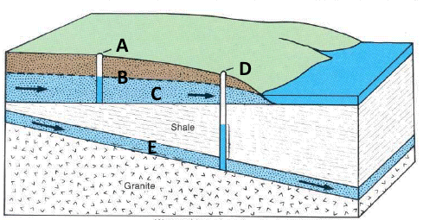
Consider the figure and answer the questions that follow.
https://pubs.usgs.gov/gip/gw_ruralhomeowner/pdf/gw_ruralhomeowner.pdf
Which letter properly labels an artesian well?
- A
- B
- C
- D
- E

Which letter properly labels a standard water table well?
- A
- B
- C
- D
- E

Which three of the following lead to groundwater recharge?
- Infiltration
- Gaining streams
- Losing streams
- Storage
- Springs
- Irrigation

Which three of the following lead to groundwater discharge?
- Infiltration
- Gaining streams
- Losing streams
- Storage
- Springs
- Irrigation

Which would be the most likely location for a spring where groundwater came to the surface?
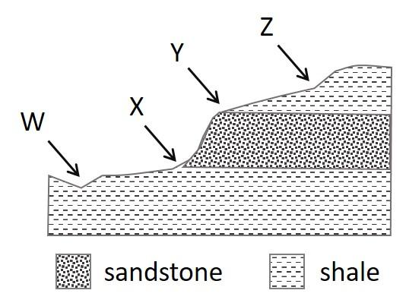
- W
- X
- Y
- Z

Water ENTERS groundwater systems through ______________ and water LEAVES groundwater systems through ______________?
- Gaining streams; infiltration
- Losing streams; infiltration
- Gaining streams; springs
- Losing streams; springs

LO9. I can explain how groundwater flows and how this can be used to identify sources of groundwater pollution.

Groundwater flow rates typically increase with increasing size of the openings through which the water flows.
- True
- False

Groundwater flow rates always increase as groundwater flows into units with a higher porosity.
- True
- False

An underground gas tank is found to have leaked into the aquifer. Given your knowledge of the water table, where would you look for the contamination? Select all that apply.
- The area immediately surrounding the tank
- The area downslope of the tank
- The area upslope of the tank

Liquid hazardous waste is disposed of by pumping it down injection wells. Which of the following descriptions of a well location would be most suitable for use as an injection well? Select all that apply.
- An unconfined aquifer
- A confined aquifer
- Into a sandstone unit just below the surface
- Into a sandstone unit between two shale units

Use the map below to answer the questions that follow. The map shows the elevation in meters of the water table in three wells (A, B, C) underlying a hill.
Read the statements below and identify the best answer.
- If well B was contaminated by a pesticide spill, wells A and C would both be at risk of contamination.
- If well B was contaminated by a pesticide spill, well A would be at risk of contamination but well C would be less likely to be at risk.
- If well B was contaminated by a pesticide spill, well A would not be at risk of contamination but well C would be more likely to be at risk.

Read the statements below and identify the best answer.
- If well C was contaminated by a pesticide spill, wells A and B would both be at risk of contamination.
- If well C was contaminated by a pesticide spill, neither well A nor B would be at risk of contamination.
- If well C was contaminated by a pesticide spill, well A would not be at risk of contamination but well B would be likely to be contaminated.

LO 10. I can discuss the types of features that cities should look for in the search for suitable groundwater resources.

Which of the following factors lead to a higher chance of finding suitable groundwater resources for an area? Select all that apply.
- A deep water table
- High porosity
- A steep surface slope
- High permeability
- A thick aquifer
- Abundant industrial development

You are looking for a site to drill a new water well. Which type of surface material would be the best to ensure a high infiltration rate for your area?
- Sand and gravel surface materials
- Sandstone surface materials
- Clay or shale surface materials

Which of the following factors lead to a higher rate of infiltration for groundwater?
- A gently sloping land surface
- A steep land surface slope

