Example of Module 1 Instructions Shared with Students for Geo Journeys Project

General Project Info
You will work in groups of 2-3 on a summative, modular project centered on creating a field trip proposal to a location features interesting rocks and geologic processes addressed in this course. Your group will integrate spatial, petrographic, geochemical, and tectonic data into an ArcGIS StoryMap™ to present a cohesive geologic story of your chosen location. Your learning objectives for this project:
- Design a field trip that is logistically feasible.
- Integrate spatial information with geologic datasets at a variety of scales.
- Interpret petrological processes within a tectonic context.
- Appraise societal implications of hosting a field trip in a particular place.
- Effectively convey a geologically relevant story by combining multiple media and communication techniques to reach a variety of audiences.

Instructions
1. Form your group.
- 2-3 students per group.
2. State your preference for the tectonic setting of your proposed field trip. In your document, list the bulleted options shown below, then put a number 1 next to your first choice, a 2 next to your second choice, and a 3 next to your third choice. If you want to a refresher on these tectonic settings, review sections 2.2.3, 2.3, 2.4, 2.5, and 2.7 on this page. Here are your options:
- Continental Divergent Boundary (rift zone)
- Oceanic Hotspot
- Continental Hotspot
- Continental Arc
- Island Arc
- Continental Collision

3. Explain your rationale for choosing these tectonic settings. In other words, why do you think the geology of each setting is important to share with others? If you are already thinking about specific locations (a particular volcano or mountain range, for instance), you can use this to explain your rationale. Write a short paragraph for each of your three choices.

Example of Instructions for Module 2 of Geo Journeys Project

Instructions:
1. State your field trip location and rationale for choice (~1 paragraph).
- Why did you choose this particular location to represent your tectonic setting? What is so special about it in geologic terms that makes it worth visiting for your proposed field trip?

2. Compile topographic, geologic, and LiDAR basemaps of your general field trip location that you will eventually add to your StoryMap.
- Specify which locations you plan on focusing on for the field trip. Do this by writing a small paragraph and circling/highlighting the relevant parts of at least one of the basemaps. It's ok if you change plans later in the project!
- To make your life easier in the future, include source information–URL, author(s), date accessed, etc. in the document you submit for this part of the project.

3. Describe the logistical details that you will need to address to visit your field trip destination. What would someone need to know to run this trip? For each of the criteria on this bulleted list, write a 1-2 sentence description, and include URLs to the businesses/resources you would use.
- Physical access to field trip sites (paved or dirt roads? trails? potentially adverse weather conditions?)
- Lodging (camping or hotels)
- Cell service (use this resource)
- Water
- Food (restaurants, grocery stores, etc)
- Hospitals/urgent care/medical services
- Permitting (what official or unofficial permissions do you need to visit your field trip locations?), such as:
- Landowner permission (Would you be visiting private land? Whose land?)
- Visas for countries outside of the U.S. (use this resource)
- Scientific research permits (use this resource or find the equivalent page if you are not visiting a U.S. national park)

4. Create an annotated bibliography (GSA citation format) that will help you investigate the igneous and/or metamorphic rocks you expect to see on your trip. The bibliography should include at least 4 sources each with annotations.
Each paragraph-long annotation should include:
- a summary of each paper
- an explanation of how it relates to your field trip location and tectonic setting.
Bibliography sources may include:
- Review papers
- field guides
- academic research papers on the geochemistry and/or petrology of your setting

5. After you complete all of the previous steps, write a 1-2-paragraph written reflection. Address the following:
- So far, what is going well in terms of your group dynamic?
- What did you like about this part of the project? In what ways are you excited about designing this proposed field trip?
- Are there any aspects of Part 2 that you found challenging, either in terms of the content of the work or the group dynamic?
- What would you like to change about the project or your group dynamic as you move on to working on part 3?

Example of Instructions for Module 3 of Geo Journeys Project

Instructions:
1. In a short paragraph, summarize the important igneous and/or metamorphic rock types you will see in your field trip. The geologic map and research papers you gathered from Part 2 should help you do this, but feel free to use other sources if they are not useful for this. Cite your sources in the GSA citation format.
- For the remaining parts of this assignment, you'll focus on four rock types. In this paragraph, be sure to explain the rationale the four types you decided to feature.
2. Hand samples: Characterize/describe hand samples of specific igneous and/or metamorphic rock types at specific field trip sites you intend to visit.
- You must write a short paragraph (3-4 sentences) for at the four different rock units. Mention the proportions of the dominant mineral phases found in each rock type, and how they can be identified in a hand sample.
- With each paragraph, show a photo of a representative hand sample of each rock type. Include some indication of scale in the photo! Feel free label the photo based on what you mention in the description (e.g., mineral types, proportions, textures, etc.)
- Mention at least one potential field trip stop for each rock unit (include GPS coordinates!). Explain how you will access the location. This does not have to be a final decision. In later parts of your project, you can opt for other locations as field trip stops!
3. Thin sections: For each of the rock types you mentioned in the previous section, Show at least one photomicrograph (both in PPL and XPL!) and label and describe what you see.
- Include a scale bar and feel free to add labels (mineral names, lines indicating foliation orientation, etc.) to these images.
- Write a few sentences that characterize what you see in the thin section photomicrographs you chose to show here, including the proportions of the dominant mineral phases found in each rock type, how these minerals are distinguished from one another in the thin section. Keep in mind that you may be able to see other (especially smaller/less abundant) mineral phases in the thin section versus the hand sample.
- Also write a few sentences interpreting these observations in terms of the petrologic history of each rock type (e.g., did one mineral phase crystallize early? Did a particular phase form before/during/after peak metamorphism or deformation?)
4. Field Photos: For each of the proposed field trip stops you mentioned, provide photos of the field relationships, structures, and other large-scale geologic features on display at each location.
- You can use a photo you have taken (if your locations are nearby).
- If you include your own photos, make sure to have something in the photo that shows the scale of the outcrop or other geologic features you are highlighting. A person, yardstick, car, are examples of what could show scale.
- Even if you include your own photo(s), you should also look for field imagery on the GigaPan online database. Try to include at least one GigaPan image.
- Beneath each image, list the interesting and noteworthy features. What is worth looking at in this location? Why are you including this stop on the trip? And how does it relate to the broader tectonic context of the region?
5. List all references for the information and images you used for sections 1-4. Use the GSA citation format.
- All of your writing must be in your own words; do not use direct quotes. You are expected to employ the vocabulary for rock and mineral descriptions used in class meetings, lab activities, and the petrology and mineralogy online textbooks.

6. Reflection: as you did for part 2, write 1-2 paragraphs about your experience working on this part of the project. Address the following:
- So far, what is going well in terms of your group dynamic?
- What did you like about this part of the project?
- What have you learned or understood better about rocks, minerals, thin sections, etc. by completing this part of the project?
- Are there any aspects of Part 3 that you found challenging, in terms of the content of the work or the group dynamic?
- What would you like to change about the project or your group dynamic as you move on to working on part 4?

Example of Instructions for Module 4 of Geo Journeys Project

Instructions:
This module is meant to guide you toward collecting, organizing, and showcasing geochemical data for your story map and identifying links to volcanology, geology hazards, and economic geology. Links and copies of the following should be compiled in a Google Doc accessible to your group members and me.
This module check-in should include multiple components:
- A spreadsheet of data from your field trip area, or your broader plate tectonic region (ex: geochemical data from Yellowstone National Park or the Cascade Range)
  - Organize your data following the format used on John Brady's geochemical tools webpage
  - Links to an external site.
  - (major element data followed by trace element data
- TAS Diagram (Na2O + K2O vs. SiO2) Select major element oxides (at least 4, plotted against either SiO2 or MgO on x-axis) presented as Harker variation diagrams
  - Use this webpage to generate Harker diagrams for at least 4 major element oxides: https://www.science.smith.edu/~jbrady/petrology/igrocks-tools/variation-diagram.php
- Trace element concentrations presented as one spider diagram
  - Use this webpage to generate plots: https://www.science.smith.edu/~jbrady/petrology/igrocks-tools/spider-diagram.php
- Description of trends observed each diagram (see examples below)
- Description of volcano type(s) in field trip destination (ex: Volcán Ometepe, in Nicaragua, is an example of a stratovolcano. This type of volcano is associated with continental arcs (ocean-continent subduction zones) and intermediate magma compositions formed by basalt differentiation (and potentially, magma contamination/mixing with partially melted continental crust).
- Description of geologic hazards (ex: lahars, pyroclastic flows, earthquakes, lava flows, etc.)
- Economic geology (ex: arc magmatism is associated with the formation of Cu porphyry systems, such as the Freeport McMoRan Morenci Mine in southern Arizona)

EXAMPLE TAS DIAGRAM
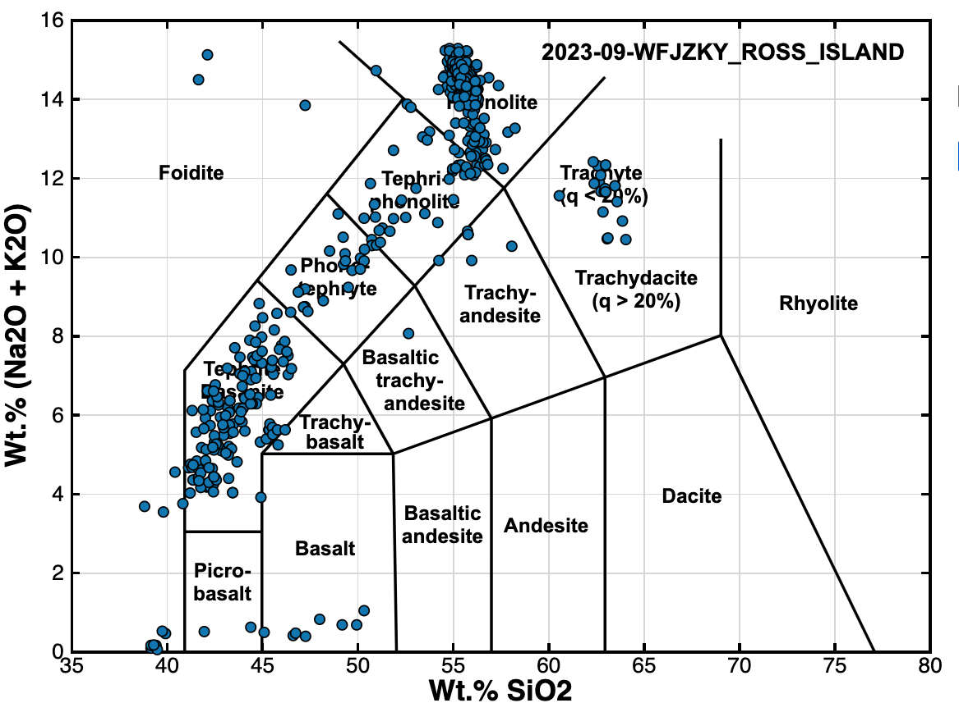
EXAMPLE DESCRIPTION OF TRENDS: Volcanic rocks from Mount Erebus range between subalkaline basalts and picro-basalts to alkaline tephrites, phonalites, and trachytes. They are dominantly alkaline, which is a common signature of melted continental crust and the waning stages of mantle plume volcanism

EXAMPLE HARKER DIAGRAM (note: four Harker diagrams are required)
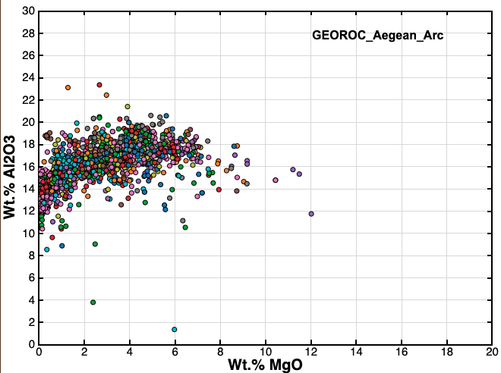
EXAMPLE DESCRIPTION OF TRENDS: This Harker diagram was created from geochemical analyses of Aegean Arc samples from the GEOROC database. Most samples plot between 14-18 wt% Al2O3 and 1-5% MgO. The most primitive samples (closest to parent composition) have MgO between 8-12 wt. %, and the most evolved samples (greater degrees of fractional crystallization) have the lowest MgO (<2 wt %) and highest Al2O3 (>20 wt%). The slight bend in the trend of MgO vs Al2O3 may indicate fractional crystallization of plagioclase.

EXAMPLE SPIDER DIAGRAM:
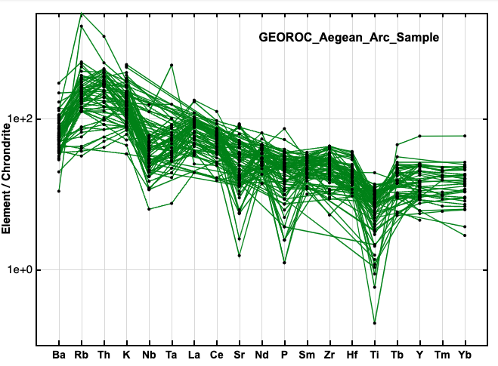
EXAMPLE DESCRIPTION OF TRENDS: This spider diagram was created from geochemical analyses of Aegean Arc samples from the GEOROC database. It shows enrichment in large ion lithophiles like Ba and Rb and depletion in HFS elements Nb, P, and Ti. This is consistent with island arc petrogenesis.
NOTE: do not use pre-made TAS, Harker, or spider diagrams from outside sources (e.g., a paper on Columbia River Basalts). I'd like you to find the geochemical data, use it to generate Harker and spider diagrams, and describe the trends that you see.
Geochemical databases:
- EarthChem: https://www.earthchem.org/
- GeoROC: https://georoc.eu/georoc/new-start.asp

Example of Rubric for Module 5 of Geo Journeys Project
Grading Rubric
Criteria | Ratings | %
Introduction + Geologic Setting  Includes components of part 1: Plate tectonic setting of field trip, Goal of field trip, number of stops,  Geographic setting of field trip (include a map),  Land acknowledgement and cultural history of field trip location | 2%  Full Marks  StoryMap include required information (maps, diagrams, descriptions) about the field trip motivation and geologic setting | 1.5%  Minor Issues  Setting inaccurately described, significance not convincingly shared | 1%  Larger Issues  Major issues with content and/or organization | 0 pts  No Marks  Missing from StoryMap
Logistics  Includes components of part 2: maps showing field trip location, lodging, food, accessibility issues, etc. | 2%  Full Marks  Includes complete description of logistics needed to introduce ERTH 3040 students to field trip. | 1.5%  Minor Issues  Materials are slightly inaccurate or do not relate to location. Some locations are not described or displayed regarding access to stops, services, etc. | 1%  Larger issues  Materials are inaccurate or do not appear to relate to locations or are logistically infeasible. | 0 %  No Marks  Missing from StoryMap
Explanation of Geology and Important Rock types  Includes components of part 3: Minerals, mineral and rock textures, and rock types (igneous and metamorphic) | 2%  Full Marks  Includes images of outcrop, hand sample, and thin sections, explanations of key textures, mineralogy, and characteristics. | 1.5%  Minor Issues  Image explanations are slightly inaccurate or incomplete. Images do not appear to relate to field trip stops/tectonic setting | 1%  Major Issues  Image explanations are inaccurate, or images do not relate to field trip stops/tectonic setting | 0 %  No Marks  Missing from StoryMap
Geochemistry Information  Includes components of part 4: TAS diagram, Harker variation diagrams, spider plot, and discussion of geochemical trends related to plate tectonic setting | 2%  Full Marks  TAS diagram and at least two Harker variation diagrams. Trends for TAS plot and at least one of the Harker diagrams are described and explained in terms of the geologic/ plate tectonic setting. | 1.5 %  Minor Issues  All plots included but they are inaccurately described or reference to plate tectonic setting is incomplete or inaccurate | 1%  Missing something  Missing plots (<2 Harker diagrams, TAS diagram) or explanations of trends and plate tectonic associations not provided. | 0 %  No Marks  Missing from StoryMap
Field Trip Stop Descriptions | 2%  Full Marks  Presents volcano type, associated hazards, and expected (or actual) economic geology associated with setting | 1.5%  Minor Issues  Completely addressed, but field trip location and their geologic context inaccurately described or reference to plate tectonic setting is incomplete or inaccurate | 1%  Missing something  Section has errors or is missing required content, such as map, photos, geolgic context. | 0 %  No Marks  Missing from StoryMap
Citations  StoryMap includes citations in the correct format (GSA) | 1 %  Full Marks  At least four citations included. Figures, images, and text are correctly cited and referenced at end of presentation using GSA format | 0.5%  Incomplete or something missing  Incorrect citation format or missing figure/image or text citations | 0 pts  No Marks  Missing from StoryMap
TOTAL % |  |  |  | 11%

