Example of Module 1 Instructions Shared with Students for Geo Journeys Project

General Project Info
You will work in groups of 2-3 on a summative, modular project centered on creating a field trip proposal to a location features interesting rocks and geologic processes addressed in this course. Your group will integrate spatial, petrographic, geochemical, and tectonic data into an ArcGIS StoryMap™ to present a cohesive geologic story of your chosen location. Your learning objectives for this project:
- Design a field trip that is logistically feasible.
- Integrate spatial information with geologic datasets at a variety of scales.
- Interpret petrological processes within a tectonic context.
- Appraise societal implications of hosting a field trip in a particular place.
- Effectively convey a geologically relevant story by combining multiple media and communication techniques to reach a variety of audiences.

Instructions
1. Form your group.
- 2-3 students per group.
2. State your preference for the tectonic setting of your proposed field trip. In your document, list the bulleted options shown below, then put a number 1 next to your first choice, a 2 next to your second choice, and a 3 next to your third choice. If you want to a refresher on these tectonic settings, review sections 2.2.3, 2.3, 2.4, 2.5, and 2.7 on this page. Here are your options:
- Continental Divergent Boundary (rift zone)
- Oceanic Hotspot
- Continental Hotspot
- Continental Arc
- Island Arc
- Continental Collision

3. Explain your rationale for choosing these tectonic settings. In other words, why do you think the geology of each setting is important to share with others? If you are already thinking about specific locations (a particular volcano or mountain range, for instance), you can use this to explain your rationale. Write a short paragraph for each of your three choices.

Example of Instructions for Module 2 of Geo Journeys Project

Instructions:
1. State your field trip location and rationale for choice (~1 paragraph).
- Why did you choose this particular location to represent your tectonic setting? What is so special about it in geologic terms that makes it worth visiting for your proposed field trip?

2. Compile topographic, geologic, and LiDAR basemaps of your general field trip location that you will eventually add to your StoryMap.
- Specify which locations you plan on focusing on for the field trip. Do this by writing a small paragraph and circling/highlighting the relevant parts of at least one of the basemaps. It's ok if you change plans later in the project!
- To make your life easier in the future, include source information–URL, author(s), date accessed, etc. in the document you submit for this part of the project.

3. Describe the logistical details that you will need to address to visit your field trip destination. What would someone need to know to run this trip? For each of the criteria on this bulleted list, write a 1-2 sentence description, and include URLs to the businesses/resources you would use.
- Physical access to field trip sites (paved or dirt roads? trails? potentially adverse weather conditions?)
- Lodging (camping or hotels)
- Cell service (use this resource)
- Water
- Food (restaurants, grocery stores, etc)
- Hospitals/urgent care/medical services
- Permitting (what official or unofficial permissions do you need to visit your field trip locations?), such as:
- Landowner permission (Would you be visiting private land? Whose land?)
- Visas for countries outside of the U.S. (use this resource)
- Scientific research permits (use this resource or find the equivalent page if you are not visiting a U.S. national park)

4. Create an annotated bibliography (GSA citation format) that will help you investigate the igneous and/or metamorphic rocks you expect to see on your trip. The bibliography should include at least 4 sources each with annotations.
Each paragraph-long annotation should include:
- a summary of each paper
- an explanation of how it relates to your field trip location and tectonic setting.
Bibliography sources may include:
- Review papers
- field guides
- academic research papers on the geochemistry and/or petrology of your setting

5. After you complete all of the previous steps, write a 1-2-paragraph written reflection. Address the following:
- So far, what is going well in terms of your group dynamic?
- What did you like about this part of the project? In what ways are you excited about designing this proposed field trip?
- Are there any aspects of Part 2 that you found challenging, either in terms of the content of the work or the group dynamic?
- What would you like to change about the project or your group dynamic as you move on to working on part 3?

Example of Instructions for Module 3 of Geo Journeys Project

Instructions:
1. In a short paragraph, summarize the important igneous and/or metamorphic rock types you will see in your field trip. The geologic map and research papers you gathered from Part 2 should help you do this, but feel free to use other sources if they are not useful for this. Cite your sources in the GSA citation format.
- For the remaining parts of this assignment, you'll focus on four rock types. In this paragraph, be sure to explain the rationale the four types you decided to feature.
2. Hand samples: Characterize/describe hand samples of specific igneous and/or metamorphic rock types at specific field trip sites you intend to visit.
- You must write a short paragraph (3-4 sentences) for at the four different rock units. Mention the proportions of the dominant mineral phases found in each rock type, and how they can be identified in a hand sample.
- With each paragraph, show a photo of a representative hand sample of each rock type. Include some indication of scale in the photo! Feel free label the photo based on what you mention in the description (e.g., mineral types, proportions, textures, etc.)
- Mention at least one potential field trip stop for each rock unit (include GPS coordinates!). Explain how you will access the location. This does not have to be a final decision. In later parts of your project, you can opt for other locations as field trip stops!
3. Thin sections: For each of the rock types you mentioned in the previous section, Show at least one photomicrograph (both in PPL and XPL!) and label and describe what you see.
- Include a scale bar and feel free to add labels (mineral names, lines indicating foliation orientation, etc.) to these images.
- Write a few sentences that characterize what you see in the thin section photomicrographs you chose to show here, including the proportions of the dominant mineral phases found in each rock type, how these minerals are distinguished from one another in the thin section. Keep in mind that you may be able to see other (especially smaller/less abundant) mineral phases in the thin section versus the hand sample.
- Also write a few sentences interpreting these observations in terms of the petrologic history of each rock type (e.g., did one mineral phase crystallize early? Did a particular phase form before/during/after peak metamorphism or deformation?)
4. Field Photos: For each of the proposed field trip stops you mentioned, provide photos of the field relationships, structures, and other large-scale geologic features on display at each location.
- You can use a photo you have taken (if your locations are nearby).
- If you include your own photos, make sure to have something in the photo that shows the scale of the outcrop or other geologic features you are highlighting. A person, yardstick, car, are examples of what could show scale.
- Even if you include your own photo(s), you should also look for field imagery on the GigaPan online database. Try to include at least one GigaPan image.
- Beneath each image, list the interesting and noteworthy features. What is worth looking at in this location? Why are you including this stop on the trip? And how does it relate to the broader tectonic context of the region?
5. List all references for the information and images you used for sections 1-4. Use the GSA citation format.
- All of your writing must be in your own words; do not use direct quotes. You are expected to employ the vocabulary for rock and mineral descriptions used in class meetings, lab activities, and the petrology and mineralogy online textbooks.

6. Reflection: as you did for part 2, write 1-2 paragraphs about your experience working on this part of the project. Address the following:
- So far, what is going well in terms of your group dynamic?
- What did you like about this part of the project?
- What have you learned or understood better about rocks, minerals, thin sections, etc. by completing this part of the project?
- Are there any aspects of Part 3 that you found challenging, in terms of the content of the work or the group dynamic?
- What would you like to change about the project or your group dynamic as you move on to working on part 4?

Example of Instructions for Module 4 of Geo Journeys Project

Instructions:
In this part of the project, you will be collecting, organizing, and showcasing geochemical data for your StoryMap.
1. In an Excel or Google Sheets spreadsheet, compile a dataset of major element oxide concentrations (weight % of SiO₂, MgO, etc.) for igneous or metamorphic rocks sampled from your field trip area or your tectonic region. In other words, if, say you're focusing on Mount St. Helens, don't just collect data for a single lava flow or eruption, collect data from multiple eruptions at that volcano and/or lavas erupted from multiple volcanoes in the Cascadian volcanic arc. This dataset should include only bulk rock or whole-rock compositions (do not use data that represent mineral grains) and it should consist of at least thirty samples. You may need to source these data from multiple journal articles.
- Use the references you’ve already used as a starting point for your search for data!
- Also consider using these two very useful databases (they will cite the original research papers the data comes from, so keep track of that info for your own references list):
- EarthChem: https://www.earthchem.org/
- GEOROC: https://georoc.eu/georoc/new-start.asp
2. Organize your data in rows and columns following the spreadsheet format used on John Brady’s geochemical tools website and save it as a comma-separated variable (.csv) file.
- These instructions will tell you how to format the spreadsheet.
- When you plot these data, assign different colors to the symbols of data that belong to different groups of your choosing. For instance, you may want to make symbols that represent lavas from one volcano red, lavas from another volcano blue. For whatever sorts of colors/groups you decide, explain your basic rationale for your groupings of the samples and state which colors represent which groups.
- Besides using the .csv file for the following steps, you will save it for your final StoryMap (Part 5 of this project).
3. To make sure your spreadsheet is properly formatted, go to this page, scroll down to the “Data Source” drop-down menu and choose the “Upload Your Own Data” option. Upload the .csv file and look through it, checking for any typos/errors/etc.
4. Create a TAS Diagram (Na₂O + K₂O vs. SiO₂). Do so by uploading your CSV file at this page.
- You can upload the spreadsheet using the “Data Source” drop-down menu and selecting the “Upload Your Own Data” option.
- Write a paragraph in which you describe the distribution of your data and then interpret the petrological processes may have caused any trends it may display. Consider processes like partial melting, fractional crystallization, and assimilation that we have discussed in class. Refer to the example provided at the bottom of these instructions. The journal articles from which you source your data may offer some insights worth using when making these interpretations.
5. Create at least two Harker diagrams. Do so by uploading your CSV file at this page.
- These diagrams should plot at least two different major elements (choose a major element besides Na₂O or K₂O) on the y-axis, plotted against either SiO₂ or MgO on the x-axis. Make sure all Harker diagrams have the same element on the x-axis with the same range of concentrations.
- You can upload the spreadsheet using the “Data Source” drop-down menu and selecting the “Upload Your Own” option.
- Like what you did for the TAS diagram, write one paragraph describing the distribution of your data and any trends it may display and then using these trends, interpreting the petrological processes that may have caused them. Refer to the example provided at the bottom of these instructions.

Example TAS Diagram:
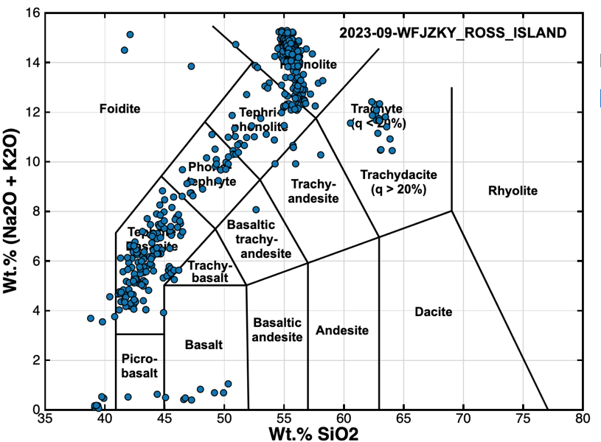
Example Description of Trends in TAS Diagram: Volcanic rocks from Mount Erebus range between subalkaline basalts and picrobasalts to alkaline tephrites, phonolites, and trachytes. They are dominantly alkaline, which is a common signature of melted continental crust and the waning stages of mantle plume volcanism (Doe et al. 2024). (That citation is not real, but just demonstrated here for the sake of the example.)
Example Harker diagram:
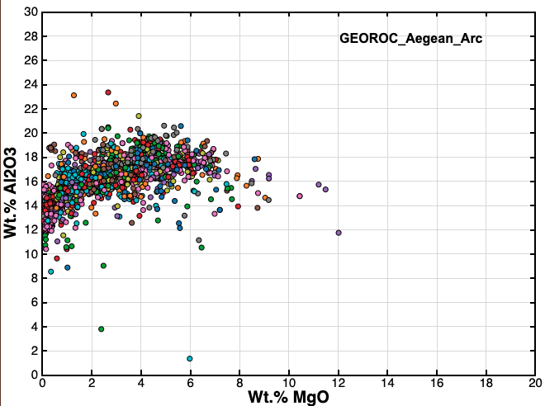
Example Description of Trends in Harker diagram: This Harker diagram was created from geochemical analyses of samples from the Aegean Volcanic Arc, downloaded from the GEOROC database. Most samples plot between 14-18 wt. % Al₂O₃ and 1-5 wt. % MgO. The most primitive samples (closest to parent composition) have MgO between 8-12 wt. %, and the most evolved samples (greater degrees of fractional crystallization) have the lowest MgO (<2 wt. %) and highest Al₂O₃ (>20 wt%). The slight bend in the trend of MgO vs. Al₂O₃ at MgO = 3-4 wt. % may indicate fractional crystallization of plagioclase.

Example of Instructions and Grading Rubric for Module 5 of Geo Journeys Project
Instructions:
1. Review the feedback shared with you for what you have submitted in parts 1-4 of this project. Address the feedback as you incorporate that content in this StoryMap.
As you create your StoryMap, make sure you structure your information in the "sidecar project" or "guided map tour" formats that you were introduced to in the UConn Library StoryMaps tutorial from the beginning of the semester.
In your approach to designing and putting together your StoryMap, keep your audience in mind: imagine that this project represents a field trip that a future ERTH 3040 class gets to go on, and your goal is to educate and excite these ERTH 3040 students for the trip!

2. As you weave together text and visuals, keep both of these elements balanced. Do not overload your StoryMap too much text. Large paragraphs can disrupt the flow of information you present and may obscure or distract from the visuals you display. Also, always provide context for the visuals! Try to ask yourself: does your audience have the labels, captions, or other forms of text needed to understand the maps, diagrams, photos, etc.?
- Throughout all of this, make sure you clearly and accurately cite your sources. You will put a references list at the bottom of the StoryMap.
- You must include in-text citations and add credits for any visuals you display (besides the built-in satellite maps... you should cite your source for geologic maps, though!).

3. Your StoryMap must include the following components (you must decide how to combine or divide these components so that it all fits together in an engaging, easy-to-follow field trip guide):
A. Introduction
State the basic motivation for this field trip in terms of its tectonic. Include at least one labeled visual aid. Why is this field trip location a special place to learn about this tectonic setting? This introduction should clarify the goal of field trip, the learning objectives intended for the field trip participants (something like those you have been given for weekly quizzes), and the number of field trip stops.
- Portray on a map and briefly describe the geographic setting of field trip (including locations of stops).
- Briefly acknowledge the cultural history of the field trip location. Who are the indigenous peoples of the lands you are visiting? This website may help you with this, depending on your field trip location.
B. Background Information and Field Trip Logistics
Provide the important logistical information that you were asked to address in part 2 (How will you get there? How will you access and when will you visit each stop? Where will you stay/eat/etc.?)
- Link this information to the map you display by adding pins/polygons/lines that indicate the locations/access routes/etc. of important services you'll need when visiting your location.
C. Geologic Context and Plate Tectonic Setting
- Provide an explanation of the geologic history and plate tectonic setting of the region you are visiting on this field trip.
- Including a figure (cartoon/cross sectional diagram/etc.) that illustrates the important geologic and plate tectonic process(es) featured on the trip.
- Display a geologic map of the region and link the explanation to it.
- Overlay your geologic map(s) on top of the basemap (satellite imagery or topo map). to show which geologic features relate to each field trip stop (more info about the stops below).
D. Important Rock Types, Mineral Assemblages, Rock Textures Featured on the Trip
- Provide a rationale for your choice of at least three of the important rock types or contacts between rock types that will be featured on the trip.
- Describe the minerals and textures observed in hand samples and thin sections of these lithologies.
- Connect your descriptions to photos of hand samples and thin section images, which must include some measurement of scale and be clearly labeled and captioned and correctly cited.
- Explain how the described mineral, textural, and rock type trends relate to the geologic context plate tectonic setting.
E. Geochemical Characteristics of Featured Rock Types
- Display a TAS diagram with an explanation of geochemical trends and which rock types are observed (as was completed for part 4)
- Provide Harker diagrams (at least two) with an description and brief explanation of their displayed geochemical trends (i.e., increasing SiO2 with decreasing MgO, because...).
- Clearly state the sources of the data (e.g., GeoROC, journal articles).
- Briefly explain how the described geochemical trends relate to the geologic context plate tectonic setting.
F. Field Trip Stops (Map-Based Representation of Where you will Go)
For at least four stops, describe their specific location and the geologic features displayed at the stop. Contextualize each stop in terms of the broader geologic "narrative" of the field trip. Consider how ordering the stops in a particular sequence will best represent the geologic narrative of the trip!
- Insert pins for each stop, and draw out the specific route that will link each stop to the next. This will make the info you present in the "sidecar" view easier to follow.
- Briefly explain how each stop highlights some important aspect of the geologic context/tectonic setting. Your explanation should also mention the important rock type(s) minerals textures observed at the stop.
- If any of the geochemical data comes from samples of rocks from a field trip stop (or nearby), make this clear as well.
- Each stop's description must include a map view (more zoomed-in than the one shown in the introduction) that clearly displays your means of accessing the stop and where you will be able to see the outcrop or other geologic feature.
- The map view of at least one stop must include a polygon that highlights a feature seen there (such as an outcrop, lava flow, cinder cone, or spatial extent of a rock formation)
- Include an outcrop-scale photo of what you may see at each stop (such as a GigaPan). If you do not have a photo taken at or near that location, include another photo that serves as a suitable comparison (be sure to cite your sources).
G. References and Group Member Contributions
List ALL references to sources used for the StoryMap in the GSA format. You should be citing sources and crediting images in the body of the StoryMap as well!
- At least four citations must be included.
- Describe the specific contributions made by each group member to the content of the Story Map.

Grading Rubric
Criteria | Ratings | %
Introduction + Geologic Setting  Includes components of part 1: Plate tectonic setting of field trip, Goal of field trip, number of stops,  Geographic setting of field trip (include a map),  Land acknowledgement and cultural history of field trip location | 2%  Full Marks  StoryMap include required information (maps, diagrams, descriptions) about the field trip motivation and geologic setting | 1.5%  Minor Issues  Setting inaccurately described, significance not convincingly shared | 1%  Larger Issues  Major issues with content and/or organization | 0 pts  No Marks  Missing from StoryMap
Logistics  Includes components of part 2: maps showing field trip location, lodging, food, accessibility issues, etc. | 2%  Full Marks  Includes complete description of logistics needed to introduce ERTH 3040 students to field trip. | 1.5%  Minor Issues  Materials are slightly inaccurate or do not relate to location. Some locations are not described or displayed regarding access to stops, services, etc. | 1%  Larger issues  Materials are inaccurate or do not appear to relate to locations or are logistically infeasible. | 0 %  No Marks  Missing from StoryMap
Explanation of Geology and Important Rock types  Includes components of part 3: Minerals, mineral and rock textures, and rock types (igneous and metamorphic) | 2%  Full Marks  Includes images of outcrop, hand sample, and thin sections, explanations of key textures, mineralogy, and characteristics. | 1.5%  Minor Issues  Image explanations are slightly inaccurate or incomplete. Images do not appear to relate to field trip stops/tectonic setting | 1%  Major Issues  Image explanations are inaccurate, or images do not relate to field trip stops/tectonic setting | 0 %  No Marks  Missing from StoryMap
Geochemistry Information  Includes components of part 4: TAS diagram, Harker variation diagrams, spider plot, and discussion of geochemical trends related to plate tectonic setting | 2%  Full Marks  TAS diagram and at least two Harker variation diagrams. Trends for TAS plot and at least one of the Harker diagrams are described and explained in terms of the geologic/ plate tectonic setting. | 1.5 %  Minor Issues  All plots included but they are inaccurately described or reference to plate tectonic setting is incomplete or inaccurate | 1%  Missing something  Missing plots (<2 Harker diagrams, TAS diagram) or explanations of trends and plate tectonic associations not provided. | 0 %  No Marks  Missing from StoryMap
Field Trip Stop Descriptions | 2%  Full Marks  Presents volcano type, associated hazards, and expected (or actual) economic geology associated with setting | 1.5%  Minor Issues  Completely addressed, but field trip location and their geologic context inaccurately described or reference to plate tectonic setting is incomplete or inaccurate | 1%  Missing something  Section has errors or is missing required content, such as map, photos, geolgic context. | 0 %  No Marks  Missing from StoryMap
Citations  StoryMap includes citations in the correct format (GSA) | 1 %  Full Marks  At least four citations included. Figures, images, and text are correctly cited and referenced at end of presentation using GSA format | 0.5%  Incomplete or something missing  Incorrect citation format or missing figure/image or text citations | 0 pts  No Marks  Missing from StoryMap
TOTAL % |  |  |  | 11%

