**Yellowstone Hotspot Track Names: __________________________**

Using the data below find when each of the volcanic fields were active.

(N. American Plate movement = 2.5 cm/ year)

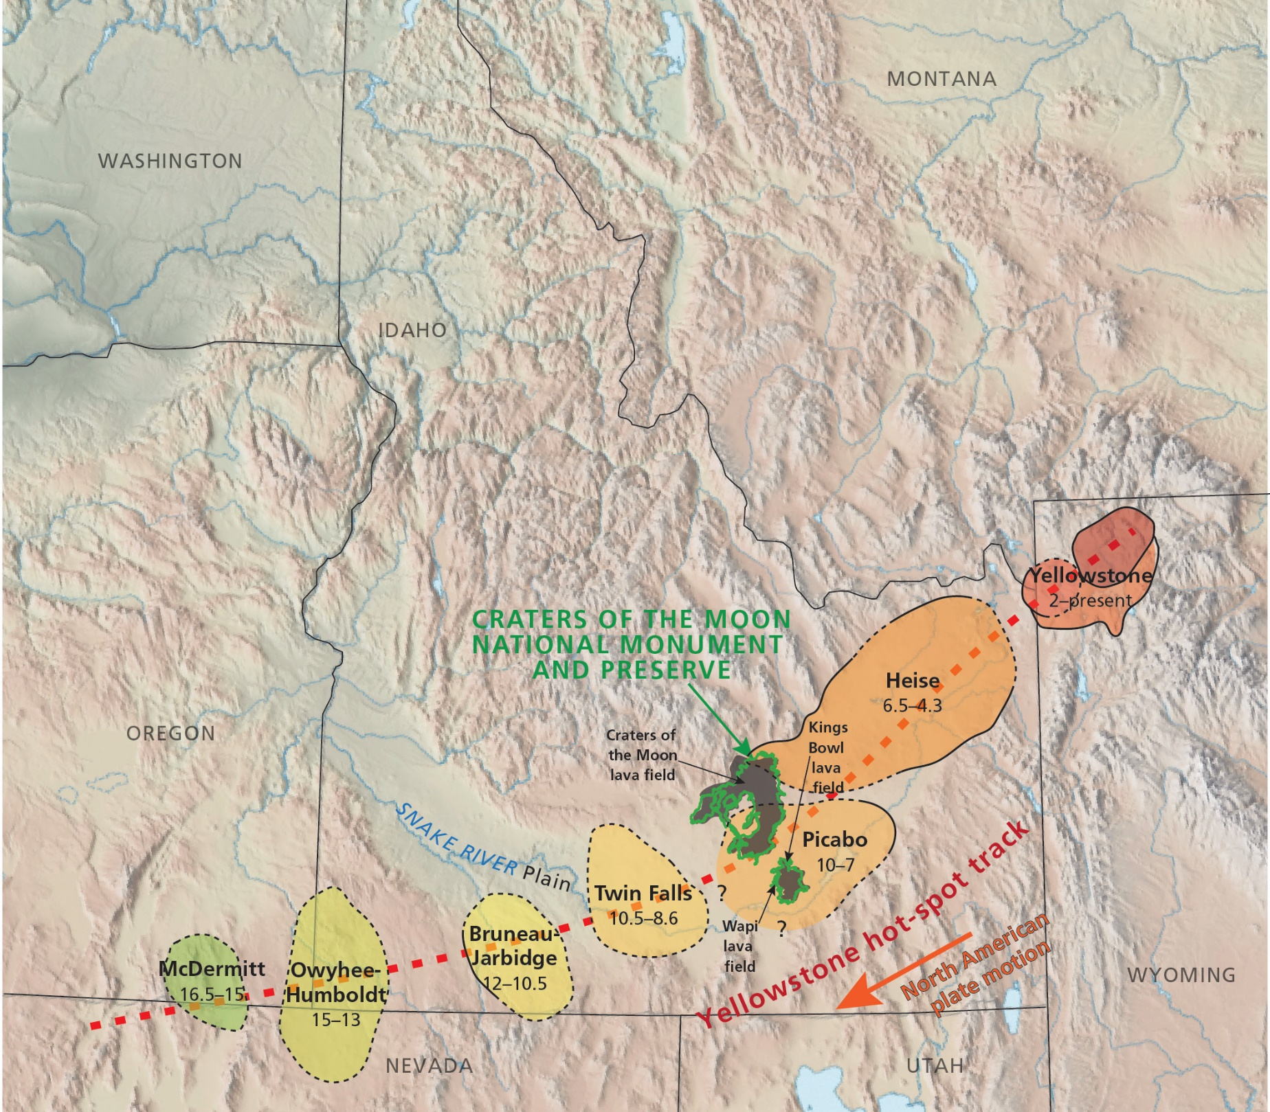

0 Ma

Graphic by Trista Thornberry-Ehrlich (Colorado State University)

|  |  |  |
| --- | --- | --- |
|  |  | Distance |
| Yellowstone | Heise | 150 km |
| Heise | Picabo | 50 km |
| Picabo | Twin Falls | 25 km |
| Twin Falls | Bruneau Jarbidge | 50 km |
| Bruneau Jarbidge | Owyhee-Humbolt | 75 km |
| Owyhee-Humbolt | McDermitt | 50 km |

Where do you think the grains in Morgan Valley are coming from? Why? How (transport)?

The detrital samples, where are those grains coming from?