Overview:
Competition occurs when a resource is consumed by multiple populations who must interact over the need for that same limited resource. Competition is an interaction that often results in a beneficial outcome for one population and a negative outcome for the other populations (though more complex feedbacks can and do occur). Direct competition is often lower than expected in modern ecological systems. This is because direct competition quickly pushes populations to divide up resources rather than risk continuing with direct competition. This results in a pattern of niche partitioning, where populations cede parts of their niche to other competitors and instead occupy a smaller subset of their potential habitat. When this type of niche partitioning is not possible, populations will be forced to compete again.
Most of the time, competition is difficult to observe in the fossil record. Since competition operates on generational time-scales, the act of competition is often too short lived to be preserved in the geologic record. Instead, we are far more likely to see the aftermath of competition (i.e. niche partitioning), though usually this is confined to very fine resolution fossil data. There are, however, some fascinating exceptions to this rule.
Encrusting organisms require a physical space to attach themselves. For many species, this physical space may be a hardened surface, such as a shell or a rock. When multiple larvae of encrusting organisms land on the same hard surface, the new colonies will compete for this space. Since many of these encrusting organisms also form hard shells, this process can be preserved in the geologic record. For this class, your group will examine fossil examples of competitive interactions between encrusting organisms, as well as run a simulation that illustrates how encrusting colonies compete for space.
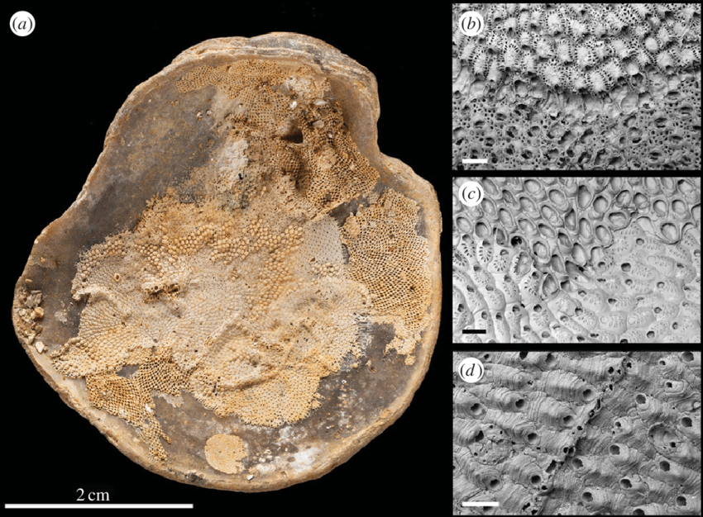
When two encrusting species come in contact with each other, there are generally three different competitive scenarios that can occur. The first is a standoff (right figure d), where neither side advances on the other. The second option is a winner-takes-all overgrowth (right figure b), with one colony growing over the top of the other colony. The third option is called reciprocal overgrowth (right figure c), which involves each colony growing over each other at various portions of the border.
Liow et al (2016), Interspecific interactions through 2 million years: are competitive outcomes predictable?, Proceedings of the Royal Society B, 283(1837).
Spatial Competition Simulation
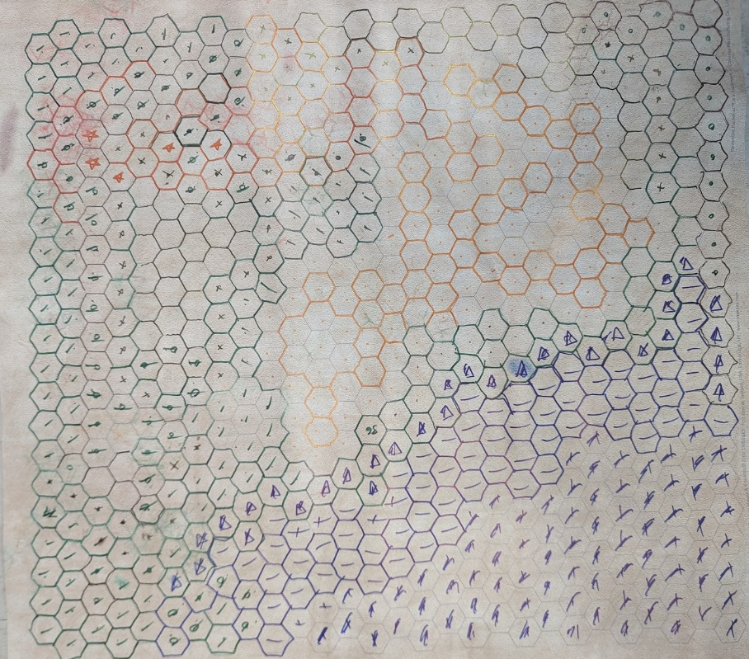
For this simulation, you will be playing the part of an encrusting organism forming a new colony on a hard surface, represented as a vinyl mat with octagonal spaces (see figure below). You will plan the growth of your colony in an attempt to occupy as many of these spaces as you can. The player who occupies the most spaces is the winner. In order to engender a healthy competition, bonus points will be awarded towards the grade for this lab based on how many spaces your colony can claim.

1st place: 6 bonus points
2nd place: 4 bonus points
3rd place: 3 bonus points
4th place: 2 bonus points

First, you will pick one organism to play as in this simulation. There are five different types of organisms: two cheilstome bryozoan species, two cyclostome bryozoan species, and one encrusting coral species. Each organism follows slightly different rules to reflect their different encrusting strategies:

Cheilostomes: always act first in the simulation and grow the fastest. The two cheilostome players will flip a coin to determine who goes first, and then will alternate each round to ensure both players get to act first.
Cyclostomes: act after cheilostomes, but receive double bonus points at the end. Similar to the cheilostome players, the two cyclostome players will flip a coin to determine who goes first for the cyclostomes, and then will alternate each round.
Coral: act last, grow slower than bryozoans, and cannot overgrow a colony (see rules below). However, bryozoans cannot grow within one space of the coral due to fouling chemicals released by the coral. Also, coral player gets +2 bonus points for every colony the coral blocks from continuing their growth (i.e. stopping the player from adding any new spaces).
Once you have picked your species, you will start the simulation as a free-swimming larvae represented as a plastic disc. Each player will pick up their plastic disc and gently toss it onto the vinyl mat. Where the larvae lands will be the start of the new colony. If necessary, move your disc onto the center of one of these spaces. Then, use a colored pen to mark an outline around all of the spaces touching your disc. Every starting player should start with 7 spaces (one in the center with 6 surrounding).
Colony Type | Growth Rate
Cheilostome | 2 new spaces for every 3 spaces occupied
Cyclostome | 1 new space for every 2 spaces occupied
Coral | 1 new space for every 3 spaces occupied
After all of the colonies have been established, each player will plan how the colony will grow over time. Using the order discussed in the species description above (cheilostomes, cyclostomes, coral), players will one at a time decide which spaces to grow into. New growth must be an extension of the colony (i.e. must be connected to some other claimed space). You will claim these new spaces by using your colored pen to draw an outline around the edges of the space your colony is growing into. Each turn, a player can expand their colony proportional to the number of spaces they currently occupy. Each colony has its own growth rate, shown in the table to the right. So, for example, since each starting colony starts with 7 spaces, the first cheilostome player will claim an additional 4 spaces (2 spaces for every 3 occupied) on their first turn. In this process, the more spaces a player controls, the more space that player can claim in the future. This would result in exponential growth for every player, assuming space was infinite. However, bryozoan players can steal spaces from other bryozoan players by overgrowing a colony, which will result in a slower growth rate for the colony that is overgrown (see rules below).
Overgrowth rules: If one bryozoan colony moves into another bryozoan colony, this results in overgrowth. The colony initiating the move claims the territory owned by the original bryozoan colony. For overgrown spaces, fill in a small circle in the center of the space with the color of the player who has claimed it. If there is at least one other space controlled by the original bryozoan colony behind the line of overgrowth, movement in either direction along that line stops for both players. If the space behind the line of overgrowth is empty, the colony that initiated the overgrowth can move into that empty space either on this turn or a subsequent turn, while the colony that was overgrown cannot. Any spaces that have been lost due to overgrowth do not count for the purposes of both scoring and calculating the number of spaces that a colony can grow.
The simulation will continue until all spaces are occupied or until only one player is capable of making a move. If only one player is able to claim new territory, that remaining player claims all available spaces that touch their colony. Scores are then calculated by counting up all of the spaces that have been claimed.

Use the scoresheet below to report everyone’s final score.

Player Name | Colony Type | Spaces Occupied

Additional Notes Space:

Comparisons Between Simulation and Reality
Take a moment and look over the results of your simulation. Take note of the distribution of the different colonies, as well as the patterns of overgrowth. Then, compare your simulation to the figure from Liow et al on the first page of this activity showing fossil interactions between bryozoans. In what ways are the results of your simulation similar to the real-world examples shown in this figure and in what ways are they different?

…………………………………………………………………………………………………..
Using the three classifications of overgrowth discussed earlier, what types of competitive interactions can you observe in the results of your simulation. List some specific examples in the space below.

…………………………………………………………………………………………………….
According to a review by Taylor (2016) of living bryozoan ecology, cheilostomes consistently overgrow cyclostomes in a winner-takes-all growth pattern in the majority of interactions, with smaller instances of cyclostome wins or mutual overgrow (i.e. reciprocal overgrowth). Does this pattern fit the simulation you ran? What are some additional factors that we are not considering in this simulation that could result in the simulation being less accurate to real life?

