STEM-A-SAURUS REX

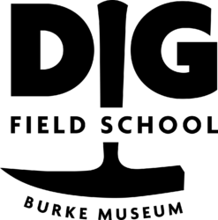 

How to reconstruct events that happened 66 million years ago.

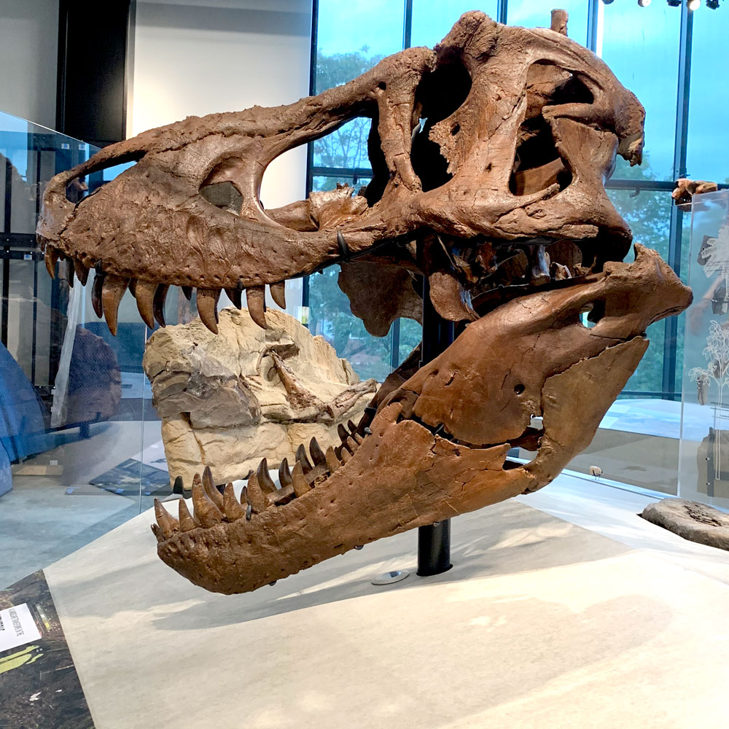

How confident are you that the following statements are true?

5= its true. 3= probably true. 1= not very confident

An asteroid hitting the Earth caused the extinction of the dinosaurs.

T-Rex was the dominant predator of the dinosaur’s time on Earth.

Children are curious and motivated to learn about dinosaurs.

Learning about prehistoric Earth uses science, technology, engineering and math.

How is this project STEM?

|  |  |  |
| --- | --- | --- |
| **STEM attribute** | **Reference** | **DIG Field School** |
| Integrates two or more of the STEM disciplines | STEM Lesson Essentials  Vasquez and Snieder. Heineman | Easily integrates all 4 disciplines plus opportunities for ELA, Art and history. |
| Involves a “Grand Challenge” | 100K in 10  100,000 STEM teachers in 10 years  https://grandchallenges.100kin10.org/ | Reconstructing Earth’s history at any time is a grand challenge. |
| Includes a connection to the community. | Creating a STEM Culture for Teaching and Learning  Jeff Weld NSTA Press | Citizen science sponsored by the Burke Museum |
| Provides opportunity to build 21st Century Skills | P21 - Partnership for 21st Century Skills | Students will, collaborate, communicate, use critical thinking and creativity in the process of reconstructing Earth of 66 million years ago. |

**All in:** Teacher applies for and attends DIG field school for a week of digging

Dinosaurs with working scientists from the UW and the Burke Museum. Then

participates in the citizen science research that is part of the program.

**Microfossil Use:** With training, teachers use the microfossils collected at DIG

Field school to join in the citizen science effort to collect data on the Earth’s

Ecosystems of 63-69 million years ago.

WSTA support: Teachers contact WSTA professional development to schedule a

Training for teachers on Washington State Earth History that includes the

DIG field school project.

Yea But……….

|  |  |
| --- | --- |
| I don’t know anything about Earth’s History. | Glad you are here by the end you will know a lot more and how to access the learning you will need. |
| How do I fit this in when there are all those state standards to teach? | The project is aligned to NGSS and CC Math standards with references to ELA as well. |
| …it’s not part of our district adopted curriculum. | True, but what STEM project is? Chances are, there are connections you can find and it will all work out with the students as the winner. |

Yea! Lets Get Started.

|  |  |
| --- | --- |
| DIG Field School | https://digfieldschool.org/apply-2/ |
| Burke Musuem | https://www.burkemuseum.org/education |
| WSTA | https://wsta.wildapricot.org/Professional-Development |
| Mark Watrin | mtwatrin@gmail.com |

A question that I personally want answered about prehistoric Earth by the end of this session is ……

A question I have about being an effective STEM teacher is……..

Utilizing a “Grand Challenge” strategy

A students’ concept of “grand”.

Solving global climate change problems is a grand challenge for the human race.

*“Hmmm, I wonder how many times the Earth solved climate change without humans?”*

Earning Washington’s Earthgen (green schools) award is a grand challenge for a

K-12 school.

Designing procedures to leave your classroom “clean for tomorrow” is a grand challenge for Kindergartners.

**DIG Field School’s Grand Challenge**

Reconstruct the ecosystems changes that occurred between 63 and 69 million years ago that include the mass extinction of “dinosaurs” and the start of the age of mammals.

Constraints

Fossils from one location in Montana.

Our skill in accurately identifying species from fossils.

Teachers willing to participate in the project.

Criteria

Identify the living species of 63-69 mya using fossils.

Compare to previous research.

Utilize students (citizens) to generate original data on the challenge.



3-5 Engineering Design

https://static.nsta.org/ngss/20130509/AppendixI-EngineeringDesignInNGSS-FINALII_0.pdf

Dig Box Lessons Science Standards

|  |  |
| --- | --- |
| 1: Rocks and Minerals | 5-PS1-c. Make observations and measurements to identify given materials based on their properties.  MS-LS2-e. Conduct an investigation of the cycling of matter among living and nonliving parts of ecosystems to support the explanation of the flow of energy and conservation of matter. |
| 2: Rock Types | MS-ESS2-1 Develop a model to describe the cycling of Earth’s materials and the flow of energy that drives the process. |
| 3: Age of the Earth | MS-ESS1-4. Construct a scientific explanation based on evidence from rock strata for how the geologic time scale is used to organize Earth’s 4.6-billion-year-old history. |
| 4: Fossilization | 4-ESS1-1. Identify evidence from patterns in rock formations and fossils in rock layers to support an explanation for changes in a landscape over time.  MS-LS4-1. Analyze and interpret data for patterns in the fossil record that document the existence, diversity, extinction, and change of life forms throughout the history of life on Earth under the assumption that natural laws operate today as in the past. |
| 5:Maps | 4-ESS2-2. Analyze and interpret data from maps to describe patterns of Earth’s features. |
| 6: Microfossils | MS-LS4-1. Analyze and interpret data for patterns in the fossil record that document the existence, diversity, extinction, and change of life forms throughout the history of life on Earth under the assumption that natural laws operate today as in the past.  MS-LS4-2. Apply scientific ideas to construct an explanation for the anatomical similarities and differences among modern organisms and between modern and fossil organisms to infer evolutionary relationships.  HS-LS4-5. Evaluate the evidence supporting claims that changes in environmental conditions may result in: (1) increases in the number of individuals of some species, (2) the emergence of new species over time, and (3) the extinction of other species.  HS-ESS2-7. Construct an argument based on evidence about the simultaneous coevolution of Earth’s systems and life on Earth. |
| 7: Teeth | 4-LS1-1. Construct an argument that plants and animals have internal and external structures that function to support survival, growth, behavior, and reproduction. |
| 8: Dinosaur Tracks | MS-LS4-1. Analyze and interpret data for patterns in the fossil record that document the existence, diversity, extinction, and change of life forms throughout the history of life on Earth under the assumption that natural laws operate today as in the past. |
| 9: Evidence Cards | HS-LS4-5. Evaluate the evidence supporting claims that changes in environmental conditions may result in: (1) increases in the number of individuals of some species, (2) the emergence of new species over time, and (3) the extinction of other species. |
| 10: Introduction to the Montana Mystery | All ESS and LS standards connected to Earth History are part of this culminating activity. |

Note: Even if you can’t get the DIG Box you can get Microfossils which is the actual research lesson. Other Burke Boxes have similar activities and content that are NGSS aligned.

|  |  |  |
| --- | --- | --- |
| Good | Better | STEM |
| Involve students in the DIG microfossil citizen science…….  (and sign up to go to 2022 DIG) | Add on a Burke Box  A Burke Museum visit  A Dig scientist guest speaker  A WSTA PD for your team/building. | Allow students to follow up with projects that are generated as a result of this experience, and present them to the public. |

Starting Points for your/student self learning

|  |  |
| --- | --- |
| Burke Museum: Burke Boxes | https://www.burkemuseum.org/education/educators-and-schools/burke-boxes |
| Burke Museum: Paleontology | https://www.burkemuseum.org/collections-and-research/geology-and-paleontology/vertebrate-paleontology |
| DIG field school | https://digfieldschool.org/ |
| Dino-doom virtual field tripms/hs | https://vft.asu.edu/iVFTLocations/KPG/KPGoptions.html |
| Paleo-portal has a bit of everything | <http://paleoportal.org/> |
| Earth Viewer shows Earth through its entire 4.6 billion year history | https://www.biointeractive.org/classroom-resources/earthviewer |
| American Museum of Natual History: Dinosaur lesson plans | https://www.amnh.org/learn-teach/curriculum-collections/dinosaurs-activities-and-lesson-plans |
| Produced specifically for young learners Pre K-5 (video format) | https://museumoftherockies.org/online-learning/tours-for-tots |
|  |  |