STEM Offering Proposal
Presenter(s) and Affiliation:
Tami Moffatt & Michelle Morrison Clover Park School District
Presentation Title: Phenomenal Outdoor Engineering K-5
STEM Categories addressed (Science, Technology, Engineering, and Math)
Please choose those that best describe your offering and explain how they connect to each other:

This session models strategies for field-based engineering design applications that engage students in engineering with a real problem to solve. Participants will identify, discuss and compare possible solutions to a real-world problem based on how well each solution is likely to meet the criteria and constraints of the ecological problem--Engineering. This session highlights the biodiversity of living things in any area, functions of different parts of plants that help them survive, and ways the engineering design process can be implemented in an outdoor environment. Participants are introduced to a step by step process to engage in the NGSS Science and Engineering Practices and ensure that students incorporate critical thinking that leads to sustainable communities opposed to teaching engineering disconnected from the systems, social and natural, that it affects. Key additions to the Engineering Design Process (EDP) requires students to reflect on the impact to the ecosystems, social systems and stakeholder views.

NGSS:
LS1. A: Structure and Function
LS4.D: Biodiversity and Humans
ETS1.A: Defining and Delimiting Engineering Problem
ETS1.B: Developing Possible Solution

SEP: Construct and/or support an argument with evidence, data, and/or a model
Asking questions
Planning and carrying out investigations
Analyzing and interpreting data
Obtaining, evaluating and communicating information.

CCC: Cause and effect
Patterns
Systems and systems models
Influence of Engineering, Technology, and Science in Society and the Natural World
Description:
During this session, participants will engage in research-based instructional strategies connected to an outdoor local phenomenon. Strategies include; modeling, graphic organizers such as KLEWS and O.W.L. charts, formative assessment, discourse tools, and student notebooks that make student thinking visible and show changes in student thinking over time. This session incorporates the Engineering Design Process (EDP) in an outdoor hands-on learning experience. Participants will receive lesson plans that can be adapted for all K-5 students and contain strategies modeled during this session.
Objectives and Expected Learning Outcomes:
Consider each of these objectives with an equity lens.
- Demonstrate tools and strategies that make all students’ thinking visible and reflect changes in students’ thinking such as models, KLEWS chart, O.W.L chart, graphic organizers, student notebooks, and student discourse tools.
- Model a step-by-step engineering process integrated into life science.
- Connect real-world phenomenon with classroom and outdoor hands-on science activities.
- Promote possible STEM careers related to engineering and life science.
Overview and Plan: Please describe in detail your 3-hour offering. Include a timeline with a description of the activities during the offering. Use the template to delineate content and activities. (example of categories: Introductions, 5-10 minutes, background information , Deep dive into content integration, Application for K-8 classrooms, classroom development planning, 20 minutes, closure 10 minutes)
Descriptive Summary of the offering; (will be more than the 75 word description)

Section | Description | Time
Entry Task &  Pre-assessment | As participants enter the session, there will be questions posted around the room on chart paper that serve as a pre-assessment for engineering vocabulary, Science and Engineering Practices (SEPS), Engineering Design Process (EDP) and high impact instructional strategies in science. Participants will walk around the room and answer questions posed and add their ideas on each poster using markers. Charts will serve as a pre-assessment and public record throughout the session.  - Prepare one chart to introduce the Plant identification Seek, I Naturalist App and provides directions to download the app onto cell-phones. Let participants know that they will be using the app later on in this session. | 10-15 minutes
Introductions (small group then whole group) | Informal introductions that include current position, and your hope for the session  - In pairs or triads  - Then have each person in the pair share about another person to the entire group. | 5-10 minutes
Introduce Engineering Design Process  &  Examples of Outdoor Phenomenon | 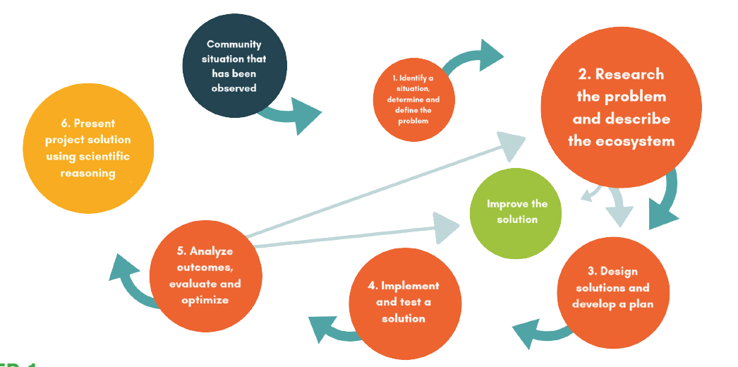  Page 13 from the Field Design Engineering Design for Field-Based Applications K-5  - What outdoor EDP looks like for 3-5 students.  - What outdoor EDP looks like for k-2 students. | 10 minutes
Introduction of Site Visit and O.W.L Document | Step 1: Identify a situation, determine and define a problem  - Let participants know that they will be going on a site visit of PLU’s outdoor space and will be using the Observations Wonderings Learnings (O.W.L) graphic organizer. Briefly introduce the O.W.L. document and ask participates to find a partner to work with. Let participants know that you are modeling a process that would happen over time with students. Observations would occur multiple times during the learning sequence.  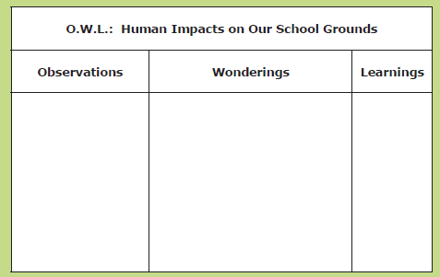  Once outside, encourage partners to record their observations and wonderings without much prompting. Establish a time and location to reassemble. If they need prompting for observations, here are a few ideas;  - Identify living and non-living things.  - What are ways that humans have changed the area?  - Describe the topography or natural and artificial features of the area. What are you noticing?  - Encourage participants to use their senses to gather information.  When working with students, this process of continually making  observations, asking questions, and reflecting on newly gained knowledge is important for learners. Students revisit the field site with their original O.W.L. chart to update previous observations and wonderings by recording their new thinking. We are condensing this process into a few hours.  An O.W.L. chart therefore becomes a visual model that demonstrates a students’ growth over the course of the project.  After 10-15 minutes reassemble the group to discuss their observations, wonderings, and anything they have learned. | 15 minutes
BioBlitz with Seek App | Introduce the Seek app to participants by saying that scientists and engineers often use technology tools to help them learn more about whatever they are studying. We will be looking at the biodiversity of this area using both the Seek app and recording our findings in the recording sheet.  Ask participants to open the Seek app and “continue without logging in”. They will use their BioBlitz Recording Sheet for this activity.  - Model using the App by having everyone take a picture of the same thing (grass, dandelion, etc.) and recording it on their recording sheet. After taking a picture, participants record the name and characteristics of the organism in their notebooks.  - Encourage participants to continue with their partner, set a specific area and safety guidelines for this activity such as: where they can venture, signal to return, what to do if they need support, etc. Students continue on their own taking pictures and collecting information about the biodiversity in the area. After 10 minutes reassemble the group in a designated location.  - Lead a discussion with the group around what they discovered using the Seek App and ways that students might use this tool. | 10 minutes
Impact Walk | Remind participants that they have gathered information about the outside area using both the O.W.L. graphic organizer and the Seek App.  - Now they will be taking another walk with their partner, an impact walk. Let participants know that their task with observing, recording, and identifying potential human impact problems that we could investigate. They will be using a different O.W.L. chart that includes looking for Human Impact on PLU’s Outdoor Space.  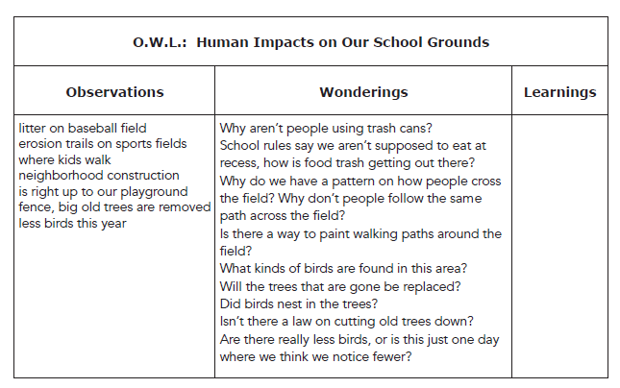  - After 10 minutes, reassemble and return to the indoor space. | 10-15 minutes
Identifying problems/phenomenon  Definition of phenomenon: Are occurrences in the natural and man-made world that can be observed and cause one to wonder and ask questions.  & KLEWS Chart | Inside, discuss participants findings about human impacts and choose a problem/phenomenon to investigate.  - Mention modifications of offering more student choice by investigating multiple problems. For this session, choose one problem to model the KLEWS chart.  Exploring the problem/phenomenon using a KLEWs chart  - Know: What do we know about this problem/phenomenon?  - Wonder: What are you wondering about the problem/phenomenon?  As appropriate, continue to add to the KLEWS chart during the session. | 15 minutes
Break |  | 10 minutes
Researching the Problem | Step 2: Research the problem, describe the ecosystem and identify key stakeholders  - Once the problem/phenomenon has been identified, have participants use pages 58-59 Researching the Problem to identify what they need to know and next steps.  --In one sentence, describe the problem you are planning to solve.  --Why is this problem important? What will happen if no changes occur?  --What I already know that may help.  --What I need to know before starting.  --Where I might find information (books, websites, experts, etc.) | 10 minutes
Stakeholder Research | Who cares?  - Review page 60 Stakeholder Research  - Participants/students begin to build an understanding of stakeholders; anyone with interests related to the problem or outcome. | 5 minutes
Solution Analysis | Step 3: Design solutions and develop a plan  - Use page 62 to develop and compare solutions  - Create a list of possible solutions from the group including ones learned from research as well as personal ideas.  - Narrow the list down. Cross out any ideas that don’t seem realistic or do not interest you.  - Choose top 3 solutions.  - Compare solutions using the Solution Comparison Table. 5. Choose the best solution for your project based on the Solution Comparison Table. | 10 minutes
Make a Plan | Step 4: Implement and test the solution  - Use pages 63-65 to make a plan.  - Use chart paper to draw a model of your plan and be prepared to explain why you think your plan will work.  - Share plans/idea. Discuss any problems that participants encountered.  - At this point we can’t actually implement and test our solutions. | 20 minutes
Reflection | - Review pages 66-67 to consider ways students might use this reflection and how this document could be adapted for k-2 and 3-5 students. | 10 minutes
Review | Steps 5 & 6:  - Analyzing outcomes, evaluate and optimize  - Present final solution using scientific reasoning | 5 minutes
Seeing Myself as a Scientist or Engineer | What careers are connected to what we have been  learning and doing?  - Brainstorm careers on sticky notes and place on a chart labeled, Seeing Myself as a Scientist or Engineer  - Check out these career cards by PEI | 10 minutes
Wrap-up Discussion | As a post assessment, participants will revisit the posters they added to at the beginning of the session and will use sticky notes to note changes in and/or additions to their thinking.  Challenge participants to use the reflection questions below to consider what they learned and/or engaged in during the sessions.  - What are you going to do with what you have learned here in your classroom?  - What equitable practices did you learn about and/or engage in today?  - How did these equitable practices help you make sense of the science?  - What more would you like to learn about science instruction?  Wrap-up:  Standing in a circle choose one of the reflection questions to share in one sentence or less and whip around the circle. | 10 minutes

Supporting Material and estimated cost for materials:
Materials per participant: $12.00 per participant
Materials: | Cost:
- Mini-KLEWs charts  - Chart paper and markers  - NGSS bookmarks (1 per participant)  - Clipboards & pencils  - Magnifying glasses  - PEI FieldDesign Engineering Design for Field-Based Applications K-5  - O.W.L documents, 2 per participant  - BioBlitz recording sheet | - PEI Document: $7.00  - 10 pages copied= $1.00  - Chart paper = $15.00 (instructor only)  - Markers provided by instructor  - NGSS bookmark = $1.00  - Clipboard & pencil = $2.00  - Magnifying glass = $1.00 (optional, could use phone app)

