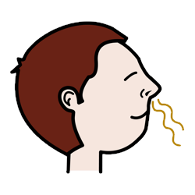
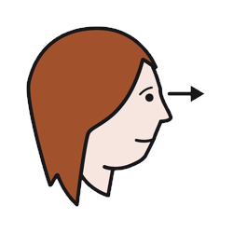
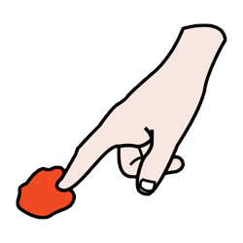

Icons by Sergio Palao, from ARASAAC licensed under CC BY-NC-SA more info

Using our 3 Senses Lesson Plan

This lesson has been adapted for non-verbal students and modified and simplified by breaking down the standard to meet these needs of these students.

-In this Guided Inquiry lesson, students will explore, through the use of their 3 of their five senses (smell, feels like/touch, looks like/sight) items found in the natural world. They will discover that our senses are the physical means by which all living things see, smell, and touch. Each sense collects information about the world. Students will collect data on an adapted recording sheet with a field of icon/visual choices for this activity is provided.

Linked South Carolina standards: (S.K.1): Students are expected to carry out investigations using their five senses to explore, observe, and ask questions about the natural world.

Learning Goals
This activity is designed to help students understand that people get all of their knowledge from their senses, and that is why our senses are so important.
Goals:
- Students will identify that our senses work together to help us understand the world around us.
- Students will record data.

Key Concepts/Essential Understandings:
- Our senses are used to help us enjoy the world and they warn us of danger.
- Our senses can work together to help us understand things in a different way.
- We may use some senses more than others.

Vocabulary Words:
Sense(s)
Smells
Feels like/Touch
Looks like/sight

Context for Use
This activity is designed to be used with a small group of students (2-4). This activity can be done within the classroom or resource room. Although it addresses a 5K South Carolina standards it can be used with upper grades for students who have special needs, lack background knowledge, or need language support (MLL). Additionally, This lesson has been adapted for non-verbal students and modified/simplified breaking down the standard to meet these needs of these students.

Description and Teaching Materials
3 Senses Chart attached below

Introduction: Explain to the group that today we will be learning about the way we gather information about our world. Discuss with the students what they know about their senses.

-Introduce each word (smells like, looks like, feels like) and meanings if needed. Use this information as a type of pre-assessment to help guide your instruction to the needs of the students and for additional lessons.

-Be purposeful in making sure that students understand that today we are going to explore how our senses help us to learn about things in our world.

Materials needed:
Slice of lemon, small potato, strong smelling herb such as mint leaf

Procedure:
- Do not show the students the objects or tell students which objects you are using; tell them that they are to identify each object using only one sense at a time.

2. I have adapted this lesson for more severe special needs students specifically non-verbal students. I considered food aversions so the smells like section is "opinion based" - a flaw, but students are expressed knowledge of a smell and like or dislikes - which can be a challenging thing for these students.

3. Place each item into a brown paper bag, students will place nose closely to the bag to smell, hand in the bag to feel and hen pull the item out for looks like/sight. Students will be presented with one object and one category at a time. This part can take as many days needed to complete. First object and one sense on day one etc. or First object and all three senses, etc. Use the hierarchy of prompt level as needed.

4. After all items and senses have been identifying/explored and recorded by the student based on their hierarchy of prompt level need. The Activity should be repeated with other objects to increase generalization.

Teaching Notes and Tips
Experimental tasting is never recommended for safety reasons, and caution should be used when having students learn about the sense of taste.

There are many online resources that can assist teachers in their own background understanding of the senses. The following links may be helpful in building that knowledge.

http://faculty.washington.edu/chudler/introb.html#se
http://www.hhmi.org/senses/a110.html
http://www.sedl.org/scimath/pasopartners/senses/
https://scetv.pbslearningmedia.org/resource/9e29b468-568b-48e5-aca7-e9bffd28a22f/ozomatli-5-senses-pbs-kids-rocks-video/

This lesson was adapted from “The Five Senses - Differentiated Lesson for ESL/Special Needs Students” by Kathy Steffens available through the SERC at Carleton College
https://serc.carleton.edu/sp/mnstep/activities/fivesenses.html
The original material is licensed under CC BY-NC-SA 4.0.

This work is licensed under CC BY-NC-SA 4.0. To view a copy of this license, visit https://creativecommons.org/licenses/by-nc-sa/4.0/

Using our 3 Senses Chart

Student Name ______________________
Today’s Date ____________

Item |  |  |  | 
Item 1

Item 2
Item 3

Item 4

Icons by Sergio Palao, from ARASAAC licensed under CC BY-NC-SA more info

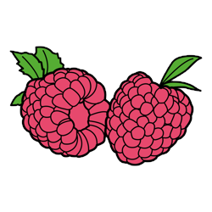
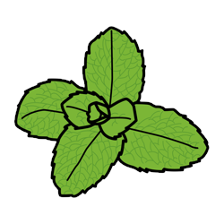
Objects Options:

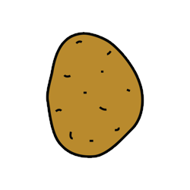


Feels like options:
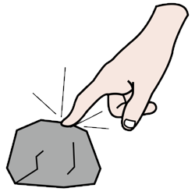
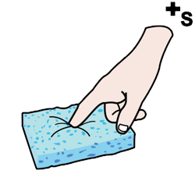

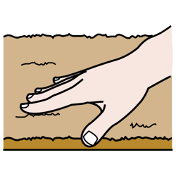
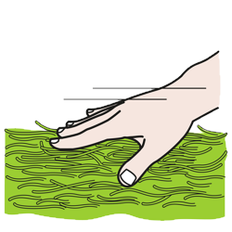

Looks like:








Smells like:



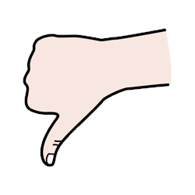

Icons by Sergio Palao, from ARASAAC licensed under CC BY-NC-SA more info

This work is licensed under CC BY-NC-SA 4.0. To view a copy of this license, visit https://creativecommons.org/licenses/by-nc-sa/4.0/

