Tile Ecosystem Descriptions
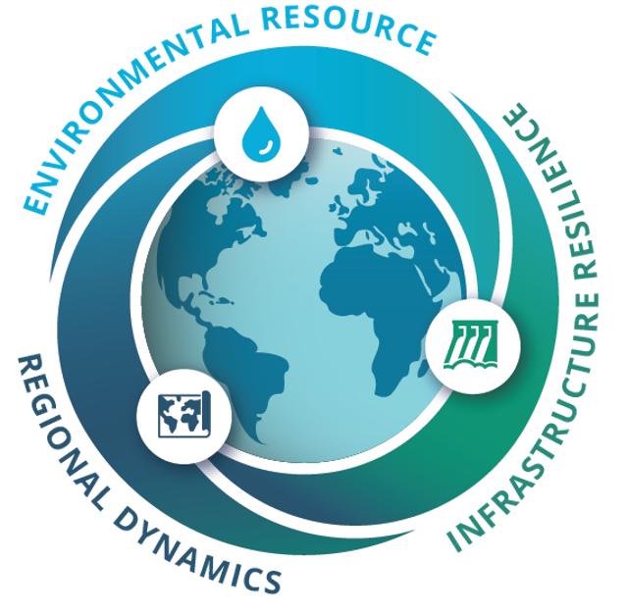
WXS connection
Ecosystems influence the role of water in various ways, that ultimately govern interactions with infrastructure and regional dynamics. For example, forests may provide water benefits, but disturbances such as wildfire can affect both ecosystems and water users. Similarly, plains can be used to support food and communities, but their resilience depends on rainfall timing, land management, and water availability. In semi-arid regions, communities must balance limited surface water, groundwater use, infrastructure needs, and long-term watershed health. Timing of water availability is further reinforced in the chaparral, where fire, drought, and recovery affect both environmental resources and downstream users. Finally, wetlands highlight the connection between ecosystem preservation, water quality, and flood buffering.

Forest
Forests have dense tree cover, rich biodiversity, and soils that can capture, slow, and store rainfall. In the game, forest tiles represent parts of the watershed that often receive moderate to high precipitation and can help stabilize water availability across the system.
Forests are important environmental resources because they influence runoff, infiltration, erosion, and downstream water quality. However, they can also be vulnerable to disturbance. Wildfire, heat, drought, and land-use change can reduce forest health and alter how water moves through the watershed.

Plains / Grasslands
Plains and grasslands are open landscapes dominated by grasses and herbaceous plants. They often support wildlife, grazing, agriculture, and rural communities. In the game, plains tiles represent areas with moderate precipitation and seasonal variability.
Grasslands can respond quickly after rainfall, but they are also sensitive to drought, overuse, soil degradation, and changing weather patterns. Because plains often support agriculture or development, they highlight the connection between environmental resources and human water demand.

Semi-Arid
Semi-arid regions are dry landscapes with sparse vegetation adapted to low and unpredictable rainfall. These areas are highly sensitive to drought and heat waves. In the game, semi-arid tiles represent places where water availability is less reliable and where planning for scarcity is especially important.
Because surface water may be limited, semi-arid regions may depend more heavily on groundwater, water trades, or upstream flows. Rare recharge or high-precipitation events can temporarily improve water availability but long-term resilience depends on careful management.

Chaparral
Chaparral ecosystems are shrubland landscapes with drought-resistant plants, often found in Mediterranean-type climates with wet winters and dry summers. In the game, chaparral tiles represent areas shaped by seasonal water availability, periodic drought, and fire-adapted vegetation.
Chaparral ecosystems can recover after disturbance, especially when wet seasons support regrowth. However, severe drought, repeated fires, or changing weather patterns can reduce recovery and increase erosion, runoff, or downstream impacts.

Wetlands
Wetlands are water-saturated ecosystems rich in aquatic plants, wildlife, and ecological services. They can store and filter water, support biodiversity, recharge groundwater, and buffer downstream areas from extreme events. In the game, wetlands represent parts of the watershed that depend on consistent water supply and upstream flow.
Wetlands are especially sensitive to reduced inflows, upstream withdrawals, drought, and development pressure. However, floods, conservation efforts, and sufficient environmental flows can enhance the services wetlands provide to the broader watershed.

