Ruleset
Watershed Works: Every Drop Counts
Players: 3–4
Time: 40-100 min

Contents: Board, 2 dice, event cards, build tokens, water tokens, development tokens, scratch paper.

Goal: Earn individual points through development while maintaining the health of the shared watershed. Players should try to earn individual points while also maintaining the long-term health of the shared watershed. The game highlights how water is influenced by its role as an environmental resource, interacts with critical infrastructure, and is affected by regional dynamics.

Board

A single river runs through the board, which represents a watershed with different ecosystems.
There are 8 buildable tiles, 4 on each side of the river, each with an ecosystem type and weather roll number. Each tile has 4 build spots to build upon.

The ecosystem types and weather roll numbers represent that water availability varies across landscapes. Some ecosystems are more likely to receive additional water through weather rolls, while event cards may affect ecosystems differently.

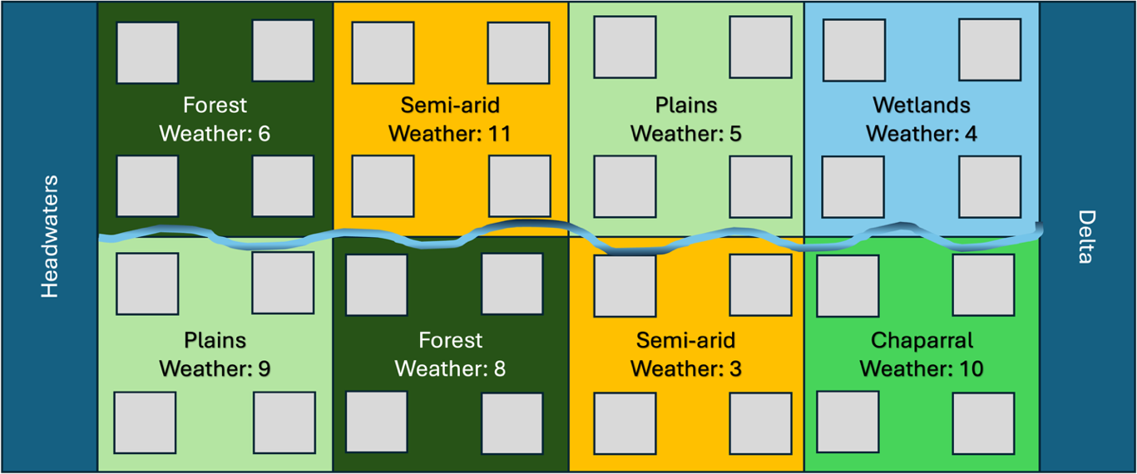

Setup
At the beginning of the game, each player rolls 1 die to determine turn order/water appropriation order. The player with the highest value goes first in each round, followed by next highest, etc. Reroll ties.
Each player controls two tiles, selected in turn. The first player selects 1 tile, then selection follows turn order. Once all players have selected 1 tile, reverse order of selection and each player selects a second tile.

Watershed health starts at 5. Aquifer level starts at 5

Round Sequence

- Headwaters Allocation
Each round, the headwaters generate water tokens equal to 3 x number of players. Water is allocated by prior appropriation / turn order:
- Player 1 takes as much water as they choose from the headwater pool.
- Player 2 then takes from what remains.
- Player 3 then takes from what remains.
- Player 4 then takes from what remains.

- Weather Roll
Roll two dice. If the combined value matches a number on a tile, the player who controls that tile receives 1 additional water token this round. Numbers closer to 7 are more likely to be rolled, representing that some locations are more likely to receive water than others.
- Event Card: System Disruption and Uncertainty
Draw one event card and read it aloud. Follow the instructions on the card. Event cards may affect water availability, infrastructure needs, aquifer recharge, ecosystem conditions, or watershed health.
- Trade, Negotiation, Build, Upkeep, Storage, Pumping, and Deconstruction
This step is timed. Suggested: 2 minutes, but can be increased/decreased if needed.
Players may use water tokens and build tokens to:
- Meet development upkeep
- Build one new development
- Store water if they have storage capacity
- Draw groundwater if they have a pump well and aquifer water remains
- Deconstruct developments
- Trade or negotiate with other players
Players may trade:
- Water tokens
- Build tokens
- Points
- Future agreements
- Round Scoring: Watershed Health and System Stability
Players score individual points or outputs only from their developments whose upkeep was met. Next, for the entire table check:
- Did any player draw from the aquifer?
- Did any event card affect watershed health?
- Did all players meet all development upkeeps?
- Did excess water flow out of the watershed?
If any player did not meet all development upkeeps, decrease watershed health by 1. If all players met all development upkeeps and excess water flowed out of the watershed, increase watershed health by 1, up to a maximum of 10.

Developments
Developments are how players can score points for themselves each round, as long as they are able to meet the water upkeep for their developments. However, if a player is unable to meet the water upkeep for their development, they do not get points (or build tokens) from that development, and the watershed health loses a point and is degraded for all players. Most developments only require some water to be built, but some also require build tokens, which are generated from Towns. Each tile has 4 spots to build upon, and players can only build one development per turn.
The following table of developments contains the cost to build, the upkeep per round, the output if the upkeep is met, the number of build spots a development uses, the cost to deconstruct the development, and any special features.

 | Build | Upkeep | Output | Build spots | Deconstruct | Special
Farm | 1 water token | 1 water token | 1 point | 1 spot | 2 water tokens
Town | 1 water token | 1 water token | 1 build token | 1 spot | 2 water tokens
Data Center | 1 build token + 3 water tokens | 3 water tokens | 4 points | 2 spots | 1 build token
Dam | 2 build tokens + 2 water tokens | 2 water tokens | 2 points | 2 spots | 4 build tokens + 4 water tokens | Stores up to 3 water tokens
Pump Well | 1 build + 1 water​ | 0 water​ | Access to 1 aquifer water | 1 spot | 1 water tokens | Aquifer must have water
Park | 1 water token | 1 water token | 2 points | 3 spots | Cannot be deconstructed
Storage | 1 water token | 0 water token | 0 points | 1 spot | No cost to deconstruct | Allows 1 water to be stored until needed

Aquifer
The aquifer represents a limited groundwater supply. Groundwater can help players meet water needs when surface water is scarce, but repeated pumping can reduce long-term resilience.

- A player may only use aquifer water if they have built a Pump Well.
- The aquifer starts with 5 water tokens.
- A maximum of 1 water token total may be drawn from the aquifer each round, and each aquifer draw reduces the aquifer level by 1.
- If more than one player has a Pump Well, players draw in turn order.
- The aquifer level only increases if an event card allows recharge.
- If the aquifer reaches 0, no more groundwater can be drawn.

Watershed Health
Watershed health represents the long-term condition of the shared water system. It includes the ability of the watershed to continue supporting environmental needs, community needs, and infrastructure demands.
Watershed health starts at 5.
- Watershed health can range from 0 to 10.
- If watershed health reaches 0, the watershed collapses and no one wins.
- If watershed health reaches 10, the watershed is highly resilient and the highest-scoring player or players win.
- The facilitator may also end the game when time is up.
Watershed health decreases by 1 when:
- Any player fails to meet all development upkeeps during the round; or
- An event card instructs players to reduce watershed health.
Watershed health increases by 1 when:
- All players meet all development upkeeps for the round; and
- At least 1 unused water token flows out of the watershed after player decisions are complete.

Winning the Game
At the end of the game play, the highest-scoring player(s) win. However, this is contingent upon the watershed health. If the watershed health reaches zero, then there are no winners in the game.

