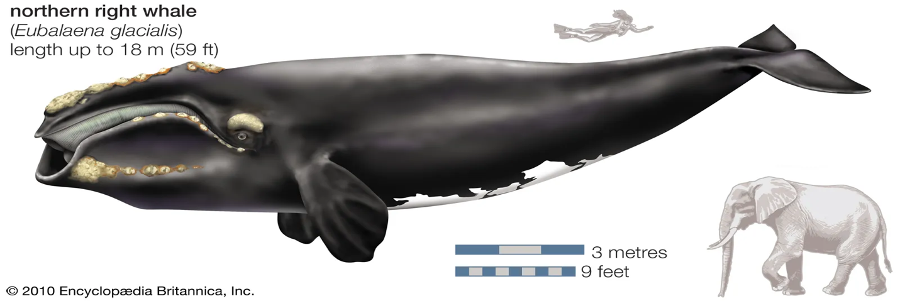
Guild 1: Whale — North Atlantic Right Whale (Eubalaena glacialis)
Habitat & Role:
Migratory baleen whale feeding on copepods and small zooplankton in coastal and shelf waters, including the mouth of the Chesapeake. Major top-down influence on planktonic ecosystems through nutrient mixing and transport.

Diet / Trophic Links:
- Eats: copepods, zooplankton
- Eaten by: none (top predator, historically hunted by humans)
- Affects: plankton balance, nutrient redistribution

Pre-Human Baseline:
Seasonal presence; supported by high plankton productivity and minimal vessel disturbance.

Potential Vulnerabilities & Responses:
- Extremely sensitive to direct harvest, noise, and ship strikes.
- Dependence on high prey densities links fate to plankton and fish community structure.
- Long generation time slows recovery.

Geohistorical Data Sources:
- Whale bones in archaeological middens and nearshore deposits
- Historical whaling logs, oil trade records, and museum specimens
- Sedimentary biomarkers for whale presence (e.g., sterols, lipids)
- aDNA from sediments indicating large-mammal presence

If Taxa Below Decline:
Loss of plankton or forage fish → migration shift or local disappearance.
If Taxa Above Decline:
Minimal effect (few predators).
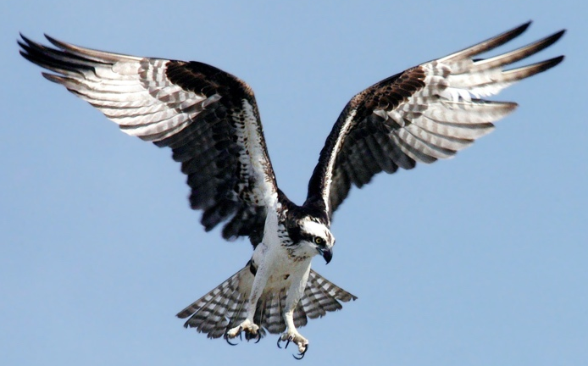
Guild 2: Seabird — Osprey (Pandion haliaetus)

Habitat & Role:
Fish-eating bird nesting near estuarine and coastal waters. Indicator of fish abundance and contamination levels.

Diet / Trophic Links:
- Eats: small to medium fish (e.g., menhaden, perch)
- Eaten by: few natural predators (eggs vulnerable to raccoons, gulls)
- Affects: fish population balance; nutrient transfer from water to land

Pre-Human Baseline:
Stable nesting populations with abundant fish prey and clean shoreline nesting habitat.

Potential Vulnerabilities & Responses:
- Affected by overfishing of prey species and contaminants (DDT, heavy metals).
- Habitat destruction (shoreline development) reduces nesting success.
- Rapid rebound possible with clean water and food recovery.

Geohistorical Data Sources:
- Bones and guano layers in coastal sediments and middens
- Stable isotopes (δ¹³C, δ¹⁵N) in guano or eggshells reflecting trophic structure
- Historical nesting surveys, naturalist records, museum skins

If Taxa Below Decline:
Loss of fish → nest abandonment, migration shifts.
If Taxa Above Decline:
Predator loss → nest success increases.

Guild 3: Turtle — Diamondback Terrapin (Malaclemys terrapin)
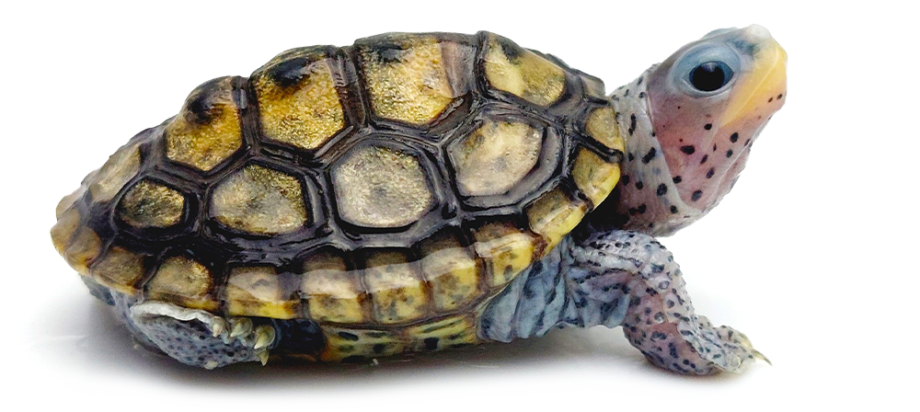
Habitat & Role:
Brackish marshes and estuaries; feeds on snails and small crustaceans. Links benthic invertebrates to higher trophic levels.

Diet / Trophic Links:
- Eats: snails, bivalves, crabs
- Eaten by: raccoons, large fish, humans
- Affects: benthic community balance

Pre-Human Baseline:
Abundant in tidal marshes and creeks; key consumer of invertebrates.

Potential Vulnerabilities & Responses:
- Overharvest for food historically severe.
- Vulnerable to habitat loss (marsh drainage, bulkheads).
- Declines with pollution and bycatch but can recover with nesting protection.

Geohistorical Data Sources:
- Turtle bones and shells in archaeological middens
- Stable isotopes in bone collagen for trophic and habitat reconstruction
- Historical fishery and market records
- Modern shell accumulations and nesting surveys

If Taxa Below Decline:
Fewer snails → reduced feeding opportunities.
If Taxa Above Decline:
Reduced predation → short-term population increase
Guild 4: Fish — Atlantic Menhaden (Brevoortia tyrannus)

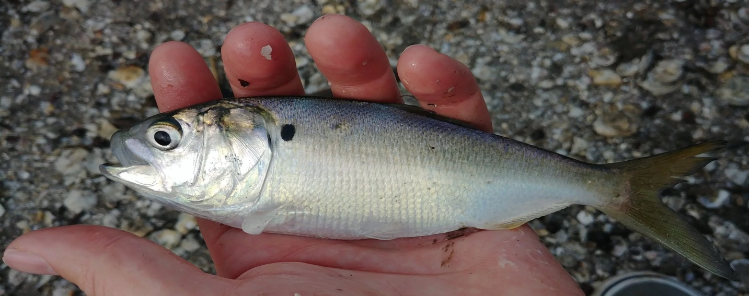

Habitat & Role:
Pelagic filter-feeder linking plankton productivity to higher trophic levels. Keystone forage species for whales, seabirds, and larger fish.

Diet / Trophic Links:
- Eats: phytoplankton, zooplankton
- Eaten by: osprey, whales, larger fish
- Affects: plankton abundance, water quality

Pre-Human Baseline:
Highly abundant; crucial in maintaining estuarine clarity and nutrient balance.

Potential Vulnerabilities & Responses:
- Sensitive to overharvest and eutrophication.
- Trophic cascades from predator removal alter population size.
- Population rebounds possible with fishing regulation and habitat restoration.

Geohistorical Data Sources:
- Fish bones and otoliths in archaeological middens and sediment cores
- δ¹³C and δ¹⁵N in sediments indicating trophic shifts
- aDNA and eDNA from cores
- Historical catch and fishery records

If Taxa Below Decline:
Phytoplankton decline → recruitment failure.

If Taxa Above Decline:
Predator loss → short-term bloom, possible algal overgrowth feedback.

Guild 5: Invertebrate — Eastern Oyster (Crassostrea virginica)

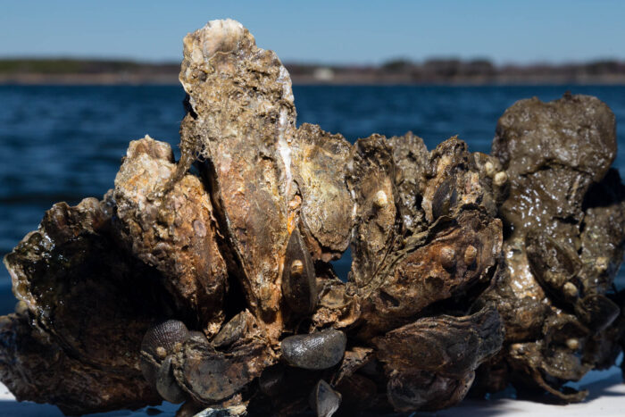

Habitat & Role:
Benthic filter-feeder forming reef structures; crucial ecosystem engineer for water clarity and habitat creation.

Diet / Trophic Links:
- Eats: phytoplankton, organic particulates
- Eaten by: crabs, starfish, humans
- Affects: nutrient cycling, water clarity, sediment stability

Pre-Human Baseline:
Massive reef complexes; clear water, extensive benthic habitat.

Potential Vulnerabilities & Responses:
- Overharvest and destructive dredging destroy reef habitat.
- Pollution and sedimentation inhibit recruitment.
- Restoration possible through reef rebuilding and water-quality improvement.

Geohistorical Data Sources:
- Shell beds and reef stratigraphy in cores
- Stable isotopes (δ¹⁸O, δ¹³C) for salinity and temperature
- Growth increments for productivity trends
- Historical fishery records and midden deposits

If Taxa Below Decline:
Loss of phytoplankton → reduced growth.
If Taxa Above Decline:
Loss of grazers → sediment and nutrient imbalance.
Guild 6: Vegetation — Smooth Cordgrass (Spartina alterniflora)

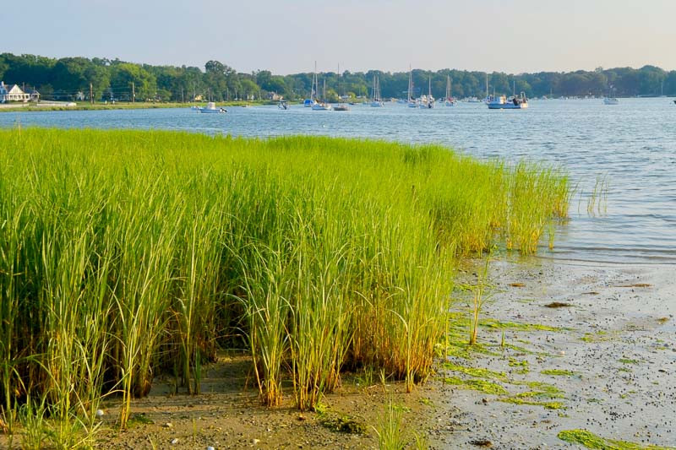

Habitat & Role:
Dominant saltmarsh grass stabilizing sediments and providing habitat for invertebrates and juvenile fish. Major primary producer in estuarine food webs.

Diet / Trophic Links:
- Base of food web; detritus supports crabs, snails, and fish.
- Affects: sediment trapping, shoreline stability, nutrient retention.

Pre-Human Baseline:
Extensive, continuous saltmarshes lining tidal flats and creek banks.

Potential Vulnerabilities & Responses:
- Draining, dredging, and shoreline hardening reduce habitat.
- Eutrophication and invasive species alter competitive dynamics.
- High resilience with sediment and hydrologic restoration.

Geohistorical Data Sources:
- Pollen and plant macrofossils in cores
- δ¹³C and lignin biomarkers in sediments
- Marsh accretion rates from stratigraphic dating
- Aerial photographs and historical maps (post-1900)

If Taxa Below Decline:
Loss of detritivores → organic buildup.
If Taxa Above Decline:
Loss of grazers → potential overgrowth and anoxia.

