Name________________________

GES 4
Extinction of the Dinosaurs: An Introduction to the Study of Earth History

Activity 3: Principles of Biostratigraphy

OBJECTIVES
Upon completion of this exercise students will be able to:

1. Describe the principles of sedimentation and relative ages.
2. Correlate stratigraphic and biostratigraphic units.
3. Identify key boundaries of geologic time as a function of the fossil record.

MATERIALS
Pencil, paper, graph paper, straight edge

INTRODUCTION
Being a geologist is a lot like being a detective. One of the primary goals of geology is to determine what has happened in the earth’s past. This is accomplished by looking at clues that are left for us in the geologic record. However, to successfully relate these clues to a coherent history or timeline of geologic events, it is important to know WHEN these clues were left relative to one another. Biostratigraphy, or the characterization and correlation of rock units based on their fossil content, is one method of establishing the relative age of rocks or rock units. This method is based on the observation that organisms have undergone successive changes through geologic time, and therefore any unit of rocks containing a discrete set of fossils can be differentiated from younger and older units based on those fossils. The geologic timescale used today was actually developed on the basis of fossil stratigraphy, and was in fact created long before absolute dates were available.

In this activity we will look at the sedimentary rock sequences in which fossils have been preserved, establish how we can use fossils to relate these sequences to one another, and use a practical example of biostratigraphy to observe how fossils have helped us to divide and categorize geologic time.

1. Relative ages and the geologic record

Of the three types of rocks (igneous, metamorphic, sedimentary), sedimentary rocks are perhaps the most useful at recording what processes were occurring on the earth’s surface in the past. Broadly, sedimentary rocks are formed by the deposition, burial and lithification (compaction and cementation) of sediment. Sediment can be composed of a variety of different minerals or materials, and have a variety of different sizes (called grain size). The type of sediment that makes up a sedimentary rock is a function of the environment in which it was deposited.

For example, a sandy beach might ultimately form sandstone. Very fine clays deposited at the mouth of a delta might be buried and become a mudstone or claystone. Limestone is a sedimentary rock that forms from the aggregation of grains or pieces of the mineral calcite (a calcium-carbonate which makes up the shells and skeletons of many marine animals) or can precipitate from water saturated with calcium and CO₂.

Our ability to use sedimentary rocks as a record of past surficial processes on Earth requires that we understand their distribution age relationships. The basic principles of these relationships are defined by three axioms, or principles, developed by a seventeenth centure Danish physician names Nicolaus Steno. Steno’s three laws postulate that:

1. In an undisturbed sequence of strata (or sedimentary layers) the oldest strata lie at the bottom and successively higher strata are progressively younger. This is the principle of superposition.

2. All strata are essentially horizontal when they form. This principle, the principle of original horizontality, is a generalization, as sediments may be deposited on sloping surfaces, or form dunes which are not horizontal. However, most sediment deposits are limited by the angle of repose to be more horizontal than they are vertical, and for the most part, especially over large areas, this is a reasonable approximation.

3. Finally, strata are laterally continuous. That is, a sedimentary layer is typically an unbroken flat expanse, extending laterally for considerable distances, slowly thinning towards the margins of the layer. This principle of lateral continuity explains how the same sedimentary unit can be found on opposite sides of a valley; the valley cut through, or eroded, the previously continuous layer.

There are additional complexities present in the rock record that also have to be rationalized to establish relative ages of sedimentary units. For example, features that cross across other strata, such as a fault or igneous intrusion, must be younger than all units that it cut across. Additionally, not all information within a rock sequence is always preserved. An unconformity is a rock surface (or contact) that represents a gap in the geologic record, in which some strata are missing (perhaps due to a pause in sedimentation) or removed, such as a surface which was eroded before more sediment was deposited on top of it.

Take a look at Example A. This is a simple geologic cross-section showing stratigraphic units A-D. This sequence of strata has maintained its original horizontality and does not seem to be disturbed. Therefore, Formation A is the oldest, and the sequence youngs upwards. This means the order of deposition of these units was A, followed by B, then C, then D.

A. B.
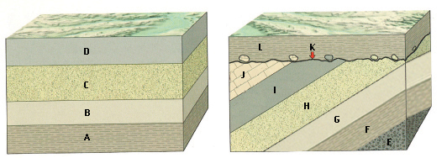

Now take a look at Example B. Beds E through J are lying at an angle, or have a dip. What may have caused this change of dip from horizontal?

When did it happen relative to the timing of deposition of these units?

Is there any way to tell what the original “up direction” of units E through J are? (e.g. did they simple become slightly tilted, or did they become completely overturned?) How might you try to test this?

Finally, what type of contact is K?

Let’s say that sequence A is an exposure at a cliff of a very wide valley. Sequence B is an exposure at the other end of the valley.

How might you show that the sequence shown in A correlates (or is continuous with) the sequence in B? How would you correlate the units? Draw tie-lines between correlating units from section A to B. Based upon this correlation, are the units A-F in B only slightly tilted, or are they completely overturned?

Finally, let’s look at a more complex geologic cross-section. Just using Steno’s three laws, and rules of cross-cutting and unconformities, can you determine the relative ages of units shown below? Place letters on the lines provided in order of oldest to youngest.

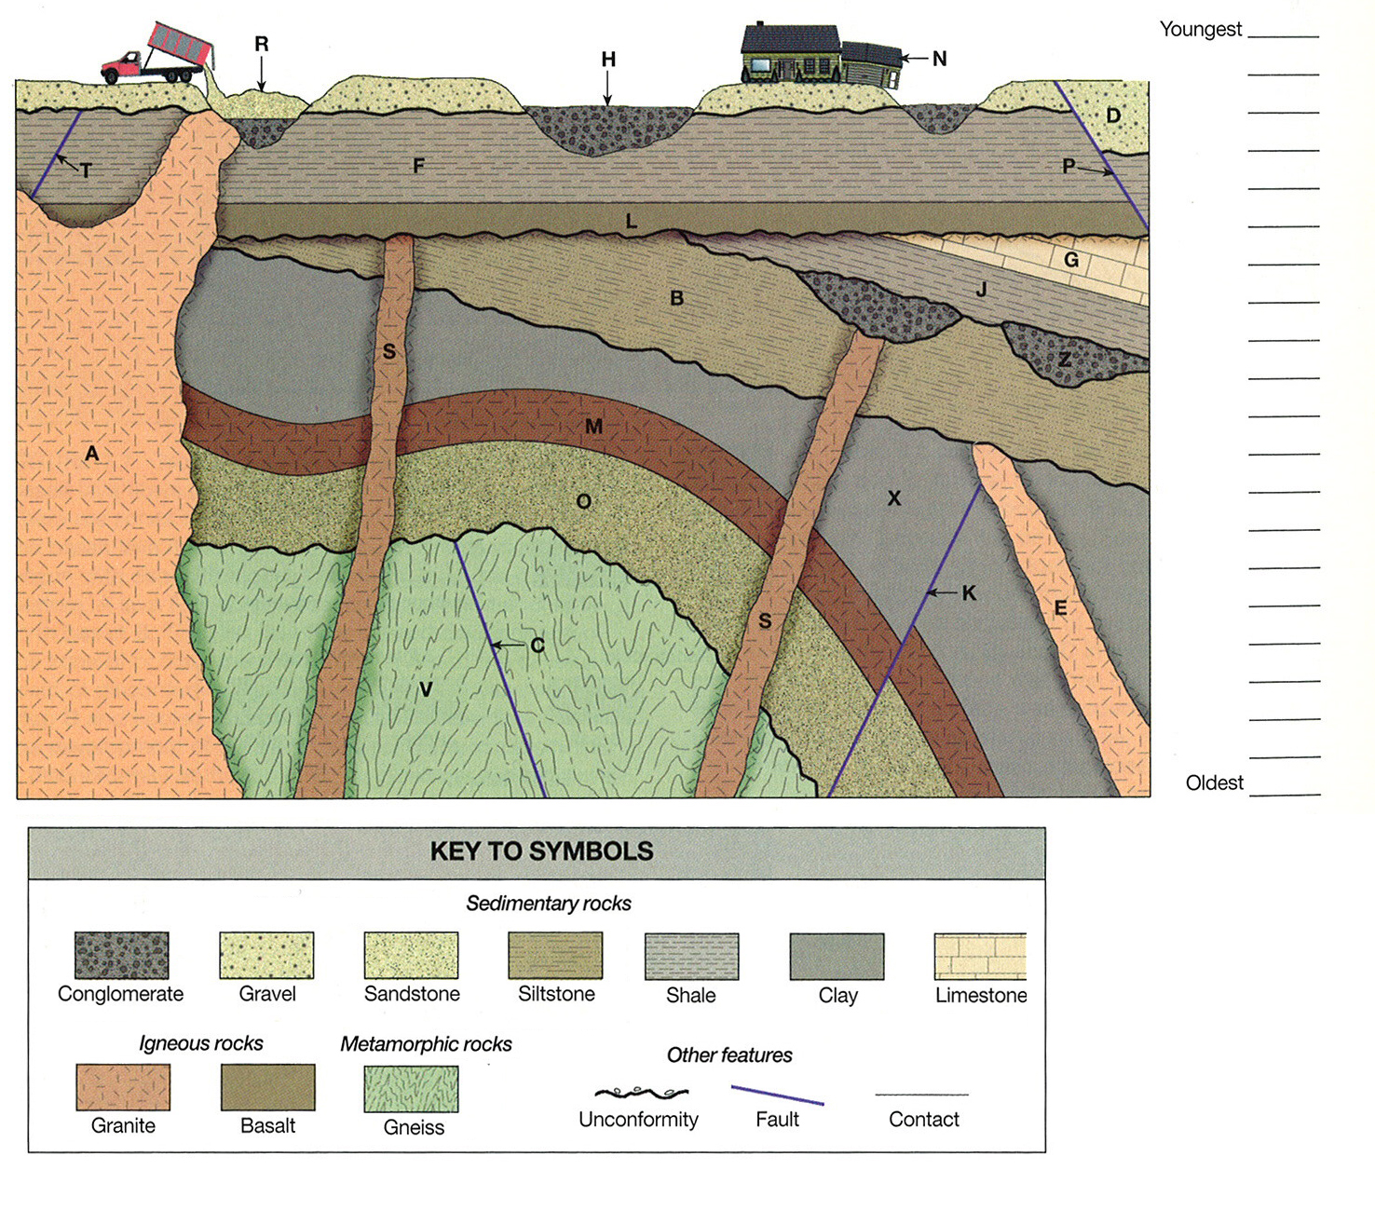
2. Biostratigraphic correlation

Now lets return to our units A and B. Say you found some fossils in these units (shown below). First, lets consider what these fossils can tell you:

1. Fossils can provide an additional measure for distinguishing stratigraphic units. When a fossil is found in a stratigraphic layer, we know that the sediment that formed that layer must have been deposited when that species was alive, so at some time in the rock record after that fossil first appeared (or the species first evolved) and before the species went extinct. Additionally, rocks located above the layer with the fossil are younger than that fossil, and units located below are older than that fossil.

2. The same fossil species found in two separate stratigraphic sequences can also be used to correlate strata, and order their sequences relative to each other. For example, a well defined fossil succession in an isolated rock outcrop can be used to place it in the sequence of other rock records on a continental (or even global) scale.

A. B.
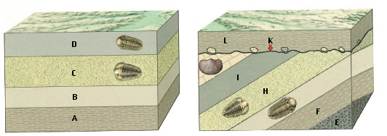

Based on the relative position of the fossils, correlate units from sections C and D as you did for A and B, drawing tie-lines between the two sequences. What is the dip of the beds in section D (is it slightly tilted, or overturned??)

If you wanted to correlate several sections of sedimentary rock using the fossil record, what kind of fossils would you look for, and why? (e.g. would you want species that were abundant or rare? Widespread or only present in small regions? Existed for long or short durations? Easily preserved or poorly preserved?)
Below is an example of units that have been correlated biostratigraphically. These rocks come from the northern Yucatan peninsula:

C.
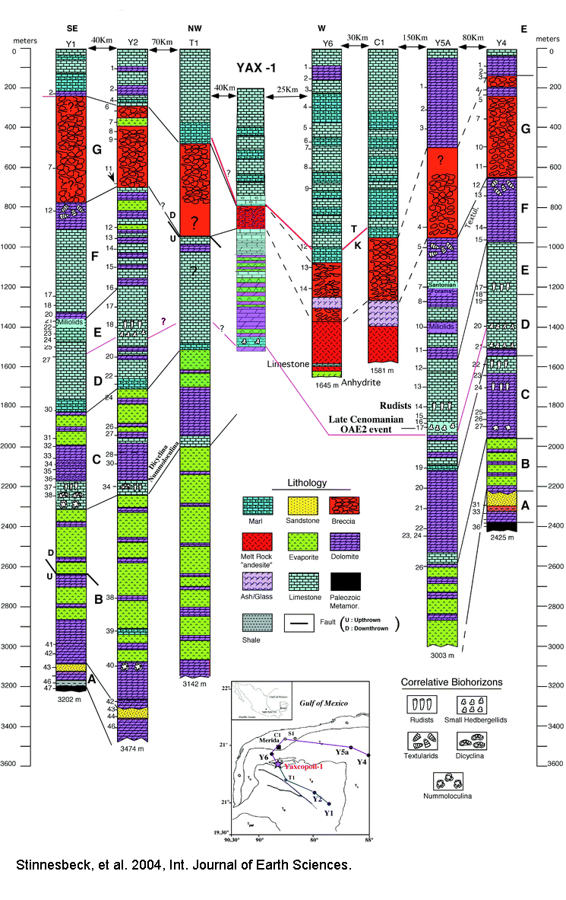
Most of the correlation of this column has been done along the top and bottom of a “breccia” unit. A breccia is a rock formed by smaller rocks that are cemented together, much like a conglomerate. The difference, however, is that the clasts in breccias are very sharp and angular, rather than rounded and smooth clasts found in conglomerates.

There are many different kinds of breccias, such as a volcanic breccia, which forms as a result of eruptive activities, or a fault breccia, which is an agglomeration of angular fragments of rock formed in the brittle zone of a fault.

Why might this breccia unit be a good useful in correlating the stratigraphic columns shown?

What other methods might a biostratigrapher use to justify his theory that the breccia unit is continuous across these sections (e.g. what other correlations have been made?)

Looking at the correlation lines between the units, you can see that the units are not uniform thickness (e.g. the correlation lines are not all horizontal and parallel to each other). This apparently conflicts with Steno’s principles of horizontal continuity. Think about why this phenomenon is observed, and what it means about how these sedimentary units were deposited. Discuss.

3. Graphic correlation

As you may have noticed in the series of stratigraphic columns shown in part (2), although the fossil distribution between different sedimentary sections may help us to correlate individual sedimentary layers to one another, they aren’t able to say a lot about the precise timing of these correlations. For example, organisms may migrate laterally at different time periods, or disappear in a local environment before their final extinction, which will confuse the boundaries between different time periods determined by fossil distribution.

Graphic correlation is a statistical method used to help resolve some of the “fuzziness” that may be seen by looking at only one or two index fossils in different stratigraphic units. This method compares the appearance and disappearance of all fossil species found in both sections, by plotting these values in one section against those of another.

For example, two stratigraphic sections are shown below, with the ranges of all fossil species present in each section plotted in meters above the base of the section.

D.
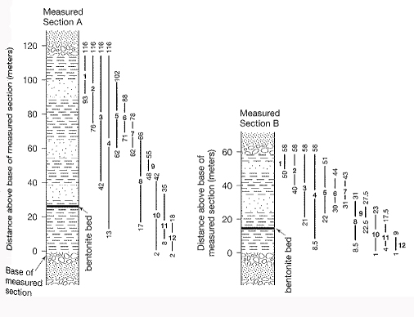
(From Boggs, 3rd ed., 2001)
To graphically correlate these two sections, one would plot the distance (in meters) from the base of the measured section of the appearance and disappearance of each listed fossil in Section A relative to the distribution of that same fossil in Section B, as shown below, in E. These points will cluster along a “line of correlation,” a best-fit that correlates the exact depth to time ratio between the two sections. Effectively, the x-y coordinates of any point on this line provide a precise time-stratigraphic correlation between the two sections.

E.
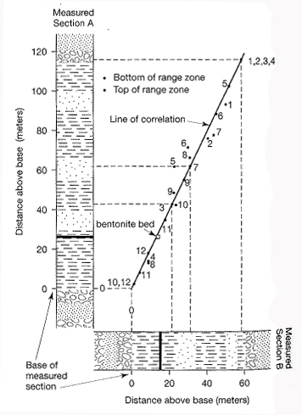
(From Boggs, 3rd ed., 2001)

In addition to providing a form of time-stratigraphic correlation, graphic correlation provides a powerful tool for evaluating differences in sedimentation rates between two sections, or the presence of a hiatus (or nonconformity) in a section. In the above example, although sections A and B contain identical fossils and therefore identical timespans, section B represents only half the rate of sediment accumulation. Therefore, the slope of the correlation line for these series is 2. If the slope of your correlation line = 1, then the two sections were being deposited at equal rates. If your correlation line shows abrupt changes in slope, it suggests a sudden change in the sedimentation rate of one of your sections.
In this exercise, you will form your own graphic correlation for the two stratigraphic columns on the following page. Plot the distance from the base of each column of the appearance and disappearance of each fossil on your x- and y- axes, then hand-draw a best-fit correlation line through your points. Your line may have to change in angle to accommodate the pattern you see in your correlation points.

You may draw your graphic correlation on graph paper or using appropriate software (e.g. Excel), but make sure your axes are equal in scale, and hand draw your correlation line.

Questions:

Describe the line you complete. Are there changes in slope? What do these mean? Explain what your slope(s) mean about the sedimentation rates of each section at a given point in time.

Notice the marked ash layer present in both of your columns. Ash often forms a rock unit that was deposited very quickly over a wide range as a result of a volcanic eruption. Does the intercept of your ash layers between section 1 and section 2 lie on your correlation line? Why is this a good check to see if your correlation line is correct?

Some of your appearance and disappearance points will plot off of your correlation line. Why might this happen?
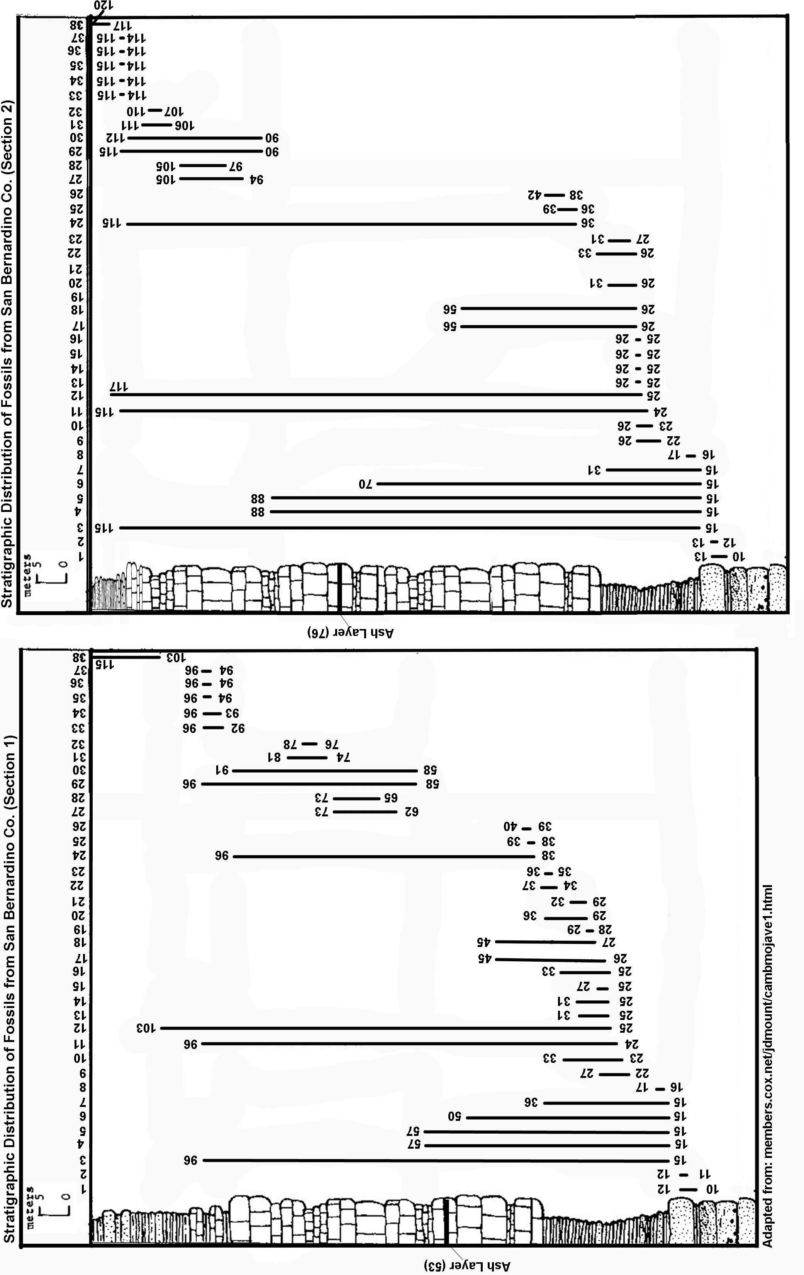
4. Developing the Geologic Timescale

After time-correlating several sections using graphic correlation, a database of fossil species has been compiled for a reference section, 100 meters long. Two subsets of this database are listed below. For each subset, draw out the stratigraphic range of each species relative to the height of the section (as shown in Figure D).

Historically, geologists have worked with these figures to categorize the history of the earth in units of time. They use places in the column where several species are first seen or last seen as a boundary between different time periods. By doing this with an extensive data set, they were able to define the entire geologic timescale before exact dating methods were available.

Take a look at both of your sections closely. Mark areas that you believe would make appropriate time boundaries in each section. You can denote major boundaries with a solid or thick line, and minor boundaries with a thin or dashed line. Once you have done this for each of your datasets, answer the following questions:

Which dataset was easier to use when defining time boundaries? Why?

What was your reasoning behind differentiating major and minor time boundaries?

What general observations can you make about the number of species and how this number changes with time?

What type of event does the “last seen” of several species occurring at the same time indicate?

Dataset 1: (Listed as height from the base)

Genus | First Seen | Last Seen
Blystagnostus | 96 | 99
Calodiscus | 10 | 65
Cephalopyge | 5 | 10
Ceragnostus | 78 | 99
Chatkalgnostus | 68 | 88
Chelediscus | 0 | 57
Ciceragnostus | 17 | 93
Clavagnostus | 3 | 68
Connagnostus | 22 | 73
Corrugatagnostus | 35 | 96
Cotaglagnostus | 37 | 46
Criotypus | 68 | 87
Cristagnostus | 27 | 58
Dawsonia | 3 | 51
Delagnostus | 25 | 50
Delgadella | 53 | 69
Denagnostus | 37 | 42
Dicerodiscus | 44 | 49
Dipharus | 100 | 100
Diplagnostus | 0 | 84
Diplorrhina | 53 | 85
Dolichoagnostus | 17 | 65
Doryagnostus | 46 | 77
Egyngolia | 84 | 94
Ekwipagetia | 35 | 37
Limarca | 47 | 88
Limopsis | 87 | 98
Mabellarca | 9 | 100
Macrodon | 31 | 95
Macrodontella | 44 | 82
Melaxinaea | 81 | 98
Myodakryotus | 33 | 44
Nipponolimopsis | 34 | 72
Noetia | 28 | 37
Noetiella | 71 | 77
Noetiopsis | 1 | 25
Notogrammatodon | 3 | 72
Okinawanoarca | 16 | 36
Ortonella | 77 | 83
Pachecoa | 66 | 72
Pentoperna | 45 | 49
Pharcidoconcha | 9 | 10
Porterius | 23 | 38
Protonoetia | 54 | 68
Quadrilatera | 22 | 79
Rasia | 68 | 80
Samacar | 3 | 75
Scapharca | 87 | 92
Sectiarca | 7 | 89
Spinearca | 10 | 41
Blystagnostus | 96 | 99
Calodiscus | 10 | 65
Cephalopyge | 5 | 10
Ceragnostus | 78 | 99
Chatkalgnostus | 68 | 88
Chelediscus | 0 | 57
Ciceragnostus | 17 | 93
Clavagnostus | 3 | 68
Connagnostus | 22 | 73
Corrugatagnostus | 35 | 96

Dataset 2: (Listed as height from the base)

Genus | First Seen | Last Seen
Acanthambonia | 60 | 99
Acanthocrania | 5 | 29
Acrothele | 62 | 92
Aktassia | 5 | 56
Alichovia | 58 | 96
Amictocracens | 34 | 50
Anabolotreta | 57 | 94
Apsotreta | 57 | 91
Celdobolus | 48 | 73
Ceratreta | 68 | 97
Cyrbasiotreta | 0 | 33
Cyrtonotreta | 3 | 32
Diandongia | 56 | 92
Ditreta | 58 | 92
Eoconulus | 33 | 50
Ephippelasma | 1 | 32
Ferrobolus | 21 | 43
Glyptacrothrele | 54 | 79
Hansotreta | 35 | 52
Hisingerella | 76 | 89
Karnotreta | 0 | 30
Aegilops | 10 | 21
Alytodonta | 38 | 51
Arginopsis | 56 | 99
Cardiolita | 57 | 93
Catamarcaia | 3 | 28
Cosmetodon | 60 | 97
Cyrtodonta | 62 | 94
Cyrtodontula | 0 | 30
Ekaterdonta | 56 | 98
Falcatodonta | 57 | 94
Grammatodon | 37 | 52
Hoernesarca | 0 | 31
Kenzieana | 5 | 32
Limarca | 36 | 96
Acadagnostus | 61 | 74
Acidusus | 34 | 52
Acmarhachis | 40 | 50
Acutatognostus | 58 | 94
Agnostaridis | 51 | 55
Agnostogonus | 36 | 50
Agnostotes | 5 | 28
Agnostus | 65 | 91
Allobodochus | 64 | 90
Ammagnostus | 36 | 52
Anglagnostus | 26 | 26
Aotagnostus | 61 | 92
Arthrorhachis | 3 | 33
Aspidagnostus | 55 | 98
Baltagnostus | 37 | 50
Blystagnostus | 59 | 90
Calodiscus | 53 | 92
Cephalopyge | 4 | 30
Ceragnostus | 56 | 93
Chatkalgnostus | 40 | 50
Chelediscus | 37 | 51
Ciceragnostus | 34 | 50
Clavagnostus | 1 | 30
Connagnostus | 39 | 50
Corrugatagnostus | 41 | 55

5. Diversity Through Time

The fossil record, including that which you have just analyzed in part 4, usually shows that diversity of life has increased through time. There is, however, an exception to this trend: certain points in earth history mark a time when many groups of organisms show a marked decrease in population and diversity. These periods are extinction events – there have been five major, or mass extinctions in earth history.

Use the data from part 4b to generate your own diversity curve (plot the number of species as a function of depth, or relative age). What observations can you make about diversification through time by looking at this diversity curve? Are these observations consistent with those suggested about diversity through geologic time and the effect of mass extinctions?

Based on your diversity curve, where would you place major boundaries? Are these boundaries the same as those you chose in part 4? Is the upper boundary of your section (0m) also a time boundary?

Finally, look at the data in Part 4a. If you were to plot a diversity curve for this section, would it look similar to your data from Part 4b? What might this tell you about the reliability of using the data in 4a to develop boundary markers on your geologic timescale??

