**Energy Sources GLE pre and post (All three module authors)**

**There is insufficient evidence (p=.778) to conclude that there is a statistically significant difference between the Pre and Post Test (where α=0.05).**

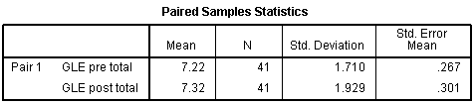

|  |  |  |  |  |
| --- | --- | --- | --- | --- |
| **Paired Samples Correlations** | | | | |
|  | | N | Correlation | Sig. |
| Pair 1 | GLE pre total & GLE post total | 41 | .274 | .083 |

