In-Class Exercise: What patterns of change can we identify in the tropical Pacific?

We understand climate variability and climate change by looking at changes in the oceans and atmosphere over a period of years. In this class, we will look at data collected from the TAO/TRITON ocean-observing array in the tropical Pacific as well as computer estimates of precipitation and temperature.

Goals:
(1) Determine what happens in the tropical atmosphere and ocean over time.
(2) Gain experience interpreting climate data.

Directions:
Your group has been given one of 3 data sets (sea-surface temperature/wind, precipitation, or pressure). Take some time to look at the data. In Part 1 below, answer the questions relevant to your dataset (you should discuss the questions as a group, but everyone will answer all of the questions). After you have some time in your group, we will discuss the data as a class. You will answer questions in Part 2 after the class discussion.

First, in your group:
Choose one recorder
Choose one reporter

As you answer the questions in Part 1, prepare a ~1 minute synopsis of your findings to share with the rest of the class at the end of the period.

Your Data Set: Temperature & Winds

You have nine years of ocean surface temperature data and wind data (1992-2000). For each year, you have a plot of the January averaged sea surface temperatures and wind, and a plot of the anomalies from latitudes 10°N to 10°S of the equator and between longitudes 140°E and 100°W. This represents a region of the Pacific Ocean spanning from just northeast of Australia to near the west coast of South America.

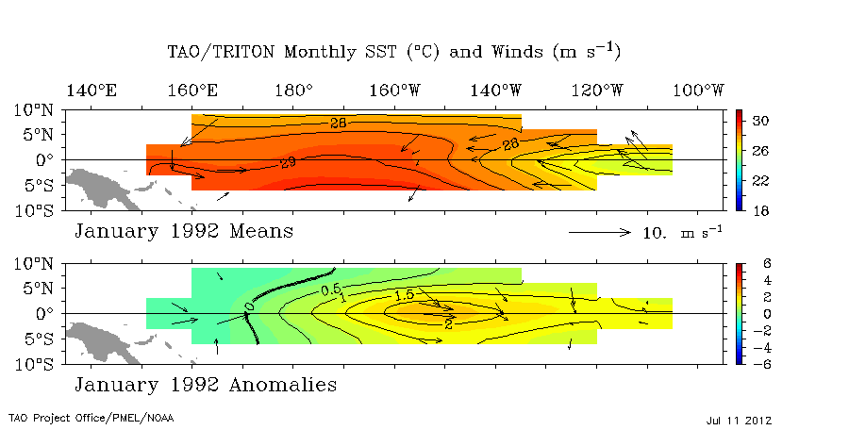
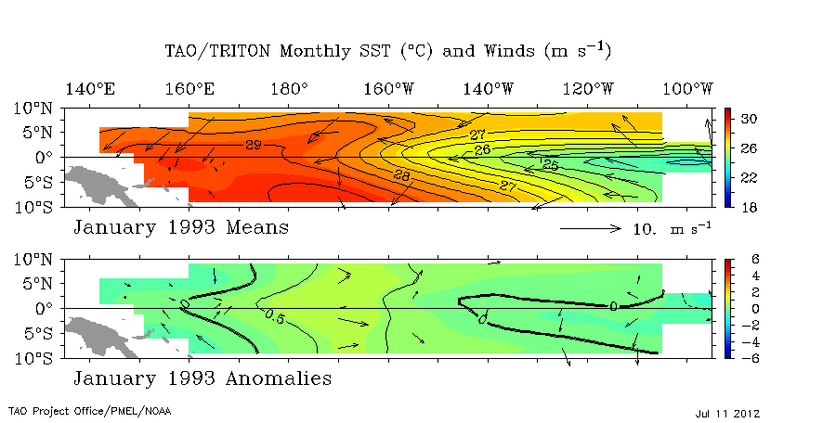
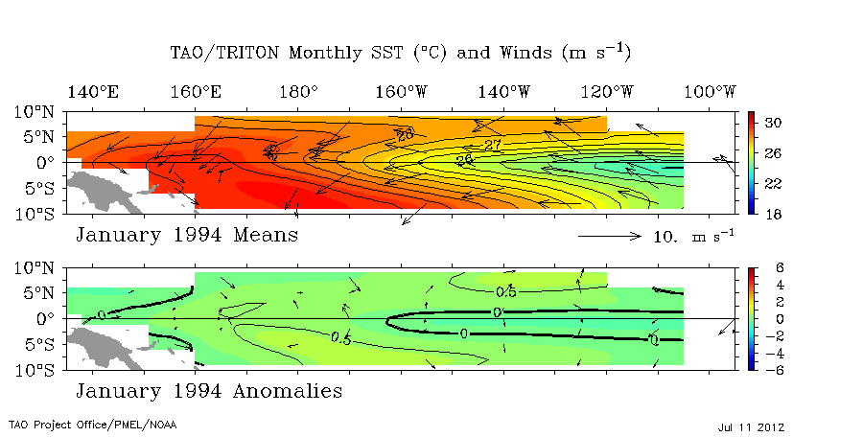
1992
1993
1994

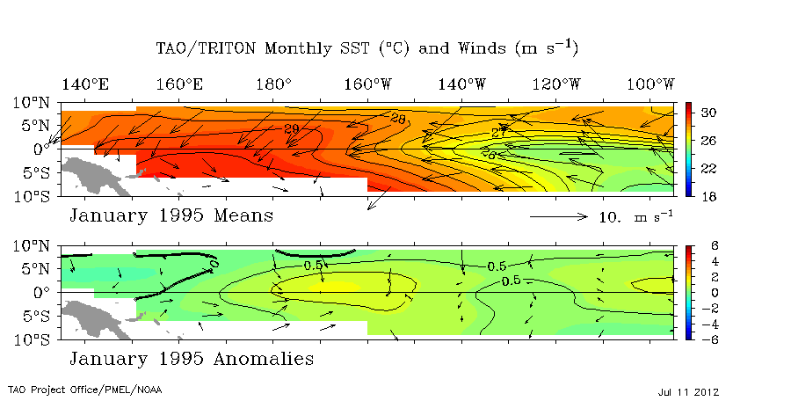
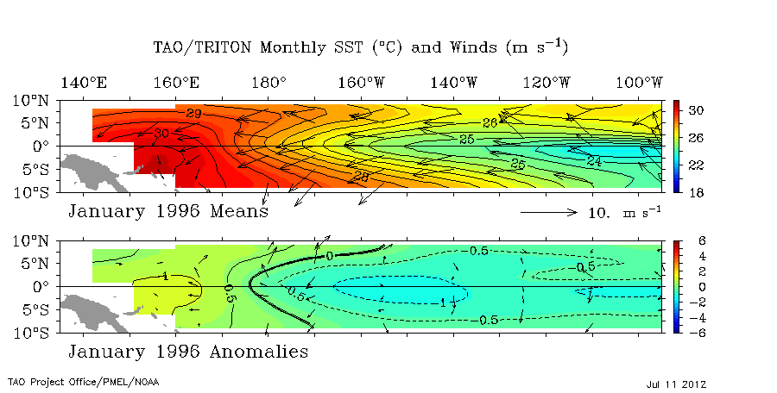
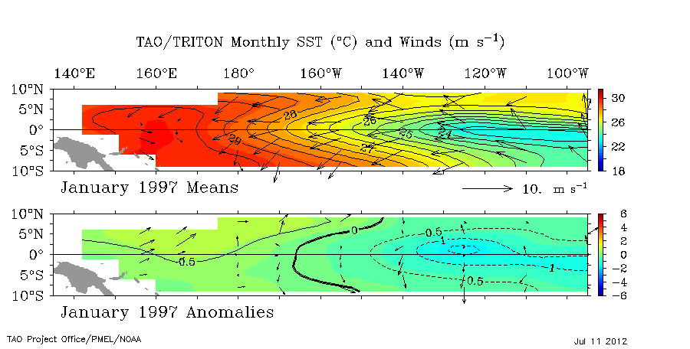
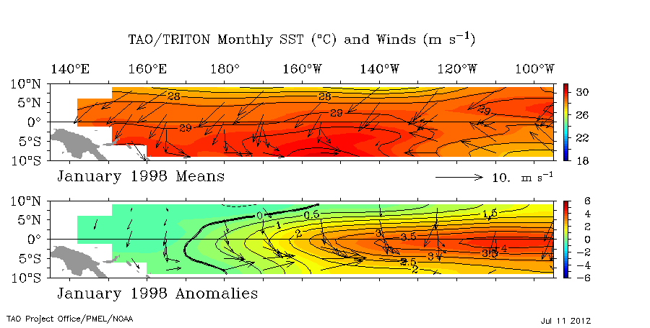
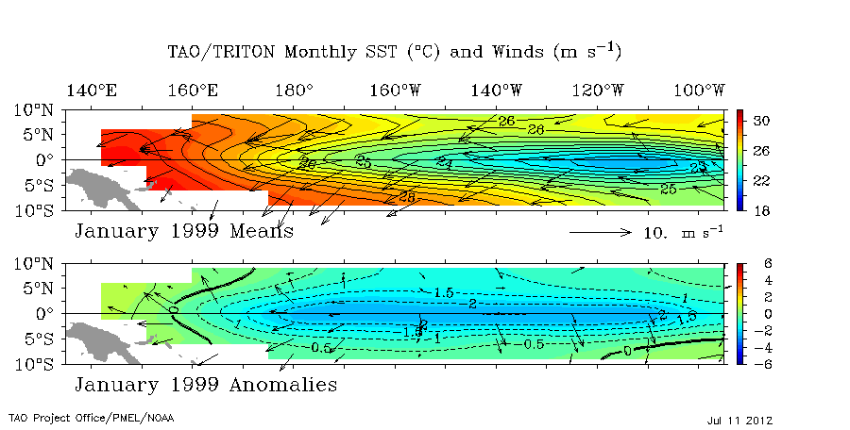
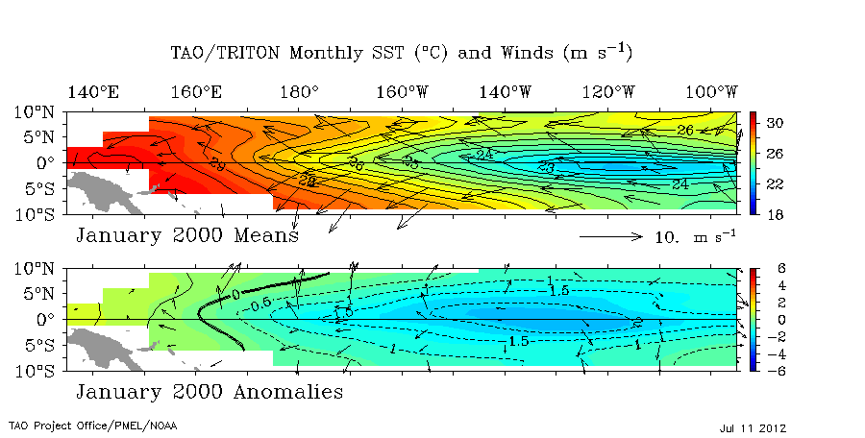
Hovmöller diagram
1995
1996
1997
1998
1999
2000
Notice that the y-axis on this plot is time and the x-axis is longitude. The first column shows monthly averaged equatorial sea surface temperature from 1992-2002, and the second column depicts the temperature anomalies over this same time period.

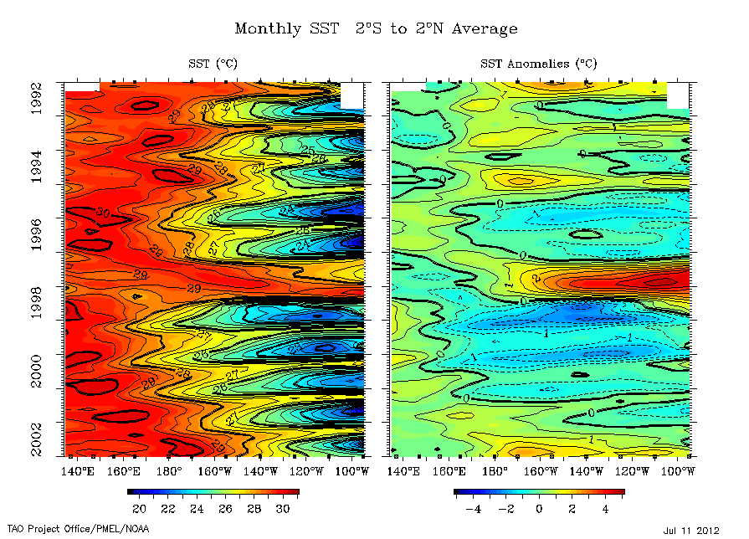
Part 1

1) In 1992, where do you find the warmest sea surface temperatures? (Specify with a range of latitude and longitude.) Where do you find the coolest temperatures?

2) In the 1992 anomalies, what is the range of values across the Pacific? Where are the largest anomalies in this plot?

Scroll through the ten years of images, notice, especially, what happens in the plots of anomalies.

3) What year(s) strike you as having the most interesting data? What about these years strike you as interesting?

4) In which area, and during which years, do you find the largest positive anomalies?

5) In which area, and during which years, do you find the largest negative anomalies?

6) In the years with the weakest anomalies, what direction are the prevailing winds? What happens to the winds in the years with the largest anomalies?

Use the Hovmöller diagram for the next question.

7) What types of things does this diagram tell you about sea surface temperatures that you couldn’t get from the other diagrams?

Part 2: Complete this question after class discussion

1) Based on your Hovmöller diagram, is examining the Northern Hemisphere winter months (December, January, February) just as informative as looking at the annual cycle? Why or why not?

