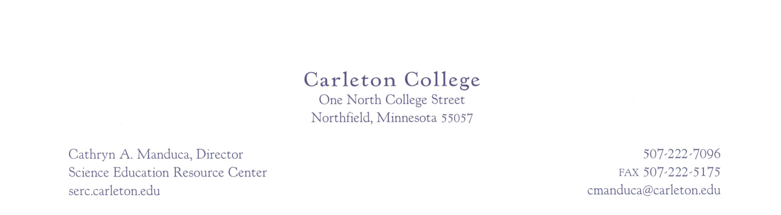

Date

Name
Institution
Department
Address
City, State Zip

Dear Author,

Thank you for agreeing to author an InTeGrate module/course. This letter serves as a contract outlining our expectations and your responsibilities.

In order to develop modules that are rigorously designed yet flexible enough to work in a wide variety of undergraduate instructional settings, all modules will be developed by teams of faculty. Groups of module/course development teams will work together with an editor within broad topic areas to ensure that materials can be used collaboratively.

Team Leader at Institution will serve as the overarching editor for your module/course and will assist you in defining the scope and approach to your module/course to ensure that the modules/courses can be used in combination to support larger segments of instruction.

Your team will consist of n faculty members drawn from n different institutions. As part of this team you will collaboratively author, revise and publish a module/course supporting approximately two weeks/8-12 week term of instruction on name of module/course topic.

All modules/courses developed through InTeGrate must meet the standards of the InTeGrate Design Rubric. All modules/courses will be published on the InTeGrate website with a complete set of materials supporting adoption and use by faculty teaching in traditional or on-line settings. Each member of the team will test the materials in their own classroom prior to revision and publication of the materials. Your team will be responsible for the full set of materials for your module/course. The materials will be freely available to faculty and not-for-profit educational institutions. The copyright for all materials will be held at Carleton College for the InTeGrate project.

By signing this contract, you agree to:

- Work as a team member over the course of two years beginning May 2013 to collaboratively author, pilot, revise and publish teaching materials as well as materials supporting their use utilizing InTeGrate templates and guidelines;
- Attend two face-to-face meetings of the name of team module/course teams; one in May 2013 and a second to be scheduled following testing of your materials to be scheduled spring/summer 2014;
- Work with the InTeGrate Assessment Team to achieve the standards laid out in the InTeGrate Design Rubric;
- Test the module/course materials in at least one of your own courses during the 2013-2014 academic year. You agree to obtain and submit data from a minimum of 80% of your students. In addition to student data, you agree to submit all other information required for testing your materials and evaluating the project;
- Revise, as a team, teaching materials based on this analysis to address issues identified in the testing of the materials and the review of supporting materials;
- Complete and publish all materials and supporting documents on the InTeGrate website using the standard InTeGrate modules for materials; and
- Document your own experience teaching the module/course for publication on the website.

For fulfilling these duties, you will receive a total stipend of $15,000 as follows:

A first payment of $7,500 will be made upon complete development of materials that are certified as meeting the standards within the InTeGrate Design Rubric by the leader of the InTeGrate Assessment Team. A second payment of $7,500 will be paid when the tested materials have been revised and published on the website with the full set of required supporting materials. To receive payment, you must complete reporting requirements as directed on the InTeGrate SERC content management page and have a completed IRS W-9 form on file at the SERC office. You can download an IRS W-9 form by visiting: http://apps.carleton.edu/campus/business/businessofficeforms/ and clicking on the “Blank W-9” link.

Please note that stipends are restricted to faculty at U.S. institutions who are citizens or permanent residents and that you are responsible for all taxes associated with these payments.

If you agree to these terms and conditions, please sign one copy and return the contract to:
Krista Herbstrith
Carleton College, W-SERC
One North College Street
Northfield, MN 55057

A duplicate is provided for your records.

Thank you very much for your commitment to developing these resources. I look forward to our work together.
Sincerely,
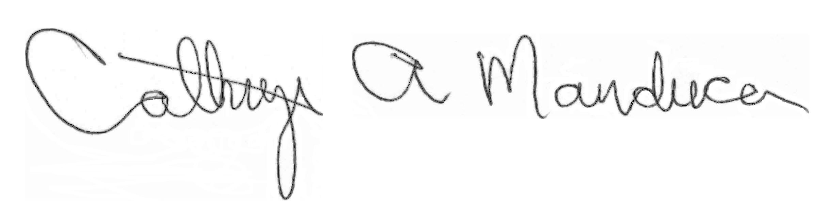
Dr. Cathryn A. Manduca, Director
Science Education Resource Center

________________________ ___________________
Signature Date
NAME

Research Release
The InTeGrate community effort aims to dramatically increase geoscience literacy of all undergraduate students. For the purposes of this grant and to improve education in geoscience education at your own institution, we are studying the impact of changes we’ve made to the curriculum based on the work of this project.
As a module author it is expected that you are also consenting to participate in the research aspects of this project. In addition to the items of your above contract, you may also be asked to participate in interviews, focus groups, or have your classroom observed. Your participation in these interviews or observations is voluntary. The notes and data shared via interviews and observations will be incorporated into our research results in aggregate. Presentation of the material will be confined to project work groups, professional publications, and conferences. When individual quotes are used to illustrate important points, your name will not be identified. There are no foreseeable risks resulting from your participation.
I am at least 18 years of age and voluntarily grant permission for the described release and use of notes and comments from interviews and/or observations.
Please select one of the following choices to indicate your level of desired participation in the study:
_____I consent to participate in ALL aspects of this study.
_____I consent to participate in all aspects of this study EXCEPT those listed in the box below:

________________________ ___________________
Signature Date
NAME

