Seismic Refraction, Unit 3: Seismic Survey Preparation—Additional Supplies, Planning, Safety, and Field Notes Recommendations

Sarah Kruse (University of South Florida)

*This document is intended to augment other guides specifically about the data collection and analysis and help people newer to seismic surveying be ready for the field.*

# Additional supplies

EarthScope Primary Instrument Center (EPIC) does not typically provide all the supporting supplies that are needed or recommended for a seismic refraction survey because needs vary and because some are prohibitively heavy to ship repeatedly. However, EarthScope may be able to help low-resource institutions purchase the supplies the first time. Contact [education@earthscope.org](mailto:education@earthscope.org) if this would reduce use barriers for your course.

* 1–2 100-meter measuring tapes
* A tarp on which to place the Geode and battery and laptop if you are working in a dusty or damp setting. This will make it easier to keep the connectors clean. Suggestion: lay out the tarp and put the equipment on the downwind side. That way if wind comes up or it starts to rain you can quickly fold the upwind half of the tarp over the equipment. (Even more luxurious is a camp chair and even a folding table. Even if you do not put it underneath, have a tarp available in case of rain.
* A full-length sledgehammer: 10-12 lbs makes for a good hit and can be swung by most people.
* A roll of electrical tape to attach the trigger to the hammer. Remember to make sure the dot is on the side facing the hammer (see trigger). Suggestions: mount the trigger 6 inches above the head of the hammer on a narrow side of the hammer. Wrap electrical tape tightly around the trigger + hammer all along the length of the trigger. Then tape the trigger cable higher on the handle as well.
* 5–6 camping stakes per 100 m tape to hold the survey tapes in the ground. Use stakes to hold both ends, and if there is topography, you may want to hold intermediate points to the ground as well. Be careful about the stake at the far end of the line—you don’t want to pull the survey tape off the spool. You can put a couple of wraps of the survey tape around a stake at the far end of the line, if you don’t leave the tape in that position for too long. Any folding from the wraps should come out as you rewind the tape. Rewind the survey tapes carefully before you move any tape to a new location, a tangled tape or one that does a 180-degree twist can cost a lot of time to fix.
* A small sledgehammer or other hammer to pound the stakes into the ground if the ground is hard.
* A 12-V car or motorcycle battery and 12-V battery charger
* An umbrella for sun, if it is sunny and not too windy. It can be hard to see the computer screen in full sun.
* Provide a set of work gloves for the student swinging the hammer. May not be needed, but nice to have on hand (no pun intended).
* Ear plugs. If you are using a high-density plastic strike plate, ear plugs may not necessary but if the strike plate is metal, they should be used. You can get these at Home Depot or a hardware store. Eye protection is also a good idea.
* Optional: If you are doing a long survey (shots more than 100 m away from the Geode) you may want walkie-talkie radios so that students sitting with the Geode can tell students when to swing the hammer.

# Before data acquisition

* Research what you might expect in the subsurface at your site. In some places the water table rather than sediment-bedrock contact may produce the first refracted arrival. To collect and assess your data it can be very useful to have some idea of both the depth to the water table and the depth to bedrock beforehand. If the water table is shallow, you may be able to auger to it and measure the depth with a survey tape (good enough to compare with the seismic data). Local well drillers or someone in your campus physical plant may have a general idea about these depths.
* Work through the Design a seismic refraction survey exercise (Unit 3 Part 1, Exercise 1) for your guesses on subsurface structure.
  + Recall from Unit 1 velocity of soil is ~ 400 m/s, velocity of water is ~1500 m/s, and velocity of bedrock is ~2000 m/s. The table on the last slide of the Unit 3 Part 2, Data Analysis and Interpretation presentation shows that these numbers lie within a range.
  + Typically, soils may be ~200 m/s–800 m/s above the water table, and >~800 m/s below the water table. Weathered rock will be in the range of 1000–2000 m/s, while intact rock is >~2000 m/s.
  + There is a nice table in <https://pburnley.faculty.unlv.edu/GEOL452_652/seismology/notes/SeismicNotes10RVel.html>. (We are measuring P wave velocities.)
  + Going through this process will help you ensure that you have enough space at your site to capture the refracted wave.
* If you have no idea about the subsurface, it can be useful to do a preliminary “walkaway” test in which you place the geophones quite close, such as 0.25 or 0.5 m apart. Then you start with a shot at one end of the line and look to see whether you capture a slope break along this line. If you don’t see a slope break, then move the shot one array length away and shoot again. (If you have put your geophones in a line starting near zero on a survey tape It can be useful to have a second tape laid out the other direction from zero to easily find the new position of the shot.) Continue until you see a slope break. At this point calculate the distance between the shot location and the slope break. Then you can decide what geophone spacing you want to use for your actual survey. It is good to set the geophone spacing close enough that you will capture the direct arrival on at least 3–4 phones before you see the slope break.
* Make a checklist for things you will take to the field and bring home from the field. (Sample checklist supplied.)
* Review the *How To: Seismic Refraction Field Set Up* video (<https://www.youtube.com/watch?v=AyOFG6ZA540>).
* The night before the survey, charge the 12V battery.  
  The day of the survey, check with a voltmeter that the 12V battery is charged (>12.7 V).
* The night before the survey, charge the laptop computer. (Bring the car computer charger to the field—EarthScope provides this, in case the laptop doesn’t hold its charge.)
* If you have an option for when to run your survey, try to avoid windy days. Or if the wind tends to come up in the afternoon, schedule in the morning, if possible.

# During data acquisition

* 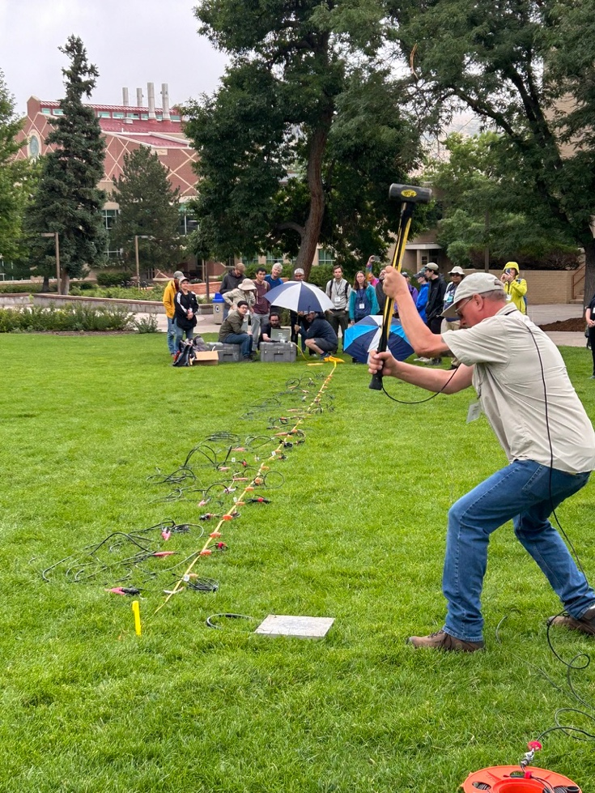Swing the hammer safely and effectively; make sure students swing the hammer with the trigger on the upper side of the hammer, so in case they miss the strike plate and hit the ground they don’t smash the trigger into the strike plate. Make sure the cable is not in the path of the hammer blow. Draping the cable over one’s shoulder can be a good way to keep it out of the way. The person operating the sledgehammer should aim to have the hammer head drop straight down and back up again without a double bounce if possible. People with back issues should not be the ones doing the sledgehammer.
* Hammer operators and nearby people should use ear plugs if using a metal strike plate. Eye protection is also a good idea.
* Students should make a sketch of the experiment in their field notebooks, carefully noting the locations of all geophones and the shot location corresponding to each file. The most common mistake is that students (or faculty) fail to update the shot location in the Geode when the shot location is moved. Then the shot location is improperly recorded in the data file. This is usually an easy fix but only if the correct shot location is recorded in a field notebook.
* Make sure students note the direction of any survey. For example, on a line that runs NW–SE, is the zero position on the survey tape at the NW end or the SE end?
* Make sure the student at the Geode and the student swinging the hammer double-check with each other the hammer location before the swinging starts. This helps to avoid the problem of not recording the shot position correctly.
* After you are finished, if the pounded-in stakes don’t come out easily, hit them on the side to create a bigger hole to pull them out.
* Pull up geophones before you pull up the survey tape. (If working in tall grass, geophones alone may be hard to find.)
* Use the checklist again at the end of the day to make sure no equipment is left in the field.