Seismic Refraction Unit 3: Geode Field Quick-Start Guide

Greg Chavez (EarthScope Consortium, greg.chavez@earthscope.org)  
Updated by Ann Mariam Thomas (EarthScope Consortium)

# Background

Geode users, this guide is intended to help you quickly start a basic Geode survey. Note that all surveys are different, and the suggestions listed in this guide may not fit your scientific objectives. It is up to you, the user, to identify the specific settings that your survey requires. For typical acquisition parameters and practices for near-surface studies, you can refer to [Near-Surface Seismic Refraction Surveying Field Methods](https://www.geometrics.com/wp-content/uploads/2018/10/SeismicRefractionSurveying_r4a.pdf) by Deborah Underwood.

All EPIC (EarthScope Primary Instrument Center) Geodes that return from the field are tested, and during this process any data and configuration settings are erased, and the unit is reset to factory default settings. This is done for two reasons: (1) we don’t want to backtrack all the user settings in order to get the control software back into a standard configuration, and (2) if the software doesn’t detect any previous configuration information, it will automatically solicit the user to enter all the valid information it needs to successfully collect a dataset. This feature makes startup for a new user fairly easy and straightforward.

If you prefer a visual start guide for your Geode survey, check out the How To: Seismic Refraction Field Set Up video (<https://www.youtube.com/watch?v=AyOFG6ZA540>).

# Part I: Equipment Setup

**Note**: Always fully charge your laptop the night before your experiment to avoid a max current draw situation in the field that may needlessly drain your field batteries.

1. **Plant the geophones** at your desired locations and **connect them to the takeouts** on the geophone takeout cable. Geophone intervals of 1–5 meters are typical for near-surface surveys. When planting geophones, it is important to keep the geophone spike vertical and push it as far into the ground as possible. Ensure that each geophone is secure by gently trying to twist it.
2. **Secure the trigger cable** onto the shaft of your sledgehammer using PVC electrical tape.
3. **Connect the Geophone takeout cable and the trigger** input to the Geode connectors with the following symbols.

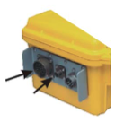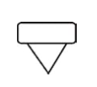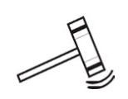

*Geophone Takeout Cable*

*Trigger*

Note that you will need an adapter if you have Cannon NK27 connectors on your takeout cables.

1. **Connect the digital interface cable** to the Geode. You will recognize the digital interface cable as it has identical connectors on either end, neither of which have pins. Geodes often have more than one digital interface cable, so you will want to connect to the one with the OUT symbol, which indicates data is transmitted OUT of the Geode back toward the storage and control device.

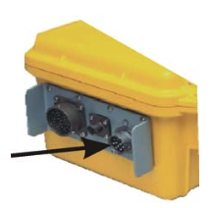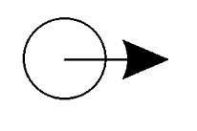

*Digital Interface*

*Cable (OUT)*

1. Connect the other end of the digital interface cable to the connector on the small **network interface box (NIB).** It is a small box, 5 cm square, with a pinless MIL connector on one side for the ES-3000/Geode interface cable and an RJ45 connector on the other. Connect the RJ45 connector to the RJ45 port on your field computer. If you have a NIB with a toggle switch on one side, put the toggle switch in the ON position.
2. **Connect your 12V power source** to the Geode by connecting the power cable to the connector with the symbol

*Power*

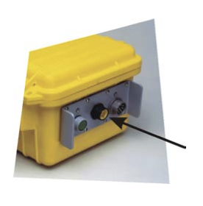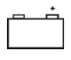

Your completed setup should look similar to Figure 1. 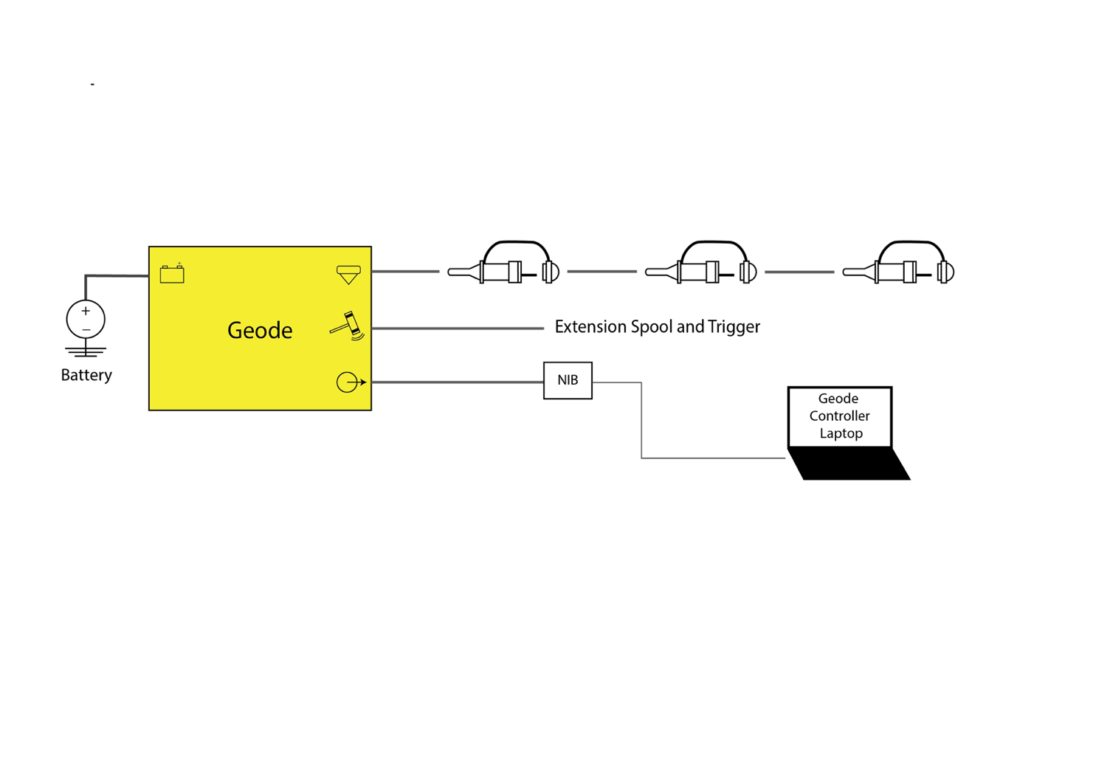

Figure 1. Equipment setup

1. Check if the blue LED light on the Geode is blinking. This indicates that the Geode has been successfully activated. If the blue LED is not blinking, toggle the Enable Power switch on the NIB. If this does not work, try pressing the red test button on the Geode. If the blue LED turns on after pressing the test button, the 9V battery in your NIB Box may need to be replaced. If the light does not turn on after pressing the button on the Geode, then your Geode is not connected properly to 12V.

# Part II: Data Acquisition using *Seismodule Controller*

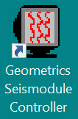

Figure 2. Desktop icon for the control software

1. After your equipment is connected and powered on, open the *Seismodule Controller* application (Fig. 2) on your field computer. If the software cannot detect any seismographs (Fig. 3), select “Retry.” Sometimes you need to try more than once for the software to detect the equipment. If the software still cannot detect your geophones, check the connections on the Geode and ensure that you have completed every step in Part I.   
   Once your equipment has been detected, you will be prompted through the following series of menus to create an acquisition configuration:

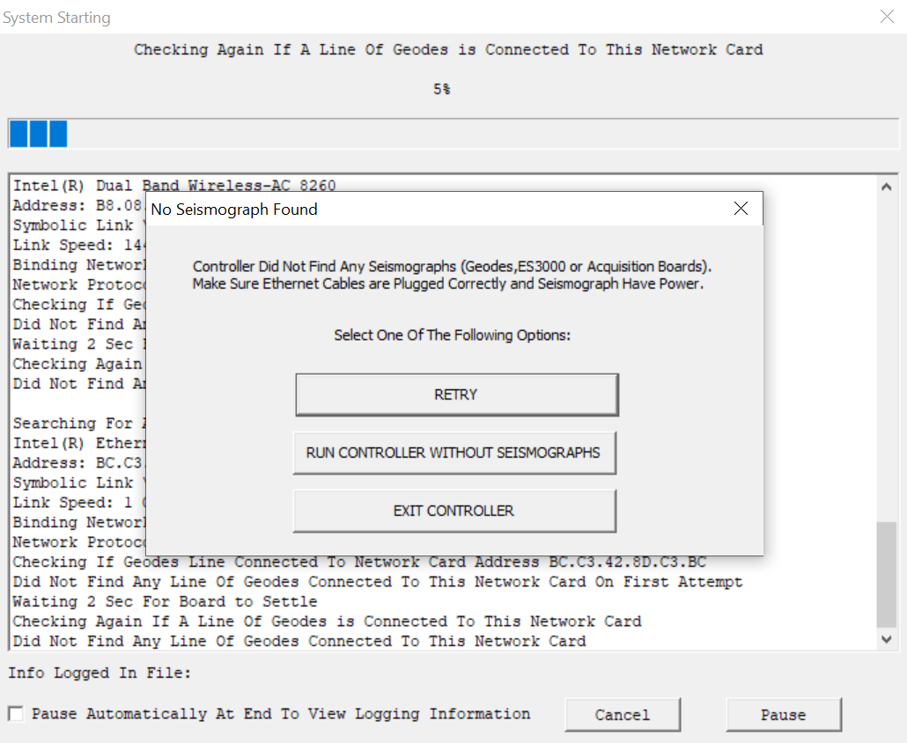

Figure 3. 'No Seismograph Found' message on Seismodule Controller

* 1. **Survey name:** Enter a helpful survey name and the initial line number (typically 0).
  2. **Acquisition correlation:** Enable or disable correlation. Disable correlation if you’re not correlating with an outside signal. In most cases, disable correlation will be checked. Keep “Pilot Channel #” at its default value of -1.
  3. A screenshot of a computer

     Description automatically generated**Acquisition stack parameters:** We recommend checking “Auto Stack,” “Stack Polarity Positive,” and “Display Intermediate Stacks.” You can set a stack limit that will automatically save files and clear memory when that stack limit is reached. If you are working with an inexperienced crew, we recommend setting this number to a high value (ex. 10; but at least 3 is good), and using the Hot Keys to save and erase manually when the desired stack limit is reached. The Hot Keys for save and erase are: F7 (Save) and F2 (Clear Data). The “Replace” option will not stack your data.

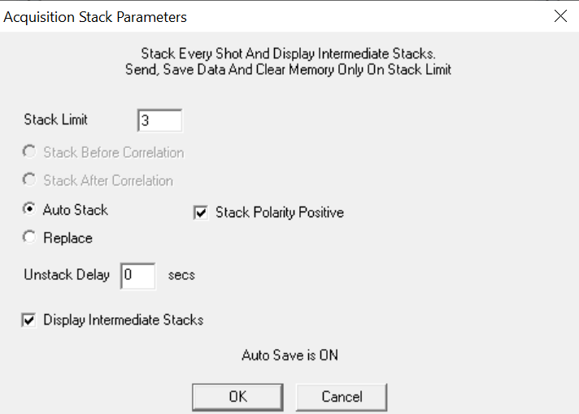

Figure 4. Setting Stack Parameters

* 1. **Acquisition timing parameters:** Set the Sample Interval (0.250 ms), Record Length (2 s), and Delay (0 s). (Fig. 5) The values given in parentheses are good options for most local strike plate cases.
  2. **Acquisition filter parameters:** We do not recommend setting filters at this stage (set both options to “FILTER OUT”).
  3. **Geophone interval:** Set your geophone spacing in meters or feet.
  4. **Gains:** High/Low gain selection. We recommend the default setting of “All Low Gain”.
  5. **Geometry menu:** This menu shows the channel use setting and spacing for each geophone channel (Fig. 6). You can set your first shot location here, in the unit you selected for your geophone interval (also given in the lower right corner of the window). For example, if your geophone interval was set to 5 meters and you plan to shoot 10 meters away from your first geophone, you would enter -10 as the “Shot coordinate.” Typically, you will take 3 shots at each geophone location. You will need to manually roll the shot location after every competed stack by entering the next location in the box. Use the F3 Hot Key after you save the previous shot. Note: The Geode also has an auto roll capability for more experienced users.

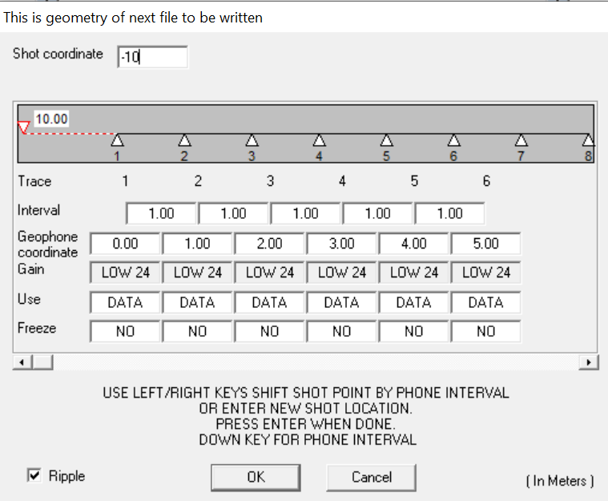

Figure 6. Set Experiment Geometry

* 1. **Storage parameters:** Select a file start number and a file format. If the start number suggested by the software is any number other that 1, you may have previously saved files in your directory. You should move these old files or change directories if you are starting a new survey. Auto save will save a file after every hammer strike or if the stack limit is reached, depending on your selections in the “Acquisition Stack Parameters”menu. If you plan to use Hot Keys to select and save your files during the survey, uncheck Auto Save. We recommend the SEG-2 file format.
  2. **Operator log:**  Select your log preferences. All selected information will be listed in the header of the log file. You can keep the default template or enter your own log items and descriptions.
  3. **Trigger Options**: Set the trigger sensitivity, hold off, master trigger, and arm mode. Setting the trigger hold off to 0.5 s and keeping the other settings at their default values can be a good option for typical cases. I have never needed to adjust the sensitivity from the default of 50%, because when most triggers fail, they fail completely, and once fully failed, modifications to sensitivity do not have any impact. By default, the master trigger is always the Geode closest to the CPUI. If you need to move the master trigger to another Geode in your survey line, you can select that option here. With Arm Mode set to Auto, the trigger will automatically re-arm after each shot.

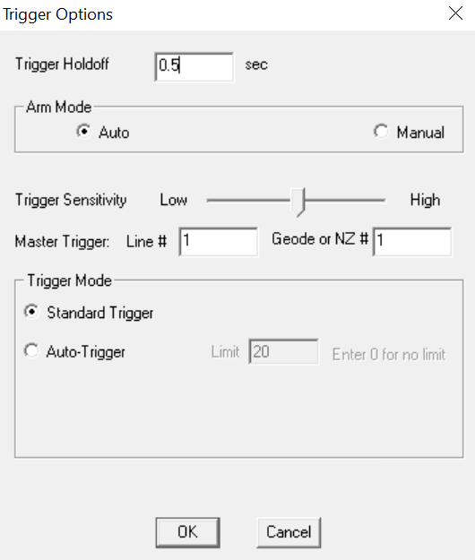

Figure 7. Set Trigger Parameters

*Figure SEQ Figure \* ARABIC 4. Set Timing Parameters*

That concludes the basic survey setup on *Seismodule Controller*.

**Troubleshooting Tip:** If you lose track of your acquisition settings and/or forget what changes you have made, you can always adjust any of the initial acquisition settings using the toolbar menu at the top of the *Seismodule Controller* software. Alternatively, you can use the following reset steps to restore the unit back to factory defaults and start fresh.

T1. In the “.System” menu at the top of the software, select “Test” --> “Troubleshooting: Reset All Parameters to Defaults When Program Restarts.”

T2. Click “Yes” and hit the red X at top right to close out of the software. Click “Yes” to terminate the survey.

T3. Erase or move your saved logs and restart the *Seismodule Controller* software.

1. Set the NIB toggle switch to the center OFF position. This will allow the software to close and power down the Geode properly when the survey is concluded.
2. **[Optional] Setting up the user interface.** After the main configuration options are selected, you are left with a geometry toolbar at bottom and several overlapping menu screens on *Seismodule Controller*. I will suggest a few options to make this display a little more user friendly.
   1. Right click on the Geometry toolbar at the bottom and select “Geometry Tool Bar Display Setting” (Fig. 8).

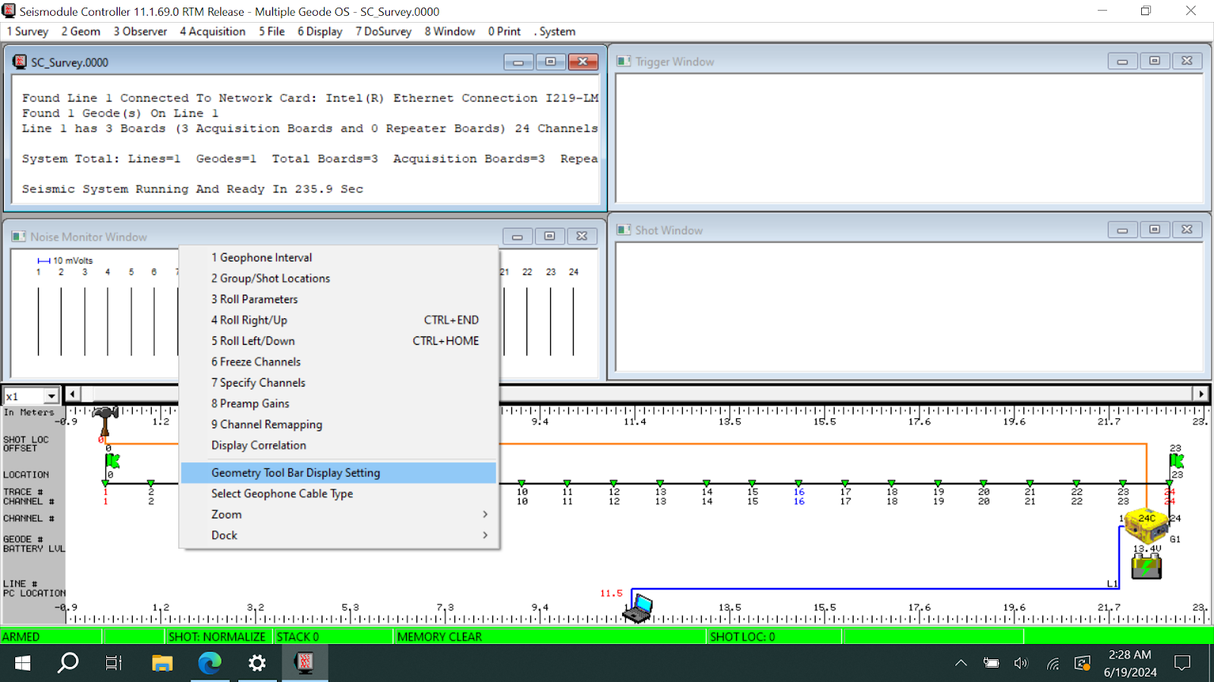

Figure 8. Selecting Display Settings

* 1. Uncheck “Show PC,” “Show Battery,” “Show Flag,” and any others you think are unnecessary (Fig. 9).

Figure 9. Checkbox selection in Geometry Toolbar Settings

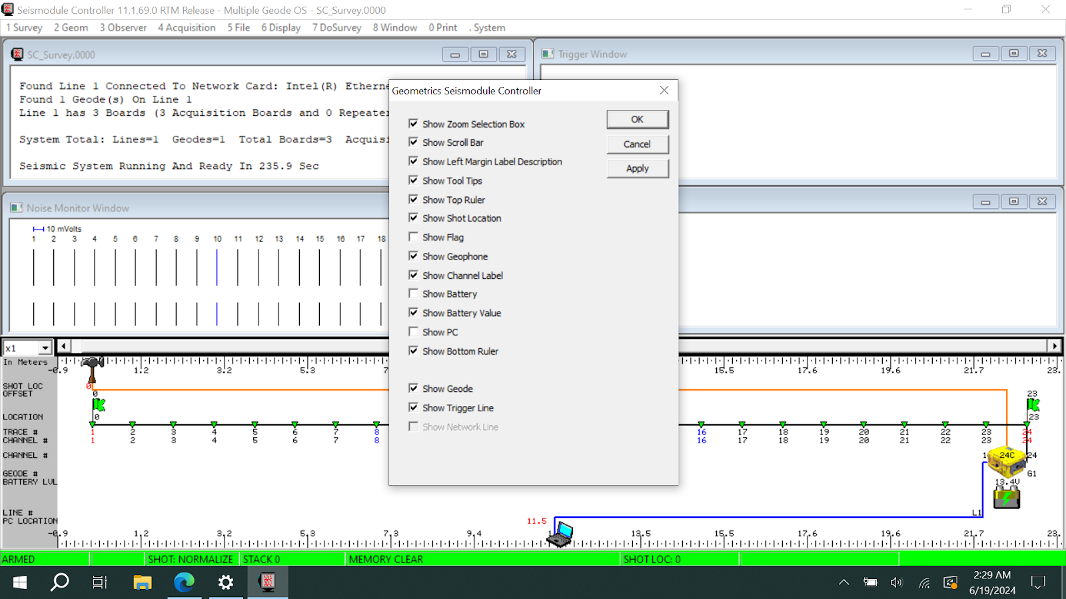

* 1. In the “Window” menu at the top toolbar, uncheck the “Pilot,” “Spectra,” and “Trigger/Gun Monitor” Windows. Then, select “Tile all Windows Vertically” (Fig. 10). You should be left with a setup that looks similar to the window shown in Figure 11.

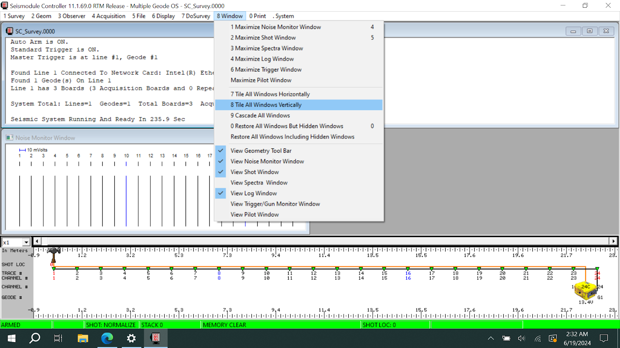

Figure 10. Checkbox options for the “Windows” Menu

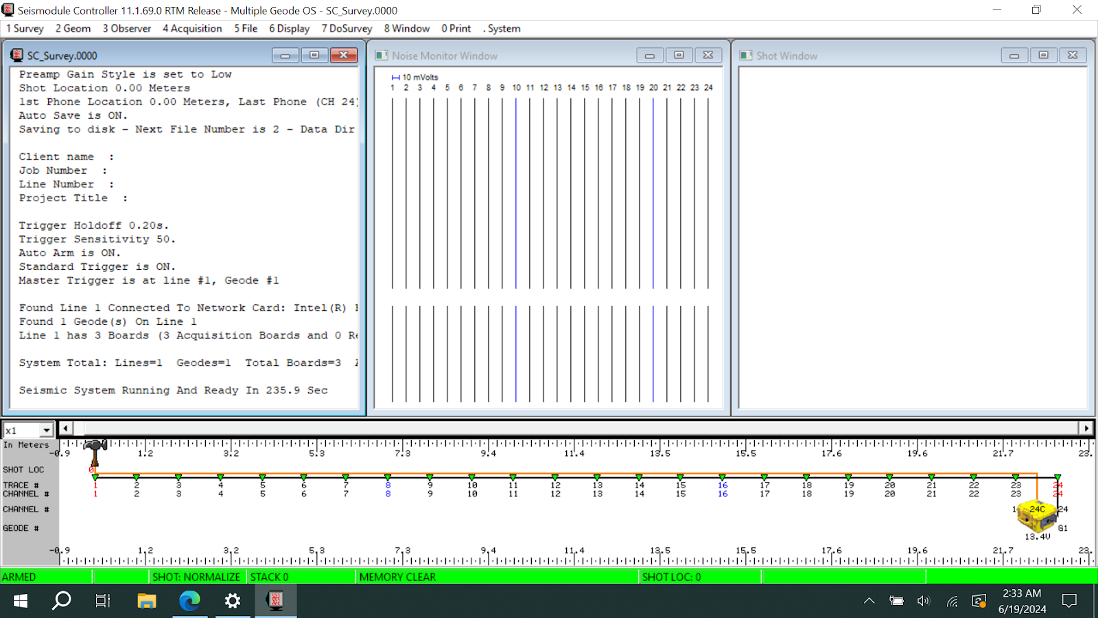

Figure 11. Appearance of Screen just prior to Shooting and Acquiring Data

1. **Stick test your geophones.** Bang the ground near each geophone with a stick and check if they react in the Noise Monitor Window on *Seismodule Controller*. Mark any unresponsive geophones with a marking tape and record them in your field notes. Leave a note in the shipment box about unresponsive geophones upon equipment return.   
   At this point you are ready to shoot and acquire data.
2. **Perform your hammer shots**, after verifying that the bottom status bar is green (‘Armed’ mode, Fig. 12). Table 1 lists the possible modes of the status bar. When striking the metal plate with the hammer, make sure that you do not let the hammer bounce on the plate. This can lead to a false trigger.
   1. More than one shot (hammer blow) at the same location, helps to determine noise vs real data.
   2. A minimum number would be 2 shots at 3 locations along the survey line (typically both ends and the middle).
   3. More ideal would be 2-3 shots and ~1/3 of your geophone locations.



Figure 12. Armed status

Table 1. Status bar modes

|  |  |
| --- | --- |
| **Status** | **Description** |
| Armed | Ready to acquire data |
| Disarmed | Data acquisition disabled |
| Acquire | Collecting data on A/D cards |
| Busy | Undertaking system management |
| Sending data | Transferring data from A/D cards to computer |
| Receiving Pilot | Getting pilot from pilot channel |
| Sending Pilot | Transferring pilot to A/D cards to use correlator |
| Processing Data | Undertaking correlation or other signal processing |

Keep detailed field notes as you change the geometry setup and shot locations of your experiment. Ensure that such properties are updated in the *Seismodule Controller* software for future visualization and analysis. Changes after initialization can be made using the top toolbar menu (e.g., you can access the Geometry menu by navigating to “2 Geom” on the toolbar and then “3 Group/Shot locations”).

1. **Transfer data files.** If you will be doing the data analysis on a different computer than the field laptop, save a copy of the raw data (.dat files) to a USB stick/external drive to transfer to the other machine.

**Tips:** Default setting has Geophone-1/channel-1 starting at the pigtail end of the cable. I prefer to reverse the order and have channel-1 starting at the first Geode location. To reverse the channel sequence, select the “9 Channel Remapping” option in the Geometry Toolbar Settings shown in Figure 8. Check the “Enable Channel Remapping box” on the bottom right corner and then check the “Reverse Channel Order” box on the top of the window. Don’t forget your Hot Keys. They are an easy and powerful way to navigate complicated software. Ideally, once you are set up you should be able to run the entire survey using only four Hot Keys. When working on a field course survey with students, for example, you may have some false trigger or bad hammer swings. In this case it might be useful to turn off the Auto Save and use the Hot Keys to save and erase only the known good data files/hammer strikes.

# Conclusion

We hope this document will help guide you in easily setting up and running a survey using the Geode Software. The options used in this demonstration are not ideal for every experiment but should provide the user with a reference and some setup experience before a field survey.

***Storage and return: There are a few things we would like you to do and not do when handling and returning the equipment***

* ***DO NOT wind the cables around your shoulder and elbow (like an extension cord), rolling or winding the cables causes internal stress on the wiring and will lead to cable failure. Cables should be loaded into the boxes or barrels spaghetti-style (Fig. 13). Do not spool them in.***
* ***Mark any bad takeouts or geophones with a marking tape and leave a note in the barrel or box.***
* ***Replace all caps on connectors and keep the connectors clean. Keep and return the Geodes clean. Thank you.***

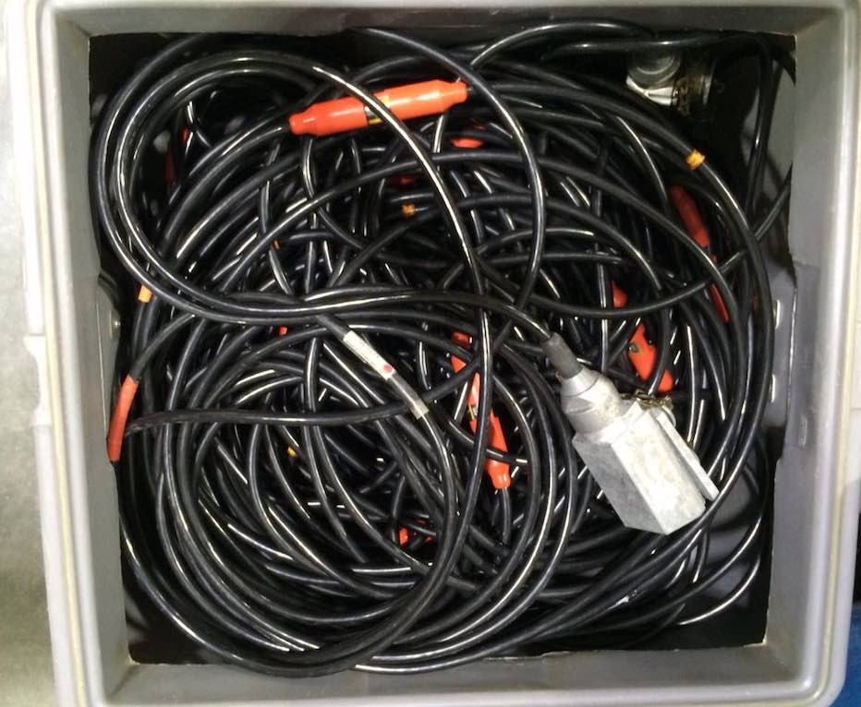

Figure 13. Proper Spaghetti-style method for storing Geode cables