Electrical Resistivity Unit 5: Geophysical Interpretation and Comparison with Vegetation Patterning and Ground Truthing – Student Exercise
Lee Slater (Rutgers University Newark)
Answer the following questions based on completing the tasks described in the student handout for this unit.

Task 5.2.1: Electrical imaging interpretation
Refer back to the narrated slideshow Geophysical Interpretation and Comparison with Vegetation Patterning to help answer the following questions
- The figure below shows the inversion of the electrical imaging dataset in relation to the surface vegetation along the line of the 96 electrodes spaced 1.5 m apart. Describe variations in the geoelectrical structure along the line. Do you see any evidence for a correlation between the electrical conductivity structure along the line and the location of the pickleweed patches? ________________________________________________________________________________________________________________________________________________________________________________________________________________________________________________________________________________________
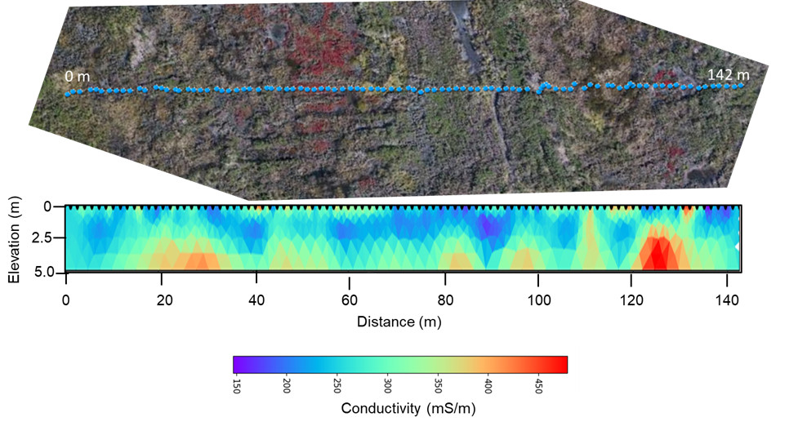
- Describe the basic vertical structure in the resistivity image, i.e. how does the resistivity vary with depth? Can you break the image into 2–3 distinct layers?________________________________________________________________________________________________________________________________________________________________________________________________________________________________________________________________________________________________________________________________________________________
- Describe the electrical conductivity of the lowest layer in the electrical image. Is it more or less conductive than the overlying layer? Can you think of some reasons for what you observe?_________________________________________________________________________________________________________________________________________________________________________________________________________________________________________________________________________________

Task 5.2.2: Visualizing and interpreting 3D electromagnetic (EM) conductivity mapping datasets
Refer to the StoryMap first used in Unit 1 answer the following questions:
- Fill in the following table based upon your observations made using the slider tool in the StoryMap. Use the color bar to approximate an average conductivity of each layer (this can just be a best guess based on the conductivity range reported on the legend for each layer). Use the patterns in conductivity for each layer/depth to decide whether or not there is evidence of a correlation between electrical conductivity structure and regions of pickleweed at each level.
- Layer | - Depth range (m) | - Approximate average electrical conductivity of layer (mS/m) | - Is there evidence for correlation between layer conductivity variation and vegetation?
- 1 | - 0.0–0.2
- 2 | - 0.2–0.5
- 3 | - 0.5–0.9
- 4 | - 0.9–1.4
- 5 | - 1.4–2.1
- 6 | - 2.1–3.3
- 7 | - Below 3.3

- In the figure from the EM inversion shown below, where would you choose to place four sampling points for direct measurements of pore fluid salinity and sediment properties? Explain your choice. ______________________________________________________________________________________________________________________________________________________________________________________________________________________________________________________________________________________________________________________________________________________________
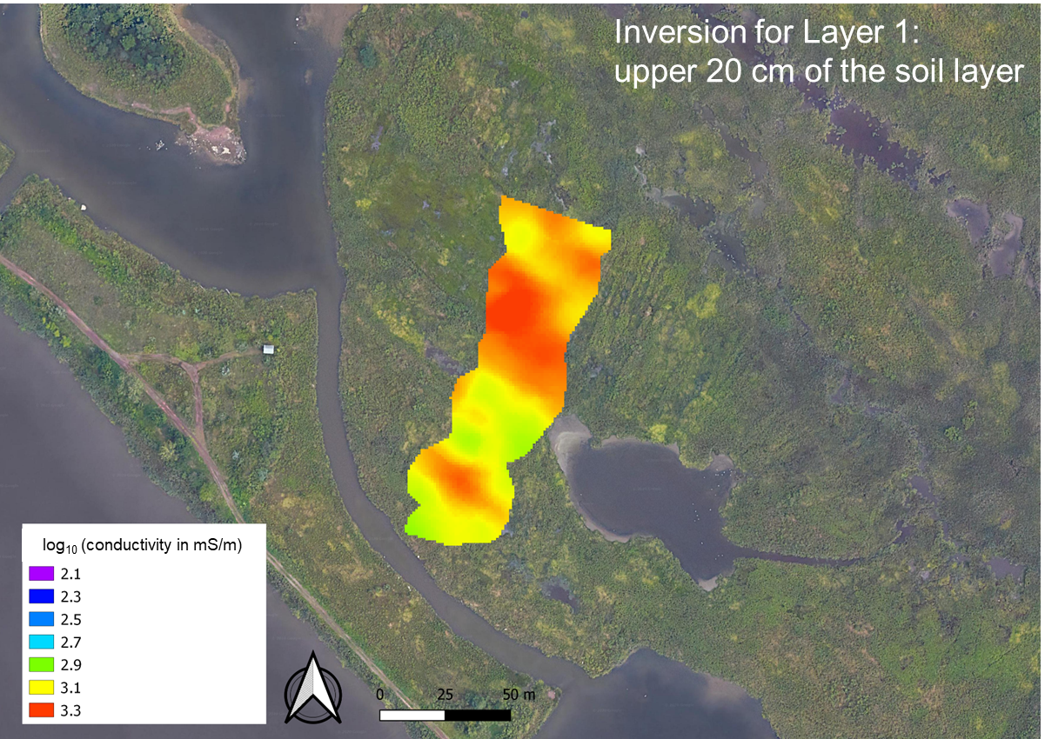

Task 5.2.3: Using ground truth data to support geophysical observations
Answer the following questions based on the results of the coring and sampling described in the narrated slideshow Geophysical Interpretation and Comparison with Ground Truthing.
- The ground truthing (coring) conducted at six locations indicated that the organic rich sediments are quite shallow (0.3–0.5 m thick) and underlain by a gravelly fill. Do the EM inversions shown on the Unit 1 StoryMap provide evidence for this fill layer? Explain your reasoning. ___________________________________________________________________________________________________________________________________________________________________________________________________________________________________________________________________________________________________________________________________________________________
- 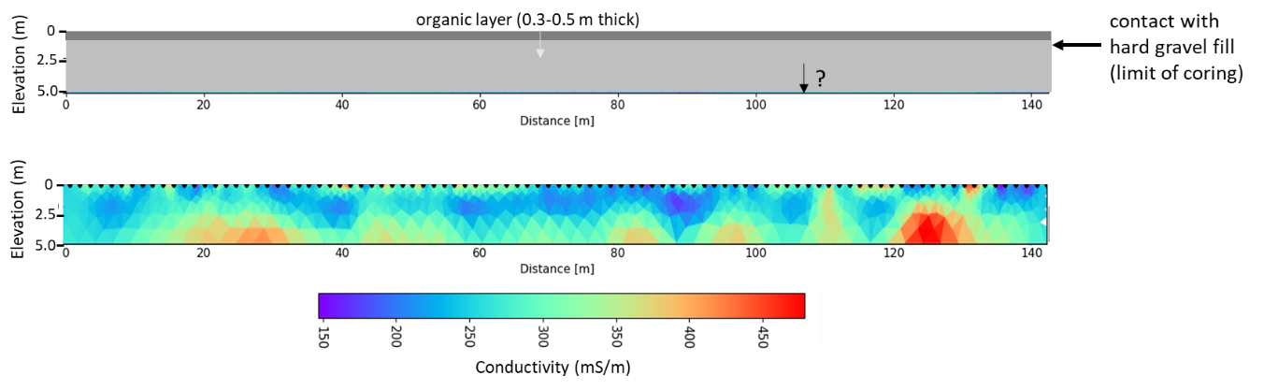
- The direct coring encountered a hard gravel layer at about 30 cm depth and could not provide any information below this depth. Does the resistivity image show evidence for another vertical contact below the gravel interface? In order to answer this, consider the resistivity variations below 30 cm depth. Do you see evidence for a change in resistivity at depth, which would be indicative of another deeper layer? ________________________________________________________________________________________________________________________________________________________________________________________________________________________________________________________________________________________
- Referring back to the Unit 1 StoryMap, are the results of the 3D EM inversion generally consistent with the results of the 2D resistivity inversion?
Keep in mind that the 3D EM inversion is limited to about 3 m deep whereas the resistivity imaging extends to 5 m. Also, watch the units here as the EM inversion in the StoryMap uses the log of the electrical conductivity in mS/m whereas the resistivity inversion is on a liner conductivity scale of mS/m. ________________________________________________________________________________________________________________________________________________________________________________________________________________________________________________________________________________________
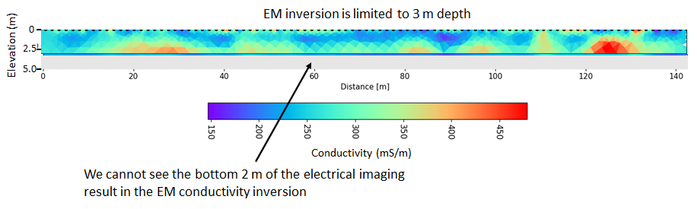
- A summary of the direct sampling dataset acquired in an effort to help constrain the geophysical dataset is provided in the table below. The image under the table shows where the samples were acquired. Critically analyze this dataset and evaluate whether there is any visual evidence of a correlation between the physical and chemical properties of the organic layer and the conductivity variations in the upper most layer (0.0–0.2 m) of the 3D EM inversion. Do a simple correlation where you compare the high and low conductivities with high and low values of the porosity, salinity, and mean grain size. You can classify this visual correlation as high, medium, or low. Note that the salinity is presented as an equivalent specific conductance of the pore fluids (in mS/cm). Fill out the table provided below.
 |  |  | Particle size data |  | Salinity
 | Thickness (m) | Porosity* (-) | d10 (μm) | d50 (μm) | Specific conductance (mS/cm)
Site 1 | 0.33 | 0.46 | 5.01 | 70.86 | 20.96
Site 2 | 0.33 | 0.22 | 3.93 | 60.42 | 19.79
Site 3 | 0.43 | 0.23 | 10.25 | 110.99 | 29.32
Site 4 | 0.48 | 0.15 | 4.38 | 113.00 | 29.38
Site 5 | 0.28 | 0.19 | 9.92 | 186.89 | 31.00
Site 6 | 0.27 | 0.18 | 18.27 | 304.97 | 30.20

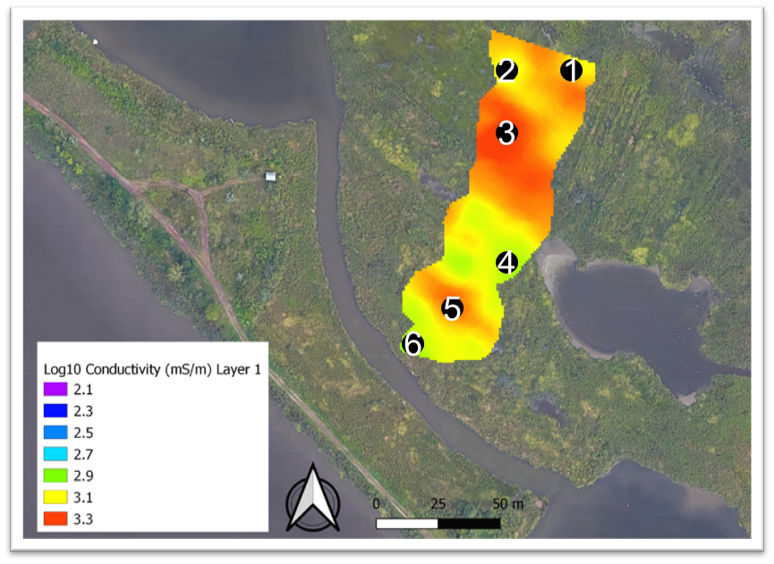
- Property | - Degree of correlation (high, medium, low) with the conductivity in the top (0.0–0.2 m) layer of the EM conductivity inversion
- Salinity
- Mean grain size
- Porosity

- Based on the analysis of the direct data, do you feel confident in explaining the likely cause of the conductivity variations recorded in the two geophysical datasets for the uppermost 20–30 cm? _____________________________________________________________________________________________________________________________________________________________________________________________________________________________________________________________________________
- Refer back to your answers from Question 4 here, based on the exploration with the slider tool in the Unit 1 StoryMap. You should have noted that there appears to be a correlation between the vegetation pattern and the pattern of the EM conductivity in both the shallowest layer (representing the organic sediment layer) and also the deeper two layers, particularly layer 5–7 spanning the depth range 0.9–3.0 m. Interestingly, the zones of pickleweed appear to correlate with slightly lower electrical conductivity at depth, the opposite to what is recorded in the surface organic sediments. What would this imply about the salinity variations in the deeper layer into the gravel? _____________________________________________________________________________________________________________________________________________________________________________________________________________________________________________________________________________
- Based on your observations in this module, do you think that the observations in Harrier Meadow support the hypothesis that “salinity-tolerant plants are thriving in areas of locally elevated electrical conductivity”? _____________________________________________________________________________________________________________________________________________________________________________________________________________________________________________________________________________

