Electrical Resistivity Unit 2: Electrical Geophysical Properties of the Subsurface – Student Worksheet
Lee Slater (Rutgers University Newark)
Answer the following questions based upon completing the tasks described in the student handout for this unit.

Task 2.2.1: Understanding electrical current flow in soils and rocks
- What are the primary electrical charge carriers in soils and rocks? ___________________________________________________
- The cementation exponent (m) in Archie’s Law is a measure of the (circle the right answer):
(a) amount of porosity (b) connectivity of the porosity (c) pore fluid electrical conductivity (d) surface conductivity
- Surface conduction is primarily controlled by soil (circle the correct answer):
(a) surface area; (b) porosity; (c) cementation; (d) pore fluid conductivity (e) saturation

Task 2.2.2: Estimating formation factor and surface conductivity for rocks and soils
Based on your spreadsheet calculations for Task 2.2.2 answer the following.
- At what fluid conductivity (σ_{w}) does the effective level of the surface conductivity become relatively insignificant for the three samples investigated (fill in the table below)? Hint: Consider how fluid and surface conductivities influence the shape of the trendline.
 | - B 49/2  (shaly sandstone) | - B66/2  (clean sandstone) | - G1  (loamy soil)
- Fluid conductivity (σ_{w})

- Describe(qualitatively) any relationship you observe between the formation factor and the surface conductivity. __________________________________________________
____________________________________________________________________________________________________________________________________________
- Do the R² values suggest that the linear model used explains the observations well? Explain your answer. __________________________________________________
____________________________________________________________________________________________________________________________________________

Task 2.2.3: Archie’s relationship between formation factor (F) and porosity (ø)
Based on your spreadsheet calculations for Task 2.2.3 answer the following.
- How does the presence of a cobble framework influence the electrical formation factor (F)? ______________________________________________________________________________________________________________________________________________________________________________________________________________
- Do you think that individual cementation exponents are needed to describe the Slater and Lesmes (2002) and the Slater et al. (2014) datasets or does a single cementation exponent for the datasets combined seem reasonable? (explain your reasoning): ____________________________________________________________________________________________________________________________________________________________________________________________________________________________________________________________________

Task 2.2.4: Predictions based on quick calculations
Based on your spreadsheet calculations for Task 2.2.4 answer the following.
- Electrical geophysicists are sometimes tempted to ignore surface conduction so that Archie’s Law can be directly applied to determine fluid conductivity (σ_{w}) or porosity (φ) from soil conductivity measurements (σ_{soil}). For samples G1 and B49/2 saturated with a fluid of conductivity 100 millisiemens/meter (mS/m), calculate the % differences between σ_{soil} for when surface conduction is included relative to when it is ignored using,
$$diff\left(\%\right)=\frac{\left(σ_{soil [with surface]}-σ_{soil [no surface]}\right)}{σ_{soil [no surface]}}×100$$
Loamy soil G1:______________________________________; Shaly sandstone B49/2:_______________________________
- Is the difference for loamy soil G1 large enough that surface conductivity needs to be included or would it be safe to neglect it for sample G1 when saturated with a typical groundwater? Explain your reasoning: ______________________________________________________________________
________________________________________________________________________________________________________________________________________________________________________________________________________________________________________________________________________________________

Task 2.2.5: Soil electrical properties in Kearny Freshwater Marsh
Following your viewing of the short, narrated PowerPoint slides on Kearny freshwater marsh answer the following:
- Based on the soil electrical conductivity estimates from the electromagnetic survey (figure reproduced below), what looks like the primary source of contamination to Kearny freshwater marsh? _______________________________________________________
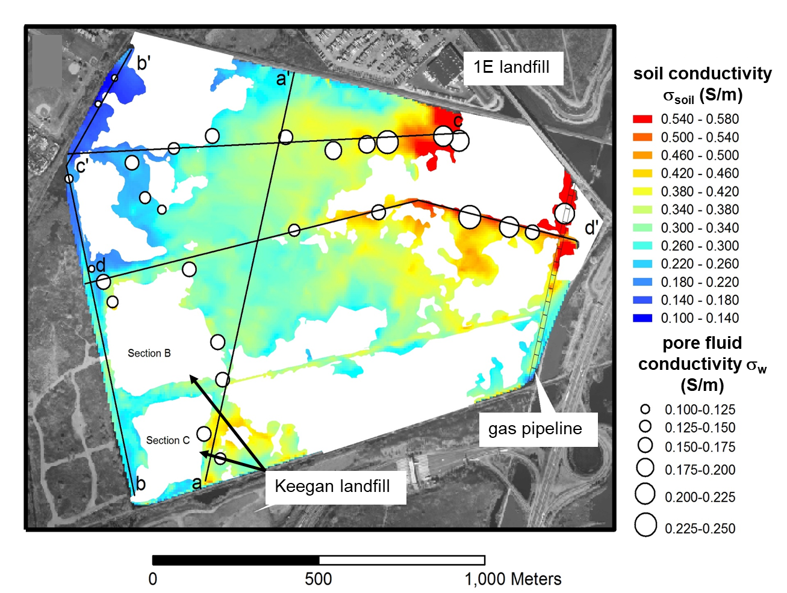
- Choose three locations to estimate formation factor from the soil conductivity estimates and the pore fluid conductivity measurements. Select a location on profile b’-c’ (NW corner), a location on profile a-a’ and a location close to point c (NE corner). It is fine to take the middle value of the value ranges to use as your estimates. Record your results in the table:
- Location | - σ_{soil} (S/m) | - σ_{w} (S/m) | - F (-)
- On profile b’-c’
- On profile a-a’
- Close to point c

- Your results to Question 12 will violate Archie’s Law if the formation factor (F) is less than 1.0. Based on what you have learned about the electrical properties of soils, speculate on why Archie’s Law might not apply in this wetland: ______________________________________________________________________________________________________________________________________________________________________________________________________________________________________________________________________________________________________________________________________________________________

