Resistivity Module Unit 2: “Electrical Geophysical Properties of the Subsurface”

Student exercise
Lee Slater, Department of Earth and Environmental Sciences, Rutgers University Newark, Newark, New Jersey

2.1 Introduction
You will use a geophysical property known as electrical resistivity to assess soil contamination in a wetland resulting from a landfill. Wetlands are unique, diverse ecosystems containing sensitive plants that are highly susceptible to soil contamination. Environmental professionals can use geophysical measurements, such as resistivity, to help understand the distribution of contaminants in the subsurface. Rather than having to dig up the soil and sample the contaminants directly, electrical resistivity methods can often detect the contaminants due to their high ionic concentrations that result in an increased electrical conductivity. This way, the contaminants can be non-invasively mapped from the surface, which results in substantial cost reductions. Furthermore, these measurements can be relatively quickly acquired over large areas. However, in order to be able to make use of these powerful imaging techniques it is first necessary to understand how and why electrical resistivity is related to the physical and chemical properties of the subsurface. The Excel spreadsheet used in this module explores the basic “petrophysical” relationships that link electrical resistivity (or its inverse, electrical conductivity) to pore fluid conductivity, porosity and surface area (or grain size).

G.E. Archie made extensive electrical resistivity measurements on rocks, resulting in a set of empirical laws published in Archie (1942). He found a linear proportionality between the electrical resistivity of the fluids filling the interconnected pores of the rock and the electrical resistivity of the rock itself. He defined the proportionality constant between the electrical resistivity of a rock and the pore fluid resistivity as the electrical formation factor (F). The formation factor describes how much more resistive the rock is due to the presence of insulating mineral grains than the pore fluid itself. Written in terms of the conductivity (1/resistivity),
$σ_{rock}=\frac{1}{ρ_{rock}}=\frac{1}{F}σ_{w}$. (1)
Archie assumed that the rock matrix was a pure insulator so that electrical current only flows through the fluids filling the interconnected pores of the rock. In fact, electrical conduction also occurs in the electrical double layer (EDL) that forms at the interface of the rock minerals and the water in the pores. A simple way to modify Archie's Law to account for this extra conduction pathway is to add a constant surface conductivity (σ_{surf}) term to Equation 1,
$σ_{rock}=\frac{1}{ρ_{rock}}=\frac{1}{F}σ_{w}+σ_{surf}$. (2)

This linear (i.e. assuming the form $y=mx+b$) equation is based on some key assumptions. These include: (1) The surface conduction occurs parallel to the conduction through the fluids occupying the interconnected pores; (2) The surface conduction does not vary with the electrical conductivity of the pore-filling fluids (σ_{w}). Equation 2 has been extensively applied to soils in addition to rocks.
In the first part of this exercise we will explore how Equation 2 describes measurements of soil conductivity (σ_{soil}) as a function of the pore fluid conductivity (σ_{w}) of different rocks and soils. By fitting equation (2) to the experimental datasets, we will determine values of F and σ_{surf} for two rocks and two soils. We will see how both F and σ_{surf} differ for unconsolidated sediments when compared to consolidate rocks.

Next we will explore the relationship between the electrical formation factor and the physical properties of rocks and soils. Archie used an extensive database of measurements from petroleum-containing rocks to show that the formation factor (F) is related to the porosity (φ) via a power law relationship,
$F=∅^{-m}$, (3)
where $m$ is the cementation exponent.
A linear form of this equation is obtained by taking the logs of F and φ,
$\log\left(F\right)=-m log⁡(∅)$ (4)
We will explore how this relationship applies to a range of unconsolidated sediments.
.

2.2 Tasks

Task 2.2.1. Comprehending electrical current flow in soils and rocks
- Watch the short, narrated slideshow tutorial that summarizes how electrical current flows in soils and rocks
- You will use this tutorial to answer the questions in Section 2.1.1 of the student worksheet.

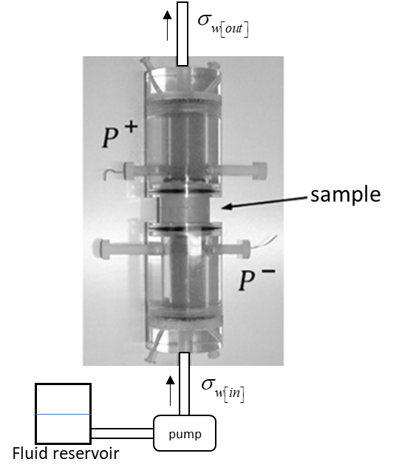
Task 2.2.2 Estimating formation factor and surface conductivity for rocks and soils
- The Excel spreadsheet Unit 2.xls contains a worksheet named Task 2.2.2. It contains four datasets with the electrical conductivity of the soil or rock plotted as a function of the fluid conductivity. These datasets were acquired by taking a rock sample and varying the saturating fluid by pumping a progressively more electrically conductive solution through the sample. This simulates changes that will occur in the field e.g. as tide rises and more saline water comes in, or falls and more fresh water comes in. The setup is shown in the figure in this box. When the conductivity of the fluid at the outflow is equal to the conductivity of the inflow fluid , the conductivity of the pore fluid is assumed to be constant and the measurement is made. The two sandstone rock datasets (B49/2 and B66/2) are from Rink and Schopper (1974). The loamy soil G1 is from Grunat et al. (2013). Use the ‘Add Trendline’ function in Excel to estimate the formation factor (F) and the surface conductivity (σ_{surf}) for each sample. You will need to add a linear trend line to represent equation 2. You expect to see a linear relationship plot as a straight line. However, when both axes are logarithmic (as in the Excel spreadsheet) then the result is a curved line (discussed further in the tutorial). Make sure to select the option ‘Display Equation on chart’ and ‘Display R-squared value on chart’ when adding your trendline.
- Record the values of the surface conductivity (obtained from the intercept of the linear equation) and the formation factor (obtained from the slope of the linear equation) in the grey shaded boxes of the spreadsheet
- Also record the coefficient of determination (R-squared value) provided when using the ‘Add Trendline’ function for each case. This tells us how much of the variation in the dependent variable (the conductivity of the sample in our case) is attributable to variations in the independent variable (the pore fluid conductivity in our case).

Task 2.2.3 Archie’s relationship between formation factor (F) and porosity (φ)
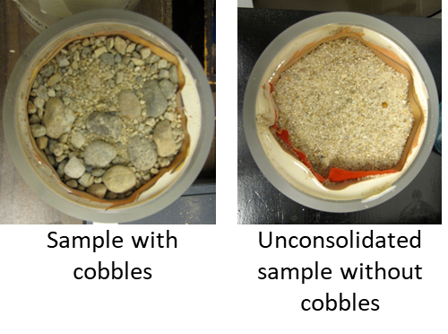
The Excel spreadsheet Unit 2.xls contains a worksheet named Task 2.2.3. It contains two datasets acquired on different types of unconsolidated sediments. The Slater and Lesmes (2002) dataset is composed of artificial unconsolidated sediments and samples of natural glacial till from different sites in Maine (USA). The Slater et al. (2014) dataset is composed of re-created flood plain deposits obtained from a gravel bar of the Boise River in Idaho (USA). These samples include significant large cobbles found at the site as shown in the photo.
- The worksheet named ‘Task 2.3.3’ contains two graphs of the data in the form of Equation 4. One shows the two datasets individually and the other is a combined dataset. Use the ‘Add Trendline’ function in Excel to estimate the cementation exponent in Archie’s Law for the two datasets separately and also for the combined dataset.
- Also record the coefficient of determination (R-squared value) provided when using the ‘Add Trendline’ function for each case

Task 2.2.4. Predictions based on quick calculations
Based on the relationships you have developed in this module complete the following calculations and record the answers in the worksheet named ‘Task 2.4.4’:
- Calculate the porosity of the loamy soil G1 assuming that the cementation factor determined in Task 2.2.3 is appropriate for this sample
- Predict the soil conductivity (σ_{soil}) for the loamy soil G1 when the fluid conductivity (σ_{w}) is 100 mS/m (typical of fresh groundwater). Perform the same prediction but assuming that surface conductivity can be ignored.
- Predict the soil conductivity (σ_{soil}) for the shaly sandstone B49/2 when the fluid conductivity (σ_{w}) is 100 mS/m (typical of fresh groundwater). Perform the same prediction but assuming that surface conductivity can be ignored. You will need to consider the importance of the surface conductivity, along with the implications of assuming it can be ignored, when completing the worksheet for this module.

Task 2.2.5. Using electrical properties of soils to infer contamination in marsh soils
- View the short, narrated set of slides on the geophysical survey performed on Kearny freshwater marsh
- You will use this tutorial to answer the questions in Section 2.2.5 of the student worksheet.

1.3 Assessment
Complete the worksheet provided with this module.
The grading rubric below will be used to grade the module.

Component | Exemplary | Basic | Nonperformance
Section 2.2.1 | 4 points:  All four questions correctly answered showing full comprehension of video | 2–3 points:  Two-three questions correctly answered showing some comprehension of video | 0–1 point:  Incomplete/incorrect answer to questions
Section 2.2.2 | 4 points:  Excel spreadsheet fully completed with correct estimates of formation factor and surface conductivity. Questions answered correctly and thoughtfully | 2–3 points:  Excel spreadsheet mostly complete and at least two of the questions answered correctly and thoughtfully | 0–1 point:  Incomplete Excel spreadsheet and weak attempt at the questions
Section 2.2.3 | 4 points:  Excel spreadsheet fully completed with correct estimates of formation factor and surface conductivity. Questions answered correctly and thoughtfully | 2–3 points:  Excel spreadsheet mostly complete and at least two of the questions answered correctly and thoughtfully | 0–1 point:  Incomplete Excel spreadsheet and weak attempt at the questions
Section 2.2.4 | 3 points:  Correct calculations for Question 10 and a well-reasoned answer to Question 11. | 2 points:  Partially correct calculations for Question 10 and partly-reasoned answer to Question 11 | 0–1 point:  Incorrect calculations and poorly-reasoned answer to Question 11
Section 2.2.5 | 3 points  Correct calculations of formation factor and logically argued explanation for deviations from Archie’s Law | 2 points:  Correct calculations of formation factor or logically argued explanation for deviations from Archie’s Law | - Point  Some attempt at questions but largely incorrect answers

1.4 References
Archie, G. E. (1942) ‘The electrical resistivity log as an aid in determining some reservoir characteristics’, Trans. Am. Inst. Min. Metall. Pet. Eng., 146, pp. 54–62.
Grunat, D. a., Slater, L. D. and Wehrer, M. (2013) ‘Complex Electrical Measurements on an Undisturbed Soil Core: Evidence for Improved Estimation of Saturation Degree from Imaginary Conductivity’, Vadose Zone Journal, 12(4). doi: 10.2136/vzj2013.03.0059.
Rink, M. and Schopper, J. R. (1974) ‘Interface conductivity and its implications to electric logging’, in SPWLA 15th Annual Logging Symposium.
Slater, L., Barrash, W., Montrey, J. and Binley, A. (2014) ‘Electrical-hydraulic relationships observed for unconsolidated sediments in the presence of a cobble framework’, Water Resources Research, 50(7), pp. 5721–5742. doi: 10.1002/2013WR014631.
Slater, L. and Lesmes, D. P. (2002) ‘Electrical-hydraulic relationships observed for unconsolidated sediments’, Water Resources Research, 38(10), pp. 1–13. doi: 10.1029/2001WR001075.

