Resistivity Module, Unit 3: Exploring Electrical Resistivity Measurement Sensitivity with SEER
Lee Slater, Department of Earth and Environmental Sciences, Rutgers University Newark, New Jersey

Introduction to SEER
With the Scenario Evaluator for Electrical Resistivity (SEER) we can model the predicted result of a resistivity survey (predicted inversion result—inversion is the topic of the Unit 4 of this module). SEER can be used to show how the resolving power of electrical imaging measurements varies as a function of the array type (e.g. Wenner, dipole-dipole, and the two combined) and the electrode spacing. We will first use SEER to first get a sense of the differences in the ability to resolve electrical structures that arise between array types. Then, we will estimate the likely depth sensitivity of measurements made with two common array configurations in Harrier Meadow. Before starting on this, watch the video that introduces how to use SEER and download the SEER folder from the USGS.

Exploring the sensitivity of different electrode arrays to the LNAPL model
The Light Non Aqueous Phase Liquid (LNAPL) Scenario shows the idealized electrical structure of an aged hydrocarbon spill in the subsurface. Because LNAPLs are less dense than water, they accumulate at the top of the water table as they move vertically under gravity through the subsurface. They typically evolve over time to have a relatively high electrical conductivity when compared to the surrounding saturated (below the water table) and unsaturated (above the water table) materials. In the LNAPL scenario, the plume is shown as the low resistivity (40 Ohm m) lens (blue) forming at the interface of resistive unsaturated sediments (the 500 Ohm m upper layer) and underlying saturated sediments (100 Ohm m). Figure 1 presents an overview of the basic conceptual model for the LNAPL scenario.
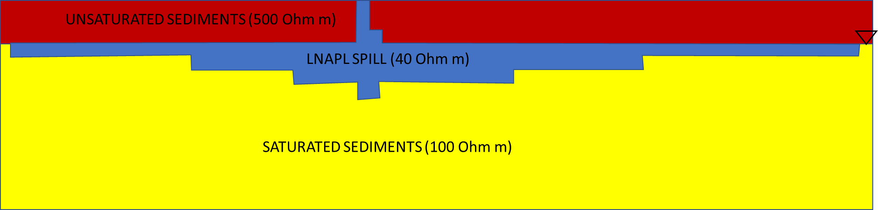
Figure 1: Overview of the basic conceptual model for the LNAPL scenario. Triangle denotes position of the water table

Use the LNAPL Scenario to explore how the two array types (Wenner and dipole-dipole) differ in their abilities to resolve the subsurface resistivity model. When choosing the LNAPL scenario make sure that the box “using SPECIFIED scenario” is checked. Set the measurement error % to 1 and select “no” to the borehole electrodes question.
- Using the dipole-dipole configuration, examine how the resolution of the conductive (blue) layer, representing the LNAPL, varies with the electrode spacing as it is changed from 1 m to 2 m to 4 m).
- Continuing to use the LNAPL scenario, compare the predicted inversion result from the Wenner configuration with that from the dipole-dipole configuration for the case when the electrode spacing is 1 m. Also compare the predicted inversion result when you combine the geometry types [Geometry type “combined”]. Describe how the three array types differ in their ability to resolve the LNAPL structure.

Using the UST model to investigate depth sensitivity of different array configurations in Harrier Meadow
Next, we will use the Underground Storage Tank (UST) model to explore the sensitivity of the dipole-dipole and Wenner measurements to a conductive block at different depths. This is a simple way of estimating the depth sensitivity of a particular array configuration. Once again, set the measurement error % to 1 and select “no” to the borehole electrodes question. For this exercise set the electrode spacing to 1 m.
For the background we will simulate the average conductivity at the survey site in Harrier Meadow. This is approximately 500 mS/m or 2 Ohm m. First, de-select the “using SPECIFIED scenario” option so that it instead shows “using CUSTOM model.” Set all the cells in the true resistivity model to the background resistivity (ρ_{bg}) of 2 Ohm m except for a 3 cell by 3 cell block that should be set to 0.2 Ohm m—the starting point for this square is rows 2-4, as shown in Figure 2. Let’s assume that a minimum 10% change from the background resistivity of 2 Ohm m is needed in at least three cells of the model to “detect” the presence of the block, in this case the three cells with the lowest values in the model. . By moving the block down one row at a time, find the maximum depth of the top of the block where it would still be detectable when using the dipole-dipole array and also the Wenner array. For the calculation of the % change of the background resistivity, use the calculation .
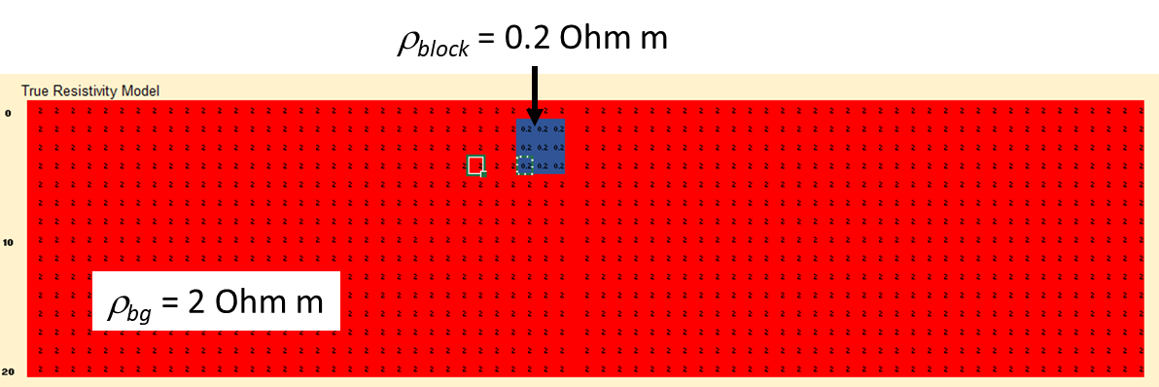
Figure 2: Starting model position and resistivity values for the CUSTOM UST model
Do this analysis for both the dipole-dipole array and the Wenner array. Record a summary of your results in the table below.

Summary of exploration results for the CUSTOM UST model
Block Depth | Array Type | Lowest three cell values | Equivalent % changes
Rows 2–4 | Dipole-dipole
Rows 2–4 | Wenner
Rows 3–5 | Dipole-dipole
Rows 3–5 | Wenner
Rows 4–6 | Dipole-dipole
Rows 4–6 | Wenner
Rows 5–7 | Dipole-dipole
Rows 5–7 | Wenner
Rows 6–8 | Dipole-dipole
Rows 6–8 | Wenner

