Electrical Resistivity Unit 4: Exploring the “Magic” of Geophysical Inversion with ResIPy – Student Exercise
Lee Slater (Rutgers University Newark)

Introduction
Earlier in this unit, we used the Excel-based Scenario Evaluator for Electrical Resistivity (SEER) to look at the approximate predicted inversion results for some synthetic resistivity models of the Earth. The remainder of this unit focuses on the use of ResIPy, a simple and intuitive graphical user interface that can be used by a nonexpert to perform a scientifically rigorous inversion of a field electrical resistivity dataset. We will use ResIPy to invert the 2D electrical resistivity imaging dataset acquired in Harrier Meadow. The 2D resistivity dataset in Harrier Meadow was acquired using 96 electrodes equally spaced 1.5 m apart for a total line length of 142.5 m. The location of the electrodes can be seen on the story map for the module. Note that the line of the electrodes crosses some of the patches of pickleweed observed in the aerial photographs of the site. Remember that we are interested in understanding whether the patches of pickleweed are located in areas of elevated electrical conductivity.

Getting Familiar with ResIPy
Processing resistivity data in ResIPy involves a number of key steps summarized in the flow chart shown in Figure 1.
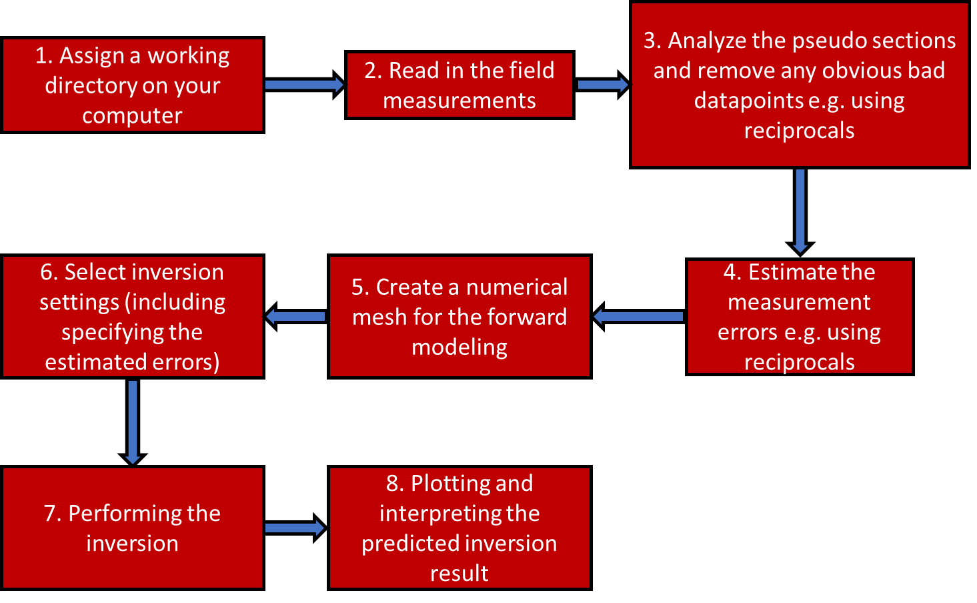
Figure 1: Summary of the main steps involved in performing a resistivity inversion
The video “ResIPy1” demonstrates the basic processing of the Harrier Meadow dataset. Watch this video and correlate the major steps with the flowchart presented in Figure 1. Watch closely and replay any steps that you need to solidify your understanding of how to run the inversion of the Harrier Meadow dataset and how to change the error model parameters.

A Note on the Misfit during the Inversion Process in ResIPy
This exercise requires you to report on some indicators of the progress of the inversion toward finding a solution to the resistivity structure that best fits the data. ResIPy seeks to find an optimal model that has a level of smoothing of model structure that is consistent with the quality of the dataset (the size of the errors in the data). ResIPy reports the progress of the inversion when you run it using the root mean square (RMS) data misfit: a measure of how close the theoretical measurements for a resistivity model are to the actual field measurements. This number needs to be reduced to a value close to 1.0 for the model to be a reasonable solution of the unknown resistivity structure of the Earth. Figure 2 shows a screenshot of ResIPy to highlight the information provided during the inversion. An iterative process is used to reach the best solution to the model structure based on the data provided. The process involves some major iteration steps, with some sub-iterations within each major iteration where ResIPy is searching for the optimal level of smoothing of the model structure that gives an adequately large drop in the data misfit between the major iteration steps. You will need to report on the initial model misfit and the total number of iterations required for the solution to converge (reach a data misfit of approximately 1.0).

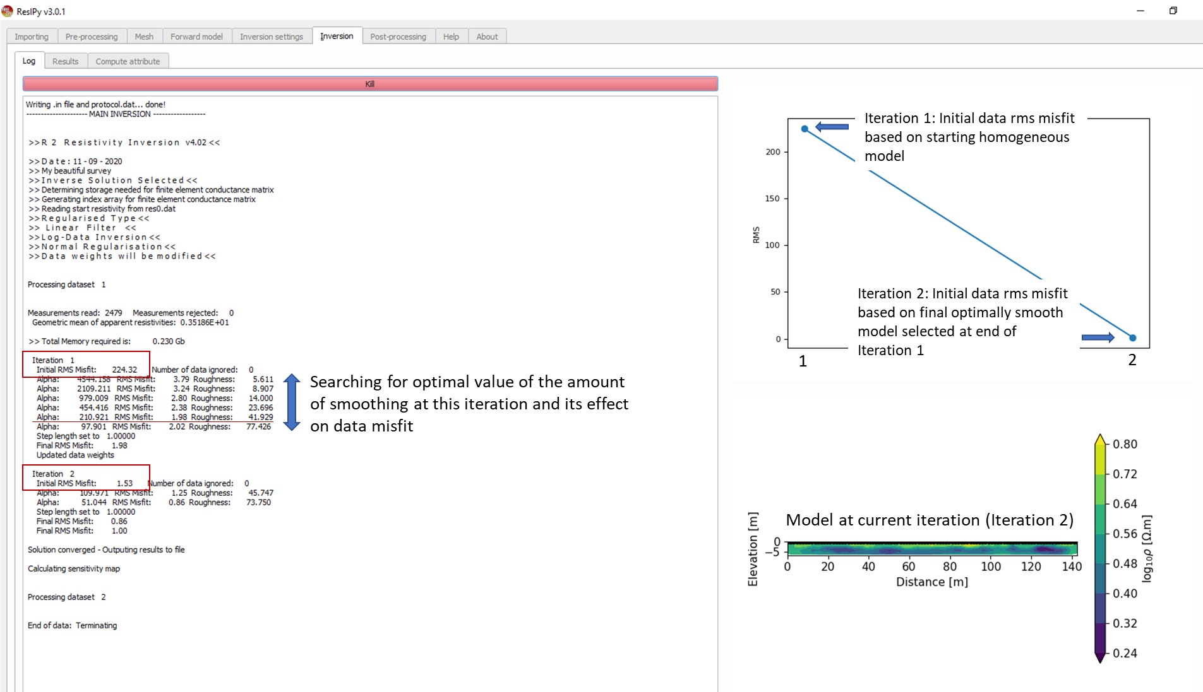
Figure 2: Screenshot from ResIPy showing some key information on the progress of the inversion toward a solution to a model for the unknown resistivity structure of the earth beneath the array of electrodes

Exploring the Effects of Measurement Errors on the Inversion
This exploration of ResIPy focuses on examining the effects of the error estimates on the inversion. Using the video as guidance, re-run the inversion of the Harrier Meadow dataset with a range of errors parameters that differ from those estimated from the reciprocal errors as described in the video. Table 1 lists six different error model scenarios that you will investigate. You should have already entered values for Scenario 1, being the case when the parameters calculated from the resistance error model are used during your viewing of the ResIPy video.
As you complete each inversion scenario, save an image file of the inversion result plotted on the linear conductivity (mS/m) scale and with the minimum set to 120 mS/m and the maximum set to 680 mS/m. Note that it is critical to set the color scales for each inversion result so you can meaningfully compare the differences between the images. Name your image files Scenario 1, Scenario 2, etc.
Table 1: Exploration of the effects of the error model parameters on the inversion of the Harrier Meadow datasets in ResIPy
Scenario |  | a_wgt (-) | b_wgt (-) | Number of iterations to reach a solution | Initial RMS Misfit | Filename for your image of the inversion
Using error resistance model with 2% threshold applied
 | From resistance error model
1 | Modification to resistance error model
Exploration of effects of errors on inversion (2% threshold still applied)
2 | Errors slightly overestimated
3 | Errors grossly overestimated
4 | Errors moderately underestimated
5 | Errors grossly underestimated
Re-running the entire dataset with the 2% error threshold ignored
6 | Modification to resistance error model

As a final step, return to the “Pre-processing” tab of ResIPy and hit “Reset” to remove the 2% filter you applied to remove bad points. Now re-run the inversion with the error settings defined from the modification of the error resistance error model. Once again, record the initial RMS misfit and number of iterations needed for the solution to converge. When viewing the inversion result make sure once again to plot using the linear conductivity (mS/m) scale and with the minimum set to 120 mS/m and the maximum set to 680 mS/m. Note that it is critical to set the color scales for each inversion result so you can meaningfully compare the differences between the images. Make sure to save the image file for Scenario 6.

Completing Task 4.2.3 of the Student Assessment
As you prepare to tackle Task 4.2.3 of the assignment make sure you have done the following:
- Completed all required entries into Table 1
- Exported six image files (labeled Scenario 1 to Scenario 6). Each file should show the inversion result with the error settings specified in Table 1 of the ResIPy handout plotted using the linear conductivity (mS/m) scale and with the minimum set to 120 mS/m and the maximum set to 680 mS/m. You will need to compare these image files as you complete the student assessment.

