SuperStingR8 ERT Quick-Start Guide
Danielle Kinkel (EarthScope Consortium)

Pre Setup
Ideally scope out potential field sites ahead of time to know conditions and survey line placement. If there is an obstacle blocking you from deploying the full line, either shift the line over or restrict the number of electrodes you use. You want to try and make the electrode line as straight as you can.
Fully charge the batteries, and any other needed equipment such as the tablet and/or computer. We recommend bringing along a portable charger for the tablet or computer, since the battery can quickly drain if you need to have the screen brightness at max in order to see it outside. A sunshade umbrella is useful to help make the tablet and the SuperSting screen easier to see in the bright sun.
You will need a command file to run your survey, defining the type and layout. There are four command files preloaded on the SuperSting, a Wenner and a Dipole-Dipole layout for 28-electrode and 56-electrode lines. The names are: “dd28fr” “dd56fr” “wn28fr” and “wn56fr”. If you wish to create your own command file, this can be done ahead of time on a laptop or tablet and then uploaded to the SuperSting. See the Appendix for instructions on how to create command files.

Safety
Always treat the system as ON whenever it is connected to a power source. Do not touch any of the electrodes or cables and maintain a few feet of distance whenever possible and avoid stepping on the cable when the battery is disconnected as well. Do not deploy a line if there is a chance of lightning. If a storm begins after you have started, immediately move away from the equipment and get to a safe location.
If you are in a public space where people may come across your equipment, it is a good idea to mark out a boundary with flags, caution tape, or signs to help prevent someone from unknowingly stepping on or touching the setup. Watch for people and spread researchers along the line, if necessary, especially if there is not clear visibility along the whole length.
Work gloves and high visibility vests are always recommended for field work.

Equipment Setup
- Lay out the measuring tape, doing your best to keep the line straight. Have someone step on the end of the measuring tape or stake it to the ground to keep the end in place.
- Begin placing the stakes at your desired spacing, using a mallet to hammer them in.
  - The stakes should be hammered into the ground at no more than 10% of the electrode spacing length; so, if the electrode spacing is 1 meter, the stakes should not be more than 10 centimeters deep. Sometimes you may need to move the stakes due to obstructions in the ground like rocks. The stakes shouldn’t deviate from their designated location by more than 10% of the electrode spacing and ideally move the stake perpendicular to the line rather than along the line.
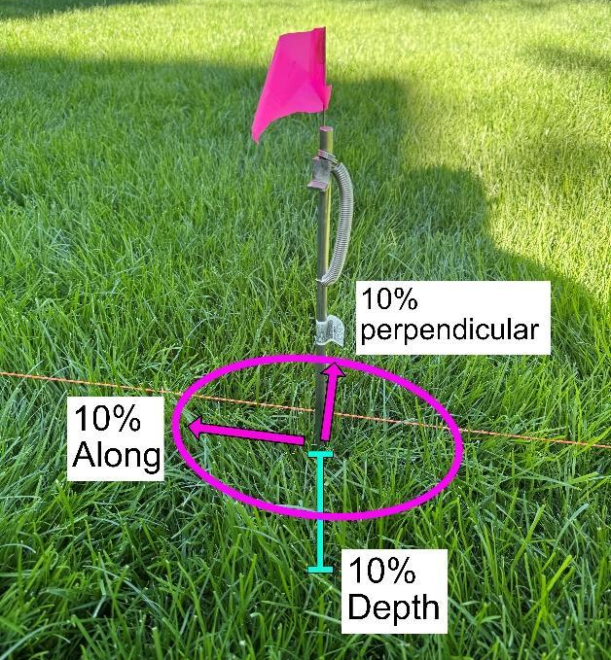
  - Stakes should be fairly vertical, although perfect verticality is not necessary. It is also helpful to place the stakes all facing the same way, towards the side of the line where you plan to leave the excess cable coils, if any.
  - If the soil is particularly hard, you can use a power drill with a standard twist bit, with a similar or smaller diameter to the stakes, to help you create a pilot hole that you can then finish hammering the stake into. You still won’t be able to go through rocks or concrete, so you will still have to move the stake location if you encounter them.
- One of the most common issues is to have poor soil contact with the electrodes, particularly if the soil is dry. This can be remedied by spraying the electrodes with water or salt water, using bentonite clay around them, or wrapping the electrode stakes in aluminum foil.
- Place the takeout cable next to the electrodes. Do not drag the cable on the ground, carry it and place the electrode takeout contacts next to the stakes.
  - The cable is labeled with the electrode numbers. Make sure the cables are connected in order, so the 1-14 cable connects to 15-28, and the 29-42 to the 43-56 cable, and the Switch Box and SuperSting are connected in between electrodes 28 and 29 for a survey with >28 electrodes.
    - If you are doing a 28-electrode survey, put the Switch Box and SuperSting before electrode 1.
  - To connect the cables (14-to-15 and 42-to-43), connect the female end of one to the male end of the other. Line up the notches and push them together. Twist until they click into place.
  - Also, for this cable and every other cable and port, try to avoid getting dirt in the connections. Leave the caps on until you are ready to connect and avoid placing uncapped connections on the ground.
- Connect the stakes to the cable. Take the spring off the stake, loop it over the cable and reconnect, adjust the cable so that the silver electrode takeout is touching the stake and on the shelf of the stake. Coil all excess cable neatly on one side of the line.
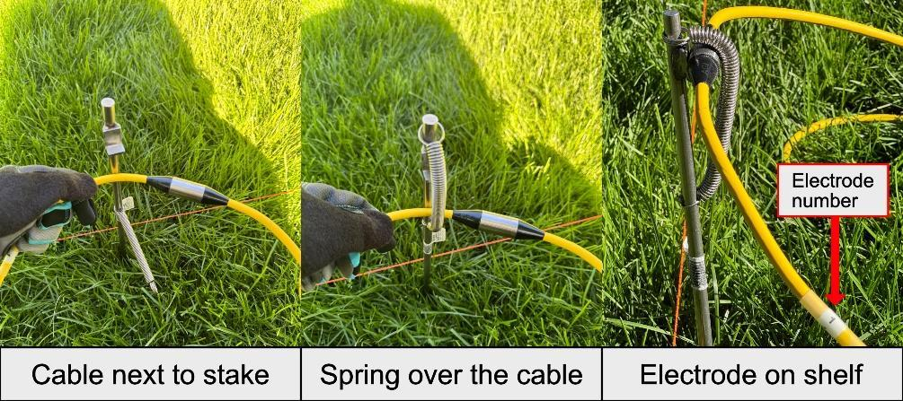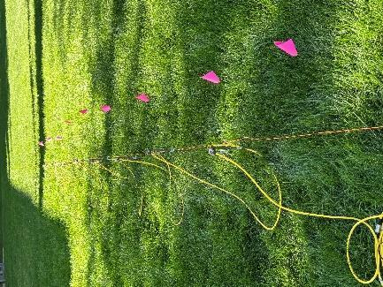
- Connect the Switch Box and the SuperSting. Ideally you want to connect to the labeled female port on the Switch Box, so connect the female end of the cable to the SuperSting, and then the male end to the Switch Box.
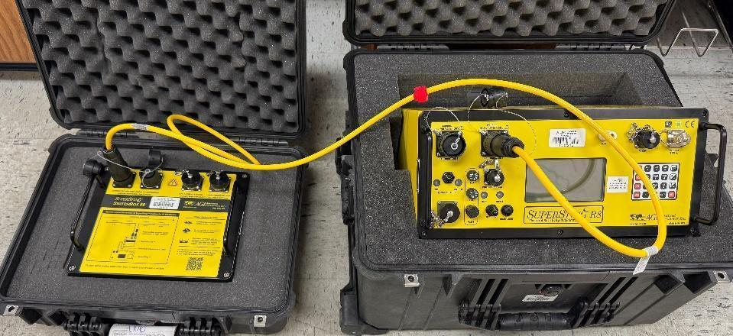
- Connecting the takeout cables to the Switch Box.
  - Electrodes 1-28 are the low addresses, 28-56 are the high addresses, make sure to connect the cables to the correctly labeled ports.
  - The low address cable can connect directly to the Switch Box.
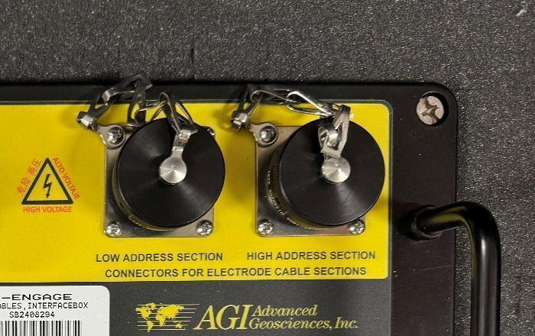
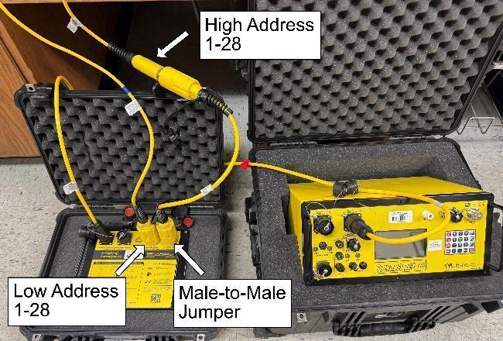
  - You will need to use the male-to-male jumper cable to connect the high addresses.
- Connect the WiFi antenna to the SuperSting. Twist into the WiFi port and tilt the antenna so it is pointing up.
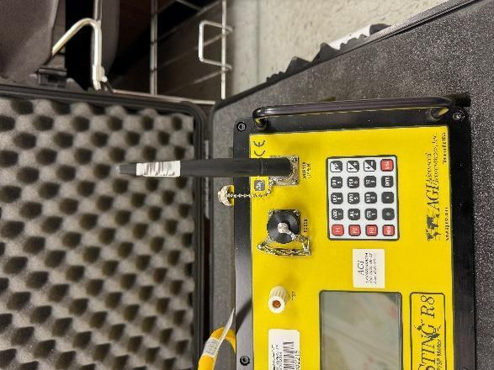
- If using a battery:
  - Connect the barrel end of the battery cable to the SuperSting.
  - Connect the additional battery cable to the first if using a second battery.
  - Connect the alligator clips to the batteries. Red to positive and black to negative.
  - Batteries should be placed on plastic or wood to prevent them from creating a ground loop with the electrodes. The outdoor example photo uses a storage tub lid.
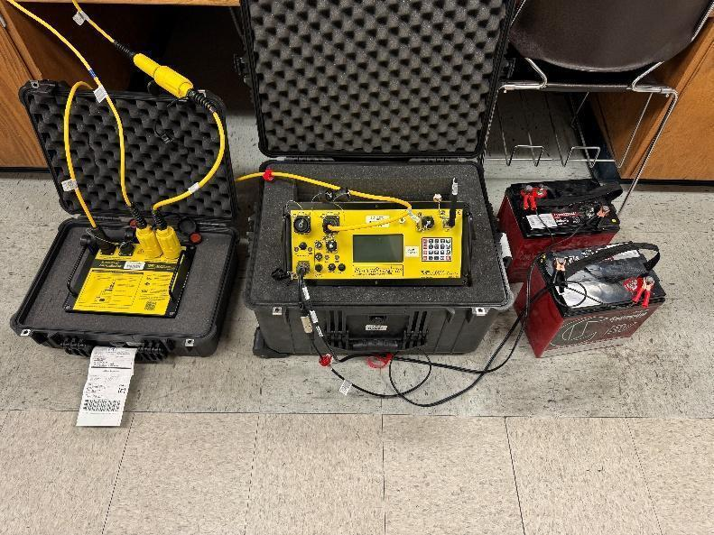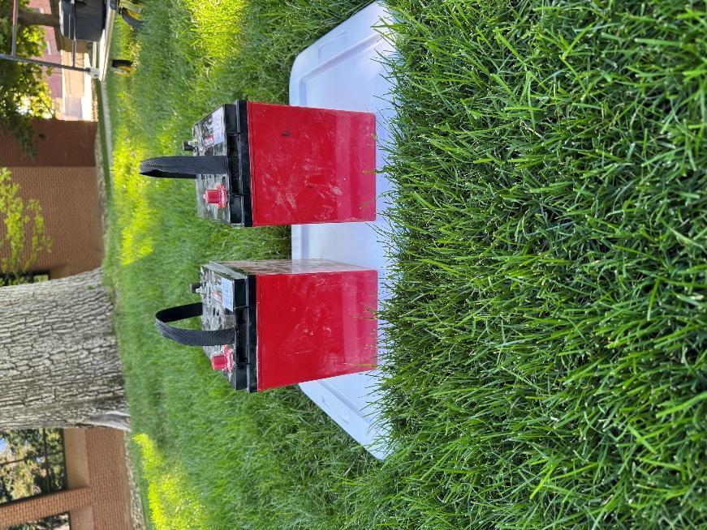

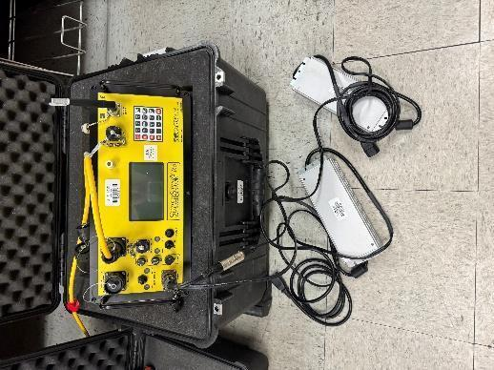
- If using a generator
  - Connect the two AGI power supplies to the SuperSting.
  - Start generator, then plug in the power supplies.
  - The generator should have a floating ground (i.e. no grounding wire).

Operating the Survey
You can operate the survey on the SuperSting with its built-in screen, or through a connected tablet. The menu layout on the SuperSting is the same as the tablet, so the photos and steps line up with whichever method you use.
- Turn on the SuperSting with the power switch, the lights and menu should come on.
- Make sure the communication switch is set to WiFi, the red light will be on.
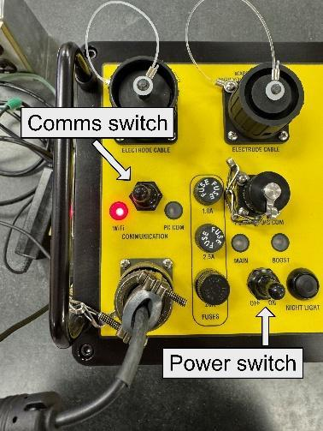
- To connect the tablet, go into the WiFi settings, connect to the one labeled SuperSting[serial number].
  - The password is SuperSting01
  - Since the SuperSting WiFi doesn’t connect to the internet, the tablet may ask if you want to stay connected, select Yes.
  - If it is not connecting, check the SuperSting is using the correct baud rate by using the numpad and menu on the SuperSting, going into “6. system settings”, then “4. general settings”, and check that “8. Baud Rate is 38400”. You can also have any device not connected to the SuperSting turn off their WiFi.
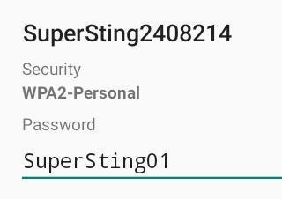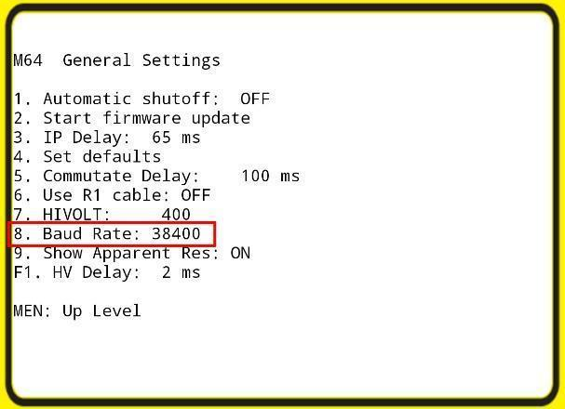
- Open the AGI SuperSting Manager app. If you are connected, it will say “SS Connected: Yes” at the top and all the tabs on the main menu will be working.
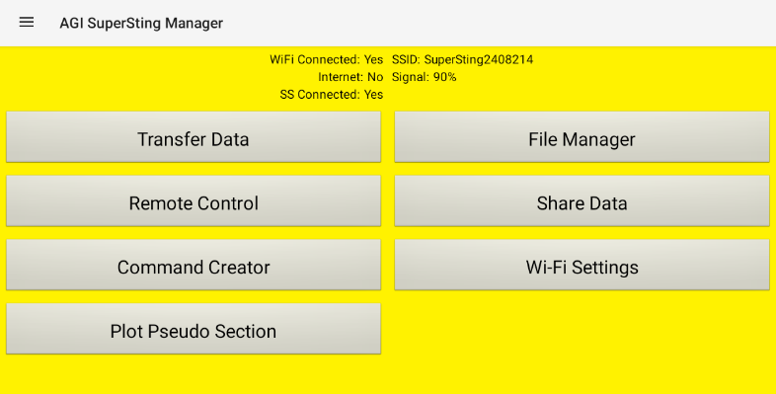
- Use the Transfer Data tab to upload your command file if you are not using one of the ones provided or have not already done so with one you made yourself (see Appendix).
- Open the “Remote Control” tab to take control of the SuperSting and begin your survey.
  - You will need to use the number pad to make your selections, e.g, pressing 6 opens System Settings.
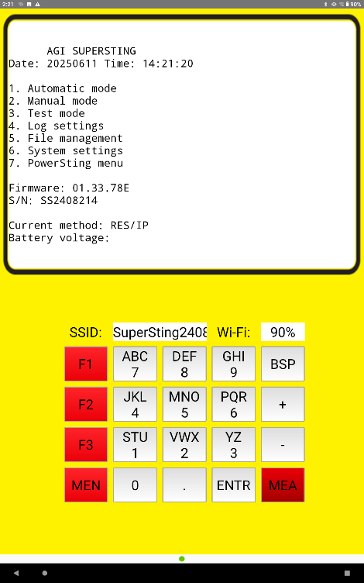
- Select “1: Automatic mode”
- Select “2: Create data file”
- You should be on the “New Data File” screen and asked to create a file name.
  - You have a maximum of 8 characters to create the name. Numbers are typed by pressing their labeled button. To type a letter, you use the F# and number buttons. The F# corresponds to the letters position on its number button. So, the letter A is F1 button, then 7 button, because A is the first letter on the 7 button. The letter R is F3 then 6 because it is the third letter on the 6 button.
  - Name the files systematically. If you have multiple locations you’re surveying, you could use “location name abbreviation-line #”, ex: “VAL-LN1”. If different groups are using the device, then we suggest “GR1-LN1” format. Different days, “month day -LN#”.
  - Press “Enter” to continue once you’re done.
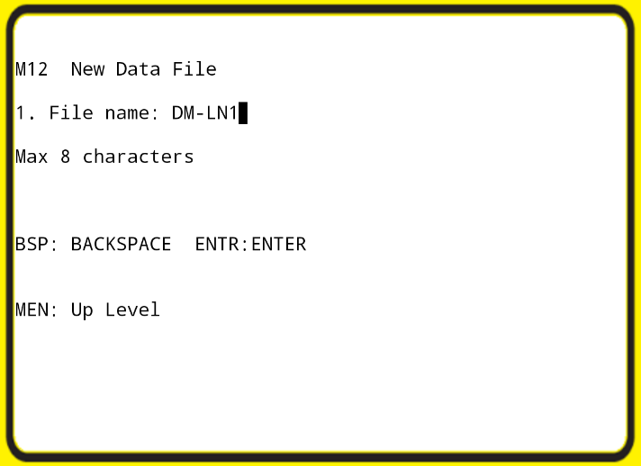
- Next you need to select the command file, the instructions to the SuperSting on how to do the survey. You can select one of the preloaded files (“dd28fr” “dd56fr” “wn28fr” “wn56fr”), or you can use one you created (see Appendix). Press “Enter” when done.
- On the “Data File Setup” screen you need to add the information specific to your survey.
  - “Scaling factor” is the distance between the electrodes. Make sure the units are set correctly.
  - The “Start“ options are for entering the starting coordinates of the line. It is not necessary to fill those out, so you can leave them as a default of 0.
  - Select Yes for “Roll-along” if you are doing a roll-along study, which is where after you finish first measurements, you take one section of cable and electrodes and leap-frog them to the other side of the other cable, advancing the line when your desired line is longer than the electrode cables. (this is less common for starting users)
  - “Edit End Addr” lets you specify the last electrode if you cannot use all the electrodes for some reason -- such as an obstruction preventing you from deploying all of them. You enter the number of the last electrode to be used.
  - Press “Enter” when done.
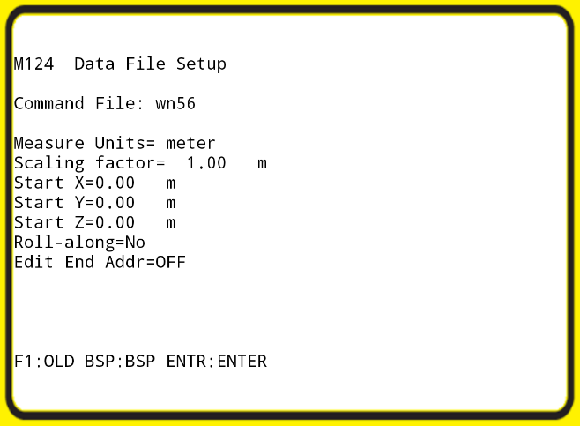
- You should arrive back to the “Automatic Mode” menu.
  - If you entered anything incorrectly, you can fix it by selecting “3: Edit survey information”
  - If everything is correct, press the “MEA” button to continue.
- Select “1. Switch Box”. Select “Add switch box”. Press the “+” key until you see “Switch box 56”. Press “ENTR”, then press “MEN” to exit.
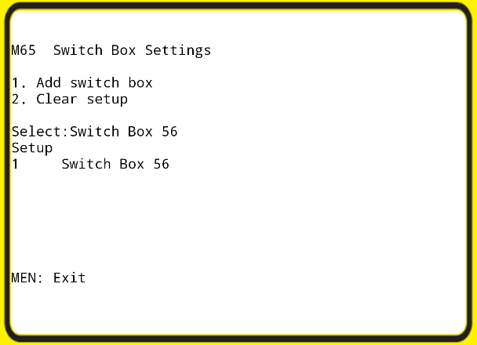
- On the “Cable Address Setup” screen you need to specify which electrode numbers go with each cable section.
  - Press “1. Add cable section”. For section 1, the low addresses, you will set “Elec Low” as 1 and “Elec High” as 28. Repeat these steps for the high addresses section, setting “Elec Low” as 29 and “Elec High” as 56. Press “MEN” when done.
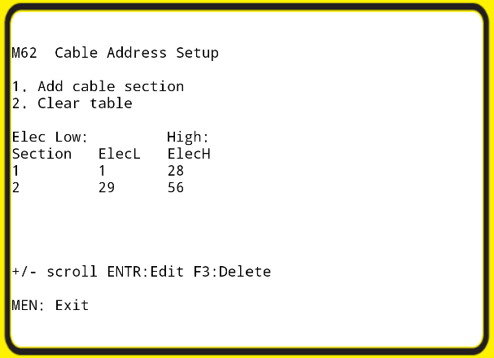
- On the “Measurement Settings” menu, it is recommended you use the factory defaults. Press F1 to change the setting if it is not correct. Press “MEN” to exit.
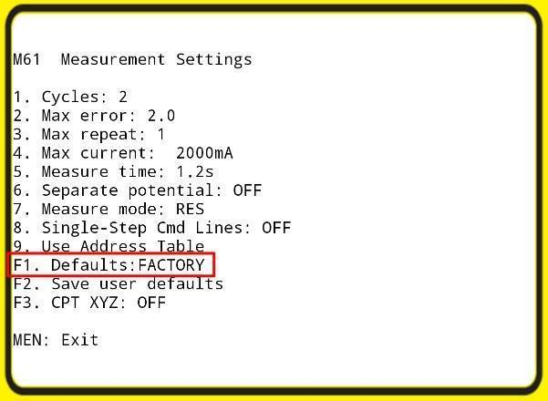
- The “Contact Resistance Test” is to make sure your electrodes have good contact with the soil.
  - Set your “Start address” to 1 and the “End address” to 56, or if you are doing a shortened survey, set the “End address” to the last electrode you are using.
  - Press F1 to start the test.
  - Great contact resistance is anything <1,800 ohms, but acceptable up to 5,000 ohms
  - If you receive an error, most likely the electrodes have poor contact with the soil, which can be helped by spraying it with water or salt water, adding bentonite clay around the stake, or wrapping aluminum foil around the stake. Also look out for any stakes that are not connected correctly to the cable.
  - If you need to touch an electrode, turn off the system and disconnect the batteries before proceeding. Anytime you need to touch cables or electrodes, disconnect the batteries to remove the risk of electrocution.
- Once you are back at the “Automatic Mode” menu, check that all the information is correct and then press “MEA” to begin collecting data. The tablet will switch to showing you a real time pseudo section once the measurements have started.
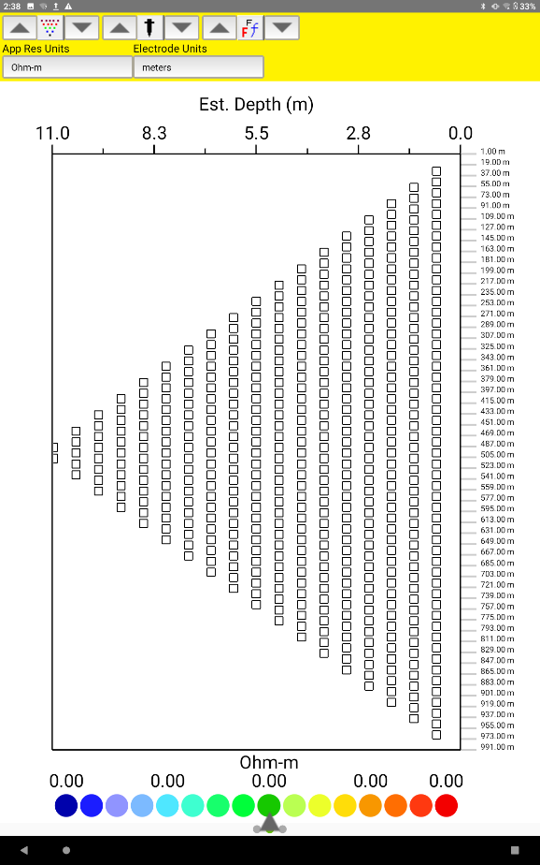

Packing up the setup
- Turn off the SuperSting, wait for the lights to go off, and then fully disconnect the batteries before doing anything else.
- We suggest you take the stakes out and then the cable since they are easier to lose in vegetation. Remove the spring, remove cable, reconnect spring. Make sure to clean all electrodes, you want to remove any soil and corrosives, like salt. The stakes should be fully dry before putting them back in the case.
- Do not drag the cable along the ground.
- Carefully coil the cable -- do over-under coiling such as with a climbing rope. Don’t wrap it around your arm like an extension cord.
- Make sure the caps are placed back on the cables and all the ports on the Switch Box and SuperSting.

Appendix: Creating Command Files
Command files tell the SuperSting what array type you are using and the specifics of how you want it done. These can be created on the tablet, ideally before going into the field. Examples are shown for Wenner and Dipole-Dipole array types. If you wish to use another array type, refer to the full manual for the information needed. Roll-along surveys use the same command files as regular surveys. There are four files preloaded for you, “dd28fr” “dd56fr” “wn28fr” and “wn56fr”, for standard Wenner and Dipole-Dipole arrays using 28 or 56 electrodes. Choose different names for your files or you won’t be able to upload them. Whatever command files you use, keep good notes about the details of your array set up.
- Open the “Command Creator” option on the tablet app.

- Start by selecting the “Array Type” and the “Instrument Type”, which should be set to SuperSting R8.

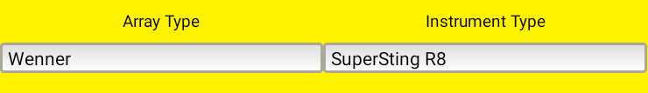

- For a Wenner array:

  - Fill out the boxes highlighted in red. The other fields are not necessary; they are for display purposes.

  - “Prog ID”: The name of the file. The recommended format is “[array type][number of electrodes]”. Ex: :wn56fr” for a Wenner array using 56 electrodes and running through both forward and reverse (reciprocal).

    - Add additional details to the name to match specific characteristics of the array or if there is a command file that already exists with the name. Ex: If you decide to change the expansion factor to 20, name the file “wn20-56”.

  - “# Elecs”: The number of electrodes you will be using.

  - “Expan Fact”: The expansion factor. Should be ≥ 0.3 times the total number of electrodes in order to sample all possible data points. E.g., for a 56-electrode array, it needs to be at least 17.

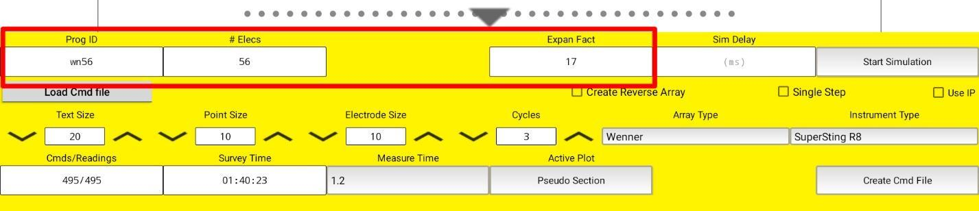

- For a Dipole-Dipole array:

  - Fill out the boxes highlighted in red.

  - “Prog ID” and “# Elecs” same as above.

  - “Max n”: The distance between the transmitter and receiver dipoles, in units of electrode spacing. 8 is typically a strong enough signal for most surveys.

    - If your spacing is 1 meter, your max n is (8 x 1) = 8 meters

  - “Max Dipole”: Controls the depths you sample. Should be at least 10% the total number of electrodes if you want to sample the deepest depth.

    - If you want to ensure you get all the data, set an arbitrarily large number.

    - If you only want to sample shallow depths, use a smaller number.

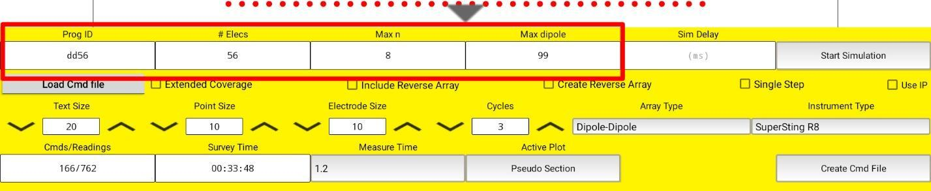

  - Check the box for “Include Reverse Array”
    - This will create the reverse (reciprocal) measurements and double the number of measurements. Note the image for step 4 shows “Cmds/Readings 166/762” and the image that includes reciprocals reads “Cmds/Readings 332/1524.”
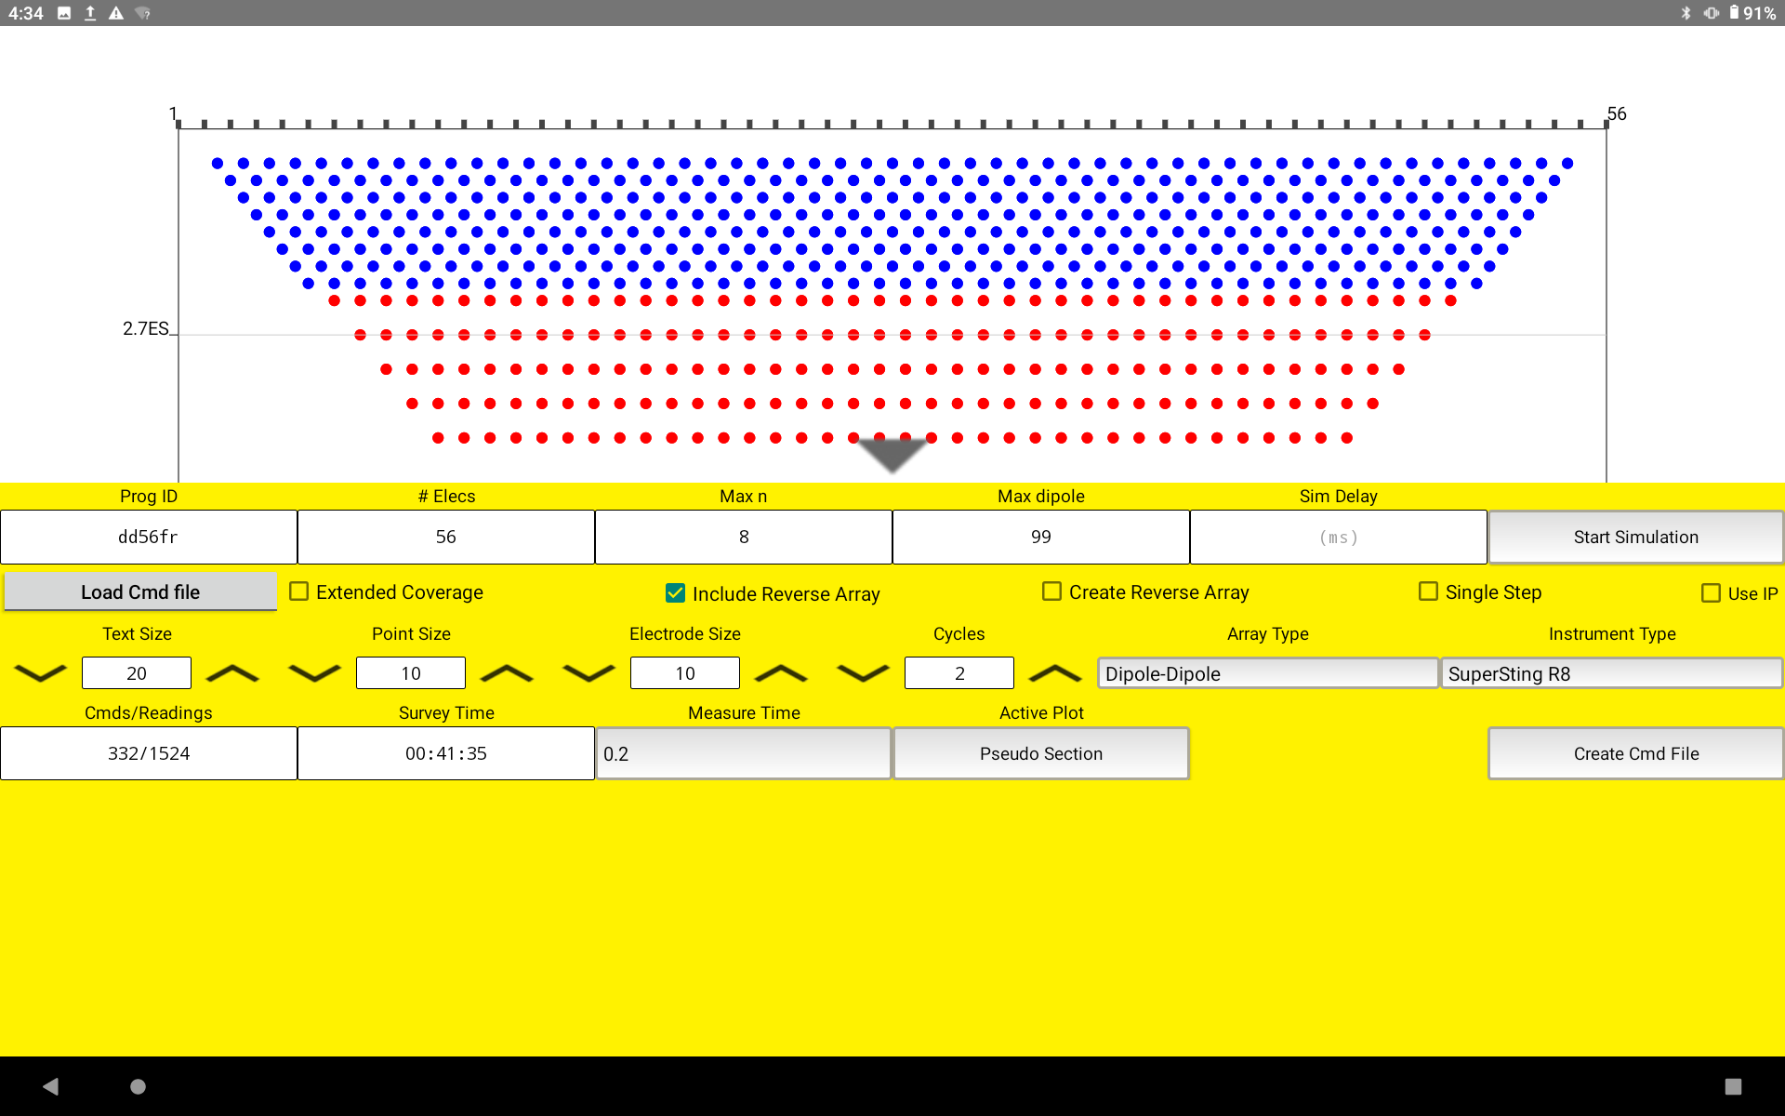
    - By convention, the Prog ID for this new array is “dd56fr,” where dd is for array type (dipole-dipole), 56 is the number of electrodes, and fr means that forward and reverse (reciprocal) measurements are included in the command file.
  - Notes:
    - This image shows the parameters for the “dd56fr” command file.
    - Including reciprocals for a Wenner array is not as straight forward. However, a dipole-dipole array is the best array to use for teaching due to its speed.
    - The other parameters in the image are slightly different to reduce the survey time. “Cycles” is reduced to 2, so each measurement is measured twice. “Measure Time” is reduced to 0.2, so current is injected for 0.2s for each cycle of each measurement.
- Once you have entered your parameters, select “Start Simulation”.

  - This will create a pseudo section showing you the expected depths it will sample, click on the grey arrow to see the whole thing.

  - This also displays the number of command lines and the time it will take to run the survey in the bottom left corner in the “Cmds/Readings” and “Survey Time” boxes.

- If everything looks correct and meets your needs, select “Create Cmd File”.

- To upload the command file to the SuperSting, go back to the app’s main menu and select “Transfer Data”, then select “Upload Command Files”.

