ResIPy Quick Guide
Lena Schwebs (University of Wyoming)
ResIPy is an open-source software for analyzing electrical resistivity data. This document is a short guide to get started using the software. It assumes that you already have data to analyze. See separate instructions for installing ResIPy if you have any issues with that part.
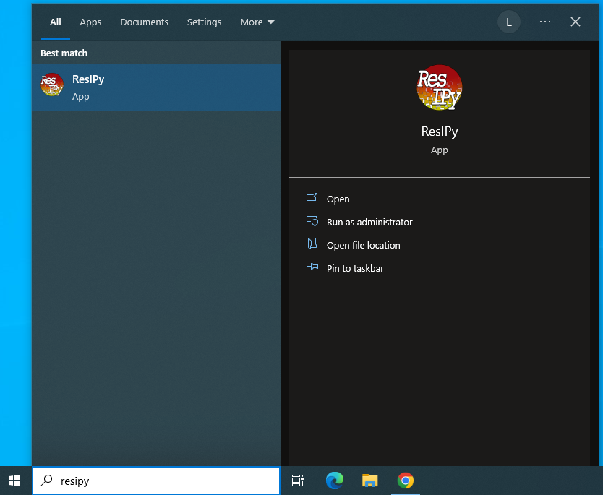
- Opening ResIPy/Uploading Data
  - Open ResIPy.
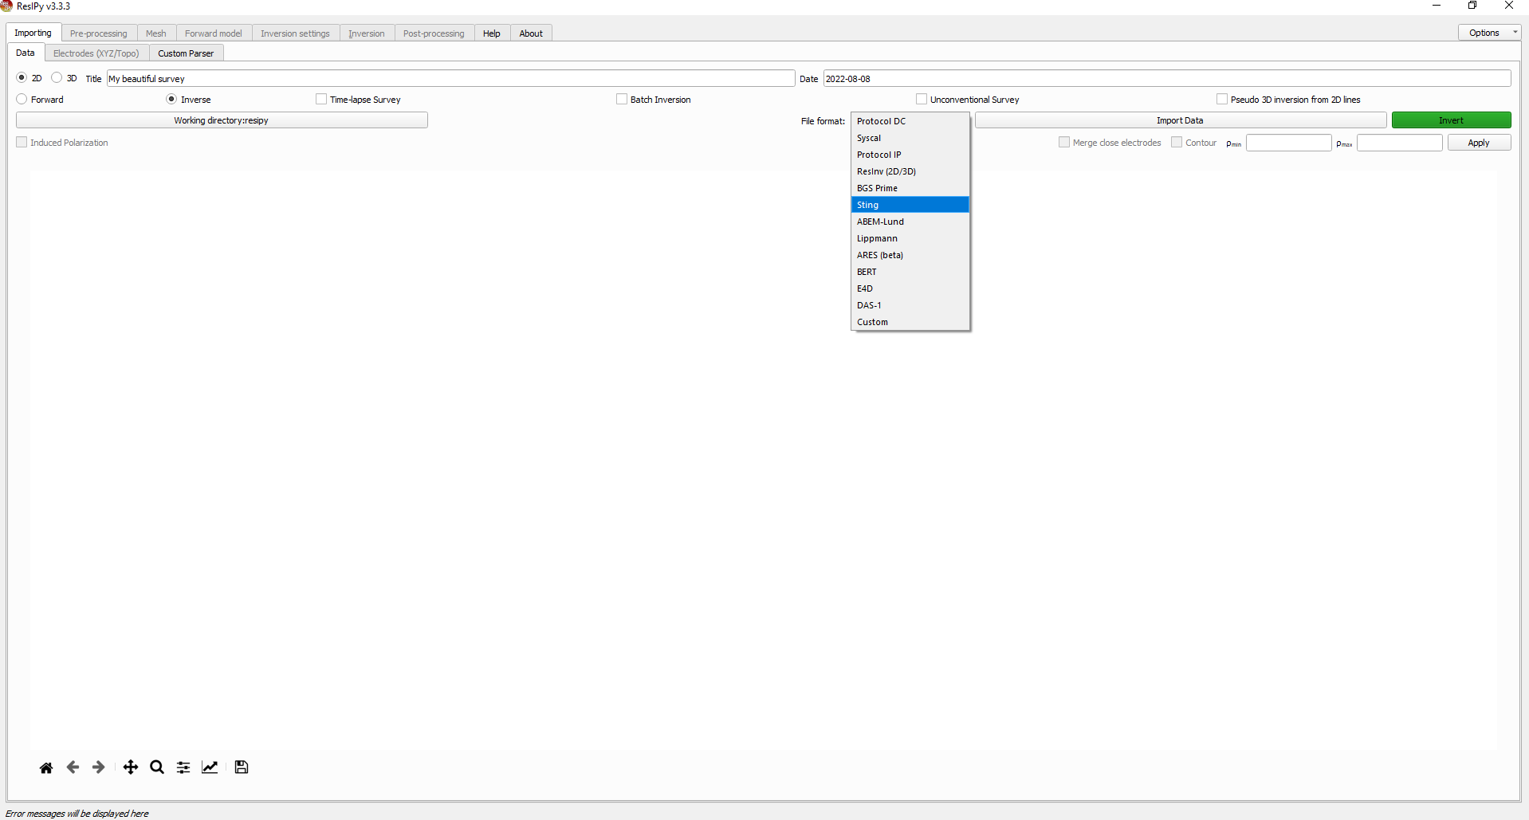
  - Change the file format to Sting and click Import Data to find the .stg file you want to open.

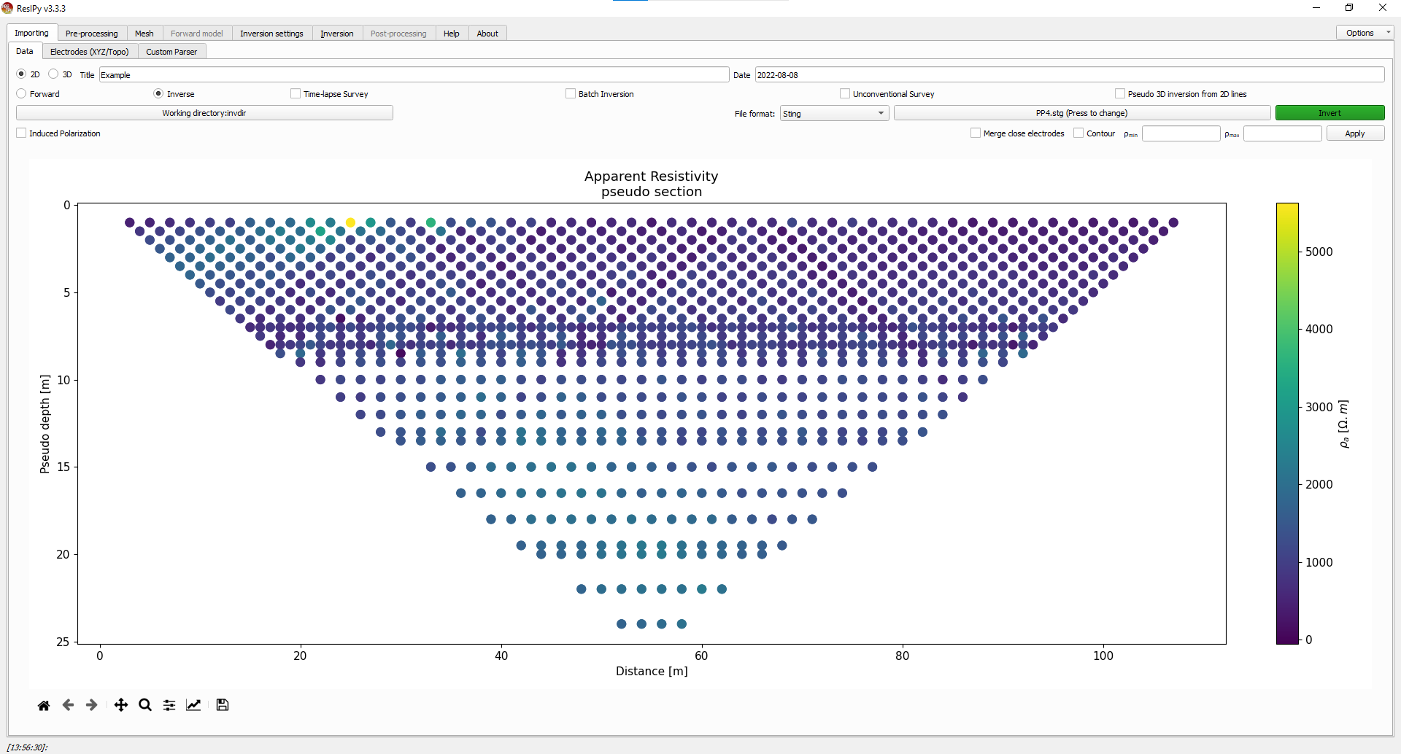
  - Change Title from “My beautiful survey” to a more suitable name.
  - Your screen should now look similar to the below image.
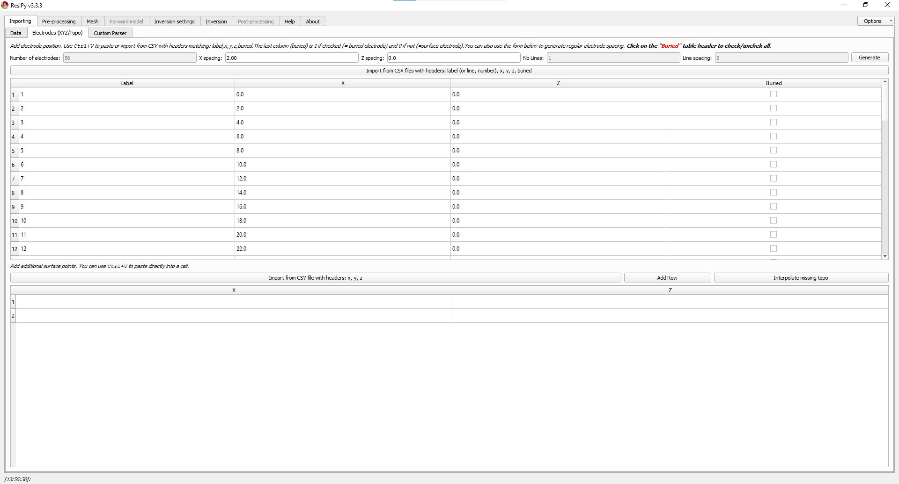
  - At this point, elevation data would typically be uploaded under the Electrodes (XYZ/Topo) tab. However, if your dataset is from a nearly level surface, this step will be skipped.

- Pre-Processing Data
  - Click on the Pre-Processing menu tab.
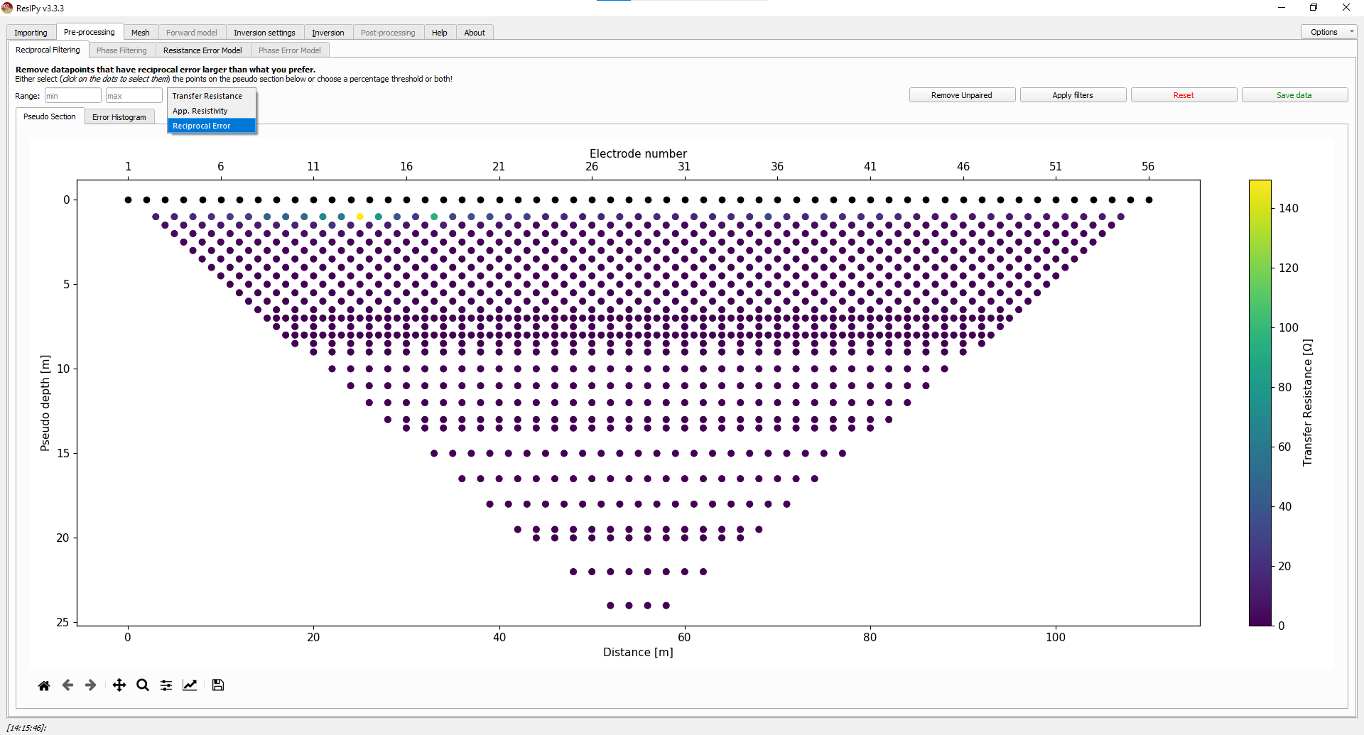
  - Choose Reciprocal Error from the drop-down.

  - Put reasonable value (5-15%) in the Threshold box left of the drop-down.
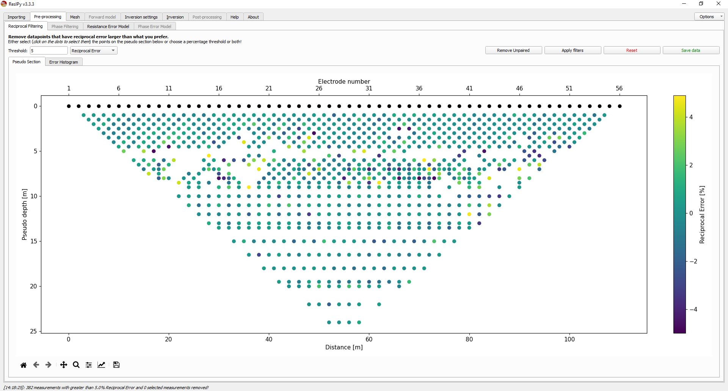
  - Click Apply Filters.

  - You should notice some points have been removed in the pseudo-section.

  - Click on the Resistance Error Model tab.
  - Select Linear from the drop-down menu.
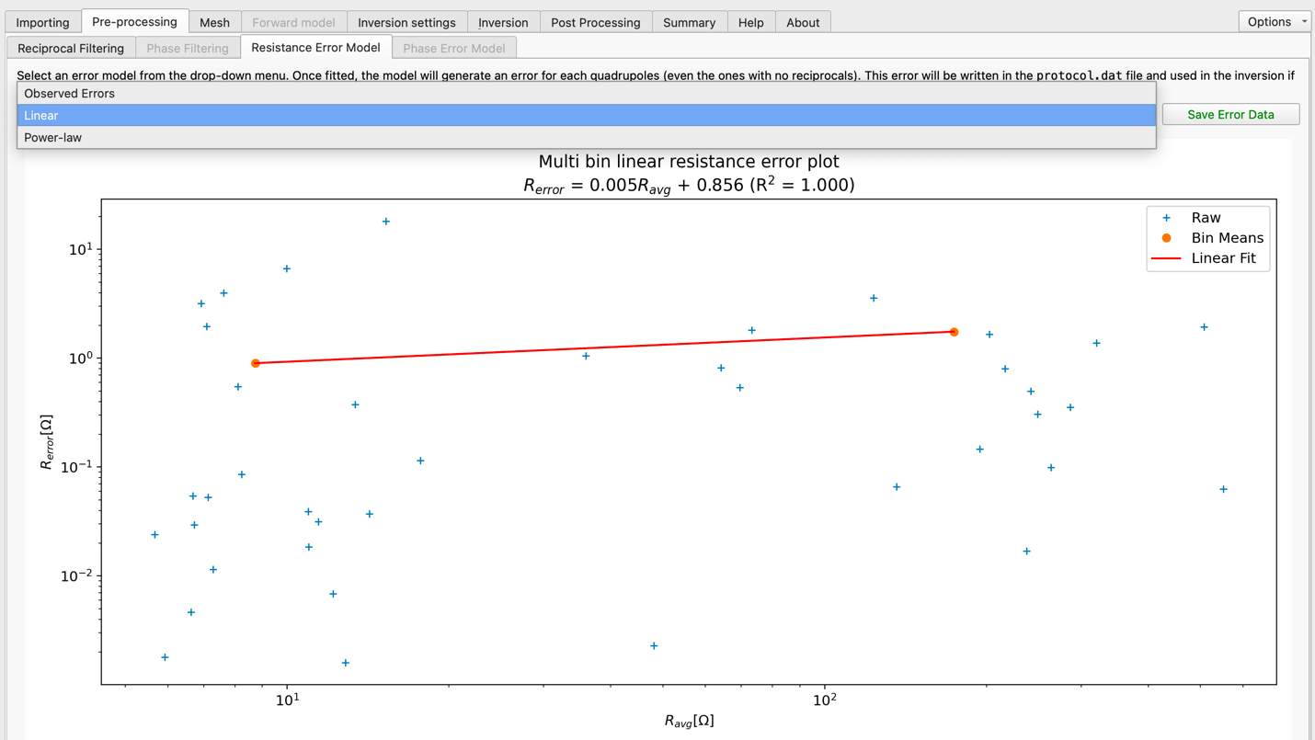
  - The image should change to include a red linear fit for the blue plus-sign errors.
- Creating a Mesh
  - Click on the Mesh menu tab.
  - Click on the yellow Triangular Mesh button.

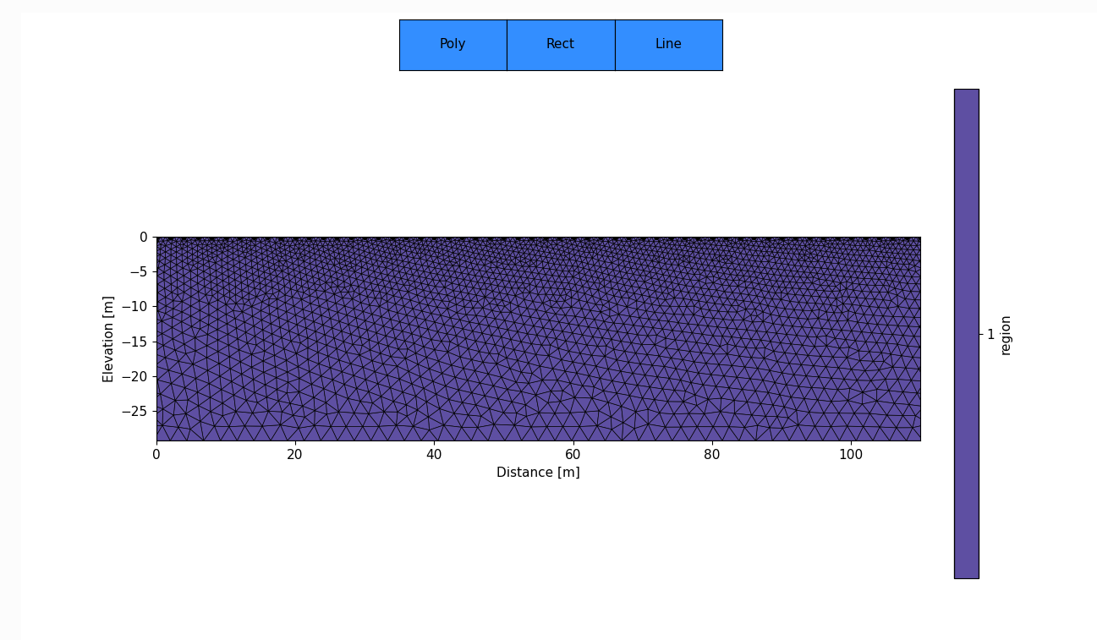
  - A mesh should be created that looks similar to this image.

- Inverting the Data
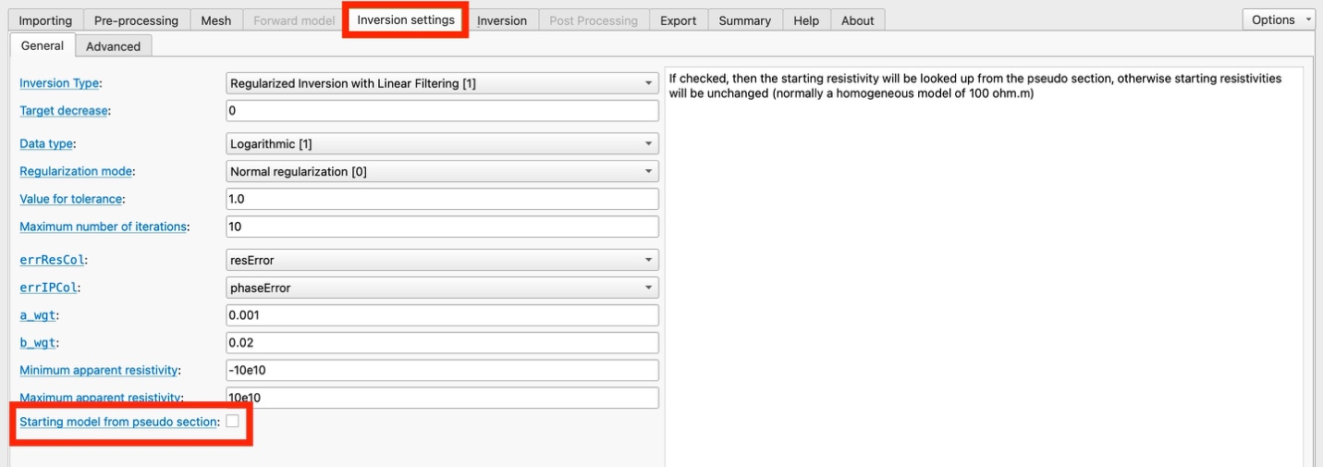
  - Under the Inversions Settings tab, make sure to uncheck “Starting model from pseudo section” (Note: this step became needed in newer versions of ResIPy)
  - Click on the Inversion menu tab.
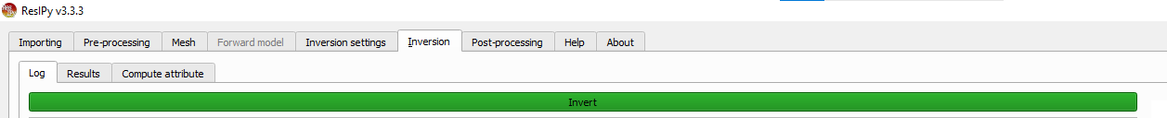
  - Click on the green Invert button.

  - The screen will begin to populate with the inversion stats. The program is set to do a maximum of 10 iterations, but it usually shouldn’t take more than 3.
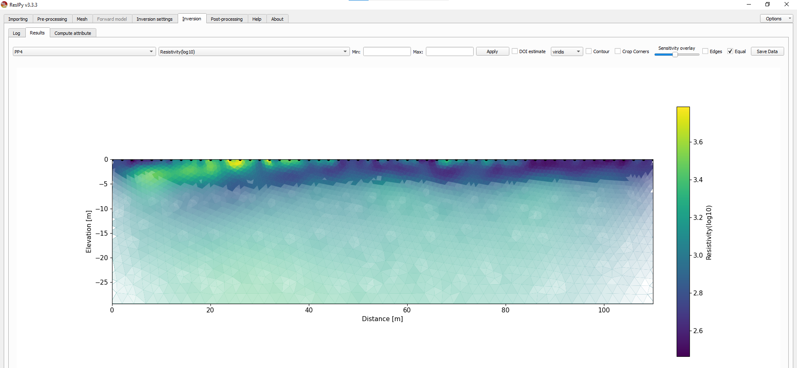
  - Once the inversion is complete, ResIPy will automatically switch to the Results tab with the completed inversion such as the picture below.

  - You have now finished processing the resistivity data!
    - It is recommended you keep the data set to Resistivity(log10), check Clip Corners, and choose the color scale you prefer from the drop-down bar.
    - The other features you can play with to see what each one does and ask questions.

  - If your colorbar is displaying linear units for Resistivity(log10):
    - Click the edit figure button (bottom screen, second to last icon, upward trend icon).
    - Select <colorbar> from the drop-down.
    - Under Y-Axis, select log from the Scale drop-down and click Apply.
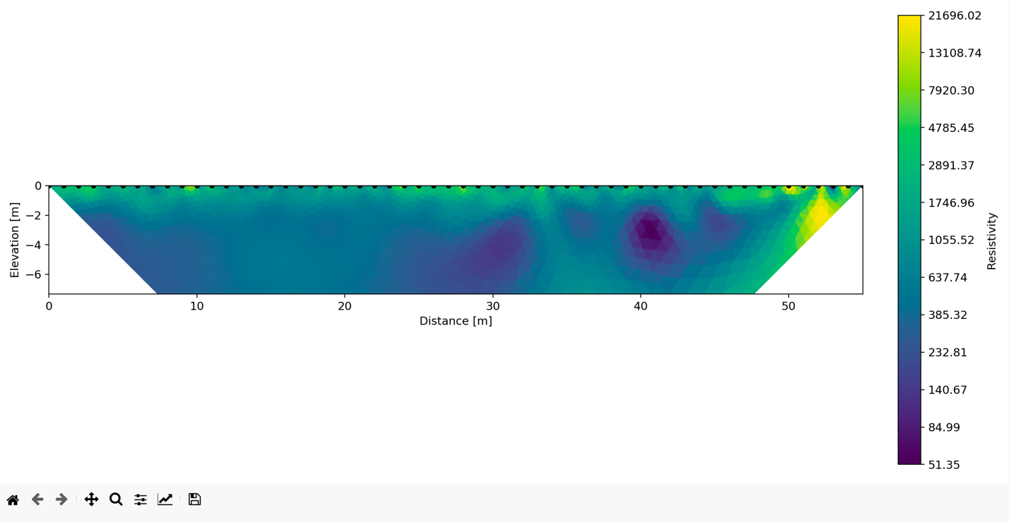
    - Then, select linear and click Apply.

