Locating Subsurface Features Using Gravity and Magnetics Unit 3: Part 2 Weyandt Farm Magnetics Survey Lab
Andy Parsekian (University of Wyoming)

2.1 Introduction
This lab explores a magnetic dataset measured with the objective of locating ‘lost’ buried piping runs. This old oil and gas infrastructure in western Pennsylvania is important to locate to ensure any future digging or building does not rupture pipes that contain hydrocarbons. Locating utilities and buried pipes is critical around construction projects—you may have even seen “call before you dig” signs before.
Piping runs tend to be linear, at least over short distances—generally there is no reason to make the piping installation more expensive by using a non-straight path. Usually magnetic exploration tracklines (i.e., the line that the operator walks along) tend to be grids or at least back-and-forth pathways designed with the goal of crossing the unknown piping run on several of the back-and-forth sweeps to indicate the direction of the buried pipe.
Our survey was done on Weyandt Farm. The magnetometer operator started near a known well location and took a sinuous (winding) trackline across open fields. The magnetic total field measured by the magnetometer is the combination of Earth’s magnetic field and any ferrous objects in the subsurface. The magnetometer collected magnetic total field datapoints four times per second. In addition to magnetic total field data, locations of each datapoint were acquired with GPS so that the data could be mapped. Note that you are only given two “lines” of data to analyze within the entire survey: line “North 3” and line “South 1” (see Figure 1). These datasets are provided in two sheets within the gravmag-unit-3-part-2-mag-data.xlsx file.
Although it is not required to complete this lab, the full raw dataset is provided to you in the third tab of the spreadsheet (raw_data) and a KML-file (gravmag-unit-3-part-2-mag-survey.kml) is provided should you want to visualize the full survey. The KML-file can be opened in Google Earth Pro (or other GIS software); note that the data are color-coded based on total magnetic field and different intervals can be toggled on and off for easier viewing of highest and lowest values.
Learning Objectives
- Interpret magnetic prospecting data to locate anomalies associated with human infrastructure.
- Recognize and describe limitations and equifinality (nonuniqueness) in geophysical prospecting map results.
- Justify interpretations of measured dataset by invoking physical properties and principles.
- Give examples of applications of magnetic geophysical prospecting applications in students’ own neighborhoods or regions.

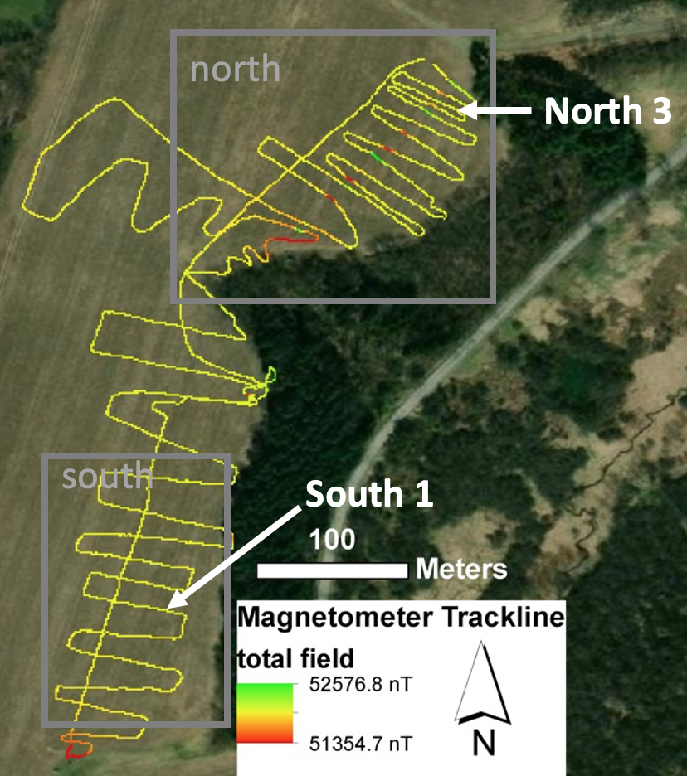

Figure 1. Map view of Weyandt Farm magnetic total field magnetometer trackline (yellow/red/green line) dataset indicating locations of two focus areas with subset lines North 3 and South 1.

2.2 Data analysis procedure
The Excel workbook that goes with this worksheet is: “gravmag-unit-3-part-2-mag-data.xlsx” For each provided tabular dataset “North 3” and “South 1” complete each of these steps in the Excel workbook provided. See Figure 1 for an illustration of where the tabular data were collected on Weyandt Farm.
- Calculate distance based on UTM coordinates: Typically, each magnetic total field datapoint is recorded with a position (latitude and longitude, or UTM easting and northing) and it is useful to convert these absolute positions (grid space) to distances (linear meter space) along the trackline. UTM stands for Universal Transverse Mercator, and it is a coordinate system that divides the surface of Earth into a grid in units of meters. In comparison, latitude and longitude are also measurements of a location on the surface of Earth, but they are measured in units of degrees. Since we are most accustomed to measuring distances in meters rather than degrees on a survey, it is most convenient to use the UTM grid to calculate distance along the measured trackline.
  - In the “distance from last point (meter)” column of the Excel workbook, we will start by finding the distance between each pair of UTM coordinates. The first row will be “zero.”
  - Since the UTM positions represent points on a regular grid and the path of the magnetometer trackline may be in any direction (i.e., not just north–south or east–west), calculating the distance between each point simply requires calculation of the length of the hypotenuse of many tiny triangles.
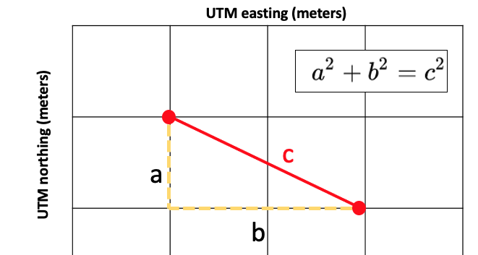
  - We will calculate the length of the red line by finding the difference in the northing values (“a”) and the difference in the easting values (“b”), then plugging those numbers into the Pythagorean Theorem equation Use algebra to isolate “c” and determine which values need to be input for “a” and “b”, then type this formula in column F and fill it down to all lines of the dataset.
  - Now that you have the “step” (or distance between each point) calculated, you can calculate the total distance traveled by calculating a running sum in the “distance from start (meters)” column. Again, the first value will be “zero” and then each subsequent value will be the sum of the “distance from last point” and the “distance from start” from the line above.

- Calculate the magnetic anomaly: The Total Field measurement is the magnitude of Earth’s magnetic field at each point in space. Compared to Earth’s magnetic field, the deflection due to the buried pipe is very small. Therefore, we will remove the average of Earth’s magnetic field from the data to leave just the local anomaly.
  - Start by selecting the first 20 Total Field values and calculating their average in the background (nT) cell (B1). Since these first 20 numbers don’t vary too much, we can assume they are the “background total field strength” for this line.
  - Next, in the “anomaly” column, subtract the average background value from each measured total field value.

- Plot the Total Field by distance: Now, use the distances that you calculated from the UTM coordinates and the provided Total Field data to produce an x/y scatterplot graph on the right side of the workbook. Be sure to label the axes as “total field, nT” and “distance, meters.”

- Plot anomaly by distance: Repeat step 3, except use the anomaly values you calculated.

- Determine direction that the data was acquired in: The order of the list of numbers is not necessarily the same as the direction the data was acquired. Look at the time column to figure out which way this was and look at the map in Figure 1 below to approximate the geographic direction of travel.
- Analyze the South 1 line: Complete steps 1-5 again for the “South 1” line of the survey (in the other sheet of the workbook). (Note: For both plotting steps, be sure to use the same y-axis range for South 1 as for North 3 data.)

2.3 Interpretation, limitations, and extension to other sites
- Interpretation:
  - Describe the pattern of magnetic field values on Figure 1 and on the scatterplot images you produced in Excel. Where are the magnetic anomalies? What large scale spatial patterns do you see?
  - Where is the piping run most likely located? If you wanted to collect more data to see where the piping run ends, where would you propose to measure?
  - How could you explain magnetic anomalies in the data that are not associated with piping runs?
  - Compare the scatterplots in your Excel workbook: what is different about South 1 compared to North 3?

- Limitations:
  - What other utilities might you expect to be buried underground? Would they be detectable with a magnetic survey? Why or why not?
  - Can you make any estimates of the depth to the pipe? Why or why not? How accurate would they be?
  - Optional extension: If you have learned about other geophysical surveying tools besides magnetism, what additional surveys could be useful to reduce uncertainty?

2.4 Evaluation/Assessment
Please prepare a lab report that includes a summary of your procedure, an explanation of your results, and answers to each of the questions above.

